Act1



Jose Alba Arrufat
Index
Tipos de datos 3
Operadores básicos 4
Array de meses del año 5
Práctica 6
1. Decir 5 números y sumarlos 6
2. Pillar números mayores a 8 de un array y sumarlos 7
3. Dar un mes del año y decir en que estación se ubica 8
4. Ver si el número es par o impar 9
5. Calcular IVA 10

Tipos de datos
Advertencia, ejecuto esto desde visual studio code con la extensión de live preview para emular un entorno servidor, alomejor alguna de las cosas que hago te falla a ti por eso.

HTML:
<!DOCTYPE html>
<html lang="en">
<head>
<meta charset="UTF-8">
<meta name="viewport" content="width=device-width, initial-scale=1.0">
<title>Names</title>
</head>
<body>

<ul id="cloop"></ul>
<p id="thirdMessage"></p>

<script src="names.js"></script>
</body>
</html>

JS:
const names = ["Hola mundo", "Jose Alba Arrufat", "Mr Babu"];

let loop = "";
for (let i = 0; i <= 1; i++) {
loop += " <li>" + names[i] + "</li>";
}

document.getElementById("cloop").innerHTML = loop;

let showThird = "";
alert(names[2]);
document.getElementById("thirdMessage").innerHTML;

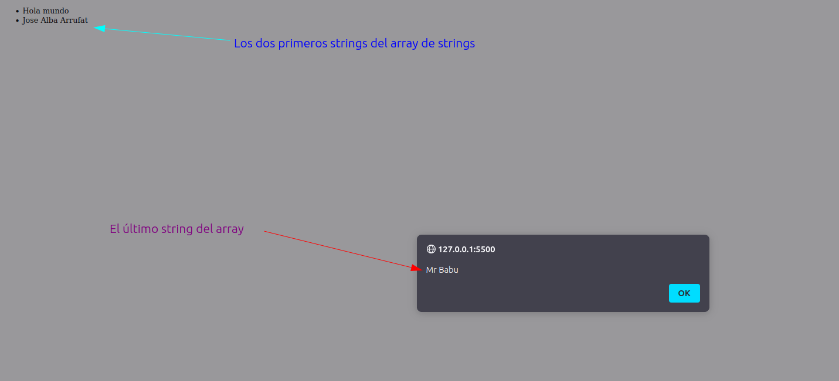

Operadores básicos

HTML:
<!DOCTYPE html>
<html lang="en">
<head>
<meta charset="UTF-8">
<meta name="viewport" content="width=device-width, initial-scale=1.0">
<title>Variables - Jose</title>
</head>
<body>

<ul id="cloop"></ul>

<script src="variables.js"></script>

</body>
</html>

JavaScript:
let number1 = 15;
let number2 = 16;
let total = number1 + number2;

const numbers = [number1 +' '+'+'+' '+number2, , "Mr Babu"];

let loop = "";
for (let i = 0; i < numbers.length; i++) {
loop += " <li>" + numbers[i] + "</li>";
}

document.getElementById("cloop").innerHTML = loop;
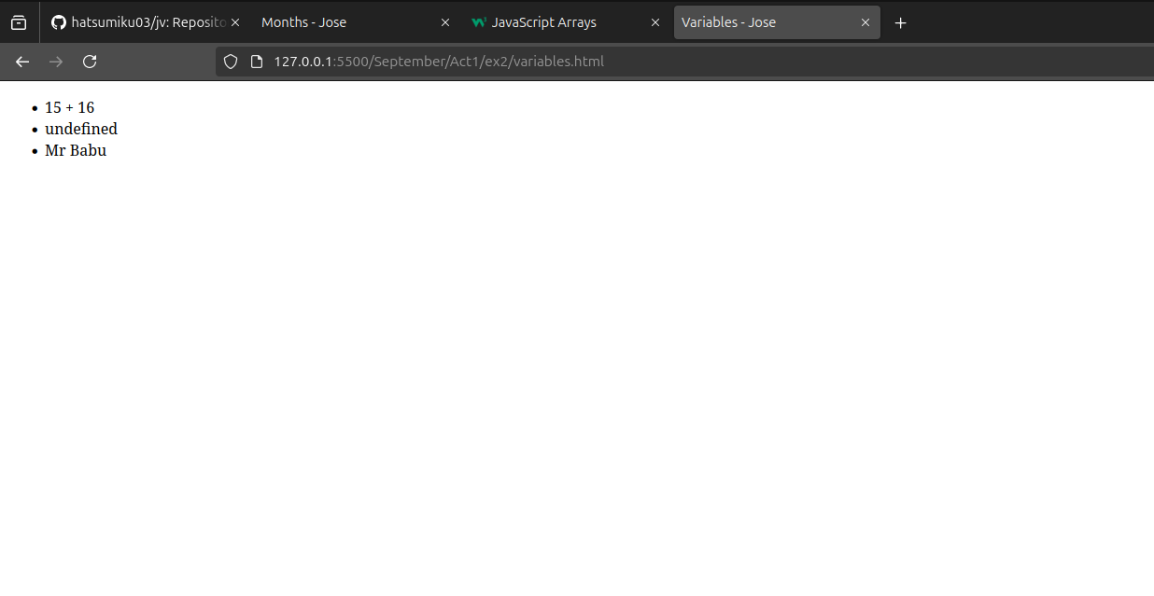

Array de meses del año
HTML:
<!DOCTYPE html>
<html lang="en">
<head>
<meta charset="UTF-8">
<meta name="viewport" content="width=device-width, initial-scale=1.0">
<title>Months - Jose</title>
</head>
<body>
<h1>Months</h1>
<p>In this web are all the months of the year :3</p>
<ul id="cloop"></ul>

<script src="months.js"></script>
</body>
</html>

JavaScript:
const months = ["1 - January", "2 - February", '3 - March', '4 - April', '5 - May', '6 - June', '7 - July', '8 - August', '9 - September', '10 - October', '11 - November', '12 - December'];

let loop = "";

for (let i = 0; i < months.length; i++) {
loop += " <li>" + months[i] + "</li>";
}

document.getElementById("cloop").innerHTML = loop;

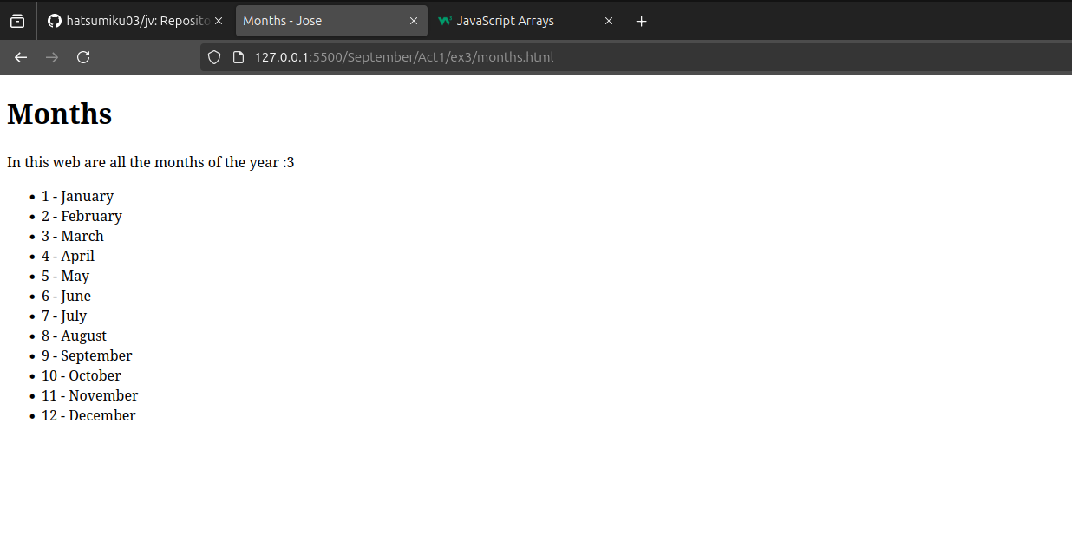

Práctica
IMPORTANTE: En esta sección adjuntare capturas de pantalla del resultado de lo que sale en la terminal.

1. Decir 5 números y sumarlos
let allNumbers = [];
let n = 0;

const reameplease = require('readline').createInterface({
input: process.stdin,
output: process.stdout
});

console.log('YOU WILL WRITE 5 NUMBERS AND YOU GET THE SUM OF ALL FIVE');

function askForNumber() {
if (n < 5) {
reameplease.question('Put a number\n', (input) => {
let number = parseFloat(input);
if (!isNaN(number)) {
n += 1;
allNumbers.push(number);
} else {
console.log('THAT\'S NOT A NUMBER, PUT A NUMBER PLEASE');
}
askForNumber();
});
} else {
// Sum
let sum = 0;
for (let i = 0; i < allNumbers.length; i++) {
if (allNumbers[i] > 100) {
// A part of the exercise
console.log('\n * ' + allNumbers[i] + ' es mayor que 100\n');
}
sum += allNumbers[i];
}
// Sum
console.log('The sum of all numbers you put is:\n', sum);
reameplease.close();
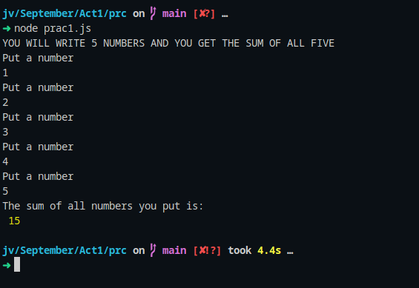
}
}

askForNumber();

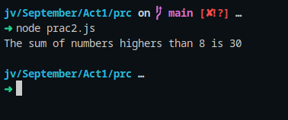
2. Pillar números mayores a 8 de un array y sumarlos
const allNumbers = [6,8,3,12,18];
let numbersHigherThanEight = [];
let sum = 0;

for(let i = 0; i < allNumbers.length; i++){
if(allNumbers[i] > 8){
numbersHigherThanEight.push(allNumbers[i]);
}
}

for(let i = 0; i < numbersHigherThanEight.length; i++){
sum += numbersHigherThanEight[i];
}

console.log('The sum of numbers highers than 8 is ' + sum);

3. Dar un mes del año y decir en que estación se ubica
const reameplease = require('readline').createInterface({
input: process.stdin,
output: process.stdout
});

reameplease.question('Put a month\n', (input) => {
let season = (input);

if(season.toLowerCase() == 'november' || season.toLowerCase() == 'december' || season.toLowerCase() == 'january' || season.toLowerCase() == 'february'){
console.log('It\'s winter');
}else if (season.toLowerCase() == 'june' || season.toLowerCase() == 'july' || season.toLowerCase() == 'august'){
console.log('It\'s summer');
}else if (season.toLowerCase() == 'september' || season.toLowerCase() == 'october'){
console.log('It\'s autumn');
}else if (season.toLowerCase() == 'march' || season.toLowerCase() == 'april' || season.toLowerCase() == 'may'){
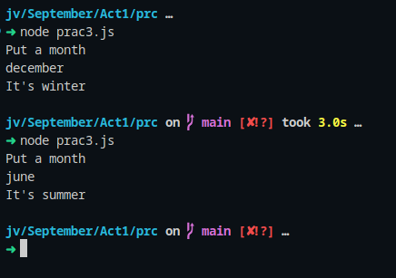
console.log('It\'s spring');
}else{
console.log('That isn\'t a month');
}
reameplease.close();
});

4. Ver si el número es par o impar
const reameplease = require('readline').createInterface({
input: process.stdin,
output: process.stdout
});

reameplease.question('Put number\n', (input) => {
let number = (input);
if (number % 2 === 0) {
console.log(`${number} is even`);
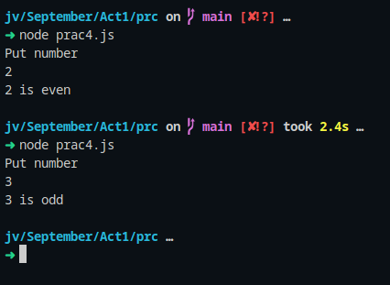
} else {
console.log(`${number} is odd`);
}
reameplease.close();
});

5. Calcular IVA
const reameplease = require('readline').createInterface({
input: process.stdin,
output: process.stdout
});

reameplease.question('Put a price for see the iva extra\n', (input) => {
let number = Number(input);
let iva = number * 0.21;

let totalprice = number + iva;

console.log('individual IVA is ' + iva +'\nThe price with the iva is ' + totalprice);
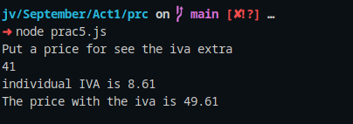
reameplease.close();
});

6. Ver una cadena en upper case, lowercase y con un método que lo revierta
const reameplease = require('readline').createInterface({
input: process.stdin,
output: process.stdout
});

function reverseString(str) {
let arrStr = str.split("");
return arrStr.reverse().join("");
}

reameplease.question('Say me a sentence\n', (input) => {
let sentence = input;

console.log('Sentence: ' + sentence +
'\n\nThe length of the sentence is ' + sentence.length +
'\n\nUpper case: ' + sentence.toUpperCase() +
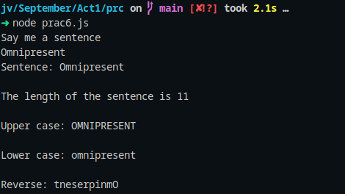
'\n\nLower case: ' + sentence.toLowerCase() +
'\n\nReverse: ' + reverseString(sentence));
reameplease.close();
});

