Image Classification based on ResNet
Vineetha Rajendran¹ and Tong Yao²
^{1,2} Friedrich Alexander University, Erlangen, 91054, Germany
Abstract. Deep Neural Network have become indispensable to the state of the art of Computer Vision Algorithms. For image classification, it has evolved from simple models to structures with multiple wiring paths. The success of ResNet is due in large part due to their wiring plans. The residual learning framework eased the training with deeper networks than the previous networks and overcomes the gradient degradation problem faced by earlier networks when networks grows deeper. In this Paper, we analyze the state-of-the-art architecture with respect to six major viewpoints such as interpretability, augmentation, model capacity, energy, reproducibility, and performance evaluation. We also present the results for small ablation study of Pretrained ResNet PyTorch models, along with previously existed models in terms of its performance.
Keywords: CNN, ResNet model, ablation study, Image classification.
- Introduction
Nowadays Image classification has become a very popular topic. Image classification, a method of image processing that separates the targets of different categories based on the different characteristics each reflects in the image information. It utilizes a computer to quantitatively analyze an image and classify the image or each pixel or region within the image into one of several categories in lieu of human visual interpretation. Convolutional Neural Network (CNN) is one method that is applied to image classification. CNNs are a class of feedforward neural networks that contain convolutional computation with deep structure and is one of the representative algorithms for deep learning. CNN contains an input layer, an output layers, and hidden layers. The hidden layers consist convolutional layers, Rectified Linear Unit (ReLU) layers, pooling layers, and fully connected layers. The convolutional layer produces a feature map to predict the class probability of each feature by attaching a filter that scans the entire image, a few pixels at a time. ReLU is a type of activation function, that is also known as nonlinear mappings, are designed to increase the expressive capability of the entire network (i.e., nonlinear). The stacking of several linear operational layers still only serves to map linearly and does not allow the formation of complex functions. Commonly used activation functions are sigmoid, hyperbolic tangent (tanh), ReLu, and so on. The pooling layer, known as the down sampling layer, shrinks the quantity of information generated by the convolutional layer for each feature and retains the most essential information. The full connected layer flattens the output generated by the previous layers into a single vector that serves as input to the next layer, and then applies weights to the input generated by feature analysis to predict an accurate label. It then generates the final probability to determine the category of the image.
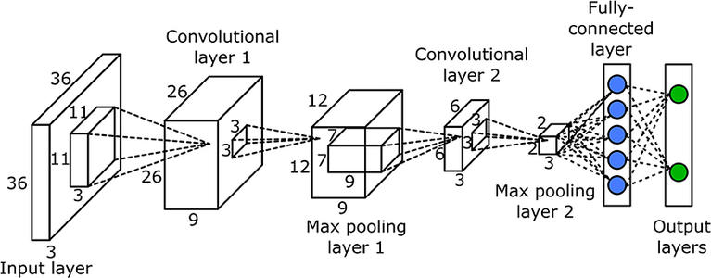
Fig. 1. The basic architecture of the CNN
- Motivation
The history of image classification based on CNN has lasted no less than 20 years. LeNet was created by Yann LeCun in 1998. However, for more than a decade after LeNet-5 was developed, the development of neural networks has been at a low level due to interpretability problems and computational resource limitations. 2012 was a turning point, as Alex Krizhevsky spearheaded AlexNet, which won the ILSVRC in that year by a significant margin, reducing the top-5 error rate to 16.4%, a dramatic improvement over the 26.2% error rate of the second-place team. In VGG-Net, proposed in 2014, the convolutional network structure was extended for the first time to layers 16 and 19 layers, also known as VGG16 and VGG19. In the same year, GoogLeNet was created, and has 22 layers. The above phenomenon shows that deep learning models are becoming deeper and deeper as computer performance is getting better and better. According to common sense, the more layers the model has, the more accurate the results will be, but this is not the case.
The Fig. 2. shows that the plain neural network with 56 layers has higher training and testing error compared to that with 20 layers. The reason for that is not because of vanishing or exploding gradients that prevent convergence of the function. In fact, stochastic gradient descent (SGD) and batch normalization (BN) have gone a long way to ameliorate the vanishing or exploding of the gradients.
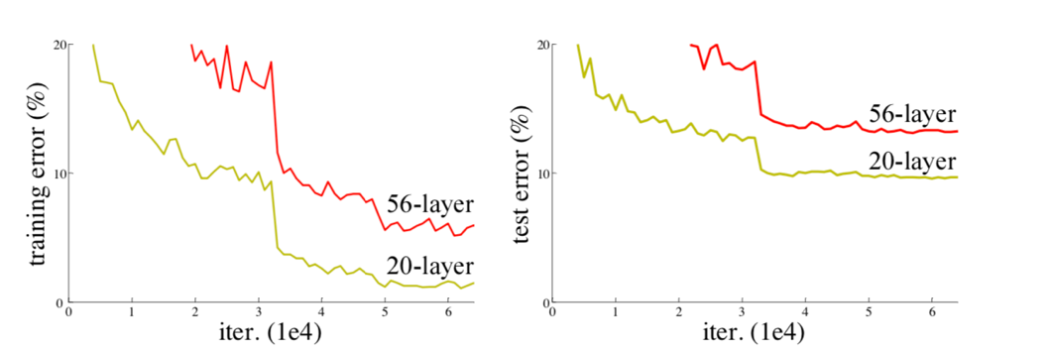
Fig. 2. The comparison of training and test error between plain networks with 56 and 20 layers [3].
According to Fig. 3, due to the presence of the nonlinear activation function ReLu, every input to output is almost irreversible, and this causes a lot of irreversible loss of information. Hence, if some useful information about a feature is lost, it is impossible for the model to have a flat performance [1].
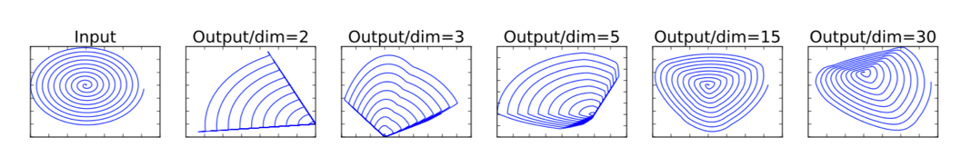
Fig. 3. Examples of ReLU transformations of low-dimensional manifolds embedded in higher-dimensional spaces. In examples above n = 2, 3 result in information loss where certain points of the manifold collapse into each other, while for n = 15 to 30 the transformation is highly non-convex.
On the other hand, as the neural network gets deeper, the correlation between the backward gradients will get worse, and eventually approach white noise. Since images have local correlations, the gradients should also have similar correlations so that the updated gradients make sense. If the gradient is close to white noise, then the gradient update may simply be doing random perturbations. Even if the modulus of the gradient stabilizes within the normal range after BN, the correlation of the gradient actually continues to decay as the number of layers increases [2]. This is the reason why a model that can tackle the degradation problem is needed. In this context, the ResNet was invented by Kaiming He and his team in 2015 and became the most advanced and accurate model at that time.
- Frameworks of Resnet
In Fig.4, from the bottom to the top, they are VGG network with 19 layers, plain network with 34 layers and residual network with 34 layers respectively. What is obvious is that ResNet has a more complex structure with more layers than VGG. Compared to plain network, ResNet has a lot more shortcut connections, that are mostly solid lines, but sometimes dashed lines. These dashed lines mean that the dimensions before and after the blocks are not consistent, because the Plain Network without the residual structure is still based on the classic VGG design: every few layers, the space (length and width of the image) is reduced twice, but the depth (number of channels) is doubled. Thus, dimensional disparity can be manifested in two ways: spatial disparity and depth disparity. If the input and output dimensions are the same, constant shortcuts can be used directly (solid line of ResNet in Fig. 4). When the dimensions are not the same (dashed line of ResNet in Fig. 4), some actions are required. In order to resolve the spatial inconsistency, a linear mapping of the inputs is added to the shortcut connection section (explained in detail in the interpretability section). For inconsistency in depth, there are two solutions, one is to add a $1×1$ convolutional layer for boosting during the jumping process, and the other is to directly fill in the tensor by zeros. Both methods are proven to be effective.
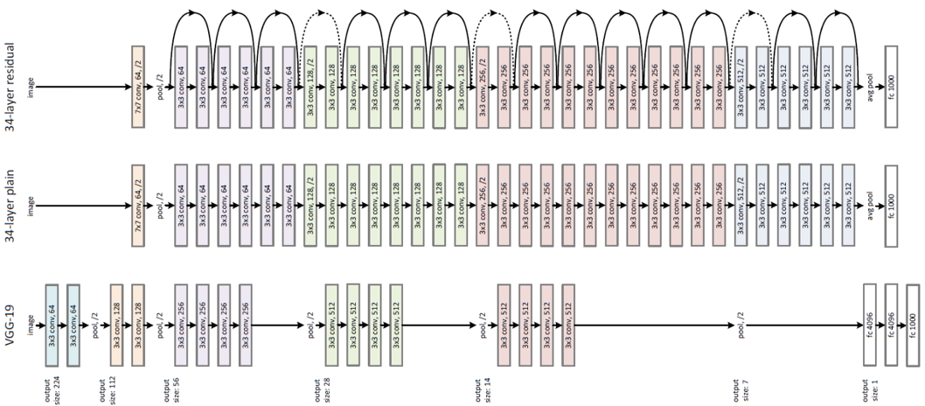
Fig. 4. Model Architecture for VGG-19, 34-layers plain network and 34-layers ResNet [3].
- Implementation of Resnet
In this part, we apply ResNet-50 model with pre-trained weights towards 10 species of fruits image from Fruit 360 dataset. The data is trained and validated in 16 epochs. Data augmentation methods such as rotation, flip, crop and batch normalization are used. It can be seen from the Fig. 5. that the training accuracy reaches almost 1.00 after the second epoch, and the validation accuracy fluctuates between 0.9 and 0.96.
The confusion matrix is plotted in Fig.6.
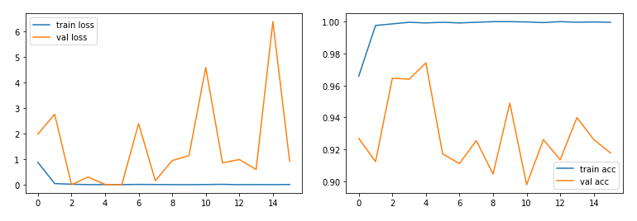
Fig. 5. The loss and accuracy for training and validation on ResNet-50 by Fruits-360 dataset.
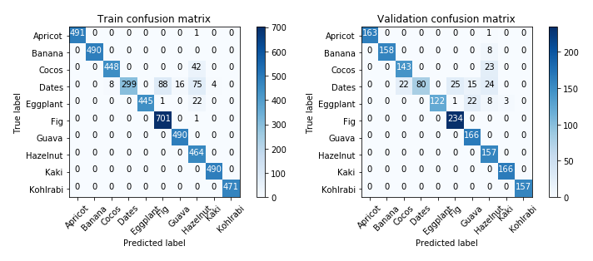
Fig. 6. The confusion matrix for training and validation on ResNet-50 by Fruits-360 dataset.
- Viewpoints
We apply 6 viewpoints that include interpretability, augmentation, model capacity, energy, reproducibility, and performance evaluation.
  - Interpretability
In this section, we explain how ResNet work in detail and why this structure of network can gain high performance in qualitative and quantitative perspectives.
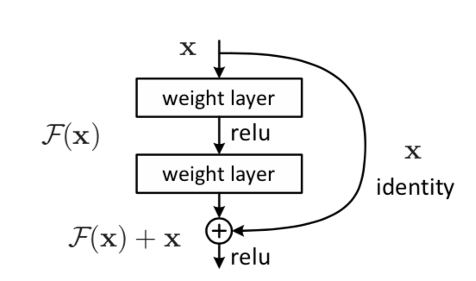
Fig. 7. A residual block in ResNet architecture [3].

Qualitative Interpretability.
This structure in Fig.7 is called a Residual Block. It is noticed that on the right side of this structure, a line connects the input tensor with the tensor passed through the two weight layers and performs an element-wise addition. With this step, the model can implement identity mapping. Assume there is an input x for residual block and blocks from plain network. The output for both blocks can be represented as H(x). For plain network, learning the mapping between input $x$ and output $H(x)$ is harder, because ReLu layer between weight layers adds nonlinearity to the tensor. For residual block, it is easier for the network to learning the residual $F(x) = H(x) – x$. For optimal condition, it is easier to push the residual to zero than to fit an identity mapping by a stack of nonlinear layers [3]. Described in mathematical language, assuming the Residual Block's input is x, the output y is equal to: $y = F (x, \{W_{i} \}) + x$. $F (x, \{W_{i}\})$is the learning objective, which is the residuals of the output and the input: $y – x$. The residual part is a double-layers weights with a ReLu activation in the middle: $F = W_{2}σ(W_{1}x)$. σ represents the ReLu function. $W_{1}$ and $W_{2}$ are weights for 2 convolutional layers. If there is a spatial inconsistency, just add a linear mapping Ws to the input x in the shortcut connection section: $y = F (x, \{W_{i} \}) + W_{s}x$. By means of residual learning, ResNet achieves good performance in image recognition.

Quantitative Interpretability.
For measuring the quantitative interpretability, several popular networks are trained and compared on datasets Places365, and these networks include ResNet, GoogleNet, and VGG. Besides, a concept – number of unique detectors is introduced. In order to compare the activation map of a low-resolution unit with the input resolution labeled mask $L_{c}$ for a certain concept $c$, the activation map was zoomed from $A_{k}(x)$ to the mask resolution $S_{k}(x)$ using bilinear interpolation, anchoring the interpolation at the center of the receptive field of each unit. $S_{k}(x)$, on the other hand, is threshered into binary partitions. $M_{k}\left(x\right)≡S_{k}(x)≥ T_{k}$ , selecting all regions with activation above the threshold $T_{k}$. These partitions are evaluated for each concept $c$ in the dataset, and for each $(k, c)$ pair the intersection $M_{k}\left(x\right) {∩L}_{c}\left(x\right)$ is computed. The score of each unit $k$ as a split of concept $c$ is reported as the intersection over the union score within the dataset,
${IoU}_{k,c}= \frac{∑\left|M_{k}\left(x\right){∩L}_{c}\left(x\right)\right|}{∑|M_{k}\left(x\right){∪L}_{c}\left(x\right)|}$ (1)
For the convenience of comparison, a detector is reported if ${IoU}_{k,c}> 0.04$ [4]. And for the convenience of analysis, the top ranked label is chosen. To quantify the interpretability of a layer, the number unique concepts aligned with units is counted, and it is called the number of unique detectors. Then network dissection is implemented to evaluate a range of network architectures and supervisions. For simplicity, the following experiments focus on the last convolutional layer of each network, where semantic detectors emerge most. Results showing the number of unique detectors that emerge from various network architectures trained on Places 360 and ImageNet are plotted in Fig. 8. In terms of network architecture, it is found that interpretability of ResNet > VGG > GoogleNet > AlexNet. Deeper architectures appear to allow greater interpretability.
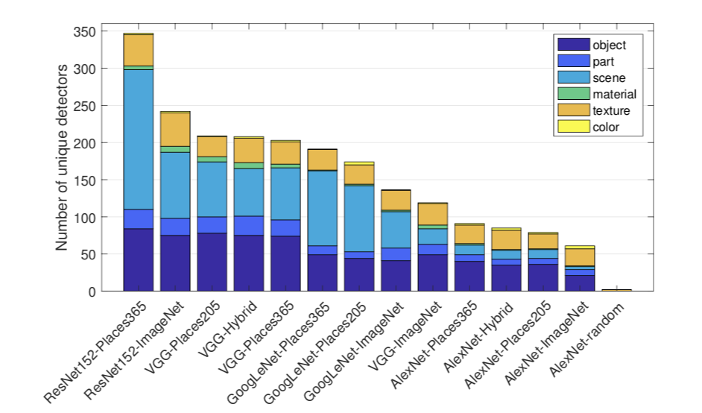
Fig. 8. Interpretability across different architectures and training.
  - Augmentation
For data augmentation, several data augmentation methods are implemented on ResNet. The first data augmentation method is to resize the image with its shorter side randomly sampled in [256,480] for scale augmentation. To be more precise, it is assumed that S is the smallest edge of the isotropically- scaled training image where the input image is cropped. For example, if the crop size is fixed at 224 × 224. In principle, S can be any value no less than 224. If $S$ = 224, the crop will capture the statistics of the entire image, spanning completely the smallest side of the training image; If $S$ ≫ 224, the crop will correspond to a small part of the image, containing a small object or an object part. To set the multi-training scale S, each training image is rescaled respectively by randomly sampling S from a certain range [$S_{min}$, $S_{max}$] ($S_{min}$=256, $S_{max}$=512 is used). Since objects in the image may have different sizes, it is effective to take this into account during the training process [5]. The second augmentation method is to randomly crop the image with 224 × 224 from the original image or its horizontal flip. The third and fourth methods are standard color augmentation and batch normalization respectively. Data augmentation in Resnet improves the size and quality of the training dataset. ResNet models require a large amount of data to avoid overfitting, and with the addition of data augmentation, it makes the model with better accuracy.
  - Model Capacity
The capacity of a model is its ability to fit various functions. Low-volume models are difficult to fit training sets, and high-volume models are easy to over-fit. The capacity of the model can be changed by processing features, for example, assuming that the real data conform to a distribution with power of three, then it is difficult to fit with quadratic functions (low capacity), the effect is improved by adding terms with power of three, and overfitting occurs if terms with power of nine are used to fit (high capacity). The model capacity of ResNet is measured by implementing this model as well as the plain network on ImageNet datasets. It can be seen from Fig. 9 that ResNet with 34 layers has less training and validation error compared with ResNet with 18 layers. Compared plain network with 18 and 34 layers, plain network with 34 layers has higher both training and validation error.
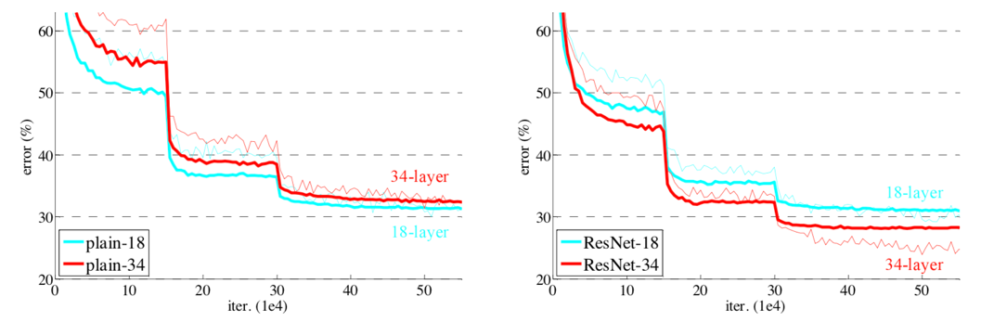
Fig. 9. The error rate on plain network and ResNet. Thin curves denote training error, and bold curves denote validation error of the center crops.
It is noticed from Table 1. that ResNet with 34 layers has the lowest top-1 error compared with other 3 networks. All the evidence shows that ResNet is more accurate than plain network, when the model has the same depth. At the same time, when ResNet becomes deeper, it performs better in image classification.
Table 1. Top-1 error rate on ImageNet validation.
 | plain | ResNet
18 layers | 27.94 | 27.88
34 layers | 28.54 | 25.03

In addition, ResNet won the first place in the ILSVRC 2015 classification competition. It then won the first place in the ILSVRC & COCO 2015 competition for ImageNet detection, ImageNet localization, COCO detection and COCO segmentation. All the strong evidence shows that the residual learning principle is generic and ResNet has good model capacity.
  - Energy
Though Deep Neural Networks (DNNs) have demonstrated as the state-of-the-art on many artificial intelligence applications, they require more computation than traditional methods that leads to high Energy consumption. Two main reasons that directly affects the energy consumption as per [6] are data movement and the memory hierarchy and dataflow that affects data movement. Based on these reasons, the energy can be estimated at each layer of the DNN as per the below equation as stated in [6].
E_{layer} = E_{comp} + E_{data} (2)
Where E_{comp} is the computation Energy and E_{data} is energy correspond to data movement. To analyze the power consumption of ResNet we collected and analyzed the accuracy values reported in literature. The Net power consumption due to only forward passing of the Deep Neural Networks for different batch size have been compared and analyzed in [7]. The observed result is based on, experiment with the help of the 200MHz digital oscilloscope considering the Idle Power of the TXI board, with no HDMI screen Connected as 1.30W average. High Sampling current read-out is used to avoid aliasing as it complicated the Power Measurement by the high frequency swing. At 1.4KHz as maximum frequency component of Power supply that corresponds to the Nyquist sampling frequency of 2.8kHz the results are depicted in Fig.10.
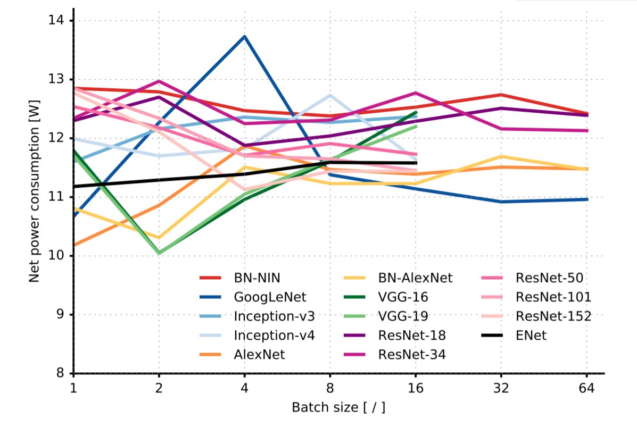
Fig. 10. Power Consumption Vs Batch Size of Different DNN Models.
From the Fig.10 [7], it has been observed that the Resnet with 34,50,101, 152 with batch size 16, the power consumption is in the range of 11.5 W- 12.8 W. This can be understood that, when ResNet goes deeper, convolution layers dominate both the energy consumption and the model size. This energy aware, prunes conversion layers effectively which significantly reduces the energy consumption. As in other perspective, the amount of power when Averaged over a year, then in terms of Carbon Emission it can be calculated about burning 2 liters of petrol.
  - Reproducibility
Though different level of stochasticity is seen in DNNs particularly in the process of sampling the dataset otherwise in model itself ,such as the random initialization of weight brings number of advantages ,it also introduces some issues with reproducibility of the experiment. The main motivation to analyze the reproducibility of DNN is that 1) it ensures correctness. 2)can get the sense of robustness in different aspects of DNN experiments. 3)also opens the opportunity for collaborations, baseline evaluation and newer experiments. In technical terms reproducibility can be stated as Standard deviation of multiple repeatability tests results where the condition of the experiment is met. ResNet architecture have been tested across various databases such as ImageNet, MS-COCO, PASCAL VOC, CIFAR -10. In order to analyze the reproducibility of the implementation, we also consider the results by the Facebook AI research (FAIR)[8] with training code in Torch, TensorFlow [9] on ImageNet which reproduces the experimental results nearly equal to the claim of original Paper with or without slight modifications. The comparison of the results obtained by various implementation on ImageNet dataset are tabulated in Table 2.
Table 2. Comparisons of Top-n Error rates of different ResNet Implementations.
Model | Original Top-1  Error % | FAIR  Top-1  Error % | TensorFlow  Top-1  Error %
ResNet – 50 | 24.7 | 24.0 | 23.61
ResNet -101 | 23.6 | 22.4 | 21.95
ResNet -152 | 23.0 | N/A | 21.51

The improved error rates by FAIR is due to slight modification in the augmentation where it uses the aspect ratio augmentation. Through the analysis, many implementations claim that implementation can achieve 0.5% variation in accuracies. An ablation study has been performed and been discussed about the reproducibility in section 6.
  - Performance Evaluation
ResNet is a powerful model that have been used as a backbone, very frequently in many computer visions tasks especially in Image Classification and Recognition. For Image classification models, most preferred model will have high predictive power along with certain level of accuracy comparatively to model with high accuracy. Thus, one of the safer metrics to analyze the performance of the DNN model is Top-n error rates and accuracies. The most predominantly used n levels are Top-1 accuracy, Top-5 accuracy, and their corresponding error rates.
Top-1 accuracy is the conventional accuracy where the value corresponds to the confidence of the predicted class for the given input. Top -5 accuracy is when the model gives 5 highest probabilities that matches the expected or can be a measure of probability of predicted class that falls in the top -5 values of the SoftMax distribution.
A literature review on the Top-1 and Top – 5 accuracies in comparison with the other DNN models [10] is tabulated in the Table 3.
Table 3. Top-1 and Top-5 accuracies of the Resnet in comparison with other models.
Model | Top-1 accuracy | Top -5 Accuracy
Alex Net | 62.5 | 86
VGG -16 | 71.5 | 90.1
ResNet -152 | 78.5 | 94.29
Inception | 78.2 | 94.1

From the Table 3, it can be noted that the ResNet performs well than other network models and can be understood as a high predictive model in comparison with other models. In original paper [3], the ResNet with different depths have also been studied and reported in Table 4.
Table 4. Top-1 and Top -5 metrics for ResNet Model with different depths.
Model | Top-1 Error | Top-1 Accuracy | Top-5 Error | Top-5 Accuracy
ResNet – 34 | 21.53 | 75.81 | 5.60 | 92.6
ResNet – 50 | 20.74 | 77.15 | 5.25 | 93.29
ResNet – 101 | 19.87 | 78.25 | 4.60 | 93.95
ResNet – 152 | 19.38 | 78.57 | 4.49 | 94.29

The Table 4 clearly shows that deeper the layer, it has high predictive value with high accuracy. There are other comparisons such as how the model is generally expected with respect to number of parameters, number of floating-point operations which determines the complexity of the Model that gives more insights about the model. An ablation study is done considering fore mentioned metrics on the ResNet Architectures are discussed in the Section 6.
- Experimental Results and Discussion
  - Experimental Setup.
The Models that have been considered are from Pre-trained PyTorch Models and has been tested over two types of databases and average of those results are considered.Set-1 is a subset of ImageNet -ILSVRC2017 test data of 5500 images out of which 200 images which belong to Animal classes are considered. Other data set is a small set of 50 Images that does not belong to these test images are considered. The images are tested over ResNet-34,50,101,152, VGG-16 with batch normalization, AlexNet, GoogleNet. Image augmentation is similar to the original implementation [3] with 256x256 resized, 224X224 center cropped and normalized. The data set and data augmentation is common for all networks to have a fair ablation study.
  - Results and Discussion

Comparison with Respect to Accuracies and Error rates
Top-1 and Top- 5 accuracies as discussed in section 5.6, have been calculated for the models and the results are showed in Fig.11 and can see that increase in depth of the ResNet architecture, there is a significant increase of accuracies in comparison with other considered networks.

Fig. 11. Comparison of Accuracy rates of Test Data for different DNN Models.

Fig. 12. Comparison of Error rates of Test Data for different DNN Models.
Top-1 and Top- 5 error rates have been calculated reported in graph as Fig.12 As Graph shows, the Resnet layers error rates are significantly lower than the other network models. The accuracies with single crop testing do not entirely match with the original implementation but it can be argued based on low-test data.

Comparison with respect to Inference time, Memory and Top-1 error.
Inference time and Memory is one of the many metrics that can be considered to say how good a model is. The model is expected to have less memory and less inference time to have practical benefits of implementing in other platforms such as mobile platform. In this experiment, model size is calculated based on the size of the PyTorch .pth file of selected models and Inference time is calculated by passing the test images and calculated the time for each test image and averaged over it and the results are depicted in Fig.13. From the graph, the Resnet models and GoogleNet takes lower time at inference step and have considerably less memory. Though ResNet architectures take more time when goes deep, its size is comparably smaller to VGG-16 model. The model which has lower test error rate, lower inference time and lower memory size is mostly expected for Image Classification task. Thereby, in the graph closer the model towards the origin and smaller in size, more desirable for the task. When observed, the ResNet architectures are more desirable even with increasing depth in terms of the metrics considered.

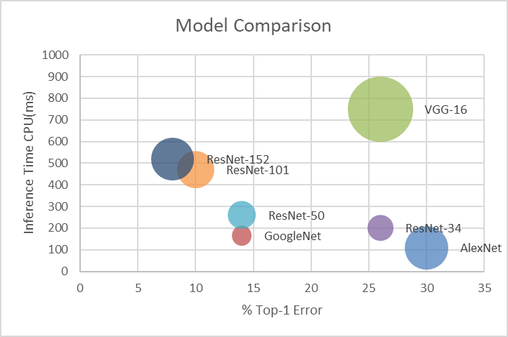
Fig. 13. Different Model comparisons-based on Memory size which is represented as size of the circle and the between Top-1 error rate and Inference time of CPU.

Comparison with respect to accuracy with complexity
In the original paper, it is claimed that though number of Parameters increases with increase in depth, still it has lower complexity than VGG network based on the Number of Floating-point operations (FLOPS) it takes. The Table 5 shows the number of parameters, and operations that each model takes in. Since it is a pretrained model, the model parameters and complexity in terms of multiply-and-accumulates (MACs) are directly observed from the PyTorch documentation.
Table 5. Representing the Parameters, multiply-and-accumulates, and accuracies of different models.
Model | Parameters (M) | MACs(G) | Top -1  accuracy | Top-5  accuracy
AlexNet | 61.1 | 0.72 | 70 | 78
VGG-16_bn | 138.37 | 7.64 | 74 | 88
GoogleNet | 6.8 | 1.0 | 86 | 92
ResNet – 34 | 21.8 | 3.68 | 74 | 92
ResNet – 50 | 25.56 | 4.12 | 86 | 94
ResNet – 101 | 44.55 | 7.85 | 90 | 96
ResNet -152 | 60.19 | 11.58 | 92 | 96

The accuracy rate for both Top-1 and Top-5 are observed from the experiment and is compared against with the complexity of the models in Table 5. The Fig.14 shows that the complexity of ResNet layer with 101 depth is still comparatively lower than the VGG -16 as claimed by the original Paper [3]. Though GoogleNet is lower in complexity than the ResNet models and has accuracy nearly equal to the ResNet-34, it has less accuracy than the deeper models of ResNet which may be considered as a good argument. Also, GoogleNet has 22 layers which may be one of the reasons for its less complexity when compared to the ResNet architectures.

Fig. 14. Graphical Representation of the comparison of various parameters as per Table 5.

Inference of Images with Different data augmentation and Noisy Images.
We have performed a small study on ResNet-50 by manipulating the images with noises and adding translations to the Images. The True Prediction with the probabilities by ResNet-50 are shown in Fig.15. The Model was able to recognize the Images with high accuracy. This shows that, ResNet Model is more robust against noisy and manipulated images.
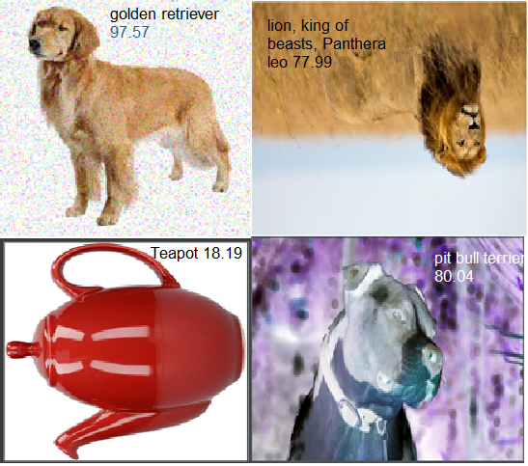
Fig. 15. Manipulated Images with True Prediction value by ResNet- 50. Top left Image added with RGB Noise, Top right Image is flipped horizontally, Bottom left Image is flipped vertically, and Bottom right image is inverted

Overall Inference
As we can observe from the study that though the ResNet Model increases in depth, it does not suffer from gradient degradation problem and have a significant increase in accuracy as claimed by the original authors. It is true that the experiment is not as extensive as its expected to reproduce the results, but the claim of its authenticity on the common grounds with pretrained models from PyTorch can be said considerably acceptable. Besides various expressions are available for ResNet models, it can still be verified with varied and wide range of train and test images.
- Conclusion
This paper discusses the ResNet architecture with six main viewpoints and have been experimentally analyzed the pre trained ResNet Model along with other pre trained models from PyTorch. As ResNet gains more and more popularity in the Computer Vision Field, the architecture is heavily studied, and this paper can be considered as one of them. We observed that ResNets are more powerful for very deep networks and shows promising landscape in deep learning and there is a lot of room to study and understand their functionality in many other Computer Vision Tasks.

References
- Sandler, M., Howard, A., Zhu, M., Zhmoginov, A., & Chen, L. C.: Mobilenetv2: Inverted residuals and linear bottlenecks. In Proceedings of the IEEE conference on computer vision and pattern recognition, pp. 4510-4520. Salt Lake City, UT (2018).
- Balduzzi, D., Frean, M., Leary, L., Lewis, J. P., Ma, K. W. D., & McWilliams, B.: The shattered gradients problem: If resnets are the answer, then what is the question? arXiv preprint arXiv:1702.08591. (2017).
- He, K., Zhang, X., Ren, S., Sun, J.: Deep Residual Learning for Image Recognition. IEEE Conference on Computer Vision and Pattern Recognition (CVPR), pp. 770-778, Las Vegas, NV (2016).
- Bau, D., Zhou, B., Khosla, A., Oliva, A., & Torralba, A.: Network dissection: Quantifying interpretability of deep visual representations. In Proceedings of the IEEE conference on computer vision and pattern recognition. pp. 6541-6549. Honolulu, HI (2017).
- Simonyan, K., & Zisserman, A.: Very deep convolutional networks for large-scale image recognition. arXiv preprint arXiv:1409.1556. (2014).
- Yang, T., Chen, Y., Sze, V.: Designing Energy-Efficient Convolutional Neural Networks using Energy-Aware Pruning. IEEE Conference on Computer Vision and Pattern Recognition (CVPR), pp. 6071-6079, Honolulu, HI (2017).
- Canziani, A., Paszke, A., Culurciello, E.: An Analysis of Deep Neural Network Models for Practical Applications. arXiv Computer Vision and Pattern Recognition, (2016).
- Torch blog: http://torch.ch/blog/2016/02/04/resnets.html, last accessed 2020/08/30.
- TensorFlow : https://github.com/tensorpack/tensorpack/tree/master/examples/ResNet, last accessed 2020/08/30.
- Simone, B., Rémi, C., Luigi, C., Paolo, N.: Benchmark Analysis of Representative Deep Neural Network Architectures. IEEE Access, pp. 64270-64277 (2018).

The code, dataset and result for ResNet Implementation are available on: https://github.com/ChillYao/resnet_paper
The average energy is calculated and the energy is converted to carbon emission with a tool- https://www.sunearthtools.com/tools/CO2-emissions-calculator.php
The Experiments along with the Test Images and Results with Predication values are made available under https://github.com/hatter222/ComputerVision_Seminar.

