Potential of elemental content in Afghan wheat landrace and their genetic studies
Elemental analysis in wheat and genetic characterization
Nature of elements and genetic characterization in Afghan wheat landraces

Ionomic variation in Afghan wheat landraces and its genome-wide association mapping

Alagu Manickavelu ¹*, Tomohiro Hattori²*, Kazusa Yoshimura ², Youichi Kondo³, Minami Matsui⁴, Tomohiro Ban^{1#}, Hiroyoshi Iwata^{2#}

¹ Plant Genetic Resources division, Kihara Institute for Biological Research, Yokohama City University, Yokohama, Japan
² Lab. Biometry and Bioinformatics, University of Tokyo, Tokyo 113-8657, Japan
³ Kanto Gakuin University, Yokohama 236-8501, Japan
⁴ Centre for Biological Resource Sciences, Yokohama, Japan

* These authors equally contributed to this work
# Corresponding authors

Abstract
Investigation of ionomic, i.e., elemental profile of wheat grain is necessary in the current cereal bio-fortification concept. Our research aimed to investigate ionomic variation of wheat grain in Afghan wheat landraces and identify the chromosomal locations of QTL associated with the accumulation of four major (Mg, Ca, K, P), four minor (Mn, Fe, Ca, Zn) and a trace (Cd) elements. Genotyping was done by array-based marker system. The Afghan landraces showed huge diversity both in marker genotypes and in ionomic phenotypes. Correlation analysis clearly separated major and minor elements. Geographical variation of the element accumulation suggested possible relationship of Zn and Ca with longitude, and of P and Fe with altitude. Overall the heritability level of elements was medium to low showed the nature of genetic inheritance of elements. Four methods, compressed mixed linear model, random forest, BayesC, extended Bayesian lasso, were applied in genome-wide association study (GWAS) and found 64 associations. Some loci harboured more than one elements. A pilot attempt of genomic selection (GS) was applied and found low prediction accuracy due to low heritability nature, indicating the nature of elements in wheat and necessity of developing new GS models. First time this study showed huge ionomic variation in Afghan wheat landraces, and the result of GWAS as well as the importance of GS models for such a low heritability characters.

Keywords:
Afghan wheat landraces, SNP, elements, GWAS, Genomic selection

Introduction
Elements, along with nucleic acids, proteins, and metabolites, are an essential building block of the living cell, and are involved in almost every process in an organism (Baxter et al. 2010). Ionome is defined as ‘the mineral nutrient and trace element composition of an organism, representing the inorganic component of cellular and organismal systems (Salt et al. 2008). For plants, which much take up all elements except carbon and oxygen from soil environment, control of the uptake and distribution of elements from the local soil environment is crucial to survive. For human, deficiency of essential elements leads to malnutrition especially pregnant women and children below the age of five who suffer from severe acute malnutrition. According to WHO report 2012, 162 and 99 million children are under stunting and underweight respectively mainly due to poor intake of essential nutrients. Cereal-based foods represent the largest proportion of the daily diet in countries with a high incidence of micronutrient deficiencies. HarvestPlus initiative of the CGIAR consortium is dedicating to alleviate deficiencies by bio-fortifying staple food crops with essential minerals and vitamins, an approach considered to be the most economical solution to human micronutrient deficiency (Welch and Graham, 2004, Bouis, 2007; Cakmak, 2008; Peleg et al., 2009, Velu et al. 2014).
Globally wheat is one of the most important crops providing over 20% of the calories consumed by the world’s population and a similar proportion of protein for about 2.5 billion people (Braun et al. 2010). But targeting wheat which respect to bio-fortification is meagre as we have seen only one huge consortium that to Zn only (www.harvestplus.org). Though dietary supplements and agronomic practices are the solutions to make-up the problem, finding solution through customary system of food uptake is sustainable in nature. Finding genetic variation and utilization in crop improvement will be the best solution in this scenario where there is huge germplasm available in wheat.
Landraces are one of germplasms where there is a possibility to find unique variation in character like elements as it has the adaptation and/or evolutionary mechanism of growing under low-input conditions. Landraces have originated together with agriculture and horticulture during the past 10,000 years. They have high adaptation to varied environmental conditions and they have probably been grown and evolve for several millennia in the crop centres of origin. Afghanistan wheat landraces collected by Dr. Kihara et al. during 1950-70 are un-tapped genetic resources in wheat where there is a chance of mining the ionomics concept. Previous studies found vast diversity in this germplasm (Manickavelu et al. 2014a, b, Quahir et al. 2014). Recent development of molecular markers and high throughput systems showed a great potential of genotypic characterization in many crops and plants (Glaszmann et al. 2010). They are consequently well suited for genomics approaches such as association mapping (Myles et al. 2009) and genomics selection (Meuwissen et al. 2001) for which a high number of markers are required. Although linkage mapping has a high power for detecting QTL specific to the parental lines of the mapping population, its mapping resolution is very limited due to the few recombination events and, hence, long linkage blocks (Mauricio 2001). With the advances in high throughput genotyping technologies, genome-wide association (GWA) mapping became available as a powerful alternative for dissecting quantitative traits in plants (Stich and Melchinger 2010). GWA mapping relies on natural linkage disequilibrium (LD) generated by ancestral recombination events in diverse populations. Depending on the level of LD in the population investigated, the mapping resolution can be up to the single nucleotide level. Although plant populations are often prone to inherent population structuring and cryptic relatedness, which can lead to spurious associations in GWA scans (Astle and Balding 2009), powerful techniques are available for decoupling genetic associations with confounding factors (Sillanpää 2011), and encouraging results have been reported for Arabidopsis (Atwell 2010) and crops such as rapeseed, potato, sugar beet, and maize (Stich and Melchinger, 2009).
To date, the ionomics are much studied in model plants like Arabidopsis in order to find the basic functions of various ions or elements (www.ionomicshub.org). In wheat, few studies were reported the occurrence of genetic variation but only for Fe and Zn elements (Nicholas et al. 2012, Velu et al. 2011, 2012). Recent development of high through-put techniques like inductively coupled plasma (ICP) and bench-top energy-dispersive X-ray fluorescence (EDX) spectrometry are widely used to nutrient density. Hence in the current study we demonstrated the identification of ionomics potential in wheat landraces, and finding genomic location for bulk, trace and essential elements by GWA mapping with the addition of train genomic selection.

Material and Methods

Plant materials and sampling
In total, 446 Afghan wheat landraces (Kihara Afghan Wheat Landraces : KAWLR) and 10 Afghan improved varieties as checks were grown in Kihara Institute experimental field in Maioka, Japan. The 20kg/100m² amount of fertilizer (N : P : K = 8 : 8 : 8) was used. The healthy grains were sown in trays and transplanted before winter (in November). For elemental analysis, 267 landraces plus 8 checks which yielded good shape grain were chosen. Fig.1 shows the geographical distribution of landraces. While selecting grains, border plants were excluded and the grains of remaining plants were pooled, and choose 12 in total to make three replications. The same set of KAWLR were also grown in Afghanistan and Mexico, and collected for measurement. 207 landraces and 7 checks were chosen in Afghanistan, and 308 landraces and 8 checks in Mexico.
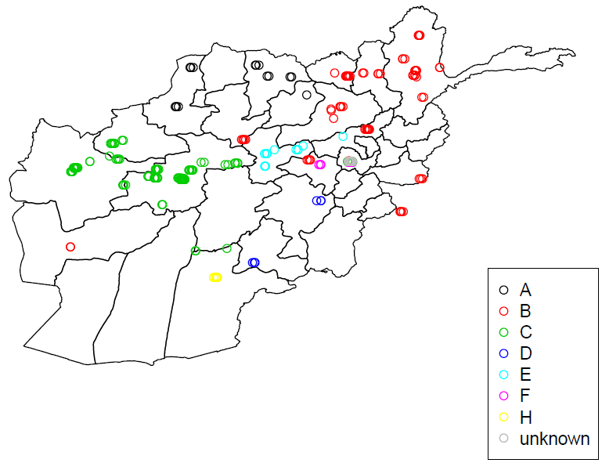

Fig.1 Geographical distribution of sampling points. The accessions belong to seven agro-climate zones (A-H).

Elemental analysis
Energy dispersive x-ray fluorescence spectrometer 720/800 HS (EDX) (Shimadzu co. ltd., Japan) was used for elemental analysis. Although it can able to measure elements in a non-destructive way, we applied a destructive way using hand-operated press (Shimadzu co. ltd., Japan) in order to avoid measuring elements present only in seed coat or aleurone layer. Tablets of seed powder were prepared for each accession and measured using 16-sample turret. As a preliminary experiment, we measured elemental accumulations in leaves and seeds, and identified detectable elements both in seeds and leaves. In this study, our target was grain, and thus the elements accumulated in wheat grains were further chosen for the present study. Four major nutrients (P, K, Ca, Mg) and four minor nutrients (Fe, Zn, Mn, Cu) were measured and studied in this study. The units of data of major elements was “%”, and of minor elements was “ppm”. In the Afghan 207 landraces, 110 accessions were lack of Cu concentration data. From Mexican sample we measured only Fe and Zn, which was applied a different unit: “mg/kg”.

Genotyping
Total genomic DNA was extracted from five-week old leaves of the samples by using the QIAGEN DNeasy modified extraction protocol, and sent to Diversity Arrays Technology Pty. Ltd, Yarralumla, Australia. The genotyping was carried out by using GBS 1.0V array as described by Wenzl et al. (2004) and Akbari et al (2006). The presence or absence of each marker was determined on the basis of the signals from the labeling and image analysis. SNP markers with minor allele frequency >10% and the markers with < 20 % missing values were selected. In total 8,465 markers were used for the further analysis.
Fig.2 shows the result of Ward’s hierarchical clustering of landraces based on SNP marker genotypes.

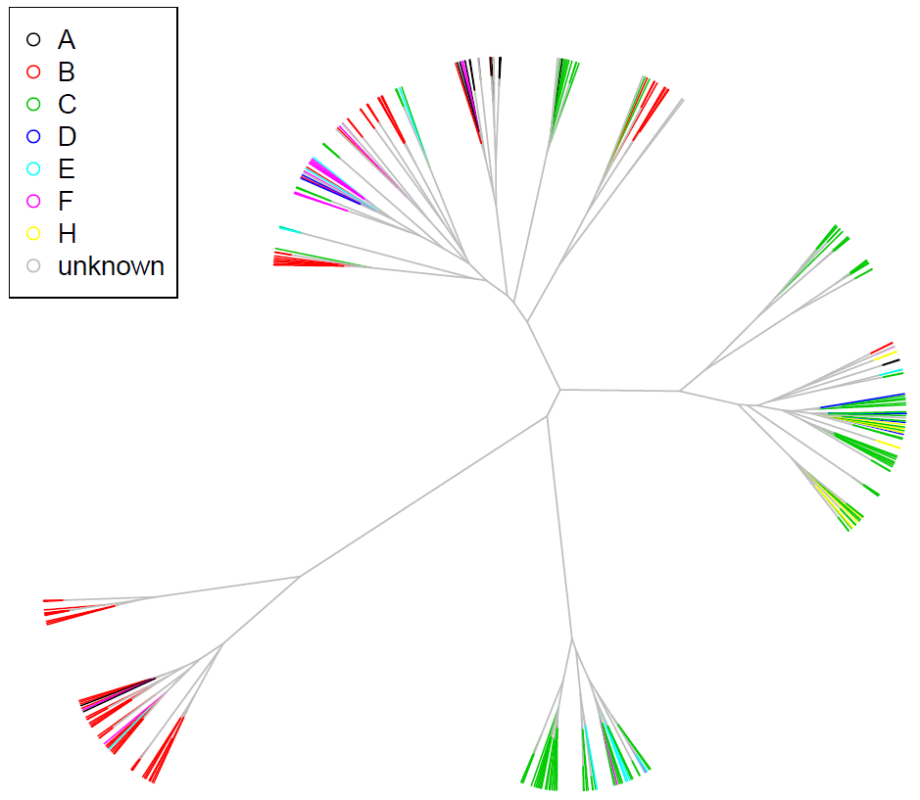

Fig.2 Ward’s hierarchical clustering of landraces based on SNP marker genotypes.

Data analysis
Genetic correlation between elements
We calculated the genetic correlation between elements, with R software. We used R package “MCMCglmm” (Hadfield 2010). Fig.2 indicated that there is population structure in this dataset, so we used the generalized linear mixed model to separate the fixed effect and the random (= genetic) effect. To calculate the correlation coefficients we used “multi-response” model, and we estimated the covariance matrix of random effect. The genetic correlation between element A and B could be calculated as this formula:
$$CorAB={CovAB}/{\sqrt{VarA VarB}}$$
This value was estimated through the Markov chain Monte Carlo methods (MCMC). The number of MCMC iterations was set to 13000, thinning interval was 10, and burn-in was 3000, which these numbers were the default value of MCMCglmm. In the prior, we didn’t set a covariance matrix B, and the expected covariance of the random effects G and of residuals R were both set I₂ with n = 4.
We checked two types of genetic correlation. The first was the correlation between different elements in the same location, and the other was the correlation of each element between different locations. We also calculated the phenotypic correlation between elements, and compared the phenotypic and genetic correlation of each element. Based on those correlation coefficients, we draw the Ward’s cluster dendrogram and checked the relation of each element.

Marker-based heritability
Using R package “MCMCglmm”, we estimated the marker-based heritability. Same as the estimation of genetic correlation, we made the generalized linear mixed model and estimated the variance matrix of genetic effects. The heritability (h₂) could be calculated as this formula:
$$h2={VarG}/{VarG+VarE}$$

where VarG was the genetic variance and VarE was the environmental variance. In this MCMC cycle we didn’t set a prior, so the default value was applied.

Genome-wide association study (GWAS)
Using R package “rrBLUP” (Endelman 2011), we did genome-wide association study. We analyzed GWA by the QK-model: the mixed linear model with Q-matrix and K-matrix to consider the population structure and the kinship.
We used the “GWAS” function. The number of principal components: n.PC = 6, and the additive relationship matrix was calculated by SNP markers using “A.mat” function. In this GWAS we ignored the SNPs that the minor allele frequencies (MAF) was < 5%. The other value was still in default.

Genomic prediction of micronutrient concentration
To see the possibility of selecting micronutrient-rich cultivars through genomic selection (GS), we conducted the simulation of genomic prediction to the concentration of elements using R package “rrBLUP”. In this package we used “kinship. BLUP” function to do the GS, and the method to calculate the additive relationship matrix was “Gaussian Kernel”. To assess the results of GS, we did 10-folds cross validation. To evaluate the accuracy of prediction, we checked the correlation coefficients between the predicted value of GS and the real phenotypic data of each accession.

Results

Elemental concentration
The boxplots of elemental concentration of 267 KAWLR along with 10 checks are shown in Fig.3. The landraces showed large variation compared with check varieties for all elements. Some outliers were found in all elements, and they showed the possibility of finding high elemental accumulating germplasm. The sign of location effect was clearly seen in all cases. In some elements (P, K, Zn) the accumulation was higher in Japan, whereas the remaining elements (Ca, Mg, Fe, Mn, Cu) was higher in Afghanistan.
Fig. 3 Boxplots of elemental content in 267 KAWLR (left: landraces) and 10 checks (right: cultivars). Three colours mean the experiment locations (red: Japan, blue: Afghanistan, green: Mexico). About Fe and Zn, data in Japan and Afghanistan were used the unit of “ppm” and those in Mexico were used “mg/kg”, so they are shown separately.

Analysis of genetic correlation between elements
Table 1 shows the phenotypic and genetic correlation between elements in three locations. In major elements, the phenotypic correlation showed high correlation (r = 0.5 ~ 0.8) in both Japan and Afghanistan. However, the genetic correlation showed quite low correlation (r ≒ 0) in both locations. In minor elements phenotypic correlation coefficients were lower than those in major element, but genetic correlation was higher.
The sign of location effect was found clearly. Phenotypic correlation in major elements in Japan was more than those in Afghanistan, and there was a clear difference about coefficients of Fe and Zn in three locations.
The correlation between major and minor elements was mostly low. Phenotypic correlation between P and minor elements was relatively certified in both locations, but the other combinations had weak relationship. In genetic correlation, there was quite low correlation between major and minor elements in both locations.
The cluster dendrogram based on phenotypic and genetic correlation coefficients are shown in Fig.4. In phenotypic correlation, major and minor elements were clearly and reasonably separated in both locations. In genetic correlation, however, the major elements were not separated, and the positions of each element differed between in the two locations.
Table 2 shows the correlation of each elements between two different locations. In all elements, the genetic correlation was greater than the phenotypic correlation.

Table 1 Phenotypic and genetic correlation coefficients between major and minor elements in each location. Phenotypic correlation is shown in red cell, and genetic correlation is in blue cell.

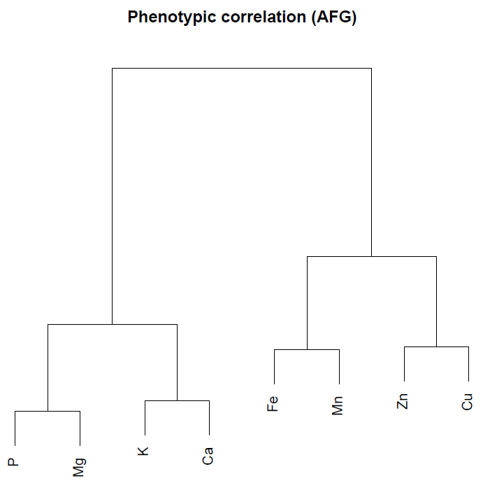
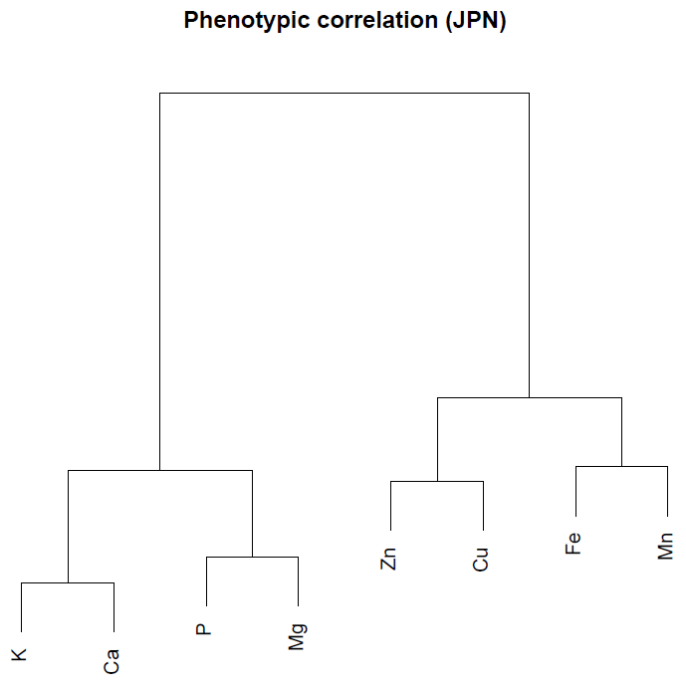

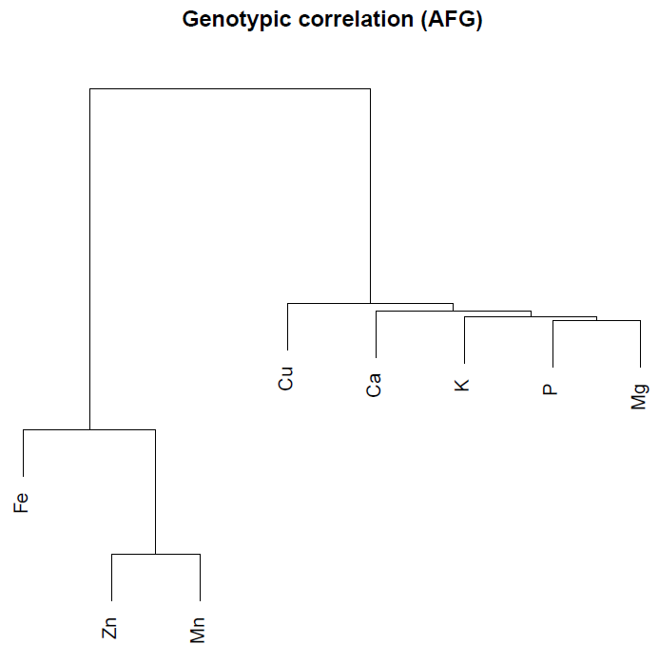
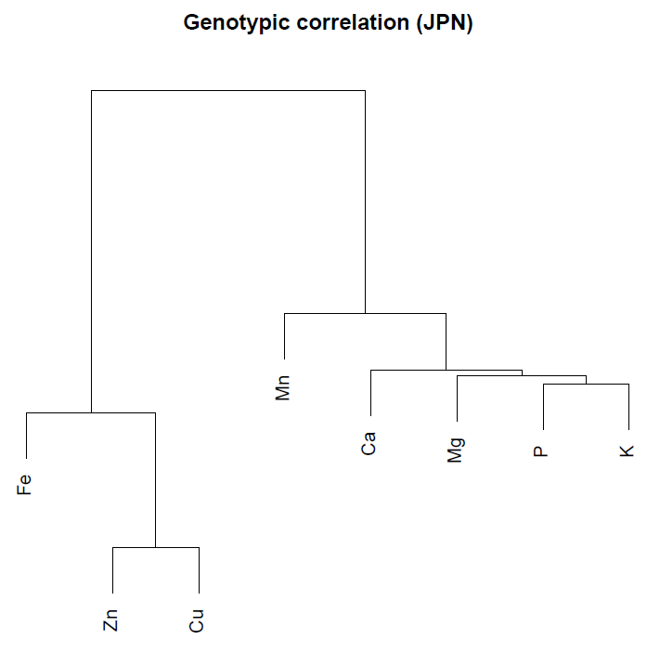

Fig. 4 Cluster dendrogram based on phenotypic and genetic correlation coefficients.

Table 2 Correlation coefficients of each element between Japan and Afghanistan (and Mexico).

Marker-based heritability
Table 3 shows the marker-based heritability estimated by MCMCglmm. In both locations major elements showed higher heritability than minor elements. There was also the sign of location effect, because heritability of all elements in Japan was higher than those in Afghanistan, and in Mexico there was the highest value of heritability of Fe and Zn. The difference of location seemed to affect the heritability strongly.

Table 3 Marker-based heritability estimated by MCMCglmm. The number inside parentheses mean 95% confidence interval.

Genome-wide association study (GWAS)
Result of GWAS, it found that 68 markers were associated with the elemental concentration. We set the threshold = 3 in this analysis, and here the P-value is shown as a form of logarithm (log10). All 68 markers are shown in Table 4, and the position of each marker on the chromosome is shown in Fig. 5.
The P-value of all 68 markers were about 3~4, and this means that those markers have weak association with elemental concentration. There is no marker which were associated with an element in the different location in common. Only the three markers were associated with two different elements in a location simultaneously: No. 1265597 (P and Ca in Japan), No. 1184876 (P and K in Japan), and No. 1111479 (Fe and Cu in Afghanistan).

Table 4 List of all 68 markers associated with elemental contents. Each of three tables shows the marker list of Japan, Afghanistan, and Mexico.

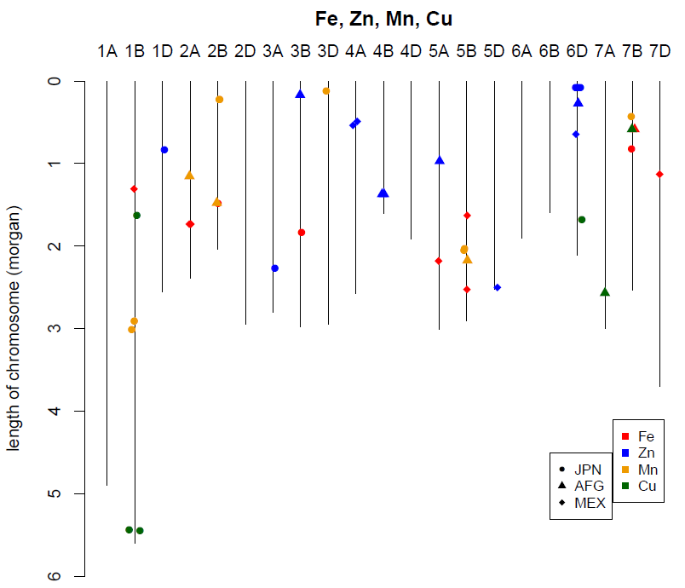
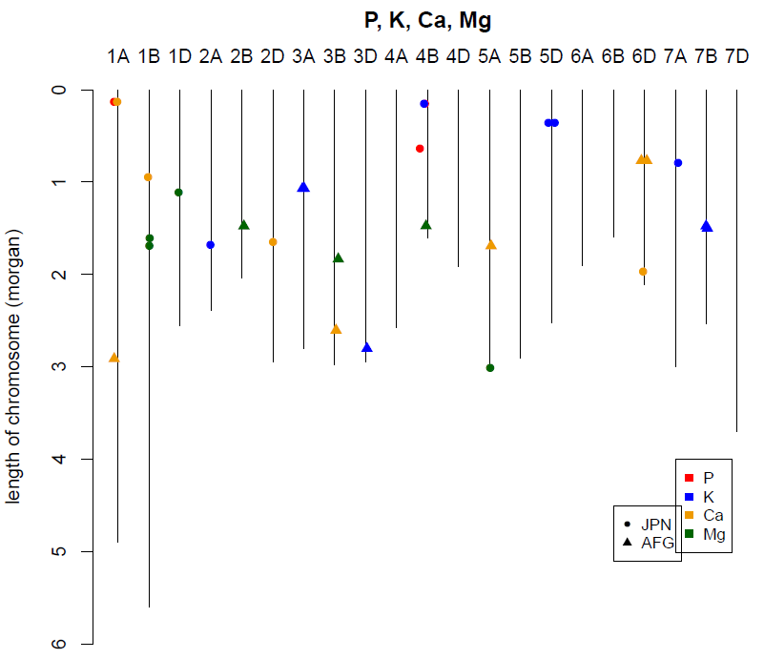

Fig. 5 Chromosome map and the position of 68 associated markers. To be seen clearly, we separate the markers which associated with major elements and those with minor elements.

Genomic selection (GS)
By using GS, we estimated the predicted value of elemental concentration of each accession in all 8 elements and 3 locations. The predictability of GS was evaluated by calculating the correlation coefficients between the predicted values of elemental concentration and the real phenotypic value. This is shown in Table 5.
The correlation coefficients of major elements were comparatively higher than those of minor elements in both locations, and some of them showed the moderate correlation (r > 0.4). As the trend, the predictability in Japan was higher than in Afghanistan, and the highest was in Mexico. This trend was also found in the marker-based heritability (Table 2), and the difference of location seemed to affect the GS strongly, too.

Table 5 Correlation coefficients between the predicted values of elemental concentration estimated in GS and the real phenotypic value.

Discussion
Most of previous researches regarding to the micronutrient concentrations in wheat grains focused mainly on Fe and Zn, which are often deficient in human nutrition and thus important targets of bio-fortification (Welch and Graham, 1999, Bouis and Welch, 2010). However, as observed in our analysis, there is often correlation between elements, which might imply the interaction of several elements in plant metabolism (Baxter, 2010). In order to increase the concentration of micronutrients such as Fe and Zn, it may also be meaningful to investigate the movement of other major elements. In addition, not only Fe and Zn, but also the deficiency of other micronutrients, such as Ca, Mg and Cu, are common in many developed and developing countries (White and Broadley, 2009). From these points of view, in the present study, we surveyed the concentration of eight elements including major (P, K, Ca, Mg) and minor elements (Zn, Fe, Mn, Cu) in Afghan wheat landraces.
It has been reported that accessions producing grains with high micronutrient concentrations are often found in landraces, wild wheat and its relatives (Frossard et al., 2000, Genc et al., 2005, White and Broadley, 2005, Monasterio et al., 2007). In this perspective, our elemental analysis of Afghan landraces is in good agreement with those previous results. For instance, the concentration of Fe and Zn in this study was ranged over 55.14-122.2 ppm and 15.56-87.29 ppm, respectively, which were much higher values than ones observed in the 132-cultivar screening conducted by CIMMYT (Fe:28.8-56.5ppm, Zn:25.2-53.3ppm; Graham et al.,1999) or in the screening of 150 lines of bread wheat representing diverse origins (Fe:28.8-50.8 ppm, Zn:13.5-34.5 ppm; Zhao et al., 2009). As for major elements, Afghan landraces showed fairly high concentrations compared to ones obtained in CIMMYT (Graham et al., 1999). But the location or soil nutrient effect or interaction is necessary to compare the result. Hence the same germplasm grown in Afghanistan was taken into consideration and found the similar trend which confirmed the potential of this orphan wheat landraces and genetic diversity. Same time the influence of environment or location was clearly seen on element accumulation. For P, K and Zn the accumulation was more in Japan than Afghanistan and vice-versa for other elements. Though the experiment was conducted with uniform nutrient management, the soil type and their nutrient content really important to consider. Previous scientific studies reported the calcareous nature of soil in Afghan (Dr. Suzuki, JICA report) which influenced the accumulation of nutrient in grains. These results clearly indicate that some Afghan landraces have the genetic potential for further improvement of grain micronutrient concentration and therefore are the important germplasm for the future breeding. There is a strong correlation was observed among major and some minor elements. These positive correlations suggest the existence of common mechanism of uptake or accumulation processes of minerals in the wheat grain. Fe and Zn concentrations also correlated positively, which is consistent with several other wheat surveys (Morgounov et al., 2007, Zhao et al., 2009). Furthermore, we first time found the correlation between Mn and Fe, and Cu and Zn, which is also supported from the result of cluster analysis. These relationships are important because the increase of Fe and Zn concentration may simultaneously contribute to the increase of Mn and Cu whose deficiency can also affect human health and nutritional status (White and Broadley, 2005), although they have not been the major target of biofortification so far.
In major elements, phenotypic correlation is high but genetic correlation is quite low. It suggests that the high phenotypic correlation is derived from the large environmental effect.

Marker-trait association by GWA mapping was carried out and found 64 loci in 20 chromosomes of common wheat. The co-localized loci somehow confirmed the phenotypic correlation among elements. Interestingly when we see the chromosome location of major and minor elements together, loci in chromosome 1B (Ca & Cd; Cu 7 Mg), 2A (Fe & K), 2B (Fe, Mn, Mg), 3B (Fe, Mg), 4B (Mg, Zn) and 6D (Zn, Ca) harbored both elements together which is different from phenotypic correlation. In this study, co-localization of QTLs for Fe and Zn was not captured, however, we found that Mn and Fe, and Cu and Zn have loci in common, which were also consolidated together in the cluster analysis based on phenotypic data and suggests the existence of shared pathways between two elements. In the case of major elements, there is no genome discrepancy as observed for domestication and other characters in wheat (Feldman et al. 2012). Whereas in minor elements, B genome contributed 60% of total QTLs. Though the GWA analysis is not very impressive the identified loci is the starting point for further understanding. The influence of location and GWA result of elements subjected to practice genomic selection models in this population. The prediction showed optimum level of accuracy and varied among elements as well as location. The comparison table of heritability, correlation and prediction accuracy showed the clear reason that due to low heritability nature of elements the GWA mapping is not very productive and the genomic prediction score also reduced (Table 4).
Table 4. Comparative analysis of heritability, correlation and genomic selection. h² - heritability) & prediction accuracy of genomic selection (r)

According to these results, it seems to be difficult to improve the content of micronutrients dramatically by genomic selection. Nevertheless, we insist that still there is a merit of genomic selection using Afghan landraces in order to increase the micronutrients in wheat grain as the conventional breeding strategy is difficult to apply due to low heritability where the training of genomic selection model will overcome the issue. Multilocation data and complete genome coverage markers are necessary to prove this concept. The political situation in Afghanistan has been gradually improving but is still rather bad. In this condition, it is really difficult to conduct breeding and screening in the field of Afghanistan. However, genomic selection enables us to select the best combination of Afghan landraces in another secure country such as Japan and then only the field trial can be conducted in Afghanistan. These “remote breeding” can contribute to the Afghan agriculture although its breeding gain is lower than usually expected. Furthermore, there is a possibility that if we can use more SNPs information, the prediction accuracy may improve better. As this is the first paper which conducted genomic prediction of micronutrient content on wheat landraces, further investigation is required in order to improve the prediction accuracy and construct the pipeline of remote breeding using genomic selection.

