key is 5-character string randomly selected from ASCII letter and digits.

i%len(key) will return a value between 0 and 4 as len(key) = 5

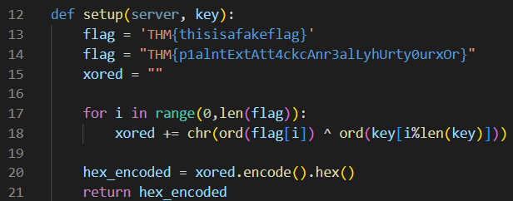

i | i%len(key)
0 | 0
1 | 1
… | …
19 | 4
20 | 0
… | …

Run the program:
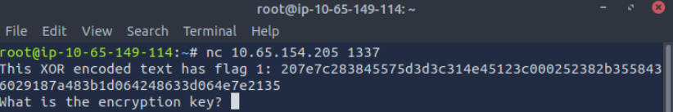

Try to decode the encoded text

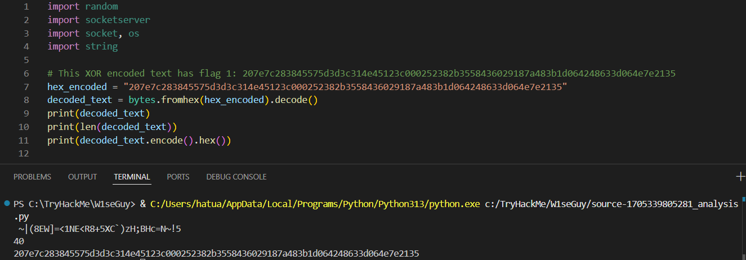

The length of the decoded text is 40.
We have flag XOR key = decoded_text, so key = decoded_text XOR flag.
flag has the pattern THM{…}, which means key = decoded_text XOR THM{…}
We can get the first 4 characters of the flag using
first_letter = chr(ord(decoded_text [0]) ^ ord("T"))
second_letter = chr(ord(decoded_text [1]) ^ ord("H"))
third_letter = chr(ord(decoded_text [2]) ^ ord("M"))
fourth_letter = chr(ord(decoded_text [3]) ^ ord("{"))
As the decoded text has 40 letters, the last letter of the key can also be obtained using the last letter to the decoded text:
last_letter = chr(ord(decoded_text[39]) ^ ord("}"))

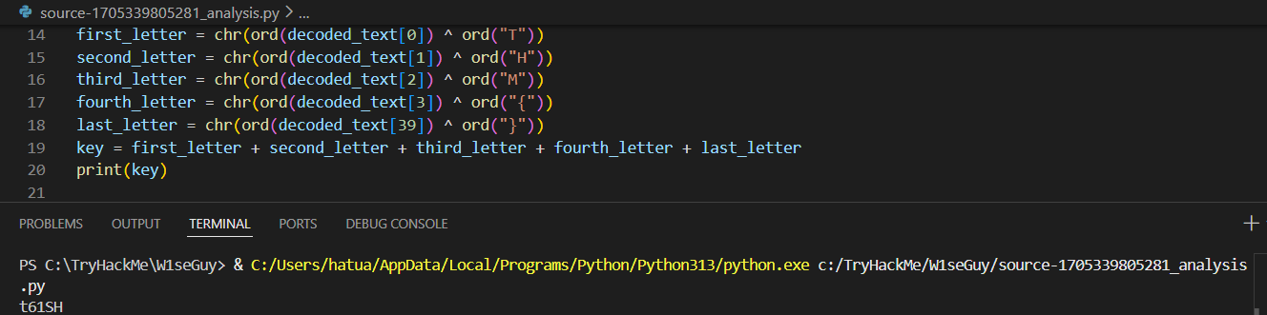

With the key, we can XOR it with decoded_text to get the first flag:
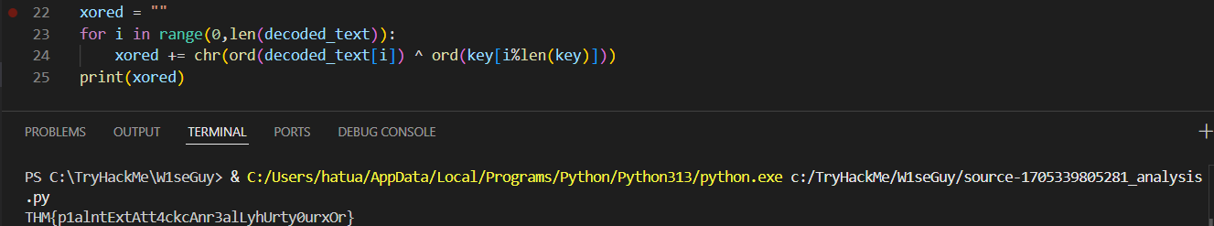

Enter the first flag in the program to get the second one:
