TENABLE CYBER EXCHANGE — PROJECT SUBMISSION
Exposure-Trigger MCP Server
An on-premises Model Context Protocol server that watches Tenable's plugin feed and known-exploited-vulnerability intelligence, then automatically launches a scoped, tag-targeted scan on Tenable Security Center or Tenable Vulnerability Management the moment a newly released plugin or a newly exploited CVE puts a customer's tagged assets at risk.
Author: Hatim Ahmitach, Tenable | Date: September 11, 2026
Target products: Tenable Security Center (TSC) / Tenable Vulnerability Management (TVM) | Category: MCP Server

Executive Summary
Today, neither Tenable Security Center (TSC) nor Tenable Vulnerability Management (TVM) will start a scan on its own just because Tenable Research shipped a new or updated plugin, or because a CVE that plugin covers has newly appeared in a known-exploited-in-the-wild catalog such as CISA's KEV. Scans run on a schedule or on a human's say-so. Dynamic asset tagging lets a customer describe ‘what matters’ (internet-facing hosts, a business unit, a software family), but tagging alone does not close the loop to a scan — that link is still manual, and it is only as fast as the analyst who reads the plugin release notes.
This document proposes Exposure-Trigger MCP, an MCP (Model Context Protocol) server that customers run inside their own environment. It watches Tenable's plugin release feed and a known-exploited-vulnerability feed, correlates the two, resolves the affected dynamic tags on the customer's own TSC or TVM instance, and — subject to configurable guardrails — launches a scan scoped to exactly those tagged assets. Because it speaks MCP, the same server can be driven autonomously on a schedule, invoked on demand by a SOC analyst's AI assistant, or wired into a larger multi-agent playbook — which is exactly the kind of component the Tenable Cyber Exchange (the CyberAgents Exchange at exchange.tenable.com) is built to host.

1. Problem Statement
- No event-driven trigger. Tenable.sc and TVM support on-demand and scheduled scans, and tag-based scan targeting, but nothing in either platform reacts automatically to ‘a new plugin just shipped’ or ‘this CVE just became a KEV entry.’ That correlation and the resulting scan launch are manual today.
- Detection-to-scan lag. Tenable Research typically ships a detection plugin for a high-profile CVE within hours of exploitation being confirmed. The customer benefit of that speed is lost if the plugin sits unused until the next scheduled scan window.
- Dynamic tagging is under-leveraged. Dynamic tags already let a customer express exposure scope (e.g., ‘Internet-Facing,’ ‘Finance-BU,’ ‘Windows-Servers’). What is missing is a mechanism that maps a newly relevant plugin/CVE to the right tags and turns that mapping directly into a scoped scan, rather than a full-repository rescan.
- Tier and topology fragmentation. Customers run a mix of TSC (on-prem) and TVM (cloud); some also run Nessus scanners whose tagging/automation capability varies by edition. Any solution has to work across that mix without assuming a single backend or a single scanner tier.
Working assumption on tagging tiers
The requester notes that dynamic tagging is only available from Nessus Professional and above, and not in Nessus Essentials. This architecture treats tag-based targeting as an optional capability the backend adapter probes for at startup: when dynamic tags are available (the normal case for TSC and TVM, both of which provide tagging independent of the Nessus edition used underneath them) the scan is scoped to the resolved tag set; when a customer's environment does not expose usable tags, the adapter falls back to a plugin-family/repository-scoped scan and flags the reduced precision in the audit log.

2. Proposed Capability
What the customer gets, in one sentence per capability.
1. Continuously watch Tenable's plugin feed for new and updated plugins, and a known-exploited-vulnerability feed (CISA KEV, extensible to others) for newly added CVEs.
2. Correlate the two: a plugin is ‘actionable’ the moment its CVE is both detectable (plugin exists) and confirmed exploited in the wild (KEV entry exists), regardless of which event happened first.
3. Resolve which of the customer's existing dynamic tags / asset groups are affected, using the plugin's family, CPE, and CVE metadata.
4. Launch a scan against only that tag-scoped set of assets on the customer's own TSC or TVM instance — not a blind full-network rescan.
5. Do all of this from inside the customer's network, so API credentials and vulnerability data never leave the customer's control boundary, and expose every step as an MCP tool so a human analyst or another agent can inspect, override, or drive it on demand.

3. Why an MCP Server, and Why It Fits the Tenable Cyber Exchange
Tenable's own developer content (the ‘FAQ about MCP and Integrating with AI for Agentic Applications’ post) frames MCP servers as the emerging integration surface for AI-driven security tooling, and recommends that any MCP deployment be inventoried, access-controlled, and monitored, with authentication treated as mandatory even though the specification only recommends it for remote transports. In August 2026 Tenable operationalized that direction by launching the CyberAgents Exchange (exchange.tenable.com) — described as ‘the only purpose-built, cybersecurity-native registry for AI agents, skills, MCP servers and multi-agent playbooks’ — as a free, open-source venue where the community lists exactly these four component types.
Exposure-Trigger MCP is deliberately shaped to be one of those MCP Server listings: it exposes read tools (list new plugins, list KEV deltas, show correlation history), a resource surface (audit log, last-run report), and one guarded action tool (launch a scoped scan) — the same shape as the community reference implementation (polarpoint-io/tenable-mcp), but purpose-built around the plugin-release-to-KEV correlation use case rather than general TVM administration. That makes it something any MCP-speaking client can drive — Claude, another vendor's SOC copilot, or a customer's own scheduler — instead of a single-purpose script.

4. Solution Architecture
The server is a single deployable unit — the Exposure-Trigger MCP — sitting between two intelligence feeds and a pluggable Tenable backend adapter. It is deployed at the customer site so that TSC session tokens or TVM API keys, and any vulnerability data the correlation logic touches, stay inside the customer's network. Figure 1 shows the components and data flow; Section 11 shows the same flow as a step-by-step sequence.
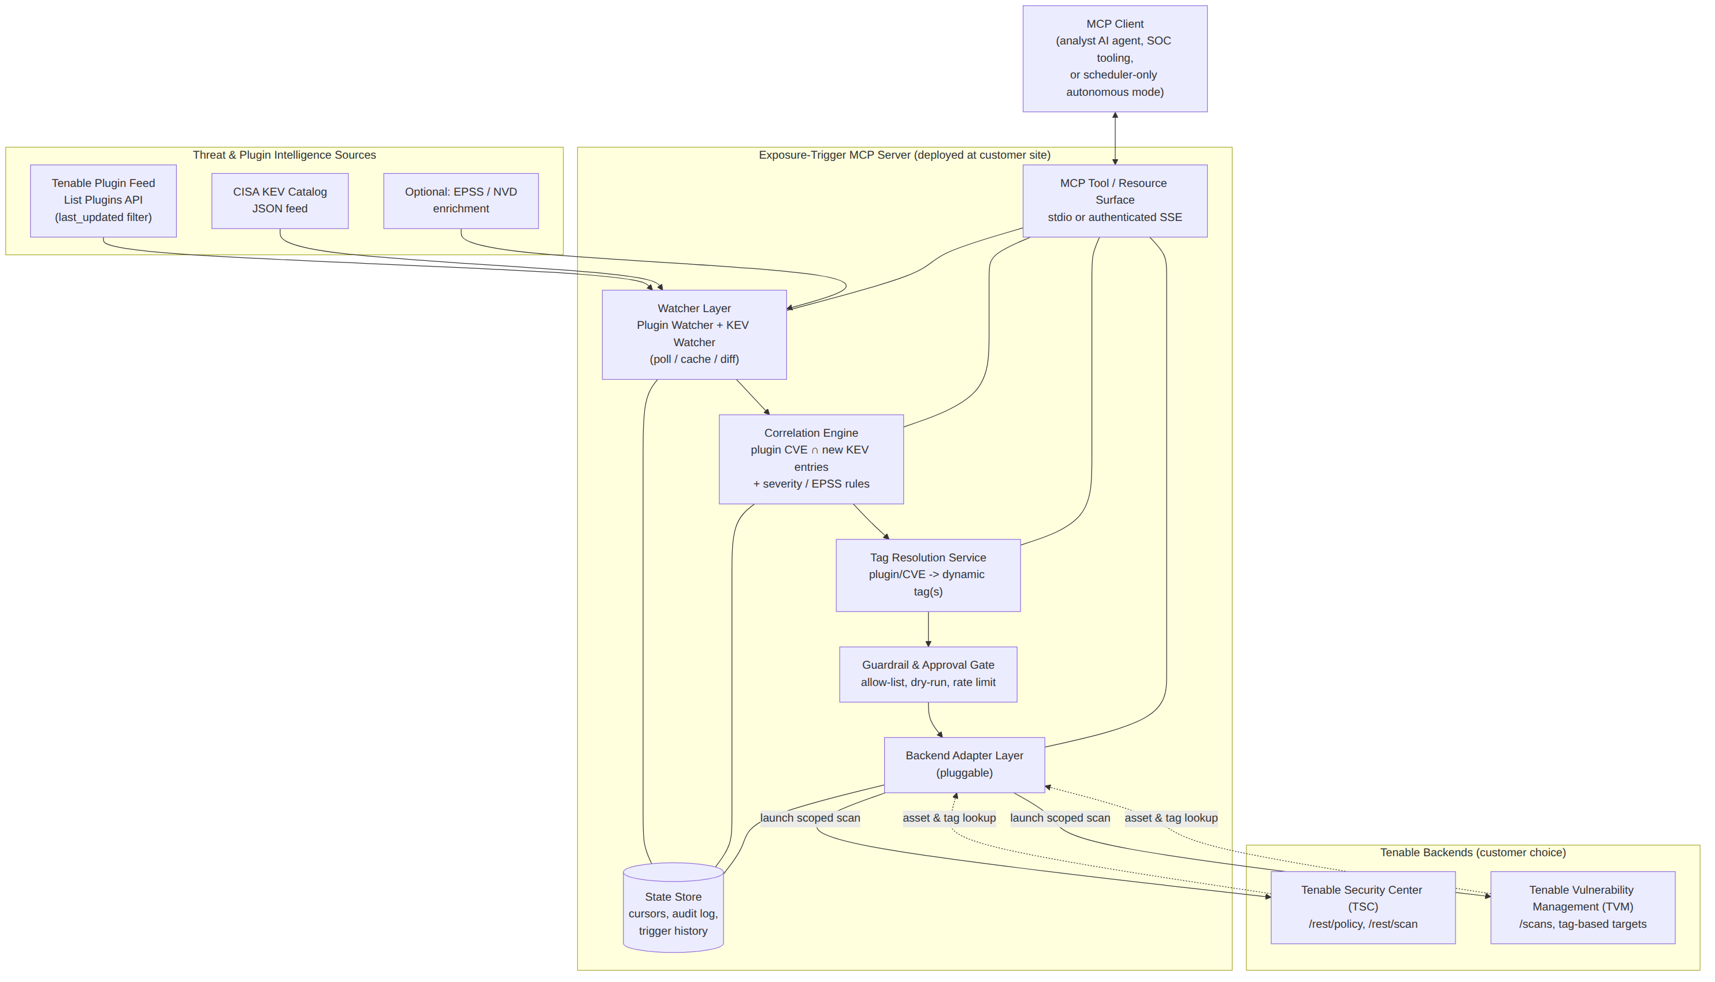
Figure 1. Exposure-Trigger MCP component architecture.

4.1 Component Summary
Component | Responsibility
Plugin Watcher | Polls the Tenable List Plugins API with a last_updated cursor; emits new/updated plugin -> CVE(s) -> plugin family records.
KEV Watcher | Fetches the CISA KEV JSON catalog on a schedule, diffs it against a local cache, emits newly added CVE entries.
Correlation Engine | Intersects plugin CVEs with KEV deltas (in either order of arrival) and applies configurable rules, e.g. minimum CVSS, EPSS score, or plugin family allow-list.
Tag Resolution Service | Maps an affected plugin family / CVE / CPE to the customer's existing dynamic tags or asset groups via the backend's own query/tag API. No new tag taxonomy is invented — it reuses what the customer already tags.
Guardrail & Approval Gate | Enforces an allow-list of tags eligible for auto-scan, a dry-run mode, a maximum scans-per-window rate limit, and an optional human-approval step exposed as an MCP tool call.
Backend Adapter Layer | Pluggable interface with two implementations — a TSC adapter and a TVM adapter — that build and launch the actual scoped scan and answer asset/tag lookups.
State Store | Local database (SQLite for small deployments, Postgres for larger ones) holding feed cursors, correlation history, and a full audit trail of every proposed and launched scan.
MCP Tool / Resource Surface | Exposes the above as MCP tools and resources over stdio (local, human- or agent-driven) or authenticated SSE/HTTP (remote orchestration), per Tenable's own MCP transport guidance.

5. Trigger and Intelligence Sources

5.1 Tenable Plugin Feed
The Plugin Watcher calls the Tenable List Plugins endpoint (developer.tenable.com) with the last_updated query parameter (YYYY-MM-DD) to pull only plugins touched since the last successful cycle, paging through results (default page size 1,000, maximum 10,000). Each returned plugin record carries its plugin ID, family, and the CVE(s) it detects, which the watcher normalizes into a plugin -> CVE map and hands to the Correlation Engine.

5.2 CISA Known Exploited Vulnerabilities (KEV) Catalog
The KEV Watcher fetches CISA's published JSON feed of the Known Exploited Vulnerabilities Catalog on a configurable interval (default: every 4 hours), diffs it against the previous cycle's cached copy by CVE ID, and emits only the newly added entries — avoiding re-triggering on CVEs the customer has already scanned for. KEV was chosen as the default ‘exploited in the wild’ source because it is authoritative, machine-readable, and free.

5.3 Optional Enrichment
The trigger source is intentionally pluggable. A customer can layer in EPSS (Exploit Prediction Scoring System) or NVD CVSS data as an additional filter — for example, ‘only auto-launch if EPSS > 0.5 even when the CVE is in KEV,’ or ‘treat a plugin as actionable on EPSS alone, without waiting for KEV.’ This keeps the correlation rule configurable per customer risk appetite rather than hardcoded to one feed.

6. Correlation and Tag Resolution Logic
At a high level, the Correlation Engine treats a plugin/CVE pair as actionable when both of the following are true, independent of arrival order:
is_actionable(plugin, cve):
covers_cve = cve in plugin.cves
newly_relevant = (plugin.last_updated > watcher.cursor)
OR (cve in kev_watcher.new_entries_since_last_cycle)
meets_threshold = (cve.cvss >= config.min_cvss)
AND (cve.epss is None OR cve.epss >= config.min_epss)
return covers_cve and newly_relevant and meets_threshold
Every plugin/CVE pair that passes is handed to the Tag Resolution Service, which asks the active backend adapter ‘which of the customer's existing dynamic tags or asset groups contain assets whose OS/software profile matches this plugin's family or CPE?’ On TSC this is a query against asset data via the existing /rest/asset and query endpoints; on TVM it is a tag-filtered asset lookup. The result is a candidate tag set, not a re-derived taxonomy — the server never creates or renames tags, it only reads the ones the customer already maintains.

7. Backend Adapter Layer: Tenable.sc vs Tenable Vulnerability Management
The adapter layer is the one piece of the architecture that differs materially between the two backends, because their scan-launch APIs are shaped differently. Both are implemented behind the same internal interface (build_policy(), launch_scan(scope), get_status(scan_id), resolve_tags(criteria)) so the rest of the pipeline is backend-agnostic.

7.1 Tenable Security Center (TSC) Adapter
Step | Call | Notes
Authenticate | POST /token | Session token required on every subsequent request header.
Identify target plugin | GET /rest/pluginFamily/{id} | Confirms plugin ID / family for the matched CVE.
Create scan policy | POST /rest/policy | context="scan", families includes the matched plugin family plus Nessus Scan Information (id 19506, family 41); policyTemplate id 1 (Advanced).
Launch scan | POST /rest/scan | schedule.type="now"; target set via assets/ipList resolved from the matched tag set; repository matches the customer's existing repository for those assets.

7.2 Tenable Vulnerability Management (TVM / tenable.io) Adapter
Step | Call | Notes
Authenticate | API key pair (X-ApiKeys header) | Access key + secret key, generated by the customer for a dedicated service account; never stored on disk by the server.
Resolve tags | Tag-filtered asset/scan target lookup | Tag-based scan targeting is a native TVM capability; the adapter resolves the matched plugin family to existing tag UUIDs.
Create / update scan | Create a Scan (API Explorer: Scans) | Scan definition scoped to the resolved tag UUIDs, reusing an existing scan template/policy rather than a full discovery scan.
Launch | Launch a Scan | Triggers immediate execution; scan ID returned for status polling.
Poll status | Get latest scan status | Tenable's own guidance: prefer this over Get scan details when polling many scans.
Design note
Neither backend is treated as primary. A customer running only TSC, only TVM, or both (common during a TSC-to-TVM migration) configures the adapter(s) they have; the correlation and guardrail layers are identical either way.

8. MCP Tool and Resource Surface
Exposing the pipeline as MCP tools is what lets Exposure-Trigger MCP be driven by an autonomous scheduler and by a human-in-the-loop client with the same code path.
MCP Tool | Input | Effect
list_new_plugins | since (date, optional) | Read-only. Returns plugins added/updated since the given date or the last cursor.
list_kev_deltas | since (date, optional) | Read-only. Returns CVEs newly added to the KEV catalog.
correlate_exploited_plugins | min_cvss, min_epss (optional) | Read-only. Returns the current actionable plugin/CVE set per Section 6.
resolve_affected_tags | plugin_id or cve | Read-only. Returns the candidate dynamic tag set on the active backend.
propose_scan | cve or plugin_id | Read-only. Returns a scan plan (tags, policy, targets) without launching — the dry-run path.
launch_targeted_scan | scan plan id, approve=true | The only mutating tool. Subject to the Guardrail Gate; launches the scan and returns a scan ID.
get_scan_status | scan_id | Read-only. Polls backend status.
audit://trigger-history | (MCP resource) | Streams the full history of proposed and launched scans with their triggering CVE/plugin.

9. Deployment Model at the Customer Site
- Packaging: a single container image (the same three launch modes as the community tenable-mcp reference: local stdio process, containerized stdio, or a standalone HTTP/SSE service on a configurable port).
- Placement: deployed inside the customer's network — alongside TSC for on-prem customers, or as an outbound-only client to TVM's cloud API for TVM customers. No inbound port is required unless the customer opts into the remote SSE transport for multi-agent orchestration, in which case it sits behind the customer's existing authentication proxy.
- Credentials: TSC session token or TVM API key pair supplied via environment variables or the customer's own secrets manager, scoped to a dedicated service account with the minimum privilege needed to read plugins/tags/assets and launch scans — never an administrator account.
- Network egress only: outbound HTTPS to the customer's TSC/TVM endpoint, to Tenable's plugin feed, and to CISA's KEV feed (or an internal mirror of it, for air-gapped environments).
- Scheduling: an internal cron-style loop (default interval configurable, e.g. every 4–24 hours) plus on-demand invocation via any MCP tool call — the same pipeline serves both modes.

10. End-to-End Sequence
Figure 2 traces one full cycle, from feed polling through the guardrail decision to a launched (or held-for-review) scan.
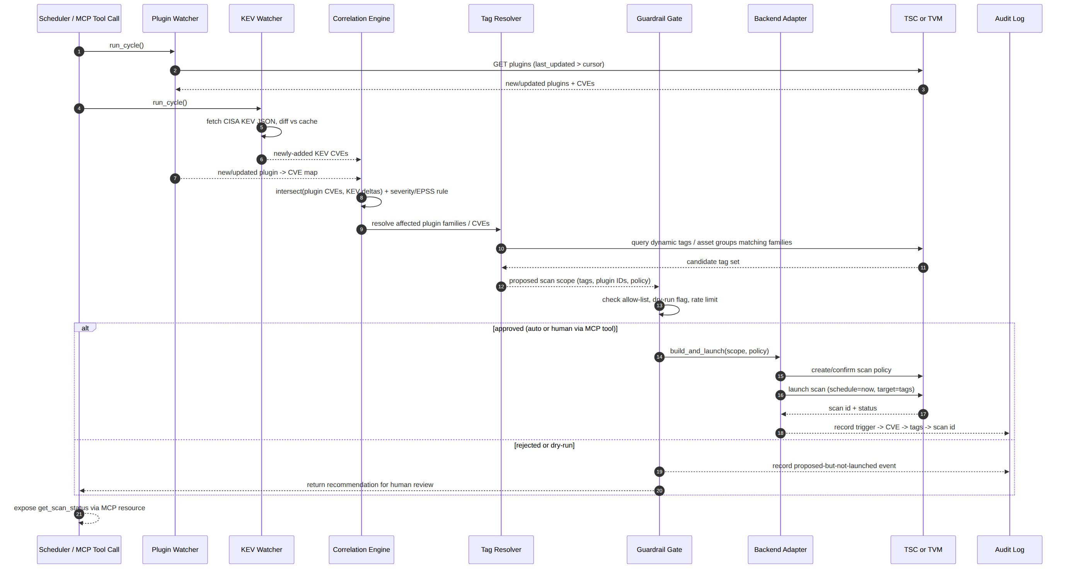
Figure 2. Trigger-to-scan sequence, including the guardrail branch.

11. Security, Guardrails, and Governance
- Least-privilege credentials: a dedicated TSC/TVM service account limited to plugin/tag/asset read and scan-launch — no user, policy, or repository administration rights.
- Credential locality: API keys/tokens are supplied at deploy time via environment variables or a mounted secret; the server never writes them to disk and never transmits them outside the customer's network (this is why the server runs at the customer site rather than as a Tenable-hosted multi-tenant service).
- Auto-scan allow-list: only tags a customer has explicitly enabled are eligible for automatic scan launch; everything else surfaces as a propose_scan recommendation for a human or a supervising agent to approve via launch_targeted_scan.
- Dry-run mode: a global switch that turns every cycle into propose_scan-only, useful for the first weeks of a deployment while the customer tunes the allow-list and thresholds.
- Rate limiting: a maximum-launches-per-window guardrail prevents a noisy KEV day or a bulk plugin release from triggering a scan storm across every tag at once.
- Full audit trail: every proposed and launched scan is recorded with the triggering CVE/plugin, the resolved tag set, the policy used, and the resulting scan ID — answering ‘why did this scan run’ after the fact.
- Transport security: stdio transport for local, single-user/agent use (Tenable's own MCP guidance notes this is safe as long as the local host itself is not compromised); authenticated SSE/HTTP — not left optional — for any remote or multi-agent deployment, matching the posture Tenable recommends even though the MCP spec itself only ‘highly recommends’ it.
- Inventory and monitoring: the server logs its own tool invocations so it can be discovered by an MCP inventory/monitoring tool, consistent with Tenable's published guidance to detect and inventory MCP installations across an environment.

12. Configuration Reference (Illustrative)
backend:
type: tvm # or: sc
url: https://cloud.tenable.com
auth:
access_key_env: TIO_ACCESS_KEY
secret_key_env: TIO_SECRET_KEY

feeds:
plugin_feed:
poll_interval_hours: 6
kev_feed:
url: https://www.cisa.gov/.../known_exploited_vulnerabilities.json
poll_interval_hours: 4
thresholds:
min_cvss: 7.0
min_epss: null # optional

guardrails:
dry_run: true # start conservative; flip to false after review
auto_scan_allow_tags: ["Internet-Facing", "Crown-Jewels"]
max_launches_per_window: 5
window_hours: 24

scan:
policy_template_id: 1 # Advanced / reused template, not full discovery
name_pattern: "Exposure-Trigger: {plugin_family} ({cve})"

13. Tenable Cyber Exchange Submission Plan
The Cyber Exchange (exchange.tenable.com, launched August 2026) lists four contribution types — AI Agents, Skills, MCP Servers, and Multi-Agent Playbooks — as a free, open-source, community-reviewed registry. Exposure-Trigger MCP is submitted under MCP Servers.
1. License and publish the server's source (README, manifest, examples) as an open-source repository, per the Exchange's stated model of community-built, open-source contributions.
2. Run the Exchange's Submission Builder Skill, which — per the contributing guide — validates the repo, asks clarifying questions, and opens the pull request automatically.
3. Where the builder skill's questions go beyond what it can infer, follow the full CONTRIBUTING.md in the Exchange's GitHub repository for the exact manifest/template fields, schema requirements, and review process (not fully enumerated on the public site at the time of writing — confirm current field names before submitting).
4. Include in the listing: the problem statement (Section 1), the architecture diagram (Figure 1), the security/guardrail posture (Section 11), and a note that it targets both TSC and TVM via the pluggable adapter — reviewers and prospective customers will be evaluating exactly these points.
5. Cross-reference the existing open-source community server (polarpoint-io/tenable-mcp) in the listing description as prior art / a complementary general-purpose TVM server, positioning Exposure-Trigger MCP as the purpose-built, event-driven companion rather than a competing general client.

14. Roadmap
- Additional exploited-in-the-wild feeds behind the same pluggable interface (e.g., vendor-specific advisories, VulnCheck) alongside CISA KEV.
- Tenable One exposure-context enrichment, so tag resolution can weigh business-criticality alongside plugin family match.
- Notification hooks (Slack/ServiceNow) firing off the same audit-log events, so a launched or held-for-review scan shows up where the SOC already works.
- A packaged Multi-Agent Playbook listing on the Cyber Exchange that chains Exposure-Trigger MCP with a triage/remediation agent, consistent with the Exchange's fourth contribution type.

Appendix A — Sample Tenable.sc Scan Launch (Illustrative)
POST /rest/policy
{
"name": "Exposure-Trigger: Family 97833",
"context": "scan",
"families": [
{ "id": "97833", "plugins": [] },
{ "id": "41", "plugins": ["19506"] }
],
"policyTemplate": { "id": "1" }
}

POST /rest/scan
{
"name": "Exposure-Trigger scan of Plugin Family #97833",
"policy": { "id": "<policy_id_from_above>" },
"repository": { "id": "<existing_repository_id>" },
"assets": [ { "id": "<resolved_tag_asset_group_id>" } ],
"schedule": { "type": "now" },
"type": "policy"
}

Appendix B — Sample MCP Tool Schema (Illustrative)
{
"name": "launch_targeted_scan",
"description": "Launch a scan scoped to the tags resolved for a matched CVE/plugin. Requires an approved scan plan id.",
"inputSchema": {
"type": "object",
"properties": {
"scan_plan_id": { "type": "string" },
"approve": { "type": "boolean", "const": true }
},
"required": ["scan_plan_id", "approve"]
}
}

Appendix C — Sources
- Tenable, “Tenable Launches Industry's First Open-Source AI Agent Exchange” (press release, Aug 2026) — CyberAgents Exchange overview and contribution types.
- exchange.tenable.com and exchange.tenable.com/contributing — Exchange scope and submission pathway (Submission Builder Skill, CONTRIBUTING.md).
- Tenable Developer Portal, developer.tenable.com — API ecosystem overview, Manage Scans (TVM), List Plugins changelog.
- docs.tenable.com/security-center — Tenable Security Center API: Launch a Remediation Scan best practice (⁄token, /rest/policy, /rest/scan).
- Tenable, “FAQ about Model Context Protocol (MCP) and Integrating with AI for Agentic Applications” (Tenable blog) — MCP transport and governance guidance referenced in Section 11.
- CISA, Known Exploited Vulnerabilities Catalog, cisa.gov/known-exploited-vulnerabilities-catalog — KEV JSON feed used as the default exploited-in-the-wild source.
- polarpoint-io/tenable-mcp (GitHub) — reference architecture for an existing open-source Tenable.io MCP server (tool grouping, auth-via-env-vars, stdio/Docker/SSE transports).

