**Performance Analysis Report**

V1.0

30/05/2020

## Action #1: Application Start Up

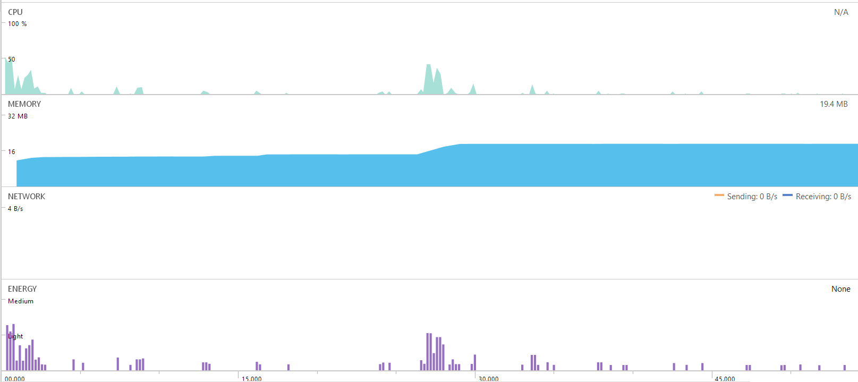

**CPU**

* During Start Up, CPU usage spike occurs at the 0.6 seconds with a peak value of 55%
* After 2.70s the CPU usage drops to 0%
* At approx. 4.00s, 8.00s and 12.00s there are some small CPU Usage instances (10% or less)
* Another CPU usage spike occurs at 27.00s with a peak usage of 43%
* CPU Usage stabilizes at 0% approx. after 50s

**Memory**

* Memory usage from 0.00s ~ 26.00s remains fairly constants around 14MB
* After 26.00s~29.00s, memory usage increases to 19.4MB and remains at 19.4MB for the remaining duration of the test.

**Network**

* No networking usage recorded.

**Energy**

* Energy graph follows the same pattern at the CPU graph.

## Action #2: API Call, Send local database to remote database

This scenario is when added all contacts to the remote database, when the remote database is empty.

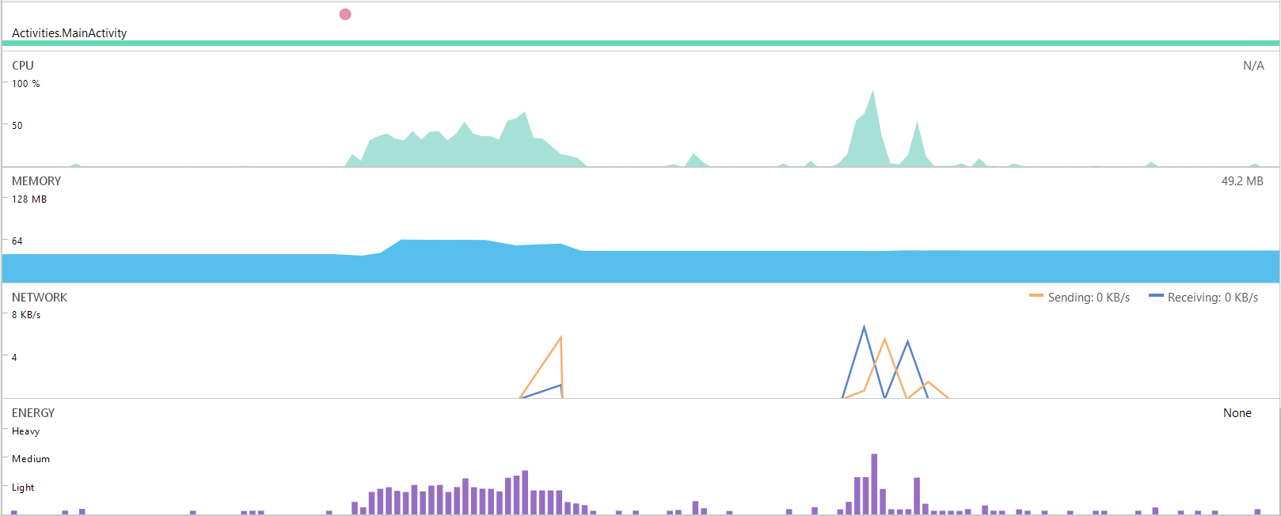

**CPU**

* CPU usage occurs as soon as “Update Server-DB” button is clicked (red dot indicates when button was pressed), with a peak CPU of 92%
* During this function, average CPU usage approx. 40%
* There were two instances of CPU usage when adding the contacts to the remote (multiple API calls to add each Contact in the Contact List)

**Memory**

* Memory usage starts at ~44Mb during idle running of app, and when function is called, memory usage increases to a peak of ~66Mb.
* After connecting to the API, memory usage drops back to ~49Mb and remains constant.

**Network**

* After Update-to-Server-DB button is clicked, network data sent and received, in this case there is network usage for each API call, i.e. an API call for each contact added to the DB.
* Each API is recorded to use ~94B

**Energy**

* Energy graph follows the same pattern at the CPU graph.
* Energy usage peaks around “medium” usage during the function

## Action #3: Loading of the List Page

This scenario is when after perform swipe gesture on Main Activity Page and Loading the List Page

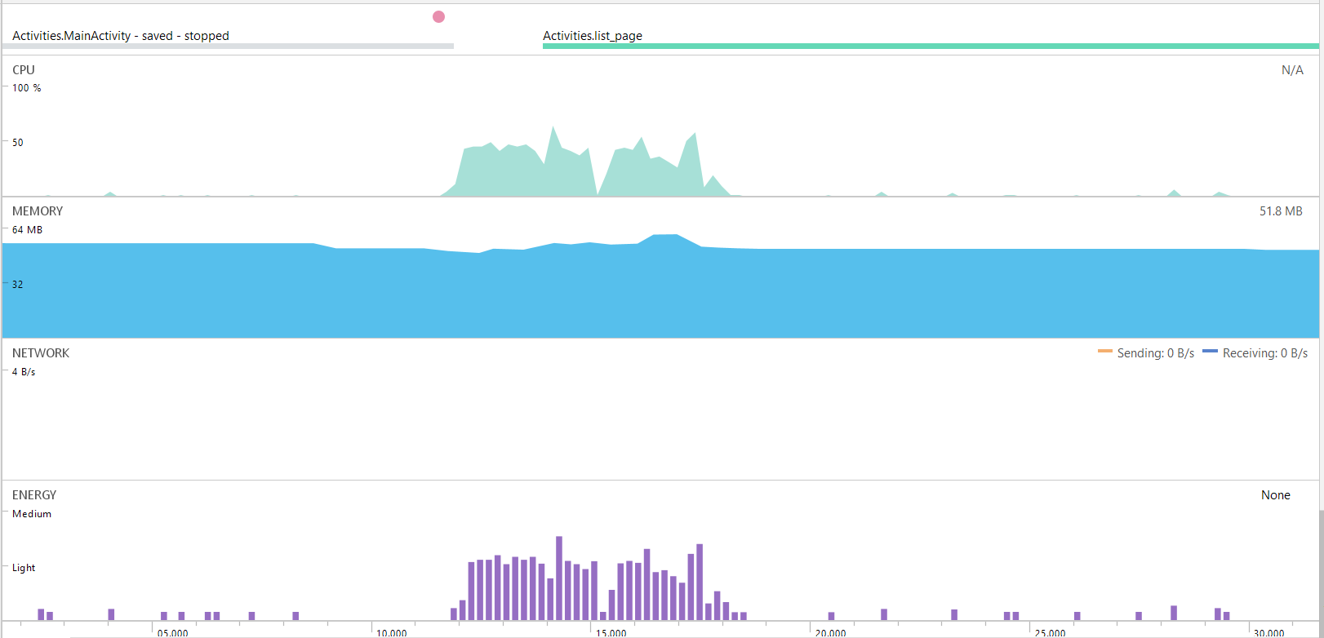

**CPU**

* CPU usage occurs as soon as swipe gesture occurs (red dot indicates when swipe occurred), with a peak CPU of 65%
* During this function, average CPU usage approx. 43%

**Memory**

* Memory usage starts at ~52Mb during idle running of app, and when function is called, memory usage increases to a peak of ~60Mb.
* After loading list page, memory usage drops back to ~52Mb and remains constant.

**Network**

* No network activity

**Energy**

* Energy graph follows the same pattern at the CPU graph.
* Energy usage peaks around “medium” usage during the function