Screenshots or program listings must be copied into appropriate cells in the following table.
Save this evidence document as evidence_ followed by your centre number_ candidate number, for example, evidence_ zz999_9999 and insert your name, centre number and candidate number into the header above.
Examiners must be able to read the contents including any screenshots without the use of a magnifying glass. Answers that are not readable or are missing will not be awarded any marks.
Save this evidence document at regular intervals, for example every 10 minutes.
Question 1
Part 1(a)
# DECLARE Animals : ARRAY[0:9] OF STRING
global Animals
Animals = [ ]

Part 1(b)
# DECLARE Animals : ARRAY[0:9] OF STRING
global Animals
Animals = []

Animals.append("horse")
Animals.append("lion")
Animals.append("rabbit")
Animals.append("mouse")
Animals.append("bird")
Animals.append("deer")
Animals.append("whale")
Animals.append("elephant")
Animals.append("kangaroo")
Animals.append("tiger")

Part 1(c)
def SortDescending():
ArrayLength = 10
for x in range(0 ,ArrayLength):
for Y in range(0, ArrayLength - x - 1):
if Animals[Y][0] < Animals[Y + 1][0]:
Temp = Animals[Y]
Animals[Y] = Animals[Y + 1]
Animals[Y + 1] = Temp

Part 1(d)(i)
SortDescending()
for x in range(10):
print(Animals[x])

Part 1(d)(ii)
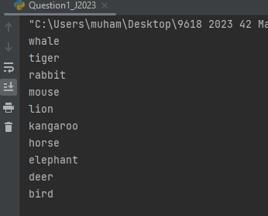

Question 2
Part 2(a)
class SaleData():
#Public SaleID : STRING
#Public Quantity : INTEGER
def __init__(self, SaleIDP, QuantityP):
self.SaleID = SaleIDP
self.Quantity = QuantityP

Part 2(b)
#DECLARE CircularQueue : ARRAY[0:4] OF SaleData
global CircularQueue
global Head
global Tail
global NumberOfItems
CircularQueue = [SaleData("", -1)] * 5
Head = 0
Tail = 0
NumberOfItems = 0

Part 2(c)
def Enqueue(NewRecord):
global CircularQueue
global Head
global Tail
global NumberOfItems

if NumberOfItems == 5:
return -1
else:
CircularQueue[Tail] = NewRecord
if Tail == 4:
Tail = 0
else:
Tail = Tail + 1
NumberOfItems = NumberOfItems + 1
return 1

Part 2(d)
def Dequeue():
global CircularQueue
global Head
global NumberOfItems

if NumberOfItems == 0:
return SaleData("", -1)
else:
record = CircularQueue[Head]
Head = Head + 1
if Head > 4:
Head = 0
NumberOfItems =NumberOfItems - 1
return record

Part 2(e)
def EnterRecord():
ID = input("Enter the SaleID: ")
Quantity = int(input("Enter the Quantity: "))
record = SaleData(ID, Quantity)
if Enqueue(record) == -1:
print("Full")
else:
print("Stored")

Part 2(f)(i)
EnterRecord()
EnterRecord()
EnterRecord()
EnterRecord()
EnterRecord()
EnterRecord()

RecordCheck = Dequeue()
if RecordCheck.SaleID == "":
print("Queue Is Empty")
else:
print(RecordCheck.SaleID + " " + str(RecordCheck.Quantity))

for x in range(5):
Record = CircularQueue[x]
print(Record.SaleID + " " + str(Record.Quantity))

Part 2(f)(ii)
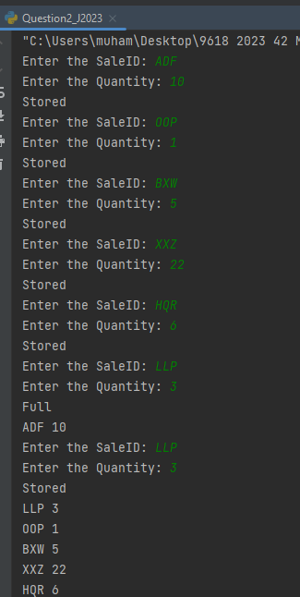

Question 3
Part 3(a)(i)
class Employee():
#PRIVATE HourlyPay : REAL
#PRIVATE EmployeeNumber : STRING
#PRIVATE JobTitle : STRING
#PRIVATE PayYear2022 : ARRAY[0:51] OF REAl
def __init__(self, HourlyPayP, EmployeeNumberP, JobTitleP):
self.__HourlyPay = HourlyPayP
self.__EmployeeNumber = EmployeeNumberP
self.__JobTitle = JobTitleP
self.__PayYear2022 = [0.0] * 52

Part 3(a)(ii)
def GetEmployeeNumber(self):
return self.__EmployeeNumber

Part 3(a)(iii)
def SetPay(self, WeekNumber, Hourworked):
Pay = self.__HourlyPay * Hourworked
self.__PayYear2022[WeekNumber - 1] = Pay

Part 3(a)(iv)
def GetTotalPay(self):
Total = 0
for x in range(52):
Total = Total + self.__PayYear2022[x]

return Total

Part 3(b)(i)
class Manager(Employee):
#PRIVATE BonusValue : REAL
def __init__(self, HourlyPayP, EmployeeNumberP, JobTitleP, BonusValueP ):
super().__init__(HourlyPayP, EmployeeNumberP, JobTitleP)
self.__BonusValue = BonusValueP

Part 3(b)(ii)
def SetPay(self, WeekNumber, Hourworked):
NewHours = Hourworked + (Hourworked * (self.__BonusValue/100))
super().SetPay(WeekNumber, NewHours)

Part 3(c)
#DECALRE EmplyeeArray : ARRAY[0:7] OF Employee
EmployeeArray = [Employee(0.0, "", "")] * 8

MaybeBonus = "" # Junior Developer
JobTitle = ""
try:
Employeefile = open("Employees.txt", "r")
for x in range(8):
HourlyPay = float(Employeefile.readline().strip())
EmployeeNumber = Employeefile.readline().strip()
MaybeBonus = Employeefile.readline().strip()
try:
Bonus = float(MaybeBonus) # float("Junior Developer")
JobTitle = Employeefile.readline().strip()
EmployeeArray[x] = Manager(HourlyPay, EmployeeNumber, JobTitle, Bonus)
except:
JobTitle = MaybeBonus
EmployeeArray[x] = Employee(HourlyPay, EmployeeNumber, JobTitle)

Employeefile.close()
except IOError:
print("File Not Found")

Part 3(d)
def EnterHours():
try:
HoursFile = open("HoursWeek1.txt", "r")
for x in range(8):
EmployeeID = HoursFile.readline().strip()
Hoursworked = float(HoursFile.readline().strip())
for y in range(8):
if EmployeeArray[y].GetEmployeeNumber() == EmployeeID:
EmployeeArray[y].SetPay(1, Hoursworked)
HoursFile.close()
except IOError:
print("File Does Not Exist")

Part 3(e)(i)
EnterHours()
for x in range(8):
EmployeeNumber = EmployeeArray[x].GetEmployeeNumber()
TotalPay = EmployeeArray[x].GetTotalPay()
print(EmployeeNumber + " " + str(TotalPay))

Part 3(e)(ii)
