

General Accessibility Guidelines

Contents

1. PRINCIPLES 2

2. UI / UX Guidelines 3

3. Developers Guidelines 5

General Accessibility Guidelines

# PRINCIPLES

Key principles and considerations of accessibility include:

1. Perceivability: Information and user interface components must be presented in a way that can be perceived by all users. This includes providing text alternatives for non-text content (such as images), ensuring that content is distinguishable and easy to read, and offering alternatives for multimedia.
2. Operability: All users should be able to interact with and navigate through content and user interface components. This involves providing keyboard accessibility, allowing users to operate functionality without time constraints, and ensuring that navigation is logical and predictable.
3. Understandability: Content and operation of the user interface should be clear and easy to understand. This includes using plain language, providing consistent navigation, and labeling, and avoiding content that might be confusing or distracting.
4. Robustness: Digital content should be designed to work well with current and future technologies. This means using standard, well-supported technologies and following coding practices that enhance compatibility and adaptability.

Web Content Accessibility Guidelines (WCAG), developed by the World Wide Web Consortium (W3C), provide a comprehensive framework for web accessibility. These guidelines offer specific success criteria and techniques for creating accessible web content and applications.

# UI / UX Guidelines

1. Text Contrast:

* Text should have a high contrast ratio against its background. This means that the text should be significantly darker or lighter than the background color.
* The Web Content Accessibility Guidelines (WCAG) provides specific guidelines for text contrast ratios.

Good Text Contrast (4.5:1 or higher):

1. Black text on a white background
2. White text on a black background
3. Dark gray text (#333) on a white background

Poor Text Contrast (Below 4.5:1):

1. Light gray text (#999) on a white background
2. Yellow text on a white background
3. Red text on a green background

* A screenshot of a phone

  Description automatically generated

1. Color Choices:

* Be mindful of color choices when designing digital content.
* Avoid using color combinations that are difficult to distinguish for individuals with color blindness or low vision.

1. Use color contrast tools to test color combinations for accessibility.
2. Font Size and Weight:

* Use legible fonts and ensure that text is of an appropriate size and weight.
* Larger and bolder text can be easier to read for many people, especially those with visual impairments.

1. Use Clear and Readable Typography:

* Select legible fonts and maintain a reasonable font size.
* Ensure there is adequate contrast between text and background colors.
* Consider using accessible color combinations and testing color contrast using tools like the WCAG Color Contrast Checker.



1. Consistency:

* Maintain a consistent color scheme and text style throughout your content.
* This helps users with cognitive or visual disabilities navigate and understand your content more easily.

# Developers Guidelines

1. Understand Accessibility Standards**:**

Familiarize yourself with accessibility standards such as the Web Content Accessibility Guidelines (WCAG) and the Americans with Disabilities Act (ADA). These guidelines provide detailed criteria for creating accessible web content.

1. Semantic HTML:

* Use semantic HTML elements to structure your content. This includes headings (h1, h2, h3, etc.), lists (ul, ol), and appropriate form elements.
* Semantic HTML provides a clear and meaningful structure to assistive technologies and helps users navigate and understand content.

1. Keyboard Accessibility:

* Ensure that all interactive elements can be operated using a keyboard alone. This includes buttons, links, form fields, and navigation menus.
* Test your interface with keyboard navigation to verify that the tab order is logical, and that focus is appropriately managed.

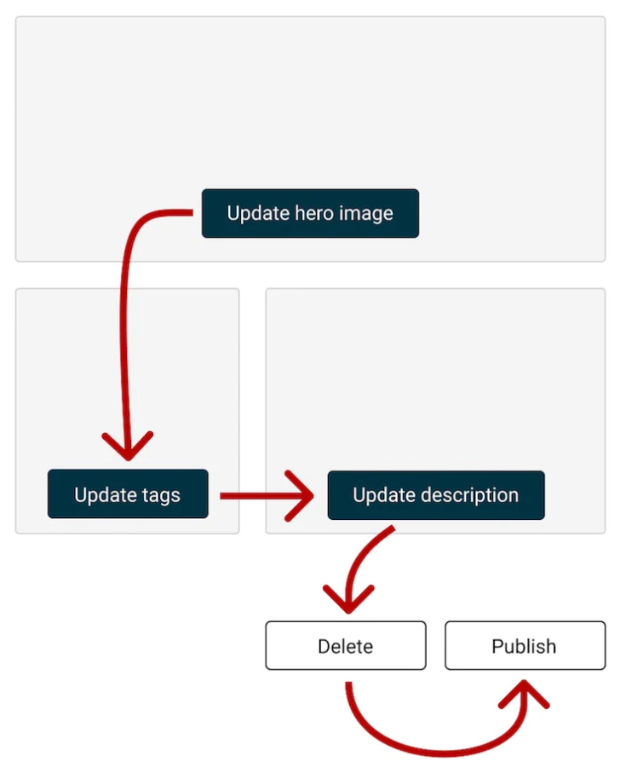

1. Alternative Text for Images:

* Include descriptive alternative text (alt text) for images, icons, and other non-text content.
* Alt text provides context for users who cannot see the visual content.

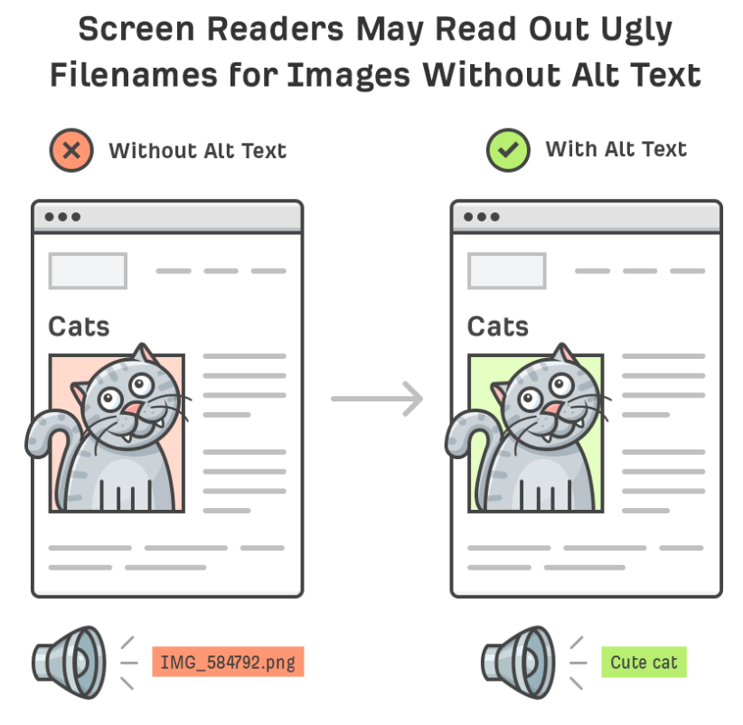

1. Accessible Forms:

* Design forms with clear and descriptive labels. Associate labels with form controls using HTML attributes.
* Provide helpful error messages and validation cues for form inputs.

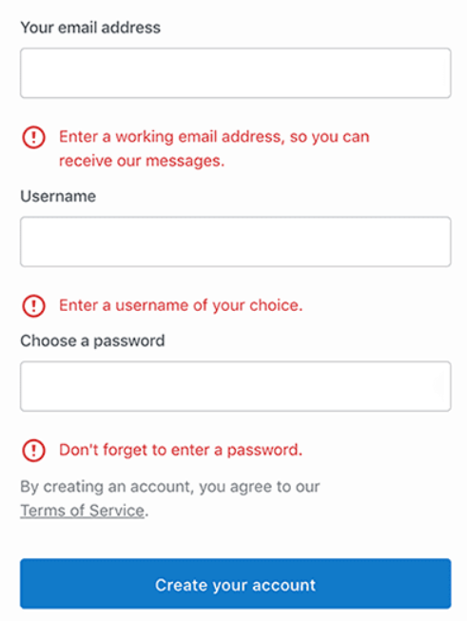

1. Color Contrast:

* Maintain sufficient color contrast between text and background colors. Ensure that text is legible for users with visual impairments.
* Use color contrast checking tools to verify compliance with accessibility standards.

1. ARIA Roles and Attributes:

* When building complex UI components (e.g., accordions, modal dialogs), use ARIA roles and attributes to enhance accessibility.
* ARIA (Accessible Rich Internet Applications) provides additional information to assistive technologies.

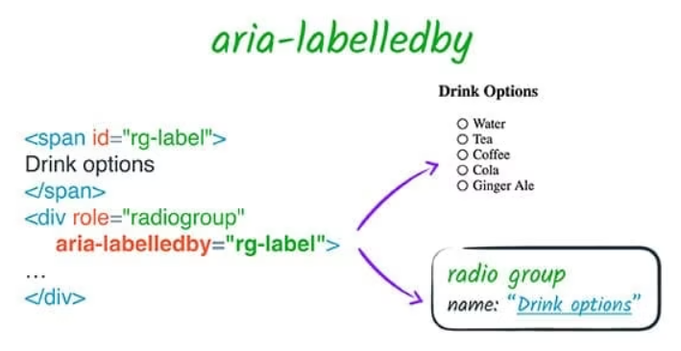

1. Focus and Hover Indication:

* Clearly indicate keyboard focus or hover on interactive elements by designing visible focus states.
* Make sure focus states are noticeable and distinct to assist keyboard users.

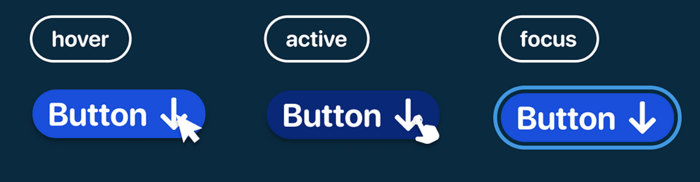

1. Accessible Multimedia:

* Make multimedia content (videos, audio, animations) accessible by providing captions, transcripts, and alternative formats.
* Allow users to pause, play, and adjust media content easily.

1. High-Quality Images:

* Use high-quality images and ensure they are appropriately sized and optimized for fast loading.
* Include descriptive alt text for all images to provide context to users who cannot see them.

1. Clear and Intuitive Navigation:

* Design a clear and intuitive navigation system.
* Use descriptive labels for links and buttons and ensure that navigation menus are easy to understand and use with keyboard input.

1. Readable Typography:

* Use legible fonts and maintain a reasonable font size.
* Provide options for users to adjust text size if necessary and ensure that text and background colors have sufficient contrast for readability.

1. Consistent and Predictable Layouts:

* Maintain a consistent layout throughout your application or website so users can predict where to find information.
* Consistency in the placement of navigation elements, menus, and interactive elements helps all users, including those using screen readers or keyboard navigation.

1. Responsive Design:

* Create responsive designs that adapt to different screen sizes and orientations.
* Test your UI on a variety of devices and browsers to ensure it works well for all users.

1. HTML tag must have lang Attribute:

* While using the html tag it must contains the lang=”” attribute.

