SQL Practice exercises

Goal: Put into practice what you have learned so far in the SQL lectures (basic queries and more advanced queries)

There are 15 questions to solve with queries that are roughly of increasing difficulty:

* Level 1: Stretching
* Level 2: Pouring some spices
* Level 3: Why so serious?

**The document to submit should be either a doc file or a pdf file with the answers to each question:**

1. **The query you ran**
2. **The result you got**

# Setup instructions

1. [Download the repository](https://github.com/datacharmer/test_db/archive/refs/heads/master.zip). Unzip the file.
2. Launch your terminal/command shell and go to the repository where you downloaded the file. Enter the folder (that you have unzipped).
3. Run the following command: *mysql -u root -p < employees.sql*

You should see the tables loading:

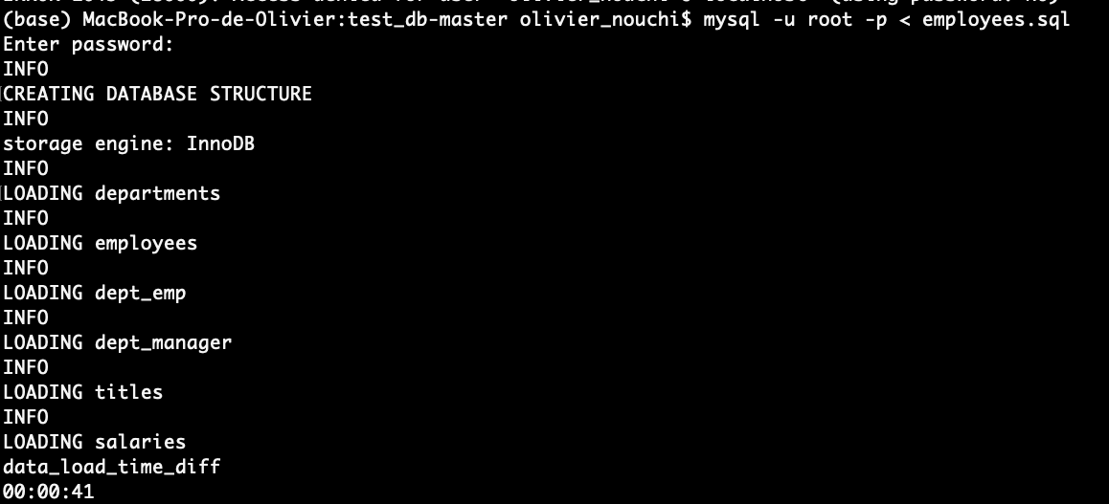

You have created the employees’ table with the tables cited above.

1. Then run the following command line: *mysql -u root -p -t < test_employees_md5.sql*

It will make sure that you have loaded everything correctly. You should be able to see the following (records matched).

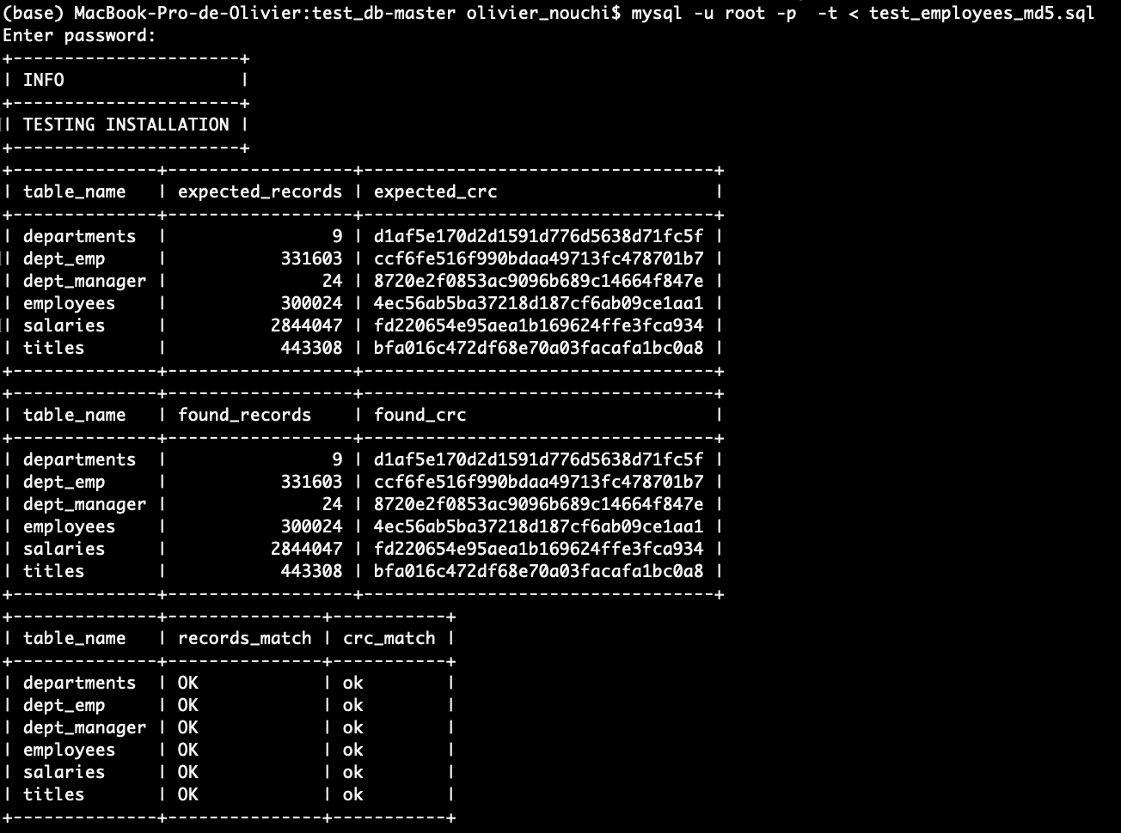

You are all set!

You can now work in MySQL Workbench.

Don’t forget to “Refresh All” if you don’t see it appear in MySQL Workbench.

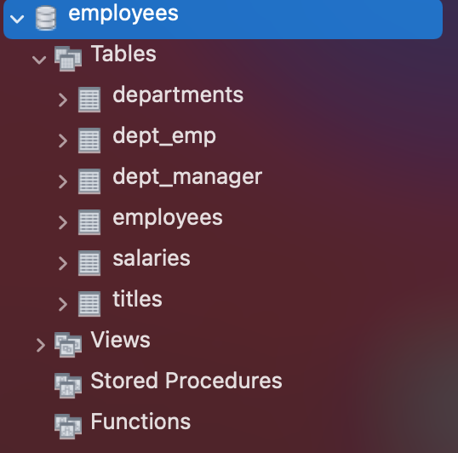

# Database schema

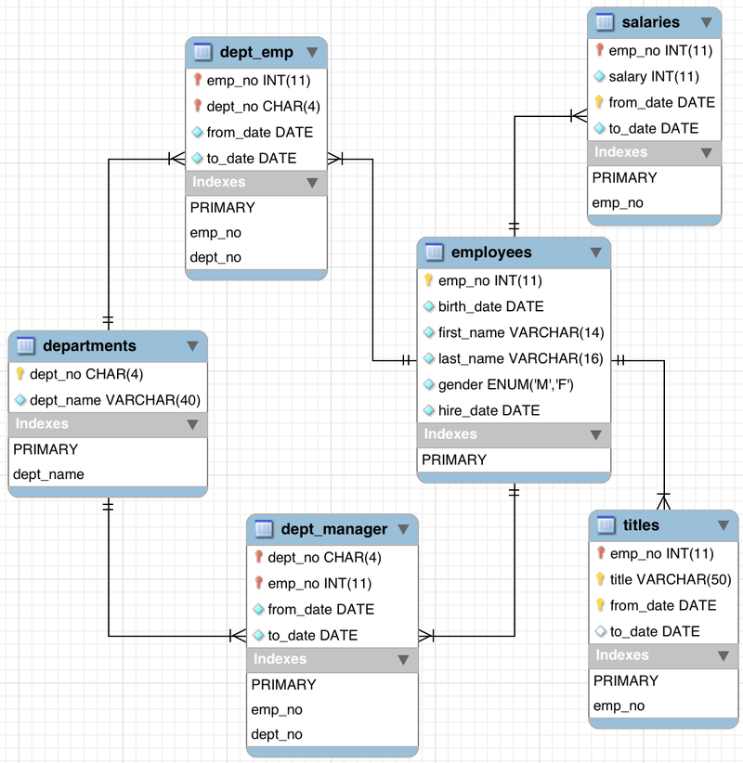

# 

# 

# Stretching

Q1 - How many unique employees are there?

SELECT count(emp_no) FROM employees.employees;

300024

Q2 - How many males and females employees are there? Order the counts in descending order.

SELECT T1.gender as male,T2.gender as female

FROM employees.employees T1 ,employees.employees T2

where T1.gender="M" AND T2.gender="F"

male: 179973

female: 120051

Q3 - Display the year and total hires for the year with the most hires

SELECT count(emp_no), YEAR(hire_date) FROM employees.employees

group by YEAR(hire_date)

order by count( emp_no ) desc

|  |  |  |
| --- | --- | --- |
| |  |  | | --- | --- | | 36150 | 1986 | |

Q4 - What is the name of the department with the most employees

SELECT count(emp_no),dept_name FROM employees.dept_emp

join employees.departments

ON employees.departments.dept_no=employees.dept_emp.dept_no

group by employees.dept_emp.dept_no

order by count(emp_no) DESC

|  |  |
| --- | --- |
| 85707 | Development |

Q5 - How many employees were born on November 12? What's the percentage out of all the employees?

SELECT COUNT(emp_no) AS number_of_employees, COUNT(emp_no) / (SELECT COUNT(emp_no) FROM employees.employees) AS perc

FROM employees.employees

WHERE MONTH(birth_date) = 11 AND DAY(birth_date) = 12;

|  |  |
| --- | --- |
| 800 | 0.0027 |

Q6 - What are the 3 most common employee titles (display the employee titles and the number of times they occur)

SELECT title,count(emp_no) FROM employees.titles

group by title

order by count(emp_no) desc

|  |  |
| --- | --- |
| Engineer | 115003 |
| Staff | 107391 |
| Senior Engineer | 97750 |

Q7 - Find the avg salary for each department (department name). Round to the nearest integer and order by avg salary from the highest to the lowest.

select dept_name, round(avg(salary),0)

from employees.salaries

join employees.dept_emp

ON employees.salaries.emp_no=employees.dept_emp.emp_no

join employees.departments

ON employees.departments.dept_no=employees.dept_emp.dept_no

group by employees.dept_emp.dept_no

order by AVG( employees.salaries.salary) desc

|  |  |
| --- | --- |
| Sales | 80668 |
| Marketing | 71913 |
| Finance | 70489 |
| Research | 59665 |
| Production | 59605 |
| Development | 59479 |
| Customer Service | 58770 |
| Quality Management | 57251 |
| Human Resources | 55575 |

# Pouring some spices

Q8 - Find the average salary by employee title. Round to 2 decimals and order by descending order

SELECT title, round(AVG(salary),2) as avrg_salary FROM employees.salaries

join employees.titles

on employees.salaries.emp_no=employees.titles.emp_no

group by employees.titles.title

order by avg(salary) desc

|  |  |
| --- | --- |
| Senior Staff | 70470.84 |
| Staff | 69309.10 |
| Manager | 66924.27 |
| Senior Engineer | 60543.22 |
| Engineer | 59508.04 |
| Assistant Engineer | 59304.99 |
| Technique Leader | 59294.37 |

Q9 - Find the number of employees who have worked in at least 2 departments

SELECT count(emp_no) -count(distinct emp_no)FROM employees.dept_emp;

31579

Q10 - Get the distribution of the year of the hire dates. (hint: you should end up with a number of employees per year of hiring date)

SELECT count(emp_no),year(hire_date) FROM employees.employees

group by YEAR(hire_date)

order by count(emp_no) desc

|  |  |
| --- | --- |
| 36150 | 1986 |
| 35316 | 1985 |
| 33501 | 1987 |
| 31436 | 1988 |
| 28394 | 1989 |
| 25610 | 1990 |
| 22568 | 1991 |
| 20402 | 1992 |
| 17772 | 1993 |
| 14835 | 1994 |
| 12115 | 1995 |
| 9574 | 1996 |
| 6669 | 1997 |
| 4155 | 1998 |
| 1514 | 1999 |
| 13 | 2000 |

Do you notice any pattern? Assuming there is no missing data, is the company hiring more or less as time goes by?

The number of the employees decreased over the year,they should increase their pay

Q11 - Display the first name, last name, and salary of the highest paid employee

SELECT first_name, last_name, salary

FROM employees.employees

join employees.salaries

ON employees.employees.emp_no=employees.salaries.emp_no

group by employees.salaries.salary

order by salary desc

|  |  |  |
| --- | --- | --- |
| Tokuyasu | Pesch | 158220 |

Q12 - Display the first name, last name, and salary of the THIRD highest paid employee

SELECT first_name, last_name, salary

FROM employees.employees

join employees.salaries

ON employees.employees.emp_no=employees.salaries.emp_no

group by employees.salaries.salary

order by salary desc

LIMIT 1 OFFSET 2;

|  |  |  |
| --- | --- | --- |
| Honesty | Mukaidono | 156286 |

# Why so serious?

Q13 - Display each department name and the age of the youngest employee at hire date

select dept_name, min(round((DATEDIFF(employees.hire_date,employees.birth_date)/365.25),2)) as youngest

from employees.employees

join employees.dept_emp

ON employees.employees.emp_no=employees.dept_emp.emp_no

join employees.departments

on employees.dept_emp.dept_no=employees.departments.dept_no

group by dept_name

order by youngest ASC

|  |  |
| --- | --- |
| Development | 20.03 |
| Research | 20.03 |
| Customer Service | 20.06 |
| Marketing | 20.06 |
| Production | 20.07 |
| Finance | 20.09 |
| Human Resources | 20.12 |
| Sales | 20.12 |
| Quality Management | 20.16 |

Q14 - What's the range of age the employees would be today (calculate their age whole years)

SELECT

min((floor(datediff(current_date(),birth_date)/365.25))) as youngest_emp,

max((floor(datediff(current_date(),birth_date)/365.25))) as oldest_emp

FROM employees.employees;

|  |  |
| --- | --- |
| 56 | 69 |
|  |  |

Q15 - How many employees were born on the same date (day-month-year) as those born in 1955.

NB: Change the according to preferences parameters if your query fails because of a timeout

SELECT count(birth_date),birth_date

FROM employees.employees

where year(birth_date)=1955

group by birth_date

order by count(emp_no) desc

limit 1

|  |  |
| --- | --- |
| 90 | 1955-03-03 |