HUMBER INSTITUTE OF TECHNOLOGY
AND ADVANCED LEARNING
(HUMBER COLLEGE)

Group Project

COURSE: Operations Metrics - BUS-5300-RLA
TEAM: 7

SUBMITTED BY:

Name | Student Number
Tzu Hsin Chang | N01701752
Wei-Wei Chiang | N01683386
David Lake | N01698267
Kuppan Murugappan | N01694284
Trung Viet Nguyen | N01704583
Dario Pineda | N01708235
Rajkumar Ramu | N01705840
Srivatsav Shrikanth | N01679678

SUBMITTED TO: Trevor Smith

SUBMITTION DATE: November 9th, 2025
Table of Contents
Executive Summary 5
Introduction 5
1. Project Process Areas 6
1.1. Inputs Required 6
1.2. Resource availability & emergency readiness 7
1.3. Benchmarking of Similar Scenarios 9
1.4. Project Process Design 10
Flow End-to-End Wildfire Operation. 10
Agency Uses and Gratifications. 11
Continuous Improvement/Post-Event Evaluation. 11
1.5. TWO Scenario Descriptions 12
Scenario 1: Small fire that could grow 12
Scenario 2: Large fire with evacuations 12
2. Measurement Plan 12
2.1. Metrics to Be Measured 12
Applying OM Theory to Wildfire Management 13
Metrics Toolbox for Wildfire Management 13
Key Performance Indicators (KPIs) for Wildfire Response 14
2.2. Scenario-Specific Measurement Plan 15
Scenario 1: Small but Growing Wildfire 15
Scenario 2: Large, Uncontrolled Wildfire 15
2.3. Key Takeaways from the Measurement Plan 16
2.4. Management By Fact (MBF): 16
Conclusions 18
References 20

Executive Summary
This project crafts a comprehensive wildfire operations plan at the Canadian provincial level, in response to increasing intensification of wildfire events due to climate change. The plan highlights the key process areas in charge of effecting proper management, which encompasses inputs from weather and climate forecasting, environmental risk indicators, resource readiness of equipment and personnel, and operational procedures for decision-making. Presented are two response scenarios: one included a small, contained fire that could potentially flare up, and a large, uncontrolled wildfire with threatening residential communities.
Using operations management frameworks, specifically the 10 OM decision areas, theory on forecasting, capacity and scheduling principles, and the Metrics Toolbox, the team developed a detailed measurement plan with comprehensive metrics for forecasting, execution, and post-event review. The toolbox that resulted includes metrics on fire risk prediction, resource utilization, supply chain reliability, safety and quality performance, and financial impact-anchored to KPI targets for response time, containment efficiency, asset readiness, and recovery turnaround.
The overall conclusion of this project is that a structured approach, using metrics, strengthens early detection, enhances response coordination, and improves post-event learning. The recommendations range from integrating real-time forecasting tools to sustaining high equipment readiness, improving responsiveness in supply chains, and using scenario-specific KPIs that guide decision-making during the wildfire event.

Introduction
Wildfires increasingly threaten Canada through rising temperatures, longer droughts, and more extreme weather, all of which elevate fire frequency and potential fire behaviors. These factors elevate risks to communities, infrastructures, and natural ecosystems, raising the need for effective wildfire planning as an important operational priority. This project applies Operations Management principles in the design of a structured approach to the preparation for and response to wildfires, incorporating forecasting inputs, resource readiness assessments, and scenario-based planning, with a comprehensive measurement framework in support of data-driven decision-making.

Project Process Areas

Inputs Required
To plan for wildfires in a Canadian province, it's best to use a range of information instead of just waiting until there's smoke. The key information can be sorted into these groups: weather and climate, environment and land, fire history, what's at risk, and real-time tech.
Weather and climate data: To guess how bad a fire could be and where it might spread, we need hourly and daily info on things like temperature, humidity, wind, rain, and lightning. In Canada, Environment and Climate Change Canada gathers this info and turns it into the Canadian Forest Fire Weather Index (FWI). Groups like Alberta Wildfire and the BC Wildfire Service then use this index to figure out which days are riskiest.
Environmental and topographic conditions: How strong a fire burns depends on the type of plants, how much fuel there is, how wet the fuel is, and how dry the soil is. The direction and speed of a fire's spread are affected by the slope, direction the land faces, and height. Maps showing old burn scars and fuel types from provincial wildfire services and the Canadian Wildland Fire Information System can show which areas are likely to catch fire again or have fast-spreading fires.
Historical wildfire and ignition records: Info on past fires gives us important background on what causes them (lightning, power lines, campfires, arson), how long they take to spot, how long to put out, and how big they get. For example, looking at the 2023 Alberta fires shows how drought can make fires much bigger if they start easily and are responded to slowly. This is why we measure things like how fast we find and deal with fires, and how often we can contain them.
Community, infrastructure, and health exposure: To decide where to put resources first, the province needs maps showing where people live, important infrastructure is (like power lines, water plants, and roads), and who is at risk. Data on air quality and smoke levels, like the AQI or AQHI, helps decide when to open clean-air shelters and tell people to leave, like BC and Alberta do when there's a lot of smoke.
Technology and remote-sensing inputs: Tech like satellite detection (e.g., NASA FIRMS), helicopter and drone images, smoke-detecting cameras, and alert systems help confirm fires quickly and track how they spread, especially in remote places. These tools are normal in US states like California and are becoming more common in Canada. They set a standard for using data to decide when to take action on fires.
The data goes straight into our Wildfire Metrics Toolbox, which informs our predictions, capacity planning, and scheduling. This way, operational choices are based on data, not just guesses.

Resource availability & emergency readiness
Table 1: Resource availability and emergency readiness
Category | Resource | Specific Materials Required | Purpose/Use | Logistics/ Mobilization
Forecasting & Modelling | Sensors | Barometer, Thermometer, Smoke Detectors | Measure weather, wind, dryness, lightning and smoke to predict how fire may spread. | Keep one kit with each crew leader and calibration before every season.
Forecasting & Modelling | Maps | Terrain, critical infrastructure, and evacuation | Give a common picture for lines access and evacuation routes. | Store paper maps in vehicles and load offline maps on the phone or tablet.
Equipment | Suppression Tools | Fire extinguisher, fire axes, shovels, flame-retardant | Build lines and knock down hotspots. | Pre-check one kit for crews and stage extra hose near high-risk area.
Equipment | Safety Equipment | PPE, hard hats, high visibility vests | Keep crews safe from heat, smoke and enable immediate care. | Issue PPE to all and restock medical items after use.
Equipment | Logistical support | Rations, gloves, first aid | Sustain crews during long shift. | Plan roughly 3000 calories and at least 2 liters of water per person.
Fleet | Air vehicles | Helicopters, water bombers | Aircraft drop water and spot hotspots quickly. | Maintain call-up contracts, pre-approve helistops sites and lunch within 20-30 mins.
Fleet | Ground vehicles | Firetrucks | Move water/crew and run hose operations on the flank | Stage forward near risk areas and daily pump check.
Fleet | Heavy machinery | Excavators, bulldozers | Cut control lines and clear routes. | Use call-when-needed contracts and assign fire watch.
Fleet | Light vehicles | ATVs | Move people quickly and patrol for blowup. | Assign sector with radio and refuel nightly.
Fleet | Fuel and supplies | Gasoline, tools for vehicle repair | Keep vehicles, pumps and saws operational. | Hold at least 48 buffers at depots.
Infrastructure | Power | Electricity, generators | Keep radio, lighting, command system working. | Maintain sufficient fuel and test it weekly.
Infrastructure | Communications | network access, mobile devices, loudspeakers, command center | Connect crews and allow fast public warnings. | Issue radio with a channel plan and keep sat phone as backup.
Infrastructure | Storage | Warehousing, garages | Store kits and spares securely. | Pre-position near risk areas.
Infrastructure | Plans | SOPs, action plans, communications plans, evacuation plans, contingency plans | Standardize roles, triggers and hand-offs. | Keep printed SOP in vehicles.
Infrastructure | Personnel | Fire crews, dispatch team, mechanics | Crews suppress fires, dispatch coordinates resources, mechanic keep the fleet running. | Staff stay on-call for surge, rotate shift and ensure 24/7 machines support.

Benchmarking of Similar Scenarios
Canada Benchmarking: British Columbia & Alberta
British Columbia and Alberta represent the most advanced wildfire management systems in Canada. BC emphasizes sophisticated prediction tools and rapid initial attack supported by strong aerial suppression capacity (BC Wildfire Service, 2025), making it highly effective for preventing early-stage fires from escalating. Alberta contributes practices suited for large and fast-moving events, including high-resolution fire-behavior modelling, cross-regional resource pooling, and robust logistics coordination (Alberta Wildfire, 2025). Together, these provinces illustrate mature approaches to forecasting, operational readiness, and multi-agency coordination within the Canadian context.
International Benchmarking: California, US & New South Wales, Australia & Portugal
International cases offer lessons from regions experiencing extreme wildfire conditions. California’s use of real-time satellite detection, the Incident Command System (ICS), and evacuation traffic modelling demonstrates advanced communication and coordination practices (State of California, 2025). New South Wales in Australia contributes strong community-readiness programs, volunteer mobilization, and standardized post-season reviews (NSW Government, 2020). Portugal’s reforms following the 2017 fires further emphasize the value of centralized command structures and consistent community communication (San-Miguel-Ayanz et al., 2020). Collectively, these cases highlight the importance of escalation triggers, coordinated command structures, and systematic post-event evaluations.
Implications for This Project
The combination of Canadian and international standards offers a moderate platform to formulate forecasting measures, preparedness indicators, evacuation catalysts, and post-event assessment models to the two wildfire scenarios described in this project.

Project Process Design

Flow End-to-End Wildfire Operation.
The WFRS is a systematic cycle of operation that passes through four primary phases.
- Early Detection/ Risk Activation.
The first step in preparedness is constant monitoring of temperature, humidity, wind speed, lightning, and fuel dryness using such tools as the Fire Weather Index (FWI), the Spread Prediction Index (SPI), satellite systems (such as NASA FIRMS) and drone surveillance. These signs regulate hazard grades and preparedness stages, in the case of the BC Wildfire Service. Once wind acceleration, humidity decreases or fuel dryness levels are attained, operations enter the active response mode.
- Mobilization of Resources and the First Strike.
After confirmation of ignition, initial-attack crews, hose lines, pumps, water tenders, and aircraft are dispatched to the fire site and integrated into the established SOPs. The initial working hours focus on perimeter evaluation, anchor points, and the prompt extinguishments. Proper capacity planning is important to make aircraft, crews, and communication systems concurrent with the projected fire behavior-the focus of Alberta Wildfire on intelligence-driven response. (Government of Alberta, 2025).
- Sustained Operations/Multi Agencies Coordination.
In case of fire escalation, a Unified Command structure becomes the integration of wildfire agencies, police/RCMP, EMS, Indigenous people, and partners in the city. The real-time spread, crew rotation, resource use, evacuation, progress, and logistics are monitored in a centralized command center. The supply chain teams are used to coordinate water, fuel, retardant, PPE, and equipment, and the public information units can provide evacuation and air-quality alerts.
- Containment, Recovery and Post-Event Evaluation.
The stabilization will cause perimeter reinforcement, hotspot removal, and mop-up. Infrastructure teams determine the damage to the transport networks and utilities. The evaluation of post-event assesses accuracy of forecasting, timing decision, resource gaps, safety and effectiveness of coordination and provides information to future SOPs and seasonal plans.

Agency Uses and Gratifications.
The management of wildfires involves the incorporation of provincial and municipal authorities.
- Unified Command System
There is a common command structure, which will make decisions between the wildfire agencies and police/RCMP, EMS, municipal fire departments, logistics teams, and Indigenous communities synchronized.
- Role-Based Operations
Wildfire facilitates suppression and hot spot clearing, police implement traffic and evacuation paths, EMS address the effects of smoke on health matters, logistic forces supply fuel, water, nourishment and aircraft turnaround, air forces implement drops and reconnaissance, communication departments offer warnings to people.
- Communication Structure
Radio channels, daily briefings, shared centralized dashboards, and satellite phones ensure that the information flow is synchronized, and delays within the information flow are minimized.
Continuous Improvement/Post-Event Evaluation.
The combination of post-event improvement is:
Performance Review: A comparison between the actual and scheduled strategy, with gaps in response time and resource availability.
Root-Cause Analysis: determines the flaws in communication, equipment or deployment time.
Continuous Improvement: addresses the SOPs' updates, training, enhancing supplier contracts, and enhancing forecasts and communication technologies to respond to changing climatic and operational needs.

TWO Scenario Descriptions

Scenario 1: Small fire that could grow
The goal is to ensure that it is contained within 48 hours. The strategy goes into effect when a fire is verified or when the situation becomes hazardous like low humidity, strong winds or wide expansion. During the first hour, the team confirms the fire by tower, satellite or drone, deploys crews in less than 20 minutes and provides an anchor point on control lines. When monitoring weather, crews place hose, reinforce lines and water or foam on hotspots. One first-attack crew of rudimentary tools, pumps, a hose, and a small engine performs most, with the assistance of a drone and a helicopter bucket, as required. In case of worsening conditions, a second crew or aircraft is introduced.

Scenario 2: Large fire with evacuations
This goal is to save lives before any other critical infrastructure and property. When the fire starts to move fast towards the communities or the air quality becomes too bad, the strategy is triggered. During the first hour, the unified command and the provincial emergency operations center are activated, notifications are posted, and evacuation routes are opened. The vulnerable citizens are first evacuated. The resources involve the ground crews, aircraft, traffic-control police, medical and shelter teams, and backup communications. In case of overload within the local capacity or the failure to meet evacuation schedules, the province needs federal or inter-provincial support. The measurement of performance is based on evacuation speed, the flow of the checkpoint, the use of shelters, the reliability of communication, and the safety of essential assets.

Measurement Plan

Metrics to Be Measured
Operations Management provides the foundation for designing the measurement system that supports planning, control, and continual improvement. Three key course concepts are guiding our plan:
(1) 10 OM Decision Areas
Capacity, scheduling, inventory, supply chain, quality, HR, maintenance, and process design define the domains of operation to be measured. These ensure that metrics reflect the full system of wildfire response and not just forecasting.
(2) Metrics Toolbox
The Toolbox classifies metrics by key groups like forecasting accuracy, utilization, quality, supply chain reliability, financial performance, and productivity; thus, it helps in establishing a well-rounded measurement plan for emergency response.
(3) Forecasting & Variability Concepts
These tools-MAD, MSE, MAPE, and tracking signals-help identify when conditions have changed and provide a sound basis for decisions regarding escalation or evacuation.
Together, these theories shape a wildfire-specific metrics toolbox.

Applying OM Theory to Wildfire Management
Operations involving wildfires involve dynamic conditions and high uncertainty.
- Forecasting metrics turn weather and environmental data into early warning indicators.
- Capacity, scheduling, and HR metrics determine crew readiness and aircraft availability.
- Inventory and supply chain metrics ensure that water, fuel, and retardants are always available.
- Quality, maintenance, and cost metrics support safe and efficient operations.

Metrics Toolbox for Wildfire Management
Table 2: Toolbox of Metrics for a Wild-Fire Event
No. | Category | Metric | Forecasting | Execution | Evaluation
1 | Forecasting Tools | FWI, SPI, Wind Speed, Fuel Dryness, MAD/MSE/MAPE | Identify risk levels & early spread patterns | Update predictions; trigger alerts | Check accuracy & improve models
2 | Capacity | Crew/aircraft utilization % | Estimate required capacity | Monitor usage & bottlenecks | Review shortages/overuse
3 | Scheduling | Deployment time, shift adherence | Plan staffing & schedules | Track delays & efficiency | Compare schedule vs. peak activity
4 | Supply Chain | Resupply time, lead time | Forecast fuel/water needs | Measure delivery reliability | Identify SC gaps
5 | Inventory | Water/fuel levels, days of supply | Predict consumption | Track stock in real time | Review sufficiency & shortages
6 | Quality | Safety KPIs, error rate | Validate model reliability | Track safety & communication errors | Review safety performance
7 | Financial | Cost variance | Estimate budget by risk | Track actual vs. planned cost | Evaluate cost efficiency
8 | Maintenance | Equipment readiness % | Assess seasonal readiness | Monitor breakdowns | Review maintenance gaps
9 | HR | Training %, staffing availability | Predict staffing needs | Monitor fatigue & availability | Evaluate HR performance
10 | Process/ Productivity | Containment %, response time | Estimate required capability | Track containment progress | Compare performance vs. standards

This measurement plan applies core OM theories to wildfire management by translating forecasting, capacity, scheduling, supply chain, quality, HR, maintenance, and financial concepts into a complete, scenario-ready Metrics Toolbox.

Key Performance Indicators (KPIs) for Wildfire Response
Table 3: KPIs performance
Stage | Decision Area | KPI | Target / Goal
Forecasting | Scheduling | FWI Forecast Accuracy | > 90%
 | Inventory | Asset Readiness | 100%
Execution | HR | Response Time | < 15 minutes
 | Supply Chain | Water Drop Efficiency | < 5% idle time
Evaluation | Quality | Containment Efficacy | 100%
 | Maintenance | Recovery Turnaround | < 48 hours

Scenario-Specific Measurement Plan
A scenario-specific measurement plan zeroes in on what matters most at each stage of a wildfire. Risks and priorities change as the fire grows, so picking the right metrics isn’t just helpful—it’s how teams move fast, keep people safe, and make the most of every resource

Scenario 1: Small but Growing Wildfire
With a small but growing fire, the first job is to spot it early and move fast. Teams keep an eye on a few things:
- Fire behavior: fire weather index, wind speed, fuel dryness.
- Growth rate: how fast the fire is spreading.
- Resource readiness: do we have water, fuel, and retardant on hand?
- Operational checks: how’s the communication? Are safety conditions holding?
If things start to go sideways—if the fire speeds up or gets bigger, teams bring in more people and gear. The whole point is to catch escalation before it turns into something big and out of control.

Scenario 2: Large, Uncontrolled Wildfire
When a fire’s already big and moving fast, the focus shifts—now it’s about public safety, teamwork, and keeping operations steady for the long haul. Here’s what matters most:
- Evacuation: how many people have gotten out, and how quickly?
- Resource levels: are there enough crews, supplies, and steady logistics?
- Interagency coordination: How fast can teams share info and move assets?
- Community and infrastructure impact: structures lost, road closures, smoke.
Safety and stability come down to three big things: keeping crews sharp, making sure equipment holds up, and staying on top of costs.
Then there’s the weather—wind kicks up; humidity drops; forecasts change, and suddenly the fire acts differently.
Right now, the goal is simple. Save lives. Keep everyone working together. Adapt on the fly, because nothing stays the same for long.

Key Takeaways from the Measurement Plan
A good plan shifts along with the fire:
If it’s small, you jump on it early for quick warnings, close watch, and fast response.
If it grows, everything changes. Now it’s about getting people out, keeping everyone safe, coordinating every move, and stretching resources as far as they go.
Tracking the right things at the right moments doesn’t just cut risk—it keeps teams ready and sharp, both now and for the next incident that comes along.

Management By Fact (MBF):
Management By Fact, as stated in (SixSigma DSI, n.d.); is a process that uses actual data to identify gaps or breaches in their operations and sets a defined measurable action plan to address this situation within an established period of time. Based on that, the following MBF plan summarizes the best measurement plan for each of the 2 cases of interest, mock data was used for visualization purposes:
MBF PROCESS TO REDUCE PROVINCIAL WILDFIRES BY 15% IN 2026
Problem Statement: In 2025, provincial wildfires increased by 27% compared to 2024, while average solving times of First Responders rose by 19%, which represented an estimated $150 million dollars loss in property damage and $500 million dollars in repair expenses.

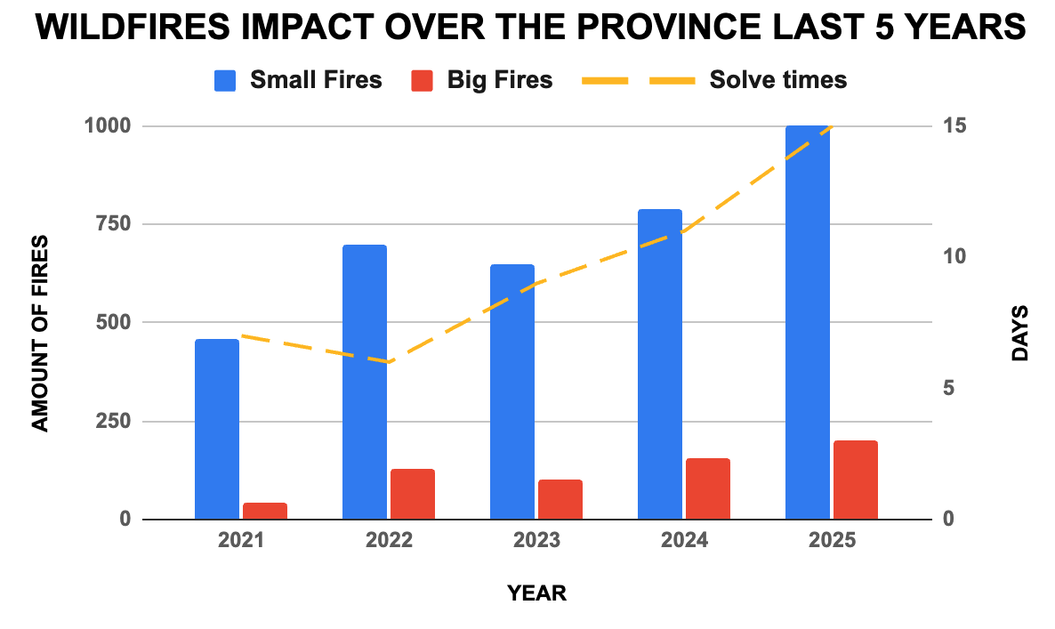
Figure 1: Wildfires' impact on the province last 5 years
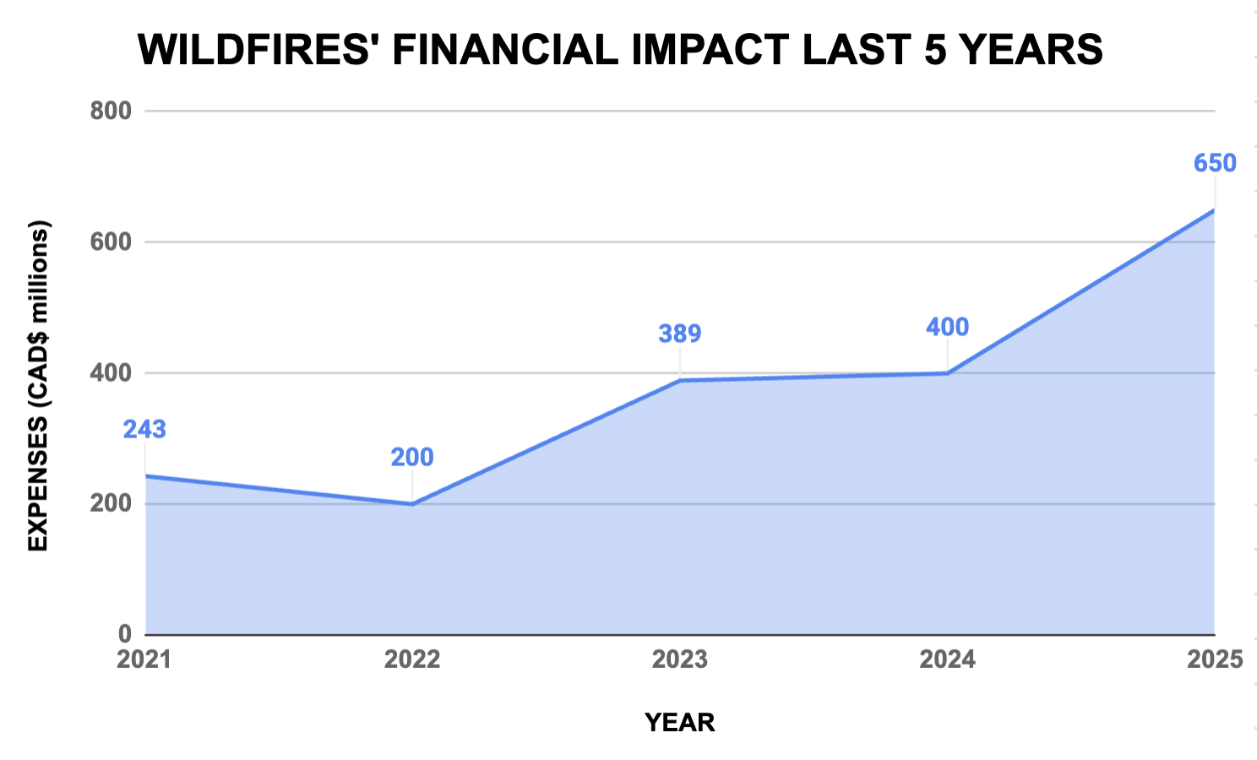
Figure 2: Wildfires' financial impact last 5 years

Table 4: Action Plan for Scenario 1 (Small fires)
Prioritization and Root Cause | Countermeasures | Who | When
Fires are not detected on time:  - No monitoring dashboard  - Lack of daily monitoring | - Implement a real-time monitoring dashboard, including an indicator of number of wildfires detected within 1 hour | Forecasting analysts | Daily before fire season
Lack of training:  - No refresher training on place  - No recurrent drills  - No awareness programs shared | - Schedule quarterly refreshers for all First Responders, measuring Completion Rate  - Launch semesterly drills for all civilians + recurrent awareness campaigns, measuring Response Times + Ratio of civilians evacuated per drill | Local authorities | Every 3 months
Containment resources shortages:  - Fewer firefighters than needed  - Unavailable air forces  - Delays to prepare material | - Train back-up non-qualified staff to support emergencies, measuring adherence of available staff/emergency  - Sign standby contracts to book exclusive emergency air forces, measuring aircrafts’ response times | Operations Manager | Monthly
Forecasting accuracy:  - Model not properly trained | - Invest in retraining the forecasting model to make it more sensitive to recent data, to ensure an Accuracy of at least 95% | Forecasting analysts | Before fire season
Supply chain gaps:  - Low stock levels  - Inefficiencies in the transportation processes | - Increase buffer emergency stocks and measure the amount used or missed per emergency addressed  - Optimize gaps between stages to ensure the amount of on-time deliveries | Operations Manager | Before fire season

Table 5: Action Plan for Scenario 2 (Major fires)
Prioritization and Root Cause | Countermeasures | Who | When
Fires are not controlled on time:  - Slow response times  - Lack of required resources | - Implement a live deployment system and measure response time  - Increase back-up resources and create alliances with other parties that may provide more resources if needed. | Local Authorities | During fire crisis
Civilians are not evacuated on time:  - Warnings taking long to be made  - Lack of civilians’ training | - Multi-channel warning system to alert as many civilians as possible simultaneously  - Semesterly fire drills to drive awareness in case of emergency, measuring participation rate | Local authorities and mass media | During fire crisis
Mixed communications between parties:  - Lack of preparation for cases alike  - Lack of defined tested protocol | - Define and practice pre-defined protocols with mock cases to ensure all parties know who to collaborate with each other, measuring solving times and protocol adherence | Operations manager and local authorities | Post fire crisis
Lack of training:  - No refresher training on place  - No recurrent drills  - No awareness programs shared | - Schedule quarterly refreshers for all First Responders, measuring Completion Rate  - Launch semesterly drills for all civilians + recurrent awareness campaigns, measuring Response Times + Ratio of civilians evacuated per drill | Local authorities | Post fire crisis
Financial distress:  - No proper budget forecasting  - No emergency fund prepared | - Increase emergencies’ budget in riskier regions, measuring percentage of expenses covered. | Financial  department | Post fire crisis

Conclusions
- In response to the increasing number of wildfires in Canada, implementing specific measurable proactive well-planed strategies would allow an immediate impact over fire control operations by targeting fires as soon as they start and reduce the chances of them scaling into larger more destructive ones. Scenario 1 focuses on early detection while Scenario 2 focuses on crisis containment.
- Using the metrics to be measured as a starting point allows for better operational process planning, as it clearly defines what needs to be achieved. Benchmarking practices also help tailor the containment plan to the affected province, ensuring that existing best practices can be leveraged without reinventing the wheel.
- A structured Management By Fact report helps identify that increasing provincial wildfire annual expenses could be reduced by directly addressing its root causes (Lack of training, daily monitoring and forecasting accuracy) through the application of the measurable plans tailored to each one of the case scenarios ensuring accountability and cost-effective operations management.

References
Alberta Wildfire. (2025). Alberta.ca. https://www.alberta.ca/alberta-wildfire
BC Office of the Fire Commissioner. (2021). Annual Report 2021. https://www2.gov.bc.ca/assets/gov/public-safety-and-emergency-services/public-safety/fire-safety/fire-reporting/office_of_the_fire_commissioner_2021_annual_report.pdf
BC Wildfire Service. (2025). Wildfire Service - Province of British Columbia. https://www2.gov.bc.ca/gov/content/safety/wildfire-status
BC Wildfire Service. (2025, May 13). Wildfire Prevention - Province of British Columbia. https://www2.gov.bc.ca/gov/content/safety/wildfire-status/prevention
Beverly, J. L., & Schroeder, D. (2024). Alberta’s 2023 wildfires: context, factors, and futures. Canadian Journal of Forest Research, 55, 1–19. https://doi.org/10.1139/cjfr-2024-0099
NASA-FIRMS. (2025). NASA-FIRMS. https://firms.modaps.eosdis.nasa.gov/
Owens, D., O’Kane, M., & NSW Bushfire Inquiry. (2020). Final report of the NSW bushfire inquiry. https://www.bluemountains.org.au/documents/bushfires/final-report-of-the-nsw-bushfire-inquiry-31jul20.pdf
San-Miguel-Ayanz, J., Oom, D., Artès, T., Viegas, D. X., Fernandes, P., Faivre, N., Freire, S., Moore, P., Rego, F., & Castellnou, M. (2020). Forest fires in Portugal in 2017. In Super Case Study (Book EUR 30183 EN). Publications Office of the European Union, Luxembourg. https://doi.org/10.2760/571085
SixSigma DSI. (n.d.). Lean Six Sigma glossary term - Management-by-Fact. SixSigma DSI. https://sixsigmadsi.com/glossary/management-by-fact/
State of California. (2025). California Department of Forestry and Fire Protection | CAL FIRE. CAL FIRE. https://www.fire.ca.gov/
Wildfire compliance and enforcement. (2025, November 20). Alberta.ca. https://www.alberta.ca/wildfire-compliance-and-enforcement

