WHAT IS GRAFANA??
Grafana is open-source platform use for data representation/visualization or monitoring.
By using it users can create a visual representation of a database which can be customized.
The visual representation has multiple properties which can be experimented on to get the best possible outcome.
Here is the report about its multiple properties and settings;

THE REPORT
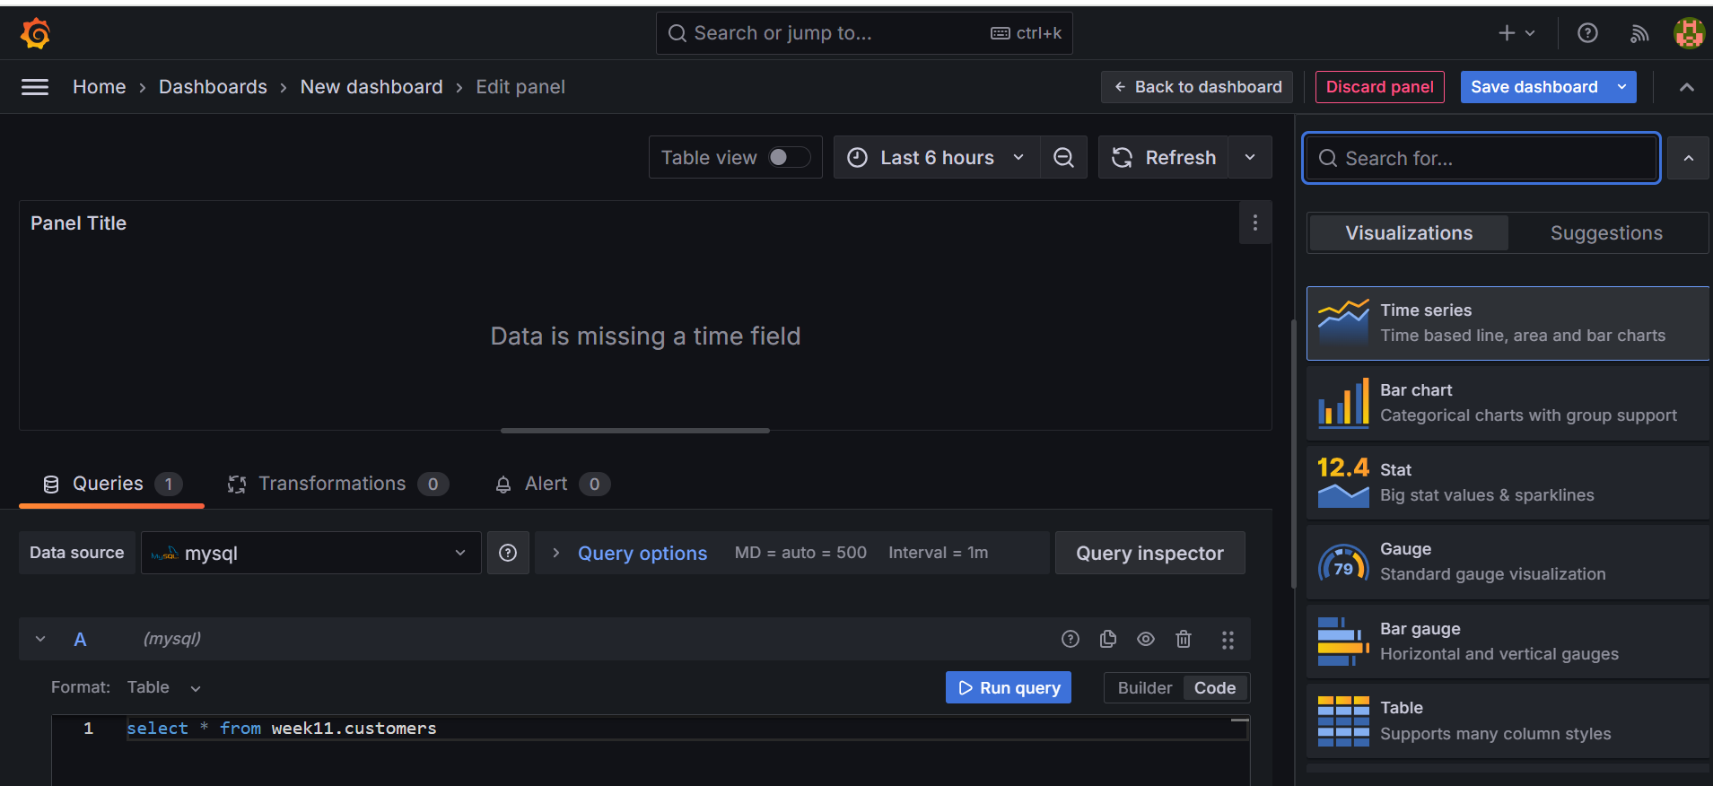

As you can see in the above picture, in the top left corner that’s the path to create a new dashboard.
When you come to the bottom part you can see where the queries can be run, after successful running of the code we can see the panel at the top, the panel will be created and will contain visual data for the table from the query.
But as you can see the panel has “Data is missing a time field” this is because I selected the Time series options from the right side of the image, which is a line chart based on time quantity on the x-axis but our table from the query doesn’t have time element such as, years, months, weeks or days.
There are many visualization options;
- Time series
- Bar chart
- Stat
- Guage
- Bar Gauge
- Table
- Pie chart
- State timeline
- Heatmap
- Status history
- Histogram
- Text
- Aler list
- Dashboard list
- Annotations list
- Candlestick
- Canvas
- Flame graph
- Geomap
- Logs
- Node graph
- Traces
The table from the database can’t be visualized in all the above 22 forms since they require specific quantities of measurements to visualize, it will be the same as shown in the above image.
Therefore, we can only see certain visuals from the suggested tab;
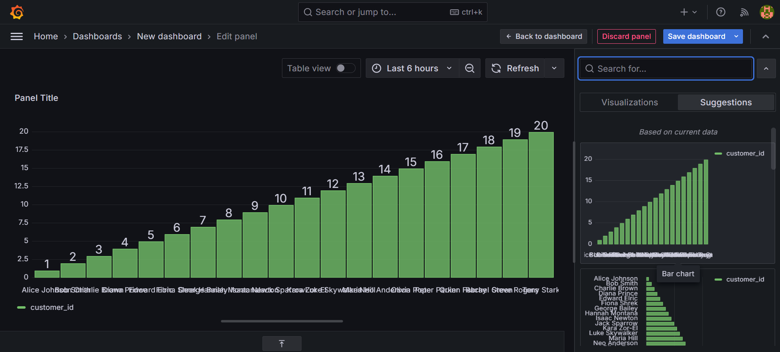
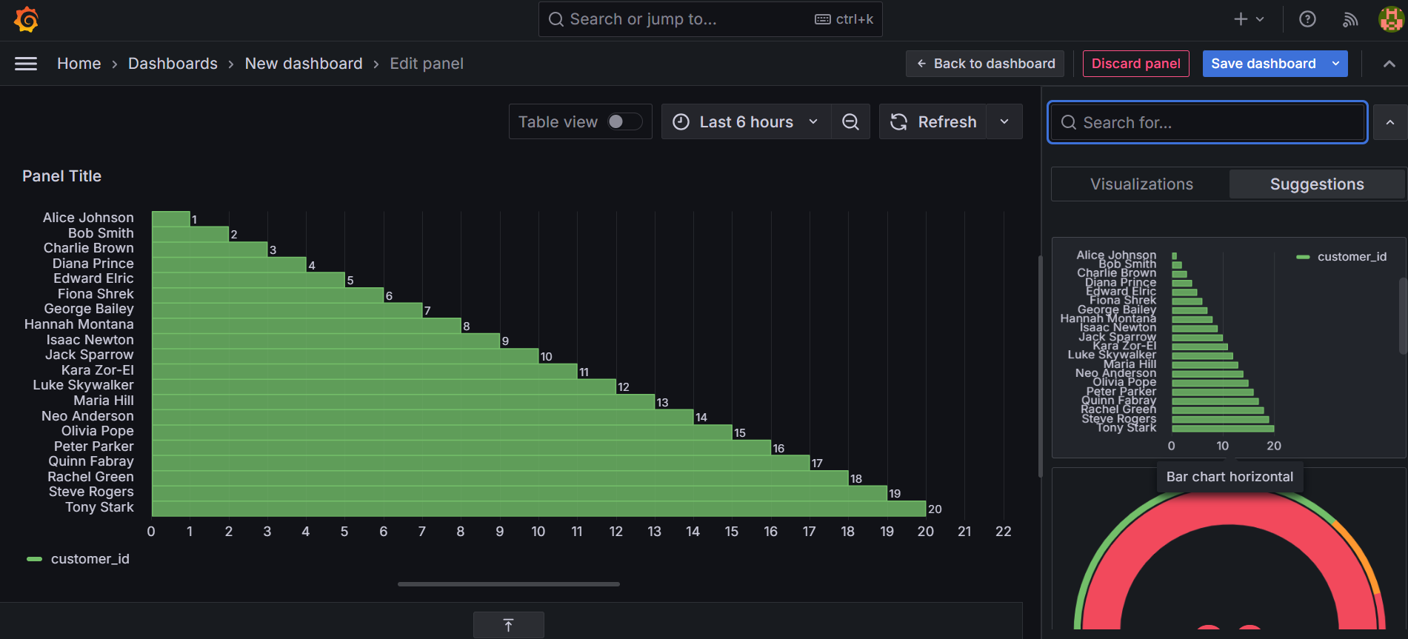
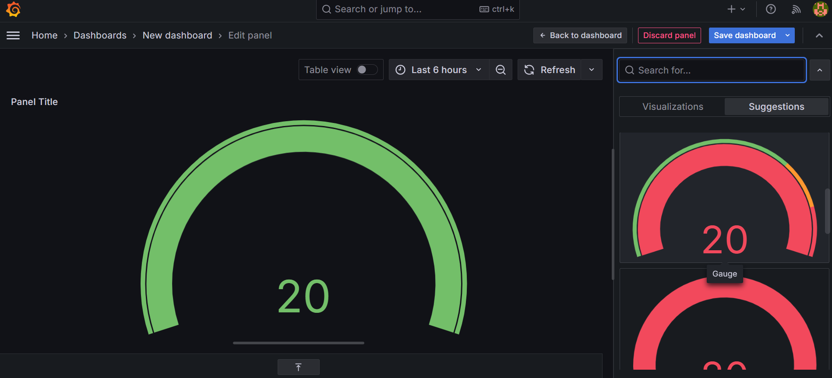
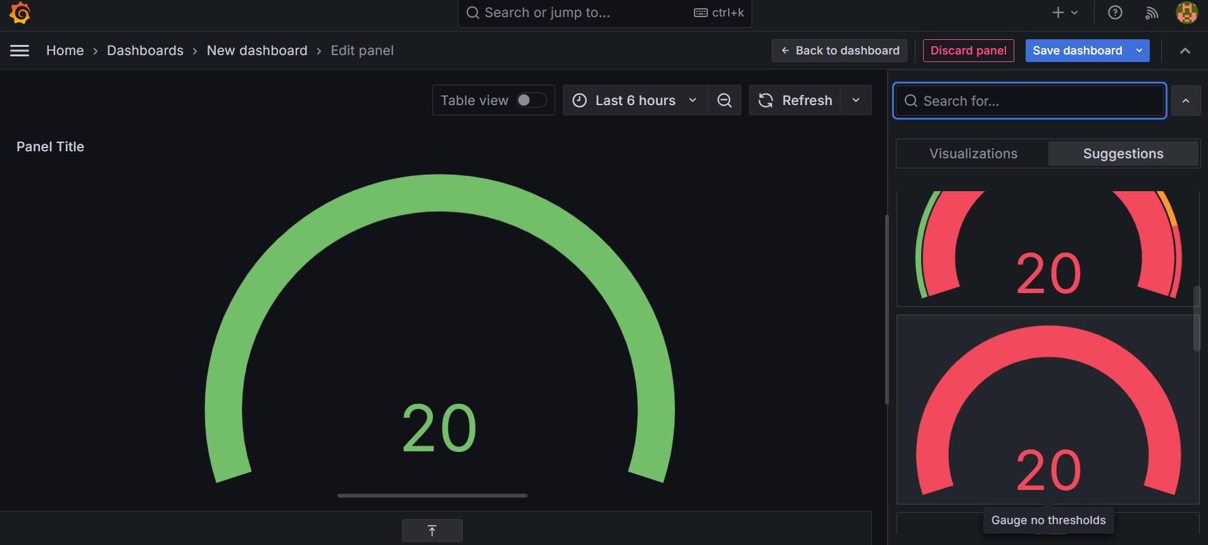
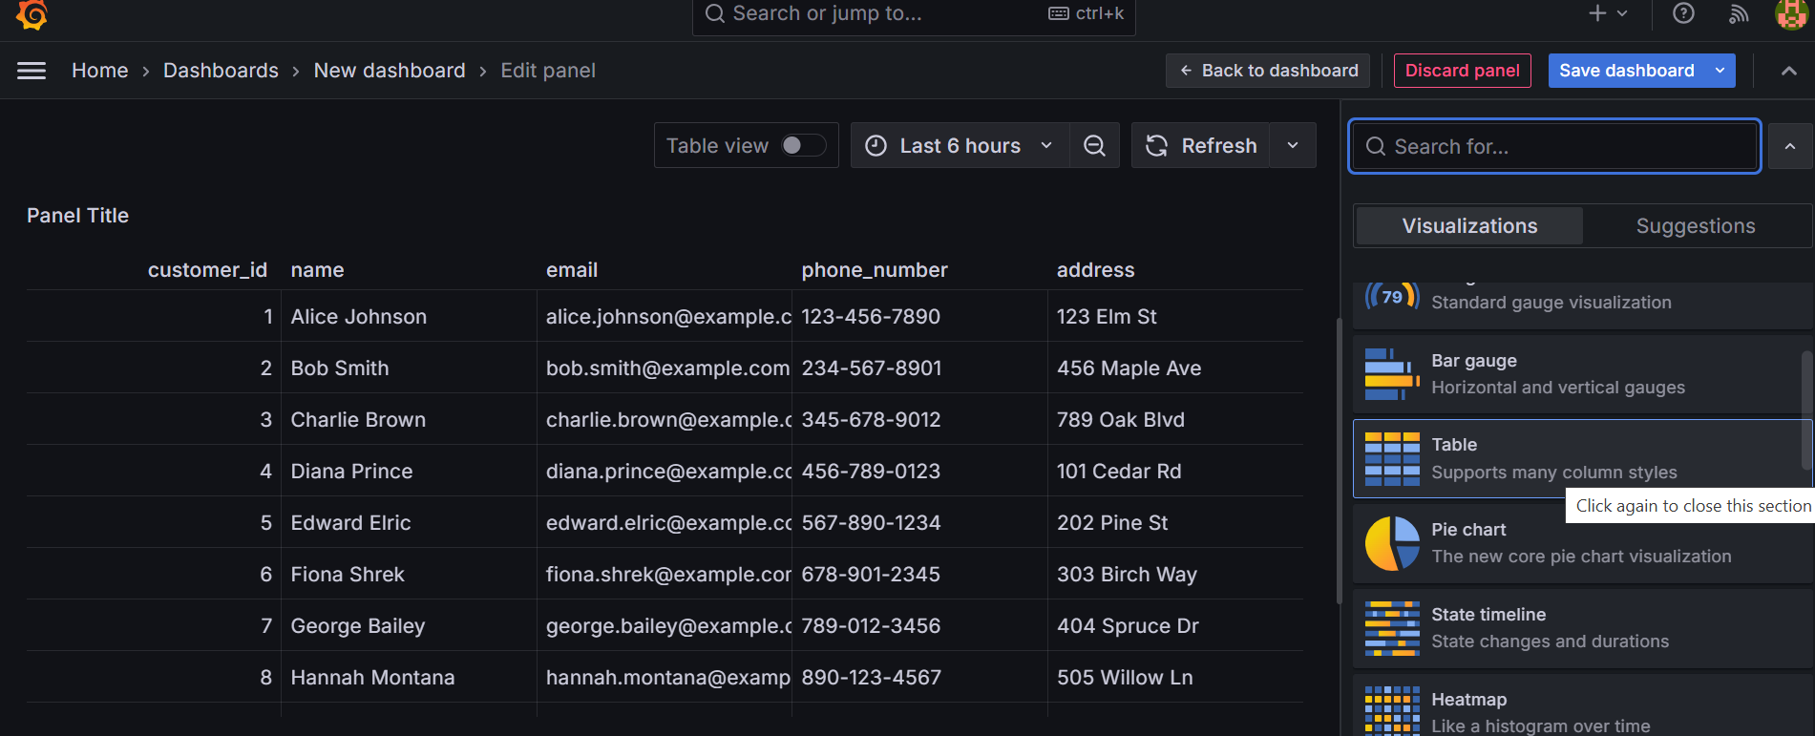
These above images show the suggested visuals of the table from the database which are the most suitable and clear representation of the data given.
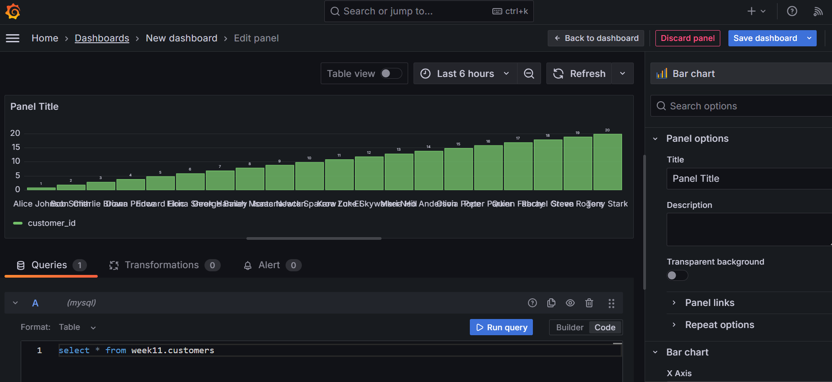
Let us first take the BAR CHART Dashboard here as an example, you can see on the right-hand side of the image there are panel options;
- Title
- Description
- Transparent background
- Panel links
- Repeat options

TITLE
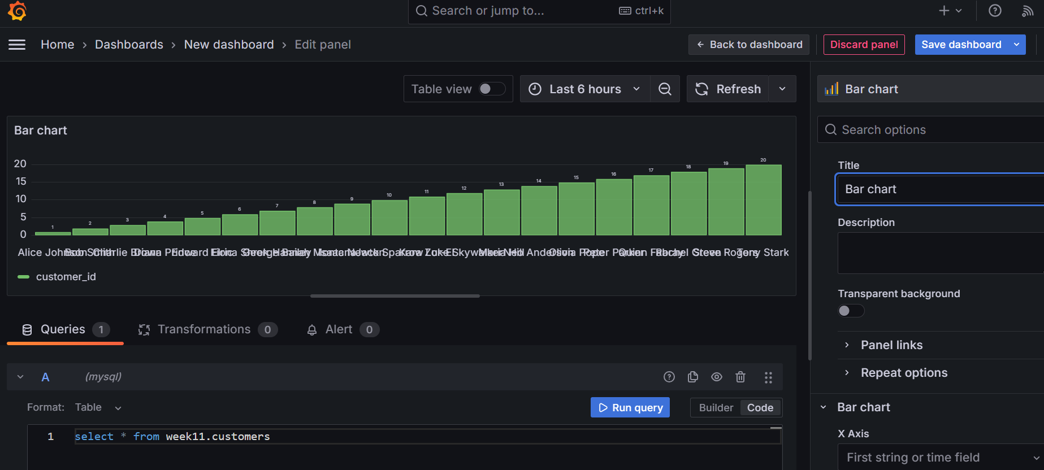
As you can see, I changed the name of the panel to “Bar chart”.

DESCRIPTION
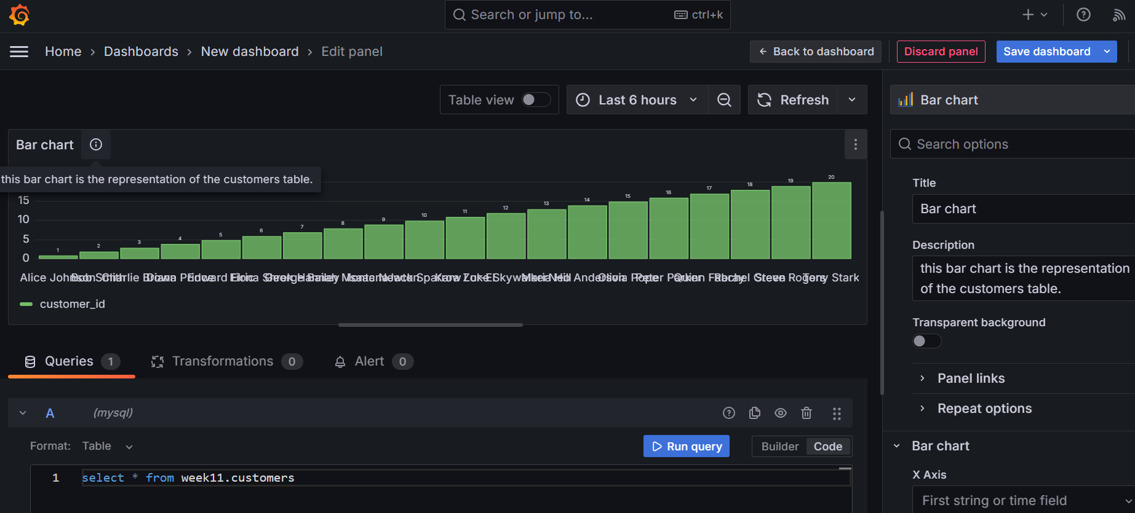
As you can see, this time I gave a description for this Bar chart and there is a small “i” icon near the panel title which displays “this bar chart is the representation of the customers table”.

TRANSPARENT BACKGROUND
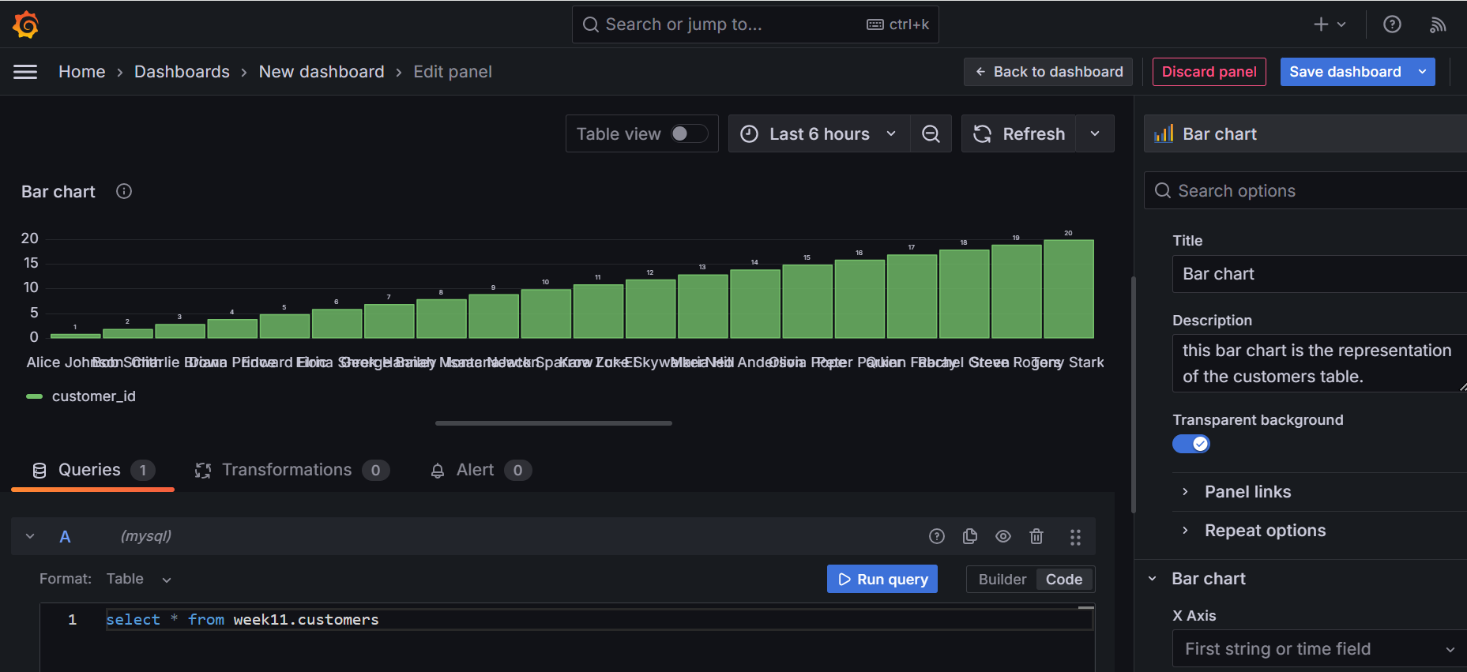
It is not visible that much, but the transparent background removes any background colours of the visual, as you can find a subtle change in the background of this image and the previous image.

PANEL LINKS
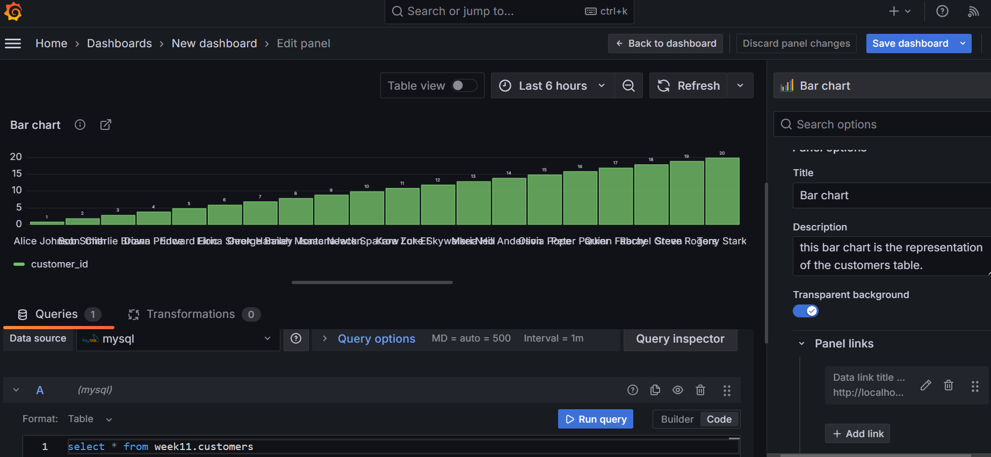
This option allows the user to add clickable links in the panel directing the user to a different dashboard or any other external source where the data is gathered, this option lets the user provide with more information about the data collected.
As you can see, I attached a link of another dashboard from my user account, like if you click the icon at the top left part of the panel that will direct you to my new dashboard.

REPEAT OPTIONS
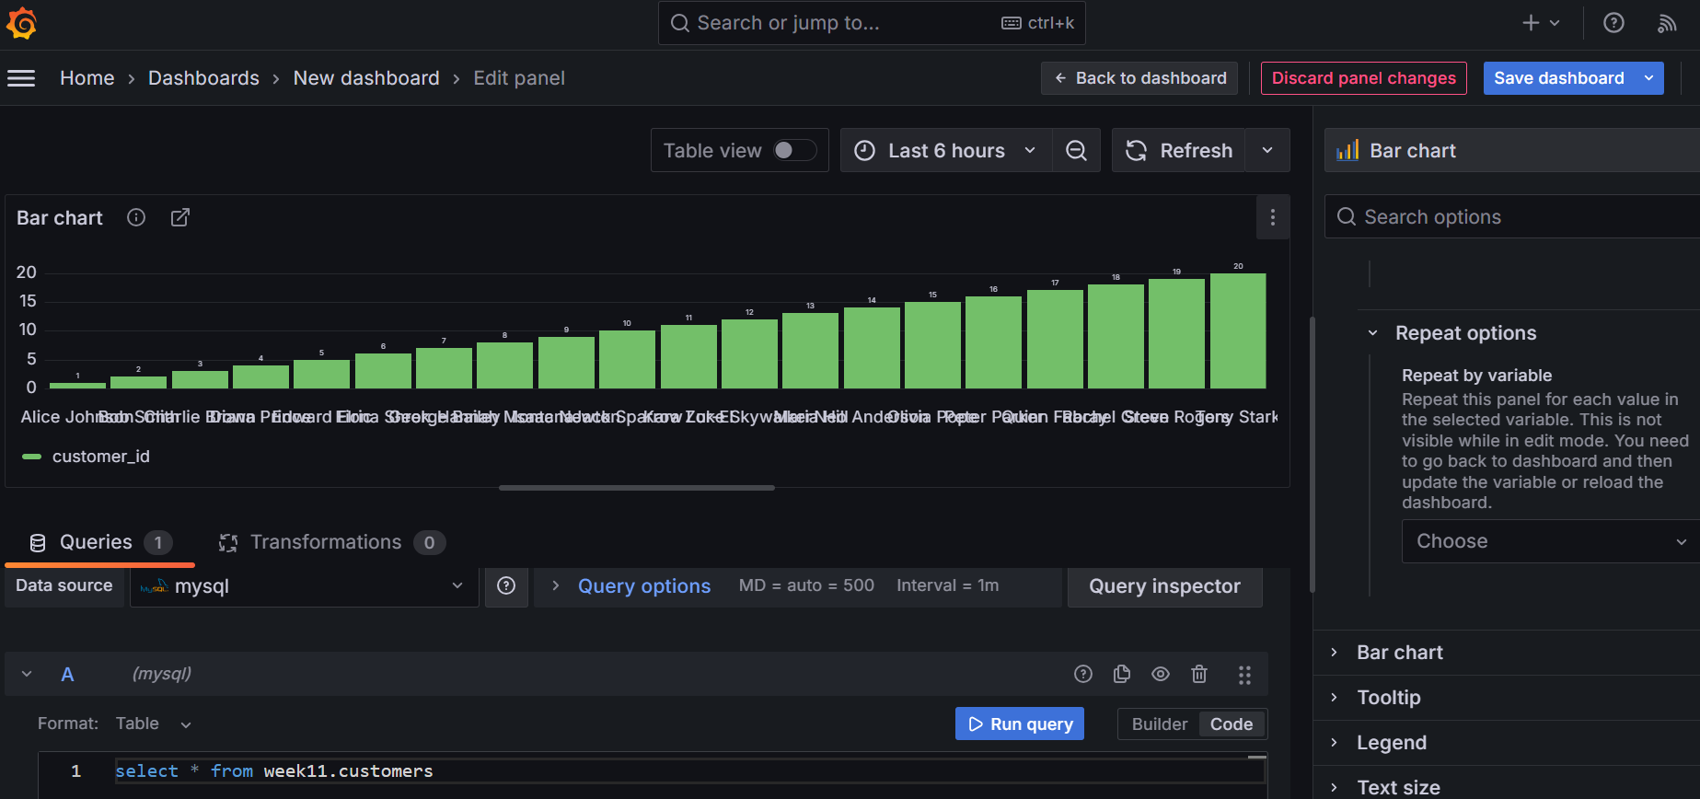
This "Repeat" options are used to dynamically create multiple panels based on the values of variables. This feature is particularly useful when you want to create a dashboard that shows similar information for multiple instances needing to manually create separate panels for each one.
Which means you choose a variable which can be assigned with different values then you will have different outcomes for each value of the variable which can be visualized in multiple panels without actually creating multiple panels.
After the PANEL OPTIONS we have the BAR CHART properties;
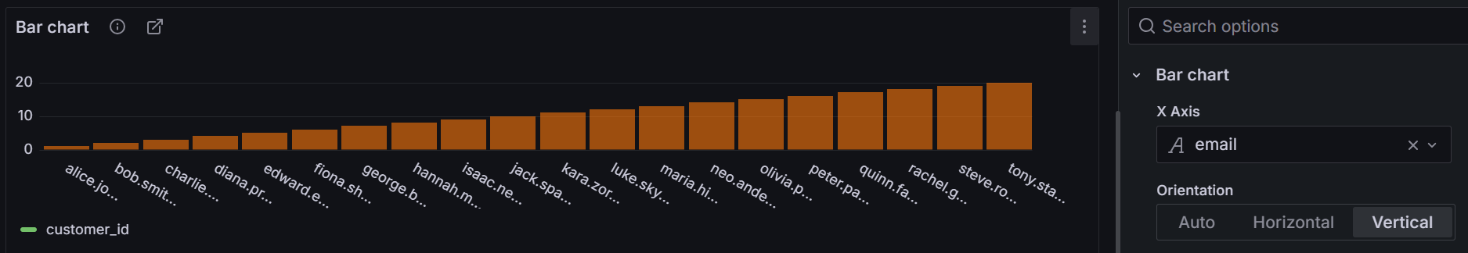
The X axis lets you choose the X axis label, I chose email of the customers.
The Orientation lets you choose Horizontal bar chart or Vertical bar chart representation.

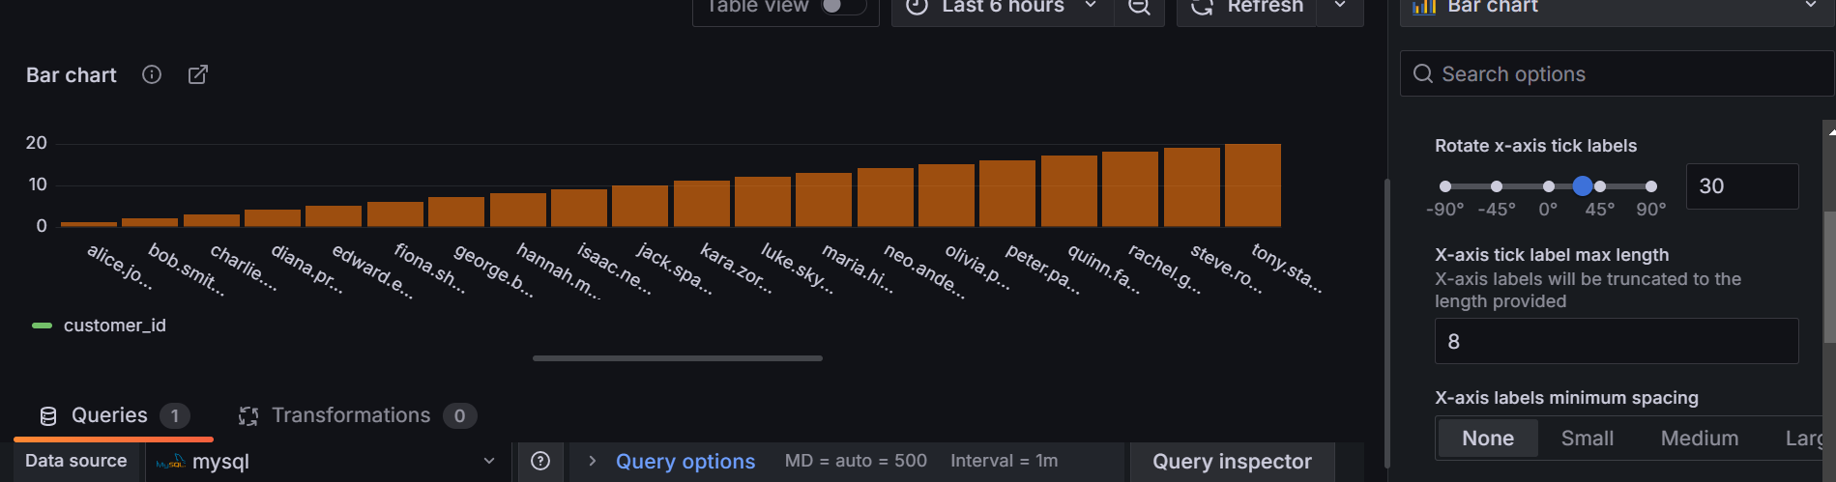
Here Rotate X axis tick labels let you rotate the label from -90 degrees to +90 degrees.
The X axis tick label max length let you truncate the maximum length of the label in the panel, as you can see the label was limited to only 8 letters(alphanumeric).
The X axis labels minimum spacing let you control the space between each label on the x axis.
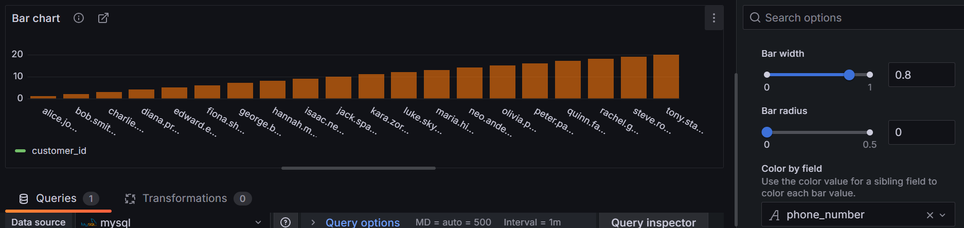
Bar width- increase or decrease the width of the bar.
Bar radius- refine the edges of the bar.
Color by field- let you change the colours of the bar.
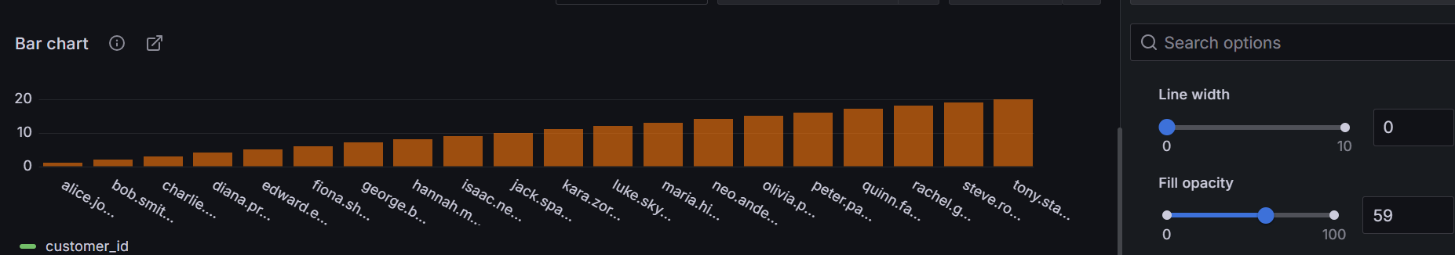
Line width- increase the width of the border line of the bar.
Fill opacity- change transparency of the colour of the bar.
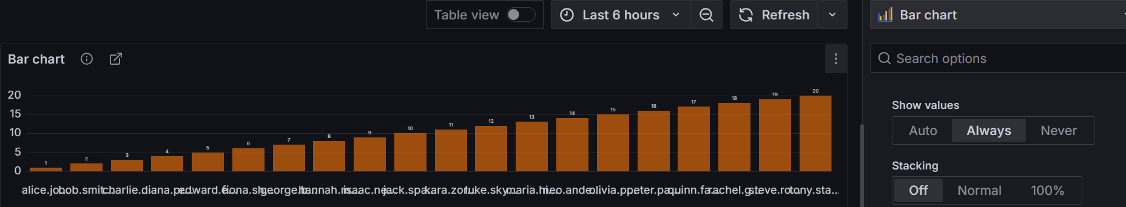
Show values- able to display the value of the bar in the panel.
Stacking- able to display bars stacked on top of each other in case of cumulative results.
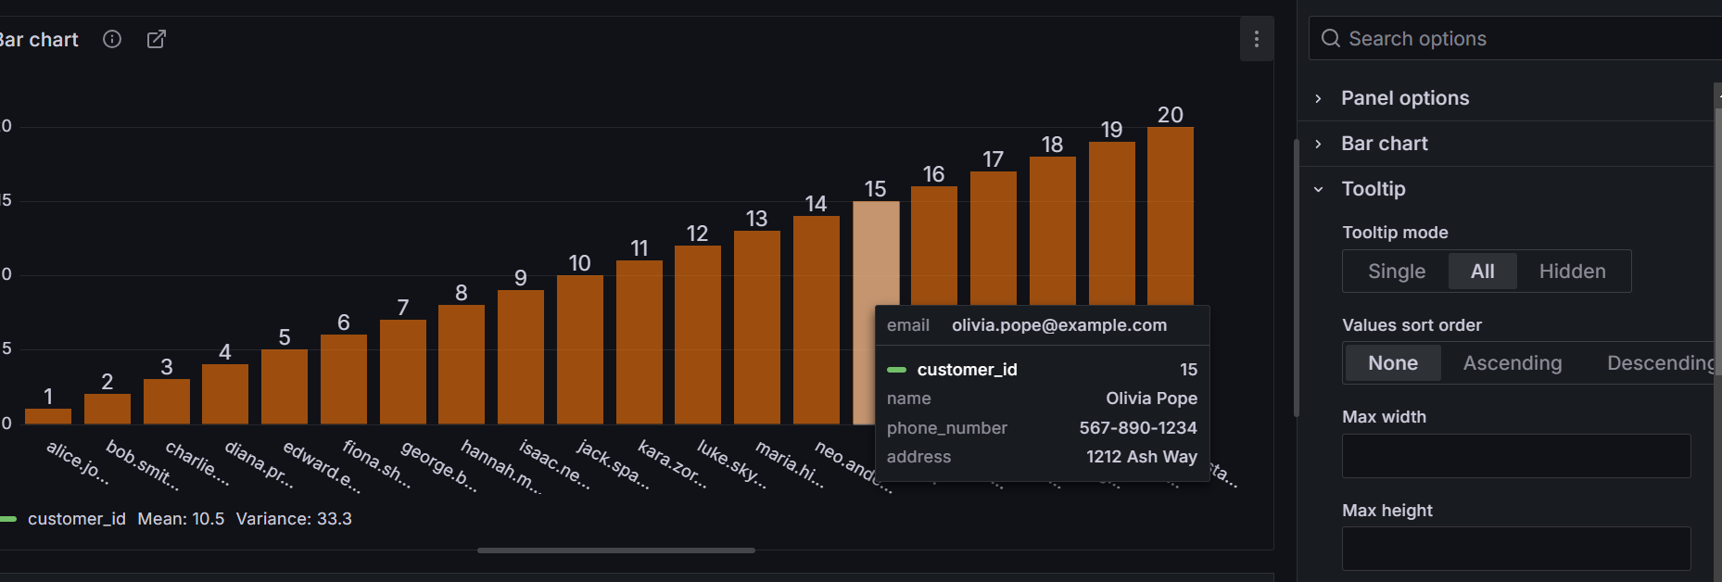
Tooltip basically controls the information that can be displayed when you move the cursor near the bar.
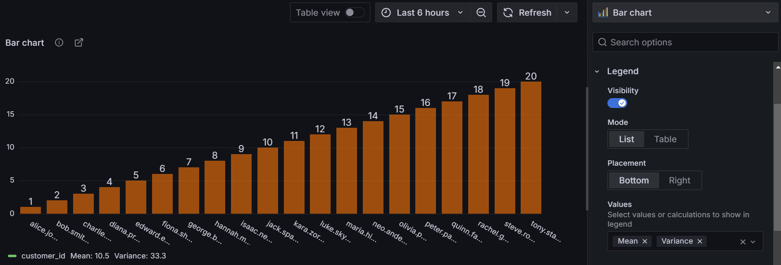
The Legend can display values like max, min, mean, median, mode, etc., in the form of a list or a table either in the bottom or the right side of the panel.
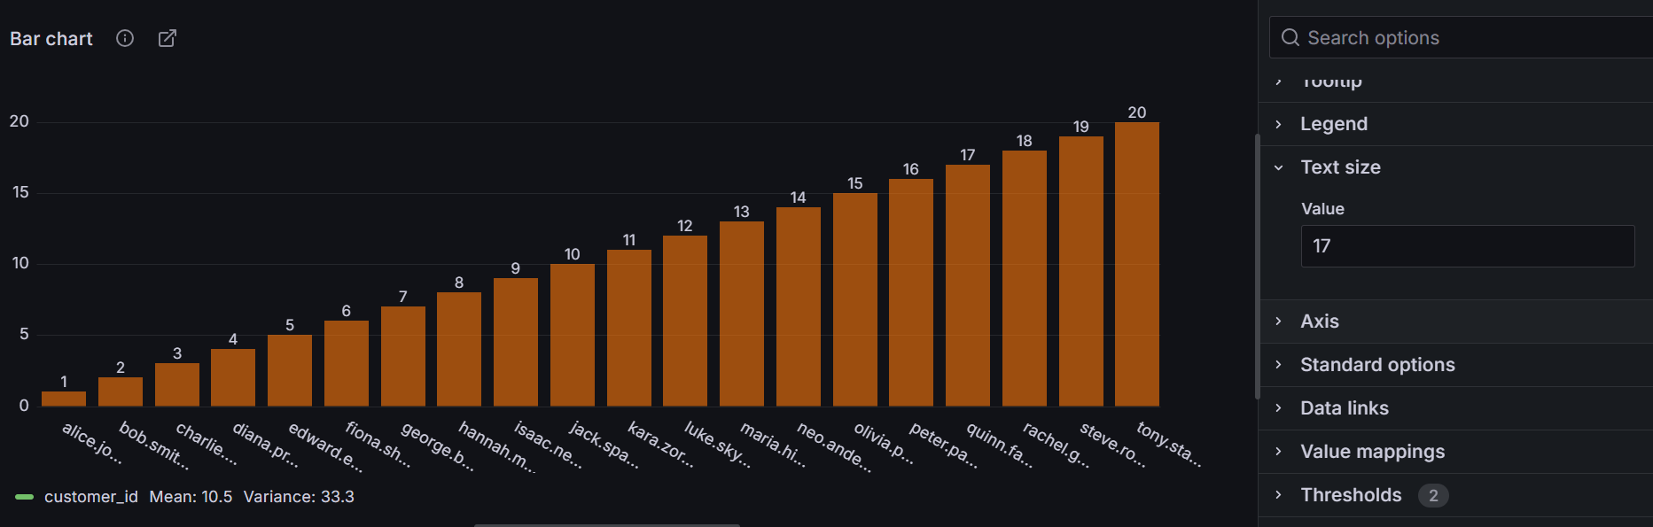
Text size- can control the font size of the bar values.
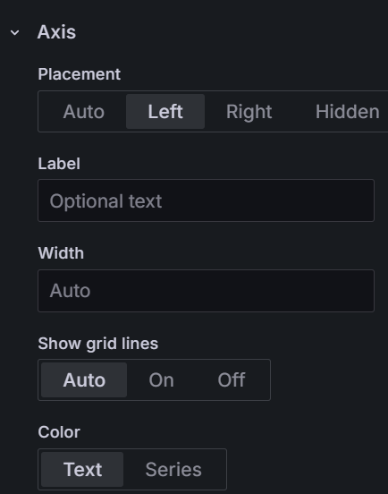
Axis;
Placement- allows user to change the placement of the both the axes.
Label- allows user to label(name) the axis.
Width- allows user to change the distance between the label and the axis.
Show grid lines- allows user to control the visibility of the grid lines(lines matching the values in the axis).
Color- allows user to change colours of the label and the values in the axis.
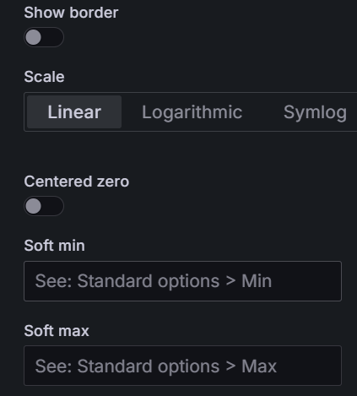
Show border- highlights the border of the axis
Scale- lets you scale the axis values(min and max), here the min=0 and max=20
And centered zero allows user to center the graph at zero with negative values below(left for vertical) and positive values above(right for horizontal)
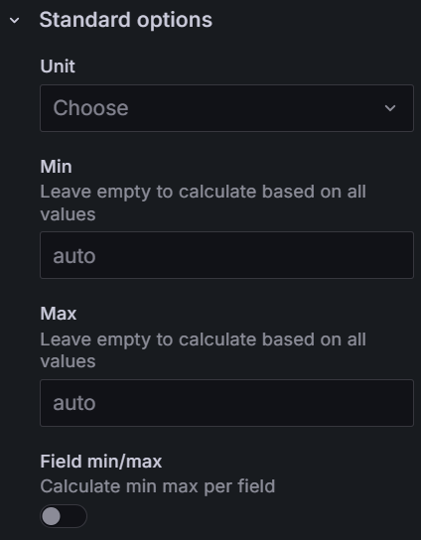
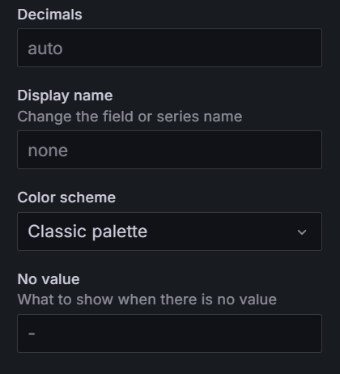
Unit- can select the unit of measurement for the displayed values.
Min/Max- allows user to set the min and max values for the data.
Field Min/Max- calculates the min/max per data field.
Decimals- sets number of decimal places for every value in the panel.
Display Name- changes the name of the field or series.
Color Scheme- allows user to choose colour of the panel visual.
No Value- specifies what to display if no value is recorded.
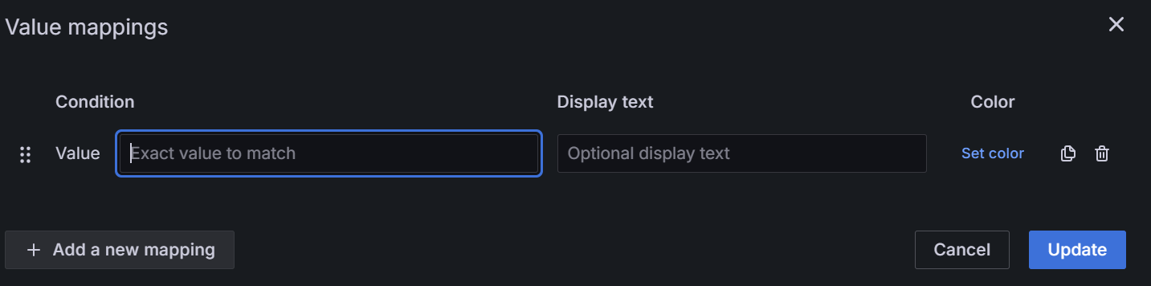
Value mappings allow user to manipulate the data values into custom values which are more so likely readable and understandable to point out the importance and differences of the visual.
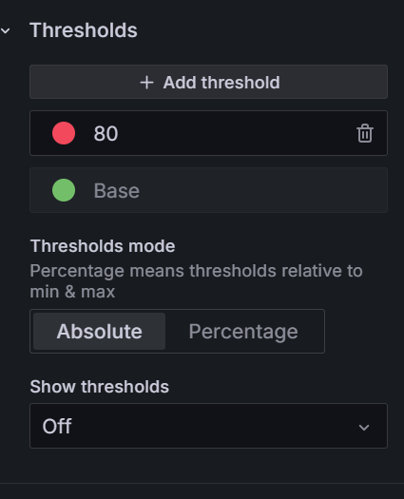
The Thresholds is like a meter for measuring the soft and critical point of the values by having a base and max values or percentages representing different colours like green for the base and red for the extreme max value.

