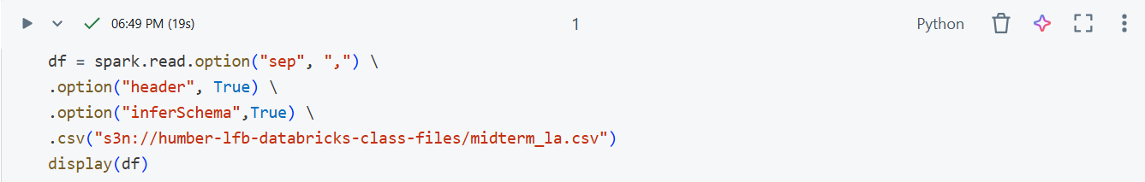
- Loading the dataset from AWS S3 into a spark data frame.

- Removing the _c37 variable column from the table as it was a null variable and displaying the first 10 rows of the data frame.
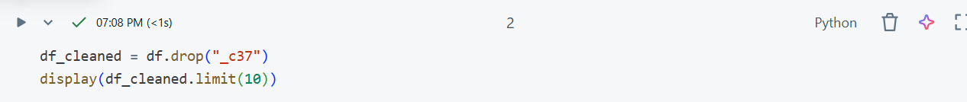

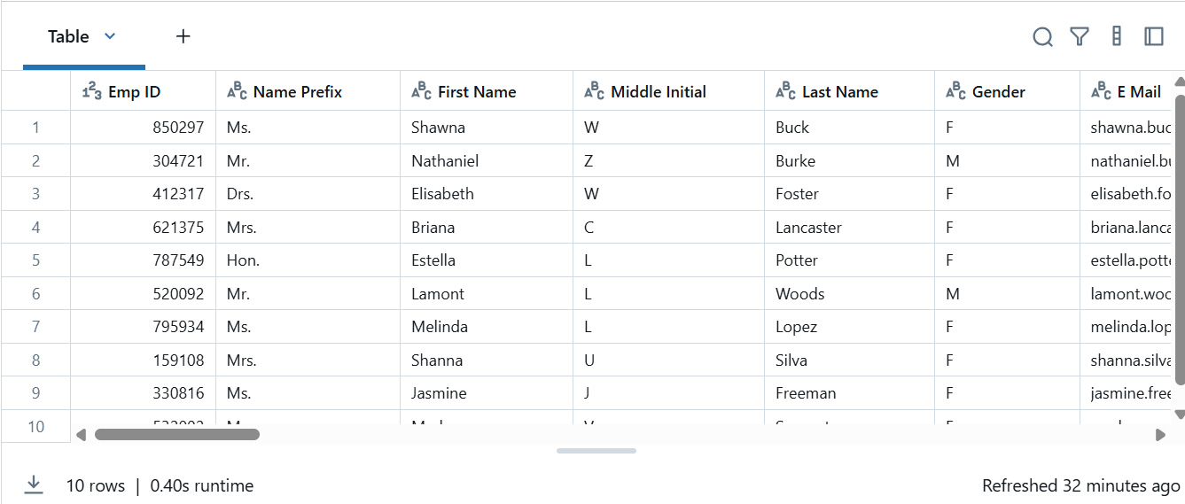

- Explaining the dataset and its structure.
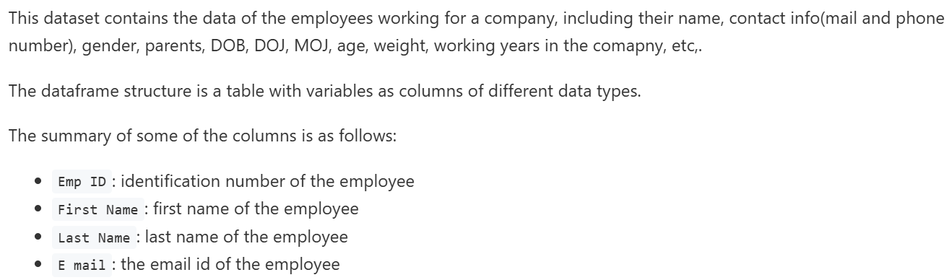

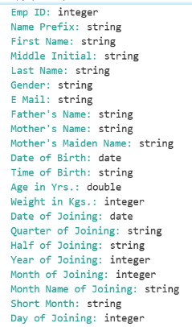

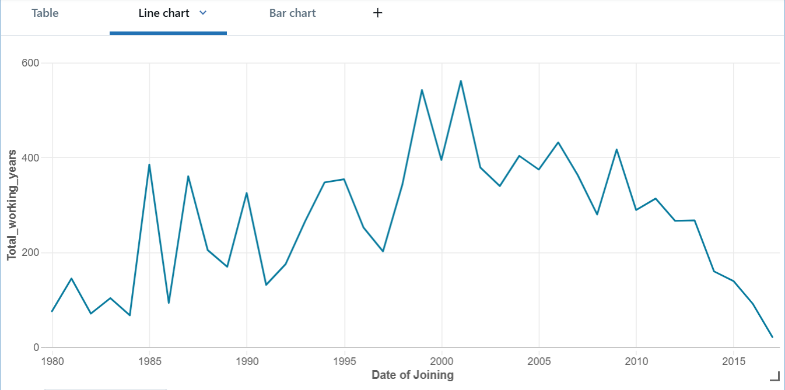
- Creating a line chart showing the trend of 'Age in Company (Years)' over time using the 'Date of Joining' field for the time axis. And identifying any noticeable trends or patterns in the data.
- Creating a bar chart to visualize the average salary by region.

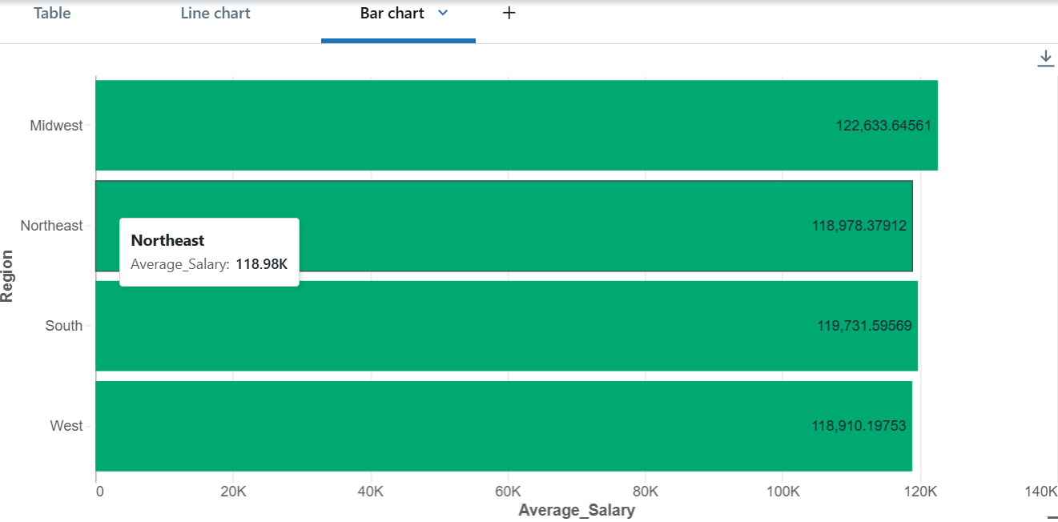
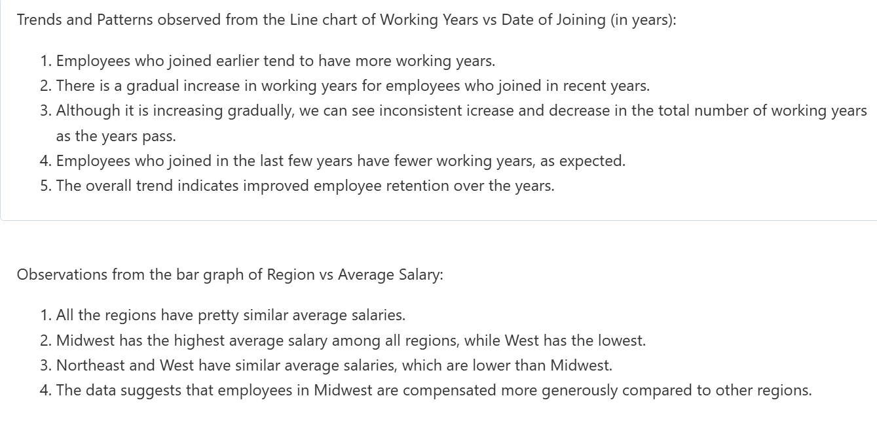
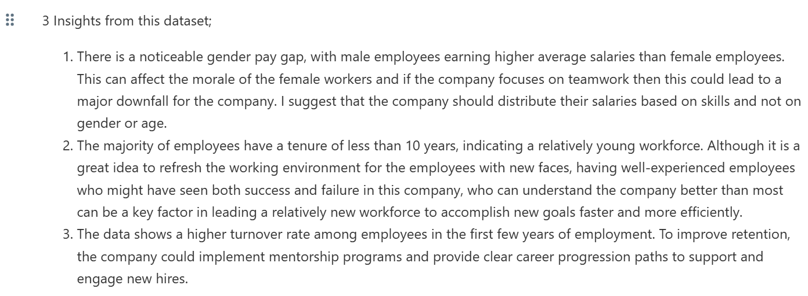
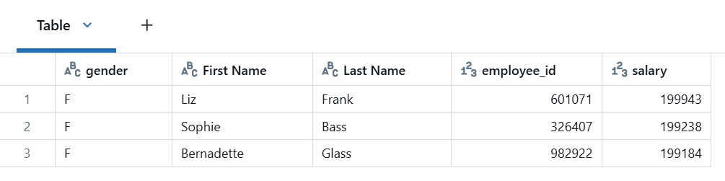
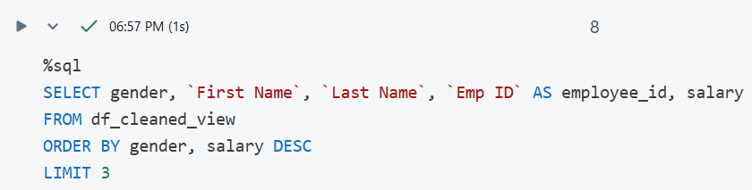
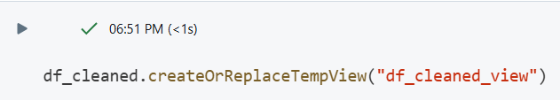
- 3 Insights from the dataset.

- Creating a temporary view and writing an SQL query to identify the top 3 highest-paid employees by gender.

