GRAFANA VARIABLES CHARACTERISTICS

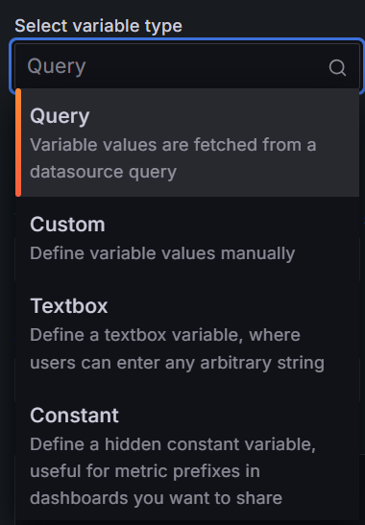
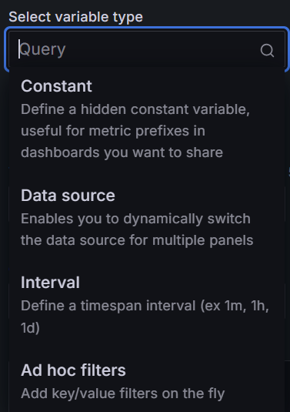
Query- We can write different queries and apply the results of those queries in the panel queries with the help of this variable.
Custom- We can customize the variable into one of these two types whether be a constant or a query.
Constant- We can write a single constant value (numerical or alphabetical value)in this variable.
Data source- We can use data from different data sources like(Prometheus, InfluxDB, MySQL) with optional filter to use only specific values.
Interval- We can select certain values in certain intervals where a panel in the database gets updated every now and then.
Ad hoc filters- More like Textbox but here we can specify certain filter values, we don’t have drop down value options or write queries.
QUERY
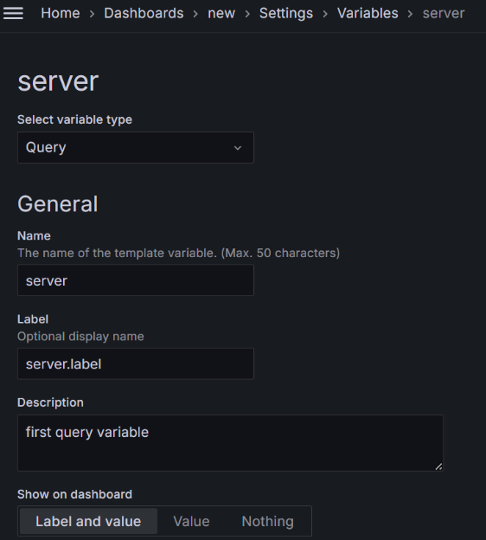
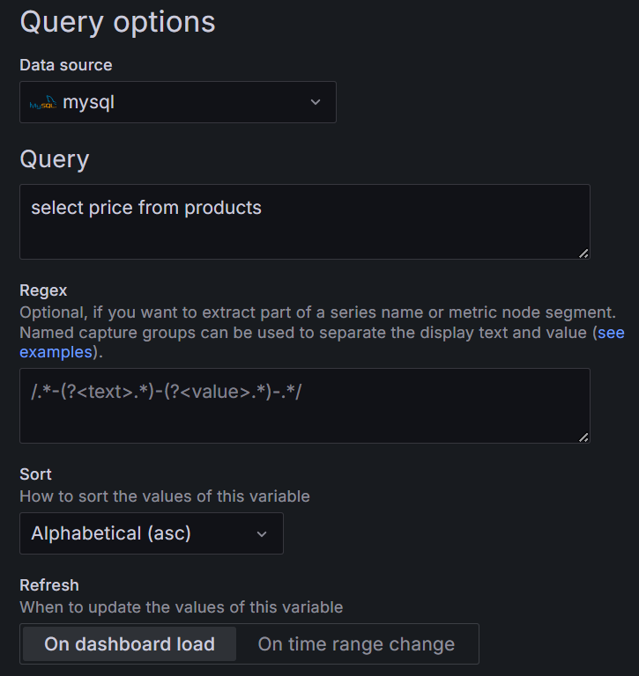
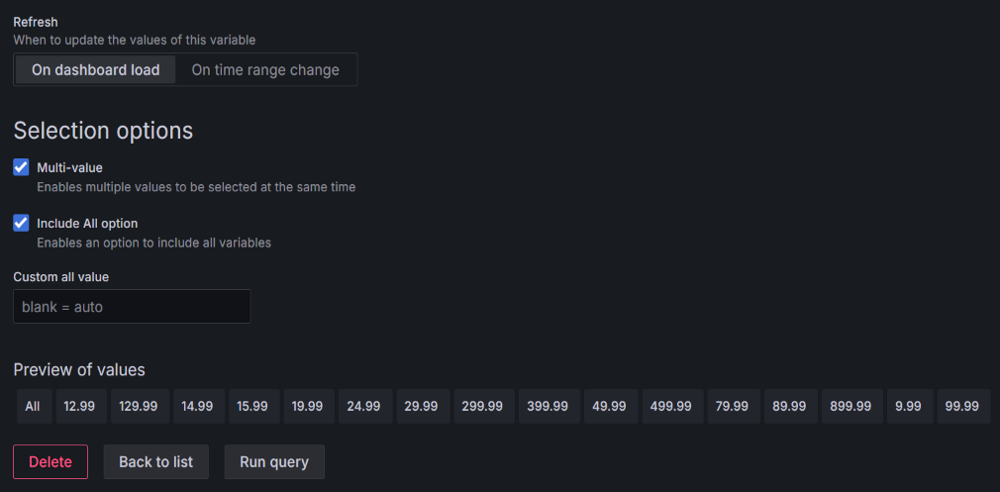
Query tab- This is where we type the queries.
Sort tab- Sorting the values of the variable whether it’s alphabetical or numerical.
Select options- Multi value(allows user to select multiple value of this variable at the same time)
Include all options(allows user to select all the values in the variable).
Preview of values- User can see the values of this variable.
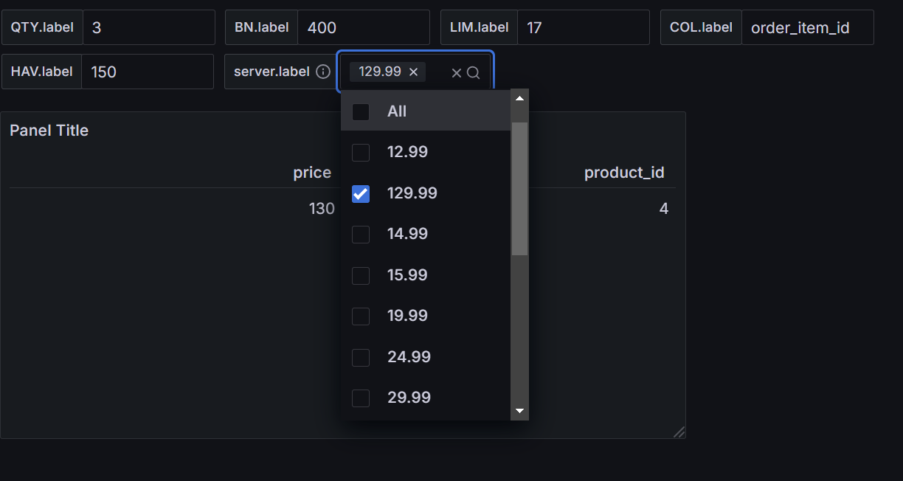
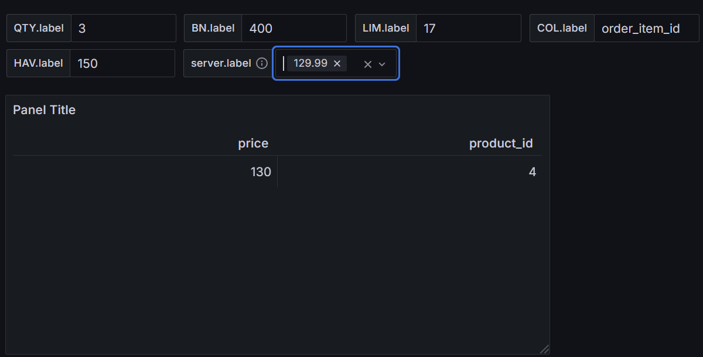

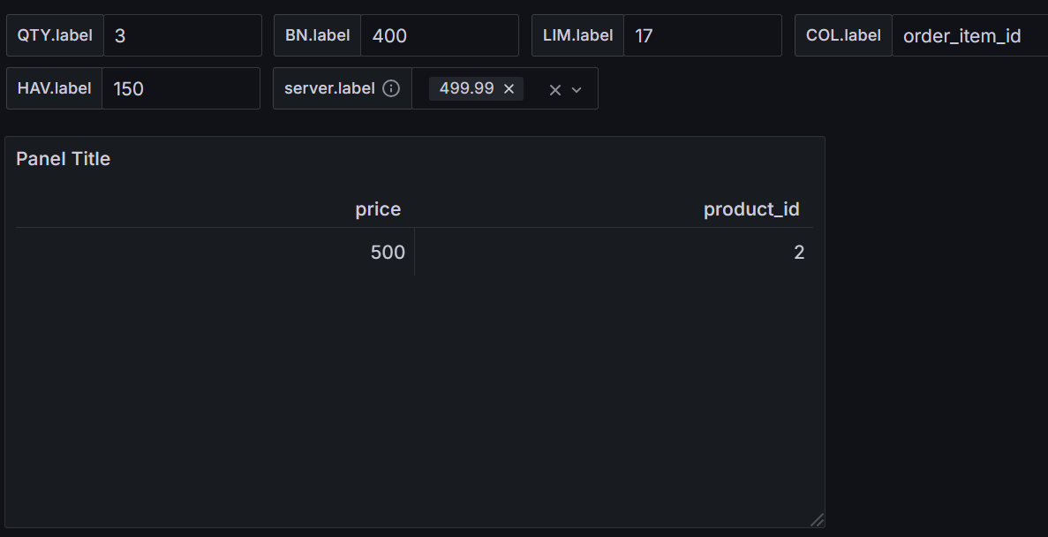
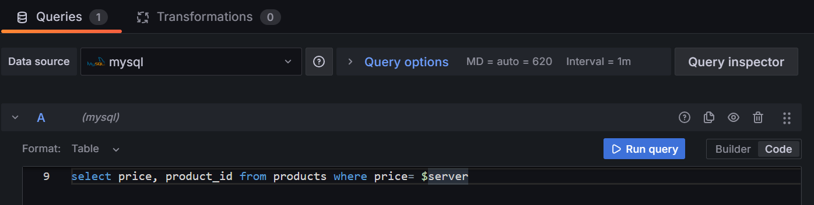
In the above 4 images;
- Drop down menu can be seen with all the values of the query variable.
- The visual table for the value 129.99 of the query variable.
- The visual table for the value 499.99 of the query variable.
- The panel query specifies the query variable as “$server”.

CUSTOM
The custom variable is as the name suggests it’s a flexible variable which can be used as one of these two types, the constant variable or the query variable.
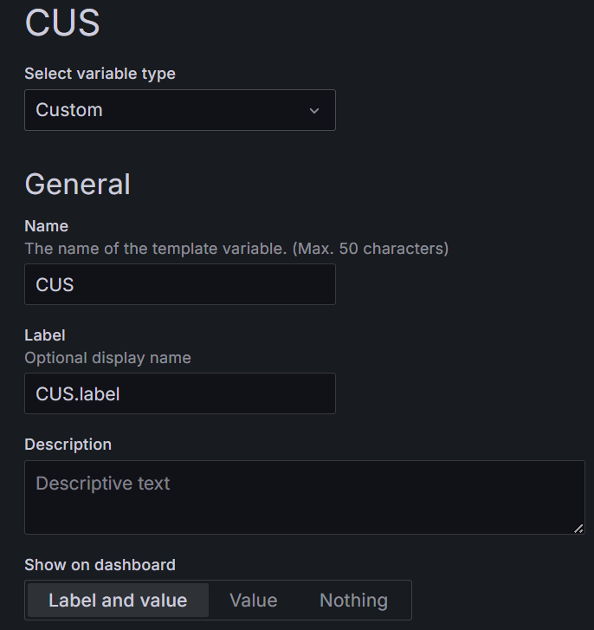
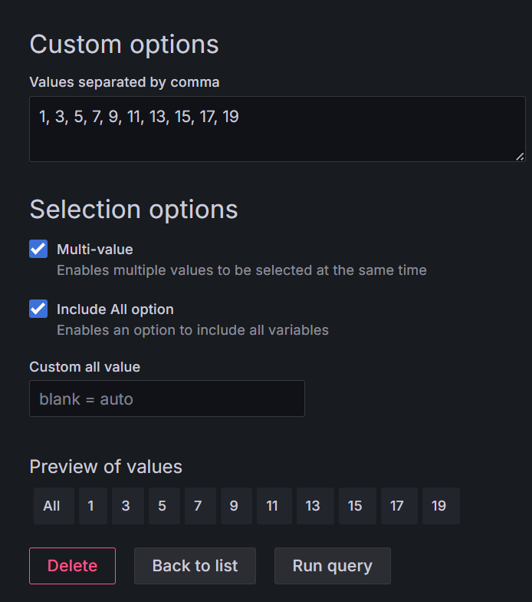

Custom options- Here user can specify values or type the query, but in this case the variable is used as the multi valued variable with commas in between.
Select options- Multi value(allows user to select multiple value of this variable at the same time)
Include all options(allows user to select all the values in the variable).
Preview of values- User can see the values of this variable.
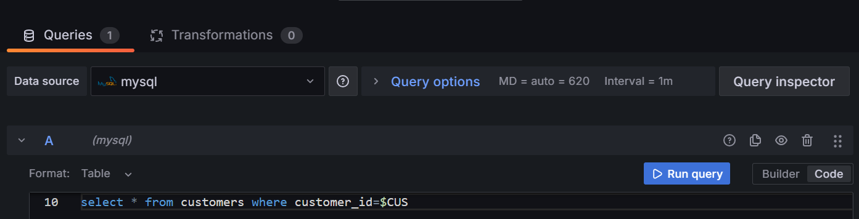
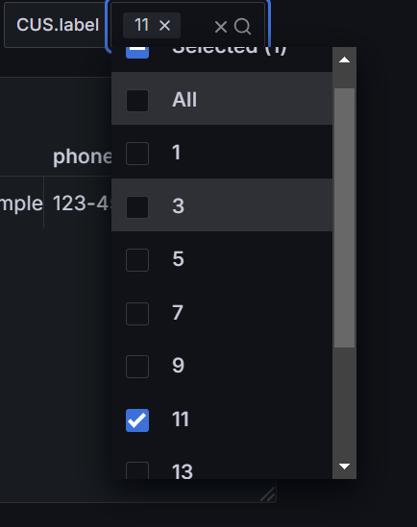
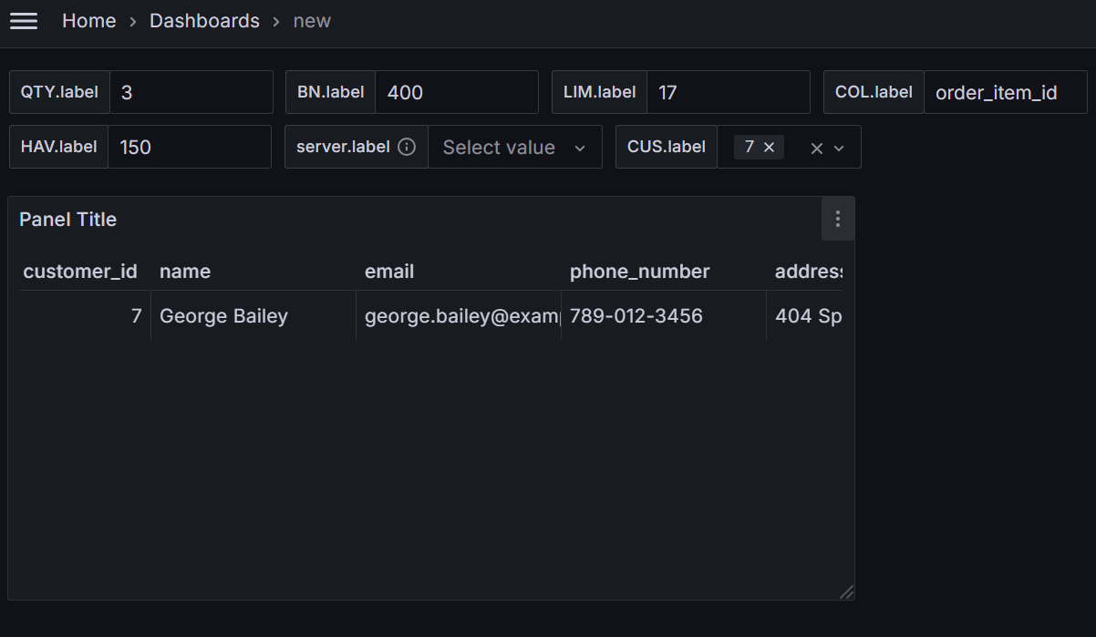
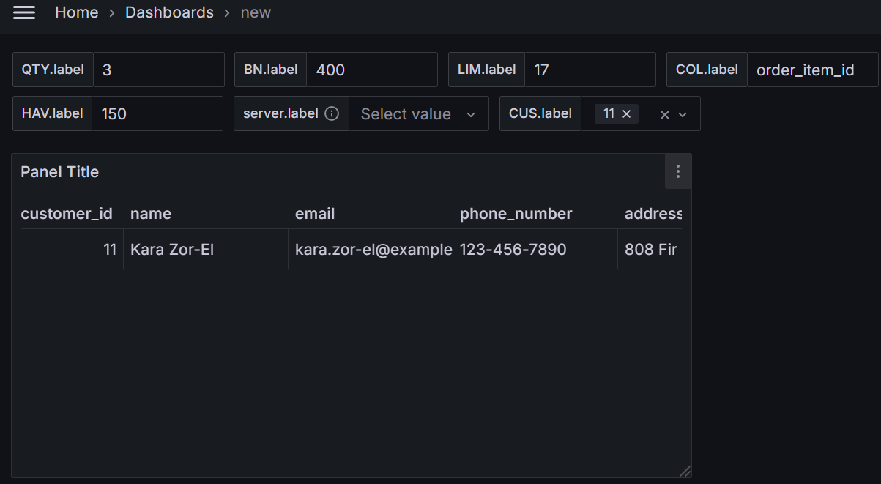
In the above 4 images;
- The panel query specifies the query variable as “$CUS”.
- Drop down menu can be seen with all the values of the custom variable.
- The visual table for the value 7 of the custom variable.
- The visual table for the value 11 of the custom variable.

CONSTANT
This variable can be assigned with only one value either a word or a single alphabet or a numerical value.
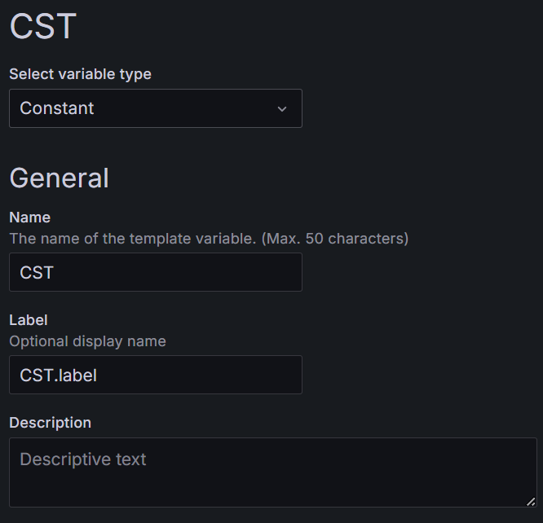
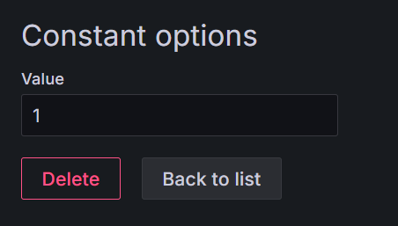
Constant options- As mentioned user can specify a constant value for the CST variable.
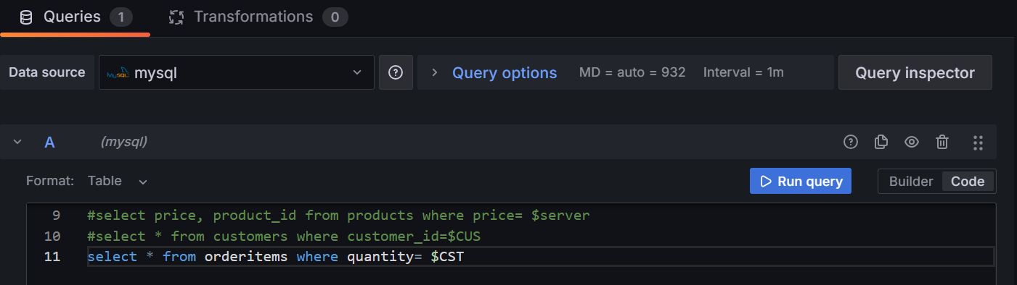
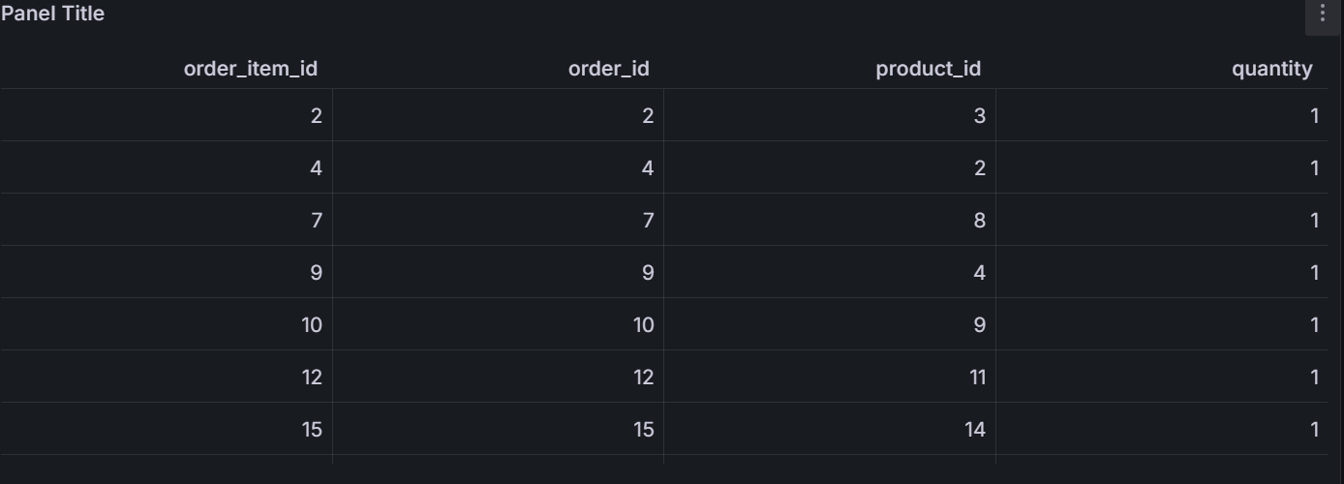
In the above 2 images;
- The panel query specifies the query variable as “$CST”.
- The panel visual with all the columns from the table orderitems but only when the quantity is 1.
DATA SOURCE
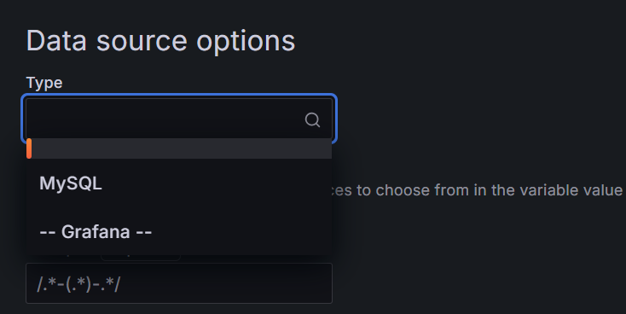
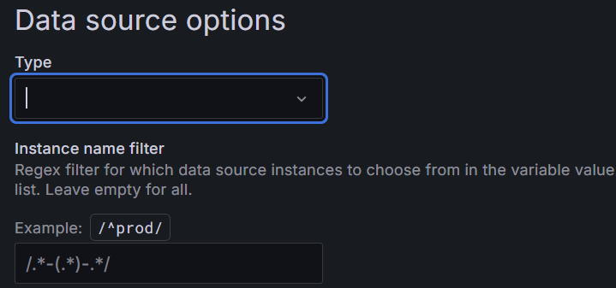
Type tab- This tab allows user to select different data sources from where the data is accessed through the data source variable.
Instance name filter- This tab allows users to filter more specific data from the data source selected.

INTERVAL
This variable is more helpful when the panel in the database is being updated constantly, so the panel is filled with massive amounts of old data. Therefore, with the help of interval variable the panel visual is filtered with a predefined interval value or there is also an option available for auto interval calculation which is calculated based on the step count from the table created using MySQL.
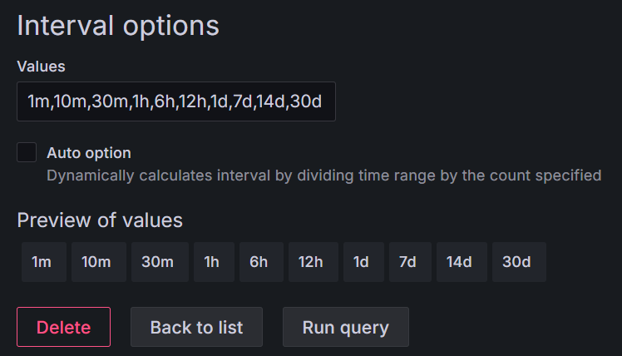
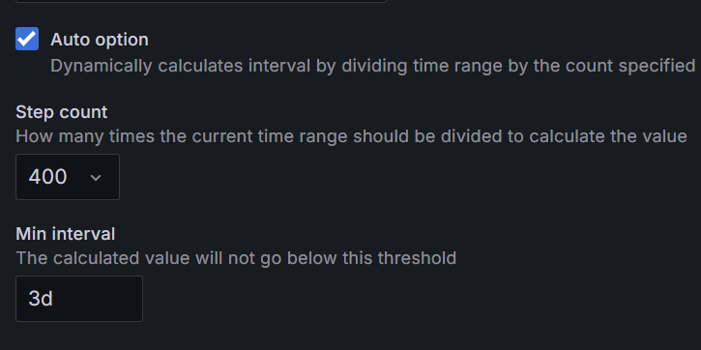
Values tab- Predefined interval values are specified with commas in between each value.
Auto option- As the name suggests, this option allows users to access dynamic interval value calculations based on the step count(number of new data set added in the panel table) and the minimum threshold interval value.

AD-HOC FILTERS
This variable is a dynamic filter with predefined value called key value, they can be used in a similar way as the constant variables.
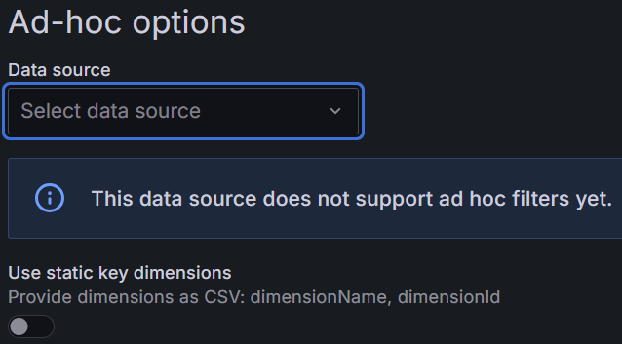
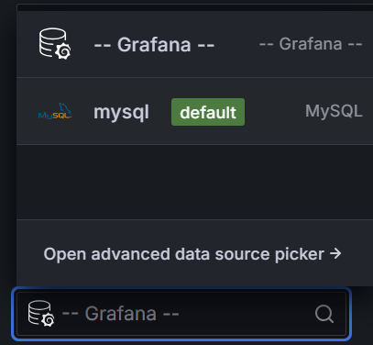
Data source tab- Allows user to select the data source where the data should be filtered, especially used for data sources such as InfluxDB, Elasticsearch and Prometheus. It doesn’t support MySQL.
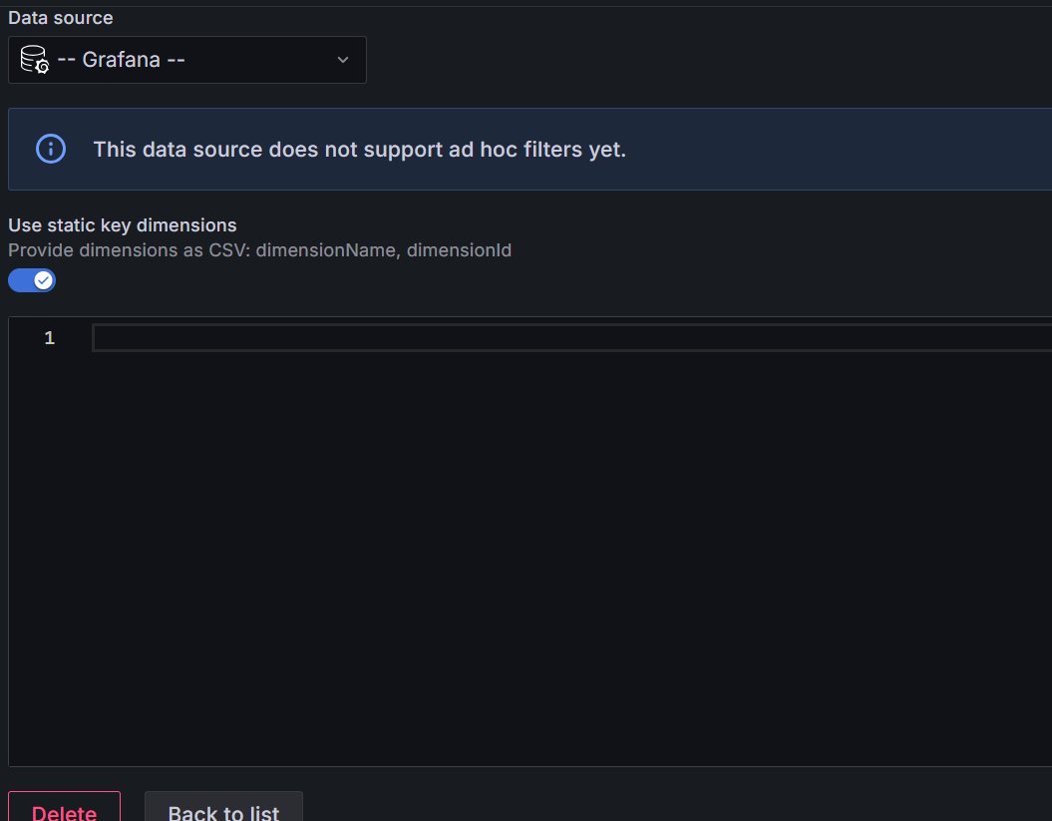
Use static key dimensions- These are used when the data from the database are consistent and not change much, like when you provide your house location when you know you are not going move to a different house anytime soon.

