Homework 1, due 1/28/2016 ( Thu )
Hau Tao
- ( 10 points )
How many processes does the following piece of code create? Why?
int main()
{
fork();
fork();
fork();
return 0;
}
The first fork creates 2 processes A, and B
The second fork creates 2 more processes from 2 previous processes (A,B,C,D)
The third fork creates 4 more processes from their ancestors (A,B,C,D,E,F,G,H)
The total process is : 8
A
B
E
G
D
C
F
H

- ( 20 points )
a) Write a C-program that creates a chain of 10 processes and prints out their process ids and relationships. For example, process 1 is the parent of process 2, process 2 is the parent of process 3, process 3 is the parent of 4 and so on. Each child has to print out all her ancestors identified by the process ids.
Source code
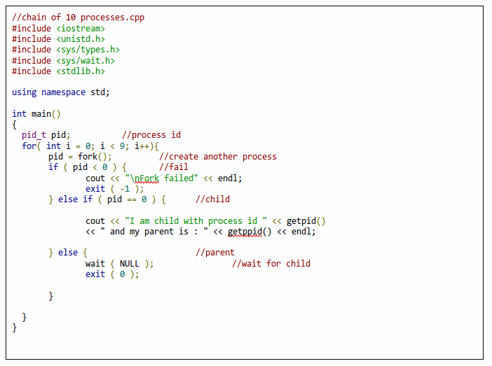

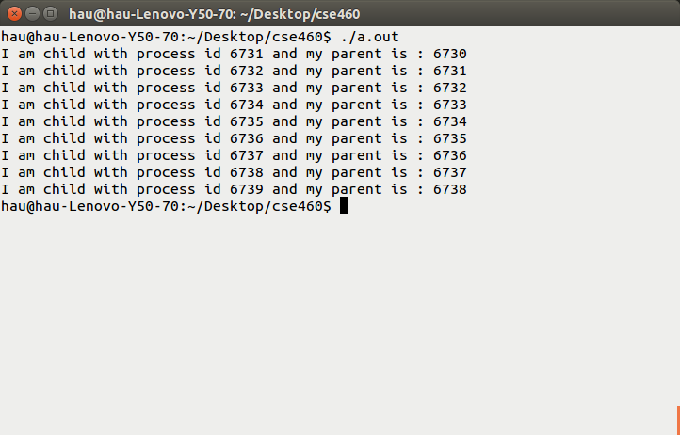

b) Write a C-program that creates a fan of 10 processes. That is, process 1 is the parent of prcocesses 2, 3, 4, 5, 6 and so on.
Source code:
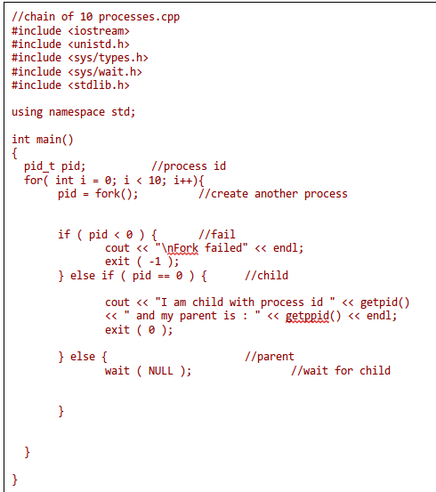

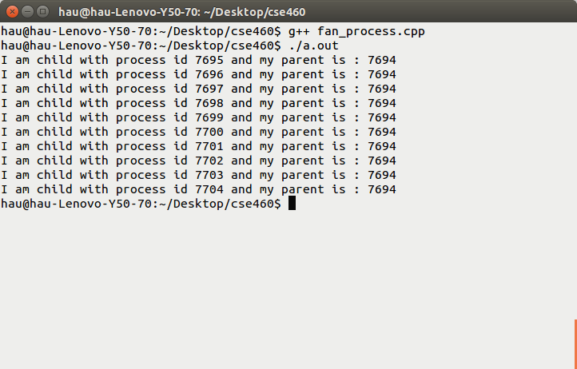

- 10 points)
a) Write a simple program named test1.cpp, which contains an infinite while loop. Compile the program to an executable named test1 and run it in the background.
Source code:
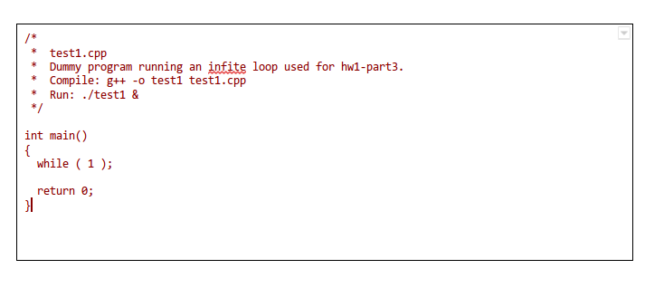
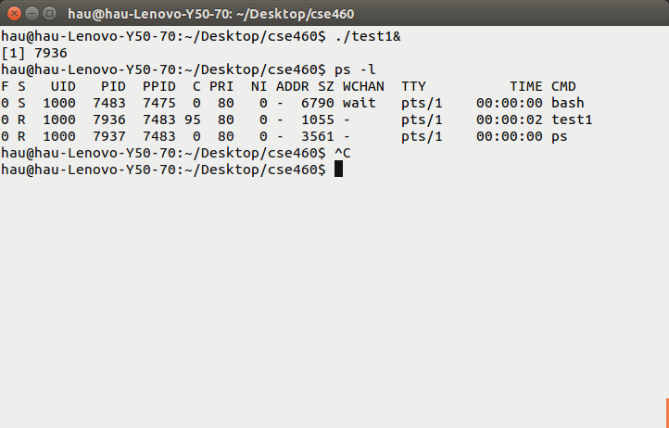

b) Write a shell script that searches for whether the process test1 is in the system. If it is not, your script displays the message 'Process test1 not running!'. If it is running, your script kills the process, and displays the message 'Process test1 killed!'.
