# **Saleforce Fundamenttals – PD1**

**Question 1 Of 33 Global Containers requires that when saving an opportunity record, a check is performed to determine if the opportunity amount is the highest value in the current year for all opportunities in the org. If so, a checkbox on the opportunity record should be marked and an email should be sent to the record owner's manager. What Salesforce feature should be recommended to handle this requirement?**

A. Apex Trigger

B. Formula Field

C. Workflow Rule

**D. Flow Builder**

A record-triggered flow, which runs in system context, can be launched when a record is saved. It can then query all the other opportunities and compare the amounts. If the triggering record contains the highest amount, its checkbox field should be set and the checkbox field of the previous record with the highest amount, if any, should be unset. An Action element can be added to the flow for sending emails.

An Apex trigger can also meet the requirement, but the best practice is to build a declarative solution when possible. Workflow rules and formula fields cannot be used to query records.

**Question 2 Of 33 Which of the following are valid considerations that a new developer should be aware of when developing in a multitenant environment? Choose 2 answers.**

A. Many customers share the same instance, so queries need to ensure the correct organization id is referenced to return the correct organizational data

B. The number of API calls allowed is unlimited

**C. Restrictions are enforced on code that can be deployed into a production environment**

**D. Governor limits ensure that the amount of CPU time is monitored and limited per customer over a defined time period to ensure that performance in one org is not impacted by another**

**Question 3 Of 33 Cosmic Solutions uses a third-party platform for managing their employees' compensation plans. It needs to be integrated with its Salesforce org. For example, when the third-party platform sends a request for a particular resource to the org, the org should respond to the request by sending data in JSON format. In addition, when certain records are changed in the org, the third-party platform should be automatically notified of the change. Which of the following should be used to meet the requirement? Choose 2 answers**

**A.REST API**

B. Bulk API

**C. Streaming API**

D. SOAP API

Both REST API and SOAP API can be used to integrate a Salesforce org with an external system. However, while REST API supports both XML and JSON data formats, SOAP API only supports XML. Streaming API, which uses the publish-subscribe model, is used for setting up notifications that can be triggered when record changes are made in the Salesforce org. For example, the external system can subscribe to a platform event in the org and receive a notification when a specific data change occurs. Bulk API is used for loading or deleting large sets of data in the org.

**Question 4 Of 33 There is a requirement that when an opportunity is closed, commission records should be created automatically for each member of the opportunity team. The Commission custom object has a Currency field wherein its value is calculated based on the opportunity team role of the member, and the Type and Amount of the related opportunity. How should this be achieved?**

A. Workfolow Rule

B. Process Builder

C. Apex Trigger

**D. Flow Builder**

A record-triggered flow can be created to run when the opportunity is closed, create the commission records, as well as perform the logic required to compute the commission values.

Workflow rules cannot create records. Although Process Builder can be used to create a record, it is not capable of creating multiple records dynamically. An Apex trigger is not needed as the requirement can be met using a declarative solution.

**Question 5 Of 33 What is true regarding the Salesforce multitenant environment? Choose 2 answers.**

A. Metadata includes configuration but not code

**B. All customizations are specified as metadata, allowing for easy upgrades**

**C. Automatic upgrades are applied during the year according to the Salesforce release schedule to all customers**

D. All customers share the same code base, but have their own database

All standard and custom configurations, functionality, and code in an org are metadata. These customizations are separated in a special metadata layer, so upgrades can easily be performed. These upgrades are released automatically three times a year for all customers.

In Salesforce's multitenant environment, users share the same code base and database. Hence, governor limits are strictly imposed.

**Question 6 Of 33 What is correct in respect to the Salesforce MVC paradigm? Choose 1 answer.**

A. Standard pages are part of MVC

**B. All Statements are true**

C. Visualforce pages are part of MVC

D. Custom Objects are part of MVC

Custom objects are part of the model in MVC, and standard and Visualforce pages are part of the View component.

**Question 7 Of 33 Cosmic Solutions has a custom object called Weekly Employee Summary, which stores a summary of employee data that is tracked in Salesforce, such as hours worked and wage totals. An autolaunched flow has been built to calculate this information and create a new Weekly Employee Summary record for each employee every time it is run. Currently, a Salesforce Administrator needs to run this flow manually once a week. They would like this flow to be run automatically in the future. Which solutions would meet this requirement?**

**A. Invoke the flow from an Apex job that runs weekly**

B. Create a workflow rule that launches the flow weekly

**C. Replace the autolaunched flow with a schedule-triggered flow**

D. Use Process Builder to invoke the flow to run weekly

The simplest solution is to invoke an autolaunched flow based on a schedule. Schedule-triggered flows can be configured to start on a specified date and time, with several frequency options. The scheduling configuration can be accessed by editing the flow's Start node.

A more complex solution would be to invoke the flow from an Apex class that implements the Schedulable interface, then schedule the class to run weekly.

Process Builder and workflow rules are not necessary to invoke scheduled flows.

**Question 8 Of 33 A developer has created a custom Lightning component, but the component isn't showing up in Lightning App Builder. Why is this happening? Choose 1 answer.**

**A. My Domain has not been defined and deployed to the org**

B. The lightning component has not been activated

C. The component has not been defined as public

D. The org doesn't support the use of custom Lightning components

My domain must be configured and deployed to the org in order to use custom Lightning components. Lightning components do not need to be activated after being deployed to the org. Lightning components are defined as public by default

**Question 9 Of 33 What is a valid consideration regarding development in a multi-tenant environment? Choose 1 answer.**

A. Salesforce organizations can choose to accept upgrades, so different organizations may be on different releases

B. Salesforce upgrades sandbox environments at the same time as production environments

C. Although Salesforce runs in the cloud, client software is still required

**D. Salesforce upgrades are automatic and cannot be scheduled on a particular date**

Salesforce updates automatically 3 times a year and cannot be scheduled. No client software is required, apart from a browser to access the internet. Sandboxes are upgraded prior to production environments so that the changes can be previewed and tested.

**Question 10 Of 33 Eric was told that Visualforce is part of the MVC paradigm. In this context, what does MVC stand for? Choose 1 answer**

A. Master Control Variable

B. Master Class Variable

**C. Model View Controller**

D. Model Variable Controller

Visualforce uses the traditional model-view-controller (MVC) paradigm, with the option to use auto-generated controllers for database objects, providing simple and tight integration with the database

**Question 11 Of 33 A company has a business requirement that cannot be met using the declarative tools available in its Salesforce org. As a result, the Salesforce Administrator of the company has resorted to installing a suitable package available in the AppExchange marketplace. What are the benefits of using AppExchange? Choose 2 answers.**

A. AppExchange installs additional development tools in the org.

**B. AppExchange apps may include support and maintenance.**

**C. AppExchange offers reviewed and proven solutions for customers.**

D. AppExchange can scan an org for any security vulnerabilities.

Salesforce AppExchange is a marketplace for downloading solutions such as apps and components for the Salesforce platform. It has both free and paid solutions, which may include support and maintenance.

The AppExchange platform is used for installing an already built solution instead of additional development tools for building the solution. It is not used for scanning security vulnerabilities.

**Question 12 Of 33 Cosmic Transport would like to use the Lightning Component Framework for adding functionality that allows the company's users to manage its transportation services. A developer has been asked to work on a few custom Lightning web components that will be added to Lightning pages and tabs. Which of the following is an important consideration for this use case? Choose 1 answer.**

A. Each Lightning web component should be inside an Aura component to configure it using Lightning App Builder.

B. A component bundle containing Controller and CSS would need to be defined for each Lightning web component.

**C. My Domain will need to be deployed for adding the components to Lightning pages and tabs.**

D. The Lightning Component Framework allows only Aura components to be added to Lightning tabs.

**Question 13 Of 33 A Salesperson wants to track customer preferences and product interests. How can the data structure required be achieved in Salesforce as per the MVC model? Choose 1 answer.**

A. Workflow

B. Validation Rules

C. Creating Custom Visualforce pages

**D. Creating object and field**

In Salesforce, the data structure can be defined with objects and fields and sits in the model part of the MVC model.

**Question 14 Of 33 A developer is creating a custom Lightning page with multiple Aura components and wants certain components to refresh when the information in other components changes. The components causing the change and the components that need to be refreshed may or may not be in the same parent component. How can this be accomplished? Choose 1 answer.**

A. Use the reRender attribute and an onchange event handler

B. Use an application event to notify other components of the change and give them a chance to handle it

C. Use viewstate to detect changes in components and update other components accordingly

**D. Use a component event to notify other components of the change and give them a chance to handle it**

The Lightning framework uses event-driven programming, so an event is the appropriate solution. Application events allow all components on a page, regardless of the containing component, to respond to an event. Component events can only be handled by components in the firing component's containment hierarchy. Since, in the given scenario, components may reside in the same or different containers, an application event is the correct approach.

**Question 15 Of 33 Which of the following are true regarding developing in the Salesforce multi-tenant environment? Choose 2 answers.**

**A. Salesforce uses and optimizes different database technologies to implement polyglot persistence**

**B. Queries should be selective in terms of the number of records returned**

C. The custom domain feature ensures that different customers do not access each other's data

D. It is not possible to index application data as each tenant stores different types of data in the same application table

Force.com integrates and optimizes several different data persistence technologies to deliver polyglot persistence. Only a single API needs to be coded to, no matter which type of persistence is optimal for a given situation. The platform monitors queries and DML operations and throws a runtime exception if they exceed governor limits.

**Question 16 Of 33 Cosmic Finance Solutions has recently switched to Lightning Experience. The Salesforce Administrator of the company would like to make use of Lightning components to enhance the user experience. Which of the following can be created using the Lightning App Builder? Choose 3 answers**.

**A. Custom home pages**

B. Lightning tabs

**C. Single-page apps**

**D. Custom record pages**

E. Custom page layouts

App pages, record pages, home pages, and email application panes can be built using Lightning App Builder.

Page layouts can be created in the Object Manager page of an object. Lightning tabs can be created in the Tabs page in Setup

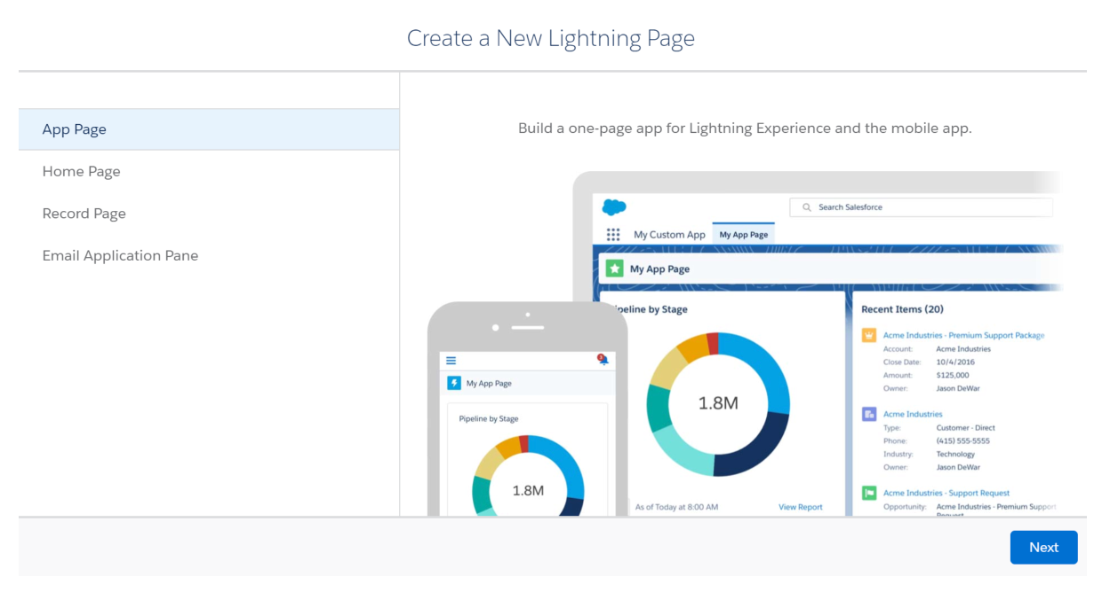

**Question 17 Of 33 Which of the following would represent the 'controller' component in the MVC model of a Salesforce application? Choose 2 answers.**

**A. Custom Apex Controller**

B. List View

C. App

**D. Visualforce Controller**

The 'controller' component includes business logic, either declarative (like workflow and escalation rules) or programmatic (like Visualforce controllers or Apex classes). The 'controller' is responsible for responding to the user input and performing interactions on the data model objects. The controller receives the input, validates it, and then performs the business operation that modifies the state of the data model in the database.

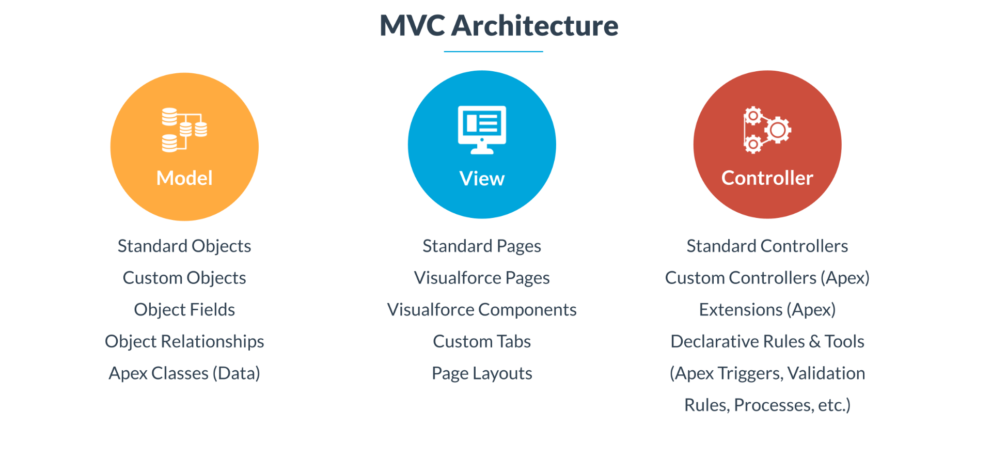

**Question 18 Of 33 Cosmic Innovation is considering the use of the Lightning Component Framework to build a custom application for managing the company's products. Which of the following are valid capabilities of the framework that would be useful for understanding how to develop and provide access to the custom application? Choose 3 answers.**

**A. The framework uses JavaScript on the client-side and Apex on the server-side.**

B. The components built using the framework offer cross-browser compatibility but not deviceawareness.

**C. The components built using the framework can be added as custom tabs on the navigation bar.**

D. The framework utilizes stateless client and stateful server, which improves efficiency and responsiveness.

**E. The framework provides two programming models for development, namely, Aura Components and Lightning Web Components.**

The Lightning Component Framework is a UI framework that allows building single-page web apps with dynamic and responsive user interfaces in Salesforce. It uses JavaScript on the client-side and Apex on the server-side. Lightning components can be built using the Aura Components or Lightning Web Components model. They can coexist and interoperate on a page.

The framework offers features such as device awareness and cross-browser compatibility, allows using various out-of-the-box components for faster development, and enables customizing Lightning Experience and communities. It utilizes a stateful client (using JavaScript) and a stateless server (Apex). The client calls the server only when absolutely necessary, which results in fewer calls to the server and more responsive and efficient apps. Lightning components can be used in many different contexts. For example, they can be added as custom tabs in Lightning Experience and the Salesforce mobile app.

**Question 19 Of 33 Which of the following use cases are valid for using declarative customization? Choose 3 answers**

A. Determining a lead rating that is based on the value of three fields on the lead recor

**B. Displaying the total discount amount on an opportunity using a roll-up summary field based on line item formula fields which reference another object**

**C. Calculating the number of days until an opportunity closes and displaying the value on a report**

**D. Calculating the sales tax applicable to a quote that is a complex calculation based on factors such as product, state, and quantity**

The NumberOfEmployees field on the Account object can be displayed in the related Opportunity object using a cross-object formula field. The TODAY() function and an Opportunity’s CloseDate field can be used in a formula to determine the number of days left leading to its close date in a custom field or row-level formula field in a report. Fields, functions, and operators can be used in a formula to generate certain output such as lead rating.

A complex calculation that involves a number of lookups would be too complex for a formula field and would need a programmatic solution. A flow could be used for a simple calculation but not when there is complex business logic involved. Cross-object formula fields cannot be used in roll-up summary fields.

**Question 20 Of 33 What constitutes the Model part in the Model-View-Controller paradigm? Choose 2 answers.**

A. Visualforce Pages

B. Standard Pages

**C. Custom Object**

**D. Standard Object**

**Question 21 Of 33 Which of the following events are fired when an Aura component loads on a page? Choose 3 answers.**

**C. Render**

**D. afterRender**

B. start

**A. init**

The 'init' event signals that a component initialization is complete. The 'render' event triggers the start of component rendering. The 'afterRender' event signals that the rendering is complete. At this point, one can interact with the DOM tree to do additional processing.

**Question 22 Of 33 A requirement has been given to display the average value of won opportunities on the Account page layout. How can this be best achieved? Choose 1 answer.**

A. Use a trigger on the opportunity object

B. Use a trigger on the account object

**C. Use roll-up summary fields and a formula field**

D. Use a roll-up summary field with the average function

This requirement can be met by the completing the following configuration. A roll-up summary field is created that counts the number of won opportunities. Second, another roll-up summary field is created that sums the amount of won opportunities. Third, a new formula field is created that calculates the average. For example, Total_Won_Amount__c / Total_Won_Count__c.

Roll-up summary fields have the Count, Sum, Min and Max functions, but do not support the Average function.

It is possible to create a trigger on the Account object, but it is not the best solution since the requirement can be achieved using declarative tools.

**Question 23 Of 33 There is a requirement to validate that the country code of an account field is a valid ISO code. There are over 200 codes. What could be used for this validation?**

A. After Update trigger

B. Before Update trigge

C. Workflow Rude

**D. Validation Rule**

A validation rule can be used to ensure that the code entered is valid. In this particular scenario, the validation rule's formula field can contain a list of ISO codes with which to verify the country code.

There is no need for programmatic customization in this case as a declarative tool can meet the requirement. Workflow rules cannot be used to perform data validation.

**Question 24 Of 33 Which of the following are part of the model layer in the MVC model? Choose 3 answers.**

**A. Objects**

B. Page Layouts

C. Tabs

**D. Field**

**E. Relationships**

The model layer includes fields, objects, and relationships, whereas tabs and page layouts are part of the view layer.

**Question 25 Of 33 Which of the following correctly describes how the Salesforce platform features map to the MVC software design pattern? Choose 1 answer**

A. Model: JavaScript; View: Visualforce Pages; Controller: Custom Apex Class

D. Model: Standard and Custom Objects; View: JavaScript; Controller: Standard and Custom

B. Model: Apex Classes; View: Pages and Components; Controller: Standard and Custom Objects

**C. Model: Standard and Custom Objects; View: Pages and Components; Controller: Standard and Custom Controllers**

The 'Model' component in the MVC pattern represents data structure, which is defined using standard and custom objects in Salesforce. The 'View' component comprises pages and components, such as Visualforce pages and Lightning components.

The 'Controller' includes any custom controller logic written in Apex and standard controllers containing standard behavior for each object implemented by the Salesforce platform.

The 'Controller' may also represent JavaScript code in the form of a client-side controller

**Question 26 Of 33 A service manager wants to send an email reminder to customers who have failed their energy audit to schedule another audit after they have completed the required modifications. They want this to be done weekly for all the records that still have a failed audit status. How can a Salesforce Administrator easily fulfill this requirement? Choose 1 answer.**

D. create workflow to select the records with a failed audit status and associate a workflow action to send an email

A. Create a batch Apex for the records that failed the energy audit and schedule Apex to send the email

**B. Create a scheduled flow for the set of records that have a failed audit status to send an email**

C. Create a process using Process Builder to select the records with a failed audit status and send an email reminder

Using a scheduled flow, a set of records can be selected based on specified criteria. A 'send email' action can be added to the flow to send an email reminder to customers who continue to have a failed audit status. This can also be done using Apex, using batch Apex to select the specific records and schedule Apex to send the email reminder. However, this is a more complex solution than using a declarative option such as flow. Processes and workflows only start when records are changed and can only send email alerts.

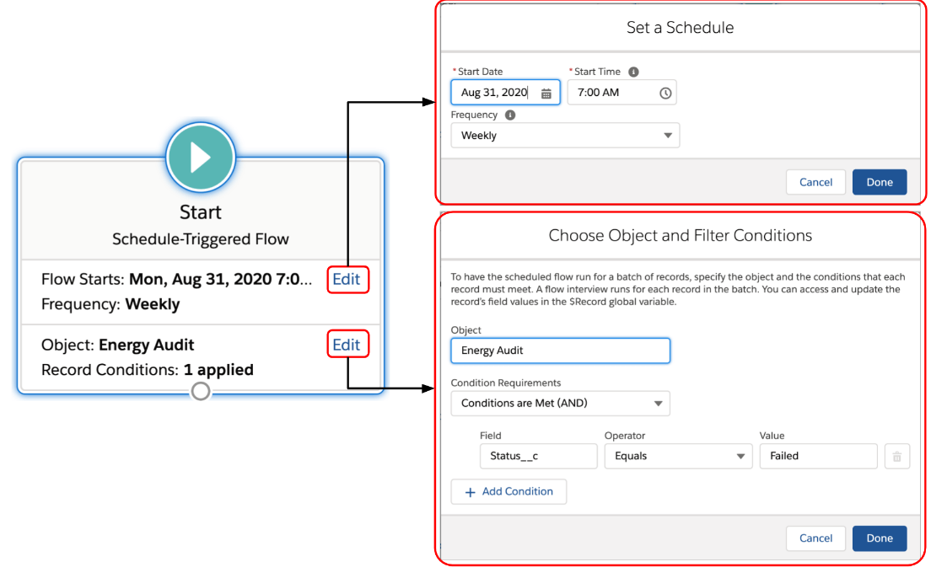

**Question 27 Of 33 A Salesforce developer is building a Lightning Aura component and is refactoring code to create a common function that will be reused by several other JavaScript functions in the component. Which file in the component bundle should contain the common function?**

A. The component file

**D. The helper file**

C. The controller file

B. The design file

The helper file is the most appropriate place to put functions that can be called by any JavaScript code in a component bundle. The component file contains the markup for the component, while the controller file contains functions that are typically called as a result of a browser or platform event. The design file exposes attributes of the component that can be modified from an interface such as Lightning App Builder.

**Question 28 Of 33 There is a requirement to rate all accounts daily based on the values of the opportunities closed in the current year, the number of open opportunities, and the opportunity close rates. The account with the highest aggregated result should be rated number 1, and so on until the account with the lowest rating is updated. How could this requirement be achieved? Choose 1 answer.**

B. Use a Batch Apex job and schedule it to run each night

**D. Use Process Builder and schedule an action to run each night to sort and rate all accounts**

A. Use an Apex trigger on the Account object and schedule it to run each night

C. Use a time-dependent workflow action update the ‘Rating’ field

Process Builder, workflow rules, or triggers cannot be configured to run periodically at fixed timings or intervals, nor can processes or workflows perform complex calculations. A scheduled Apex would be suitable for this requirement since it can be set to run at regular intervals and perform the required logic. Note that autolaunched flows can also be scheduled, but if the logic is too complex, Apex should be used. Also, batch Apex has much higher governor limits compared to scheduled flows.

So, a batch Apex job can be used to process all the account records daily. An Apex class that implements the 'Database.Batchable' interface can be created for the batch Apex job. Another Apex class that implements the 'Schedulable' interface can be created to execute the batch Apex job at regular intervals.

The 'Schedule Apex' page in the Salesforce user interface or the 'System.schedule' method can be used to specify the schedule. The Apex class defined for the batch Apex job must use the following syntax:

global class BatchApexClass implements Database.Batchable {

global (Database.QueryLocator | Iterable) start(Database.BatchableContext bc) {//Code}

global void execute(Database.BatchableContext bc, List) { //Code }

global void finish(Database.BatchableContext bc) { //Code }

}

The schedulable Apex class must use the following syntax:

global class SchedulableApexClass implements Schedulable { global void execute(SchedulableContext sc) {   
BatchApexClass b = new BatchApexClass();

Database.executebatch(b);

}

} 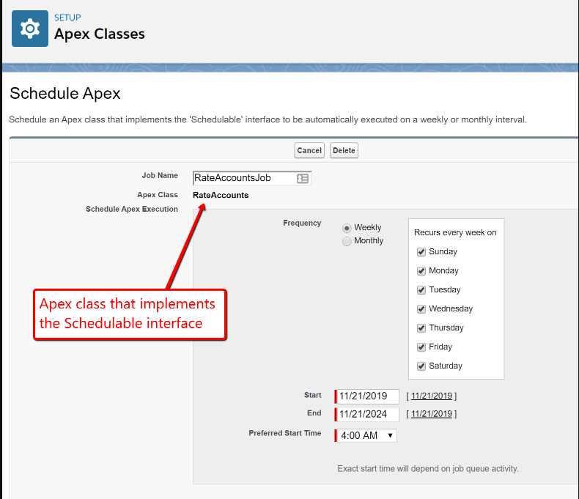

**Question 29 Of 33 A Salesforce developer wants to build a custom user interface for internal users. The interface will contain fields pulled from different Salesforce objects, some of which are not related. Which is the most suitable solution in the given options? Choose 1 answer.**

A. Build a page using Dynamic Forms and Field Section Lightning components

**B. Develop a Visualforce page to display fields from the different objects**

D. Develop an application using Heroku and embed it in the Salesforce org

C. Build a custom page layout in Salesforce containing the required information

Since the custom user interface is for internal use only and needs to pull in Salesforce data from different objects, a programmatic solution such as a Visualforce page or custom Lightning component is required.

A page layout cannot display fields from unrelated objects. Heroku is best used for customer-facing sites. Dynamic Forms and Field Section Lightning components are supported in Lightning record pages only and support fields that are related to the primary record. 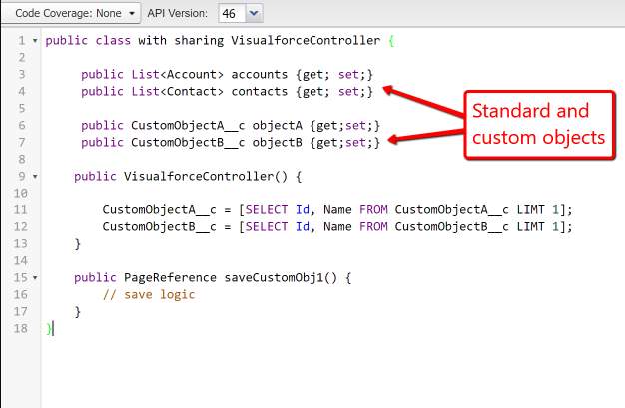

**Question 30 Of 33 Because Apex runs in a multitenant environment, the Apex runtime engine enforces limits to ensure that Apex code or processes don't monopolize shared resources. What are valid examples of these limits? Choose 3 answers.**

**D. Time executing a SOQL query**

**B. Total number of records retrieved by SOQL queries**

A. Maximum execution time for a DML operation

E. Maximum number of records that can be stored

The runtime engine enforces limits of how long a SOQL query can run, how many records can be returned in a query and the maximum amount of CPU time a transaction can take. The maximum number of records that can be stored in an object is dependent on the storage available and is not subject to a governor limit.

Unlike SOQL queries, there is no maximum execution time for DML statements. There is, however, a limit for the total number of DML statements that can be executed in an Apex transaction.

**Question 31 Of 33 Sarah has set up the standard Email-to-Case functionality and is testing it. She has found that cases are created from emails sent to the designated email address with the subject populated from the email subject and the case description populated from the email body. The support emails are sent using a standard format that includes the case priority and site location of the customer issue. How can these fields be set automatically when the case is created? Choose 2 answers.**

A. Add field mappings for custom priority and site location in the Email-to-Case settings

**B. Create a custom email handler to map the fields**

C. Create a workflow rule to update the case priority and site locatioin fields

**D. Create a before insert trigger on the case object to update the case priority and site location fields**

A custom email handler can be used to parse the email and update the case priority and site location fields. A before insert trigger on the Case object can also be used to parse info from the description field which contain the mail body after cases are created from Email-to-Case

Email-to-Case can only map the email subject to the case subject and the email body to the case description. It is not possible to add further field mappings. Workflow rules alone cannot handle the complex parsing required in this scenario 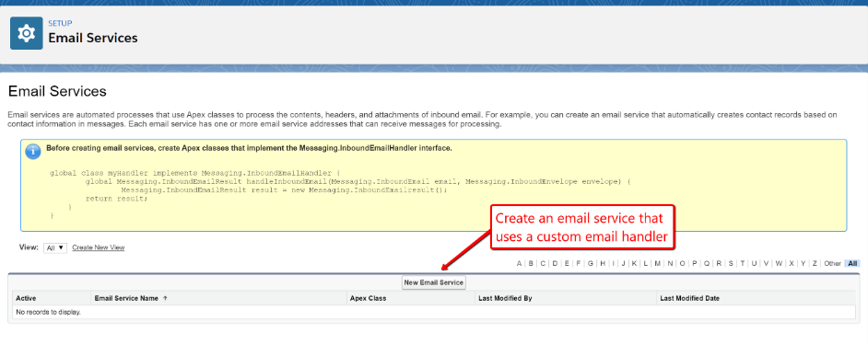 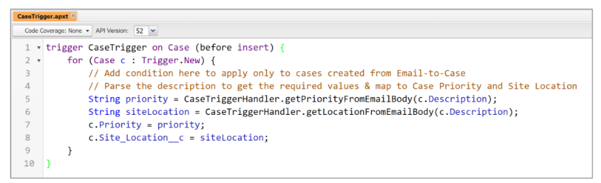

**Question 32 Of 33 A developer is required to ensure that a reason is entered if an opportunity stage is updated to 'Closed Lost'. What is the best way to meet this requirement?** **Choose 1 answer.**

A. Required field

B. Workflow rule

**C. Validation rule**

D. Apex Trigger

A validation rule can be used to check both the stage and reason fields of an opportunity during the update. If the stage is set to ‘Closed Lost’ and the reason field is empty, then the validation rule can display the error message.

The requirement can be met using a declarative tool, so there is no need to use an Apex trigger. A workflow rule cannot be used to validate field data. Setting the field to ‘Required’ will require that field to be always populated regardless of the opportunity stage. 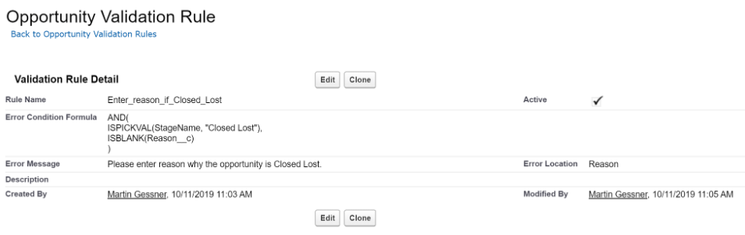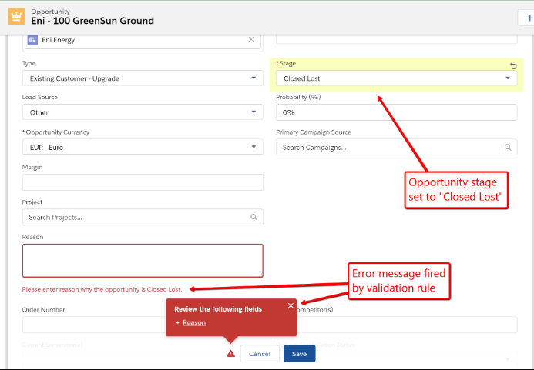

**Question 33 Of 33 Global Insurance would like users to be able to enter policy and advisor details on a screen. When a user clicks the 'Next' button on the screen, the advisor commission related to the details entered by the user should be displayed on the next screen. What would be the recommended solution for this requirement? Choose 1 answer.**

C. Create a process with Process Builder

A. Create a Visualforce wizard

D. Create an approval workflow

**B. Create a flow with Flow Builder**

A flow can be used to create a wizard-like interface where details can be entered on one screen and a calculation displayed on the next screen.

Visualforce is not necessary as the requirement can be met by a declarative solution. Neither approval workflows nor Process Builder can be used for building interfaces.

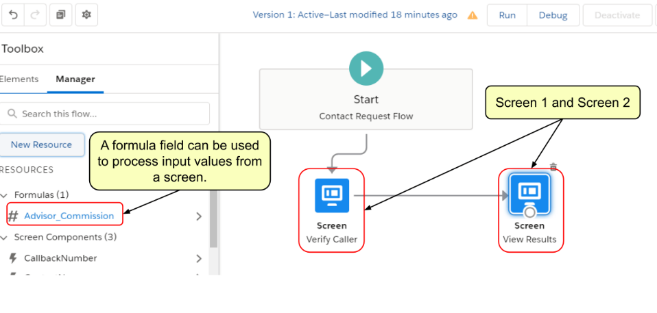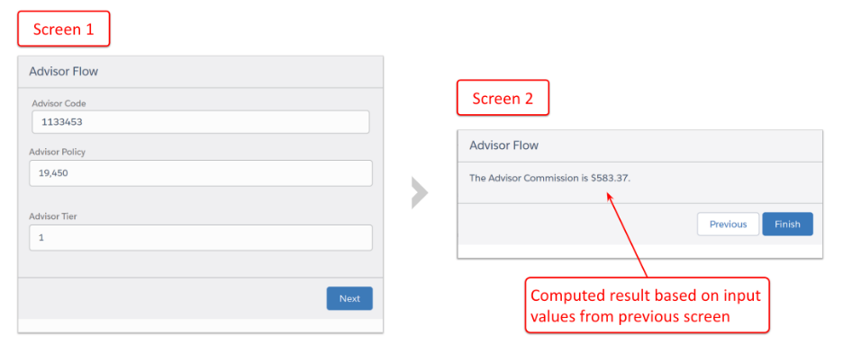

# **Data Modeling and Management – PD1**

**Question 1 Of 24 A developer is unable to delete a custom field as it is referenced somewhere in Salesforce. Which of the following might contain the conflicting reference? Choose 3 answers.**

**A. Email Template**

**B. Formula field**

**C. Apex Class**

D. Email template

E. Dynamic SOQL

Below is a list of some of the components that when a field is referenced, the reference should be deleted or updated first before the field can be deleted: Apex Class, Apex Trigger, Visualforce Page, Visualforce Component, Workflow Rule, Field Update, Criteria-Based Sharing Rule, Flow, Jobs, etc.

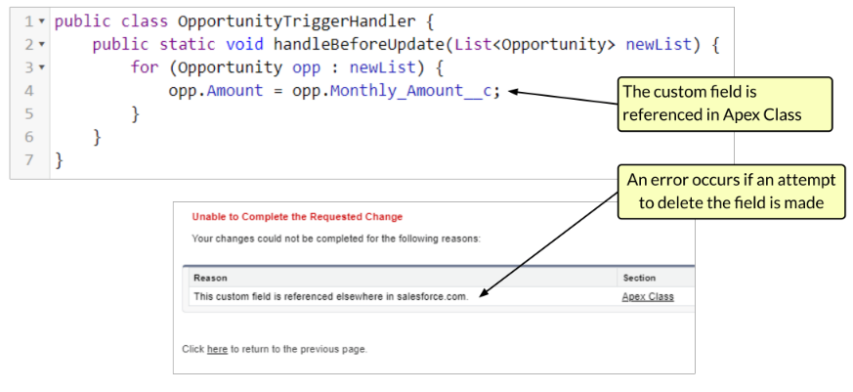

**Question 2 Of 24 What is true regarding accessing sharing programmatically? Choose 3 answers.**

**A. AccountShare is the sharing object for the Account object**

B. Account__Share is the sharing object for the Account object

C. Programmatic sharing can only give record access to one individual user at a time

**E. CustomObject__Share is the sharing object for a custom object**

**D. Objects on the detail side of a master-detail relationship do not have a sharing object**

To access sharing programmatically, the sharing object associated with the standard or custom object being worked on should be used. The naming convention for standard objects simply adds Share to the Object name: AccountShare, CaseShare, ContactShare, etc. Custom objects require appending __Share to the custom object name (but without a "c"). For example, the sharing object for MyCustomObject would be called MyCustomObject__Share.

Objects on the detail side of a master-detail relationship do not have an associated sharing object and access to the detail records is determined by the master object sharing object and the sharing setting of the relationship.

Record access can be granted to users or groups with programmatic sharing. 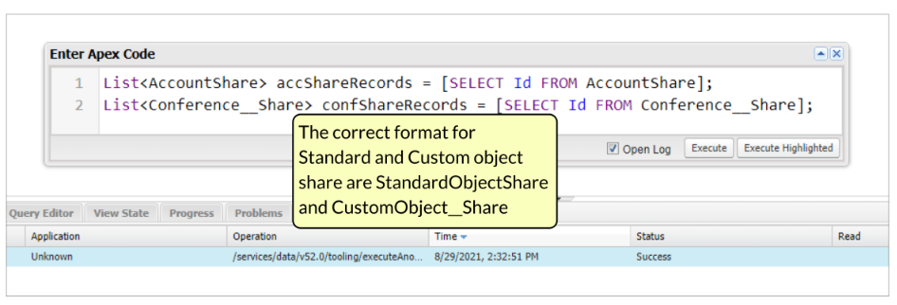 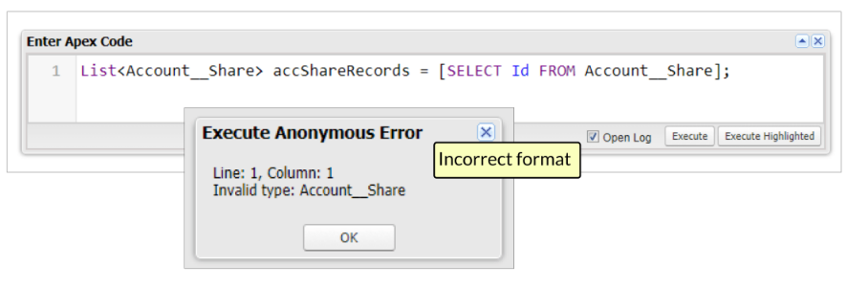

**Question 3 Of 24 Steadfast Insurance Inc. has a custom object Claim to track insurance claims for its team members. When a team member creates a claim record, an approval process is started, which is used by the insurance manager to approve or reject the claim. In order to assist the manager, the claim record should display the most current value of the record owner's claim limit. 'Claim Limit' is a custom field on the User object. What is the recommended solution to meet the requirement? Choose 1 answer.**

**A. Use a cross-object formula to display the user's limit on the claim record**

B. Use Process Builder to populate the user limit field when the claim is created

C. Use a field update in a workflow rule to copy the team member's claim limit onto the claim record

D. Use a trigger to populate the user limit field when then claim is craeted

Technically, all the options can be used to meet the requirement. However, using a cross-object formula is recommended as it is the most straightforward solution to achieve what is required. Cross-object formulas can reference fields on related records. In this case, the claim limit can be made available to the claim record by creating a cross-object formula through Claim > Owner (User) > Claim Limit.

Relatively, more declarative customization work will be required for workflow rules or Process Builder. An Apex trigger would not be required as a declarative option is available.

**Question 4 Of 24 A developer has declared and initialized a variable named 's' of type String[] to store multiple sObject types. He uses the code below to get describe metadata information for the sObject types. Schema.DescribeSobjectResult[] r = Schema.describeSObjects(s); Which method of the DescribeSObjectResult class can be used to determine whether an sObject appears as 'Account' in the user interface?**

A. isName()

B. isLabel()

**C. getLabel()**

D. getName()

The getLabel() method of the DescribeSObjectResult class returns the object's label, which may or may not match the object name.

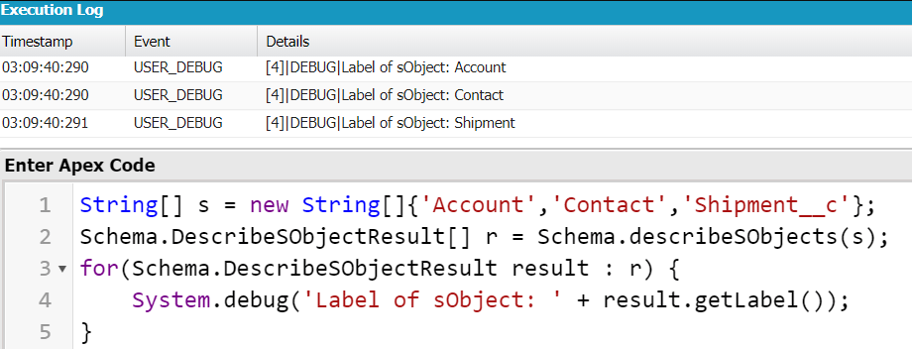

**Question 5 Of 24 Stock Symbol is a custom field on the Account object. What is the best way to make this field appear on the Contact detail page layout? Choose 1 answer.**

A. Lookup field

B. Roll-Up Summary field

C. Requires Apex Code

**D. Formula Field**

Formula fields allow inserting references to fields of a parent object. For example, Account.Stock_Symbol__c

Roll-Up Summary fields aggregates value from children records to the parent record. Lookup fields are used in establishing a lookup relationship between two objects. This scenario does not require Apex code since a formula field is sufficient.

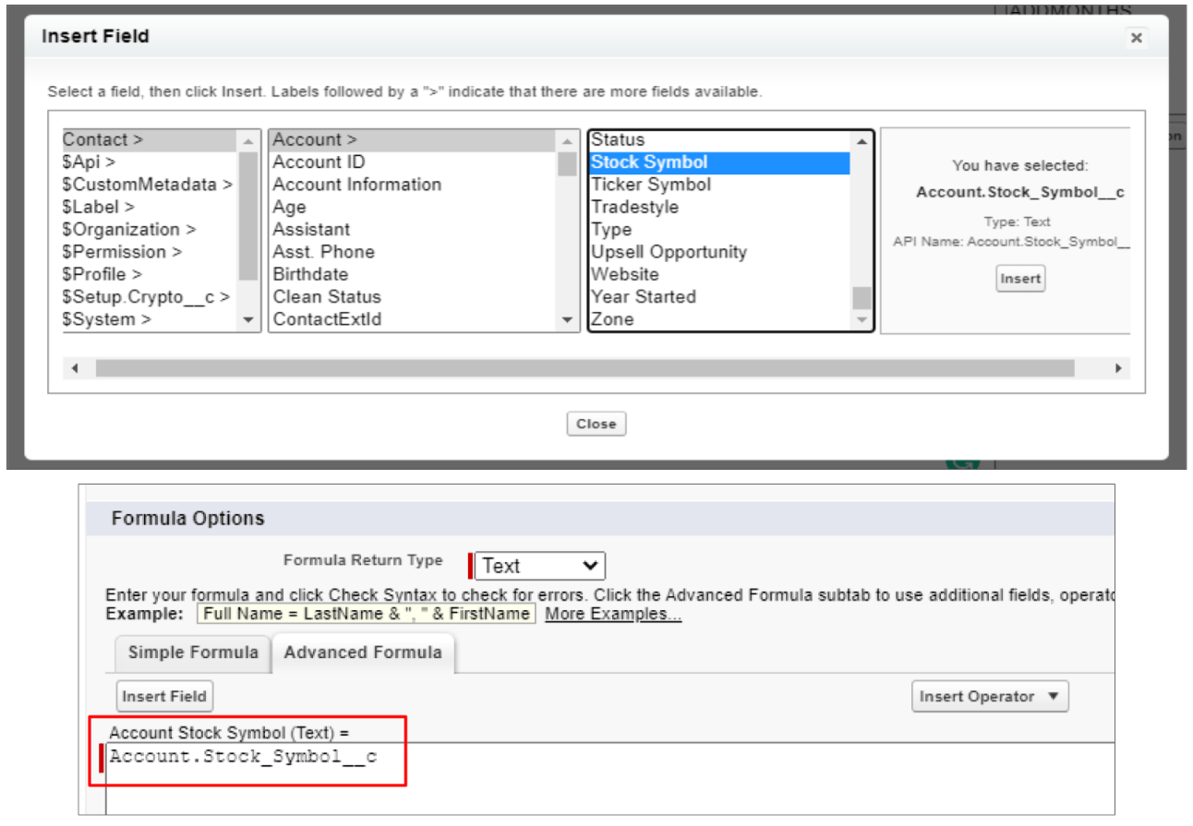

**Question 6 Of 24 At Global Conferences, the custom objects Conference and Speaker are in a many-to-many relationship via a junction object called Conference Speaker. A request has been made to the Salesforce Administrator for a solution after a group of users who only have 'read' access to the Conference and Speaker objects were unable to create or modify Conference Speaker records. How can the Salesforce Administrator give the users create and edit access to the Conference Speaker object most efficiently? Choose 1 answer.**

A. Edit the sharing settings on the master-detail relationships on the junction object to 'Read/Write'

C. Edit the sharing settings on the master-detail relationships on the junction object to 'Read'

D. Change the org-wide sharing settings of the junction object to 'Public Read/Write'

**B. Edit the sharing settings on the master-detail relationships on the junction object to 'Read Only’**

When creating or editing the master-detail relationships on the junction object, the sharing settings can be set to determine edit, create, and delete access to the junction object records based on the level of access on the master objects. Since the users have 'read' access to the master objects, the 'Read Only' option should be chosen for the users to allow them to perform CRUD operations on the junction object.

'Read' is not a valid value for the sharing settings.

The org-wide sharing settings of an object that is on the Detail side of a Master-Detail relationship cannot be edited directly. 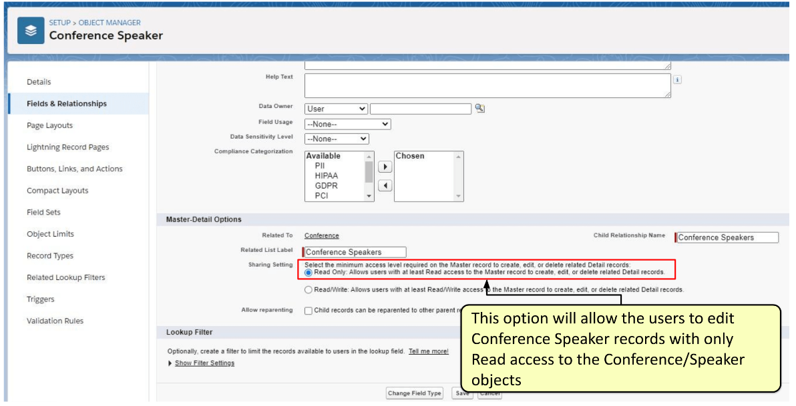

**Question 7 Of 24 How can a developer check if a user has read access to a field and if the field can be displayed on a Visualforce page? Choose 1 answer.**

**D. Call the isAccessible() method of Schema.DescribeFieldResult to verify field level read permission**

B. Call the IsAccessible() method of Schema.DescribeSObjectResult to verify field level read permission

C. Call the isViewable() method of Schema.DescribeFieldResult to verify field level read permission

A. Call the isReadable() method of Schema.SObjectResult to verify field level read permission

The isAccessible method of Schema.DescribeFieldResult can be called to check the current user's read access for a field.



**Question 8 Of 24 What is true regarding record access in a master-detail relationship? Choose 2 answers**.

**A. The detail object inherits the sharing and security settings of the master record**

**D. The owner of a master record is automatically used to set the owner of its associated detail records**

B. The record owner can be changed on the detail object

C. The detail object can have its own sharing rules

The Owner field on the detail object is not available and is automatically set to the owner of its associated master record. Custom objects on the detail side of a master-detail relationship cannot have sharing rules, manual sharing, or queues, as these require the Owner field. The detail record inherits the sharing and security settings of its master record.

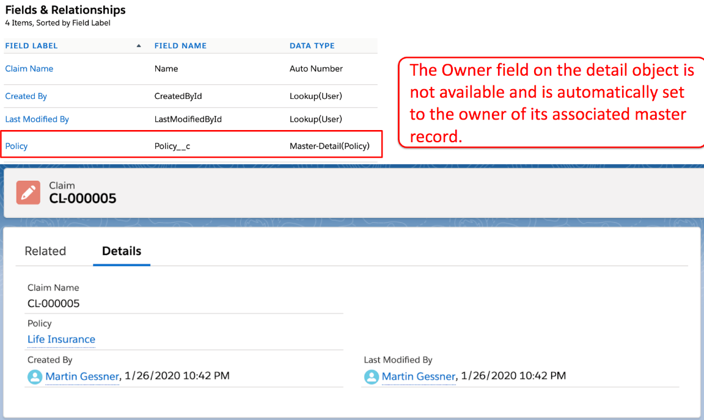

**Question 9 Of 24 A developer needs to update existing Account records using an import file. How can the records be matched so that the correct record is updated? Choose 2 answers.**

A. Match the order of the data in the import file to the order of the records in Salesforce

**B. Match an external id field defined on the acount object to a column in the import file**

C. Match the Account Name to a column in the import file

**D. Match the record id field to a column in the import file**

An External ID field or the Salesforce ID can be used to match records from an import file to existing records in Salesforce. If using the Data Import Wizard, there is also the option to match based on the combination of Account Name and Site.

