**At a glance: USD weakness to be extended temporarily**

Yesterday we received a bit more clarity in terms of short-term directions for the **USD** as **Cable** has now broken key-pivotal resistance at 1.7044/49 (2009 high/2005 low) decisively and **EUR/USD** finally broke above 1.3673/76 (200 DMA/pivot). Both breaks imply that we are dealing with an extended USD setback to at least 1.7332 (50 %) in Cable and to the main T-junction for EUR/USD at 1.3877 (minor 76.4 %). The latter will determine whether we can even extend to 1.4240/59/83 (monthly Ichimoku-lagging/76.4 % on higher scale/pivot). As for **EUR-Crosses** we also see good chances for a broader recovery, but for **EUR/JPY** to escape a looming setback to 135.55 or 134.36 (int. 38. %/C = A) it would take a break above 139.92/140.08 (minor 38.2 %/pivot). Prospects for a broader recovery are much better in **EUR/Commodity FX** but for the latter to receive stronger support it takes breaks above 1.4726 and 1.4833 (daily trend/minor 38.2 %) in **EUR/CAD**, above 1.4564 (pivot) in **EUR/AUD**, above 1.5750 (pivot) in **EUR/NZD** and above 8.4350 (minor 76.4 5) in **EUR/NOK**. The same applies for **USD/NOK** where we’d have to clear 8.2045 (minor 76.4 %) to eliminate the risk ofhaving only performed a countertrend rally. **USD/SEK** already failed to display a weekly close above 6.7346 (minor 76.4 %) but as long as 6.6509 to 6.6264 (minor 38.2 %/pivot) is defended we see 6.9032 (C = A) and a 76.4 % retracement on higher scale at 7.0789 in focus whereas **EUR/SEK** seems to be focusing on 9.2586 (int. wave 3 projection) and possibly even on 9.3119 (int. 38.2 %) next. No change for **EUR/GBP** where we see room for a temporary bounce to the first T-junction at 0.8126/57 (minor 38.2 %/pivot) as long as pivotal support at 0.7961/59 is defended. As for **emerging FX** we received a first indication that the broader **RUB** downtrend has been resumed via the re-break above 34.105 (daily breakout line) in **USD/RUB** which would be confirmed on a break above 47.414 (minor 38.2 %) in **EUR/RUB**.



The trade recommendations for the Tech Alerts (inclusive the Elliott Model Portfolio) can be found on Morgan Markets or can be received simultaneously via e-mail if desired

## EUR/USD daily – The break above 1.3673/76 opened limited upside to 1.3877

* Following the defense of key-support at 1.3477 (2014 low) the market finally managed to clear key-resistance at 1.3673/76 (200 DMA/pivot) yesterday which cleared the way for a stronger wave 2 or wave B countertrend rally.
* The latter is normally retracing 76.4 % (1.3877) of the preceding decline (wave A or wave 1) where a perfect risk reward would be given to re-enter a strategic short position in anticipation of a C.-or 3rd wave decline. Only a decisive break above 1.3877 would re-open the upside towards 1.4240/59/83 (m. Ich.-lagging/76.4 %/pivot).

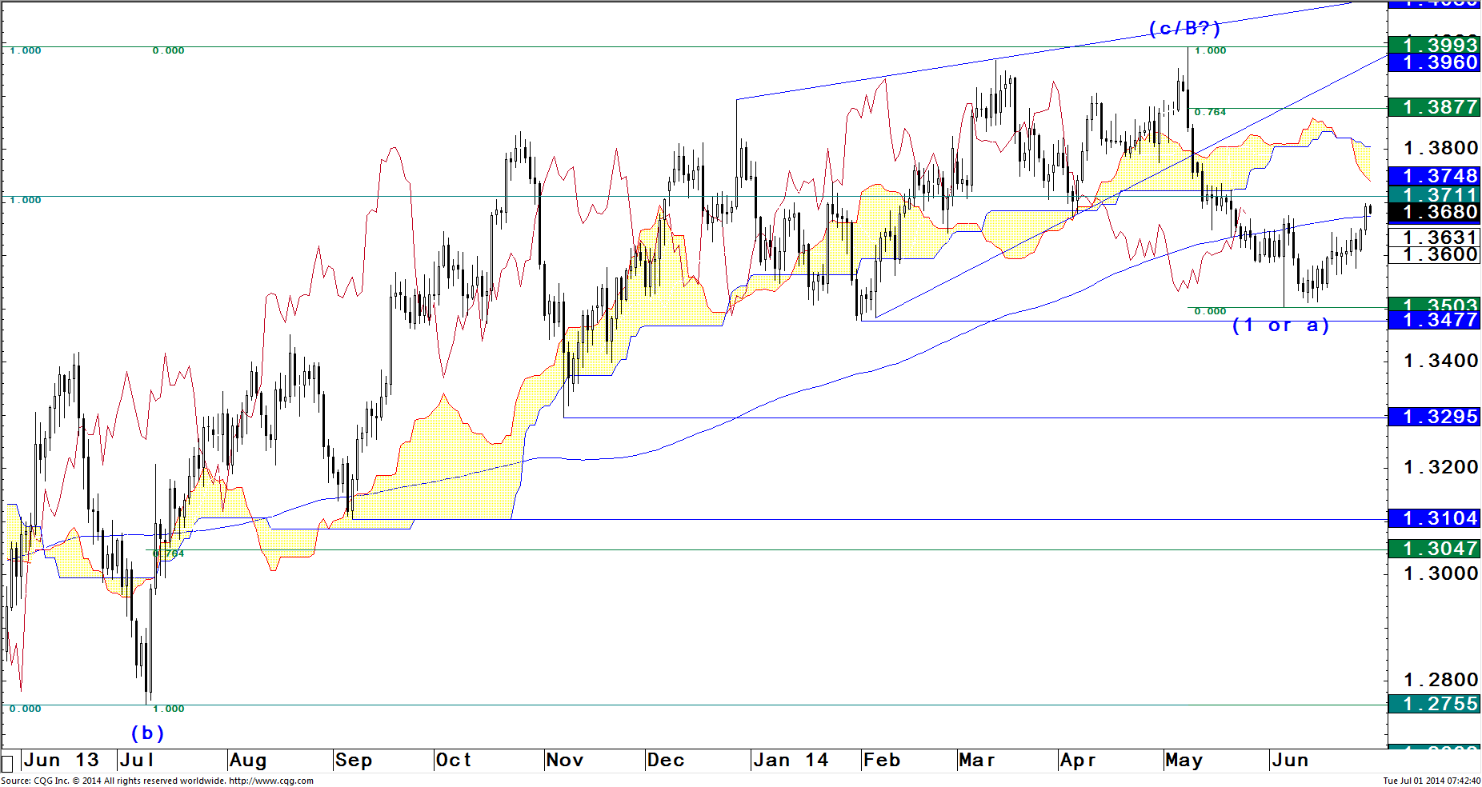

## GBP/USD weekly– An extension to 1.7332 or to 1.7768 is indicated

* Having finally managed to break decisively above key-pivotal resistance 1.7044/49 (2009 high/2005 low) the market has eliminated the imminent setback risk and has opted for a straight extension higher.
* Looking at the big picture as shown below there is now nothing left in terms of resistance up to 1.7332, followed by 1.7768 (50 %/C = A). Only two consecutive lower hourly closes of the lagging line below the Ichimoku-cloud (currently at 1.7002) and a decisive hourly close below 1.6957 (minor 38.2 %) would now question this bull-view.

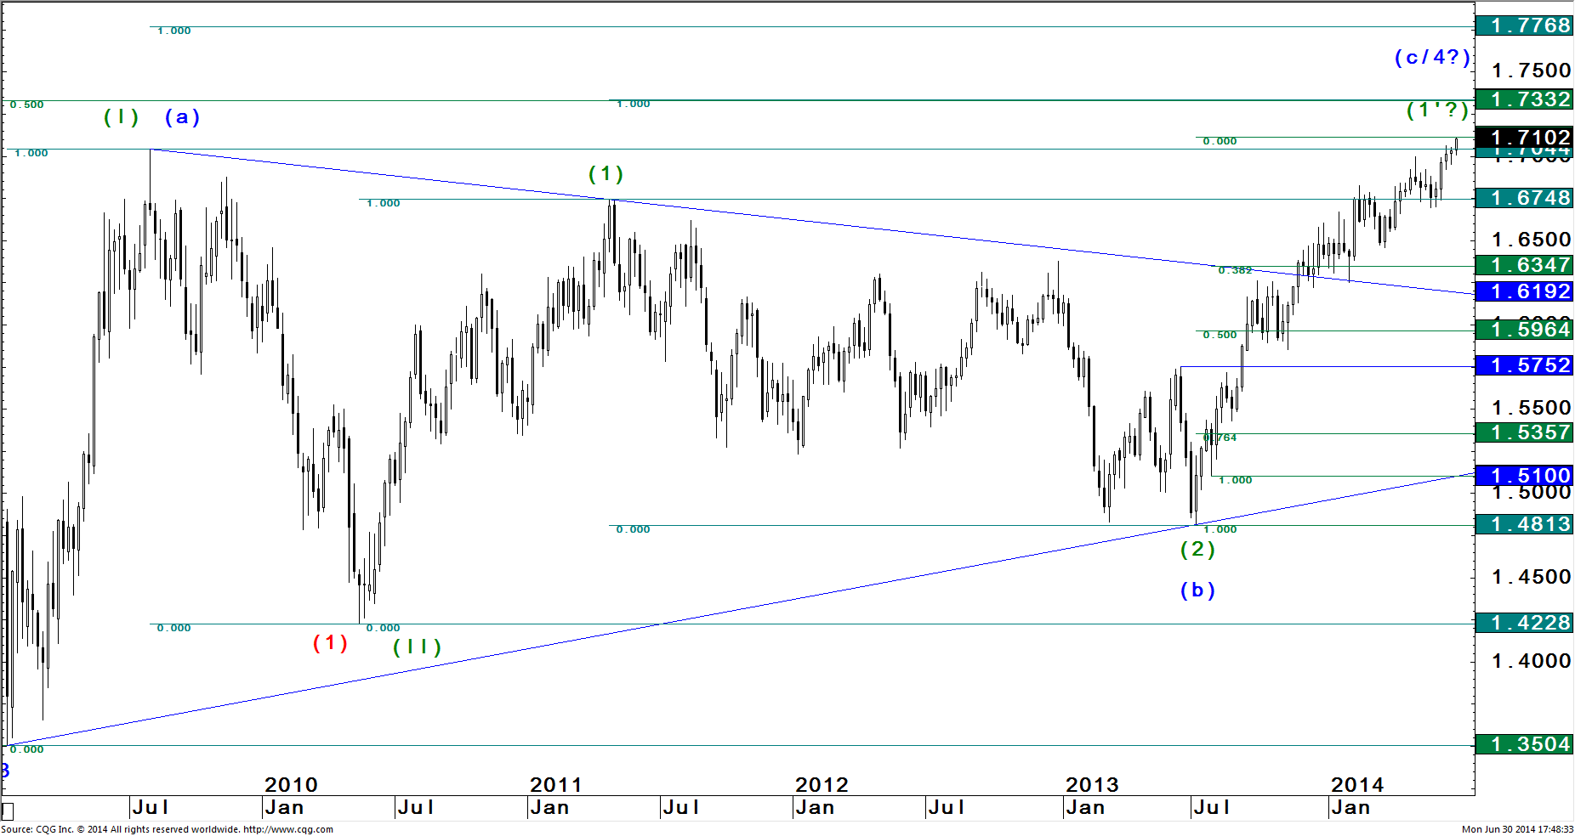

## EUR/GBP daily– A range breakout between 0.7959 & 0.8074 is needed for directions

* Having already exceeded the internal 76.4 % retreatment at 0.8005 quite a bit, chances of running into a straight extension towards 0.7755/44 (pivot/50 % on higher scale) had increased significantly.
* But as it is quite common that 76.4 % retracements are overshot we handled this break with care as pivotal support at 0.7961 held which kept the door for a stronger bounce open.
* Attempts to gain some up-momentum however failed so far so that it would take a break above daily trend line resistance at 0.8074 to at least be able to challenge key-resistance at 0.8126/57 (minor 38.2 %/pivot). Particularly below 0.8074 though, the market remains vulnerable to a break below 0.7959 for a straight extension lower.

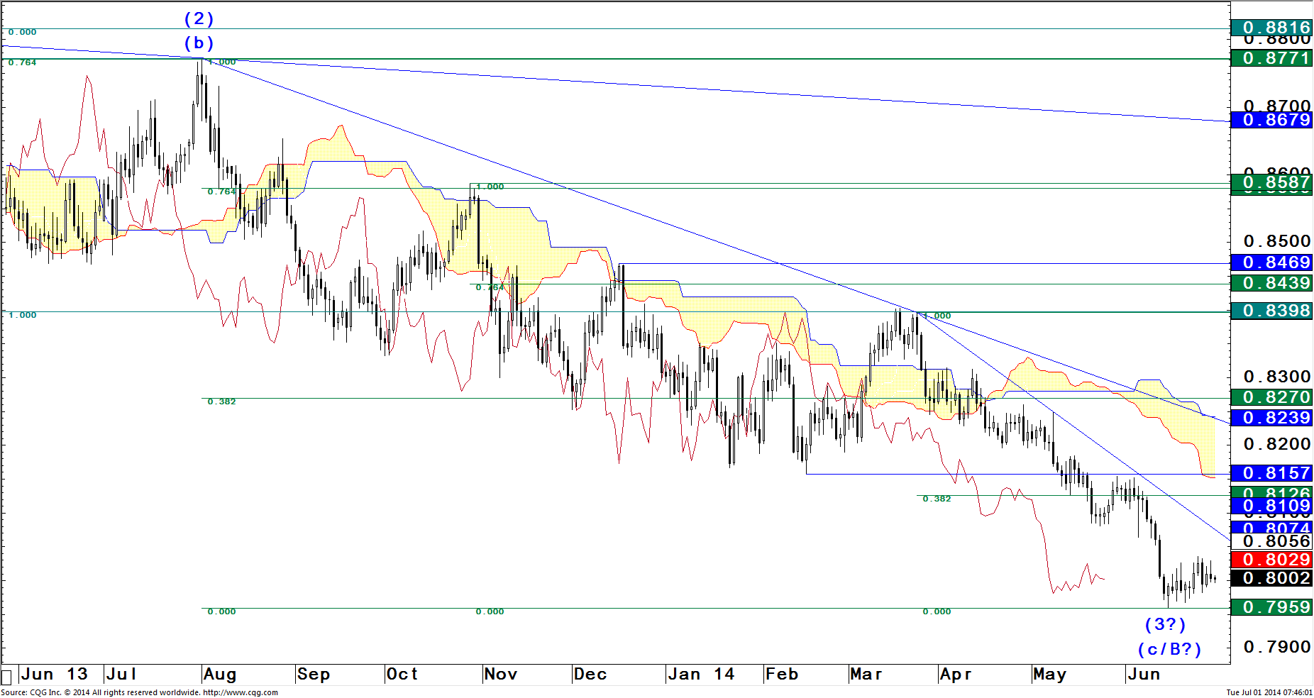

## USD/SEK daily – Above 6.6509 to 6.6264, a straight extension higher can be expected

* The general idea that that market is getting ready for a broad C-wave up to at least 7.6200 (C = A) on higher scale is still our favored one as we have already seen a whole row of higher lows since the April 2011 low was marked.
* But in the early stages of a new and broader up-trend markets tend to form so-called sub-counts whereas each bull-market impulse gets retraced by 76.4 % before acceleration up sets in.
* That said we have to watch the support zone between 6.6509 and 6.6264 (minor 38.2 %/pivot) carefully as the latter would provide a new base in case we'd only be dealing with an internal 4th wave setback. .
* If 6.6264 would be taken out though we'd have to be prepared for a deeper 2nd wave setback to 6.4299 (int. 76.4 %) whereas a break above the last top at 6.7683 would give room to extend up to 6.9032 (c = a)..

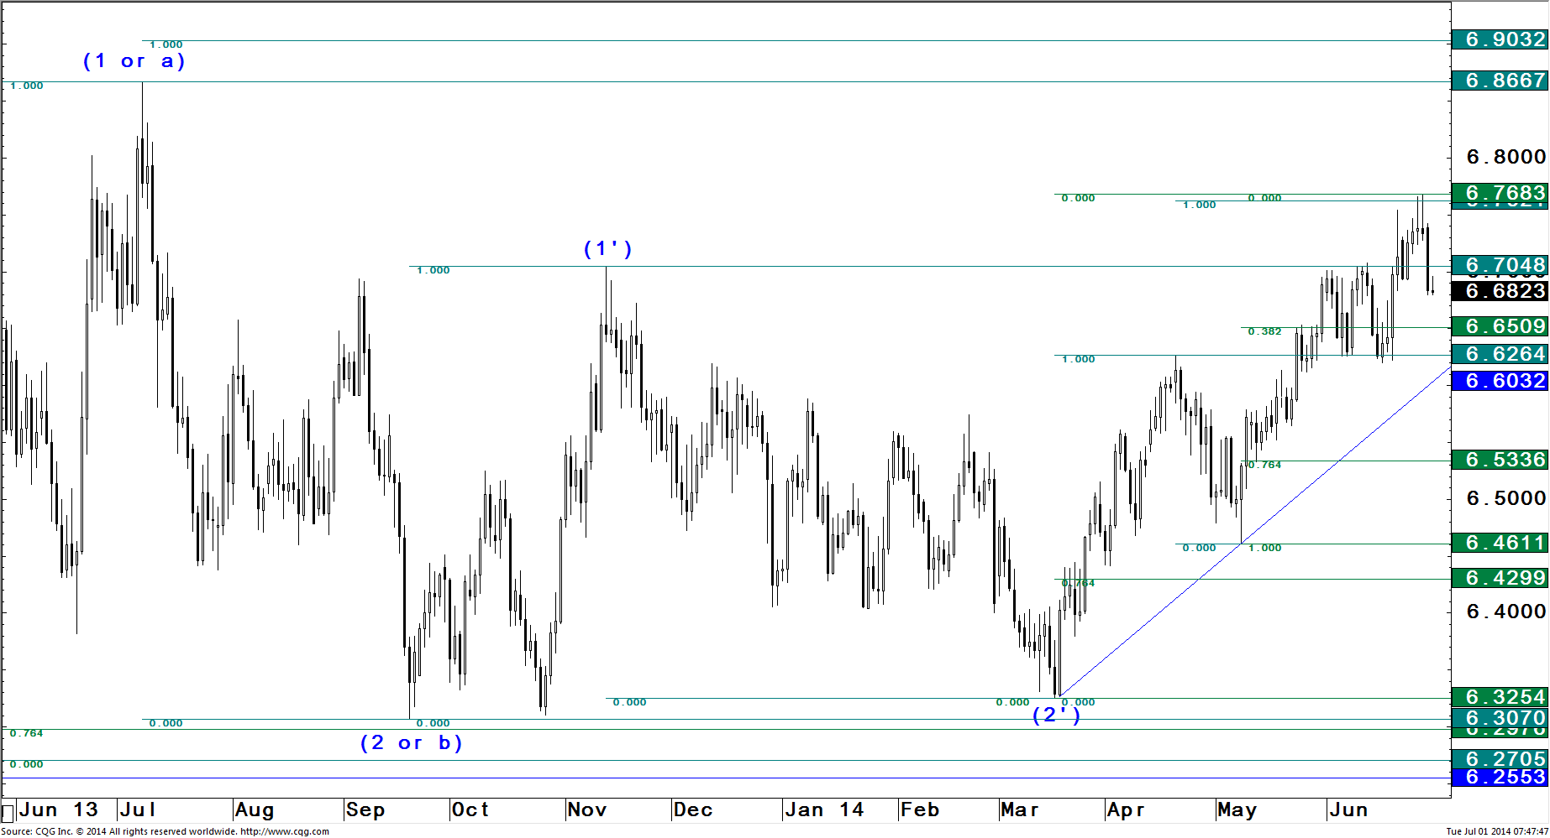

\

**Disclosures**

**Analyst Certification:** The research analyst(s) denoted by an “AC” on the cover of this report certifies (or, where multiple research analysts are primarily responsible for this report, the research analyst denoted by an “AC” on the cover or within the document individually certifies, with respect to each security or issuer that the research analyst covers in this research) that: (1) all of the views expressed in this report accurately reflect his or her personal views about any and all of the subject securities or issuers; and (2) no part of any of the research analyst's compensation was, is, or will be directly or indirectly related to the specific recommendations or views expressed by the research analyst(s) in this report. For all Korea-based research analysts listed on the front cover, they also certify, as per KOFIA requirements, that their analysis was made in good faith and that the views reflect their own opinion, without undue influence or intervention.

**Company-Specific Disclosures:** Important disclosures, including price charts, are available for compendium reports and all J.P. Morgan–covered companies by visiting<https://jpmm.com/research/disclosures>, calling 1-800-477-0406, or e-mailing [research.disclosure.inquiries@jpmorgan.com](mailto:research.disclosure.inquiries@jpmorgan.com) with your request. J.P. Morgan’s Strategy, Technical, and Quantitative Research teams may screen companies not covered by J.P. Morgan. For important disclosures for these companies, please call 1-800-477-0406 or e-mail [research.disclosure.inquiries@jpmorgan.com](mailto:research.disclosure.inquiries@jpmorgan.com).

**Analysts' Compensation:** The research analysts responsible for the preparation of this report receive compensation based upon various factors, including the quality and accuracy of research, client feedback, competitive factors, and overall firm revenues.

**Other Disclosures**

J.P. Morgan ("JPM") is the global brand name for J.P. Morgan Securities LLC ("JPMS") and its affiliates worldwide. J.P. Morgan Cazenove is a marketing name for the U.K. investment banking businesses and EMEA cash equities and equity research businesses of JPMorgan Chase & Co. and its subsidiaries.

**Options related research:** If the information contained herein regards options related research, such information is available only to persons who have received the proper option risk disclosure documents. For a copy of the Option Clearing Corporation's Characteristics and Risks of Standardized Options, please contact your J.P. Morgan Representative or visit the OCC's website at <http://www.optionsclearing.com/publications/risks/riskstoc.pdf>

**Legal Entities Disclosures   
U.S**.: JPMS is a member of NYSE, FINRA, SIPC and the NFA. JPMorgan Chase Bank, N.A. is a member of FDIC. **U.K**.: JPMorgan Chase N.A., London Branch, is authorised by the Prudential Regulation Authority and is subject to regulation by the Financial Conduct Authority and to limited regulation by the Prudential Regulation Authority. Details about the extent of our regulation by the Prudential Regulation Authority are available from J.P. Morgan on request. J.P. Morgan Securities plc (JPMS plc) is a member of the London Stock Exchange and is authorised by the Prudential Regulation Authority and regulated by the Financial Conduct Authority and the Prudential Regulation Authority. Registered in England & Wales No. 2711006. Registered Office 25 Bank Street, London, E14 5JP. **South Africa**: J.P. Morgan Equities South Africa Proprietary Limited is a member of the Johannesburg Securities Exchange and is regulated by the Financial Services Board. **Hong Kong**: J.P. Morgan Securities (Asia Pacific) Limited (CE number AAJ321) is regulated by the Hong Kong Monetary Authority and the Securities and Futures Commission in Hong Kong and/or J.P. Morgan Broking (Hong Kong) Limited (CE number AAB027) is regulated by the Securities and Futures Commission in Hong Kong. **Korea**: J.P. Morgan Securities (Far East) Ltd, Seoul Branch, is regulated by the Korea Financial Supervisory Service. **Australia**: J.P. Morgan Australia Limited (JPMAL) (ABN 52 002 888 011/AFS Licence No: 238188) is regulated by ASIC and J.P. Morgan Securities Australia Limited (JPMSAL) (ABN 61 003 245 234/AFS Licence No: 238066) is regulated by ASIC and is a Market, Clearing and Settlement Participant of ASX Limited and CHI-X. **Taiwan**: J.P.Morgan Securities (Taiwan) Limited is a participant of the Taiwan Stock Exchange (company-type) and regulated by the Taiwan Securities and Futures Bureau. **India:** J.P. Morgan India Private Limited (Corporate Identity Number - U67120MH1992FTC068724), having its registered office at J.P. Morgan Tower, Off. C.S.T. Road, Kalina, Santacruz - East, Mumbai – 400098, is a member of the National Stock Exchange of India Limited (SEBI Registration Number - INB 230675231/INF 230675231/INE 230675231) and Bombay Stock Exchange Limited (SEBI Registration Number - INB 010675237/INF 010675237) and is regulated by Securities and Exchange Board of India. Telephone: 91-22-6157 3000, Facsimile: 91-22-6157 3990 and Website: [www.jpmipl.com](http://www.jpmipl.com). For non local research reports, this material is not distributed in India by J.P. Morgan India Private Limited. **Thailand**: This material is issued and distributed in Thailand by JPMorgan Securities (Thailand) Ltd., which is a member of the Stock Exchange of Thailand and is regulated by the Ministry of Finance and the Securities and Exchange Commission and its registered address is 3rd Floor, 20 North Sathorn Road, Silom, Bangrak, Bangkok 10500. **Indonesia**: PT J.P. Morgan Securities Indonesia is a member of the Indonesia Stock Exchange and is regulated by the OJK a.k.a. BAPEPAM LK. **Philippines**: J.P. Morgan Securities Philippines Inc. is a Trading Participant of the Philippine Stock Exchange and a member of the Securities Clearing Corporation of the Philippines and the Securities Investor Protection Fund. It is regulated by the Securities and Exchange Commission. **Brazil**: Banco J.P. Morgan S.A. is regulated by the Comissao de Valores Mobiliarios (CVM) and by the Central Bank of Brazil. **Mexico**: J.P. Morgan Casa de Bolsa, S.A. de C.V., J.P. Morgan Grupo Financiero is a member of the Mexican Stock Exchange and authorized to act as a broker dealer by the National Banking and Securities Exchange Commission. **Singapore**: This material is issued and distributed in Singapore by or through J.P. Morgan Securities Singapore Private Limited (JPMSS) [MCI (P) 199/03/2014 and Co. Reg. No.: 199405335R] which is a member of the Singapore Exchange Securities Trading Limited and is regulated by the Monetary Authority of Singapore (MAS) and/or JPMorgan Chase Bank, N.A., Singapore branch (JPMCB Singapore) which is regulated by the MAS. This material is provided in Singapore only to accredited investors, expert investors and institutional investors, as defined in Section 4A of the Securities and Futures Act, Cap. 289. Recipients of this document are to contact JPMSS or JPMCB Singapore in respect of any matters arising from, or in connection with, the document. **Japan**: JPMorgan Securities Japan Co., Ltd. is regulated by the Financial Services Agency in Japan. **Malaysia**: This material is issued and distributed in Malaysia by JPMorgan Securities (Malaysia) Sdn Bhd (18146-X) which is a Participating Organization of Bursa Malaysia Berhad and a holder of Capital Markets Services License issued by the Securities Commission in Malaysia. **Pakistan**: J. P. Morgan Pakistan Broking (Pvt.) Ltd is a member of the Karachi Stock Exchange and regulated by the Securities and Exchange Commission of Pakistan. **Saudi Arabia**: J.P. Morgan Saudi Arabia Ltd. is authorized by the Capital Market Authority of the Kingdom of Saudi Arabia (CMA) to carry out dealing as an agent, arranging, advising and custody, with respect to securities business under licence number 35-07079 and its registered address is at 8th Floor, Al-Faisaliyah Tower, King Fahad Road, P.O. Box 51907, Riyadh 11553, Kingdom of Saudi Arabia. **Dubai**: JPMorgan Chase Bank, N.A., Dubai Branch is regulated by the Dubai Financial Services Authority (DFSA) and its registered address is Dubai International Financial Centre - Building 3, Level 7, PO Box 506551, Dubai, UAE.

**Country and Region Specific Disclosures   
U.K. and European Economic Area (EEA):** Unless specified to the contrary, issued and approved for distribution in the U.K. and the EEA by JPMS plc. Investment research issued by JPMS plc has been prepared in accordance with JPMS plc's policies for managing conflicts of interest arising as a result of publication and distribution of investment research. Many European regulators require a firm to establish, implement and maintain such a policy. This report has been issued in the U.K. only to persons of a kind described in Article 19 (5), 38, 47 and 49 of the Financial Services and Markets Act 2000 (Financial Promotion) Order 2005 (all such persons being referred to as "relevant persons"). This document must not be acted on or relied on by persons who are not relevant persons. Any investment or investment activity to which this document relates is only available to relevant persons and will be engaged in only with relevant persons. In other EEA countries, the report has been issued to persons regarded as professional investors (or equivalent) in their home jurisdiction. **Australia:** This material is issued and distributed by JPMSAL in Australia to "wholesale clients" only. This material does not take into account the specific investment objectives, financial situation or particular needs of the recipient. The recipient of this material must not distribute it to any third party or outside Australia without the prior written consent of JPMSAL. For the purposes of this paragraph the term "wholesale client" has the meaning given in section 761G of the Corporations Act 2001. **Germany:** This material is distributed in Germany by J.P. Morgan Securities plc, Frankfurt Branch and J.P.Morgan Chase Bank, N.A., Frankfurt Branch which are regulated by the Bundesanstalt für Finanzdienstleistungsaufsicht. **Hong Kong:** The 1% ownership disclosure as of the previous month end satisfies the requirements under Paragraph 16.5(a) of the Hong Kong Code of Conduct for Persons Licensed by or Registered with the Securities and Futures Commission. (For research published within the first ten days of the month, the disclosure may be based on the month end data from two months prior.) J.P. Morgan Broking (Hong Kong) Limited is the liquidity provider/market maker for derivative warrants, callable bull bear contracts and stock options listed on the Stock Exchange of Hong Kong Limited. An updated list can be found on HKEx website: http://www.hkex.com.hk. **Japan:** There is a risk that a loss may occur due to a change in the price of the shares in the case of share trading, and that a loss may occur due to the exchange rate in the case of foreign share trading. In the case of share trading, JPMorgan Securities Japan Co., Ltd., will be receiving a brokerage fee and consumption tax (shouhizei) calculated by multiplying the executed price by the commission rate which was individually agreed between JPMorgan Securities Japan Co., Ltd., and the customer in advance. Financial Instruments Firms: JPMorgan Securities Japan Co., Ltd., Kanto Local Finance Bureau (kinsho) No. 82 Participating Association / Japan Securities Dealers Association, The Financial Futures Association of Japan, Type II Financial Instruments Firms Association and Japan Investment Advisers Association. **Korea:** This report may have been edited or contributed to from time to time by affiliates of J.P. Morgan Securities (Far East) Ltd, Seoul Branch. **Singapore:** JPMSS and/or its affiliates may have a holding in any of the securities discussed in this report; for securities where the holding is 1% or greater, the specific holding is disclosed in the Important Disclosures section above. **India:** For private circulation only, not for sale. **Pakistan:** For private circulation only, not for sale. **New Zealand:** This material is issued and distributed by JPMSAL in New Zealand only to persons whose principal business is the investment of money or who, in the course of and for the purposes of their business, habitually invest money. JPMSAL does not issue or distribute this material to members of "the public" as determined in accordance with section 3 of the Securities Act 1978. The recipient of this material must not distribute it to any third party or outside New Zealand without the prior written consent of JPMSAL. **Canada:** The information contained herein is not, and under no circumstances is to be construed as, a prospectus, an advertisement, a public offering, an offer to sell securities described herein, or solicitation of an offer to buy securities described herein, in Canada or any province or territory thereof. Any offer or sale of the securities described herein in Canada will be made only under an exemption from the requirements to file a prospectus with the relevant Canadian securities regulators and only by a dealer properly registered under applicable securities laws or, alternatively, pursuant to an exemption from the dealer registration requirement in the relevant province or territory of Canada in which such offer or sale is made. The information contained herein is under no circumstances to be construed as investment advice in any province or territory of Canada and is not tailored to the needs of the recipient. To the extent that the information contained herein references securities of an issuer incorporated, formed or created under the laws of Canada or a province or territory of Canada, any trades in such securities must be conducted through a dealer registered in Canada. No securities commission or similar regulatory authority in Canada has reviewed or in any way passed judgment upon these materials, the information contained herein or the merits of the securities described herein, and any representation to the contrary is an offence. **Dubai:** This report has been issued to persons regarded as professional clients as defined under the DFSA rules. **Brazil**: Ombudsman J.P. Morgan: 0800-7700847 / ouvidoria.jp.morgan@jpmorgan.com.

**General:** Additional information is available upon request. Information has been obtained from sources believed to be reliable but JPMorgan Chase & Co. or its affiliates and/or subsidiaries (collectively J.P. Morgan) do not warrant its completeness or accuracy except with respect to any disclosures relative to JPMS and/or its affiliates and the analyst's involvement with the issuer that is the subject of the research. All pricing is as of the close of market for the securities discussed, unless otherwise stated. Opinions and estimates constitute our judgment as of the date of this material and are subject to change without notice. Past performance is not indicative of future results. This material is not intended as an offer or solicitation for the purchase or sale of any financial instrument. The opinions and recommendations herein do not take into account individual client circumstances, objectives, or needs and are not intended as recommendations of particular securities, financial instruments or strategies to particular clients. The recipient of this report must make its own independent decisions regarding any securities or financial instruments mentioned herein. JPMS distributes in the U.S. research published by non-U.S. affiliates and accepts responsibility for its contents. Periodic updates may be provided on companies/industries based on company specific developments or announcements, market conditions or any other publicly available information. Clients should contact analysts and execute transactions through a J.P. Morgan subsidiary or affiliate in their home jurisdiction unless governing law permits otherwise.

"Other Disclosures" last revised June 21, 2014.

**Copyright 2014 JPMorgan Chase & Co. All rights reserved. This report or any portion hereof may not be reprinted, sold or redistributed without the written consent of J.P. Morgan.** #$J&098$#*P