Research Questions
- What are the variables that affect hotel reservation cancellations?
- How can we make hotel reservations cancellation better?
- How will hotels be assisted in making pricing and promotional decisions?
Hypothesis
- More cancellations occur when prices are higher.
- When there is a longer waiting list, customers tend to cancel more frequently.
- Most clients are coming from offline travel agents to make their reservations.
Analysis & Findings
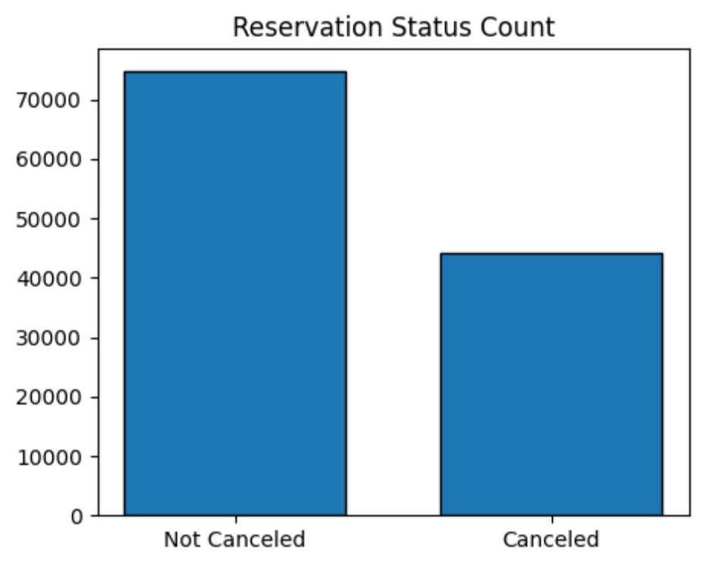
The accompanying bar graph shows the percentage of reservations that are canceled and those that are not. It is obvious that there are still a significant number of reservations that have not been canceled. There are still 38% of clients who cancelled their reservation, which has a significant impact on the hotel’s earnings.
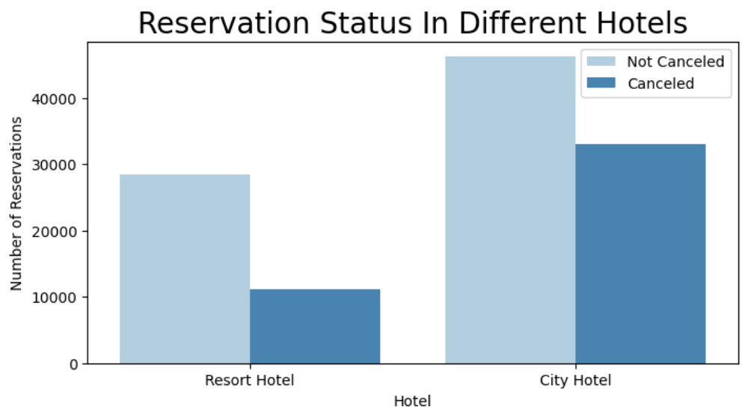
In comparison to resort hotels, city hotels have more bookings. It is possible that resort hotels are more expensive than those in cities.

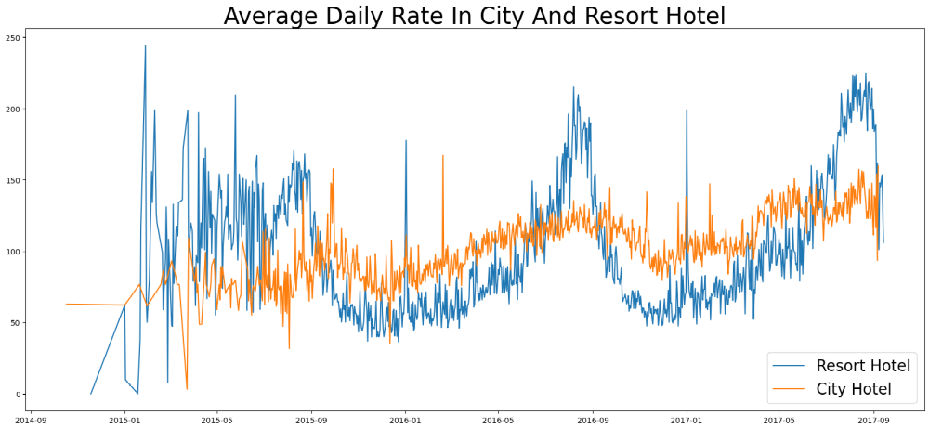
The line graph above shows that, on certain days, the average daily rate for a city hotel is less than that of a resort hotel, and on other days, it is even less. It goes without saying that weekends and holidays may see a rise in resort hotel rates.
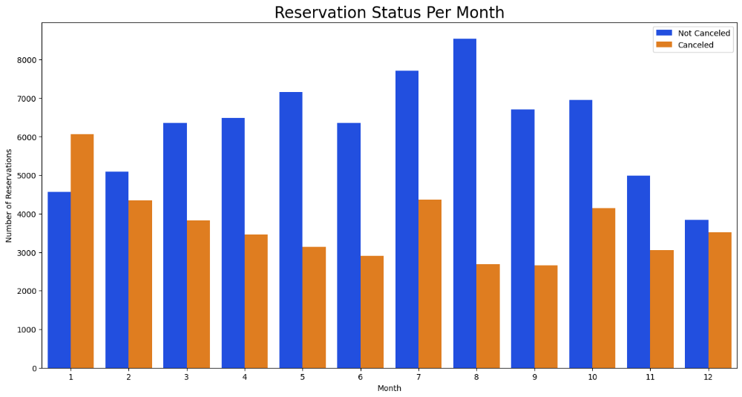
We have developed the grouped bar graph to analyze the months with the highest and lowest reservation levels according to reservation status. As can be seen, both the number of confirmed reservations and the number of canceled reservations is largest in the month of August, whereas January is the month with the most cancelled reservation.
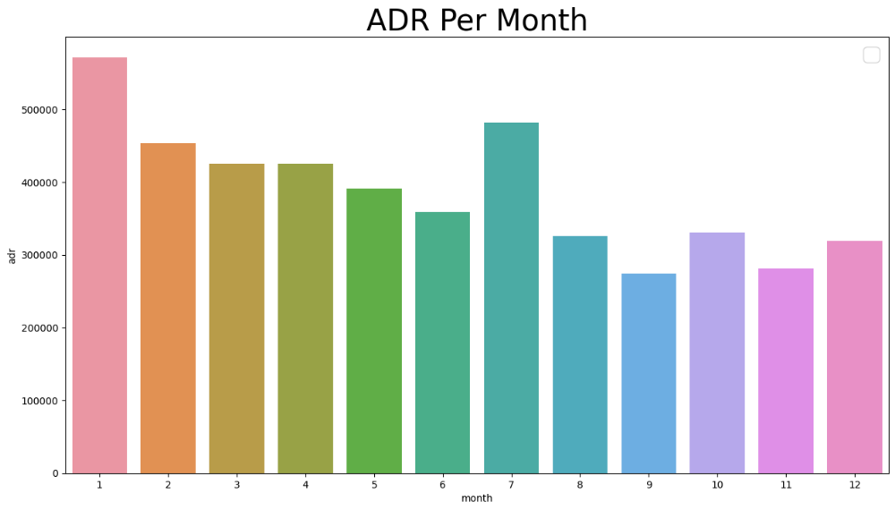
The bar graph demonstrates that cancelations are most common when prices are greatest and are least common when they are lowest. Therefore, the cost of the accommodation is solely responsible for the cancellation.
We will move to see which country has the highest reservation canceled. The top country is Portugal with the highest number of cancellations.
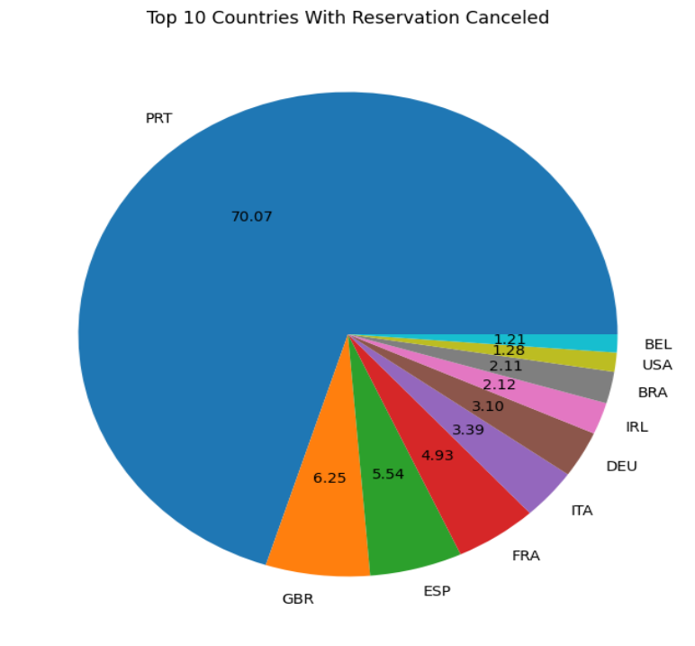
Let us check the area from where guests are visiting the hotels and making reservations. Is it coming from direct or groups, online or offline travel agents? Around 46% of the clients come from online travel agencies, whereas 27% come from groups. Only 4% of clients book hotels directly by visiting them and making reservations.
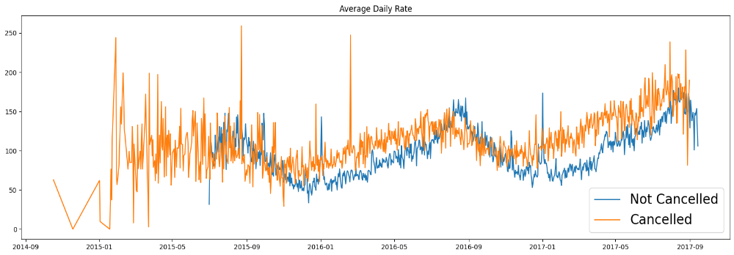

Suggestions
- Cancellations rates rise as the price does. To prevent cancellations of reservations, hotels could work on their pricing strategies and try to lower the rates for specific hotels based on locations. They also can provide the promotions to customers.
- As the ratio of the cancellation and not cancellation of the resort hotel is higher than city hotels, the hotel should provide a reasonable discount on the room prices on weekends or on holidays.
- They can also increase the quality of their hotels and their services mainly in Portugal to reduce the cancellation rate.

