CSE 501 A. Compiler Construction

Homework #2.

Jae Dong Hwang(0726655)

Jaedong@uw.edu

1. (Aho, Sethi, Ullman) Consider the grammar:   
     
   S ::= aSbS | bSaS | ε
   1. Show that this grammar is ambiguous by constructing two **leftmost** derivations for the sentence abab.
   2. Show that this grammar is ambiguous by constructing two **rightmost** derivations for the sentence abab.
   3. Construct the corresponding parse trees for your derivations.

=========================================================================

Rules:

|  |  |
| --- | --- |
| 1 | aSbS |
| 2 | bSaS |
| 3 | ε |

1. Leftmost derivations

|  |  |  |  |
| --- | --- | --- | --- |
| Rules | Deviations | Rules | Deviations |
| 1 | a S b S | 1 | a S b S |
| 2 | a b S a S b S | 3 | a ε b S |
| 3 | a b ε a S b S | 1 | a ε b a S b S |
| 3 | a b ε a ε b S | 3 | a ε b a ε b S |
| 3 | a b ε a ε b ε | 3 | a ε b a ε b ε |
| sentence | a b a b | sentence | a b a b |

1. Rightmost derivations

|  |  |  |  |
| --- | --- | --- | --- |
| Rules | Deviations | Rules | Deviations |
| 1 | a S b S | 1 | a S b S |
| 1 | a S b a S b S | 3 | a S b ε |
| 3 | a S b a S b ε | 1 | a b S a S b ε |
| 3 | a S b a ε b ε | 3 | a b S a ε b ε |
| 3 | a ε b a ε  b ε | 3 | a b ε a ε b ε |
| sentence | a b a b | sentence | a b a b |

1. Parse trees:

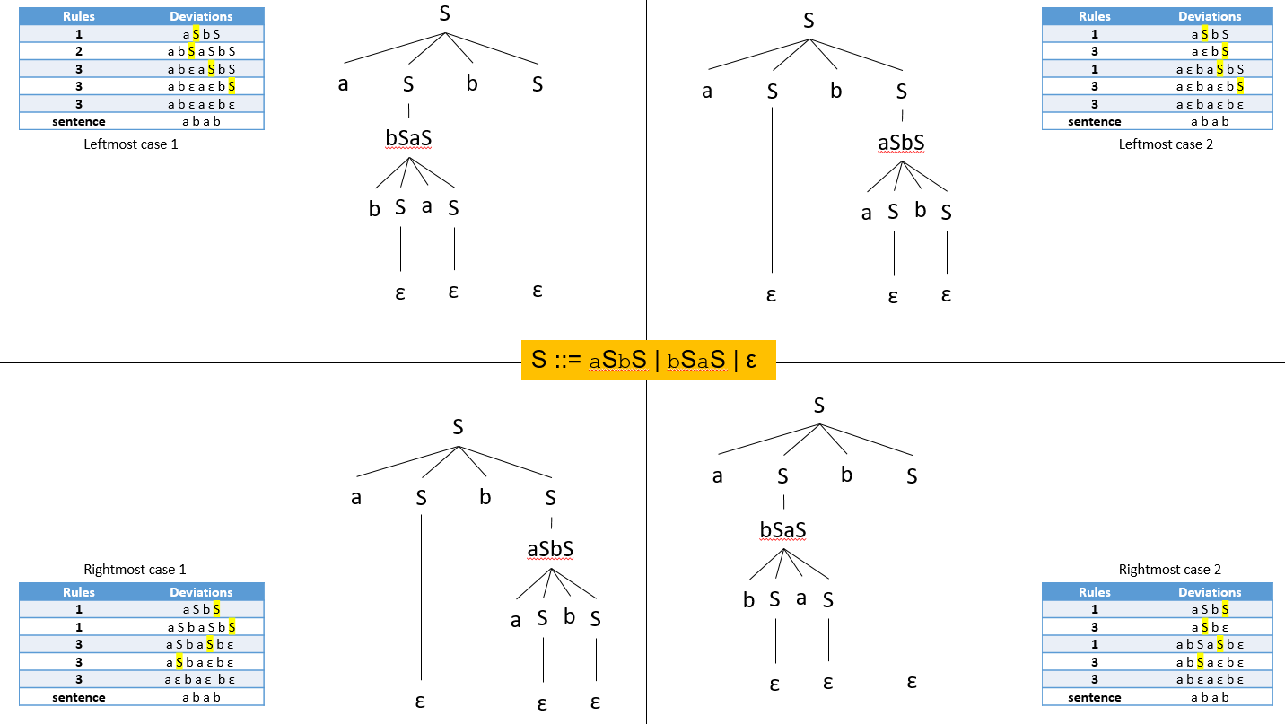

1. (Aho, Sethi, Ullman) Given the following grammar:  
     
   S ::= ( L ) | x  
   L ::= L , S | S
   1. Give a left-most derivation of (x, (x, x)) .
   2. Give a right-most derivation of (x, (x, x)) .
   3. Show the steps that a shift-reduce parser goes through when it parses (x, x, x) . That is, show the contents of the stack and remaining input at each step.
   4. Suppose we replace the left-recursive production L::=L,S with a right-recursive one L::=S,L. What general effect does this have on the depth of the stack during a shift-reduce parse? (You might work through the parse of (x, x, x) again to see what changes.)
2. (see below)
3. (see below)

|  |  |
| --- | --- |
| Leftmost derivation | Rightmost derivation |
| **S** | **S** |
| (**S**, S) | (S, **S**) |
| (x, **S**) | (S, (**L**)) |
| (x, (**L**)) | (S, (L, **S**)) |
| (x, (**L**, S)) | (S, (**L**, x)) |
| (x, (**S**, S)) | (S, (**S**, x)) |
| (x, (x,**S**)) | (**S**, (x, x)) |
| (x, (x, x)) | (x, (x, x)) |

1. L::=L, S|S

|  |  |
| --- | --- |
| Steps | Stacks |
| 0 | (x, x, x) |
| 1 | (S, x, x) |
| 2 | (L, x, x) |
| 3 | (L, S, x) |
| 4 | (L, x) |
| 5 | (L, S) |
| 6 | (L) |
| 7 | S |

1. L::=S, L|S

|  |  |
| --- | --- |
| Steps | Stacks |
| 0 | (x, x, x) |
| 1 | (S, x, x) |
| 2 | (S, x, x) |
| 3 | (S, S, x) |
| 4 | (S, S, S) |
| 5 | (S, S, L) |
| 6 | (S, L) |
| 7 | (L) |
| 8 | S |

The depth of the stack increases until we can find the handle, L::= S, L.

1. ~~Postponed until hw3 (LR construction).~~
2. (Appel) Write a grammar for English sentences using the words

time arrow banana flies like a an the fruit

and the semicolon. Be sure to include all the senses (noun, verb, etc.) of each word. Then show that this grammar is ambiguous by exhibiting more than one parse tree for the sentence "time flies like an arrow; fruit flies like a banana". (Hint: do not go overboard. This is not an exercise in computational linguistics or Natural Language Processing. If you've done "sentence diagrams" in grade school, that's the right level of complexity for the grammar here.)

