Test of inline images
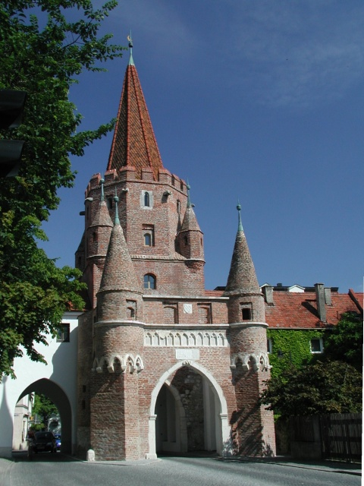
This paragraph contains an image at the right.
This paragraph contains an image in a frame at the left.

This paragraph contains an image with description at the right margin.
Abbildung 1: Kreuztor in Ingolstadt, Germany.

This paragraph contains an image with description at the left margin.
Abbildung 2: Also in Ingolstadt, Germany.

