Build Backend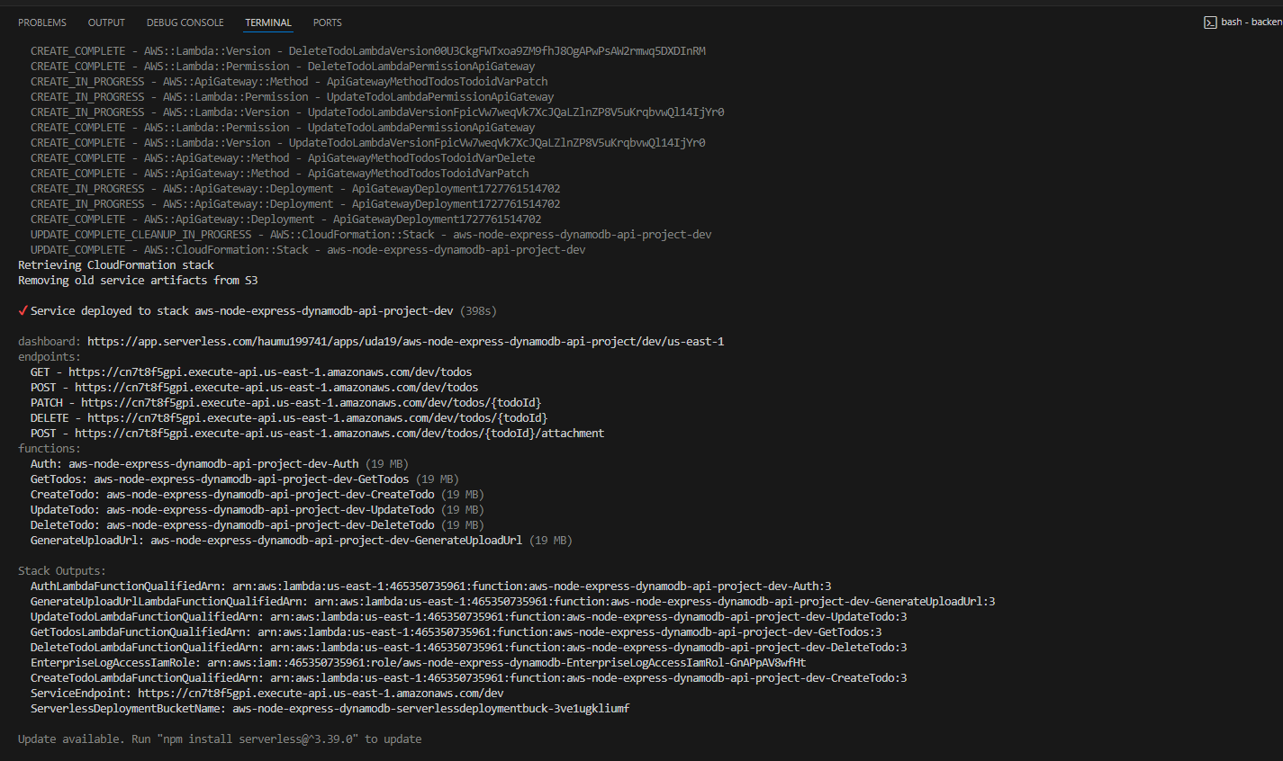

App serverless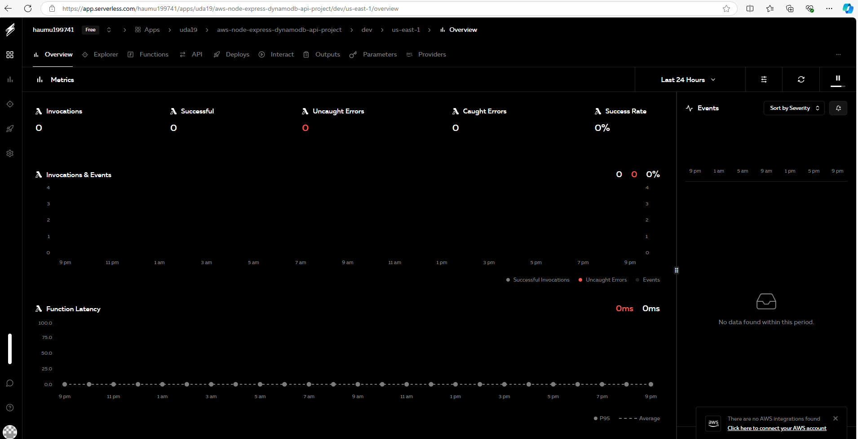

Auth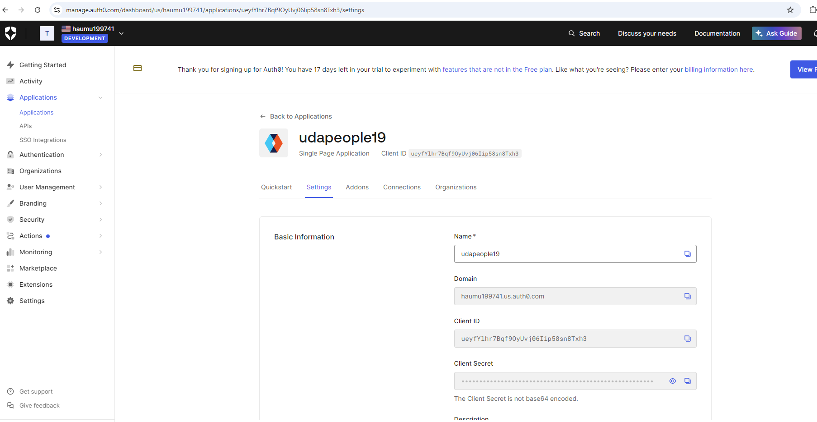

File .ENV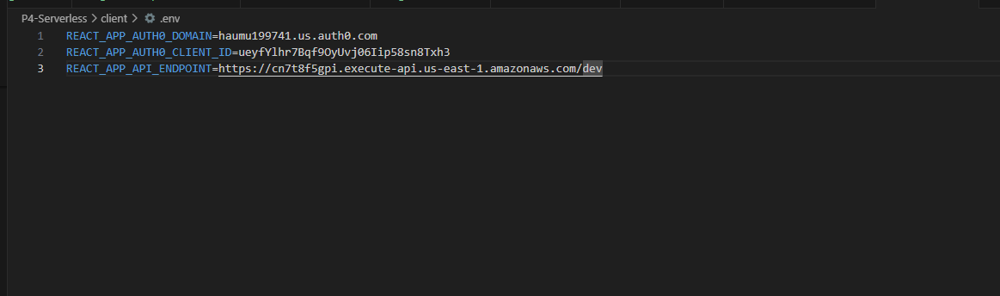

Create todo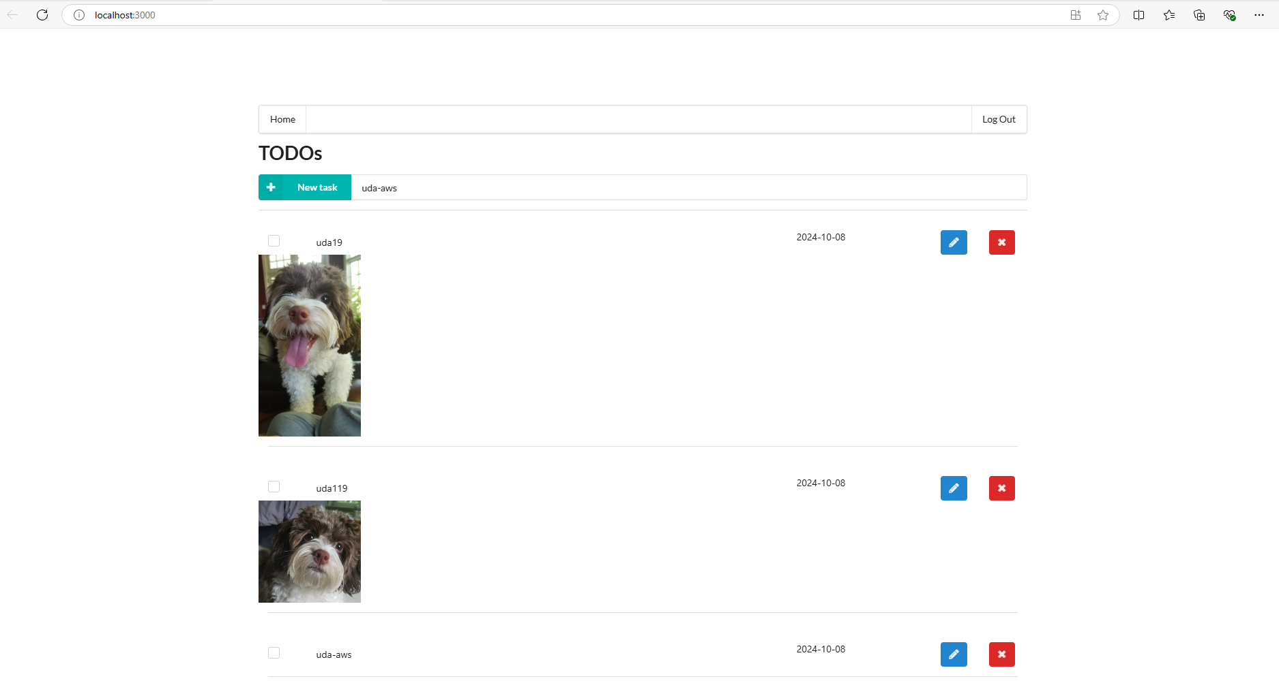

upload a file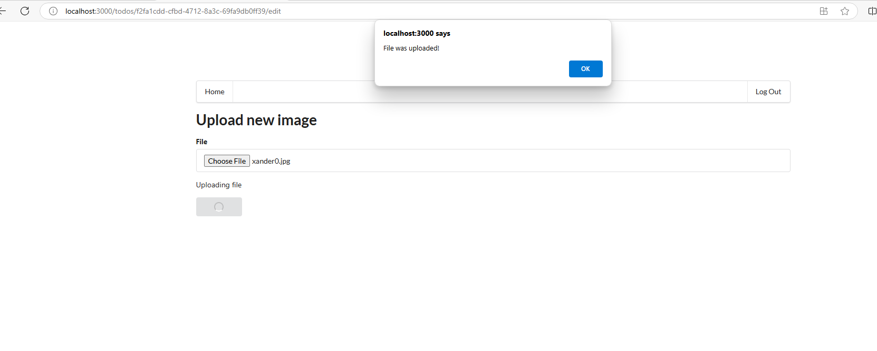

Delete todo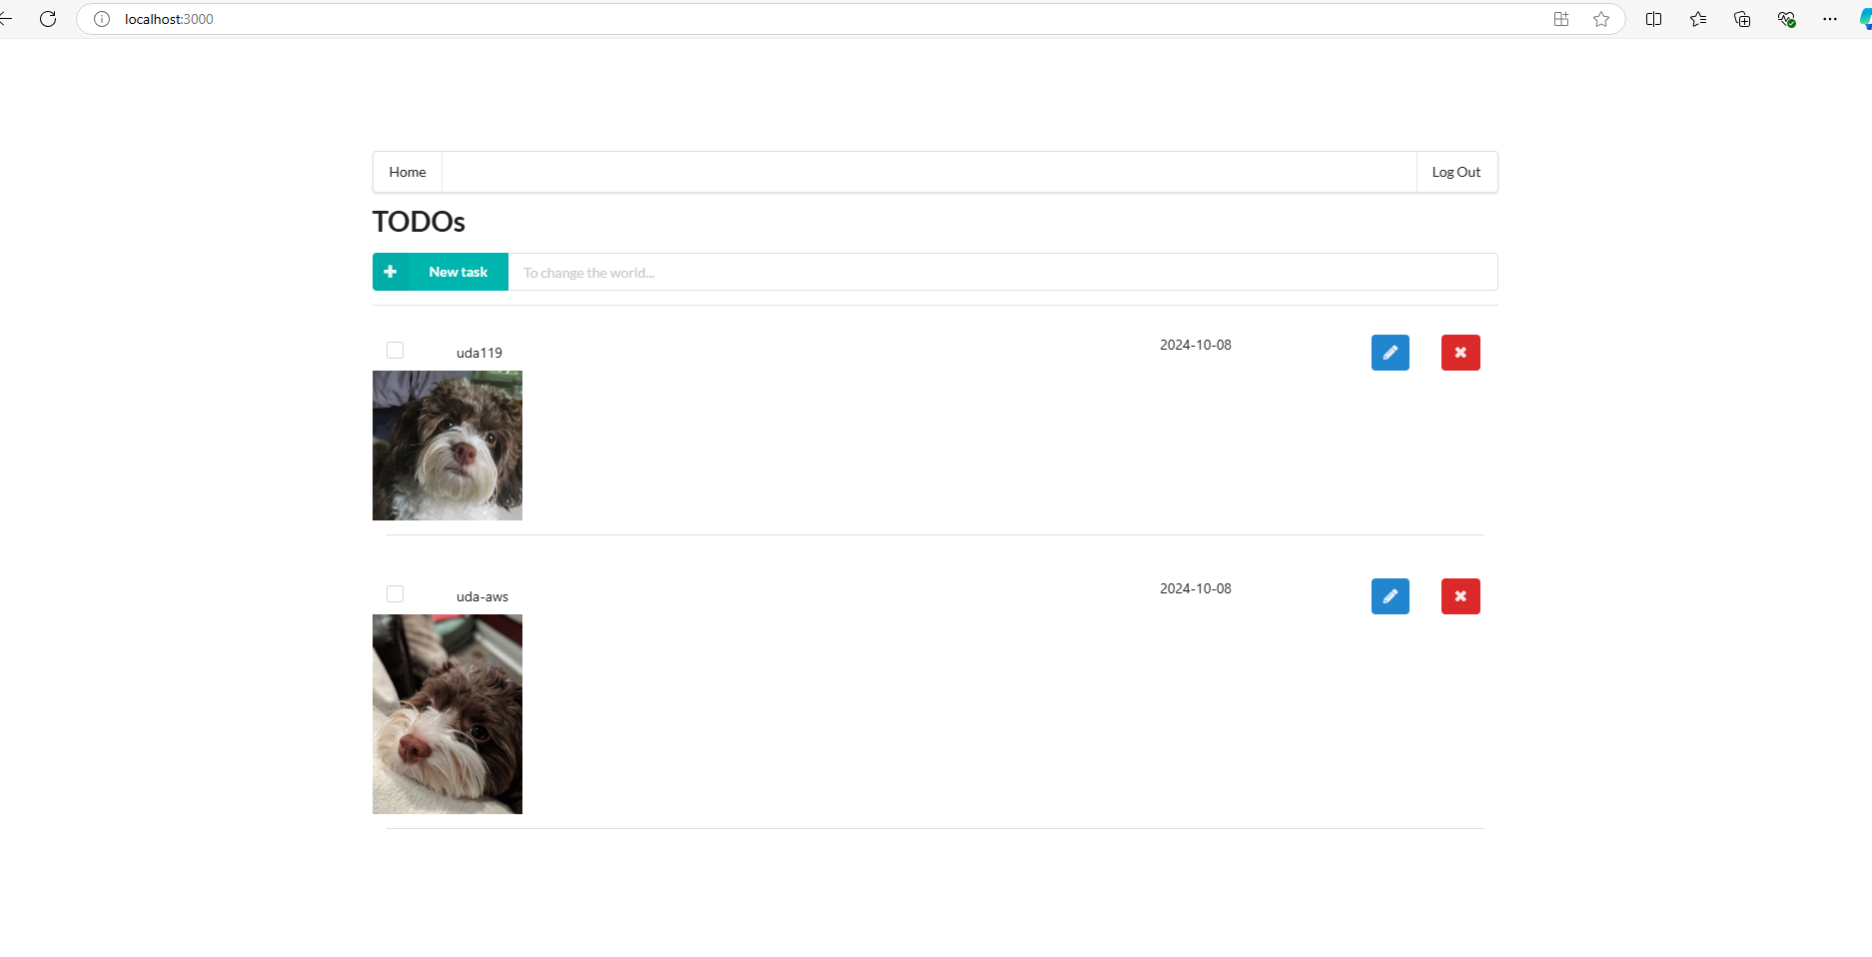

Create fail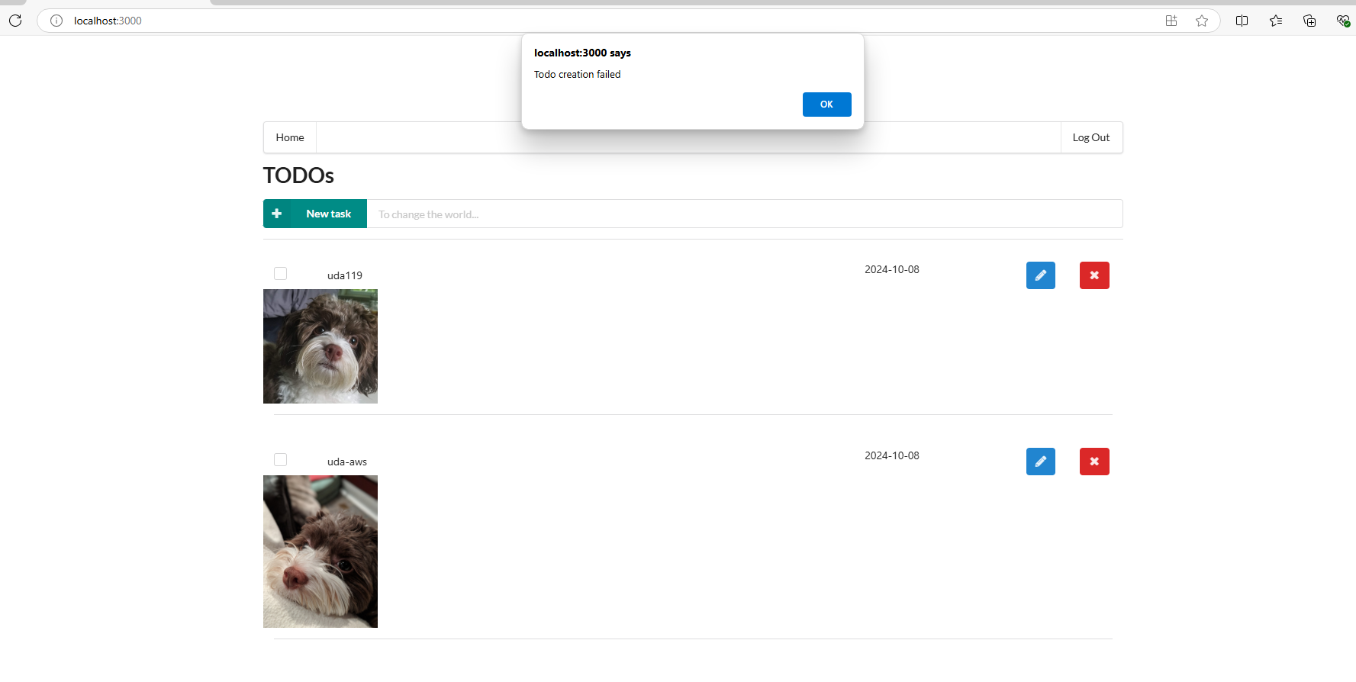

Ckeckbox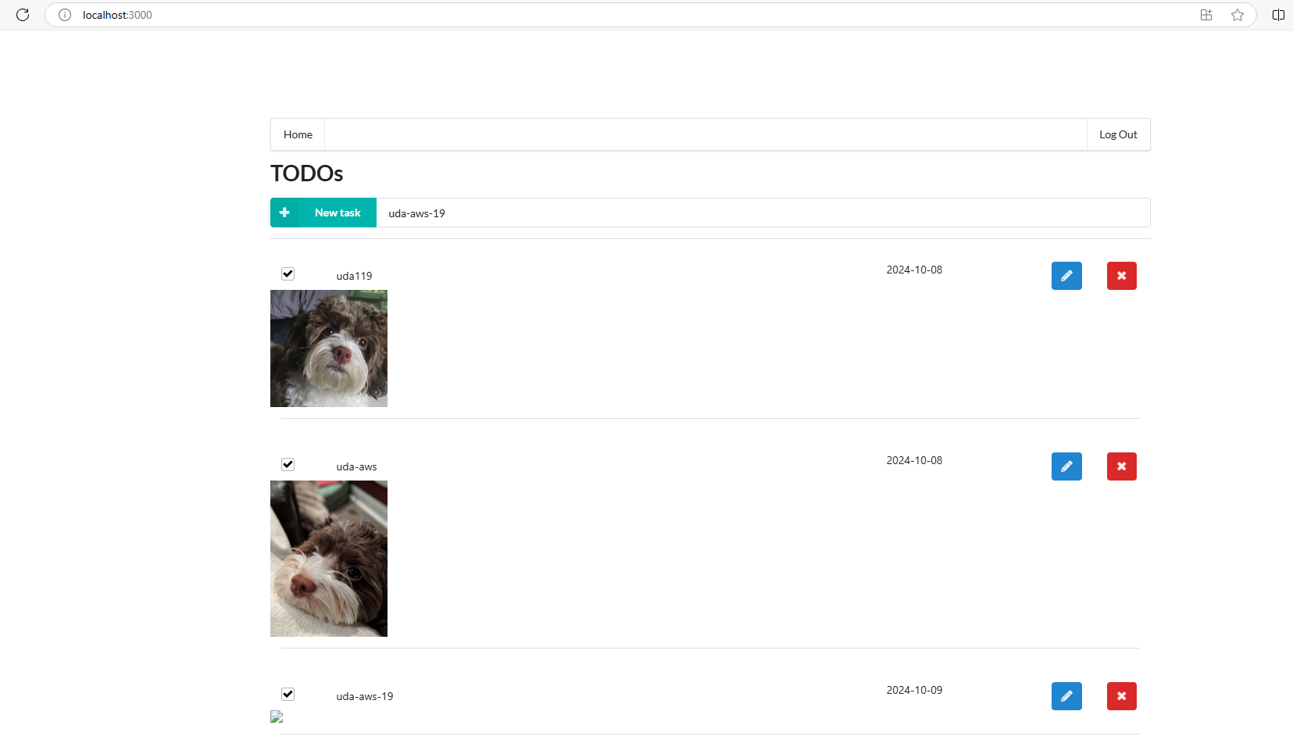

Login with auth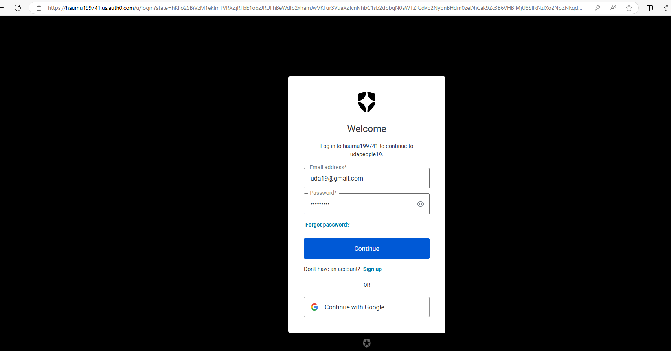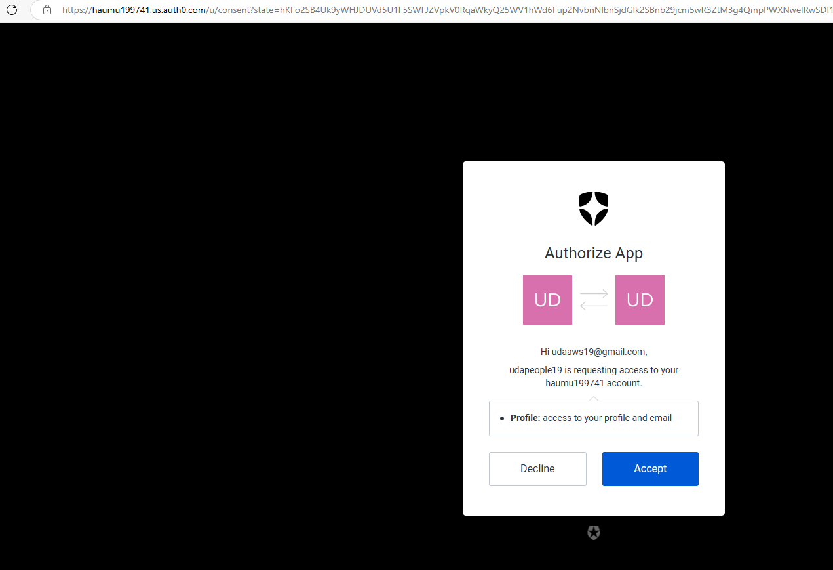

**Deploy the Backend:**

cd backend

npm update --save

npm audit fix

# For the first time, create an application in your org in Serverless portal

serverless

# Next time, deploy the app and note the endpoint url in the end

serverless deploy --verbose

# If you face a permissions error, you may need to specify the user profile

sls deploy -v --aws-profile serverless

# sls is shorthand for serverless

# -v is shorthand for –verbose

**Run the Frontend:**

cd client

npm install

npm run start

Server: http://localhost:3000/