**.**

**Group Project Documentation   
Advanced Cross-Platform Application Programming with .NET**

***Dental Appointment Scheduling Platform***

**Prepared by Bee team**

***Nguyễn Thụy Phúc Lộc - SE170228***

***Nguyễn Trung Hậu - SE170203***

***Nguyễn Nhật Hào - SE170355***

***Nguyễn Trung Kiên - SE173466***

**Ho Chi Minh City, 2024**

**Table of Contents**

**Table of Contents ii**

**Revision History ii**

**1.** **Project Introduction 1**

1.1 Product Perspective 1

1.2 User Classes and Characteristics 1

**2.** **Database Design 1**

**3.** **System Architecture 1**

**4.** **Implementation 2**

4.1. Deployment Considerations 2

4.2. Screenshots and explanations 2

**5.** **References 2**

**Revision History**

| **Name** | **Date** | **Reason For Changes** | **Version** |
| --- | --- | --- | --- |
| Hau Nguyen | 15 May 2024 | Make document |  |

# **Project Introduction**

## **Product Perspective**

The Dental Appointment Scheduling Platform is designed to streamline and enhance the process of booking and managing dental appointments. It is a web-based application aimed at connecting patients with dental clinics and professionals, providing a seamless and efficient scheduling experience. The platform addresses the needs of various users including patients, dentists, clinic owners, and system administrators, offering tailored functionalities to each user group.

## **User Classes and Characteristics**

1. **Guest:**

* View general information about the dental clinic, appointment schedule, and list of services.
* Register and verify personal information to become a customer.

1. **Customer:**

* Schedule a dental appointment once or according to the dentist's periodic treatment schedule
* Receive examination results and treatment information from the dentist.
* Message and communicate directly with the clinic's dentist.

1. **Dentist:**

* View their weekly appointment schedule.
* Propose periodic check-up schedules for patients.
* Upload examination results and treatment information to the system.
* Communicate with patients through the system's chat channel.

1. **Clinic Owner:**

* Register clinic information and verify it.
* Register information about the dentists working in the clinic.
* Manage information, appointment schedules, and patient records.
* Manage communication between dentists and patients.

1. **System Admin:**

* Approve clinic and dentist information.
* Manage user accounts and access permissions.

**1.3 List of business processes**

#### **Main Flow 01: Patient Scheduling an Appointment :**

1. Patient logs into the platform -> (2) Searches for clinics based on location and filters -> (3) Views list of clinics and available services -> (4) Selects a clinic from the search results -> (5)Views detailed information about the clinic (services, operating hours) -> (6) Selects a service -> (7) Views available time slots -> (8) Selects a suitable appointment slot -> (9) Reviews appointment details -> (10) Confirms the appointment booking -> Success make appointment

#### **Main Flow 02: Dentist Managing Schedule**

1. Dentist logs into the platform -> (2) Views weekly schedule and upcoming appointments -> (3) Clicks on specific appointments for details > (4) Updates platform with proposed periodic check-up schedules -> (5) Sends notifications to patients about treatment plans -> (6) Marks appointments as completed or missed.

#### **Main Flow 03: Clinic Owner Managing Clinic Operations**

1. Clinic Owner logs into the platform -> (2)Create and manage clinic details (name, address) -> (3) Registers and manages dentist profiles -> (4) Sends confirmation notifications to patients and dentists -> (5) Monitors clinic performance through reports and analytics

**1.4 Business Rule**

| **ID** | **Business Rule** | **Description** |
| --- | --- | --- |
| BR01 | Valid Email Format | All user email addresses must be in a valid email format. |
| BR02 | Unique Email | Each user email must be unique across the platform. |
| BR03 | Future Appointment Dates | Appointments must be scheduled for future dates only. |
| BR04 | Clinic Operating Hours | Appointments can only be booked during the clinic's operating hours. |
| BR05 | One Active Appointment | A patient cannot have more than one active appointment with the same dentist for the same time slot. |
| BR06 | Patient Confirmation | Patients must confirm their appointment at least 24 hours in advance. |
| BR07 | Appointment Cancellation | Appointments must be cancelled at least 24 hours before the scheduled time. |
| BR08 | Secure Patient Data | Patient data must be stored securely and only accessible by authorized personnel. |
| BR09 | Notification Reminder | Patients must receive a reminder notification 24 hours before their appointment. |
| BR10 | Dentist Availability | Dentists can only be booked for appointments during their set availability hours. |
| BR11 | Clinic Owner Verification | Clinic Owner must verify all new appointments within 2 hours of booking. |
| BR12 | Unique Appointment ID | Each appointment must have a unique ID. |
| BR13 | Valid Contact Information | Patients and clinic owners must provide valid contact information (phone and email). |
| BR14 | User Authentication | All users must authenticate via email and password to access the platform. |
| BR15 | Patient - Dentist Communication | Patients and dentists must be able to communicate securely through the platform |
| BR16 | User Role Restrictions | Users can only perform actions that are permitted by their role |

# **Database Design**

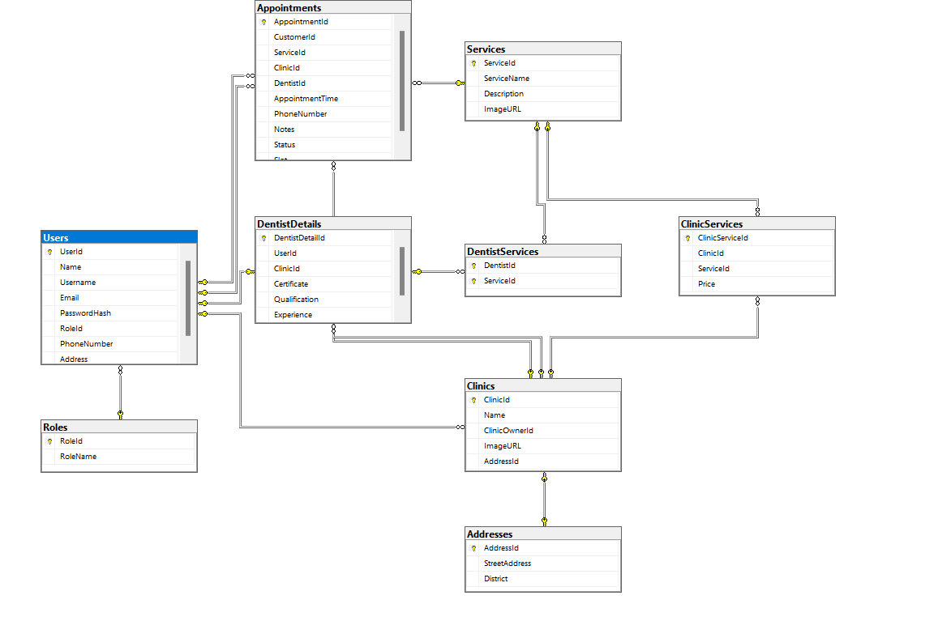

1. **Class Diagram**

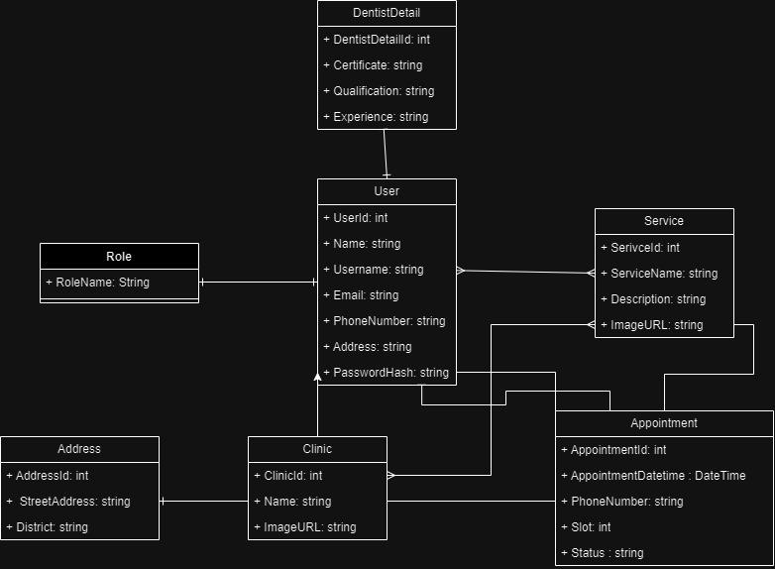

# **System Architecture**

* **Environment:**
* The project will operate on cloud servers, accessible globally via web platforms. Compatibility will be ensured across various operating systems.
* **Design:**
* Web-based application with a client-server architecture.
* Client-side: ….
* Server-side: Using C# with ASP.NET Core, SQL Server.
* **Diagrams:**
* Deployment Diagram: Describing the distribution of components and interactions.
* Class Diagram: Illustrating the class structure and relationships.
* **New Technologies:**
* Serverless Computing: Optimising resource utilisation.
* Containerization: Ensuring consistent deployment across various environments.

=> This architecture ensures scalability, reliability, and performance for the dental clinic scheduling platform.

# **Implementation**

## **Deployment Considerations**

* **Effective Deployment Activities**
* Pre-deployment Testing: Comprehensive testing (unit, integration, UAT), load testing.
* Data Migration: Transfer and verify data.
* Training: Provide training sessions, user manuals, and videos.
* Communication Plan: Inform schedule, provide support channels.
* Post-deployment Monitoring: Monitor system, collect feedback.
* **User Access Requirements**
* Distributed Access: Support time zones, ensure system availability.
* Location and Timing of Access: Support multiple locations, access during and outside business hours.
* **Infrastructure Changes**
* Capacity and Network Access: Ensure server load handling, stable and secure network connectivity.
* Data Storage and Backup: Use cloud storage, regular data backups.
* Training and Business Process Modifications
* Training Materials: Develop guides, conduct training sessions.
* Business Process Changes: Update SOPs, train staff on new processes.
* **Implementation Steps**
* Initial Setup: Set up system, migrate data.
* User Training: Conduct training sessions, distribute materials.
* Go-Live Preparation: Final system checks, announce go-live date.
* Go-Live: Launch, monitor performance, provide support.
* Post-Implementation Review: Collect feedback, improve system.

## **Screenshots and explanations**

1. **Screen flow**
2. **Login**

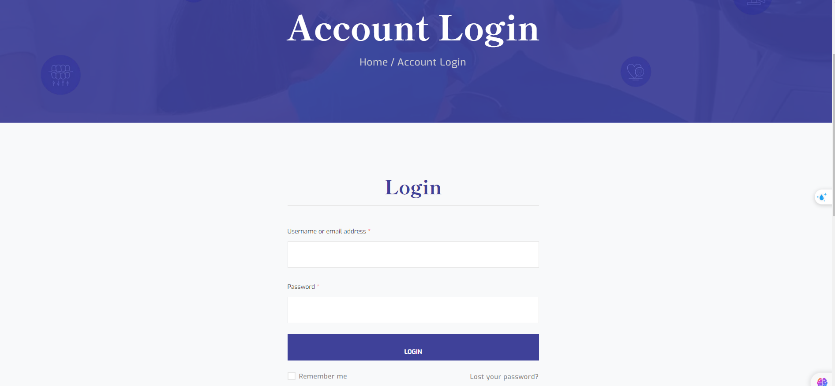

1. **Register**

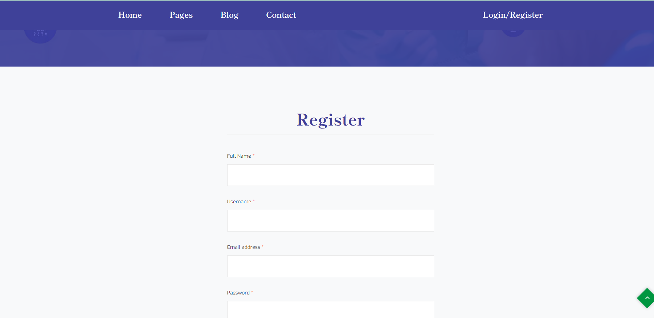

1. **Home Page (Guest)**

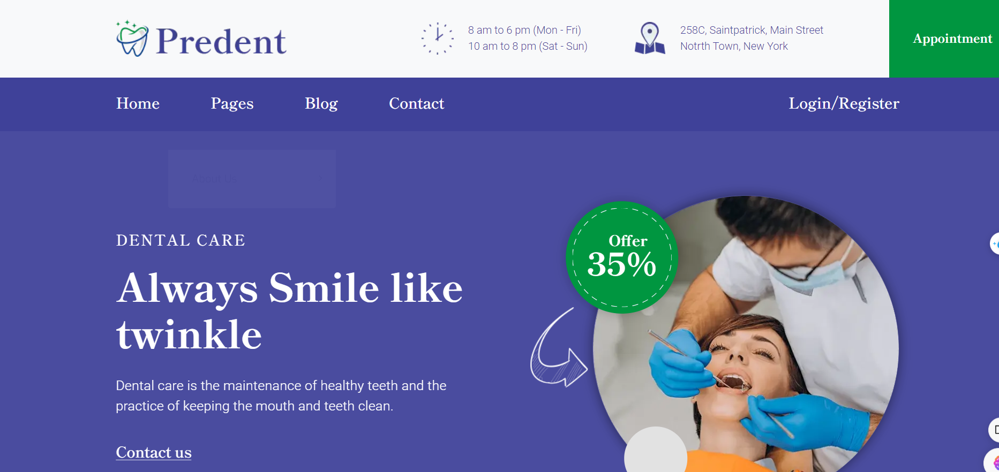

1. **Home Page (Customer)**



1. **Clinic**



1. **Service**



1. **Make Appoinment**



1. **View Appointment**



1. **Reschedule**

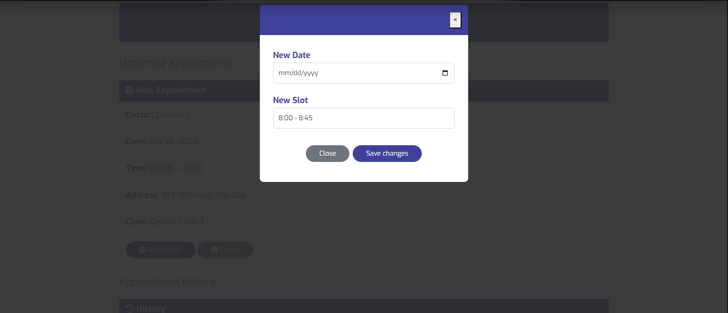

1. **Dentist View Appointment**

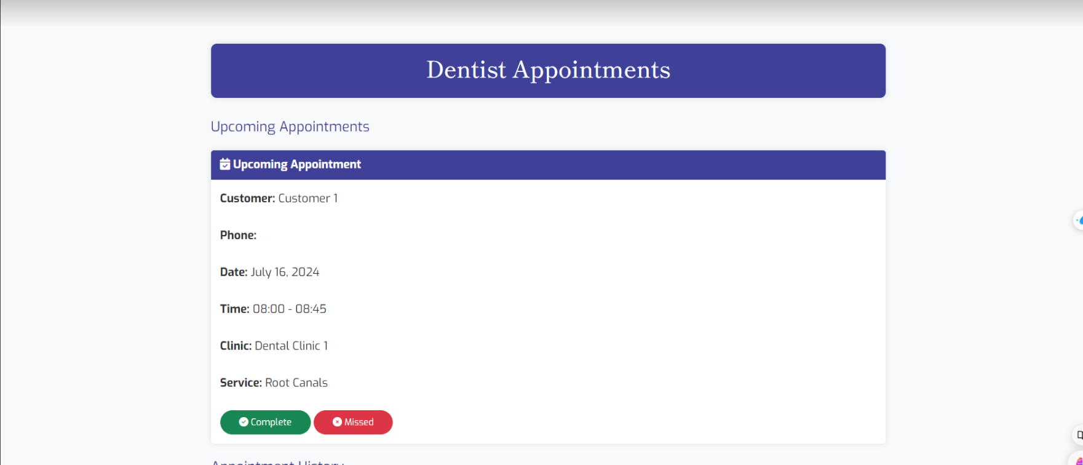

1. **History Appointment**

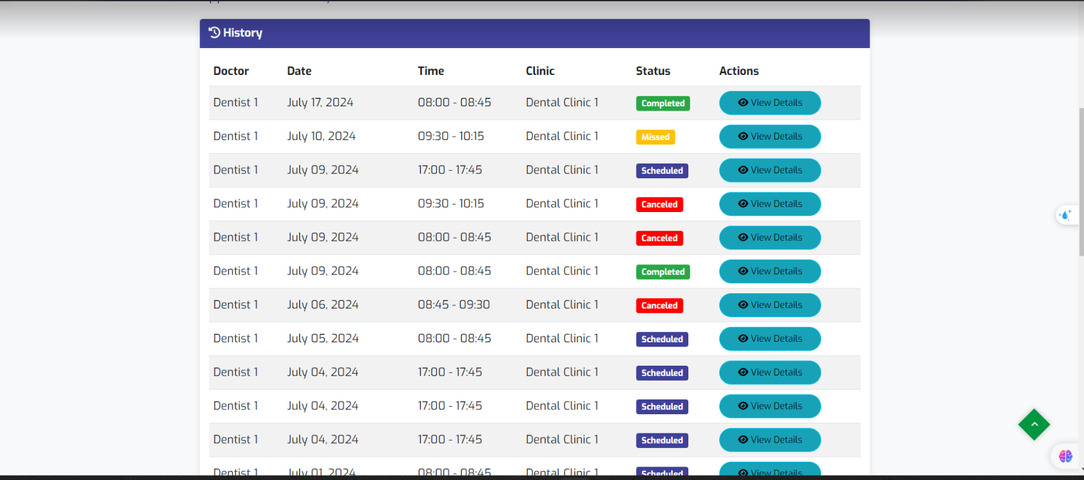

1. **View Detail Appointment**

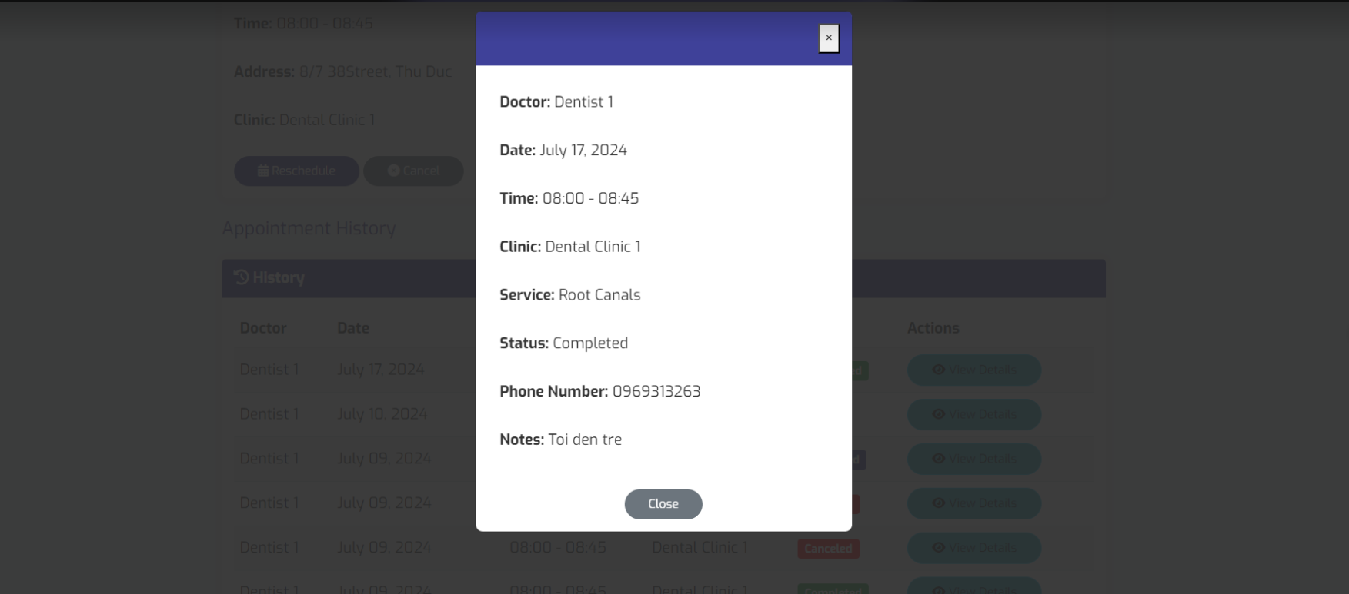

1. **Admin Dashboard**

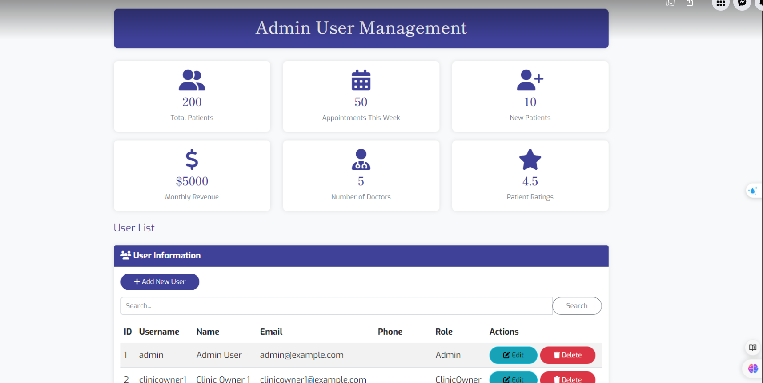

1. **Admin Manage User**

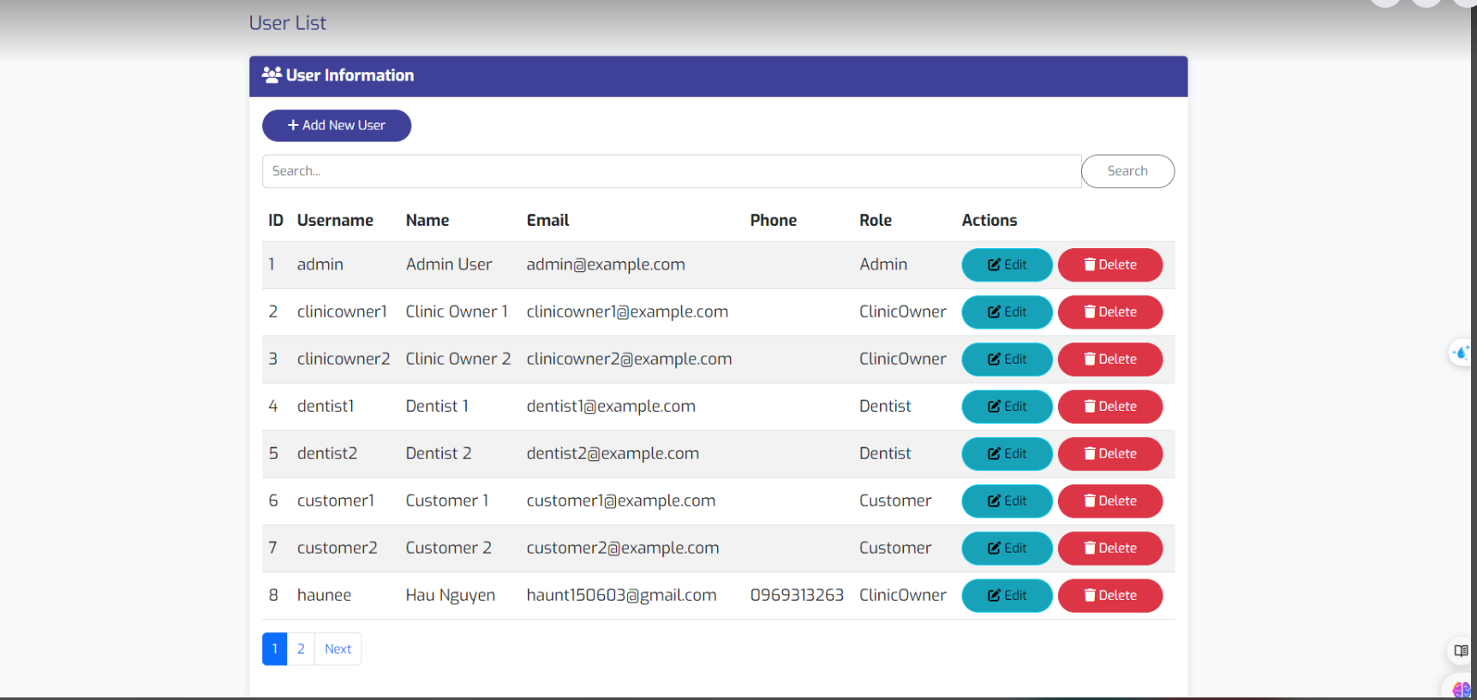

1. **Clinic Management**

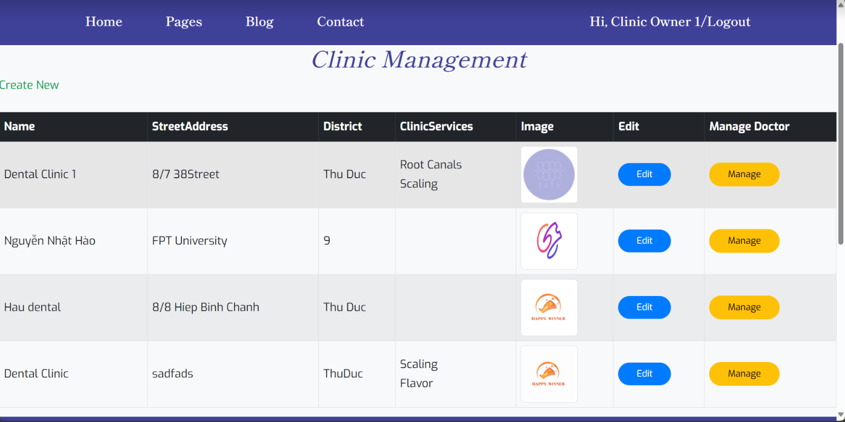

1. **Manage Clinic Doctors**

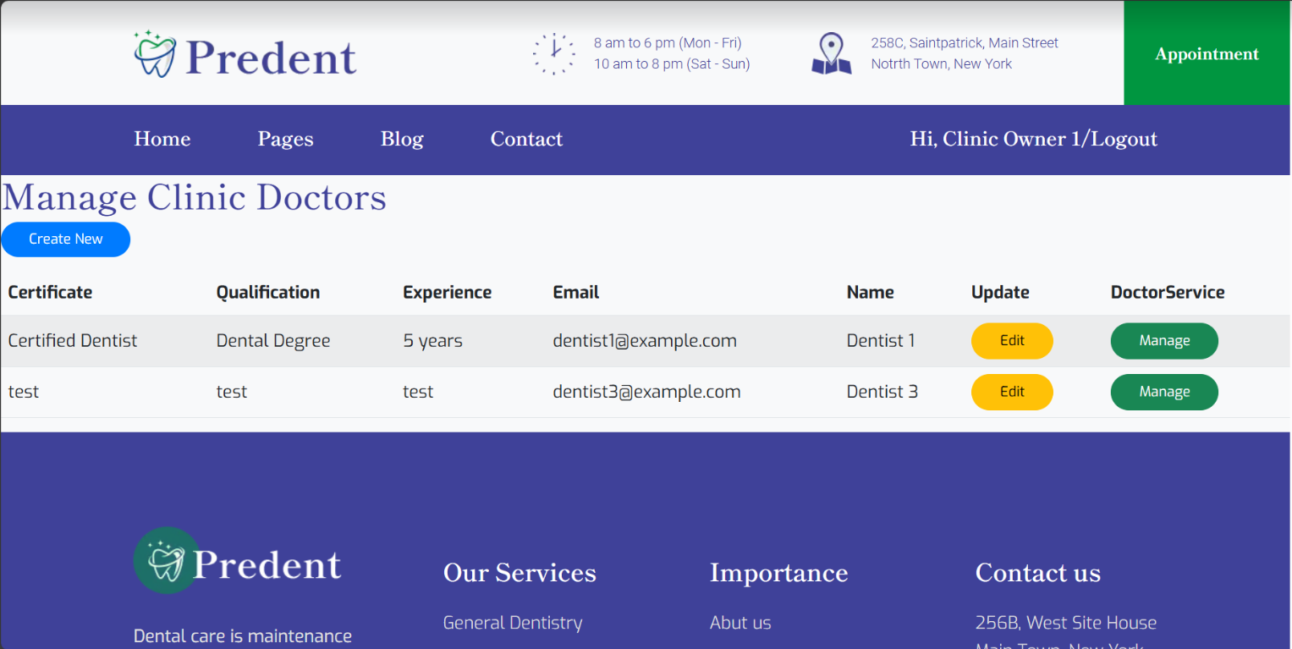

1. **Dialog Map**

# **References**

**Website Template:** <https://htmldemo.net/predent/tf.html?storefront=envato-elements&fbclid=IwZXh0bgNhZW0CMTAAAR2_XNoJiugdAMHTrggD8HRnW3iO9x1I1U4Cxog_1W4uUg2gjJvJ0_2Xi7k_aem_SoOToAIgUxaDnidEfWLJMg>