
EASTERN INTERNATIONAL UNIVERSITY
SCHOOL OF COMPUTING AND INFORMATION TECHNOLOGY


OmniPlant - Manufacturing ERP - Capstone 2

Tran Quoc An - 2231200001
Nguyen Phuc Hau - 2231200065
Dang Cao Cuong - 2231200087

Software Engineering

Ho Chi Minh City, August, 2026
EASTERN INTERNATIONAL UNIVERSITY
SCHOOL OF COMPUTING AND INFORMATION TECHNOLOGY

OmniPlant - Manufacturing ERP - Capstone 2

Tran Quoc An - 2231200001
Nguyen Phuc Hau - 2231200065
Dang Cao Cuong - 2231200087

Software Engineering

Ho Chi Minh City, August, 2026

ABSTRACT
OmniPlant is a web-based Manufacturing Enterprise Resource Planning system designed for small and medium-sized assembly manufacturers. The Capstone 2 phase transforms the analytical foundation and prototype produced in Capstone 1 into an API-backed production loop that links customer demand, material planning, production execution, quality disposition, inventory and traceability. The implemented flow begins with a confirmed Sales Order, creates an immutable Material Requirements Planning run, explodes active multi-level Bills of Materials, nets eligible stock and safety stock, emits MAKE and deferred BUY suggestions, converts approved production suggestions into Work Orders, reserves and issues materials, records manual work-in-progress results, approves production receipts and releases accepted finished goods through a HOLD-to-AVAILABLE quality gate.
The solution combines a Next.js and TypeScript frontend with a Spring Boot modular-monolith backend, PostgreSQL, Redis, JWT authentication and dynamic role-based access control. Capstone 2 emphasizes operational correctness: immutable BOM and Routing snapshots, Plant and Warehouse scoping, lot/serial genealogy, exclusion of HOLD and REJECTED stock from planning, retry-safe idempotent commands, confirmation for integrity-sensitive actions, and bilingual desktop/tablet workspaces. Live integration and regression acceptance demonstrate the complete production spine from Sales Order demand to quality-approved inventory. Full Purchasing, delivery and invoicing, detailed manufacturing costing, OEE and MES/PLC integration remain intentionally deferred to Capstone 3. Standalone Production Estimation is not part of the focused Capstone 2 MVP because the authoritative Planning Run covers the operational MRP purpose.

ACKNOWLEDGEMENT
First and foremost, we would like to express our deepest gratitude to our project supervisor, Mr. Ha Minh Ngoc, for his invaluable guidance, continuous support and constructive feedback throughout the Capstone 2 implementation phase. His academic insight and careful reviews helped the team convert the Capstone 1 design into a coherent, testable and deployable Manufacturing ERP production loop.
We also extend our sincere appreciation to Mr. Tran Phan Thien Phuc, Project Manager at the Industry 4.0 Innovation Centre. His manufacturing-domain mentorship was essential in validating the Sales Order, MRP, Work Order, material issue, work-in-progress, production receipt and quality-control boundaries, especially where the academic design had to be adapted to a practical ERP environment without MES integration.
We are grateful to the faculty members of the School of Computing and Information Technology at Eastern International University for the technical foundation, facilities and academic environment provided throughout the project.
Finally, we thank our families, peers and team members for their patience, motivation and close collaboration during the design, implementation, integration, testing and documentation of OmniPlant.

TABLE OF CONTENTS
ABSTRACT I
ACKNOWLEDGEMENT II
TABLE OF CONTENTS III
LIST OF FIGURES VI
LIST OF TABLES VII
LIST OF ABBREVIATIONS VIII
CHAPTER 1. INTRODUCTION 1
1.1. Project Background 1
1.2. Problem Statement 1
1.3. Project Objectives 2
1.4. Project Scope 2
1.4.1. In-Scope for Capstone 2 2
1.4.2. Out-of-Scope and Deferred 3
1.5. Capstone 2 Contributions 3
1.6. Report Structure 4
CHAPTER 2. RELATED WORKS 5
2.1. Overview of Existing Systems 5
2.2. Comparative Analysis 5
2.3. Identified Gap and Design Position 5
CHAPTER 3. SYSTEM ARCHITECTURE, ANALYSIS, DESIGN AND IMPLEMENTATION 7
3.1. Technical Design Overview 7
3.2. Actor and Access Model 8
3.2.1. ADMIN Actor 8
3.2.2. MANAGER Actor 8
3.2.3. OPERATOR Actor 8
3.3. Functional Module Design 9
3.4. Overall Production Activity 10
3.4.1. Authentication and Master Data Setup 10
3.4.2. Sales Order and Demand Flow 10
3.4.3. Material Planning and MRP 11
3.4.4. Work Order, Reservation and Release 11
3.4.5. Material Issue and Manual WIP Execution 12
3.4.6. Production Receipt, Approval and QC 12
3.4.7. Inventory and Reporting 12
3.5. Business Rules and State Controls 13
3.6. Data Model and Traceability 13
3.7. API, Security and Network Resilience 14
3.8. Frontend Interaction and UI/UX Design 15
3.9. System Operation and Deployment 15
CHAPTER 4. RESULTS AND DISCUSSION 17
4.1. Implementation Results 17
4.2. API-Backed Interface Evidence 17
4.2.1. Dashboard Overview 18
4.2.2. Item Master 19
4.2.3. Stock Balance 20
4.2.4. Inventory Lots 21
4.2.5. Stock Movement History 22
4.2.6. BOM List 23
4.2.7. Active BOM Detail 24
4.2.8. Multi-Level BOM Tree 25
4.2.9. Sales Order List 26
4.2.10. Sales Order Detail 27
4.2.11. Material Planning Workspace 28
4.2.12. Planning Run Detail 29
4.2.13. Work Order List 30
4.2.14. Work Order Detail 31
4.2.15. Material Issue Workspace 32
4.2.16. Production Execution Workspace 33
4.2.17. Production Receipt List 34
4.2.18. Inventory Lots after Quality Control 35
4.2.19. Login and Session Initialization 36
4.2.20. User Management 37
4.2.21. Role Management 38
4.2.22. Permission Catalog 39
4.2.23. Access Scope Management 40
4.2.24. User Assignment 41
4.2.25. Organization Structure 42
4.2.26. Unit of Measure Management 43
4.2.27. Audit Logs 44
4.3. Validation and Acceptance Results 44
4.4. Operational Demonstration Result 45
4.5. Engineering Discussion 45
4.5.1. Planning Run versus Standalone Production Estimation 45
4.5.2. Immutable Snapshots and Idempotency 45
4.5.3. Availability and Quality Semantics 46
4.5.4. ERP Execution without MES 46
4.6. Known Limitations 46
CHAPTER 5. CONCLUSION AND FUTURE WORKS 47
5.1. Conclusion 47
5.2. Future Works 47
5.3. Recommended Capstone 3 Sequence 48
REFERENCES 49
APPENDIX 50
5.4. Operational State Reference 50
5.5. Focused MVP Screen Inventory 50
5.6. End-to-End Demonstration Checklist 50

LIST OF FIGURES

Figure 1. OmniPlant Capstone 2 system architecture 7
Figure 2. End-to-end Capstone 2 production flow 10
Figure 3. Traceability chain from demand to quality-controlled output 14
Figure 4. Dashboard with API-backed operational overview and alerts 18
Figure 5. Item Master with item types, UOM and tracking-policy evidence 19
Figure 6. Stock Balance with on-hand, reserved and available quantities 20
Figure 7. Inventory Lots with AVAILABLE, HOLD and REJECTED status evidence 21
Figure 8. Stock Movement history with transaction types and trace references 22
Figure 9. BOM list with active and draft lifecycle visibility 23
Figure 10. Active BOM detail with revision, output quantity and component lines 24
Figure 11. Multi-level BOM tree showing nested sub-assemblies and component quantities 25
Figure 12. Sales Order list with lifecycle and fulfillment status evidence 26
Figure 13. Sales Order detail with line allocation and fulfillment quantities 27
Figure 14. Material Planning workspace with confirmed demand and Planning Run history 28
Figure 15. Planning Run detail with shortage and MAKE/BUY supply decisions 29
Figure 16. Work Order list with production lifecycle status evidence 30
Figure 17. Work Order detail with complete reservation readiness 31
Figure 18. Material Issue workspace with component and issue-history evidence 32
Figure 19. Production Execution workspace with good, scrap and rework quantities 33
Figure 20. Production Receipt list with approval and QC lifecycle states 34
Figure 21. Inventory Lots after QC with AVAILABLE, HOLD and REJECTED output 35
Figure 22. Login interface for session and Plant-scope initialization 36
Figure 23. User management with account lifecycle status 37
Figure 24. Role management with active responsibility groups 38
Figure 25. Permission catalog with resource and action codes 39
Figure 26. Access Scope management across organization levels 40
Figure 27. User Assignment form linking User, Role and Scope 41
Figure 28. Organization structure with Company, Plant and Warehouse evidence 42
Figure 29. UOM management with reusable measurement codes 43
Figure 30. Audit Logs with actor, entity, action and timestamp evidence 44

LIST OF TABLES
Table 1. Capstone 2 functional scope 2
Table 2. Comparison of related manufacturing ERP systems 5
Table 3. Technology stack 7
Table 4. Implemented OmniPlant modules 9
Table 5. Core business validation rules 13
Table 6. Production genealogy evidence 14
Table 7. Operational startup and verification checklist 15
Table 8. Capstone 2 delivery summary 17
Table 9. Quality and acceptance evidence 44
Table 10. Recommended Capstone 3 implementation sequence 48
Table 11. Primary document state transitions 50
Table 12. Focused Capstone 2 MVP navigation 50

LIST OF ABBREVIATIONS
No. | Term | Meaning
1 | API | Application Programming Interface
2 | BOM | Bill of Materials
3 | ERP | Enterprise Resource Planning
4 | FEFO | First Expired, First Out
5 | FG | Finished Good
6 | JWT | JSON Web Token
7 | MES | Manufacturing Execution System
8 | MPS | Master Production Schedule
9 | MRP | Material Requirements Planning
10 | OEE | Overall Equipment Effectiveness
11 | QC | Quality Control
12 | RBAC | Role-Based Access Control
13 | ROP | Reorder Point
14 | SME | Small and Medium-sized Enterprise
15 | SO | Sales Order
16 | UOM | Unit of Measure
17 | WIP | Work in Progress
18 | WO | Work Order

INTRODUCTION

Project Background
Manufacturing SMEs operate through a tightly coupled flow of customer demand, material availability, engineering definitions and shop-floor execution. A finished product may depend on multiple levels of semi-finished assemblies and raw materials, while the same warehouse stock can already be reserved, quarantined or rejected. When these relationships are managed with spreadsheets or disconnected applications, a production decision can be based on stale quantities, obsolete BOM versions or incomplete traceability.
Capstone 1 established the OmniPlant concept, domain analysis, database direction, role model and enterprise-style interface. Capstone 2 moves beyond a prototype by implementing the production spine as an integrated ERP workflow. Customer demand is captured as a Sales Order, translated into an immutable Planning Run, converted into traceable Work Orders and executed through controlled stock and quality transactions. The system deliberately avoids claiming MES behavior: actual progress, good quantity, scrap, rework and time are entered manually by authorized users.
The frontend is designed for desktop and tablet use by administrators, production managers, warehouse staff and shop-floor operators. Its visual approach is inspired by ERPNext: compact list views, clear filters, stable forms, status badges and confirmation dialogs are prioritized over promotional or consumer-style layouts.

Problem Statement
The implementation addresses five operational gaps that remain common in smaller manufacturing organizations:
- Disconnected demand and production: Confirmed customer orders are not consistently converted into material requirements and executable production documents.
- Unreliable availability: Physical on-hand stock is often confused with stock that is actually available after reservations and quality status are considered.
- Version drift: A Work Order can become inconsistent when its BOM or Routing master changes after planning unless the selected versions are snapshotted.
- Weak execution traceability: Material issues, WIP confirmations, output receipts and lot genealogy are difficult to reconcile when each step is recorded separately.
- Unsafe retries and approvals: Network failures, duplicate submissions and unconfirmed stock-changing actions can create duplicate or inconsistent records.

Project Objectives
- Deliver an end-to-end production loop: Implement the sequence from confirmed Sales Order demand to QC-approved finished-goods inventory.
- Provide authoritative MRP: Use immutable Planning Runs, multi-level BOM explosion, safety-stock netting and explicit MAKE/BUY suggestions.
- Protect inventory integrity: Separate on-hand, reserved and available quantities; exclude HOLD and REJECTED lots; use append-only movement records.
- Preserve production genealogy: Link Sales Order lines, Work Orders, BOM/Routing snapshots, issued lots, WIP confirmations, Production Receipts and output lots.
- Enforce role and scope control: Apply dynamic permissions and Plant/Warehouse access at navigation, route, action and data levels.
- Support resilient ERP operation: Use idempotency keys, stable API envelopes, explicit errors and forms that preserve user input after failures.
- Validate the implementation: Cover core rules through automated regression, API contract checks and desktop/tablet acceptance.

Project Scope

In-Scope for Capstone 2
Table 1. Capstone 2 functional scope
Area | Implemented Capstone 2 boundary
Platform and administration | Authentication, rotating session tokens, users, roles, permissions, access scopes, Plant selection and audit visibility.
Manufacturing foundation | UOM, Item Master, Item-Warehouse settings, multi-level BOM, inventory balances, lots and stock movements.
Demand and planning | Sales Orders, confirmed planning demand, immutable Planning Runs, BOM explosion, safety-stock netting, exception reporting and MAKE/BUY suggestions.
Production documents | Work Order creation/conversion, demand allocation, BOM/Routing snapshots, material readiness, release and cancellation.
Execution | Reservation, Material Issue, over-BOM variance seam, manual good/scrap/rework/time confirmation and WIP trace.
Receipt and quality | Partial Production Receipts, Manager approval/rejection, HOLD output and QC disposition to AVAILABLE or REJECTED.
Reporting and UX | Inventory Dashboard, low-stock alerts, movements, bilingual EN/VI UI, loading/empty/error states and desktop/tablet support.

Out-of-Scope and Deferred
- Full Purchasing: Supplier lifecycle, Purchase Requisition, Purchase Order, Goods Receipt and commercial approval workflow are deferred to Capstone 3. BUY suggestions remain visible but read-only in the focused MVP.
- Sales fulfillment: Delivery orders, invoicing, payment and customer credit are deferred.
- MES and telemetry: PLC/IoT integration, automatic machine signals, dispatching, downtime and OEE are deferred; Capstone 2 uses manual ERP confirmation.
- Detailed costing: Labor, overhead, WIP valuation, standard-versus-actual cost and profitability are deferred.
- Advanced scheduling: Capacity warnings and Routing context are retained, but automatic finite-schedule optimization is not part of the focused MVP.
- Standalone Production Estimation: The legacy what-if calculator is not included in the Capstone 2 production spine because the API-backed Planning Run is the authoritative MRP function.

Capstone 2 Contributions
The principal contribution of Capstone 2 is not a collection of unrelated screens but a controlled state transition across business documents. Each transition has an owner, permission, validation rule, inventory effect and trace relationship. This design allows the same flow to be demonstrated from demand through approved output without inventing MES data or bypassing the inventory ledger.
A second contribution is the separation of master data from execution evidence. Active BOM and Routing versions are selected at planning time, while a Work Order receives immutable snapshots. The resulting document can therefore be audited even when engineering masters later change.

Report Structure
- Chapter 1 introduces the implementation problem, objectives, Capstone 2 scope and contributions.
- Chapter 2 compares the focused OmniPlant approach with established ERP manufacturing systems.
- Chapter 3 documents architecture, actors, modules, workflows, business rules, APIs, security, traceability and system operation.
- Chapter 4 presents implemented results, API-backed interface evidence, testing outcomes, limitations and engineering discussion.
- Chapter 5 concludes the Capstone 2 phase and defines the Capstone 3 roadmap.

RELATED WORKS

Overview of Existing Systems
Commercial and open-source ERP platforms provide useful references for manufacturing workflows. SAP S/4HANA supports large-scale material requirements planning, production planning and detailed scheduling. Odoo provides Bills of Materials, manufacturing orders, work orders, work centers and shop-floor-oriented execution. ERPNext provides production plans, Work Orders, Stock Entries, Job Cards, BOM explosion and inventory integration in a comparatively accessible open-source suite.
These systems confirm the standard manufacturing pattern adopted by OmniPlant: engineering masters precede planning; confirmed demand is converted into planned supply; Work Orders define internal production; material consumption and finished output update inventory through controlled documents. OmniPlant intentionally follows these recognizable concepts so operators do not need to learn an unconventional model.

Comparative Analysis
Table 2. Comparison of related manufacturing ERP systems
System | Relevant strengths | Capstone 2 consideration
SAP S/4HANA | Enterprise-scale MRP, PP/DS, costing and global integration | High implementation cost and complexity for a focused SME capstone deployment
Odoo Manufacturing | Configurable manufacturing orders, work centers, shop-floor and inventory integration | Broad suite and configuration surface can exceed the targeted workflow
ERPNext | Accessible BOM, Production Plan, Work Order and stock-oriented workflow | Still includes a wider generalized ERP model requiring adaptation
OmniPlant | Focused demand-to-QC production loop, dynamic RBAC, lot genealogy and explicit manual-without-MES boundary | Narrower scope; purchasing, finance, MES and detailed costing are deferred

Identified Gap and Design Position
The gap addressed by OmniPlant is not the absence of mature ERP software. It is the difficulty of applying a large generalized platform to a small manufacturing team that needs a transparent, demonstrable and traceable production loop. OmniPlant therefore selects a smaller number of concepts and makes their rules explicit: what stock is eligible, when a Work Order is releasable, who approves a receipt, how quality affects availability and how one can navigate from a customer order to an output lot.
The project also distinguishes operational planning from ad-hoc estimation. ERPNext and comparable suites demonstrate that production planning begins with demand and creates executable production documents. Capstone 2 adopts this operational model through immutable Planning Runs. A separate one-product what-if estimator may still be useful in a future presentation or quotation context, but it is not allowed to replace the MRP evidence in the implemented scope.

SYSTEM ARCHITECTURE, ANALYSIS, DESIGN AND IMPLEMENTATION

Chapter Overview
This chapter presents the analysis, architectural design, business-process design, database structure, and implementation principles of OmniPlant. The chapter begins with the overall technical architecture and actor model before describing how the main actors interact with the system. It then explains the end-to-end operational workflow through a swimlane activity diagram.
The database design is divided into six major functional modules. This modular presentation makes the data model easier to understand while preserving the relationships among administration, master data, sales and planning, purchasing, inventory, and manufacturing execution. The final sections describe the core business rules, API and security design, frontend interaction principles, and deployment environment.

System Architecture

Architectural Style
OmniPlant is implemented as a web-based Manufacturing ERP system using a modular-monolith architecture. This approach maintains a single deployable backend while separating the application into clear functional modules. It provides simpler deployment and transaction management than a distributed microservice architecture while still preserving domain boundaries.
The frontend is responsible for user interaction, client-side validation, permission-aware navigation, query state, internationalization, and responsive presentation. The backend remains the authoritative source for authentication, authorization, business-state transitions, inventory effects, material planning calculations, approval rules, and database consistency.
PostgreSQL stores transactional and master data, while Redis supports session and token-management functions. Communication between the frontend and backend is performed through RESTful API endpoints under the /api/v1 namespace.
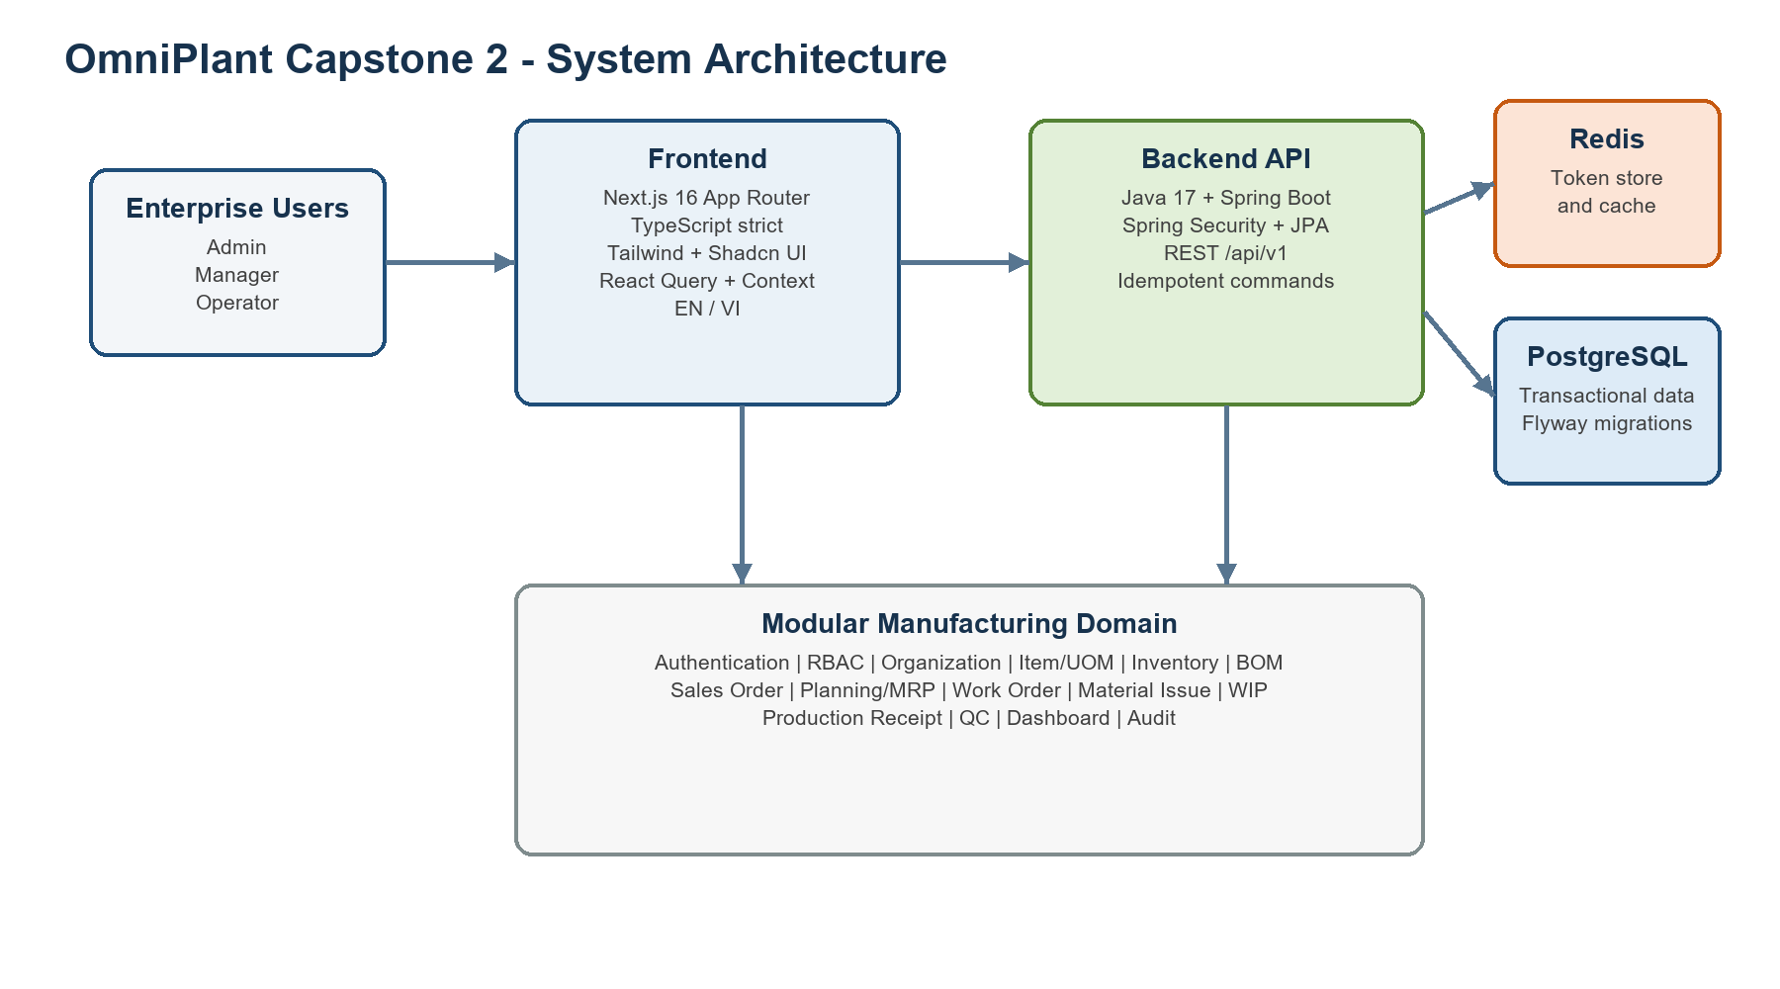
Figure 1. OmniPlant Capstone 2 system architecture
The architecture separates presentation concerns from business authority. Although the frontend prevents invalid actions where possible, all critical rules are revalidated by the backend. This includes Plant and Warehouse access, Work Order release readiness, material availability, approval permissions, quality disposition, and idempotent inventory transactions.

Technology Stack
The major technologies and their responsibilities are summarized in the following table.
Layer | Technology and responsibility
Frontend | Next.js 16.2.10 App Router, React 19, TypeScript strict
UI and styling | Tailwind CSS, customized Shadcn UI and Lucide icons
Client state | React Query for server state; Context API for authentication and selected Plant
Internationalization | next-intl with English and Vietnamese namespaces
Backend | Java 17, Spring Boot, Spring Security and JPA/Hibernate
Persistence | PostgreSQL with Flyway migrations; Redis for token/session support
Integration | RESTful /api/v1 endpoints with a standard response envelope and UUID identifiers
Table 3. Table Stack

Functional Analysis and Actor Model

System Actor
OmniPlant defines three primary human actors: Administrator, Manager, and Operator. The actors are separated according to responsibility and authority rather than only by screen visibility.
Actor | Main responsibilities
Administrator | Maintains users, roles, permissions, access scopes, organizational structure, and system-level master data. Reviews audit information and controls access assignments.
Manager | Manages Sales Orders, material planning, supply decisions, Work Orders, purchasing documents, production approvals, quality disposition, and operational monitoring.
Operator | Performs authorized warehouse and production activities, including material reservation, material issue, production reporting, goods receipt, and Production Receipt submission.
System | Performs automated authentication, authorization, MRP calculation, BOM explosion, inventory updates, status transitions, variance calculation, and audit logging.
The System is not a human actor. It represents automated application behavior triggered by the actions of authenticated users.

Use Case Model
Figure 2 presents the functional boundary of OmniPlant and the interactions between its three human actors and the major system functions.
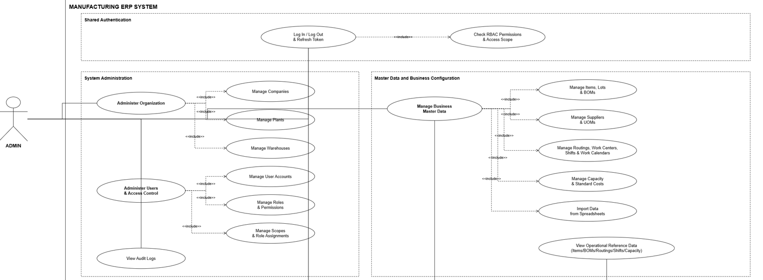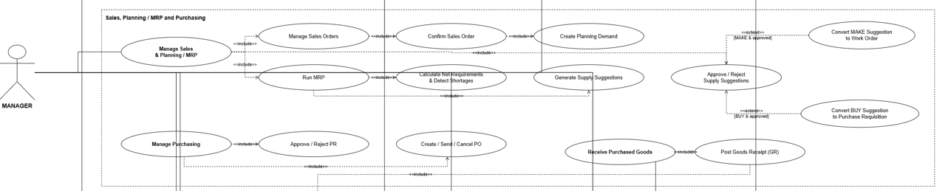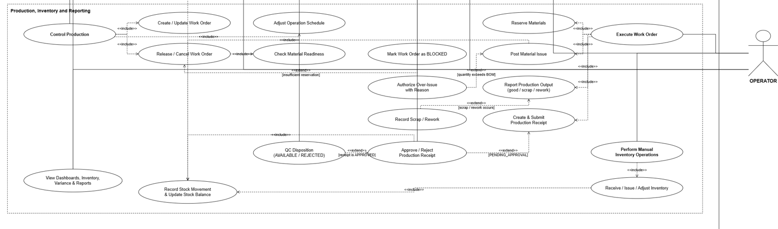
Figure 2. Use case diagram of OmniPlant actors and major system functions.
The use case diagram describes functional responsibility but does not represent execution order. Administrator use cases focus on system configuration, organizational data, access control, and auditability. Manager use cases cover planning, approval, production control, purchasing, and quality decisions. Operator use cases cover the direct execution of inventory, receiving, and manufacturing activities.
Several use cases are shared between actors but are controlled by different permissions. For example, both Managers and Operators may view Work Orders, while only authorized Managers can create or release them. Operators may create and submit Production Receipts, but they cannot approve their own receipts or perform final quality disposition. This separation of duties prevents the same user from executing and approving an integrity-sensitive transaction.

End-to-End Business Process Design
The operational behavior of OmniPlant is document-driven. A user cannot move directly from demand to inventory output without passing through the required planning, production, approval, and quality-control documents. Figure X presents this workflow using four swimlanes: Administrator, Manager, Operator, and System.
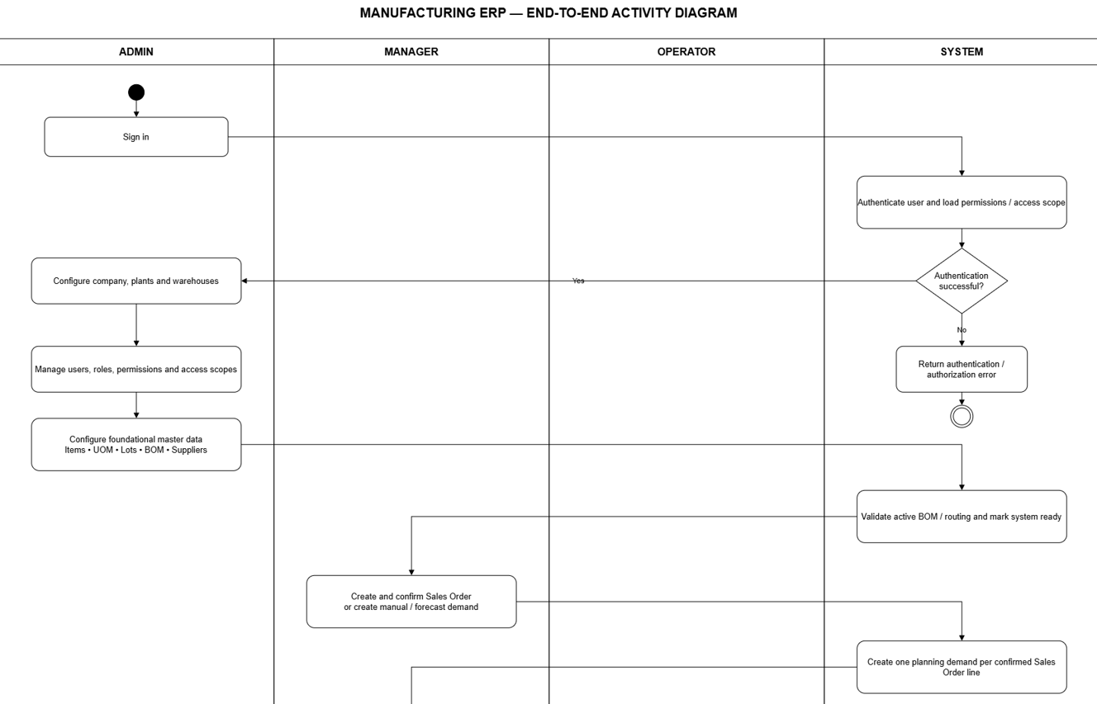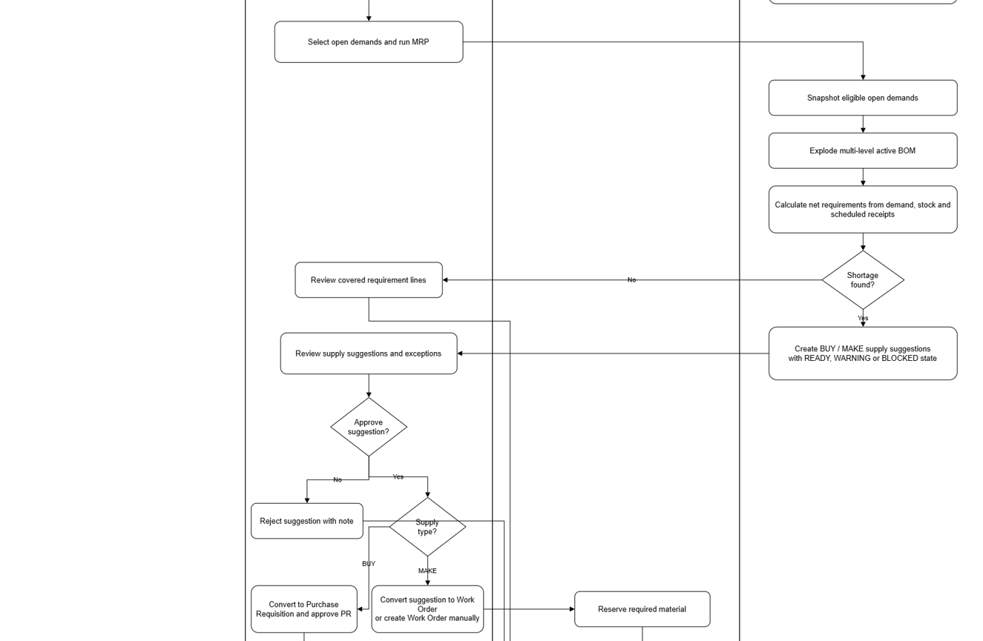
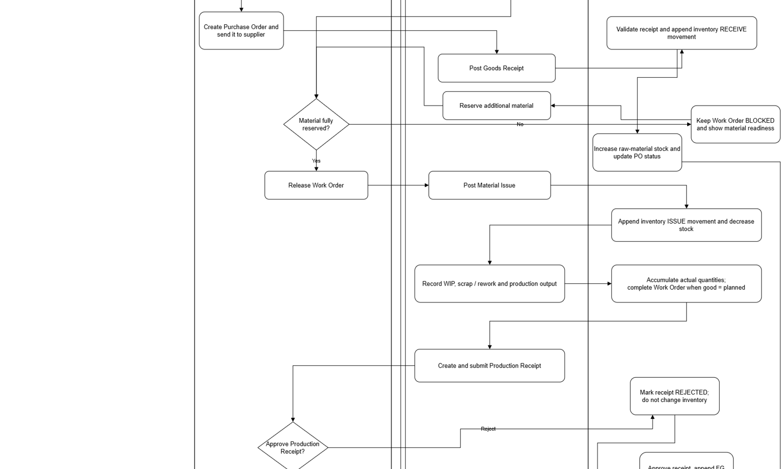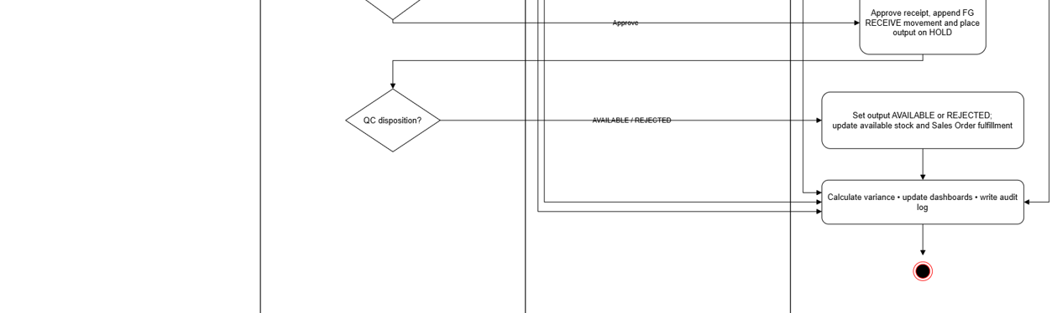
Figure 3. Swimlane activity diagram of the end-to-end OmniPlant business process.
The swimlane diagram identifies both execution sequence and responsibility. Human decisions are assigned to the role that owns the business outcome, while validation, calculation, inventory posting, and audit recording are placed in the System lane. The diagram also demonstrates that the Administrator prepares the operating environment but does not participate directly in daily purchasing or production execution.
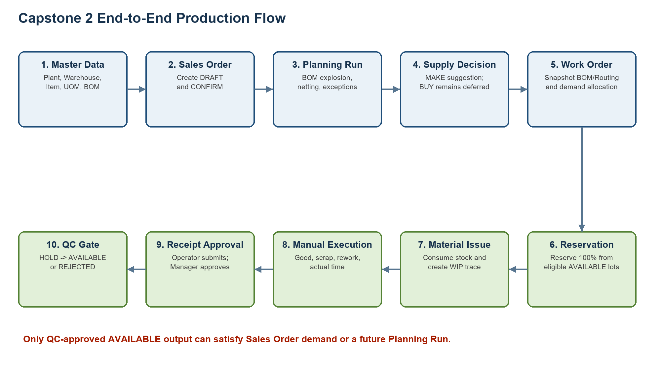
Figure 2. End-to-end Capstone 2 production flow
The complete loop is document-driven. A user cannot skip directly from a shortage to inventory receipt. Each intermediate record controls state, quantity, actor and traceability. This is especially important in a system without MES because manual execution entries must remain distinguishable from planning records and stock ledger events.

System Setup and Access Control
The process begins with authentication and authorization. The System validates the user credentials and loads the corresponding roles, permissions, and access scopes. If authentication fails, the request is rejected without entering the business workflow.
Before operational activities begin, the Administrator configures the Company, Plants, Warehouses, users, roles, permissions, and access scopes. Foundational master data such as units of measure, Items, Bills of Materials, suppliers, Routings, Work Centers, shifts, and work calendars must also be available according to the relevant module permissions.
The System validates important master-data invariants. Examples include preventing circular BOM structures, requiring an active BOM for material explosion, and ensuring that production master data belongs to the correct Company or Plant context.

Sales and Material Planning
A Manager creates and confirms a Sales Order or records a manual or forecast demand. Confirmation converts the commercial requirement into an eligible planning demand. Draft Sales Orders do not participate in MRP.
The Manager selects eligible demand and starts an MRP run. The System creates an immutable snapshot of the selected demand, explodes the active multi-level BOM, evaluates eligible inventory and scheduled supply, and calculates the net requirement.
The principal requirement formula is:
netRequirement = max(0, grossRequirement + stockTarget - projectedAvailable)
If sufficient supply exists, the requirement is marked as covered. Otherwise, the System creates a supply suggestion. A suggestion may recommend purchasing the material or manufacturing it internally. The Manager reviews the suggestion, its exception state, and any missing BOM or Routing information before approving, rejecting, or converting it.

Purchasing Flow
For a BUY requirement, an approved supply suggestion may be converted into a Purchase Requisition. The Manager reviews and approves the requisition before converting it into a Purchase Order and sending the order to the selected supplier.
When the supplier delivers the material, the Operator posts a Goods Receipt. The System validates the Purchase Order line, Warehouse, received quantity, lot information, and idempotency key. A valid receipt creates an inventory RECEIVE movement, increases raw-material stock, and updates the received quantity and status of the Purchase Order.

Manufacturing Execution Flow
For a MAKE requirement, an approved suggestion is converted into a Work Order. The Work Order stores the selected product, planned quantity, output Warehouse, BOM evidence, Routing evidence, and demand allocations.
Materials are reserved before release. Reservation reduces available quantity but does not change physical on-hand stock. If the reservation does not cover all component requirements, the System keeps the Work Order in the BLOCKED state and reports the missing quantities. After sufficient material is reserved, the Manager releases the Work Order.
The Operator posts a Material Issue for eligible reserved components. The System creates an inventory ISSUE movement and decreases the corresponding stock balance. Issues above the Work Order BOM requirement require an explicit reason and an authorized override.
During production, the Operator records good, scrap, and rework quantities. These transactions update the Work Order’s actual quantities and preserve WIP evidence. OmniPlant records these results manually and does not claim automated MES or machine-data integration.

Material Issue and Manual WIP Execution
Material Issue references the Work Order, component requirement, Warehouse and required lot/serial. The transaction cannot exceed the eligible available or reserved quantity. An issue above the Work Order BOM snapshot is treated as a material variance and requires an explicit reason and override permission before posting.
A successful issue consumes reservation, creates an inventory ISSUE movement and transfers the quantity into a WIP trace. Because MES is outside the current scope, the Operator manually records actual start/end time, good output, scrap, rework and notes. Cumulative good output is validated against the Work Order planned quantity, and required execution preconditions prevent completion without issued material.

Production Receipt, Approval and QC
The Operator may create multiple partial Production Receipts from confirmed good WIP. The cumulative quantity cannot exceed the available WIP output or the Work Order planned quantity. Submission creates a PENDING_APPROVAL document; rejection requires a reason and has no inventory effect.
Manager approval creates finished output in HOLD. A separate QC permission performs disposition to AVAILABLE or REJECTED. Only AVAILABLE output can satisfy Sales Order demand or reduce a later Planning Run requirement. This gate prevents uninspected or rejected production from appearing as usable supply.
DRAFT -> PENDING_APPROVAL -> APPROVED/HOLD -> AVAILABLE or REJECTED

Inventory and Reporting
Inventory is represented through append-only movements and query-optimized balances. Manual receive, issue and adjustment remain available for authorized warehouse operations, but they are not used to bypass Work Order Material Issue or Production Receipt. Lot/serial input is mandatory only when the Item's tracking policy requires it.
The Dashboard aggregates configured items, Warehouses, LOW_STOCK and REORDER_NEEDED lines plus recent movements. Safety Stock and Reorder Point remain separate concepts: the former protects dependent-demand planning, while the latter supports independent-demand replenishment for MRO and consumable items.

Business Rules and State Controls
Table 5. Core business validation rules
Rule | Enforced contract
Quantity | Receive, issue, adjustment, Sales Order and production quantities must be greater than zero.
Stock issue | Issue cannot exceed authoritative available/reserved quantity.
Scrap rate | 0 <= scrapRate < 1.
Lot eligibility | HOLD and REJECTED lots are excluded from availability, reservation, MRP and fulfillment.
Demand | Only confirmed/open Sales Order demand participates in planning and allocation.
Snapshot | Work Orders keep immutable BOM and Routing evidence.
Release | All BOM snapshot component requirements must be 100% reserved.
Issue variance | Over-BOM issue requires reason and Manager override permission.
Receipt | Cumulative approved good output cannot exceed planned quantity.
QC | Approved receipt enters HOLD; only QC AVAILABLE can satisfy demand.
Mutation safety | Integrity-sensitive commands require confirmation and stable Idempotency-Key reuse on retry.

Data Model and Traceability
The data model separates masters, documents and ledger evidence. Items, BOMs and Routings describe what may be produced. Planning Runs and Work Orders preserve the decision context. Reservations, issues, WIP transactions, receipts, stock movements and lots record execution. Audit logs record actor and field-level changes for sensitive actions.
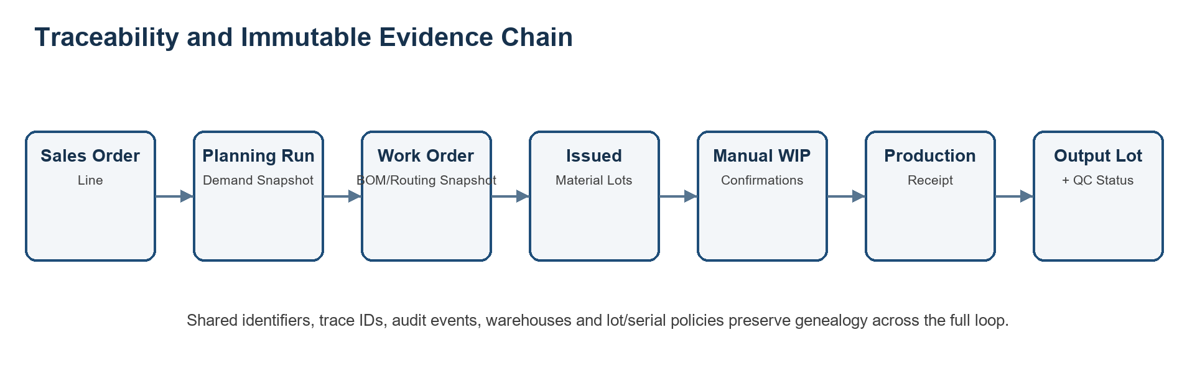
Figure 3. Traceability chain from demand to quality-controlled output
Table 6. Production genealogy evidence
Trace layer | Primary evidence
Demand identity | Sales Order and Sales Order line identifiers
Planning identity | Planning demand ID, Planning Run ID and requirement/suggestion IDs
Production identity | Work Order ID plus demand allocation records
Engineering evidence | BOM and Routing snapshot version/code
Material genealogy | Material Issue lines, Warehouse and input lot/serial
Execution evidence | WIP trace ID, actor, timestamps, good/scrap/rework quantities
Output genealogy | Production Receipt, output lot/serial and QC status/reason

API, Security and Network Resilience
Every backend response uses a standard envelope containing code, message and an optional result. Paginated results expose content, page, size, totalElements and totalPages. The client branches on stable error codes rather than parsing human-readable messages, maps UUIDs and decimal quantities without converting them to unsafe JavaScript numbers, and validates wire data before rendering.
Authentication uses access and rotating refresh tokens. Concurrent token-expired responses share one refresh request, after which the profile is refreshed before retrying. Revoked or malformed tokens clear the session; permission-denied responses are not treated as authentication failures. Plant headers are attached only when an endpoint contract explicitly contains the same Plant identifier.
Each state-changing submission generates an Idempotency-Key. A retry of the same logical submission reuses the same key, preventing duplicate production documents or inventory movements during intermittent factory connectivity. Errors never clear the form automatically, allowing the operator to correct or retry without re-entering data.

Frontend Interaction and UI/UX Design
- Loading state: Dense tables and forms use Skeleton placeholders rather than full-page spinners.
- Empty state: The screen explains why no records exist and shows a creation CTA only when the user has permission.
- Error state: API and validation errors are specific and preserve entered values.
- Confirmation state: Critical transitions such as confirm, activate, release, issue, approve, reject and QC disposition require explicit confirmation.
- Status semantics: Green indicates good/available/completed; blue indicates active progress; yellow/orange indicates hold or pending; red indicates shortage/rejection; gray indicates draft/inactive/closed.
- Responsive target: Desktop and tablet are primary; mobile remains supported but secondary.
- Internationalization: All user-visible text is provided in English and Vietnamese namespaces.

System Operation and Deployment
A standard local deployment starts PostgreSQL and Redis, runs the Spring Boot API on port 8080 and runs the Next.js client on port 3000. API health is checked before the frontend is used. Swagger/OpenAPI documents the deployed contract, while the frontend endpoint matrix tracks whether each UI boundary is integrated, live-accepted or intentionally deferred.
Table 7. Operational startup and verification checklist
Operational step | Expected check
1. Start infrastructure | PostgreSQL and Redis are healthy; migrations complete.
2. Start API | Actuator health reports UP; OpenAPI is reachable.
3. Start frontend | Application loads without console errors and redirects unauthenticated users to Login.
4. Authenticate | Profile, permissions, scopes and default Plant are loaded.
5. Select Plant | Queries cancel/refetch without showing stale data from another Plant.
6. Execute flow | Use confirmation and idempotent commands; verify document status after each transition.
7. Verify inventory | Check movements, lot status, Dashboard and Sales Order fulfillment after QC.

RESULTS AND DISCUSSION

Implementation Results
Capstone 2 completed the focused ERP production loop from confirmed Sales Order demand to QC-approved AVAILABLE inventory. The implementation is no longer a high-fidelity prototype: the primary MVP routes use backend APIs, UUID identifiers, decimal-safe adapters, permission-aware React Query hooks and documented invalidation across related modules.
Table 8. Capstone 2 delivery summary
Area | Delivered behavior | Status
Planning | Confirmed demand -> immutable run -> requirements/netting -> MAKE/BUY suggestions | Complete and API integrated
Work Order | Conversion/manual draft, plan, snapshots, readiness, reservation, release, cancel/close | Complete and API integrated
Material Issue | Reservation-backed and eligible-stock issue, stock movement, trace and variance seam | Complete and live write accepted
Manual Execution | Good/scrap/rework, actual time, notes and WIP history | Complete and API integrated
Production Receipt | Partial receipt, submit, approve/reject, HOLD and QC disposition | Complete and API integrated
Inventory/Dashboard | Balances, lots, movements, availability exclusion, alerts and recent activity | Complete and live accepted
Admin/RBAC | Users, roles, permissions, scopes and assignments | Complete for current three-actor model

API-Backed Interface Evidence
The following subsections present the current OmniPlant interface screenshots embedded in the Capstone 2 presentation. Each subsection documents one screen, its operational purpose and the evidence visible in the refreshed demonstration dataset.

Dashboard Overview
This screen gives managers an API-backed summary of current inventory and manufacturing activity. It highlights operational alerts and recent movements so exceptions can be identified quickly.
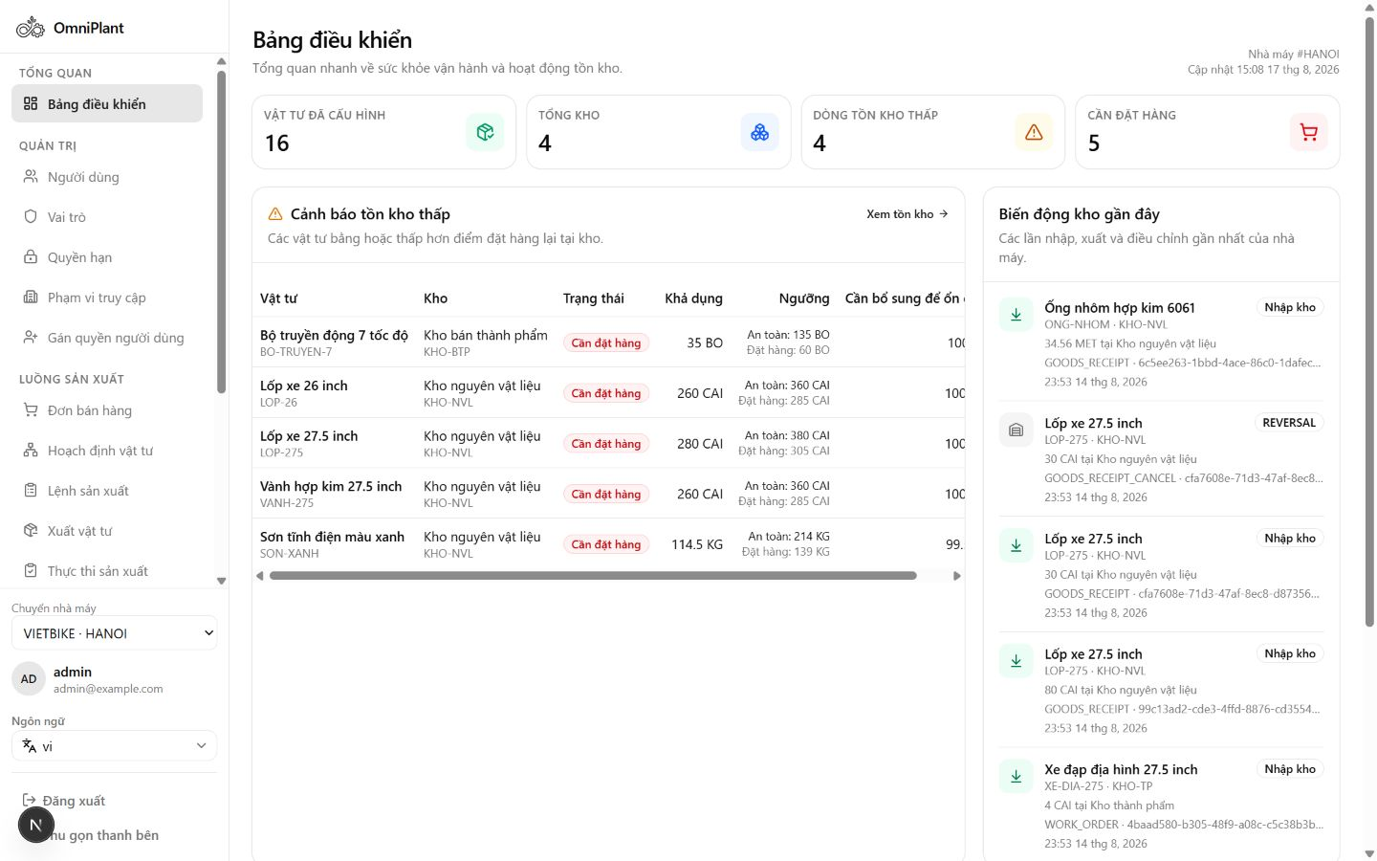
Figure 4. Dashboard with API-backed operational overview and alerts

Item Master
This screen maintains the core item records used across inventory, BOM and production processes. It shows item type, unit of measure and tracking policy to ensure consistent downstream transactions.
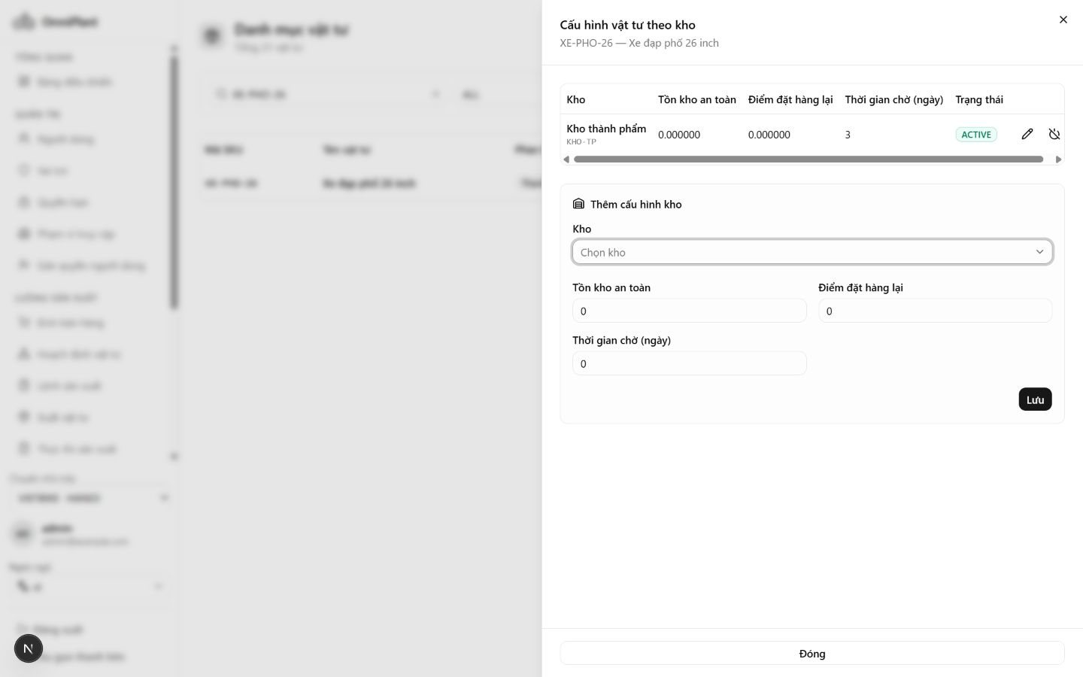
Figure 5. Item Master with item types, UOM and tracking-policy evidence

Stock Balance
This screen presents inventory quantities by item and storage location. On-hand, reserved and available balances are separated so users can evaluate usable stock accurately.
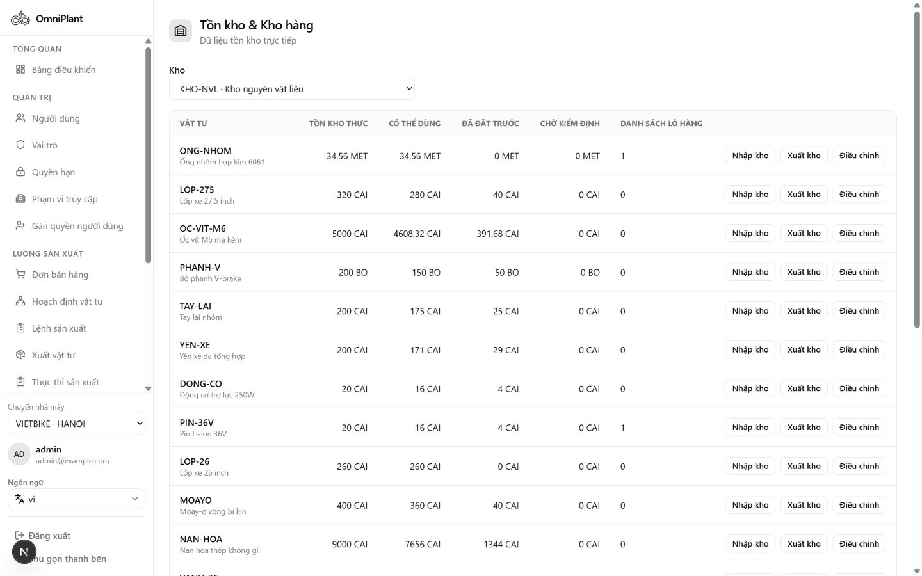
Figure 6. Stock Balance with on-hand, reserved and available quantities

Inventory Lots
This screen provides lot-level inventory visibility for traceable materials and products. Status values such as AVAILABLE, HOLD and REJECTED make quality eligibility clear before planning or issue.
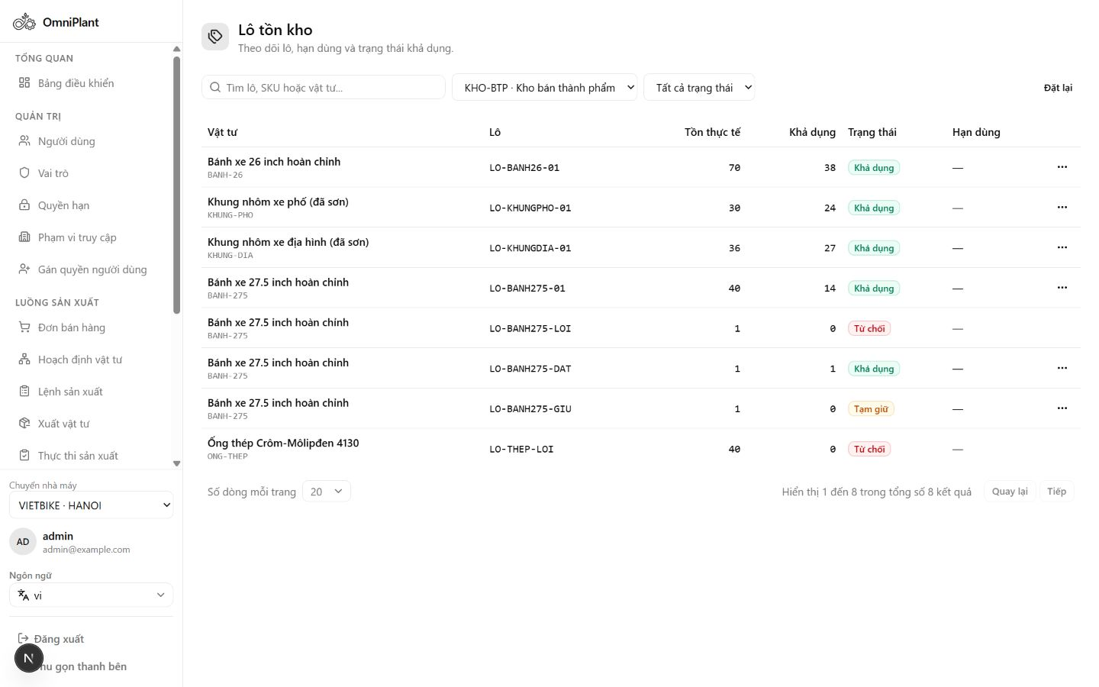
Figure 7. Inventory Lots with AVAILABLE, HOLD and REJECTED status evidence

Stock Movement History
This screen records the append-only history of inventory transactions. Movement types and trace references help users audit how stock quantities changed over time.
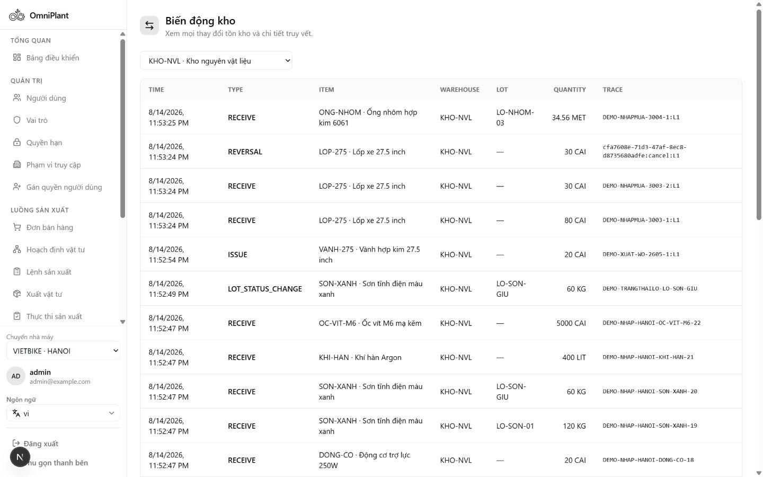
Figure 8. Stock Movement history with transaction types and trace references

BOM List
This screen lists Bills of Materials and their lifecycle states. Users can distinguish active production definitions from drafts before selecting a structure for planning or execution.
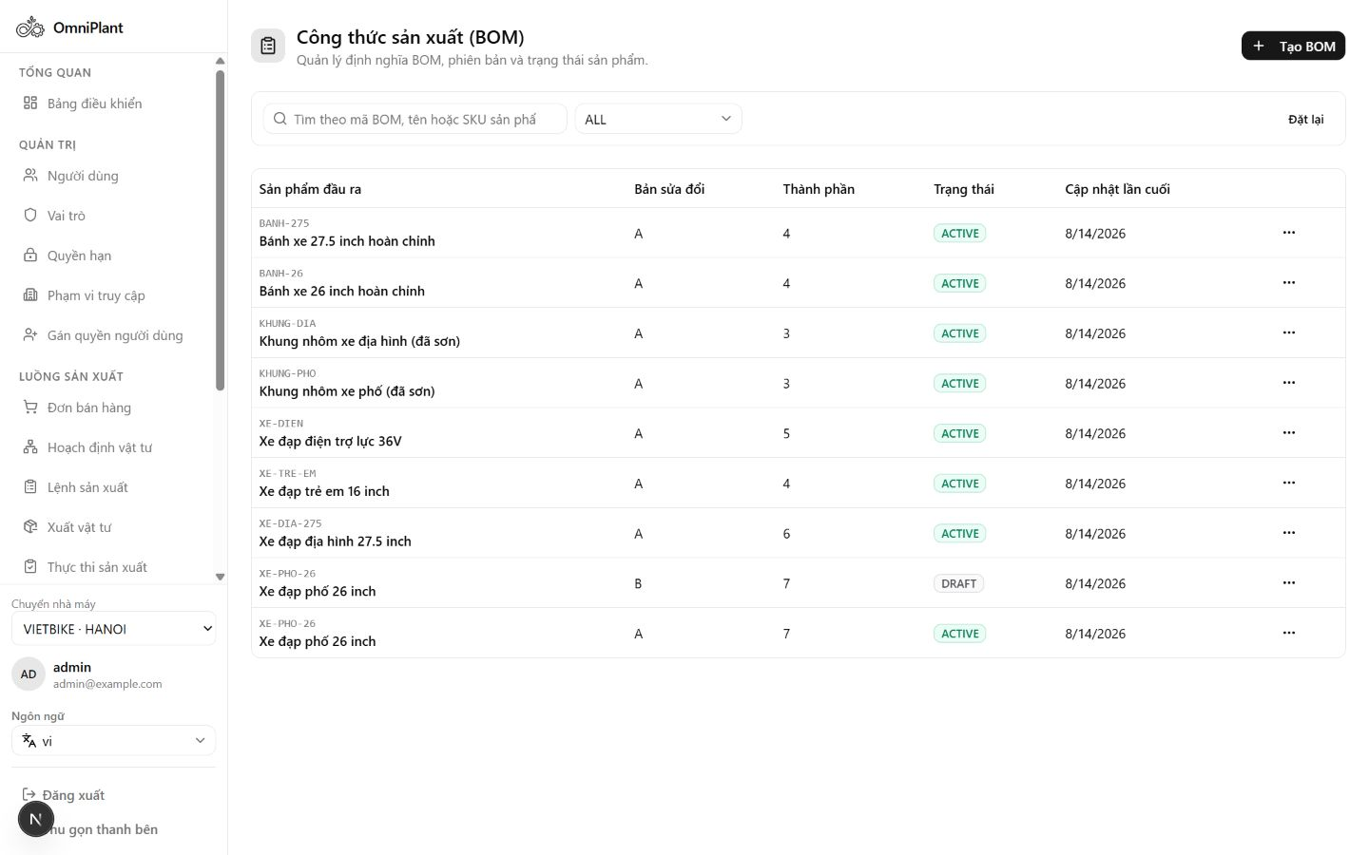
Figure 9. BOM list with active and draft lifecycle visibility

Active BOM Detail
This screen displays the approved product structure for a manufactured item. Revision, output quantity and component lines define the material basis used by planning and Work Orders.
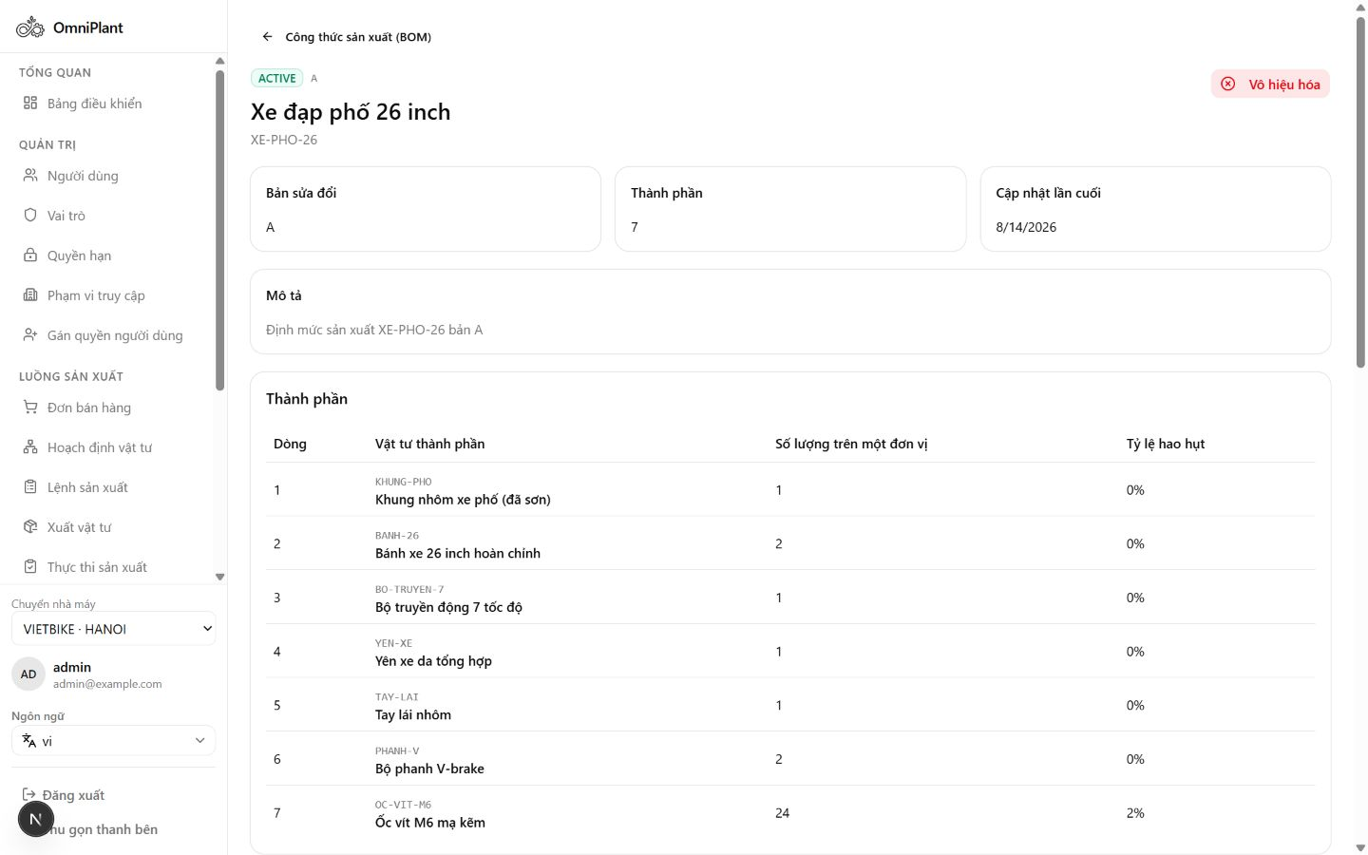
Figure 10. Active BOM detail with revision, output quantity and component lines

Multi-Level BOM Tree
This screen visualizes nested assemblies and components across multiple BOM levels. The hierarchy helps users understand dependent quantities and the full material composition of the finished product.
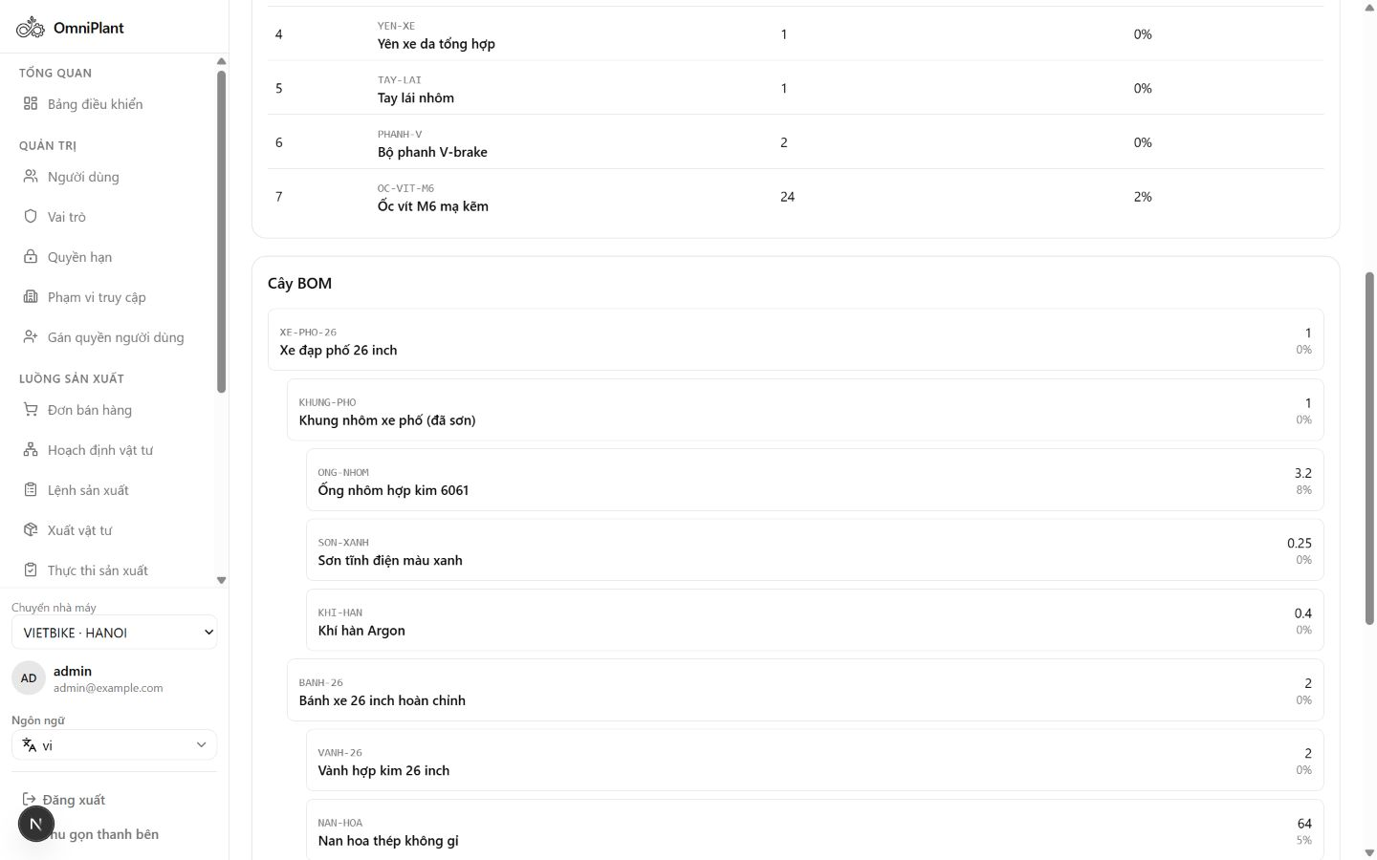
Figure 11. Multi-level BOM tree showing nested sub-assemblies and component quantities

Sales Order List
This screen summarizes customer demand and its document lifecycle. Order and fulfillment statuses allow managers to identify confirmed demand that is ready for material planning.
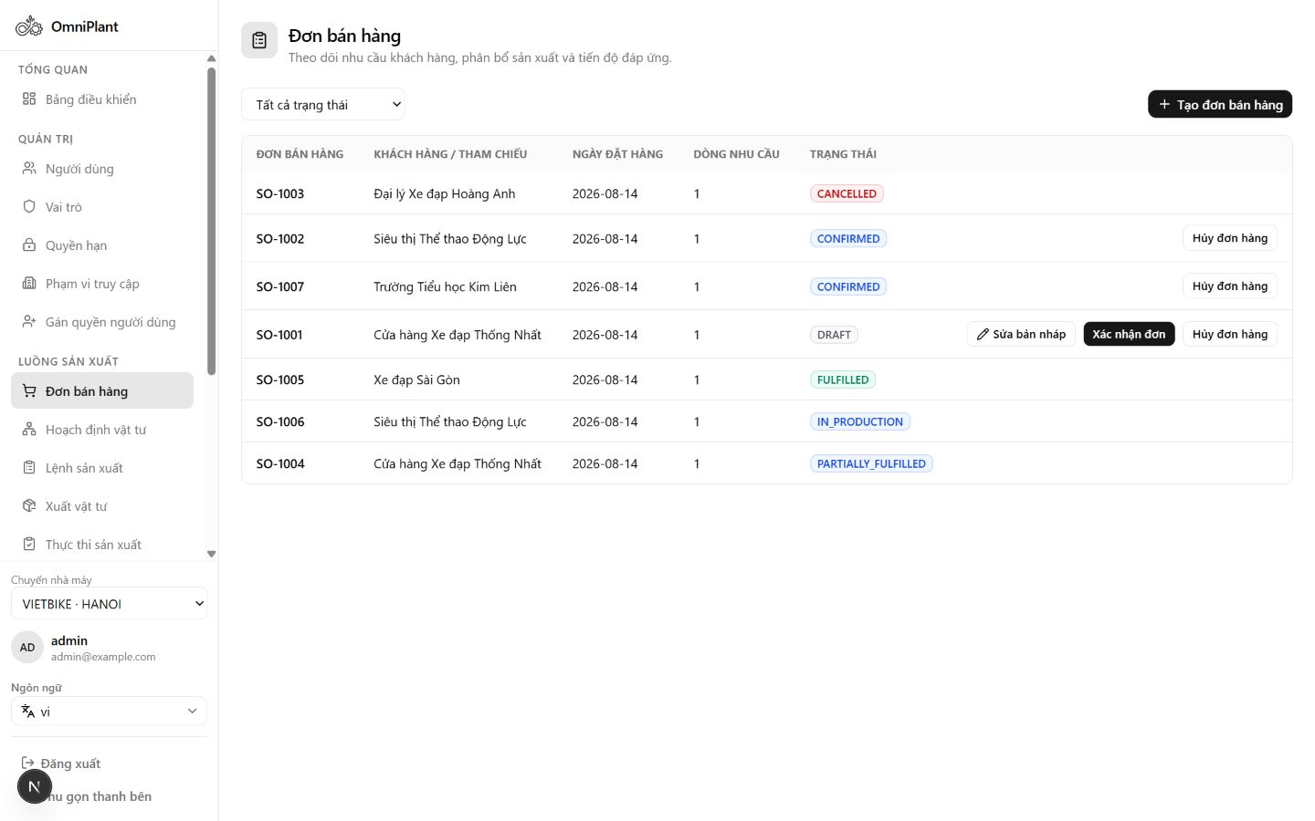
Figure 12. Sales Order list with lifecycle and fulfillment status evidence

Sales Order Detail
This screen shows the selected order, its line items and requested quantities. Allocation and fulfillment values connect customer demand with later planning and production results.
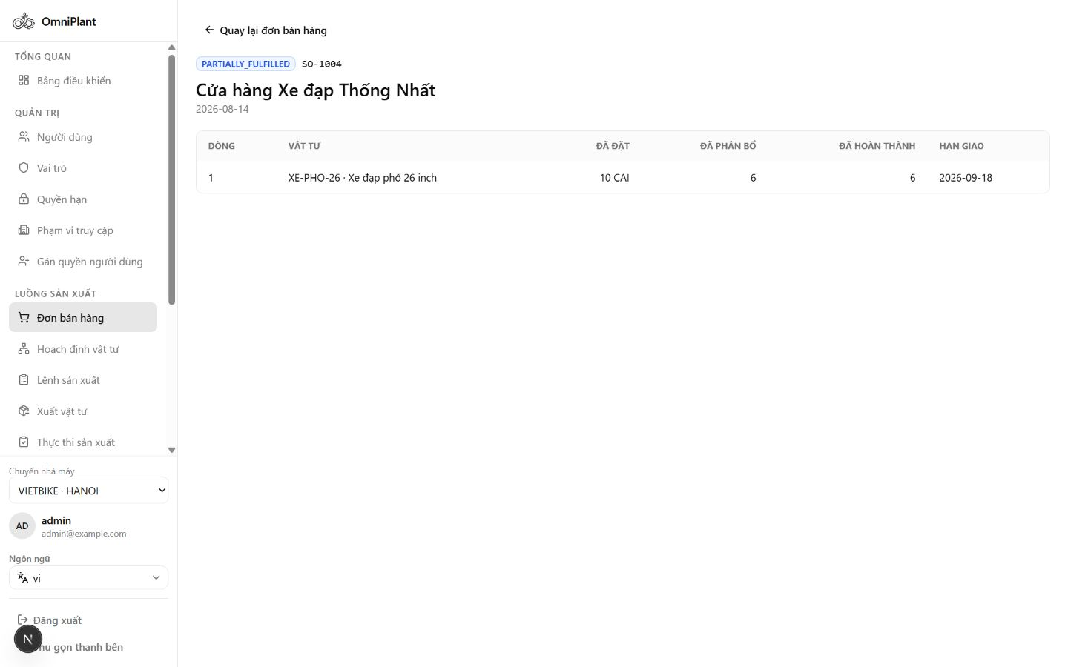
Figure 13. Sales Order detail with line allocation and fulfillment quantities

Material Planning Workspace
This screen is the entry point for converting confirmed demand into an MRP Planning Run. It presents eligible Sales Orders and previous run history for controlled, auditable planning.
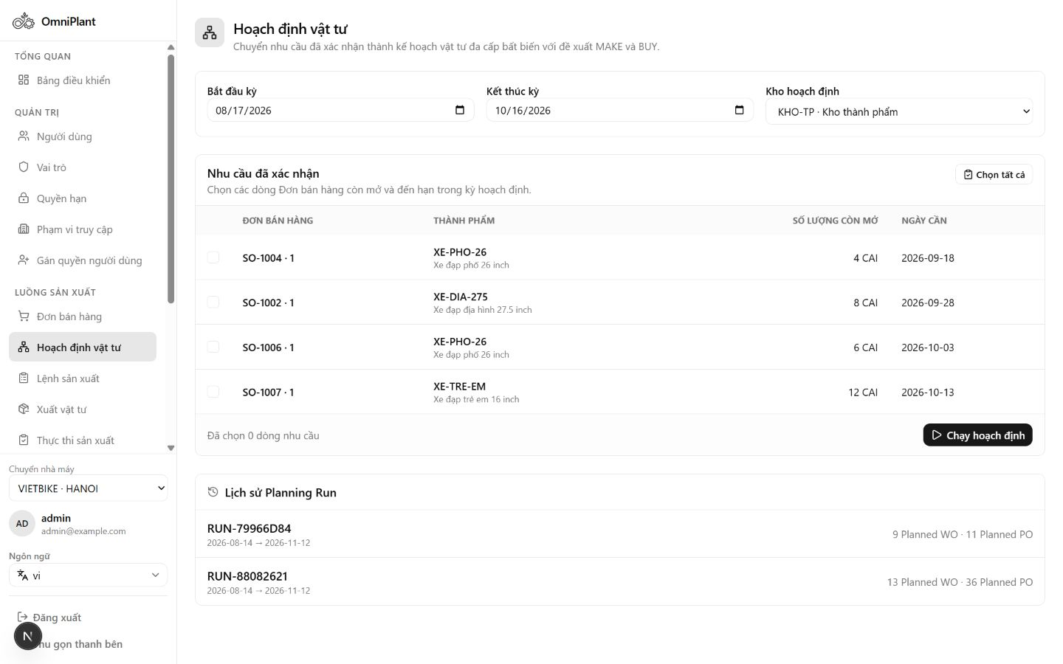
Figure 14. Material Planning workspace with confirmed demand and Planning Run history

Planning Run Detail
This screen explains the calculated material requirements for a specific immutable Planning Run. Shortages and MAKE or BUY suggestions show how available supply is compared with production demand.
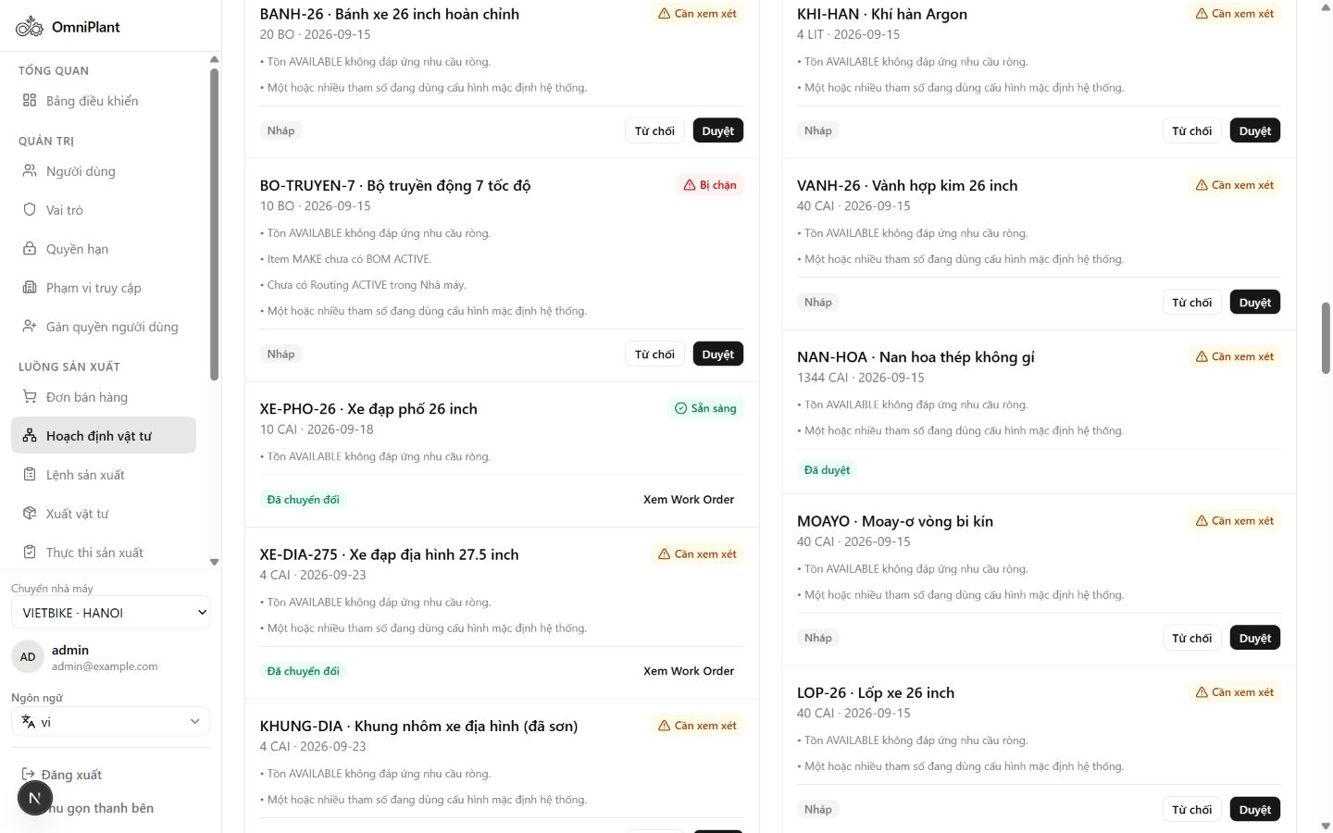
Figure 15. Planning Run detail with shortage and MAKE/BUY supply decisions

Work Order List
This screen provides an overview of manufacturing orders and their current lifecycle states. Users can monitor which orders are planned, released, in progress, blocked or completed.
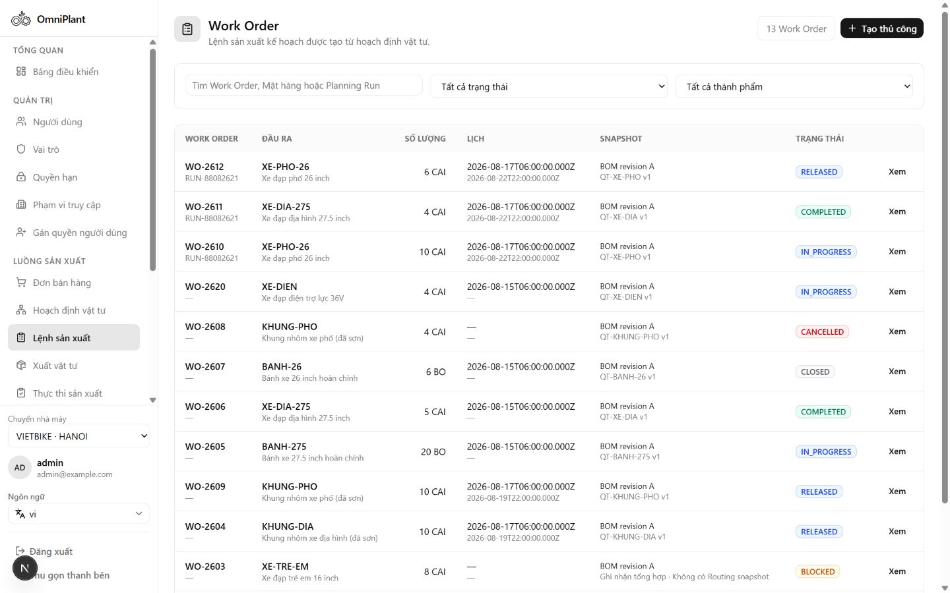
Figure 16. Work Order list with production lifecycle status evidence

Work Order Detail
This screen consolidates the production scope, snapshots and material readiness of a Work Order. Reservation status supports the decision to release the order safely for execution.
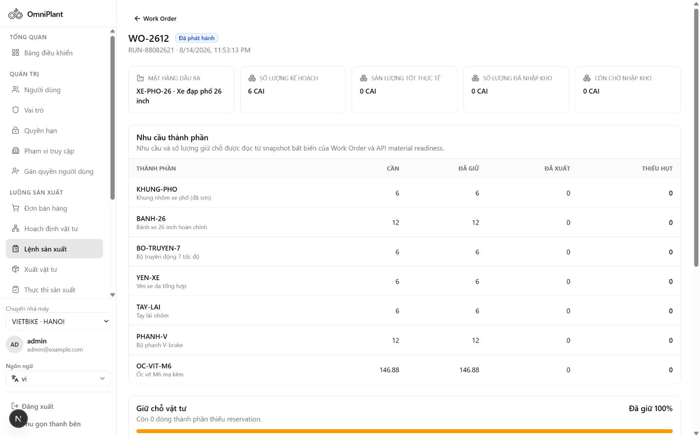
Figure 17. Work Order detail with complete reservation readiness

Material Issue Workspace
This screen supports controlled consumption of reserved components for a Work Order. Component requirements and issue history help operators verify eligible quantities and preserve inventory traceability.
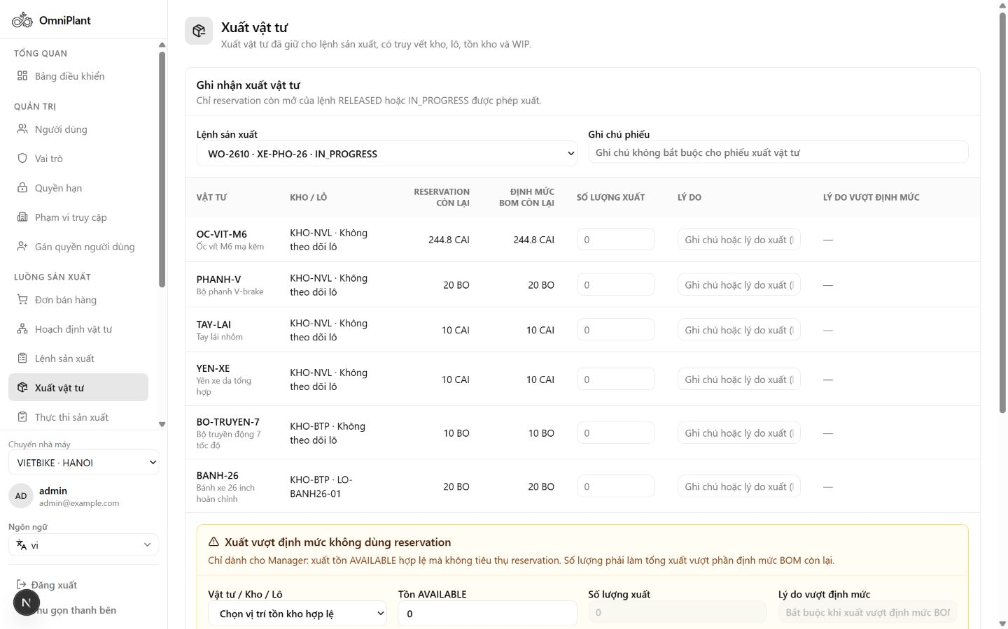
Figure 18. Material Issue workspace with component and issue-history evidence

Production Execution Workspace
This screen records manual shop-floor results without claiming MES integration. Operators capture good, scrap and rework quantities together with actual execution evidence.
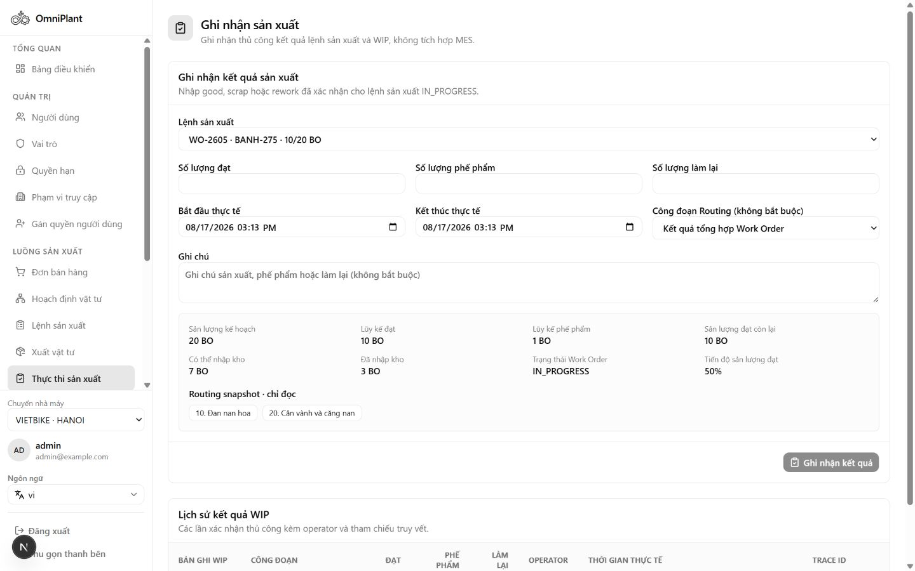
Figure 19. Production Execution workspace with good, scrap and rework quantities

Production Receipt List
This screen tracks finished-output receipt documents and their approval states. It supports the transition from reported production into HOLD inventory pending quality disposition.
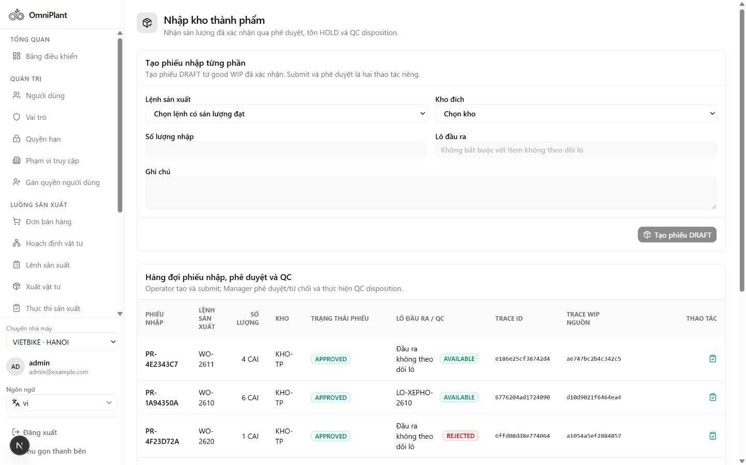
Figure 20. Production Receipt list with approval and QC lifecycle states

Inventory Lots after Quality Control
This screen shows the quality outcome of received production lots. AVAILABLE, HOLD and REJECTED statuses demonstrate which output can be used for planning or fulfillment.
Figure 21. Inventory Lots after QC with AVAILABLE, HOLD and REJECTED output

Login and Session Initialization
This screen authenticates the user and initializes the authorized operating context. Session and Plant scope are established before protected ERP functions become available.
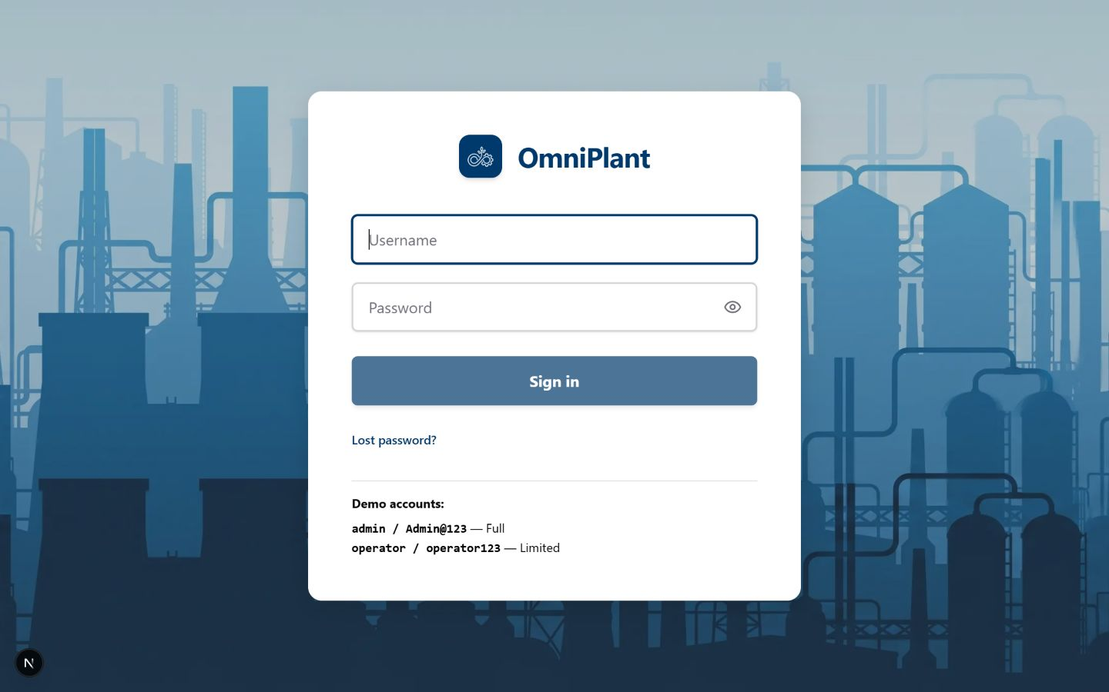
Figure 22. Login interface for session and Plant-scope initialization

User Management
This screen maintains application accounts and their lifecycle status. Administrators can review active or inactive users before assigning responsibilities and access scope.
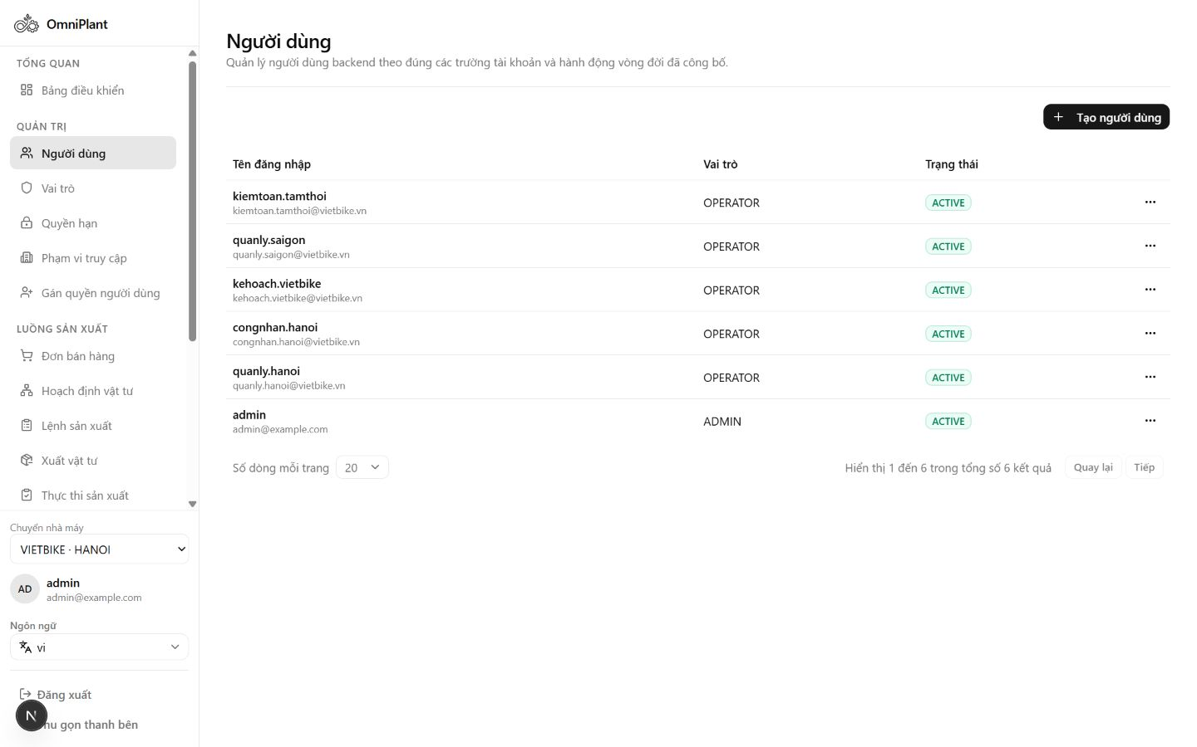
Figure 23. User management with account lifecycle status

Role Management
This screen defines the responsibility groups used by dynamic role-based access control. Active roles provide a reusable basis for assigning operational permissions to users.
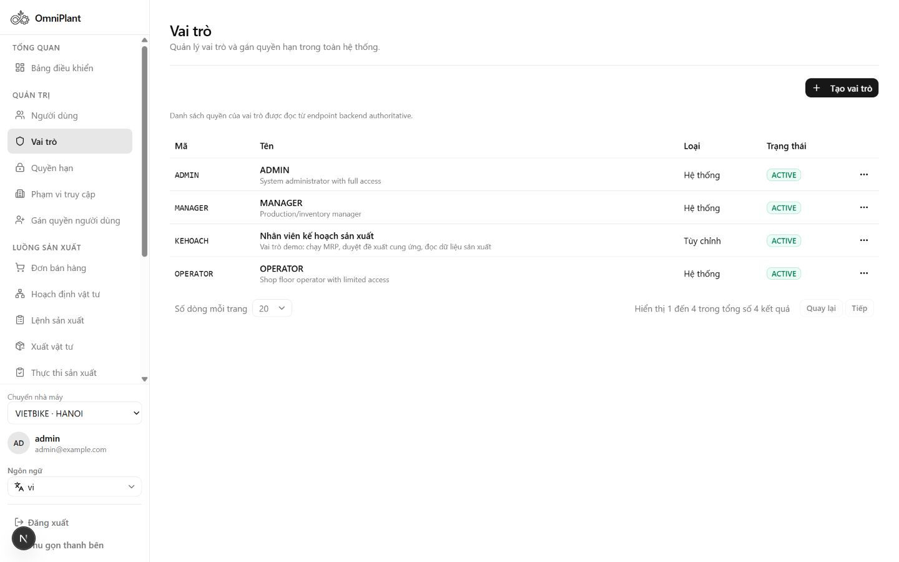
Figure 24. Role management with active responsibility groups

Permission Catalog
This screen lists the resource and action permissions recognized by the system. The catalog makes authorization rules explicit and supports consistent role configuration.
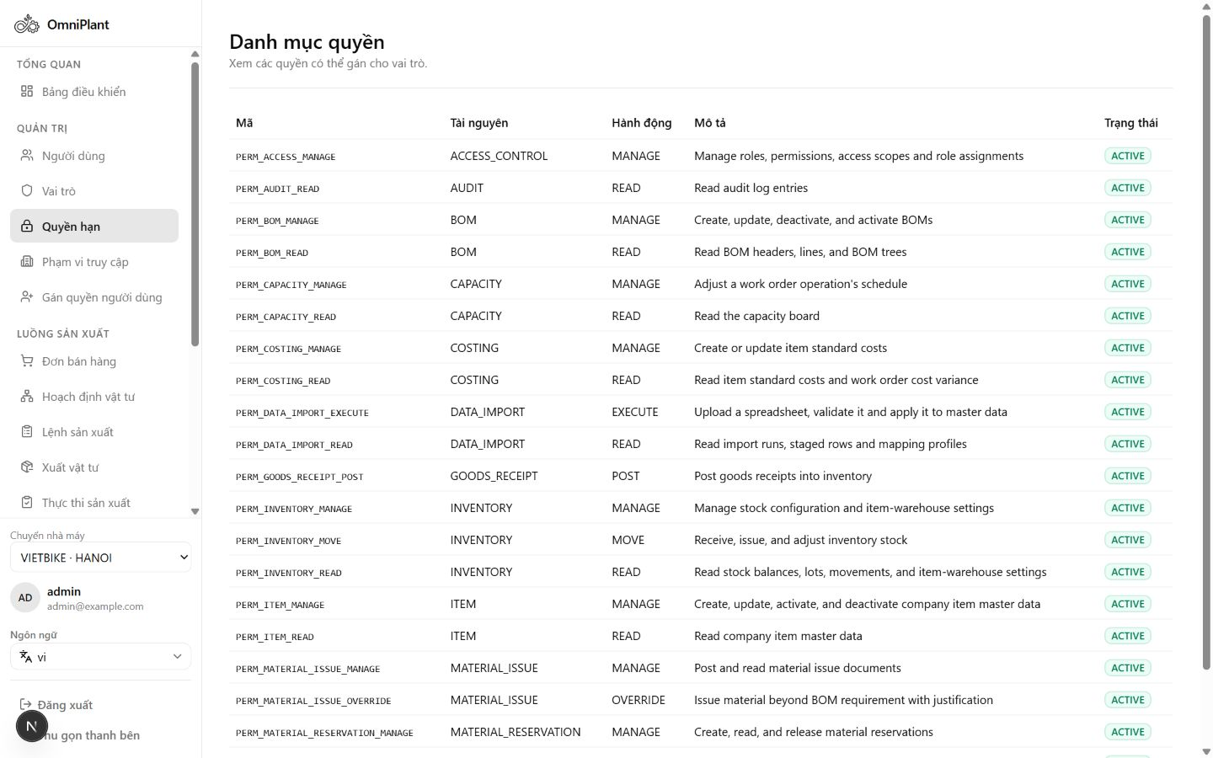
Figure 25. Permission catalog with resource and action codes

Access Scope Management
This screen defines where an assigned role is allowed to operate. Organization-level scopes restrict data and actions to the appropriate Company, Plant or Warehouse context.
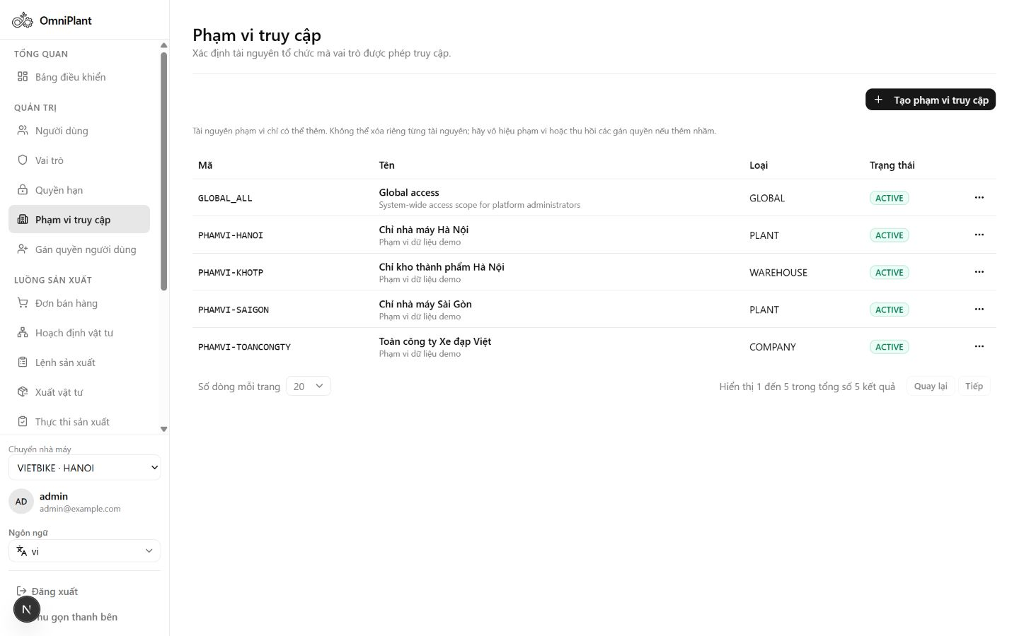
Figure 26. Access Scope management across organization levels

User Assignment
This screen links a user with a role and an access scope. The assignment form combines responsibility and organizational boundary into one authorization record.
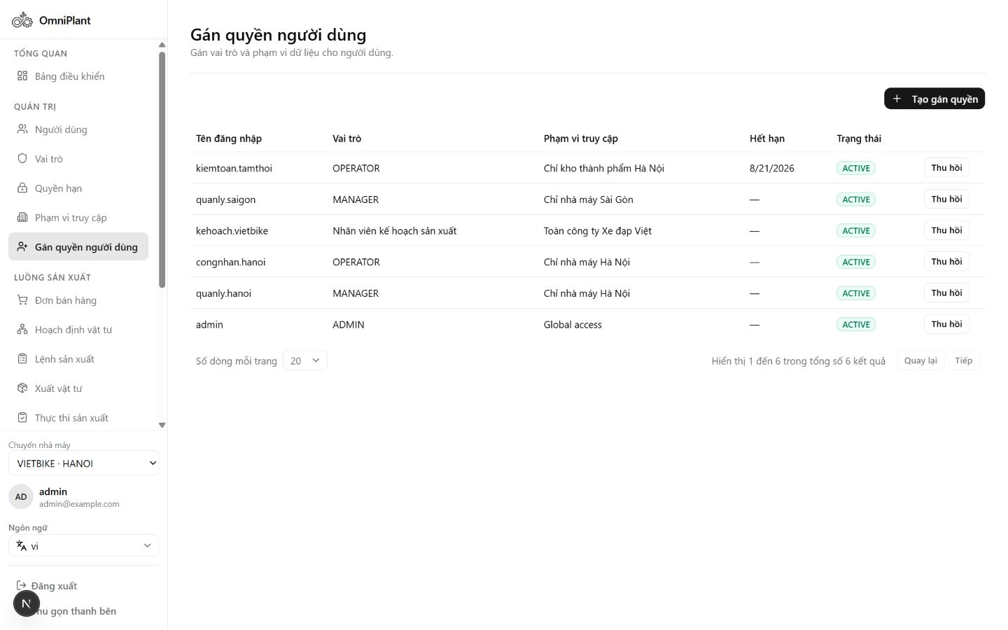
Figure 27. User Assignment form linking User, Role and Scope

Organization Structure
This screen represents the Company, Plant and Warehouse hierarchy used throughout OmniPlant. The structure provides the organizational context for inventory, production and scoped authorization.
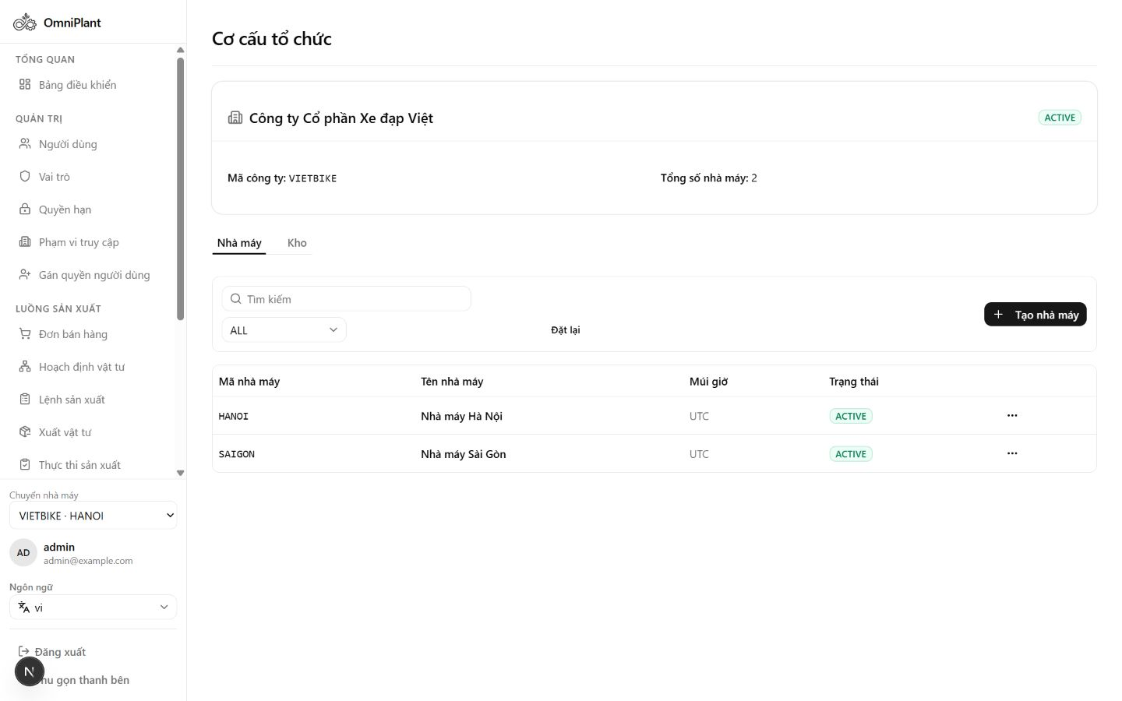
Figure 28. Organization structure with Company, Plant and Warehouse evidence

Unit of Measure Management
This screen maintains reusable units of measure for item and transaction data. Standardized codes help keep quantities consistent across BOM, inventory and production workflows.
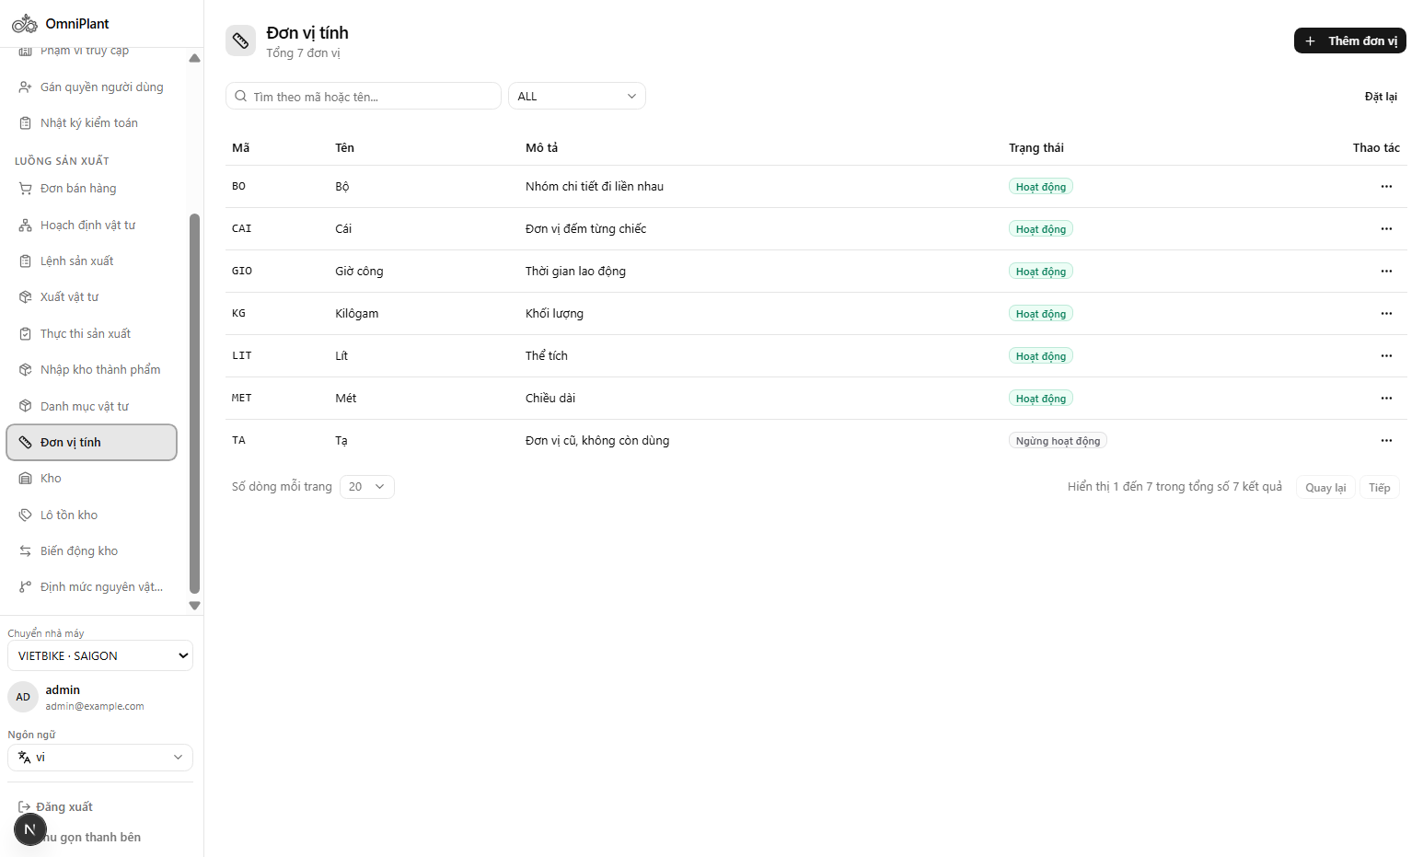
Figure 29. UOM management with reusable measurement codes

Audit Logs
This screen provides evidence of sensitive system and data changes. Actor, entity, action and timestamp fields support accountability and operational review.
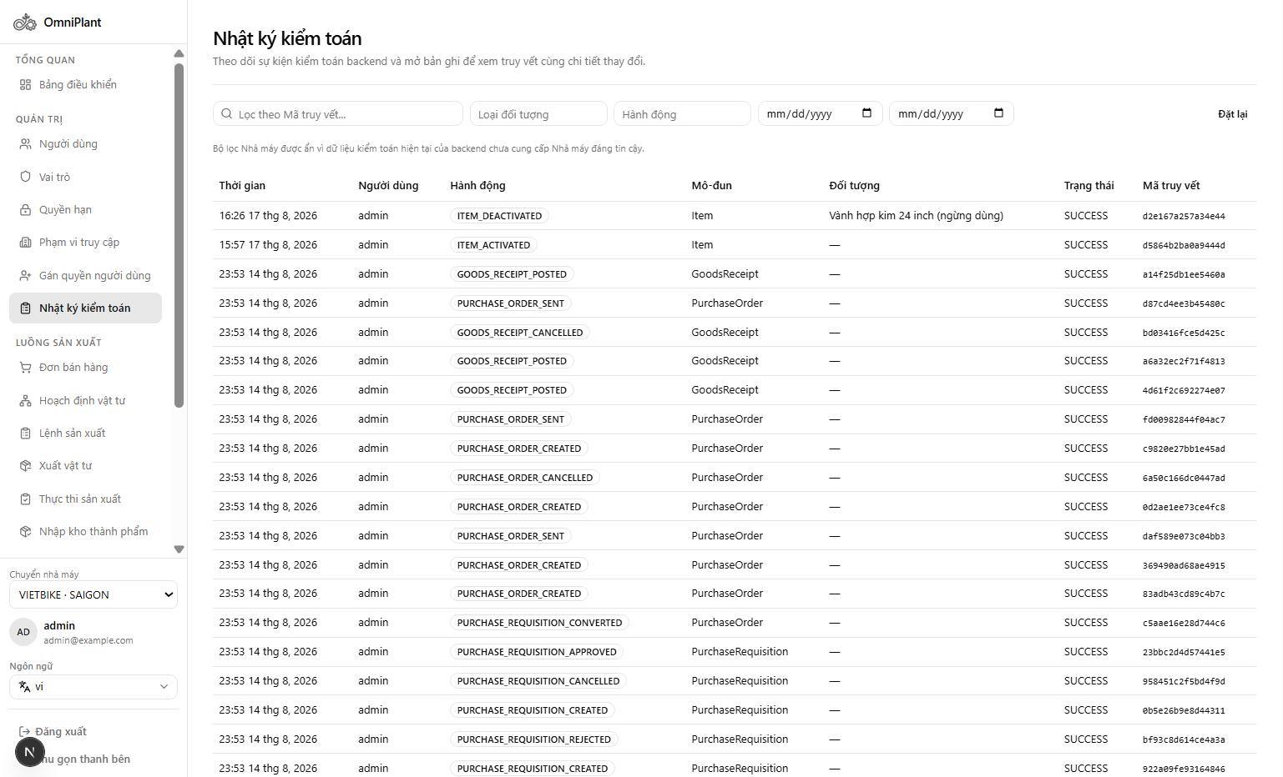
Figure 30. Audit Logs with actor, entity, action and timestamp evidence

Validation and Acceptance Results
The implementation was validated through focused domain tests, API contract tests, component presentation tests, permission/navigation tests and live browser acceptance. The latest complete repository gate recorded before this report included 59 Vitest files with 265 passing tests, strict TypeScript, EN/VI translation parity, API coverage checks, production build, ESLint and diff validation. Earlier Scope 4 acceptance specifically covered planning, allocation, reservation, issue, WIP, partial receipt, rejection, QC, stock effects and cancellation.
Table 9. Quality and acceptance evidence
Gate | Recorded outcome
Automated regression | 59 Vitest files / 265 tests passed at the completed integration gate
Type safety | Strict TypeScript and runtime schema/adapter validation
API coverage | Guard prevents MVP routes from silently reverting to mock-only runtime boundaries
Internationalization | English/Vietnamese key parity
Responsive QA | Desktop and tablet checks with no document-level horizontal overflow
RBAC | Admin, Manager and Operator permissions/actions verified; no-permission state covered by regression
Inventory effects | Reservation, issue, HOLD receipt, QC AVAILABLE/REJECTED and Dashboard invalidation verified

Operational Demonstration Result
The presentation fixture demonstrated a completed Planning Run containing two demands, eight requirement lines, six shortages, three MAKE suggestions and three BUY recommendations. Work Orders were exercised across PLANNED, RELEASED, BLOCKED, IN_PROGRESS and COMPLETED states. Execution evidence recorded good, scrap and rework quantities, while Production Receipts covered DRAFT, PENDING_APPROVAL, APPROVED/HOLD, QC AVAILABLE and QC REJECTED outcomes.
The demonstration also showed partial Sales Order fulfillment after QC AVAILABLE output, confirming that accepted finished goods flow back into business demand status rather than appearing only in an isolated inventory screen.

Engineering Discussion

Planning Run versus Standalone Production Estimation
Both functions use BOM explosion and stock comparison, but their business purposes differ. A standalone estimator answers an ad-hoc question about one product and target quantity. The Planning Run begins with confirmed demand, creates an auditable immutable snapshot, applies safety-stock netting, produces supply suggestions and continues into Work Orders. For this reason, the Planning Run is the authoritative Capstone 2 evidence and Production Estimation remains outside the focused scope.

Immutable Snapshots and Idempotency
Manufacturing records must remain explainable after engineering masters change. Snapshotting BOM and Routing content into the Work Order provides that stability. Idempotency addresses a different time dimension: it prevents a repeated network submission from creating a second logical document. Together, these mechanisms protect both historical meaning and transactional uniqueness.

Availability and Quality Semantics
On-hand quantity alone is insufficient for planning. OmniPlant separates reservations and quality status so that only eligible stock becomes projected supply. The same rule is applied across Dashboard alerts, MRP, reservation, issue selection and Sales Order fulfillment. This consistency is more important than any single screen because a mismatch would produce false production readiness.

ERP Execution without MES
Capstone 2 records actual production manually rather than simulating machine integration. The interface captures quantities, times, actor and notes, while the model preserves an extensible execution-source boundary. This approach delivers a usable ERP process now and avoids misleading claims about real-time telemetry, OEE or automated shop-floor dispatching.

Known Limitations
- Full BUY-side execution is deferred; a BUY suggestion does not create a committed scheduled receipt in the focused MVP.
- Capacity is advisory and retained as a supporting master/scheduling seam; automatic finite optimization is not implemented.
- The current three-actor model assigns Production Receipt approval and QC disposition to Manager through separate permissions; a dedicated QC role can be added later.
- Detailed manufacturing cost, labor/overhead valuation, OEE and profitability are not calculated.
- MES, PLC and IoT data are not integrated; all execution confirmation is manual.
- Presentation fixture audits documented idempotency/atomicity and availability edge cases for continued backend hardening; the business contracts remain explicitly tested and monitored.

CONCLUSION AND FUTURE WORKS

Conclusion
Capstone 2 converted OmniPlant from an analysis-and-prototype project into an integrated Manufacturing ERP application with a coherent operational spine. The system captures customer demand, performs material planning, creates and controls Work Orders, preserves inventory and lot traceability, records manual production execution, approves output and enforces a quality gate before finished goods become available.
The implementation demonstrates that a focused SME-oriented ERP can maintain enterprise-level safeguards without adopting the full complexity of a large commercial suite. Dynamic permissions, Plant scoping, immutable snapshots, append-only inventory movements, idempotent commands, explicit states and responsive list/form workspaces provide a disciplined foundation for real operational use and later expansion.
The most important project result is the continuity of evidence. A reviewer can navigate from a Sales Order line through an immutable Planning Run and Work Order to issued material lots, WIP confirmation, Production Receipt, QC outcome and output inventory. This continuity is the defining achievement of the Capstone 2 scope.

Future Works
- Purchasing: Implement suppliers, Purchase Requests/Requisitions, Purchase Orders, Goods Receipt, approval and incoming-quality workflow; only confirmed receipts should become scheduled supply.
- Sales fulfillment: Add delivery allocation, goods issue, invoicing, payment and customer-credit controls.
- Manufacturing costing: Add material, labor and overhead rates, WIP valuation, cost variance and profitability analysis.
- MES integration: Connect ISA-95-aligned messages, PLC/IoT telemetry, automatic execution events, downtime and OEE while retaining manual fallback.
- Advanced scheduling: Add finite-capacity optimization, dispatching, rescheduling and scenario comparison beyond advisory overload warnings.
- Quality management: Add dedicated QC roles, inspection plans, measurements, non-conformance, quarantine and corrective actions.
- Optional what-if analysis: Migrate standalone Production Estimation to the backend only if Product Owner or presentation needs justify a separate non-executable calculator.

Recommended Capstone 3 Sequence
Table 10. Recommended Capstone 3 implementation sequence
Priority | Extension | Reason
1 | Purchasing and scheduled receipts | Closes the BUY suggestion loop and improves MRP realism.
2 | Delivery and invoicing | Closes Sales Order fulfillment beyond production completion.
3 | Costing and variance | Uses the quantity/time evidence already collected in Capstone 2.
4 | Dedicated quality management | Expands the current HOLD/AVAILABLE/REJECTED gate into measurable inspection.
5 | MES/OEE and finite scheduling | Builds on stable ERP documents after transactional foundations are proven.

REFERENCES
[1] SAP SE, SAP S/4HANA Production Planning and Material Requirements Planning Documentation, https://help.sap.com, accessed August 2026.
[2] Odoo S.A., Manufacturing Orders and Work Orders, Odoo Documentation, https://www.odoo.com/documentation/master/applications/inventory_and_mrp/manufacturing/, accessed August 2026.
[3] Frappe Technologies, Manufacturing in ERPNext; Production Plan; Work Order, https://docs.frappe.io/erpnext/manufacturing, accessed August 2026.
[4] Spring, Spring Boot Reference Documentation, https://docs.spring.io/spring-boot/, accessed August 2026.
[5] PostgreSQL Global Development Group, PostgreSQL Documentation, https://www.postgresql.org/docs/, accessed August 2026.
[6] Redis Ltd., Redis Documentation, https://redis.io/docs/, accessed August 2026.
[7] Vercel, Next.js App Router Documentation, https://nextjs.org/docs/app, accessed August 2026.
[8] TanStack, TanStack Query Documentation, https://tanstack.com/query/latest, accessed August 2026.
[9] OmniPlant Project Team, Frontend System Context, Business Flow, API Guide and Capstone 2 Progress Records, internal project documentation, 2026.

APPENDIX

Operational State Reference
Table 11. Primary document state transitions
Document | Primary transition
Sales Order | DRAFT -> CONFIRMED -> IN_PRODUCTION -> PARTIALLY_FULFILLED -> FULFILLED -> CLOSED
Planning Run | PENDING/RUNNING -> COMPLETED or FAILED; result is immutable
Supply Suggestion | DRAFT -> APPROVED/REJECTED -> CONVERTED for eligible MAKE
Work Order | DRAFT -> PLANNED -> RELEASED -> IN_PROGRESS -> COMPLETED -> CLOSED; BLOCKED/CANCELLED branches
Production Receipt | DRAFT -> PENDING_APPROVAL -> APPROVED/HOLD -> AVAILABLE or REJECTED
Inventory Lot | AVAILABLE, HOLD or REJECTED; only AVAILABLE is eligible supply

Focused MVP Screen Inventory
Table 12. Focused Capstone 2 MVP navigation
Navigation group | Visible MVP workspaces
Overview | Dashboard
Admin | Users; Roles; Permissions; Access Scopes; User Assignments
Demand and planning | Sales Orders; Material Planning; Planning Run Detail
Production | Work Orders; Material Issues; Production Execution; Production Receipts
Manufacturing foundation | Item Master; UOM; Stock; Inventory Lots; Stock Movements; BOM

End-to-End Demonstration Checklist
- Authenticate as Manager and select an authorized Plant.
- Verify active Item, UOM, Warehouse, BOM and eligible inventory data.
- Create and confirm a Sales Order with positive quantity and due date.
- Run Material Planning and inspect requirements, shortage messages and MAKE/BUY suggestions.
- Approve and convert an eligible MAKE suggestion into a Work Order.
- Reserve 100% of required components and release the Work Order.
- Post Material Issue using eligible lot/serial stock and confirm the movement/trace.
- Record manual execution good, scrap, rework and actual time.
- Create and submit a Production Receipt; approve it into HOLD.
- Perform QC disposition and verify AVAILABLE or REJECTED output behavior.
- Verify Sales Order fulfillment, inventory lot, stock movement, Dashboard and genealogy links.

