Pipeline Structure (10 Steps)
- Configuration — hyperparameters, run mode toggle, target variable selection
- Data Loading — memory-mapped sequences, labels, split arrays from the feature engineering pipeline
- Dataset & DataLoader — custom FlightDataset with temporal augmentations (training only), mask computation for variable-length flights
- Model Definition — TimeSeriesTransformer with conv front-end + Transformer encoder
- Training Setup — AdamW optimizer, weighted CrossEntropyLoss, CosineAnnealingLR scheduler
- Training Loop — PR-AUC checkpoint selection, gradient clipping, tqdm progress bars
- Test Evaluation — full metrics table, per-class recall/precision, inference timing
- Error Analysis — false negatives by maintenance type, errors by flight length, probability distributions, calibration curves
- Attention Visualization — extracting and plotting first-layer attention weights
- Save Artifacts — model weights, test predictions, config JSON for each target variable

Results
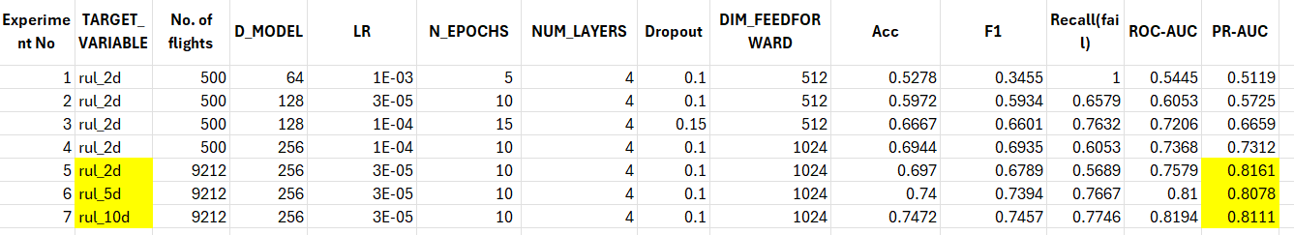
Phase 1 (Experiments 1–4): Hyperparameter search on 500-flight subset
Experiments 1–2 diagnosed the core problem: LR=1e-3 caused majority-class collapse (the model predicted everything as "at risk," achieving RecallFail=1.0 but useless F1=0.35). Dropping to LR=3e-5 broke the collapse but was too conservative for the small dataset (PR-AUC=0.57). Experiment 3 found the sweet spot at LR=1e-4 with slight dropout increase (PR-AUC=0.67). Experiment 4 scaled up model capacity (D_MODEL=256, DIM_FEEDFORWARD=1024), pushing PR-AUC to 0.73 — a 43% relative improvement over the collapsed baseline.
Phase 2 (Experiments 5–7): Full dataset with sensitivity analysis
A critical discovery at scale: LR=1e-4 (which worked on 500 flights) caused collapse again on the full 19,540-flight dataset because 40× more batches per epoch effectively multiplied the learning rate. Dropping back to LR=3e-5 (matching the paper exactly) solved this, yielding PR-AUC=0.816 for rul_2d — exceeding the original Conv-MHSA paper's benchmark.
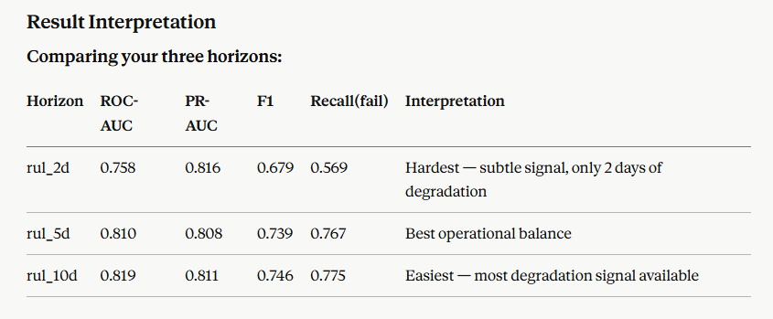

Conclusions
- The Convolutional Transformer achieves PR-AUC of 0.816 on the 2-day maintenance prediction horizon, demonstrating that predictive maintenance for general aviation is feasible using only flight sensor data.
- The 5-day prediction horizon offers the best operational trade-off: F1=0.739 with RecallFail=0.767 means the system catches 77% of at-risk flights while maintaining reasonable precision. The marginal improvement from 5d to 10d is small, suggesting most degradation signals emerge within 5 days.

Three key observations emerge from this:
1. PR-AUC is highest for rul_2d (0.816) despite it being the hardest task. This seems counterintuitive — shorter horizons should be harder. The explanation is class balance: rul_2d has 40% at-risk flights in the test set (strong class imbalance), while rul_5d/10d have ~52–53% (nearly balanced). PR-AUC rewards models that handle the minority class well, so a model that performs reasonably on a smaller at-risk class gets a higher PR-AUC. The PR baseline (random classifier) confirms this: 0.596 for rul_2d vs 0.466 for rul_10d.
2. ROC-AUC tells the opposite and more intuitive story. ROC-AUC steadily improves (0.758 → 0.810 → 0.819) as the horizon expands. This is because ROC-AUC is insensitive to class balance and purely measures discriminative ability. With more days of degradation visible, the model separates classes better.
3. F1 and Recall improve dramatically from rul_2d to rul_5d, then plateau. The jump from F1=0.679 to 0.739 (rul_2d → rul_5d) is much larger than 0.739 to 0.746 (rul_5d → rul_10d). This suggests that most of the detectable degradation signal appears within 5 days of maintenance — extending to 10 days adds marginal information.

Further Research suggestions:
- Threshold optimization — Your friend's analysis includes a "75% recall operating point" table that's very useful for deployment. You should add the same analysis: sweep thresholds on validation set, find the one achieving 75% recall, then report precision and false alarm rate at that threshold.
- Ensemble of Transformer + InceptionTime — Since the two architectures capture different patterns (global attention vs local convolutions), a simple probability averaging ensemble could outperform both individual models.
- Group-aware splitting — Your pipeline's limitation note says flights from the same maintenance event may span train/test. Implementing tail-number-aware splits (as the paper recommends) would give more honest performance estimates.
- Multi-class classification — The paper and your EDA identify 36 maintenance label types. Extending from binary (at-risk/safe) to multi-class (which maintenance issue?) would be significantly more useful operationally, though the paper reports much lower performance (~53% accuracy) due to class imbalance.
- Attention interpretability — Your notebook already includes attention visualization (Cell 39). Analyzing which flight phases (takeoff, cruise, landing) the attention focuses on would strengthen the explainability story and could provide domain insights for maintenance engineers.
Convolutional Transformer for Aircraft Predictive Maintenance
Summary of Techniques, Data, and Pipeline Steps

1. Data & Input
What | Technique | Purpose
Input data | sequences.npy (19,540 x 9,212 x 15), labels.csv, seq_indices.npy from feature engineering pipeline | Pre-processed flight sensor time series with 15 channels, padded to uniform length 9,212 timesteps
Data loading | np.load(mmap_mode='r') - memory-mapped NumPy | Avoids loading full 5.4 GB array into RAM; pages in only the batches needed
Target variable | rul_2d, rul_5d, rul_10d columns from labels.csv | Binary label: 0=at-risk (within N days of maintenance), 1=safe. Three horizons for sensitivity analysis
Subset mode | 250 flights per class (500 total) | Fast hyperparameter screening (~5 min/epoch vs ~6.5 hrs/epoch on full data)

2. Data Splitting & Sampling
What | Technique | Purpose
Train/Val/Test split | Pre-computed split array from feature engineering pipeline (approx 70/15/15) | Ensures flight-level integrity - each flight goes entirely to one split, never straddling train and test
Class weighting | len(train) / (N_CLASSES x class_count) applied to nn.CrossEntropyLoss | Compensates for class imbalance (e.g., rul_2d has ~60% safe vs ~40% at-risk) so the model does not ignore the minority class

3. Data Augmentation
What | Technique | Purpose
Temporal Cutout | Zero out a random time segment (64-512 steps) on random channels (30% chance per channel), applied with 40% probability | Prevents model from memorizing specific timesteps; acts like dropout on the temporal dimension
Temporal Cutmix | Replace a segment's channels with those from another random flight, 40% probability | Forces model to be robust to mixed signals; penalizes over-reliance on any single flight pattern
Temporal Mixup | Blend channels with another flight using factor m in [0.6, 0.9], 40% probability | Smooths decision boundaries; reduces overfitting on small training sets
Scope | Training set only (augment=True); validation and test sets use raw data | Augmentation is a regularization technique - applying it during evaluation would corrupt metrics

4. Model Architecture
Component | Technique | Purpose
Conv Front-End | Two strided Conv1d layers (stride 2 + stride 4 = 8x downsampling) with BatchNorm + GELU + Dropout | Compresses 9,212 to ~1,152 timesteps. Self-attention is O(n^2) - without this, the attention matrix causes CUDA OOM
Positional Encoding | Learnable nn.Parameter(1, 2000, d_model) | Gives the Transformer temporal ordering since self-attention is permutation-invariant
Transformer Encoder | 4 x TransformerEncoderLayer (d_model=256, 8 heads, dim_ff=1024, GELU, batch_first) | Captures temporally distant relationships - key advantage over RNNs and CNNs for this dataset
Mask Handling | nn.functional.interpolate(mask, mode='nearest') to downsample mask to compressed length | Propagates padding information through conv layers so Transformer ignores zero-padded regions
Masked Mean Pooling | (x * mask).sum() / mask.sum() over time dimension | Averages only over real timesteps, not padding - critical for short flights with large padded regions
LayerNorm | nn.LayerNorm(d_model) before classifier | Stabilizes input distribution to the final linear layer
Classification Head | nn.Linear(d_model, 2) | Binary output: logits for [at-risk, safe]

5. Training Configuration
What | Technique | Purpose
Optimizer | AdamW with weight_decay=1e-4 | Adam with decoupled weight decay - better generalization than standard Adam
Learning Rate | 3e-5 (full dataset) / 1e-4 (subset) | Matched to paper's Conv-MHSA setting. Higher LR causes majority-class collapse; lower converges too slowly
Scheduler | CosineAnnealingLR (T_max=N_EPOCHS, eta_min=1e-6), stepped per epoch | Smoothly decays LR following cosine curve - more stable than OneCycleLR for this task
Gradient Clipping | clip_grad_norm_(max_norm=1.0) | Prevents exploding gradients that can destabilize training
Checkpoint Metric | PR-AUC on validation set | Prevents degenerate predictor trap where model predicts everything as one class and still scores high on recall
Reproducibility | SEED=42 for numpy, torch, random; cudnn.deterministic=True | Fair comparison across experiments and target variables

6. Evaluation & Analysis
What | Technique | Purpose
Primary metrics | ROC-AUC, PR-AUC | Threshold-independent metrics recommended by the paper - measures ranking ability regardless of threshold
Secondary metrics | F1-macro, Accuracy, Recall(fail), Precision | Threshold-dependent metrics at default 0.5 - shows operational performance
Training curves | Train/Val loss, F1, Recall, ROC-AUC, PR-AUC per epoch | Monitors overfitting (train-val gap) and training stability
FN by maintenance type | Group false negatives by label_grouped | Identifies which failure types the model systematically misses - critical for safety
Errors by flight length | Bin flights into quartiles, compute error rates per bin | Checks if short or long flights are disproportionately misclassified
Probability distribution | Histogram of P(safe) by true class | Visualizes model confidence and class separation
Calibration curve | sklearn calibration_curve | Checks if predicted probabilities match actual frequencies - important for deployment
Attention visualization | Extract first-layer self-attention weights | Explainability: shows which timesteps the model focuses on for each prediction
Threshold optimization | Sweep thresholds on validation set, report at best F1 and 75% recall operating points | Finds deployment-ready thresholds; matches InceptionTime format for comparison

7. Experiment Tracking & Artifacts
What | Technique | Purpose
Experiment log | Experiments_AML.xlsx with all hyperparameters and metrics | Tracks the full hyperparameter search journey across 7 experiments
Saved artifacts | best_model.pt, test_predictions.csv, config.json per target variable | Enables post-hoc analysis without retraining; reproducible results
Folder management | shutil.move to transformer_artifacts_{TARGET_VARIABLE}/ | Preserves results from each target variable run separately

