20260520
- Dataset: Licence, source: Kaggle, 31GB, stratified or process all.
- What is Y here?

❌ What Has NOT Been Done Yet
❌ Feature selection → correlated features NOT removed yet
❌ Train/test split → not done (need event-based split)
❌ Scaling/normalization → not applied to model-ready data
❌ Short flight filter → flights < 100 steps not removed
❌ Imputation strategy → missing values not formally handled
❌ Any model training → no model built yet

📋 Recommended Next Steps (In Order)
Step 1 → CLEAN
Filter flights < 100 timesteps
Drop hierarchy column (63% missing)

Step 2 → FEATURE SELECTION
Option A: Keep only 1 from each correlated group
e.g. keep EGT1, drop EGT2/3/4
Option B: Keep all, let tree models handle it
(RF and XGBoost are naturally robust)

Step 3 → HANDLE MISSING VALUES
Use median imputation (already done in PCA section)
Or flag missingness as a feature itself

Step 4 → PROPER TRAIN/TEST SPLIT
Split by maintenance EVENT (not random)
70% train / 15% val / 15% test

Step 5 → SCALING
Use RobustScaler (handles outliers well)
Apply AFTER split (fit on train only)

Step 6 → BUILD MODELS
Start: Random Forest (baseline)
Then: XGBoost
Then: Logistic Regression
Then: Neural Network
Then: Naive Bayes
Finally: Stacking ensemble

Step 7 → EVALUATE
Use weighted F1-score (NOT accuracy)
Compare all models on same test set

20260530

Flight length
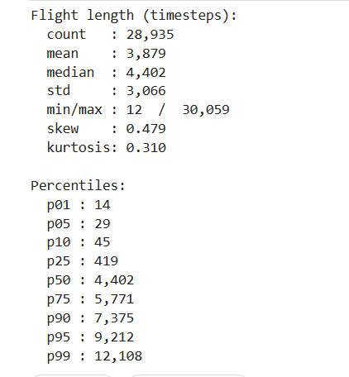
The p01–p10 range reveals very short "flights" that may be noise. Flights with 14–45 timesteps are probably not real flights — they're likely engine run-ups, sensor tests, or recording glitches.

Key Insights: Outlier Flight Lengths
We find that 4,001 flights (13.8%) are shorter than 100 timesteps, likely representing ground runs, sensor tests, or recording errors rather than actual flights. These should be filtered out during preprocessing to avoid introducing noise.
On the other end, only 290 flights (1.0%) exceed the p99 threshold of 12,108 timesteps. These are rare and can be handled by truncating to a fixed sequence length during model training.
After removing the very short flights, the clean dataset reduces from 28,935 to approximately 24,934 flights, where every record represents a meaningful period of actual aircraft operation with usable sensor data.

Leak data
On data leakage, you raise a valid concern. The stratified sampling here is random across all flights regardless of time, which is fine for EDA since we're just describing the data. However, when you move to model training and evaluation, you must not use random splits. Here's why:
The dataset contains multiple flights from the same aircraft before and after the same maintenance event. If flight #3 and flight #4 both come from the same plane before the same repair, and you randomly put #3 in training and #4 in test, the model can "cheat" because those flights share very similar sensor patterns from the same aircraft in the same condition. This is data leakage.
For proper train/test splitting, you should split by maintenance event (not by individual flight). All flights belonging to one maintenance event go entirely into train or entirely into test. This ensures the model is evaluated on truly unseen aircraft conditions.
Additionally, since flights have a temporal order (date_diff, number_flights_before), a time-based split is even more rigorous: train on earlier maintenance events, test on later ones. This simulates the real-world scenario where you're predicting future maintenance from past patterns.

Steps
