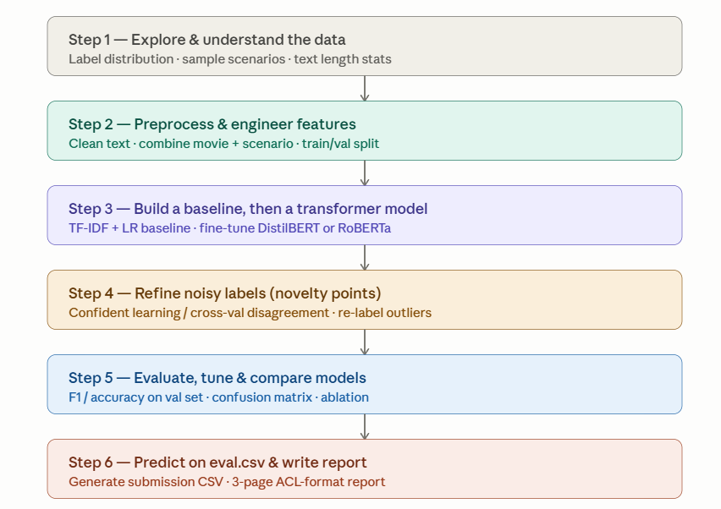
- Update TOC
- Need literature review here: Fine-tune a pre-trained DistilBERT model for binary classification. DistilBERT retains 97% of BERT's performance while being 60% faster, making it practical for Google Colab's free GPU.

