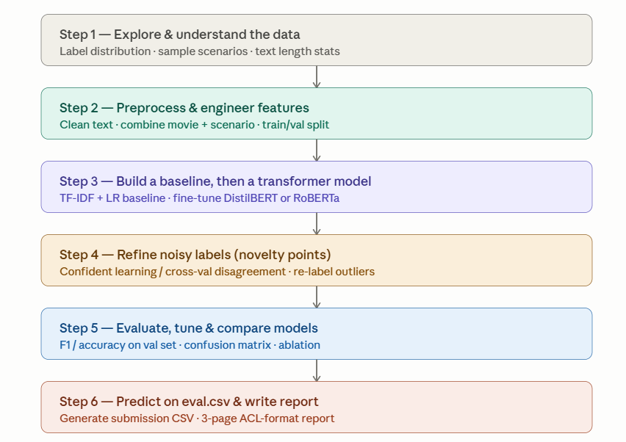

Prompt
- This is my current code so far with insights. I see the result of transformer is not high enough. I want to improve it. Suggest me which methods to improve. No code needed yet, just discuss with me. Can ask me any follow-up questions.
- I have one week to do assignment, I have pro account of PGU. I want code to run RoBERTa. Writing without dash. Before each code block, state the purpose. Can ask me any questions if you want clarify.
- add RoBERTa as a separate section. Just write new code, no need rewrite the whole previous code, I want add new cells by myself. Put them into a jupyter notebook. Can ask me any questions if you want clarify before starting.

To-do list
- Update TOC
- Need literature review here: Fine-tune a pre-trained DistilBERT model for binary classification. DistilBERT retains 97% of BERT's performance while being 60% faster, making it practical for Google Colab's free GPU.
- Literature review on RoBERTa
- Literature review on DeBERTa-v3

- First time:
  - NUM_EPOCHS = 4
  - LEARNING_RATE = 2e-5
  - WARMUP_RATIO = 0.1

  - 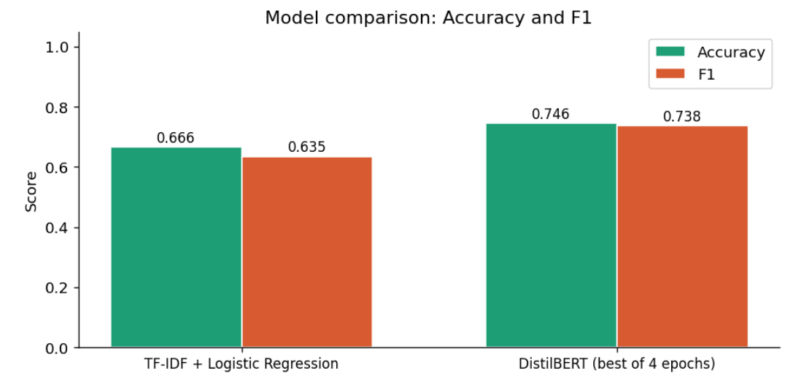
- Decide to run RoBERTa for more precise on binary prediction

