* Block: have

+ Data: transacts…

+ Hash: string hash generated by hash function with unique output and unique input

+ lastHash: is hash of last block, is a chain of blocks

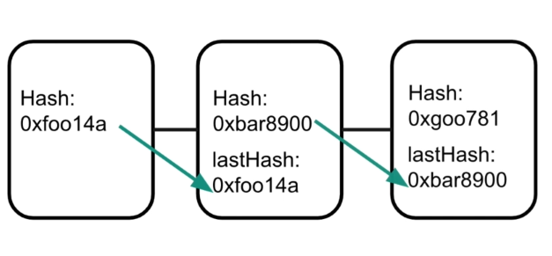

A new block reference is a hash of the lash block in the current chain.

* Ledger: it records all transactions: payments, contracts movements of assets etc. itself is distribute because nodes or computers connect to the block chain network by connecting to the block to a network
* 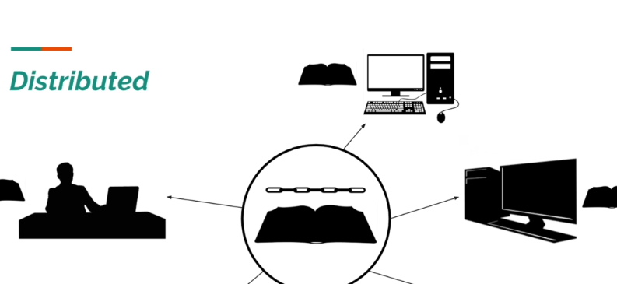
* Block chain as only one of its pieces not primarily a cryptocurrency is a digital media of exchange.
* Have three aspects: Blockchain, wallet, mining.
* **The first aspect:**
* 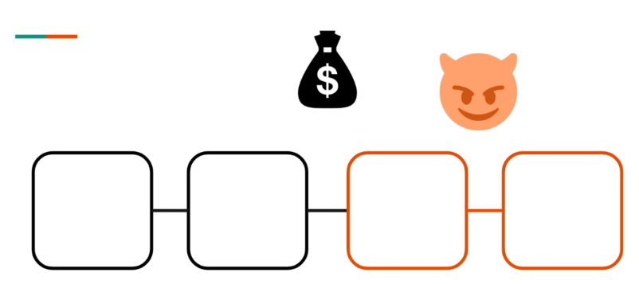
* To prevent such malicious behavior: uses cryptography to protect the blockchain, that using algorithms to obscure data.
* The main application of cryptography is giving individuals the ability to generate unique digital signatures.
* Each individual who wants to record a transaction in the blockchain must **stamp** that transactional data.
* 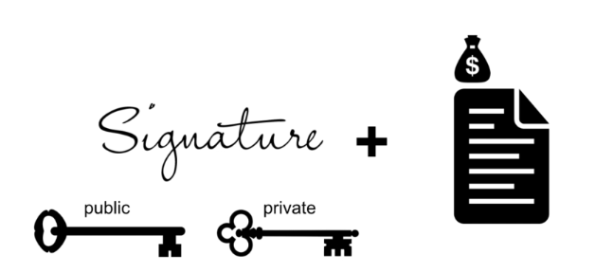
* Signature: is based on a pair of cryptographic keys
* **Second aspect:**  is wallets
* is software keeper of the public and private key.
* The public key is use as an address for your wallet. It’s used by other individuals to send cryptocurrency to you. Then you use private key to make transactions official.
* 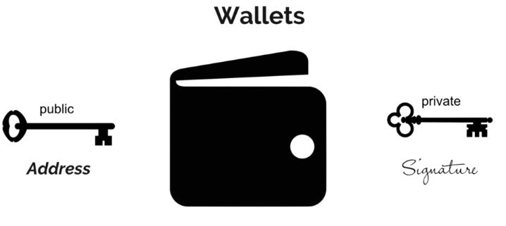
* **Final aspect:** mining

Mine is the work of adding transaction to blockchain

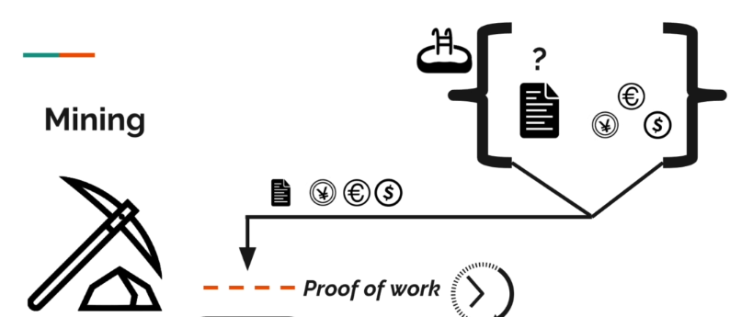

After hours solving algorithm, miner will buzzy, and then added new block to blockchain net work. Other miner will then recognize the solution.

**? why we need proof of work,** it’s costing them so much money, power.

* As a reward for doing the task of mining the miner will receive some cryptocurrency.