# Overview of Studies

We ran four preregistered studies to examine whether conscientiousness moderates the relationship between political ideology and the sharing of misinformation {Lawson and Kakkar, 2021, #43064}. Study 1 recruited participants from Lucid, delivering a sample that matched the distribution of American residents on age, gender, ethnicity, and geographical region. Studies 2 to 4 recruited from Amazon Mechanical Turk. All data and code are available [here](https://www.dropbox.com/sh/41h6xyh8vrjsaw2/AABUNOZfuxs39VGoQcAVHJrva?dl=1) [Dropbox link].

All participants first completed a news sharing task where they indicated (no, maybe, or yes) whether they would consider sharing a set of news headlines on social media (headlines were presented in a random order). "No" responses were coded as 0, whereas "maybe" and "yes" responses were coded as 1. They then answered two personality measures (Big Five, Comprehensive Thinking Styles Questionnaire), political ideology, and other demographic questions.

Three screeners were also presented to evaluate how attentive participants were: one before the news sharing task, another after the two personality measures, and one at the end of the study (after the demographic measures). Mean accuracy across these three screeners was our measure of attentiveness.

## Preregistered analyses

To test our main hypotheses, we fitted logistic regression models with standard errors clustered within each participant and headline. Studies 1, 2, and 4 included both true and false headlines, but Study 3 included only false headlines, so model 3 was not fitted in Study 3. Unless stated otherwise in the model specifications below, all continuous regressors were z-scored.

* Model 1 (only 12 false headlines): sharing ~ ideology + conscientiousness + ideology:conscientiousness
* Model 2 (only 12 false headlines): sharing ~ ideology * (conscientiousness + extraversion + agreeableness + negative emotionality + openness + age + gender + education + attentiveness + thinking styles)
* Model 3 (12 true and 12 false headlines): sharing ~ headline veracity [coded 0/1] * ideology * (conscientiousness + extraversion + agreeableness + negative emotionality + openness + age + gender + education + liberal-leaning-news [coded 0/1] + conservative-leaning-news [coded 0/1] + attentiveness + thinking styles)

## Preregistered sampling strategy and exclusion criteria

Across all studies, we used an open-ended Sequential Bayes Factor design where we performed statistical tests after every *n* participants and could stop data collection whenever there was strong evidence for either the alternative or null hypothesis {Schönbrodt and Wagenmakers, 2018, #39827}. We preregistered recruiting a minimum of 500 participants for each study. We evaluated the evidence for the null hypothesis (coefficient of interest b = 0) and the alternative (or complement) hypothesis (b ≠ 0) by computing the Bayes factor (BF) whenever we recruited 250 additional participants recruited (e.g., 500, 750, 1000 etc.). For the studies that included both true and false headlines (Studies 1, 2, and 4), the coefficient of interest was the ideology-conscientiousness-veracity interaction in model 3; for the study that only had false headlines (Study 3), we focused on the ideology-conscientiousness interaction in model 2. We planned to stop data collection when there was compelling evidence for either the alternative hypothesis (b ≠ 0, BF10 > 10) or the null hypothesis (b = 0, BF01 > 10). Note that in our case, these two hypotheses are reciprocals: BF01 = 1 / BF10.

We excluded participants who (1) completed the study more than once (based on repeat IP addresses or participant IDs), (2) failed one or more (of three) trivial attention checks/bot screeners at the start of the study (different from the three attention checks described above), (3) had non-US IP addresses, and (4) had IPs from potentially suspicious sources {Kennedy et al., 2020, #158807}.

# Study 1

## Method

The preregistration can be found at https://osf.io/k9yns.

## Participants

We recruited participants from Lucid, which provided samples that matched the distribution of American residents on age, gender, ethnicity, and geographical region. The final sample consisted of 490 participants (Mage = 46.27, 254 females, 226 males, 10 others).

## Materials and procedure

Participants indicated their intentions to share 24 political news headlines {\12 true, 12 false; taken from \Pennycook et al., 2020, #71494}. Within the set of true and false headlines, six were conservative-leaning and six were liberal-leaning. These headlines were also used in Lawson & Kakkar's Study 2 {&Lawson and Kakkar, 2021, #43064}.

## Results

Across all analyses, the Bayes factors (BF) suggest there was strong evidence for the null hypothesis (b = 0). For model 3 (main preregistered model), we found a null ideology-conscientiousness-veracity interaction effect (b = -0.03 [-0.15, 0.08], p = .562, BF01 = 88; Fig. 1A). That is, there was 88 times more evidence for the null hypothesis b = 0 than the alternative hypothesis b ≠ 0. There was also a strong null effect for the ideology-conscientiousness interaction in this model (b = 0.09 [-0.12, 0.29], p = .408, BF01 = 74; Fig. 1A left panel; see Lawson and Kakkar’s Fig. S5 right panel for direct comparison).

When the analyses included only false headlines (models 1 and 2), we also observed null ideology-conscientiousness interaction effects (model 1: b = 0.08 [-0.06, 0.23], p = .259, BF01 = 40; model 2: b = 0.09 [-0.12, 0.30], p = .410, BF01 = 53). See Table 1 for full results.

# Study 2

## Method

The preregistration can be found at https://osf.io/4hwcv.

## Participants and materials

We recruited participants from Amazon Mechanical Turk. They were paid $1.10 for completing the study. The final sample consisted of 484 participants (Mage = 41.85, 251 females, 225 males, 8 others). The headlines are the same as those in Study 1.

## Results

Across all analyses, the BFs suggest there was strong evidence for the null hypothesis. For model 3 (main preregistered model), we found a null ideology-conscientiousness-veracity interaction effect (b = -0.05 [-0.15, 0.04], p = .286, BF01 = 60; Fig. 1B). There was also a strong null effect for the ideology-conscientiousness interaction in this model (b = 0.04 [-0.10, 0.19], p = .557, BF01 = 90; Fig. 1B left panel; see Lawson and Kakkar’s Fig. S5 right panel for direct comparison).

When the analyses included only false headlines (models 1 and 2), we also observed null ideology-conscientiousness interaction effects (model 1: b = -0.05 [-0.16, 0.07], p = .448, BF01 = 57; model 2: b = 0.04 [-0.10, 0.19], p = .560, BF01 = 63). See Table 2 for full results.

# Study 3

## Method

The preregistration can be found at https://osf.io/4e8sg.

## Participants and materials

We recruited participants from Amazon Mechanical Turk. They were paid $1.00 for completing the study. The final sample consisted of 465 participants (Mage = 42.17, 223 females, 238 males, 4 others). Only the 12 false headlines in Study 1 were presented in this study.

## Results

Again, contrary to previous work (see Lawson and Kakkar’s Study S2, Table S5), the BFs suggest there was strong evidence for the null hypothesis. For model 2 (main preregistered model), we found a null ideology-conscientiousness interaction effect (b = 0.04 [-0.11, 0.20], p = .589, BF01 = 63; Fig. 1C). We similarly observed a strong null interaction effect in model 1 (b = 0.05 [-0.08, 0.18], p = .431, BF01 = 55). See Table 3 for full results.

# Study 4

## Method

The preregistration can be found at https://osf.io/h6gzw.

## Participants and materials

We recruited participants from Amazon Mechanical Turk. They were paid $1.10 for completing the study. The final sample consisted of 495 participants (Mage = 41.89, 265 females, 220 males, 10 others). Participants indicated their intentions to share 24 news headlines related to politics and COVID-19. Within the set of true and false headlines, six were conservative-leaning and six were liberal-leaning. These headlines were obtained from a pre-test we ran recently.

## Results

As with the previous studies, the BFs suggest there was strong evidence for the null hypothesis. For model 3 (main preregistered model), we found a null ideology-conscientiousness-veracity interaction effect (b = 0.05 [-0.11, 0.21], p = .574, BF01 = 92; Fig. 1D). There was also a strong null effect for the ideology-conscientiousness interaction in this model (b = -0.04 [-0.28, 0.20], p = .740, BF01 = 65; Fig. 1D left panel).

When the analyses included only false headlines (models 1 and 2), we also observed null ideology-conscientiousness interaction effects (model 1: b = -0.003 [-0.18, 0.17], p = .973, BF01 = 77; model 2: b = -0.04 [-0.28, 0.20], p = .741, BF01 = 72). See Table 4 for full results.

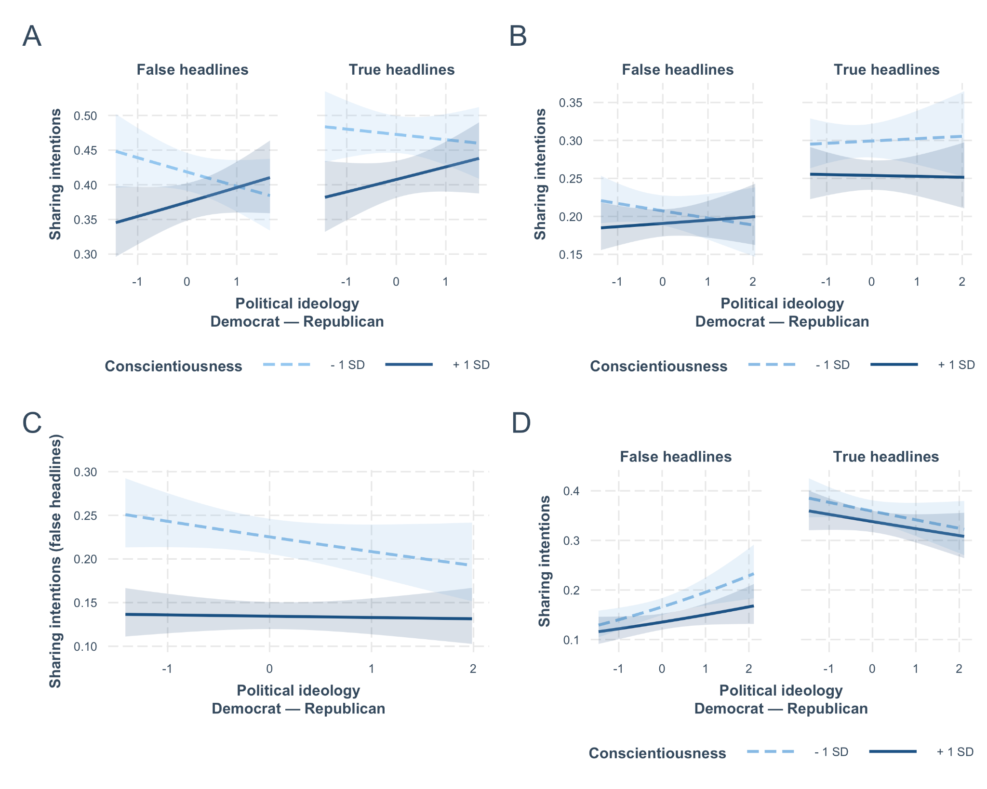

Figure 1. Sharing intentions as a function of political ideology and conscientiousness. A. Lucid sample. B. MTurk sample. C. MTurk sample. Only false headlines were presented. D. MTurk sample. 95% CIs are shown.

Table 1. Study 1. Lucid sample.

| Model | 1 | 2 | 3 |
| --- | --- | --- | --- |
| (Intercept) | -0.334*** (0.027) | -0.425*** (0.101) | -0.425*** (0.100) |
| demrep_c | -0.136*** (0.028) | -0.002 (0.097) | -0.002 (0.096) |
| bfi_c | -0.344*** (0.028) | -0.092 (0.105) | -0.092 (0.105) |
| demrep_c × bfi_c | 0.083** (0.027) | 0.088 (0.106) | 0.088 (0.106) |
| bfi_e |  | 0.322*** (0.079) | 0.322*** (0.079) |
| bfi_a |  | -0.157 (0.101) | -0.157 (0.100) |
| bfi_n |  | 0.131 (0.092) | 0.131 (0.092) |
| bfi_o |  | -0.008 (0.098) | -0.008 (0.098) |
| age |  | -0.364*** (0.080) | -0.364*** (0.079) |
| gender |  | 0.105 (0.069) | 0.105 (0.069) |
| edu |  | 0.033 (0.070) | 0.033 (0.070) |
| attention_score |  | -0.112 (0.069) | -0.112 (0.069) |
| ctsq_aot |  | -0.592*** (0.092) | -0.592*** (0.091) |
| demrep_c × bfi_e |  | -0.086 (0.085) | -0.086 (0.084) |
| demrep_c × bfi_a |  | 0.035 (0.088) | 0.035 (0.088) |
| demrep_c × bfi_n |  | 0.121 (0.080) | 0.121 (0.080) |
| demrep_c × bfi_o |  | 0.162+ (0.086) | 0.162+ (0.086) |
| demrep_c × age |  | -0.018 (0.079) | -0.018 (0.079) |
| demrep_c × gender |  | 0.045 (0.075) | 0.045 (0.075) |
| demrep_c × edu |  | -0.121+ (0.069) | -0.121+ (0.069) |
| demrep_c × attention_score |  | -0.061 (0.076) | -0.061 (0.076) |
| demrep_c × ctsq_aot |  | 0.216** (0.071) | 0.216** (0.071) |
| veracity |  |  | 0.176* (0.087) |
| veracity × demrep_c |  |  | 0.021 (0.100) |
| veracity × bfi_c |  |  | -0.042 (0.050) |
| veracity × bfi_e |  |  | -0.060+ (0.031) |
| veracity × bfi_a |  |  | -0.032 (0.042) |
| veracity × bfi_n |  |  | -0.017 (0.038) |
| veracity × bfi_o |  |  | 0.147** (0.051) |
| veracity × age |  |  | 0.199*** (0.038) |
| veracity × gender |  |  | 0.078** (0.027) |
| veracity × edu |  |  | 0.001 (0.035) |
| veracity × attention_score |  |  | -0.004 (0.038) |
| veracity × ctsq_aot |  |  | 0.027 (0.062) |
| veracity × demrep_c × bfi_c |  |  | -0.034 (0.059) |
| veracity × demrep_c × bfi_e |  |  | -0.026 (0.048) |
| veracity × demrep_c × bfi_a |  |  | 0.036 (0.045) |
| veracity × demrep_c × bfi_n |  |  | 0.022 (0.047) |
| veracity × demrep_c × bfi_o |  |  | -0.088** (0.029) |
| veracity × demrep_c × age |  |  | 0.026 (0.042) |
| veracity × demrep_c × gender |  |  | -0.054 (0.042) |
| veracity × demrep_c × edu |  |  | 0.016 (0.031) |
| veracity × demrep_c × attention_score |  |  | 0.066* (0.032) |
| veracity × demrep_c × ctsq_aot |  |  | -0.106** (0.040) |
| Num.Obs. | 5712 | 5472 | 10944 |
| AIC | 7582.0 | 6308.2 | 12989.1 |
| BIC | 7608.6 | 6453.6 | 13310.3 |
| Log.Lik. | -3786.993 | -3132.101 | -6450.537 |

Table 2. Study 2. Amazon Mechanical Turk sample.

| Model | 1 | 2 | 3 |
| --- | --- | --- | --- |
| (Intercept) | -1.329*** (0.033) | -1.387*** (0.165) | -1.387*** (0.162) |
| demrep_c | 0.148*** (0.032) | -0.023 (0.125) | -0.023 (0.123) |
| bfi_c | -0.170*** (0.032) | -0.052 (0.082) | -0.052 (0.081) |
| demrep_c × bfi_c | -0.045 (0.030) | 0.043 (0.074) | 0.043 (0.073) |
| bfi_e |  | 0.034 (0.088) | 0.034 (0.088) |
| bfi_a |  | 0.026 (0.099) | 0.026 (0.098) |
| bfi_n |  | -0.005 (0.097) | -0.005 (0.096) |
| bfi_o |  | -0.154* (0.074) | -0.154* (0.074) |
| age |  | -0.048 (0.074) | -0.048 (0.074) |
| gender |  | 0.157* (0.076) | 0.157* (0.075) |
| edu |  | 0.040 (0.068) | 0.040 (0.068) |
| attention_score |  | -0.163* (0.070) | -0.163* (0.069) |
| ctsq_aot |  | -0.473*** (0.103) | -0.473*** (0.102) |
| demrep_c × bfi_e |  | 0.055 (0.087) | 0.055 (0.087) |
| demrep_c × bfi_a |  | -0.046 (0.105) | -0.046 (0.105) |
| demrep_c × bfi_n |  | 0.122 (0.101) | 0.122 (0.100) |
| demrep_c × bfi_o |  | 0.033 (0.083) | 0.033 (0.082) |
| demrep_c × age |  | 0.090 (0.069) | 0.090 (0.069) |
| demrep_c × gender |  | 0.015 (0.057) | 0.015 (0.057) |
| demrep_c × edu |  | -0.068 (0.050) | -0.068 (0.050) |
| demrep_c × attention_score |  | 0.114 (0.073) | 0.114 (0.072) |
| demrep_c × ctsq_aot |  | 0.110 (0.068) | 0.110 (0.067) |
| veracity |  |  | 0.422* (0.177) |
| veracity × demrep_c |  |  | 0.024 (0.159) |
| veracity × bfi_c |  |  | -0.062 (0.054) |
| veracity × bfi_e |  |  | -0.042 (0.067) |
| veracity × bfi_a |  |  | 0.077 (0.069) |
| veracity × bfi_n |  |  | -0.001 (0.076) |
| veracity × bfi_o |  |  | 0.073+ (0.044) |
| veracity × age |  |  | 0.177** (0.060) |
| veracity × gender |  |  | 0.062 (0.055) |
| veracity × edu |  |  | 0.066 (0.051) |
| veracity × attention_score |  |  | 0.173*** (0.047) |
| veracity × ctsq_aot |  |  | 0.203* (0.089) |
| veracity × demrep_c × bfi_c |  |  | -0.053 (0.050) |
| veracity × demrep_c × bfi_e |  |  | -0.045 (0.054) |
| veracity × demrep_c × bfi_a |  |  | 0.037 (0.064) |
| veracity × demrep_c × bfi_n |  |  | -0.094 (0.072) |
| veracity × demrep_c × bfi_o |  |  | 0.004 (0.058) |
| veracity × demrep_c × age |  |  | -0.062 (0.052) |
| veracity × demrep_c × gender |  |  | -0.019 (0.039) |
| veracity × demrep_c × edu |  |  | 0.012 (0.037) |
| veracity × demrep_c × attention_score |  |  | -0.069 (0.056) |
| veracity × demrep_c × ctsq_aot |  |  | -0.101+ (0.056) |
| Num.Obs. | 5760 | 5652 | 11304 |
| AIC | 5899.4 | 5541.5 | 12133.3 |
| BIC | 5926.1 | 5687.6 | 12456.0 |
| Log.Lik. | -2945.710 | -2748.741 | -6022.662 |

Table 3. Study 3. Amazon Mechanical Turk sample. Only false headlines.

| Model | 1 | 2 |
| --- | --- | --- |
| (Intercept) | -1.452*** (0.035) | -1.545*** (0.182) |
| demrep_c | 0.142*** (0.035) | -0.056 (0.134) |
| bfi_c | -0.294*** (0.033) | -0.313*** (0.077) |
| demrep_c × bfi_c | 0.051 (0.033) | 0.043 (0.080) |
| bfi_e |  | 0.091 (0.074) |
| bfi_a |  | 0.021 (0.097) |
| bfi_n |  | -0.075 (0.096) |
| bfi_o |  | -0.153+ (0.082) |
| age |  | -0.020 (0.080) |
| gender |  | 0.081 (0.076) |
| edu |  | 0.039 (0.073) |
| attention_score |  | -0.091+ (0.050) |
| ctsq_aot |  | -0.474*** (0.093) |
| demrep_c × bfi_e |  | 0.101 (0.074) |
| demrep_c × bfi_a |  | -0.013 (0.069) |
| demrep_c × bfi_n |  | 0.015 (0.077) |
| demrep_c × bfi_o |  | -0.023 (0.082) |
| demrep_c × age |  | 0.117+ (0.067) |
| demrep_c × gender |  | -0.202** (0.072) |
| demrep_c × edu |  | 0.096 (0.073) |
| demrep_c × attention_score |  | 0.003 (0.052) |
| demrep_c × ctsq_aot |  | 0.146* (0.070) |
| Num.Obs. | 5532 | 5340 |
| AIC | 5389.3 | 4914.8 |
| BIC | 5415.8 | 5059.6 |
| Log.Lik. | -2690.665 | -2435.405 |

Table 4. Study 4. Amazon Mechanical Turk sample.

| Model | 1 | 2 | 3 |
| --- | --- | --- | --- |
| (Intercept) | -1.664*** (0.036) | -1.731*** (0.129) | -1.731*** (0.127) |
| demrep_c | 0.242*** (0.036) | 0.158 (0.204) | 0.158 (0.200) |
| bfi_c | -0.112** (0.036) | -0.121 (0.089) | -0.121 (0.089) |
| demrep_c × bfi_c | -0.003 (0.035) | -0.040 (0.121) | -0.040 (0.120) |
| bfi_e |  | 0.132+ (0.073) | 0.132+ (0.073) |
| bfi_a |  | 0.144 (0.089) | 0.144 (0.088) |
| bfi_n |  | -0.007 (0.089) | -0.007 (0.089) |
| bfi_o |  | -0.185* (0.073) | -0.185* (0.073) |
| age |  | -0.005 (0.079) | -0.005 (0.078) |
| gender |  | -0.072 (0.078) | -0.072 (0.077) |
| edu |  | -0.129+ (0.070) | -0.129+ (0.069) |
| attention_score |  | -0.064 (0.065) | -0.064 (0.064) |
| ctsq_aot |  | -0.529*** (0.102) | -0.529*** (0.101) |
| demrep_c × bfi_e |  | 0.156* (0.076) | 0.156* (0.076) |
| demrep_c × bfi_a |  | 0.044 (0.082) | 0.044 (0.082) |
| demrep_c × bfi_n |  | 0.031 (0.103) | 0.031 (0.103) |
| demrep_c × bfi_o |  | -0.082 (0.082) | -0.082 (0.082) |
| demrep_c × age |  | -0.058 (0.084) | -0.058 (0.083) |
| demrep_c × gender |  | 0.034 (0.086) | 0.034 (0.085) |
| demrep_c × edu |  | 0.016 (0.065) | 0.016 (0.065) |
| demrep_c × attention_score |  | 0.066 (0.068) | 0.066 (0.068) |
| demrep_c × ctsq_aot |  | 0.262** (0.091) | 0.262** (0.090) |
| veracity |  |  | 1.105*** (0.184) |
| veracity × demrep_c |  |  | -0.227 (0.248) |
| veracity × bfi_c |  |  | 0.075 (0.068) |
| veracity × bfi_e |  |  | 0.057 (0.058) |
| veracity × bfi_a |  |  | 0.010 (0.069) |
| veracity × bfi_n |  |  | 0.017 (0.064) |
| veracity × bfi_o |  |  | 0.068 (0.052) |
| veracity × age |  |  | 0.049 (0.063) |
| veracity × gender |  |  | 0.125+ (0.068) |
| veracity × edu |  |  | 0.048 (0.049) |
| veracity × attention_score |  |  | 0.088+ (0.049) |
| veracity × ctsq_aot |  |  | 0.462*** (0.094) |
| veracity × demrep_c × bfi_c |  |  | 0.046 (0.082) |
| veracity × demrep_c × bfi_e |  |  | -0.129* (0.065) |
| veracity × demrep_c × bfi_a |  |  | 0.139* (0.061) |
| veracity × demrep_c × bfi_n |  |  | -0.030 (0.079) |
| veracity × demrep_c × bfi_o |  |  | 0.058 (0.060) |
| veracity × demrep_c × age |  |  | -0.010 (0.064) |
| veracity × demrep_c × gender |  |  | -0.065 (0.064) |
| veracity × demrep_c × edu |  |  | -0.016 (0.053) |
| veracity × demrep_c × attention_score |  |  | -0.062+ (0.037) |
| veracity × demrep_c × ctsq_aot |  |  | -0.233** (0.077) |
| Num.Obs. | 5892 | 5772 | 11544 |
| AIC | 5179.1 | 4805.1 | 12164.3 |
| BIC | 5205.9 | 4951.6 | 12487.8 |
| Log.Lik. | -2585.571 | -2380.531 | -6038.129 |

# 

# Appendix

