MC:

* We know she has magic, but maybe she’s part lycanthrope??
  + Because dad
* Cece?

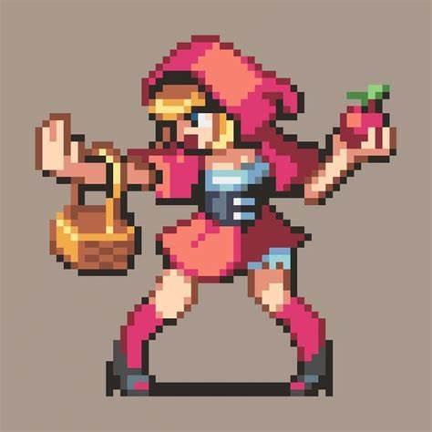

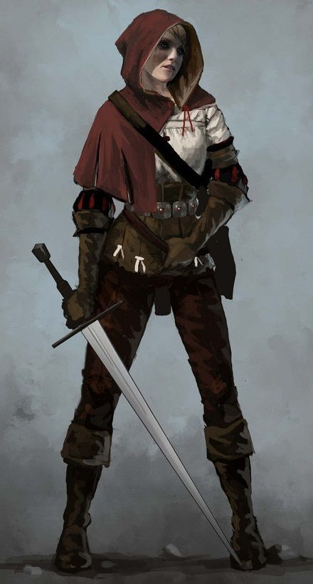

Hunter:

* Himbo
* 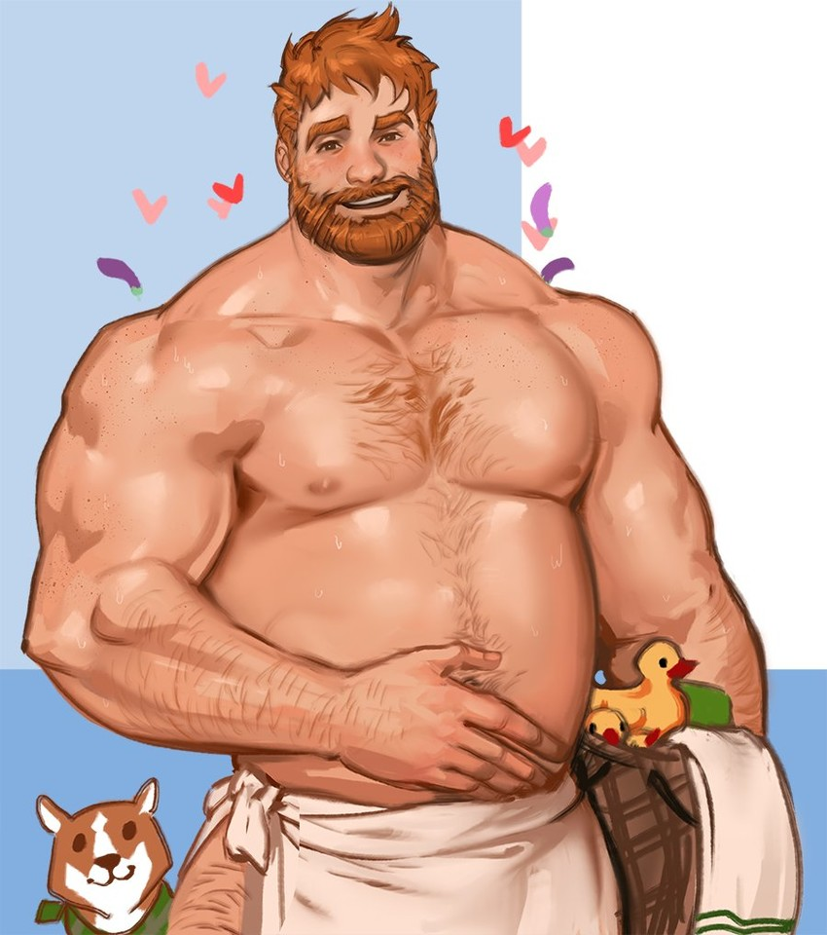

Goldi

Wolf



BBEG