We had a community sample of 163 participants attend the viewing and complete both pre- and post- movie surveys, none of whom reported seeing either movie previously. Participants were then randomly assigned to a theatre with 80 (49 female) viewing Joker and 84 (53 female) viewing Terminator. In both groups, the average age was 30 years old and there was a representative mix of ethnicities. In the pre-movie survey, participants reported demographics and a baseline level of prejudice. Directly after viewing the movie, participants completed the post-movie survey, reporting levels of prejudice, empathy, and authoritarianism using Likert scales. We conducted confirmatory factor analysis to produce latent variables of each scale for our analyses.

Change in prejudice was assessed using a lagged Bayesian regression, with weakly informative priors. Specifically, our outcome was prejudice after the movie, while using prejudice before the movie as a covariate, along with age, gender, mental illness history, movie, empathy, and authoritarianism. We also included an empathy-movie and authoritarianism-movie interaction. Our analysis indicated that Joker significantly increased prejudice relative to Terminator, as did higher levels of authoritarianism increase prejudice (All posterior probabilities above 95%; Table 1). We also noted that higher levels of authoritarianism significantly increased the prejudice elicited by Joker (Figure 1).

**Figure 1.** Significant two-way interaction between movie and levels of standardised authoritarianism when predicting change in prejudice. Error bands are 95% credible intervals.

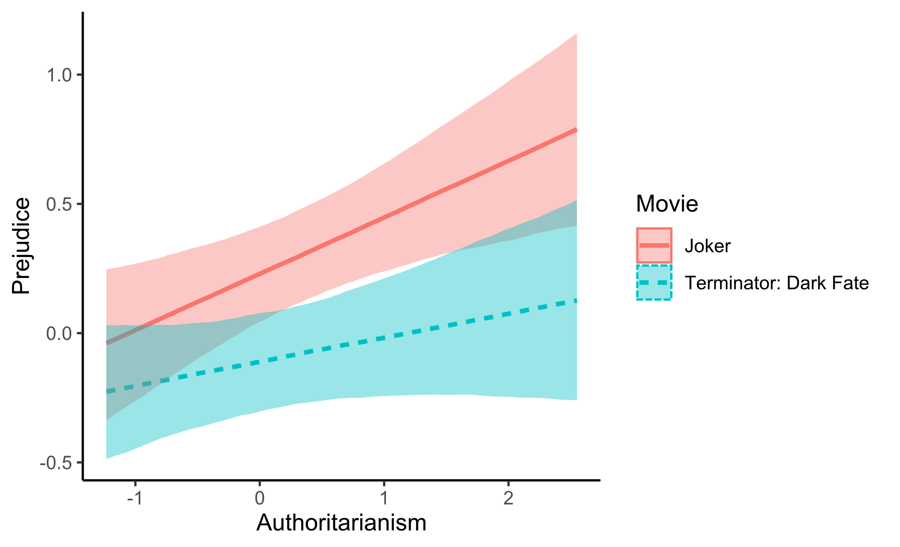

**References**