**Influence of violent depictions of mental illness on prejudice; ‘Why so serious?’**

…

**Method**

We had a community sample of 163 participants attend the viewing and complete both pre- and post- movie surveys, none of whom reported seeing either movie previously. Participants were then randomly assigned to a theatre with 80 (49 female) viewing Joker and 84 (53 female) viewing Terminator. In both movie conditions, the average age was 30 years old with standard deviation of 9.8 years old for Joker, and 10.5 years old for Terminator. We also had a representative mix of ethnicities with the Joker group being 39% European, 33% Asian, 15% Maori or Pacifica, and 14% other ethnicities. The Terminator group consisted of 61% European, 27% Asian, 12% Maori or Pacifica, and 11% other ethnicities. In the pre-movie survey, participants reported demographics and a baseline level of prejudice. Directly after viewing the movie, participants completed the post-movie survey, reporting levels of prejudice (Kenny, Bizumic, & Griffiths, 2018) and authoritarianism (Davis, 1983) using Likert scales. We conducted confirmatory factor analysis to produced latent variables of each scale for our analyses.

**Results**

Change in prejudice was assessed using a lagged Bayesian regression, with weakly informative priors. Specifically, our outcome was prejudice after the movie, while using prejudice before the movie as a covariate, along with age, gender, mental illness history, movie, authoritarianism, and an interaction between authoritarianism and movie. Our analysis indicated that Joker significantly increased prejudice relative to Terminator (posterior probability above 95%; Table 1). We also noted that higher levels of authoritarianism significantly increased the level prejudice elicited by Joker (Figure 1).

**Table 1.** Summary of lagged Bayesian regression analysis on change in prejudice after watching Joker.

|  |  |  |  |  |
| --- | --- | --- | --- | --- |
|  |  | 95% Credible Interval | |  |
|  | Estimate | Lower | Upper | PP |
| Intercept | 0.05 | -0.13 | 0.23 | 72.9% |
| Prejudice (lag) | 0.88 | 0.77 | 1.00 | 100.0% |
| Age | 0.01 | -0.09 | 0.10 | 56.3% |
| Sex (female) | 0.01 | -0.18 | 0.20 | 54.6% |
| Mental health history | -0.09 | -0.32 | 0.12 | 83.5% |
| Movie (Joker) | 0.32 | 0.16 | 0.49 | 100.0% |
| Authoritarianism | 0.08 | -0.05 | 0.21 | 91.2% |
| Movie (Joker) * Authoritarianism | 0.12 | -0.06 | 0.30 | 96.8% |
| NB: PP is the posterior probability, the probability an effect deviates from zero in its given direction. | | | | |

**Figure 1.** Significant two-way interaction between movie and levels of standardised authoritarianism when predicting change in prejudice. Error bands are 95% credible intervals.

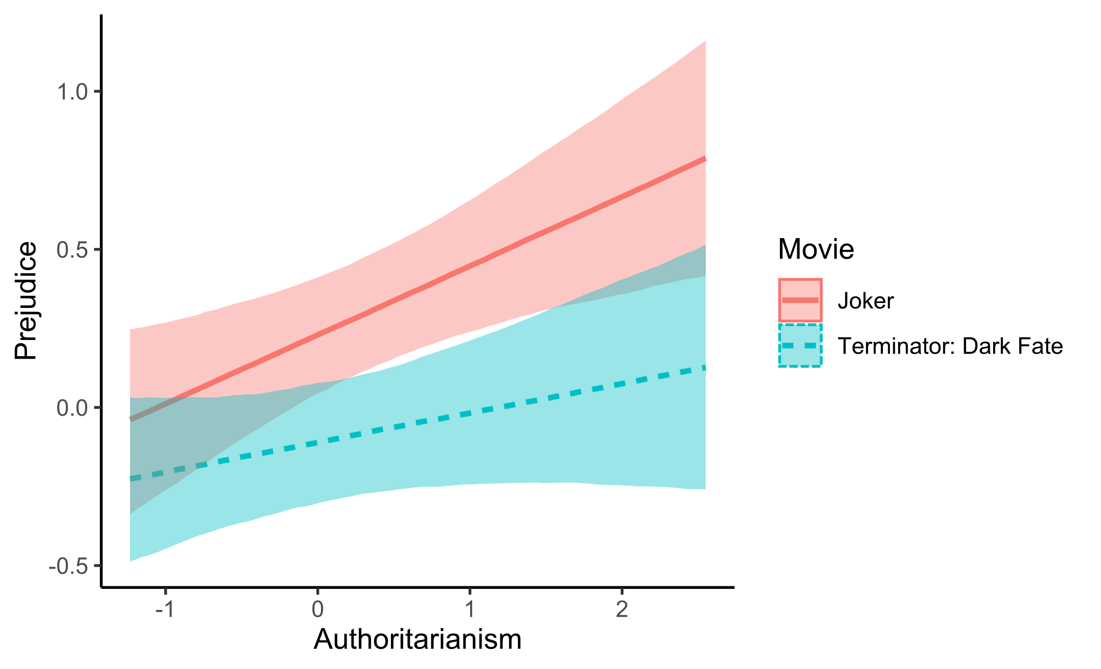**Discussion**

…

**References**

Bizumic, B., & Duckitt, J. (2018). Investigating Right Wing Authoritarianism with a Very Short Authoritarianism scale. *Journal of Social and Political Psychology*, *6*(1), 129–150. https://doi.org/10.5964/jspp.v6i1.835

Kenny, A., Bizumic, B., & Griffiths, K. M. (2018). The Prejudice towards People with Mental Illness (PPMI) scale: Structure and validity. *BMC Psychiatry*, *18*.