**DCCL LAB1**

**matlab**

電機碩一 111521035 林豪澤

1. Write down the initial state. Print out the m-sequence.(Use command “stem”)

The initial state is: [ 1 1 1 1 ]

The PN sequence is:

b = [1 0 1 0 1 1 0 0 1 0 0 0 1 1 1];

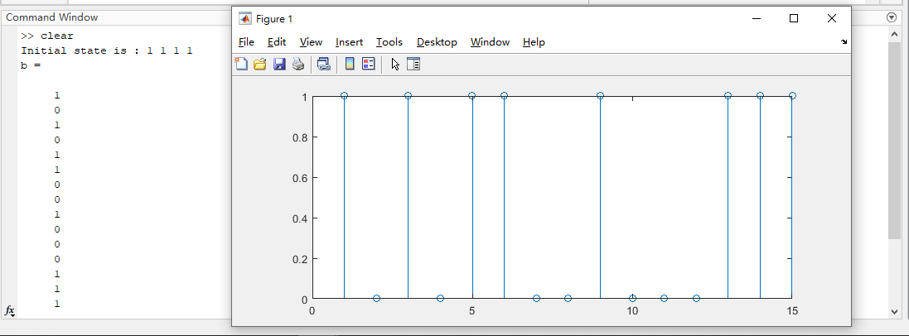

1. Draw the autocorrelation result.

Use 103oct and initial state [ 1 1 0 0 1 1 ] to generate sequence b.

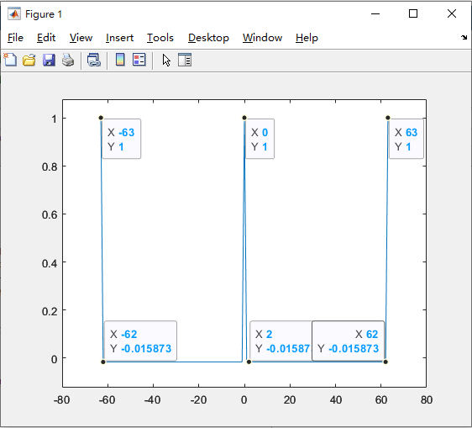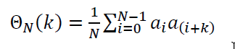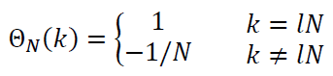The autocorrelation result is:

1. Write down the initial state that you use to generate sequence

Use 103oct and initial state [ 1 1 0 0 1 1 ] to generate sequence b.

Use q=13 to generate sequence b’.

b = [1 0 0 0 1 0 1 1 1 1 0 0 1 0 1 0 0 0 1 1 0 0 0 0 1 0 0 0 0 0 1 1 1 ...

1 1 1 0 1 0 1 0 1 1 0 0 1 1 0 1 1 1 0 1 1 0 1 0 0 1 0 0 1 1]; 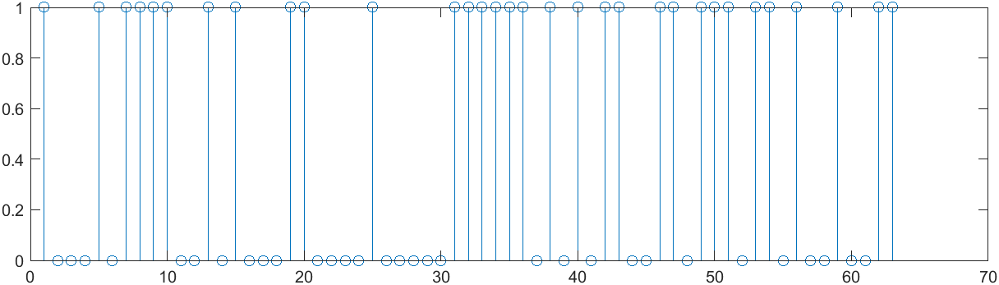

b_prime = [1 0 0 1 1 0 0 0 1 0 1 0 1 0 0 1 1 1 1 1 1 0 1 0 0 0 0 0 1 1 ...

0 0 0 0 1 0 0 1 0 0 0 1 1 0 1 1 0 0 1 0 1 1 0 1 0 1 1 1 0 1 1 1]; 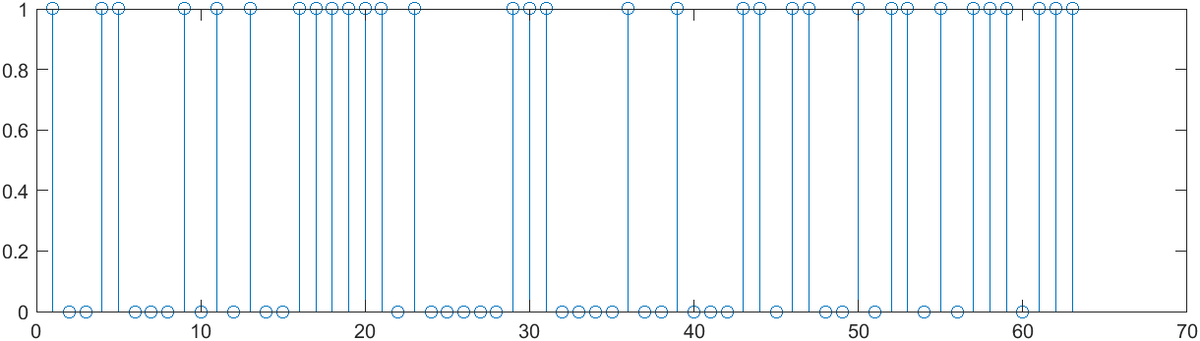

b and b_prime’s full-period cross-correlation:

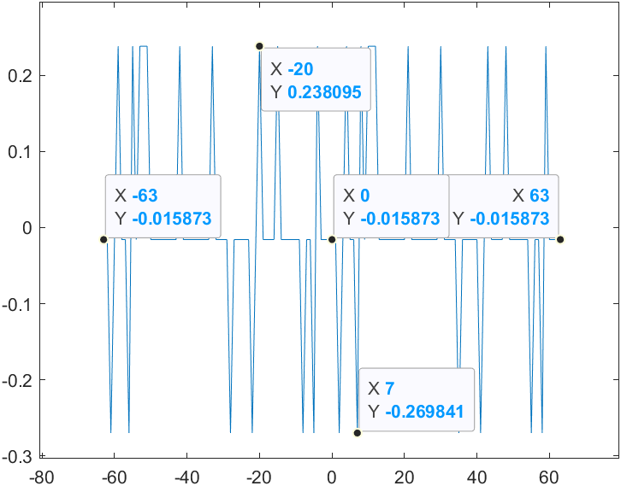

$t\left(r\right)=\left\{\begin{aligned}1+2^{0.5\left(r+1\right)}, & for odd r \\ 1+2^{0.5\left(r+2\right)}, & for even r\end{aligned}\right.$,three possible values: $\left\{\begin{aligned}-\frac{1}{N}*t\left(r\right)=-0.2698 \\ -\frac{1}{N}=-0.01587 \\ \frac{1}{N}*\left(t\left(r\right)-2\right)=0.2381\end{aligned}\right.$

1. Write down the initial state that use to generate sequence b’’.

Use 133oct and initial state [ 1 1 0 1 1 0 ] to generate sequence b’’.

b’’ = [0 1 0 0 0 0 0 1 1 1 0 0 0 0 1 0 0 1 0 0 0 1 1 0 1 1 0 0 1 0 1 1 ...

0 1 0 1 1 1 0 1 1 1 1 0 0 1 1 0 0 0 1 0 1 0 1 0 0 1 1 1 1 1 1];

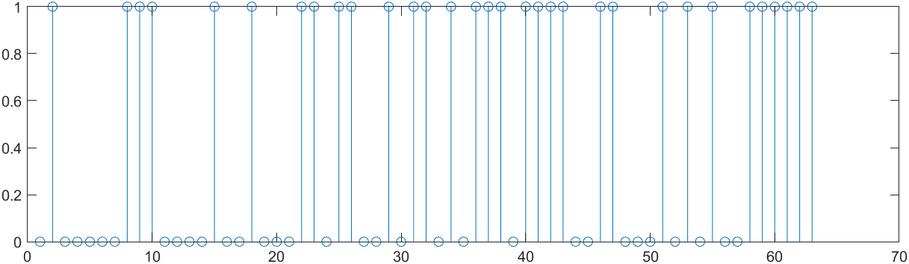

The way to check if b’ and b’’ are the same sequence:

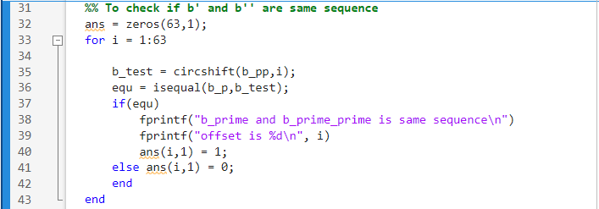

1. 假設b’與b’’為同一sequence，但是具有不同的offset。
2. 使用circshift函式移動(右移)其中一個陣列，一共移動N=63次。
3. 使用isequal函式逐一比對移動過的陣列是否相等，一共比對63次。

如果相等則在ans陣列中標註為1並輸出其offset位置

結果:

b’ 與 b’’ 為相同的sequence，其offset 為右移 21 個位元。

b_prime and b_prime_prime is same sequence

offset is 21

1. Print out 5 sequence among 65 Gold code sequences according to procedure 5.

First sequence in Gold code(i.e. b):

[1 0 0 0 1 0 1 1 1 1 0 0 1 0 1 0 0 0 1 1 0 0 0 0 1 0 0 0 0 0 1 1 1 1 ...

1 1 0 1 0 1 0 1 1 0 0 1 1 0 1 1 1 0 1 1 0 1 0 0 1 0 0 1 1]; 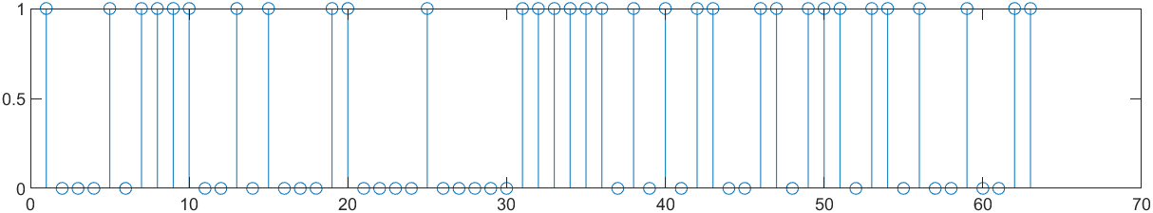

Second sequence in Gold code(i.e. b’):

[ 1 0 0 1 1 0 0 0 1 0 1 0 1 0 0 1 1 1 1 1 1 0 1 0 0 0 0 0 1 1 1 0 0 0 ...

0 1 0 0 1 0 0 0 1 1 0 1 1 0 0 1 0 1 1 0 1 0 1 1 1 0 1 1 1];

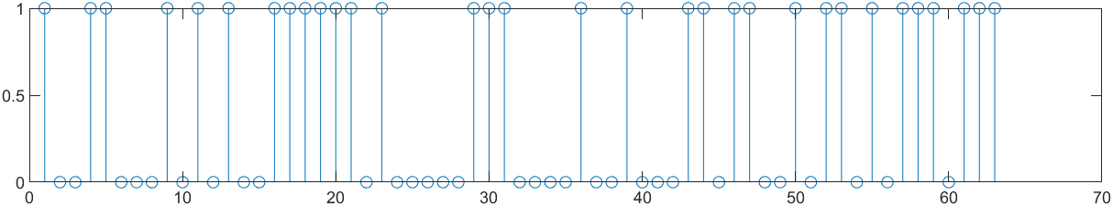

Third sequence in Gold code(i.e. b+b’):

[0 0 0 1 0 0 1 1 0 1 1 0 0 0 1 1 1 1 0 0 1 0 1 0 1 0 0 0 1 1 0 1 1 1 ...

1 0 0 1 1 1 0 1 0 1 0 0 0 0 1 0 1 1 0 1 1 1 1 1 0 0 1 0 0]; 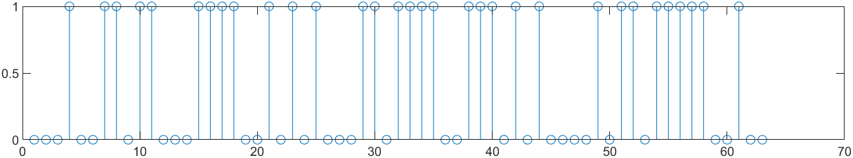

Fourth sequence in Gold code(i.e. b+Db’):

[0 1 0 0 0 1 1 1 1 0 0 1 1 1 1 0 1 1 0 0 1 1 0 1 1 0 0 0 0 1 0 0 1 1 ...

1 1 1 1 0 0 0 1 1 1 1 1 0 1 1 1 0 0 0 0 0 0 0 1 0 1 0 0 0]; 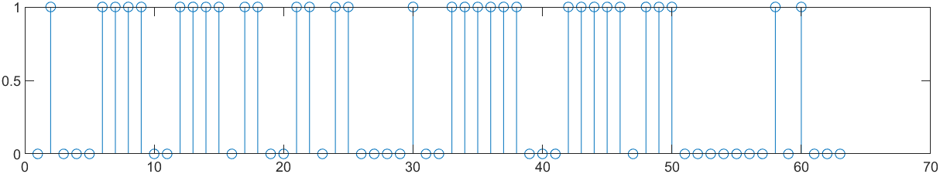

(Fifth sequence in Gold code is print on next page)

Fifth sequence in Gold code(i.e. b+D2b’):

[0 1 1 0 1 1 0 1 1 1 1 0 0 0 0 0 0 1 0 0 1 1 1 0 0 0 0 0 0 0 0 0 0 1 ...

1 1 0 0 0 1 1 1 1 0 1 0 1 1 0 1 1 1 1 0 1 1 1 0 0 1 1 1 0]; 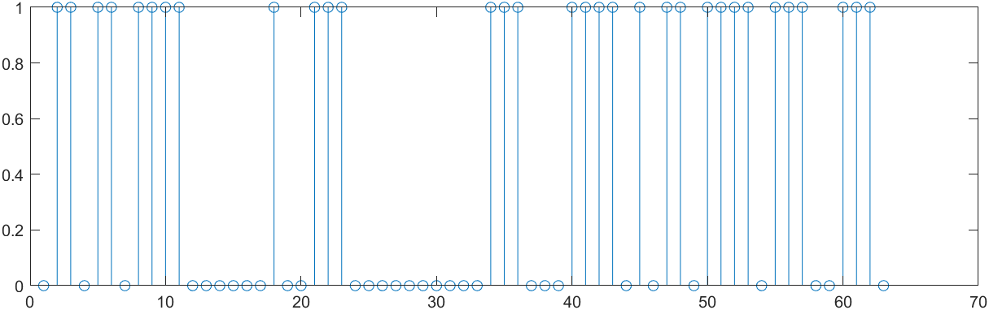

1. Write down the base sequence.

The base sequence is same as result 3.

b = [1 0 0 0 1 0 1 1 1 1 0 0 1 0 1 0 0 0 1 1 0 0 0 0 1 0 0 0 0 0 1 1 1 ...

1 1 1 0 1 0 1 0 1 1 0 0 1 1 0 1 1 1 0 1 1 0 1 0 0 1 0 0 1 1]; 

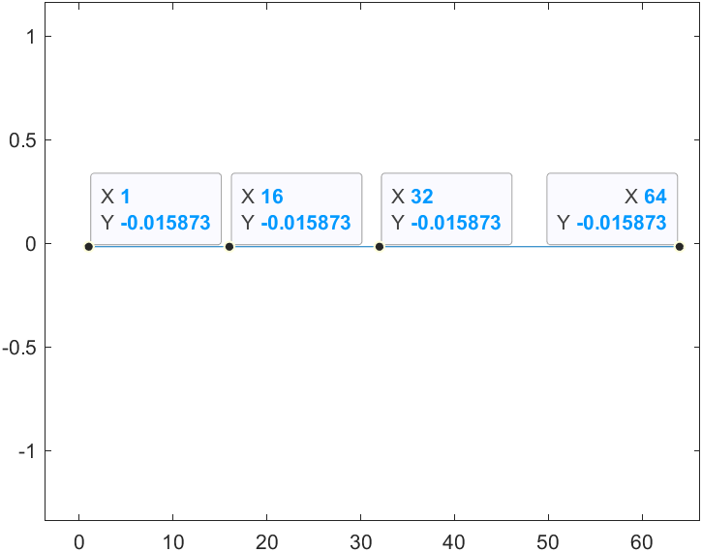Draw the result of full-period cross-correlation in a figure.

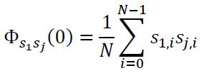

All the result in full-period cross-correlation is -0.0159. i.e. (-1/N),N= 63

1. Write down the base sequence.

The base sequence is same as result 6.

b = [1 0 0 0 1 0 1 1 1 1 0 0 1 0 1 0 0 0 1 1 0 0 0 0 1 0 0 0 0 0 1 1 1 ...

1 1 1 0 1 0 1 0 1 1 0 0 1 1 0 1 1 1 0 1 1 0 1 0 0 1 0 0 1 1]; 

Draw the result of full-period cross-correlation in a figure.

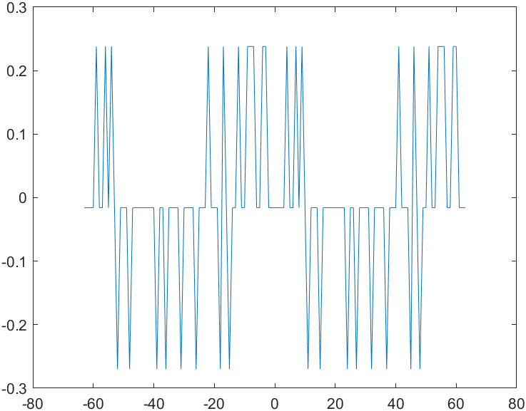

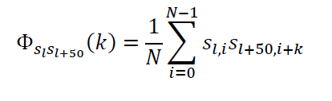

$t\left(r\right)=\left\{\begin{aligned}1+2^{0.5\left(r+1\right)}, & for odd r \\ 1+2^{0.5\left(r+2\right)}, & for even r\end{aligned}\right.$, three possible values: $\left\{\begin{aligned}-\frac{1}{N}*t\left(r\right)=-0.2698 \\ -\frac{1}{N}=-0.01587 \\ \frac{1}{N}*\left(t\left(r\right)-2\right)=0.2381\end{aligned}\right.$