**DCCL LAB2**

**matlab**

電機碩一 111521035 林豪澤

1. The random sequence we generate with 32 elements is:

rand_32 = [14 -75 25 20 -65 -79 -98 -40 13 56 -94 -6 5 74 -111 37

77 71 36 64 -118 -107 94 -20 -64 -122 88 -26 -19 -57 -68 -43]

Y: -128~127

minimum

maximum

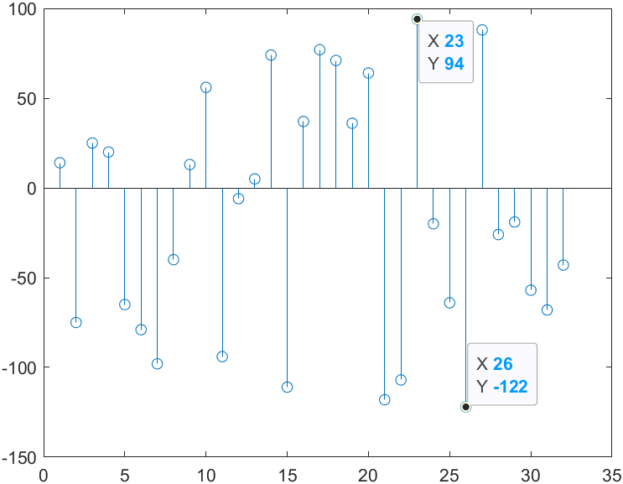

𝑥: 1~32

The maximum value with index is : 94/23

The minimum value with index is : -122/26

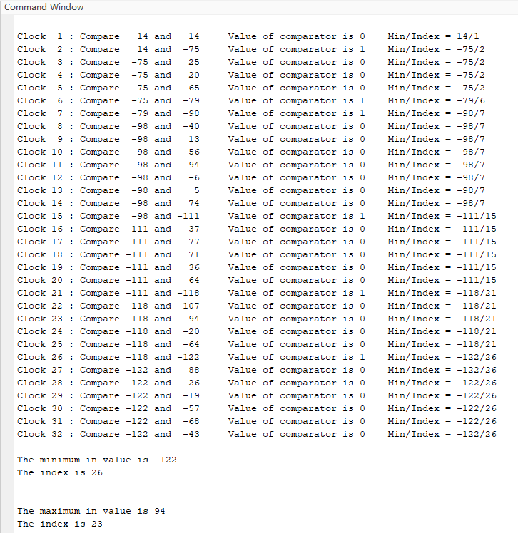

使用32個clock依序比較出陣列中Minimum value與其Index。



1. The inputs is the same as result 1:

rand_32 =[14 -75 25 20 -65 -79 -98 -40 13 56 -94 -6 5 74 -111 37

77 71 36 64 -118 -107 94 -20 -64 -122 88 -26 -19 -57 -68 -43]

For the pre-processing, for each value in the matrix we add the associated index after the values.

mat_32 = [1401 -7502 2503 2004 -6505 -7906 -9807 -4008 1309 5610 -9411

-612 513 7414 -11115 3716 7717 7118 3619 6420 -11821 -10722

9423 -2024 -6425 -12226 8827 -2628 -1929 -5730 -6831 -4332];

mat_16 = [-7502 2004 -7906 -9807 1309 -9411 513 -11115 7118 3619 -11821 ...

-2024 -12226 -2628 -5730 -6831];

mat_8 = [-7502 -9807 -9411 -11115 3619 -11821 -12226 -6831];

mat_4 = [-9807 -11115 -11821 -12226];

mat_2 = [-11115 -12226];