**DCCDL LAB1**

**Verilog**

電機碩一 111521035 林豪澤

8.

Draw the block diagram of the LFSR with coefficients 23oct. (10%)

23oct = 10011bin

g(D) = D3+D+1

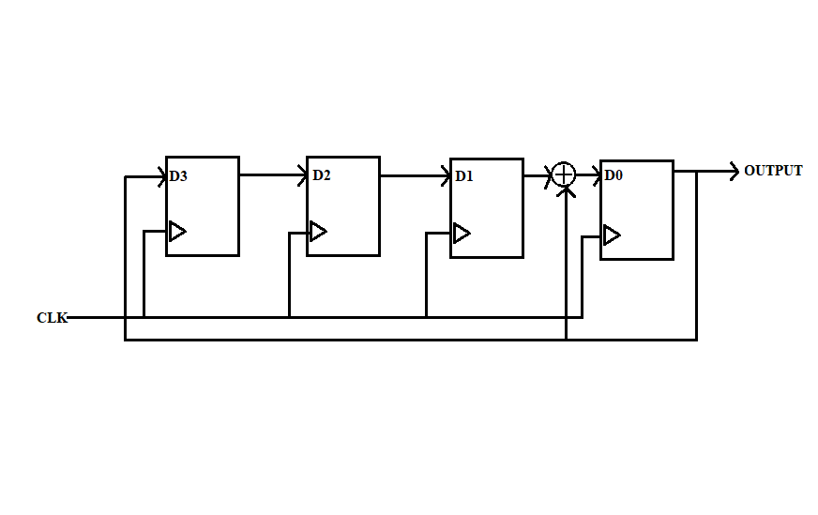

Implement block diagram by Verilog to see if the RTL simulation results are the same as the Matlab results.Print out the Verilog codes. (20%)

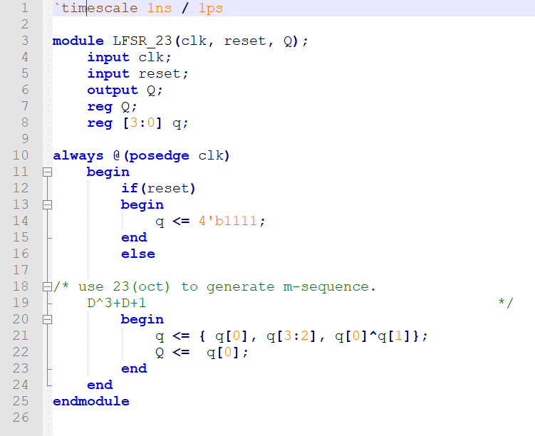

Print out the timing diagram of RTL simulation.

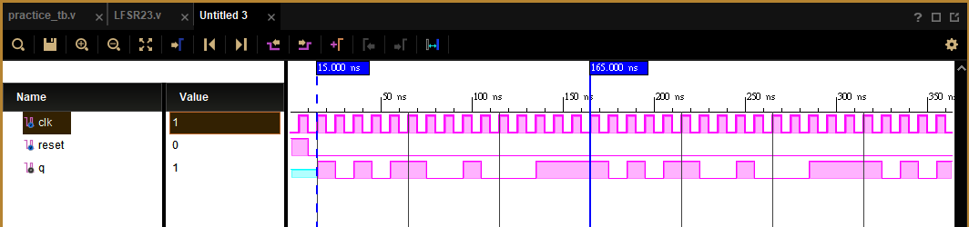

The result is q: [1 0 1 0 1 1 0 0 1 0 0 0 1 1 1], same as the result of Matlab.(start at 15ns, end at 165ns.)

9.

Draw the block diagram of your Gold code generator. (10%)

Upper LFSR’s coefficient is 103oct , g(D) = D6+D+1.

lower LFSR ‘s coefficient is 133oct , g’(D) = D6+D4+D3+D+1

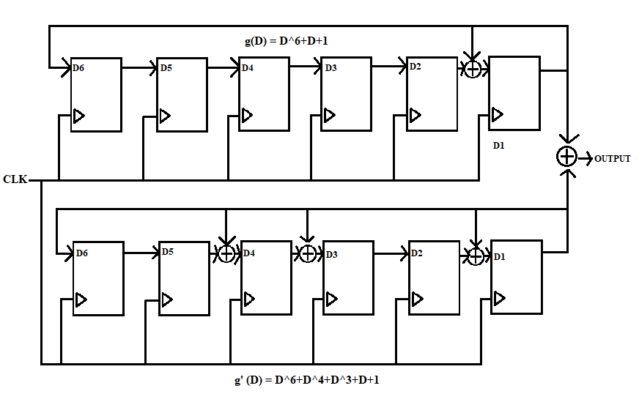

Print out Verilog code including test bench. (25%)

Use module ‘LFSR103’ to implement upper LFSR circuit with 103oct.

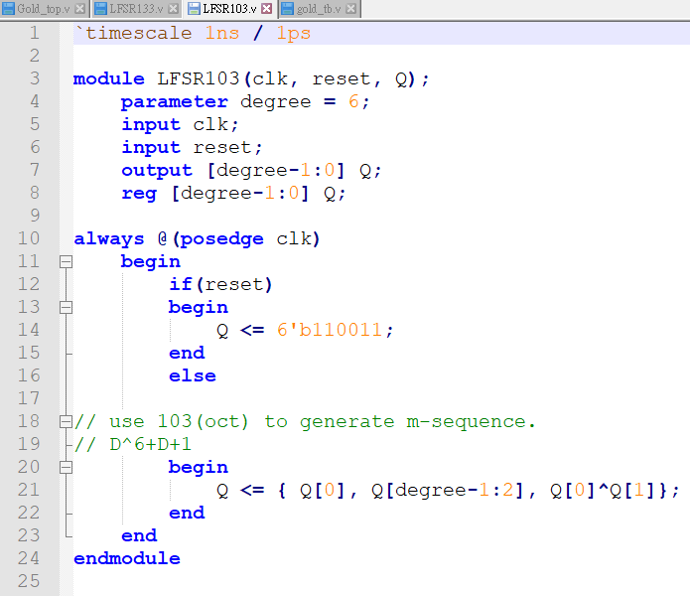

Use ‘module LFSR133’ to implement lower LFSR circuit with 133oct. 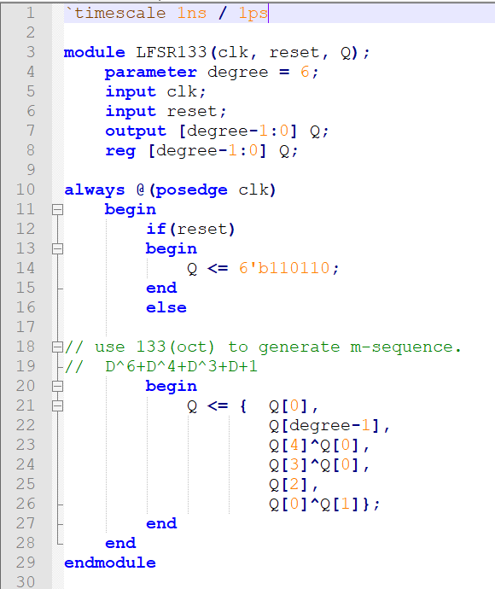

Use module ‘Gold_top’ to implement all circuit in one circuit.

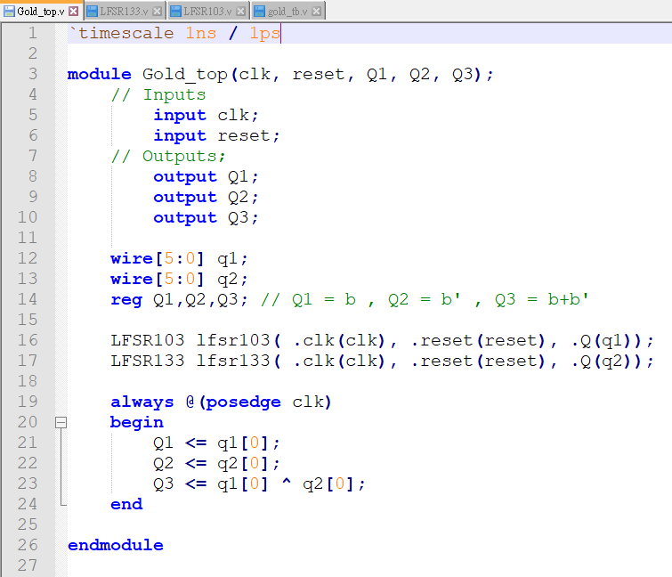

Testbench of ‘gold_top’

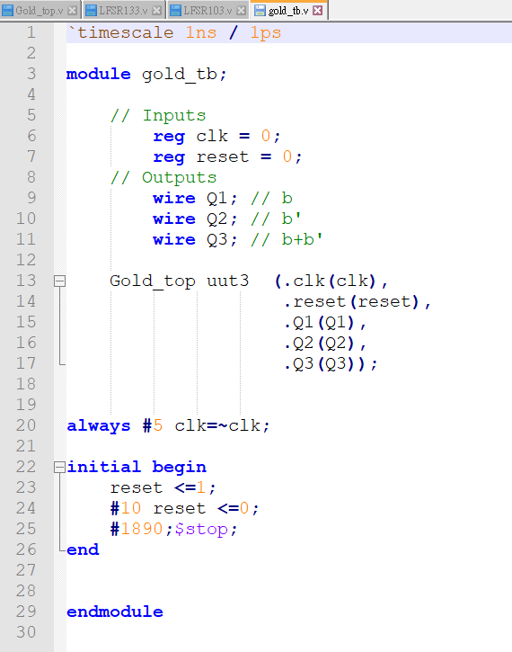

Print out the timing diagram of three code sequences. (10%)

(start at 15ns, stop at 635ns)

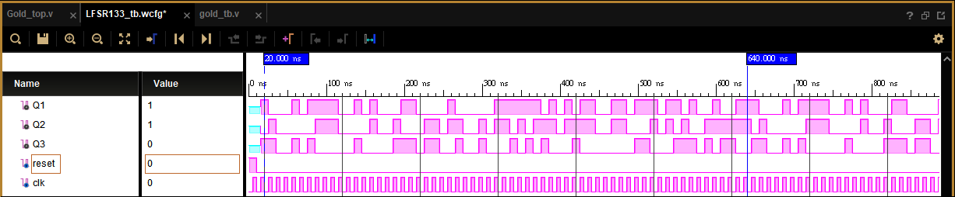

Q1:[ 1 0 0 0 1 0 1 1 1 1 0 0 1 0 1 0 0 0 1 1 0 0 0 0 1 0 0 0 0 0 1 1 1 1

1 1 0 1 0 1 0 1 1 0 0 1 1 0 1 1 1 0 1 1 0 1 0 0 1 0 0 1 1 ]

Q2:[ 1 0 1 0 0 0 0 0 1 1 1 0 0 0 0 1 0 0 1 0 0 0 1 1 0 1 1 0 0 1 0 1 1 0

1 0 1 1 1 0 1 1 1 1 0 0 1 1 0 0 0 1 0 1 0 1 0 0 1 1 1 1 1 ]

Q3:[ 1 1 0 0 1 0 1 0 0 0 0 0 1 0 0 0 0 1 1 1 0 1 1 0 0 1 0 0 1 0 0 0 1 0

1 0 1 0 0 0 1 0 0 0 0 0 0 0 1 1 0 0 0 1 1 1 0 1 0 1 1 0 0 ]

Show that three code sequences generated by Verilog are part of the sequences in Q5. (10%)

offset

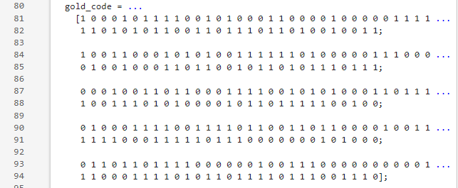

b’

b



b+D43b’

如圖所示，b、b’、b+b’為Q5所產生的前三個 gold code sequences。

而Verilog所產生的Q1 與matlab中的gold code第一個sequence一模一樣。

Q2則是與b’相差了offset 21 個bits，為相同sequence。

Q3 由Q2與Q1運算而來，為Q5所產生的第45個gold code sequence。

由此可得知Verilog所產生的code sequence是Q5所產生的gold code sequences的一部分。

10. Why do Q9 and Q5 generate the same Gold code sequences? (5%)

使用同一組initial state生成upper sequence與 Q5第一個生成的 gold code sequences為同一個。lower sequence 與 Q5 中生成的b’為相同sequence，只是相差了21個bits的offset。同理位移過21次的b’與b做互斥或運算與Q5中第45個gold code sequence一樣。因此Q9與Q5生成相同的gold code sequences。