**DCCDL LAB4**

**matlab**

電機碩一 111521035 林豪澤

1. Please draw the time-domain impulse response of the linear interpolator, second-order polynomial interpolator, and piecewise parabolic interpolator. Show the correct labels of x axis and y axis. (20%)
2. Time-domain impulse response of the linear interpolator:

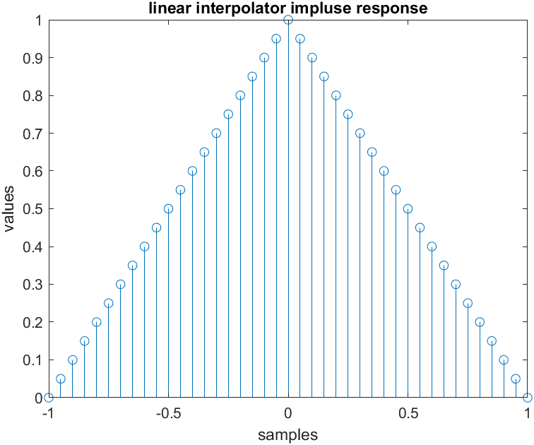

1. Time-domain impulse response of the second order interpolator:

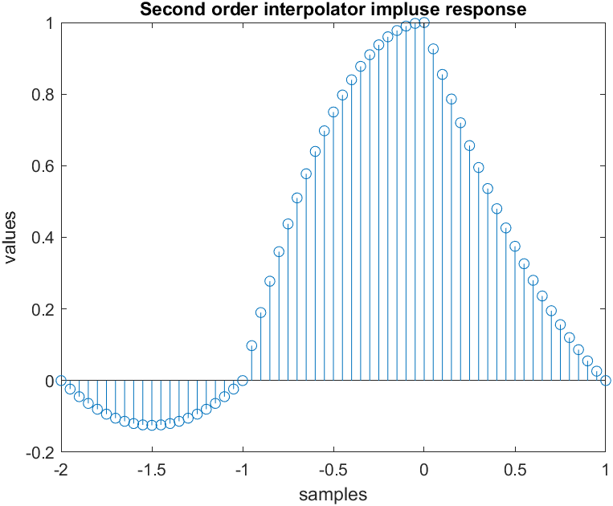

1. Time-domain impulse response of the piecewise parabolic interpolator:

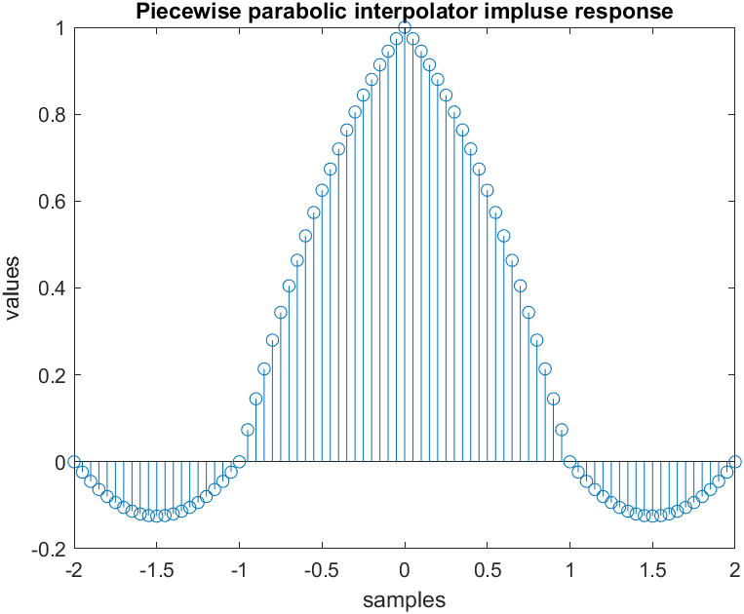

1. Please draw the frequency response, including magnitude and phase, of the linear interpolator, second-order polynomial interpolator, and piecewise parabolic interpolator. Observe their properties in the frequency domain. Note that proper resolution may be required for the observation. Show the correct labels of x axis and y axis. The magnitude

is expressed by dB with a 60-dB range of Y axis from the maximum.(20%)

1. frequency response of the linear interpolator:

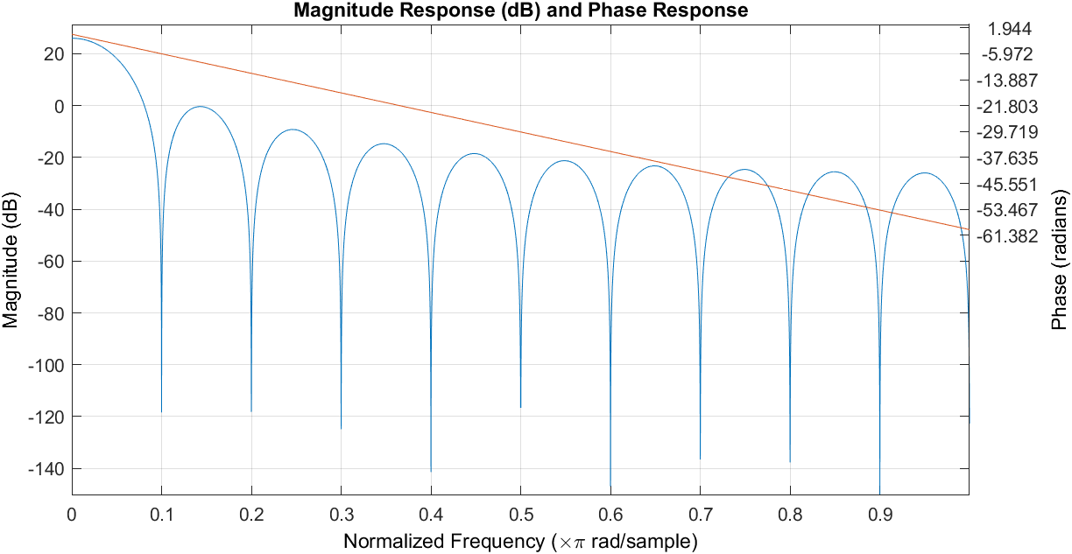

1. frequency response of the Second order polynomial interpolator:

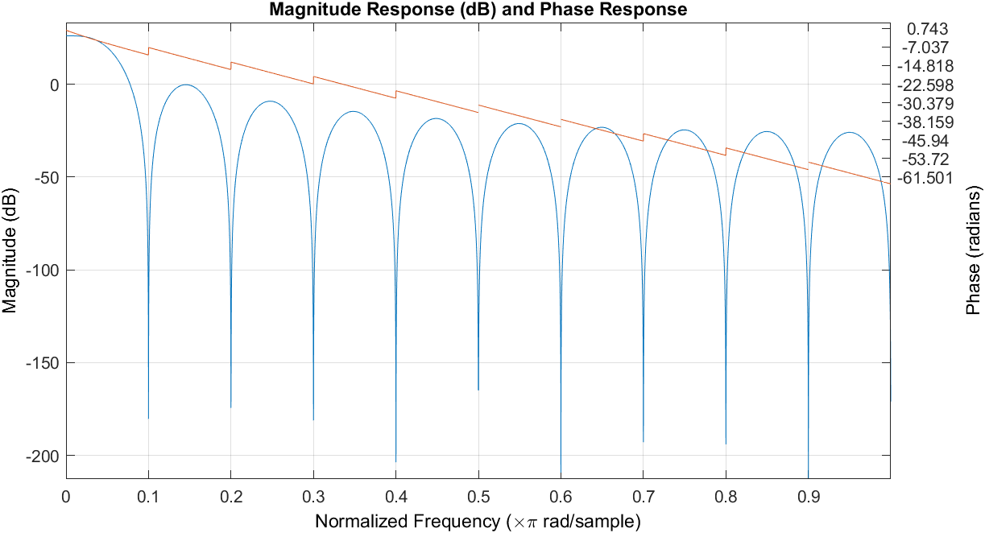

1. frequency response of the piecewise parabolic interpolator:

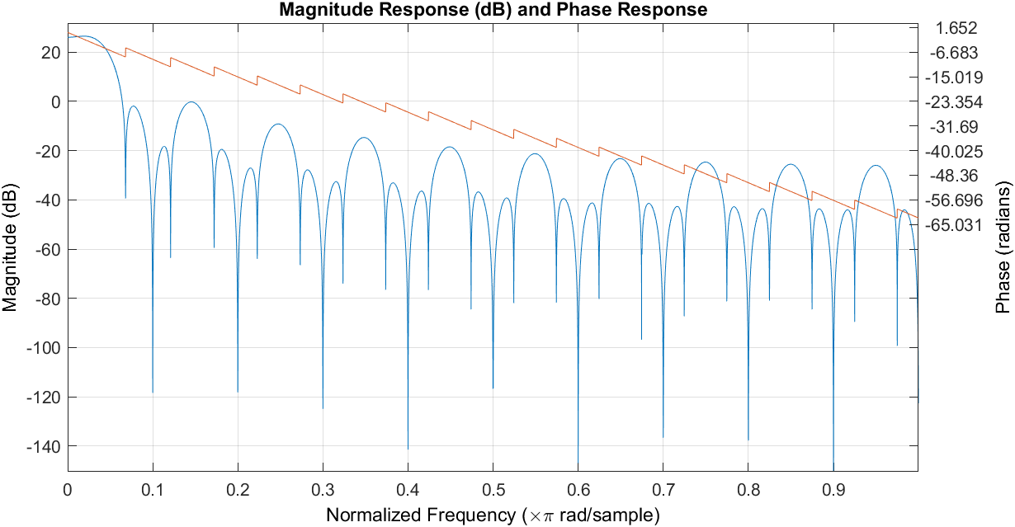

1. Show the error between the floating-point results and the interpolated outputs by linear interpolator, second-order polynomial interpolator, and piecewise parabolic

interpolator in the region of 48 ≤ 𝑚 ≤ 96 with 𝜇 == 0, 1/8 , 2/8 , … 7/8 . (15%)

1. The error between the floating-point results and the interpolated outputs by linear interpolator:

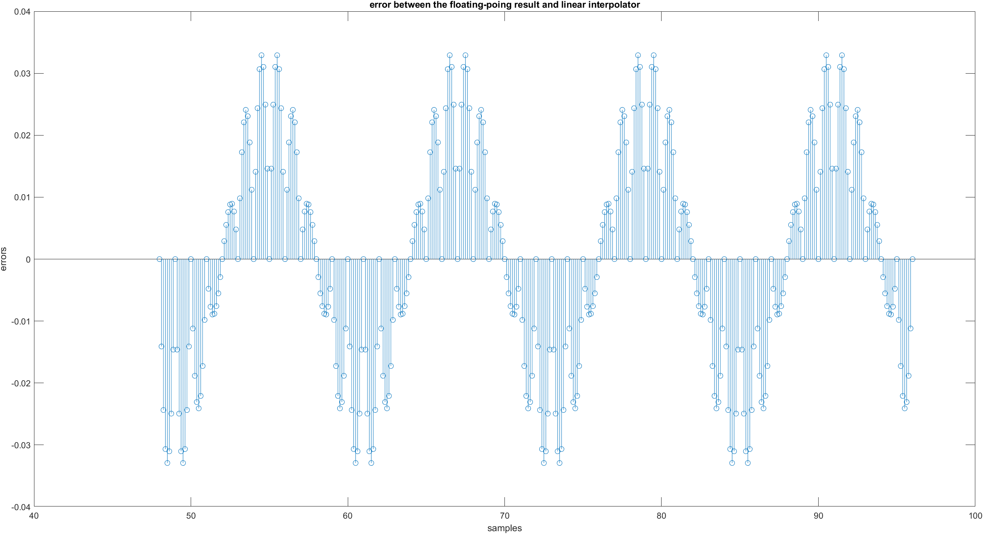

1. The error between the floating-point results and the interpolated outputs by Second order polynomial interpolator:

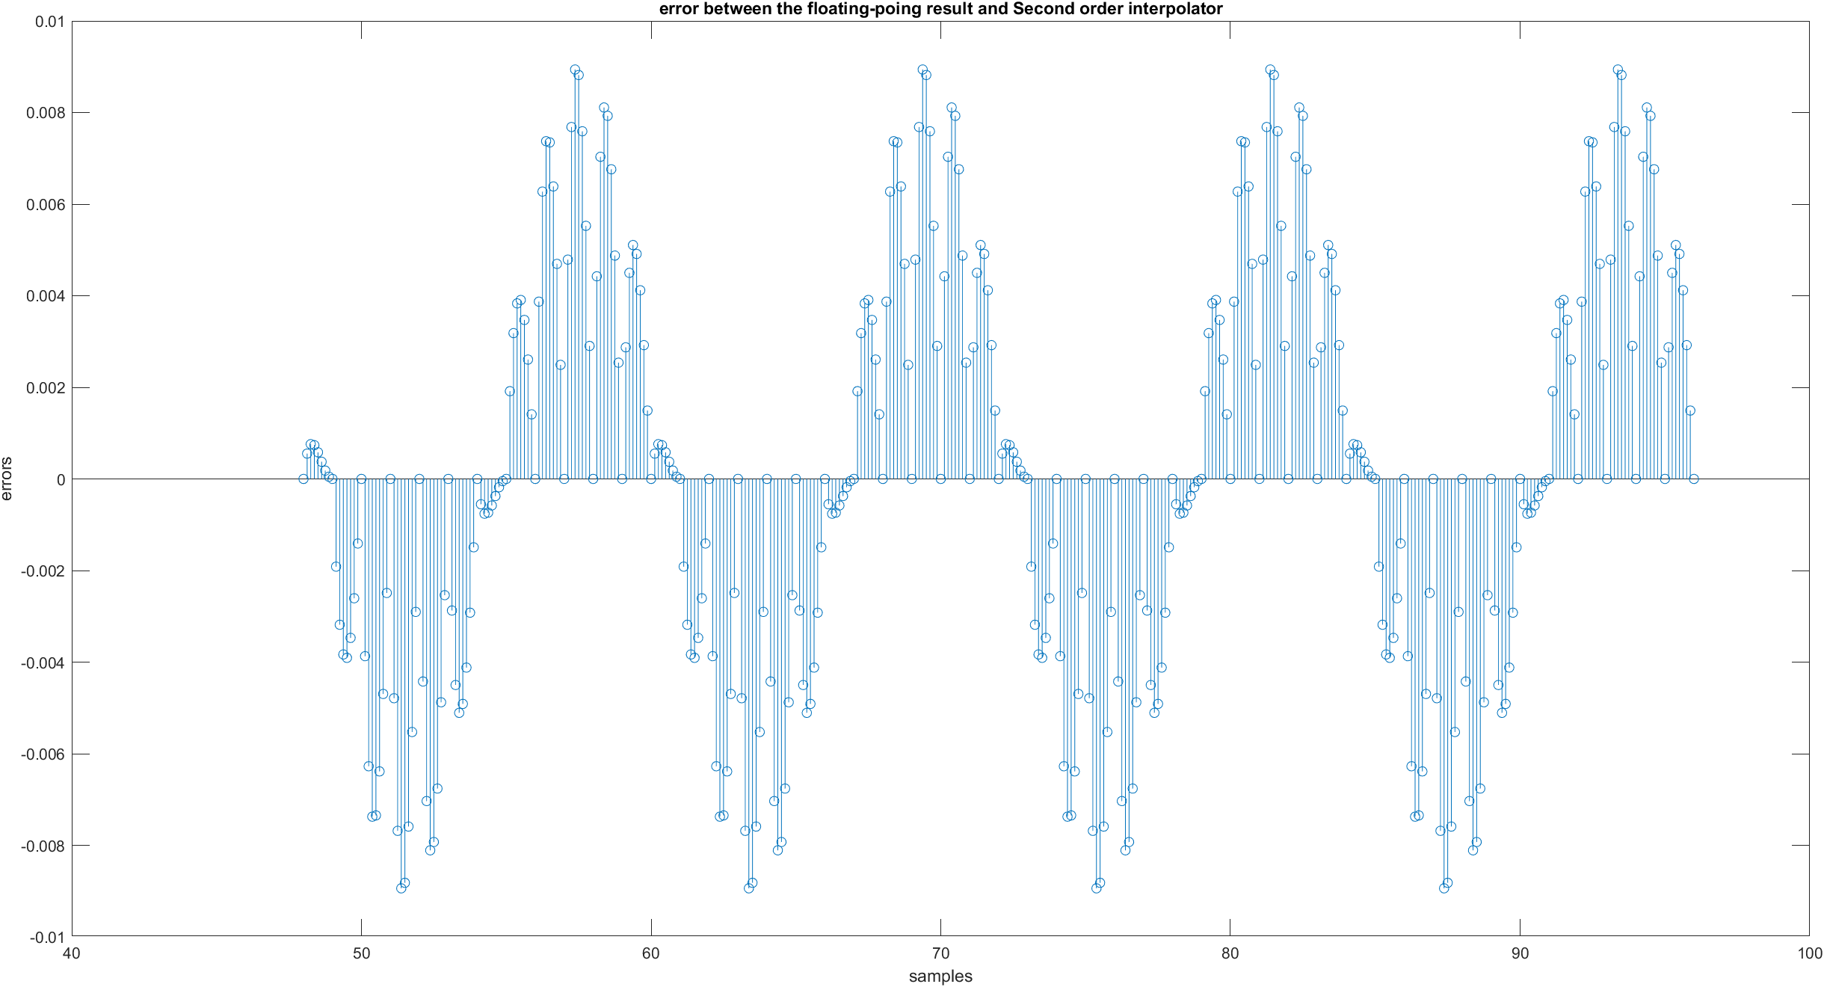

1. The error between the floating-point results and the interpolated outputs by piecewise parabolic interpolator:

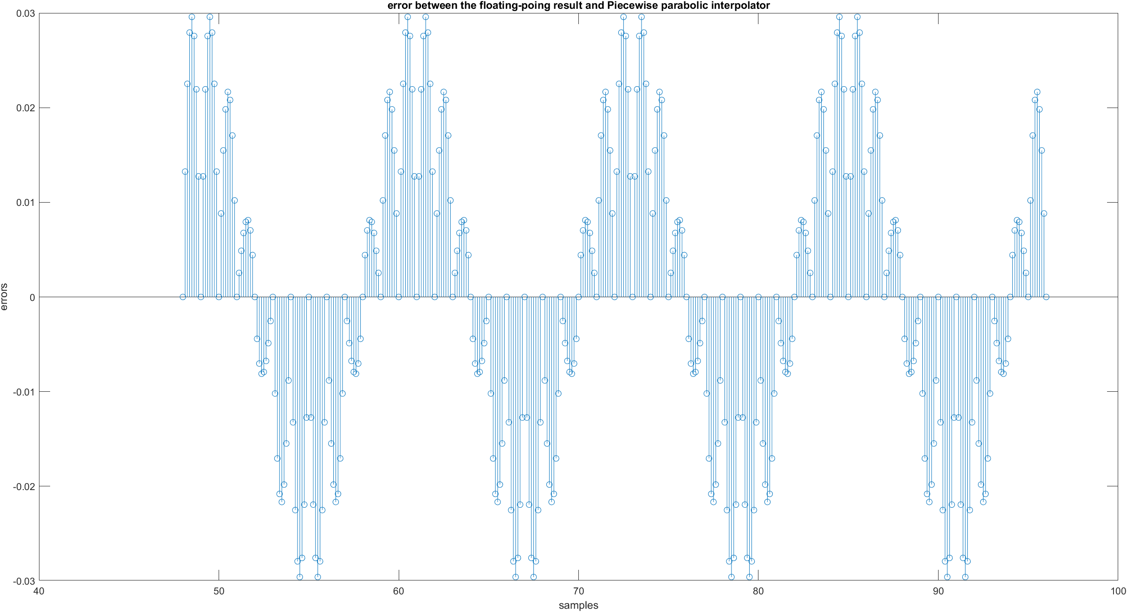

Write your comments about comparison of interpolators. (5%)

Linear interpolator 是上述 interpolators最簡單的一個，依據前後的x(m)與x(m+1)決定插值的值，此作法容易根據sample rate的不同而有很大的誤差範圍。在此例

中Linear interpolator則是三種interpolators中平均誤差最大的。

Second order polynomial interpolator 相對於 linear interpolator則是多考慮一個sample的點，大幅增加了插值後的精度。在此例中second order polynomial interpolator是所有插值器中平均誤差最小的。

Piecewise parabolic interpolator是三種差值器考慮的samples最多的差值器，理論上來說會是三者中誤差最小的差值器，不料此差值器在此例中平均誤差竟與Linear interpolator不相上下。此結果是由於α設在0.5所導致，學生分別使用0.25、0.5與0.75做了比較發現，α越小piecewise parabolic interpolator的誤差會越小。

1. Show the error between the floating-point results and the interpolated outputs by linear interpolator, second-order polynomial interpolator, and piecewise parabolic

interpolator in the region of 12 ≤ 𝑚 ≤ 24 with 𝜇 = 0, = 0, 1/8 , 2/8 , … 7/8 . . (15%)

1. The error between the floating-point results and the interpolated outputs by linear interpolator:

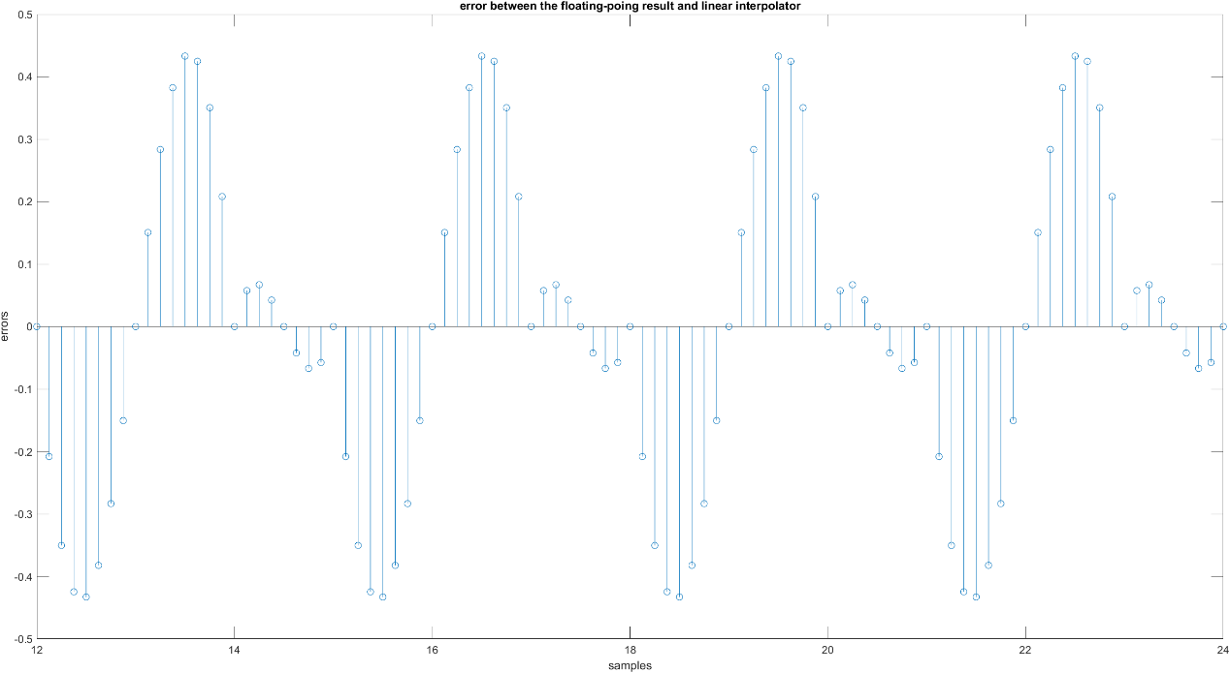

1. The error between the floating-point results and the interpolated outputs by Second order polynomial interpolator:

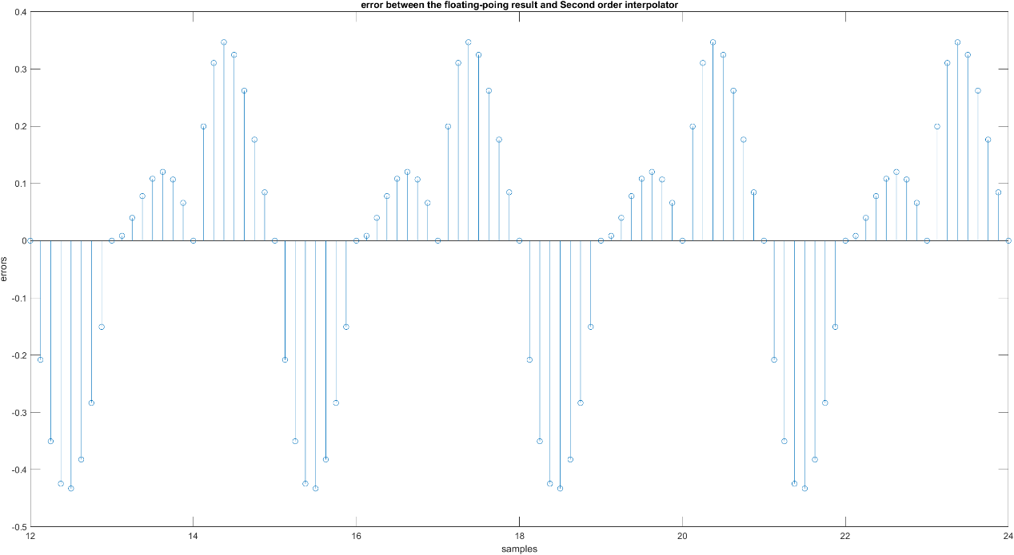

1. The error between the floating-point results and the interpolated outputs by piecewise parabolic interpolator:

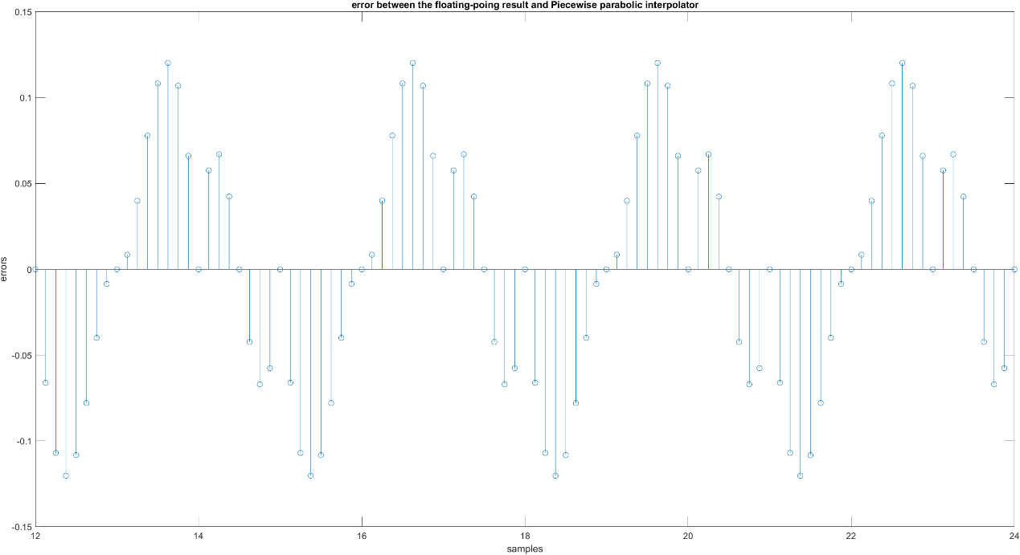

Write your comments about comparison of interpolators (5%)

Linear interpolator 是上述 interpolators最簡單的一個，依據前後的x(m)與x(m+1)決定插值的值，此作法容易根據sample rate的不同而有很大的誤差範圍。在此例

中Linear interpolator則是三種interpolators中平均誤差最大的。

Second order polynomial interpolator 相對於 linear interpolator則是多考慮一個sample的點。在此例中因取樣的頻率不同，Second order polynomial interpolator

的平均誤差與Linear interpolator差不多。

Piecewise parabolic interpolator是三種差值器考慮的samples最多的差值器，在此例中Piecewise parabolic interpolator是所有插值器中平均誤差最小的。學生分別使用0.25、0.5與0.75做了比較發現，α越大piecewise parabolic interpolator的誤差會越

大。

1. Please depict the final architecture of the linear interpolator (6%) and show the results of different word-length settings versus the root mean squared error for
2. Word-length of input. (7%)

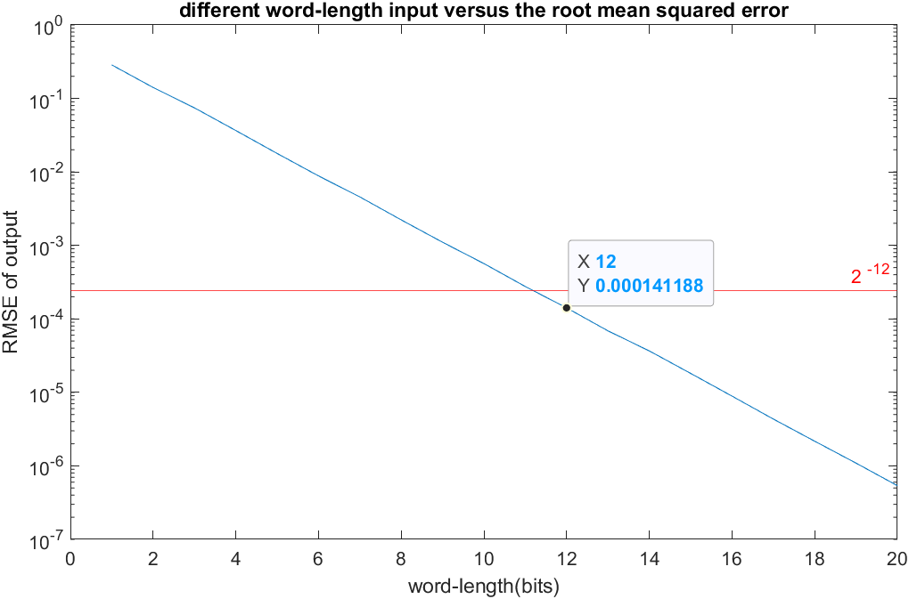

1. Word-length of 𝜇. (7%)

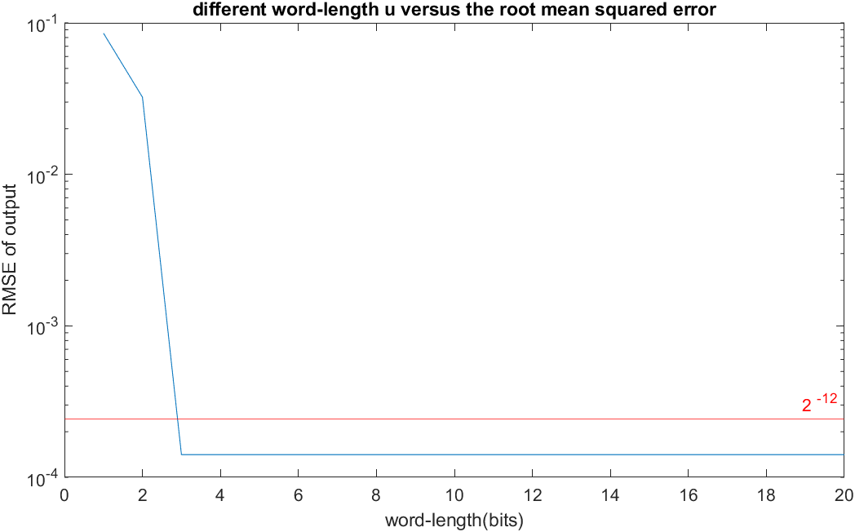

The architecture of the linear interpolator:

