**DCCDL LAB5**

**matlab**

電機碩一 111521035 林豪澤

1. Please show how you calculate the scaling factor, write down the 𝑁 value that you use and the result of 𝑆(𝑁).

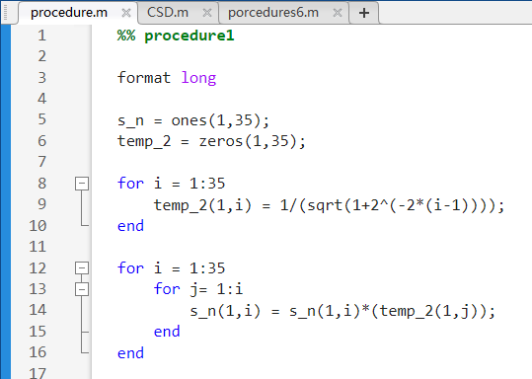

S(N) = $\frac{1}{\prod_{i=0}^{N-1}{\sqrt{1+2^{-2i}}}}$

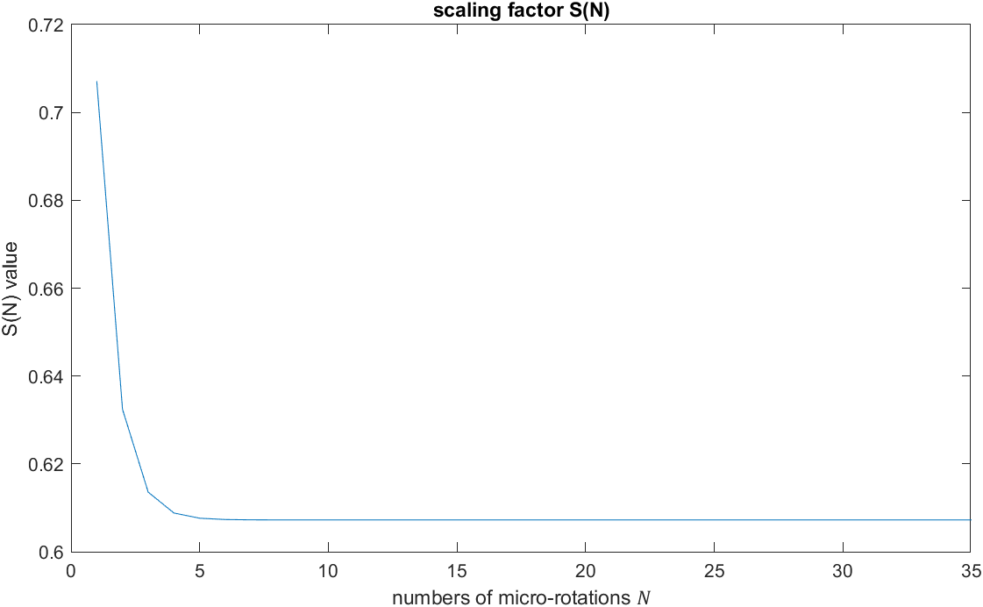

S(N)= [0.70710678118654746 0.63245553203367577 0.61357199107789628 0.60883391251775243 ...

0.60764825625616825 0.607351770141296 0.60727764409352614 0.60725911229889284 ...

0.60725447933256249 0.60725332108987529 0.60725303152913446 0.607252959138945 ...

0.60725294104139727 0.60725293651701029 0.60725293538591352 0.60725293510313938 ...

0.60725293503244582 0.6072529350147724 0.607252935010354 0.60725293500924948 ...

0.60725293500897337 0.60725293500890432 0.60725293500888711 0.60725293500888278 ...

0.60725293500888167 0.60725293500888144 0.60725293500888144 0.60725293500888144 ...

0.60725293500888144 0.60725293500888144 0.60725293500888144 0.60725293500888144 ...

0.60725293500888144 0.60725293500888144 0.60725293500888144];

此次架構我預計使用N=20，S(N)= 0. 60725293500924948。

1. Write down the word-length of 𝑋(𝑖) and 𝑌(𝑖) that you use. Please explain it.

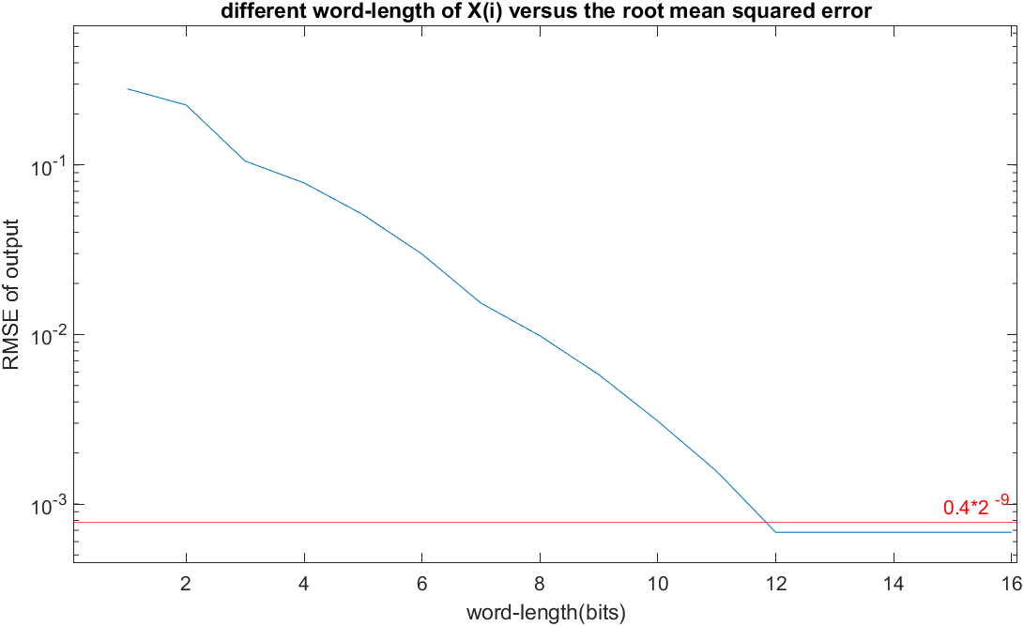

word-length of X(i) = S2.12, 15bits

上圖為不同的X(i)word-length與相對應的RMSE的關係圖，從結果來看我將小數位定為12bits。考慮到X(i)成長的可能性，為防止其溢位將整數位多增加一位。

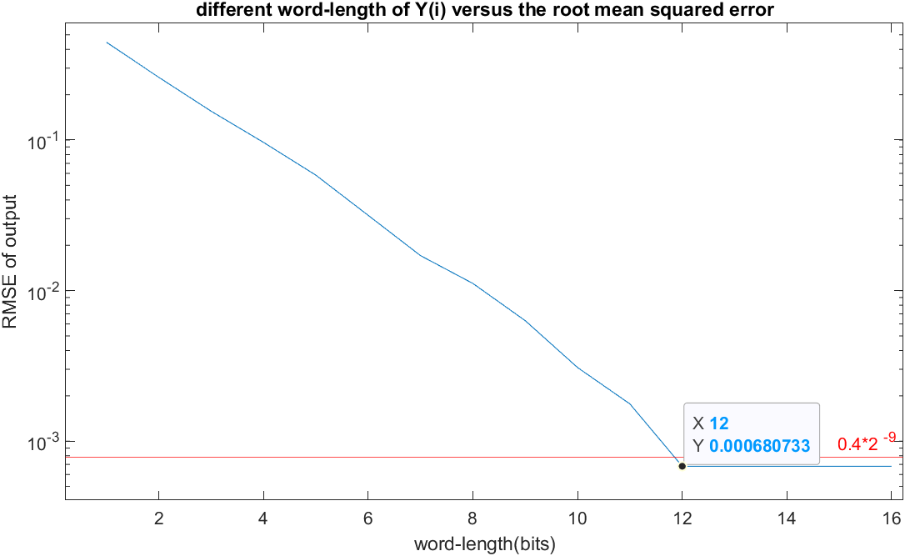

word-length of Y(i) = 2.12, 15bits

上圖為不同的Y(i)word-length與相對應的RMSE的關係圖，從結果來看我將小數位定為12bits。但是在每級計算中Y(i)皆與X(i)做加減法，因此將其長度與X(i)設為相同長度。

1. Please draw a figure to denote the average phase errors of 11 input pairs (𝑋, 𝑌) versus different numbers of micro-rotations 𝑁 and draw a figure to show the resulted phase errors of 11 input pairs versus the word-length of quantized elementary angles. Explain how you determine it. Also list a table of the elementary angles (both in floating-point representation and binary fixed-point representation).

學號尾數為5，β=2 ,a = 0.4x 2-9

The average phase errors of 11 input pairs (𝑋, 𝑌) versus different numbers of micro-rotations 𝑁:

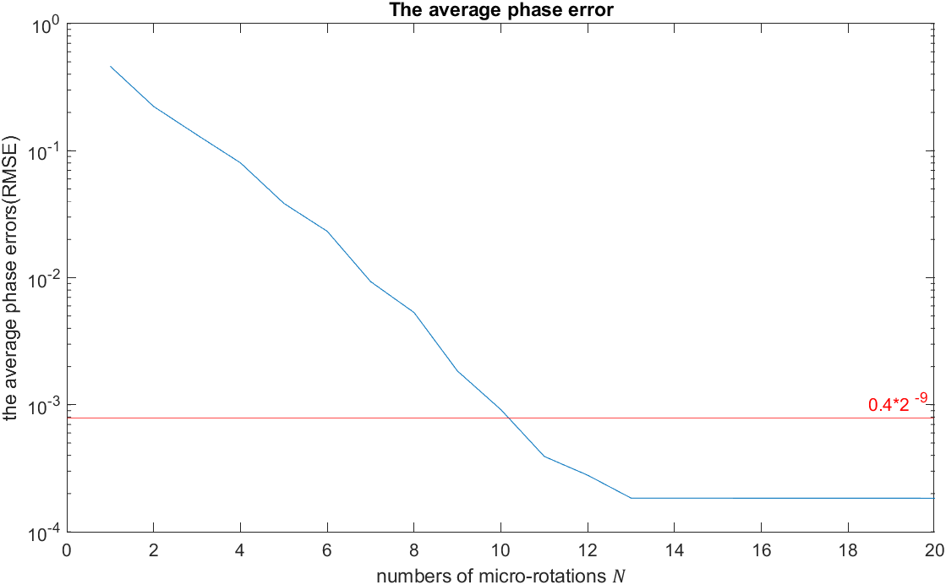

The resulted phase errors of 11 input pairs versus the word-length of quantized elementary angles:

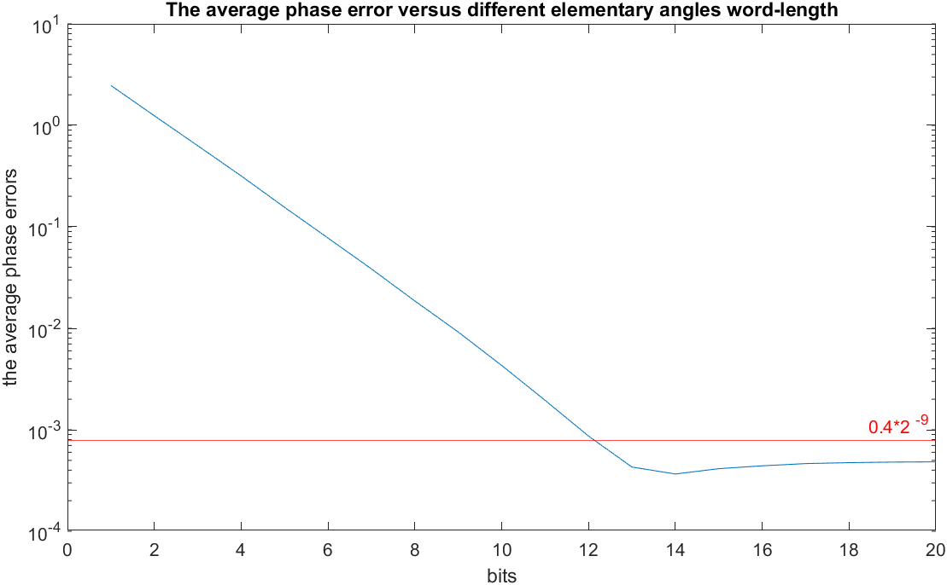

Elementary angle word-length: s1.13 (15bits)

Table of the elementary angles (floating-point representation):

Form N=1 ~ N=11 , table of the elementary angles:

0.785278320312500 0.463623046875000 0.244873046875000 0.124267578125000 0.0623779296875000 0.0311279296875000 0.0155029296875000 0.00769042968750000 0.00378417968750000 0.00183105468750000 0.000854492187500000

Table of the elementary angles (fixed-point representation):

Form N=1 ~ N=11, word-length:16bits(s1.14) , table of the elementary angles:

0.463623046875000 0.244964599609375 0.124328613281250 0.0624084472656250 0.0312194824218750 0.0155944824218750 0.00778198242187500 0.0038757324218750 0.00192260742187500 0.000946044921875000 0.0004577636718750

Binary: (N=1~11)

1100100100001

0111011010110

0011111010110

0001111111010

0000111111111

0000011111111

0000001111111

0000000111111

0000000011111

0000000001111

0000000000111

1. Please show how you decide the number of micro-rotations for the magnitude function with error tolerance of 0.2%.

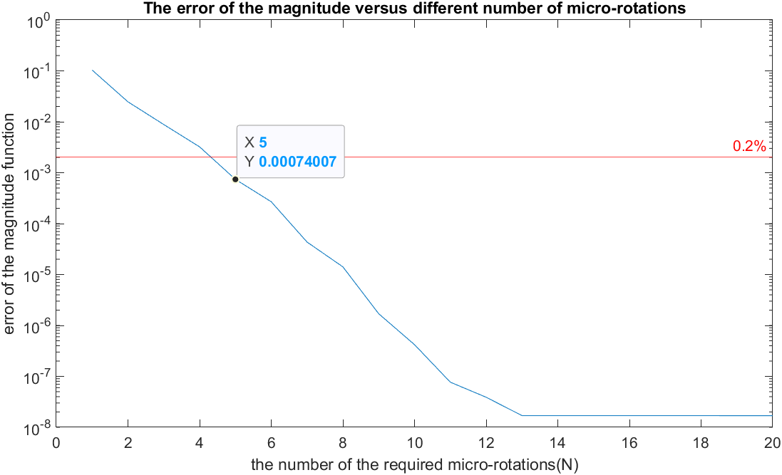

Need 5 times of micro-rotations.

考慮Q3需要 11次的micro-rotations，而Q4只需要5次即可達到magnitude error 小於容忍值的結果，因此採用11次micro-rotations的架構。

1. Write down the power-of-2 expression for the scaling factor 𝑆(𝑁). Depict your design for the shift-and-add block. (Using CSD)

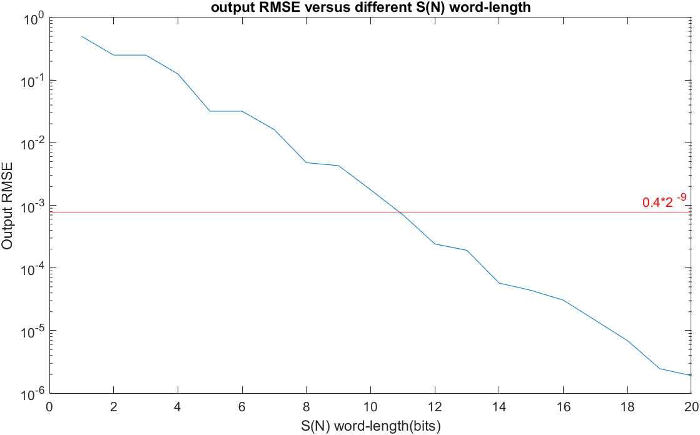

S(N) = 0.607253031529135;

運算時將S(N)的word-length設為s1.12

將S(N)量化之後乘上212後的值為2487

其二進位表示法為 00 1001 1011 0111

經過CSD運算後為 00 1010 0-100 -100-1

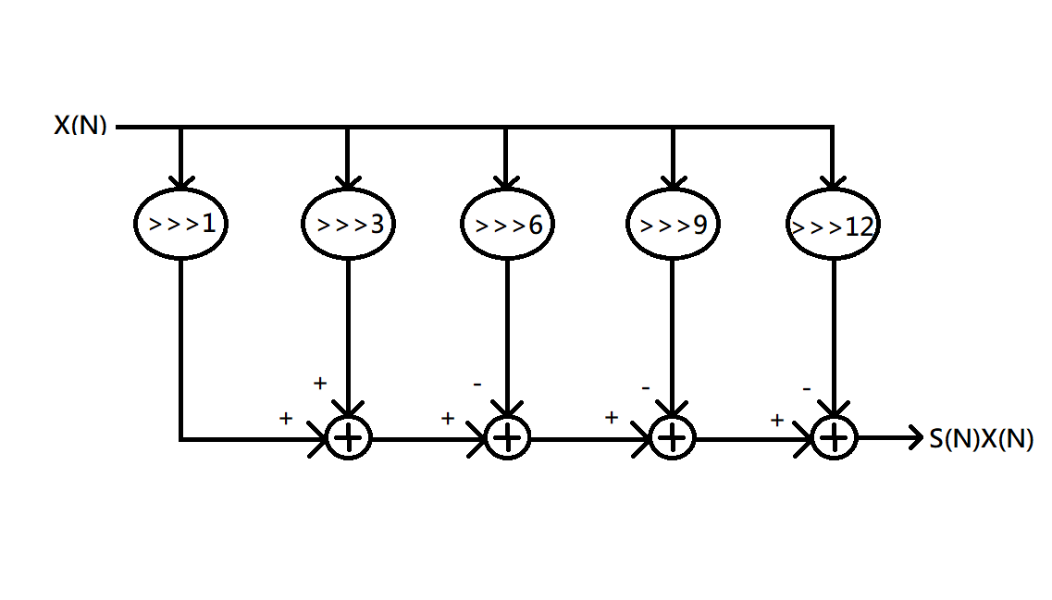

1. Depict your design of the complete CORDIC architecture for the arctangent function. Mark the word-length in the block diagram.

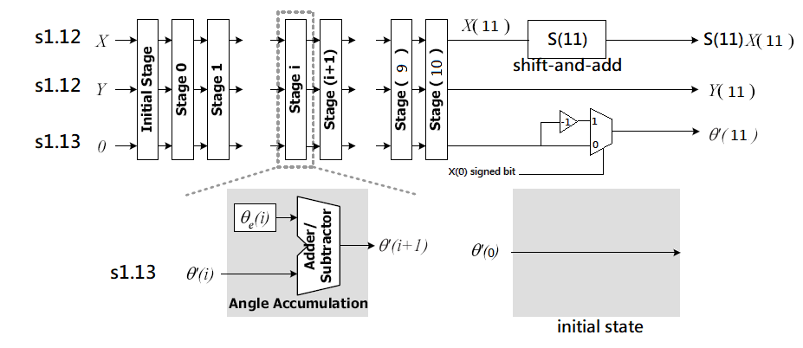

1. Depict your design of the complete CORDIC architecture for the magnitude function. Mark the word-length in the block diagram.

