**DCCDL LAB6**

**Part I**

電機碩一 111521035 林豪澤

1. Draw your block diagram for the butterfly and commutator modules and explain the timing diagram of the control signals to the commutator modules at all the stages.

Butterfly block diagram:

Stage1:

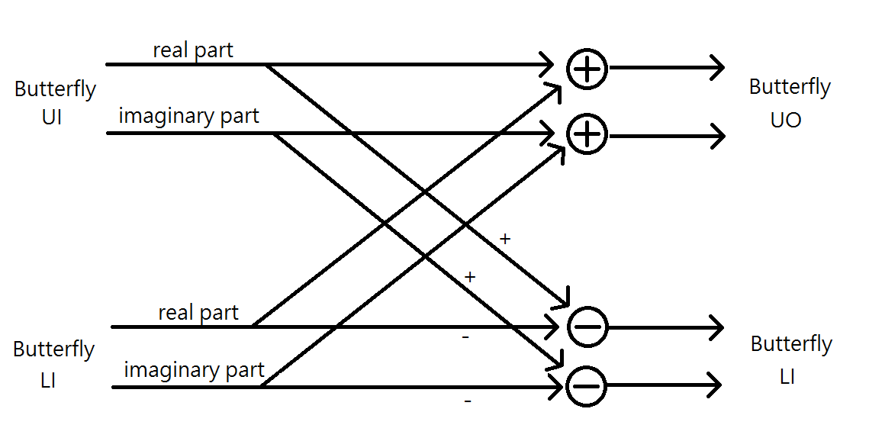

Stage2:



Stage3:



Commutator block diagram:

Stage1:

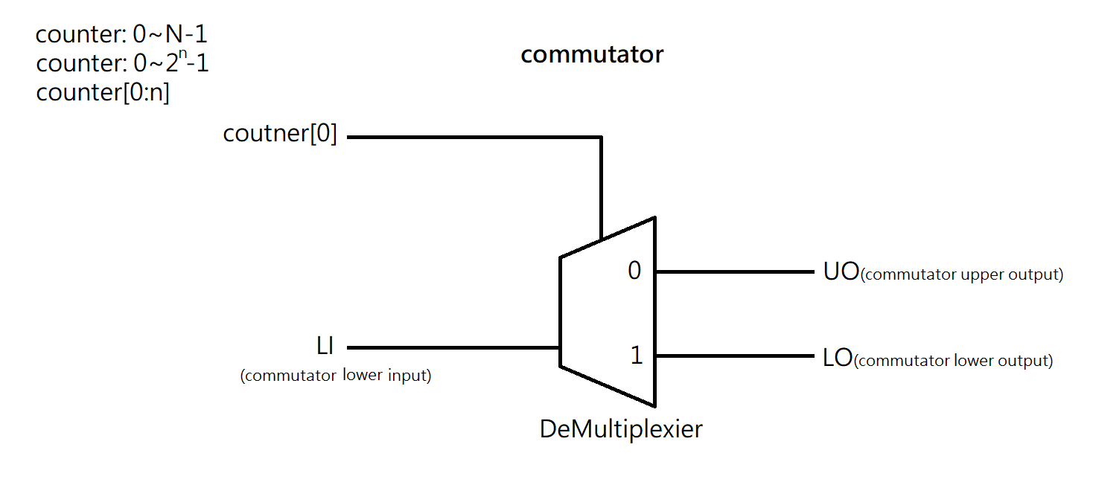

Stage2:

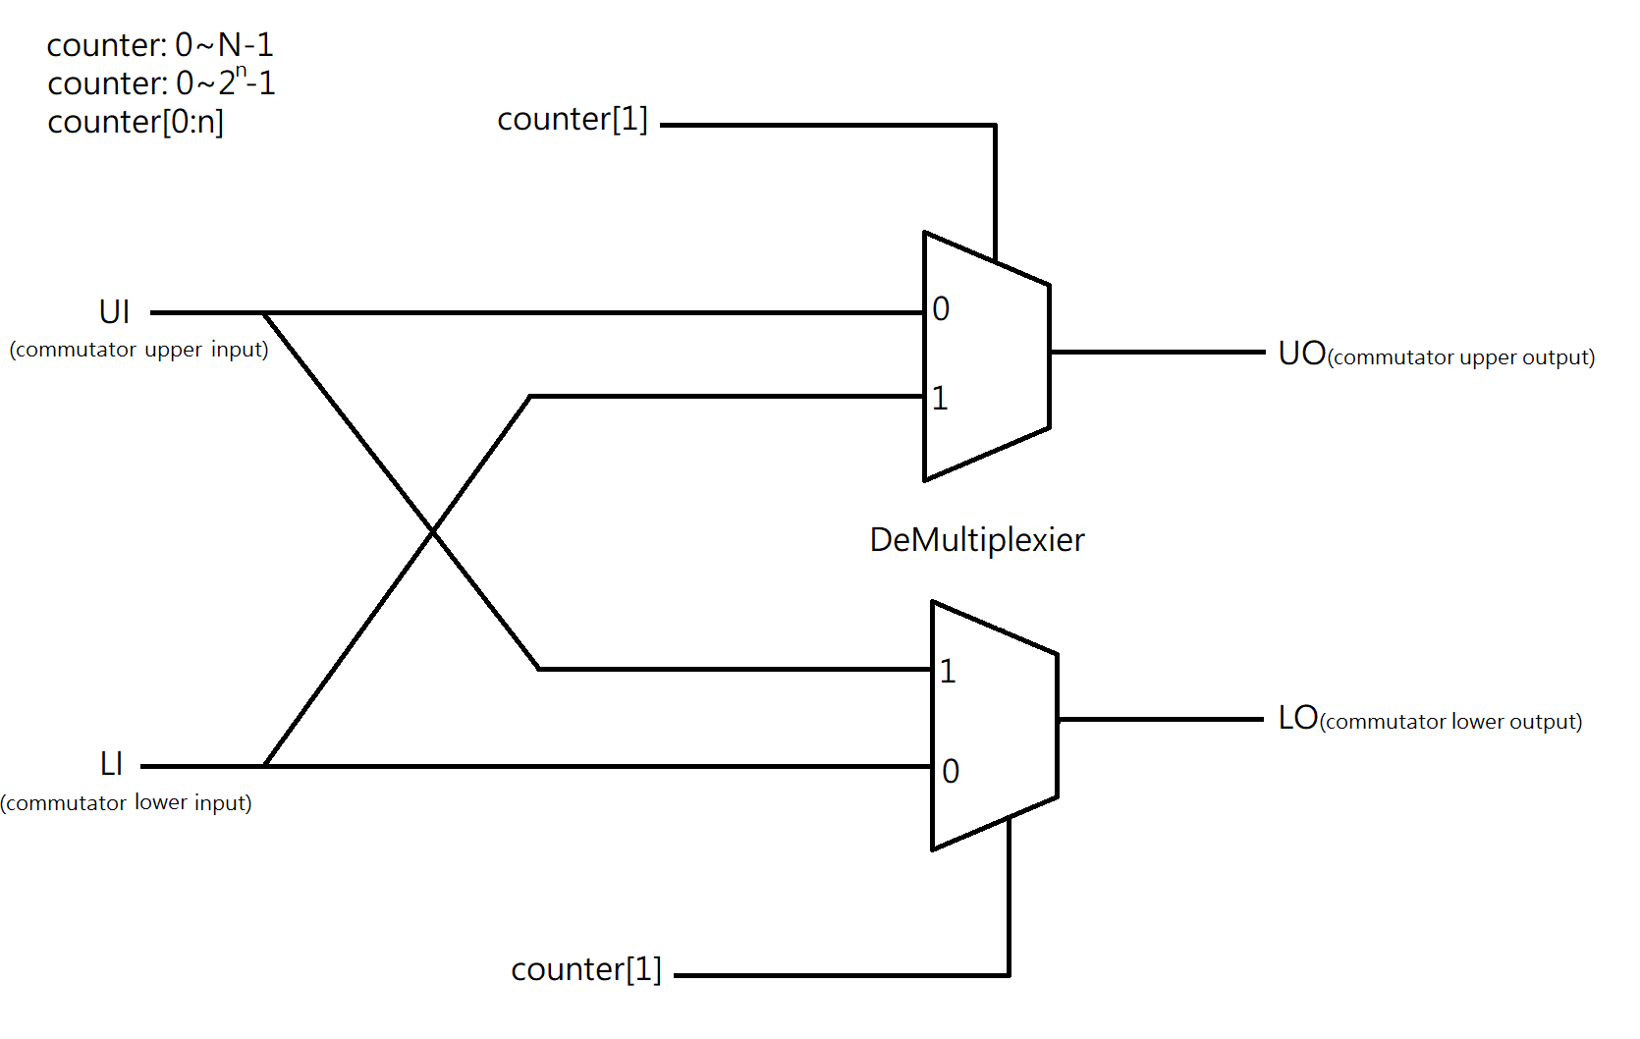

Stage3:



1. Draw the timing diagram of the control signals to the complex multiplier blocks at all the stages.
2. Show your design for bit-reversal module to allow the frequency-domain samples appearing in order.
3. Use Matlab program to implement 8-point MDC FFT architecture and the bit-reversal module. Draw the real-part and imaginary-part of 𝑋0~𝑋7. Compare them with the real-part and imaginary-part of 𝑌0~𝑌7. Depict the error.

5. Show the timing diagram of your Verilog behavior and post-route simulation results of 8-point MDC FFT. Compare with the Matlab results to check your implementation error. Depict the error of the real part and imaginary part of each point using figures.