**DCCDL LAB5**

**Verilog**

電機碩一 111521035 林豪澤

8. Print the timing diagram of the behavior simulation result and post-route simulation result of your arctangent function. Show the error between the Verilog output and Matlab output by figures.

Xout: [4097, 4098, 4097, 4098, 4097, 4097, 4101, 4098, 4096, 4097, 4097]

Yout: [0, -4, -2, 0, 1, 0, -5, 0, -2, -3, 0]

Ang_out: [10810, 5674, 514, -4626, -9794, -10810, -5646, -514, 4626, 9794, 10810]

behavior simulation result timing diagram:

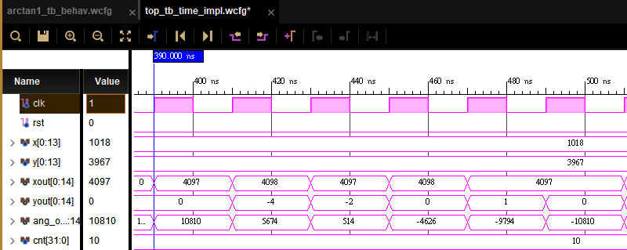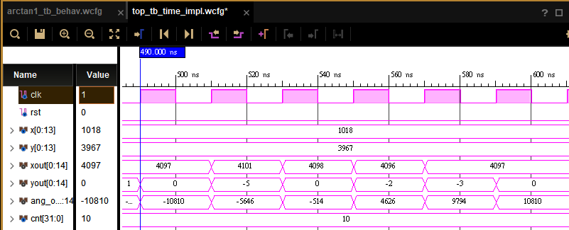

synthesis simulation result timing diagram:

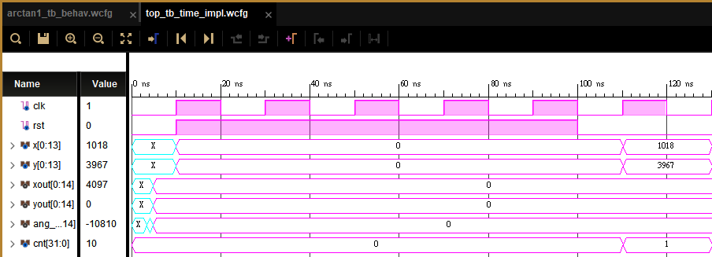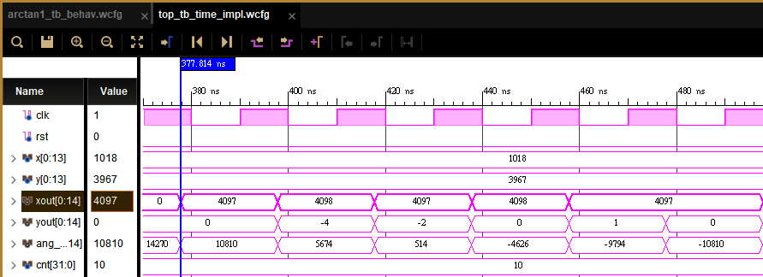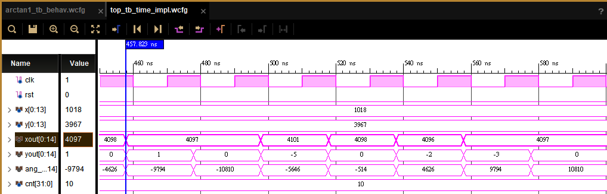

implementation simulation result timing diagram:

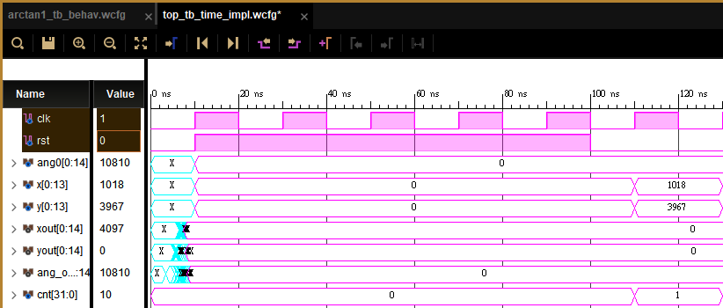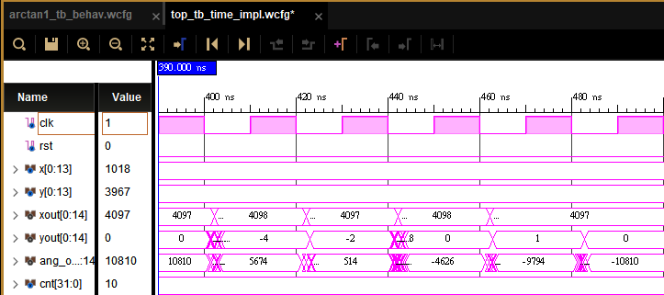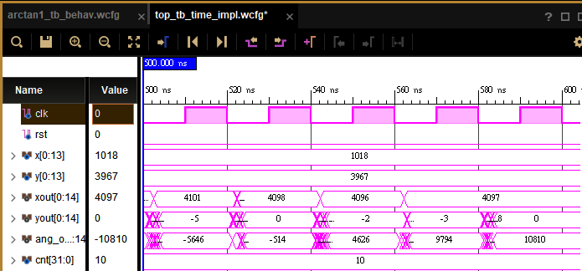

The error between the Verilog implementation simulation and Matlab output:

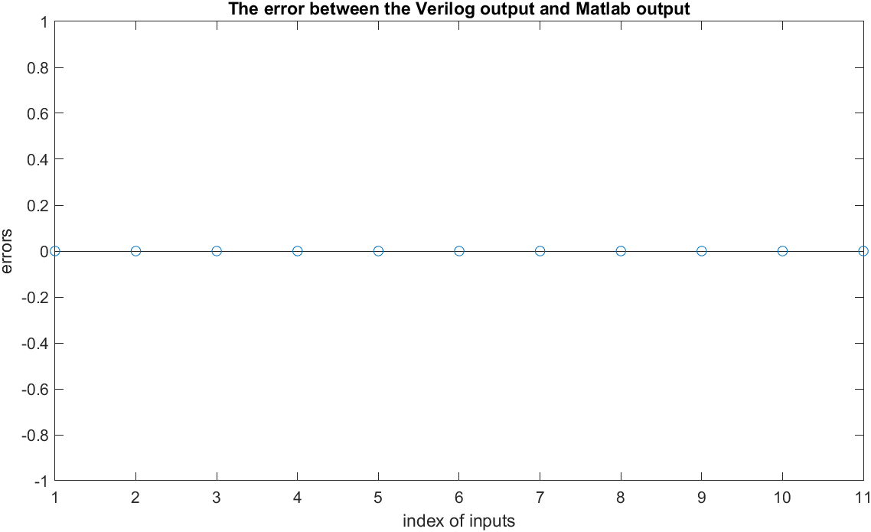

9. List the timing report of the arctangent function and show the critical path in your block diagram.

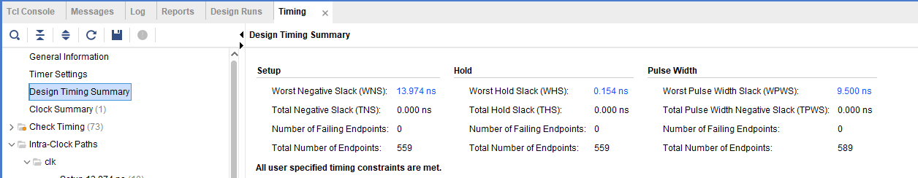

Setup:

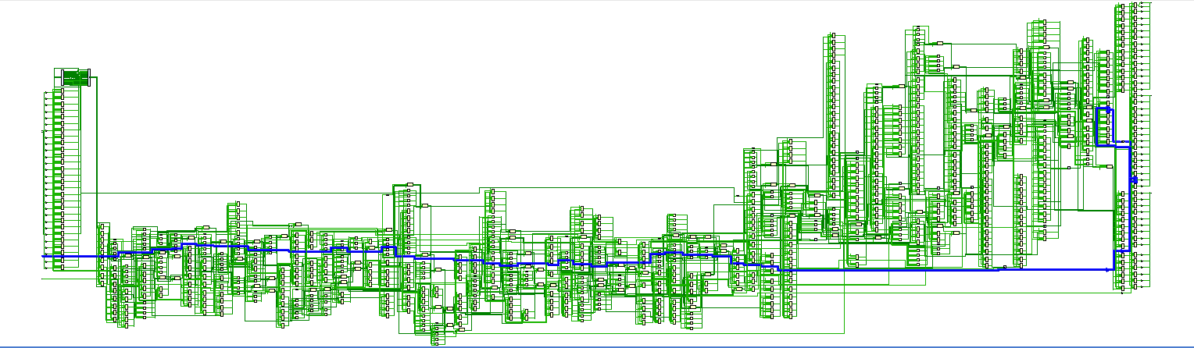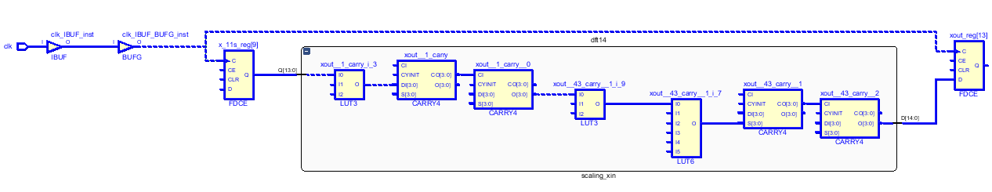

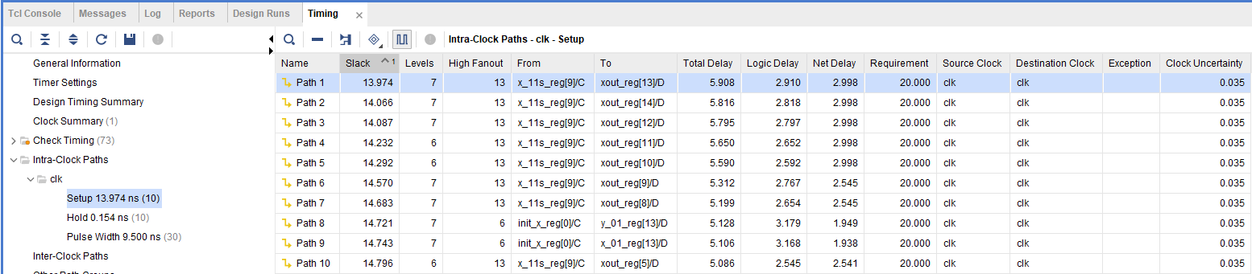

Hold time:

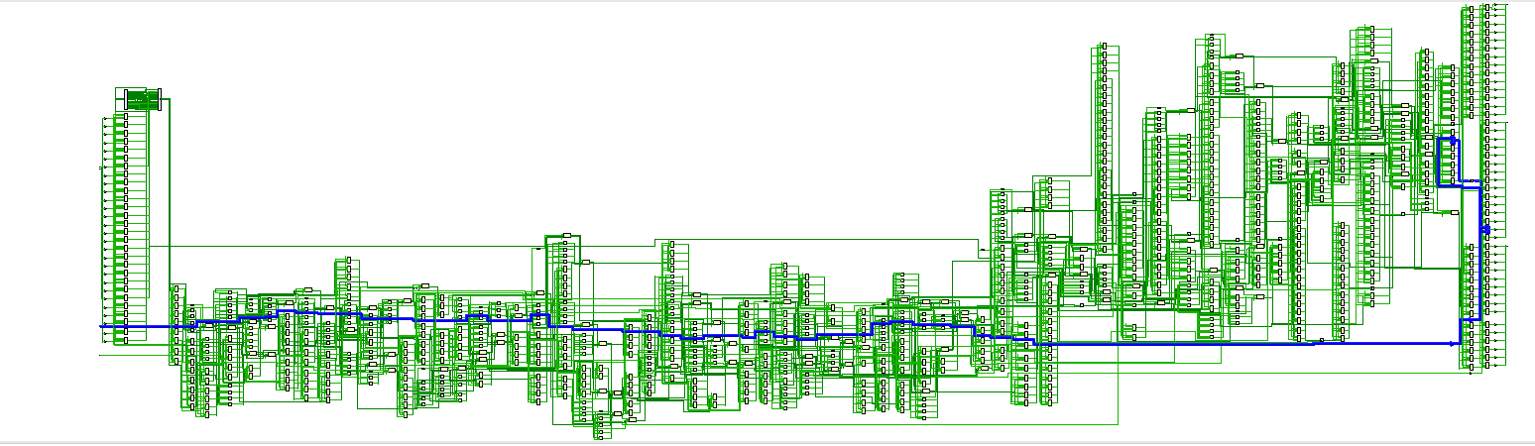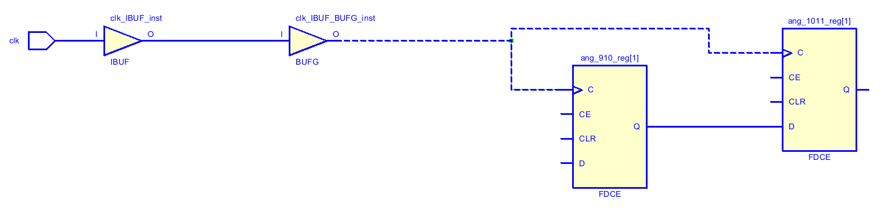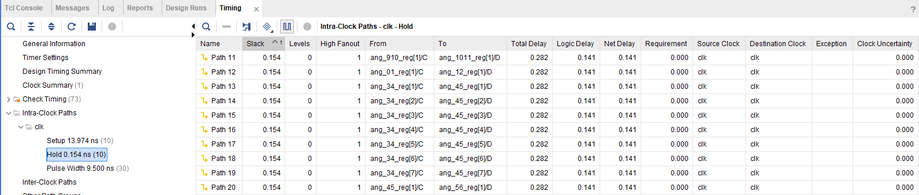

10. Print the timing diagram of the behavior simulation result and post-route simulation result of your magnitude function. Show the error between the Verilog output and Matlab output by figures.

Xout: [4097, 4098, 4097, 4098, 4097, 4097, 4101, 4098, 4096, 4097, 4097]

Yout: [0, -4, -2, 0, 1, 0, -5, 0, -2, -3, 0]

Ang_out: [10810, 5674, 514, -4626, -9794, -10810, -5646, -514, 4626, 9794, 10810]

behavior simulation result timing diagram:



synthesis simulation result timing diagram:







implementation simulation result timing diagram:







The error between the Verilog implementation simulation and Matlab output:



11. List the timing report of the magnitude function and show the critical path in your block diagram.

Timing diagram:

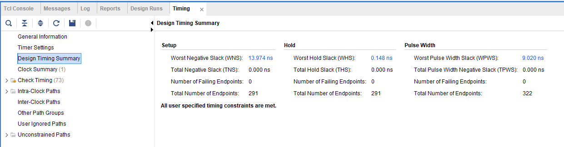

Setup timing report

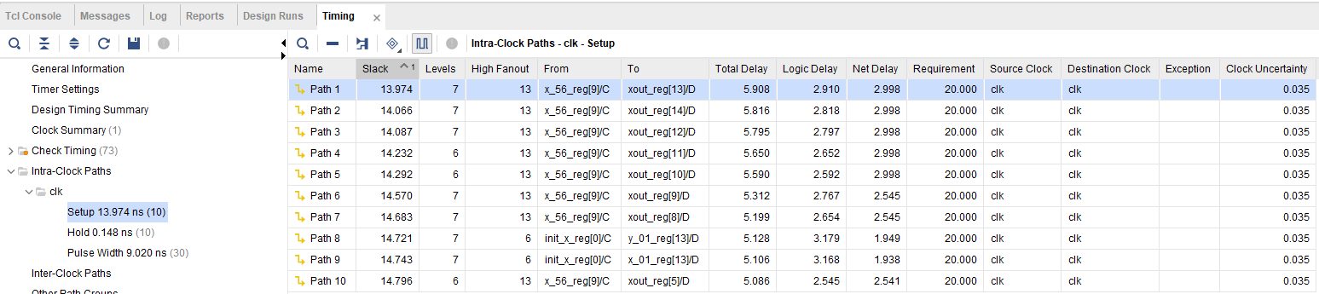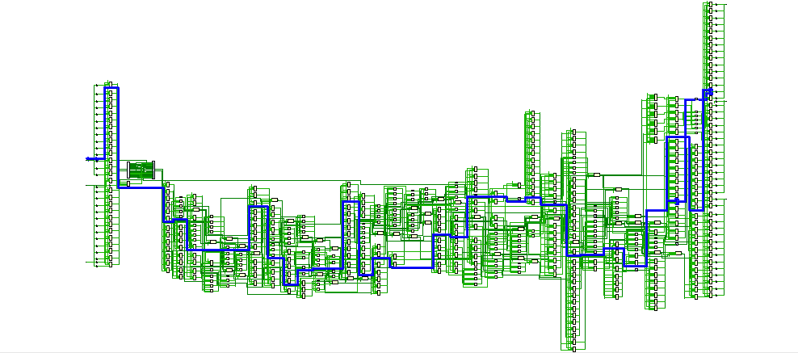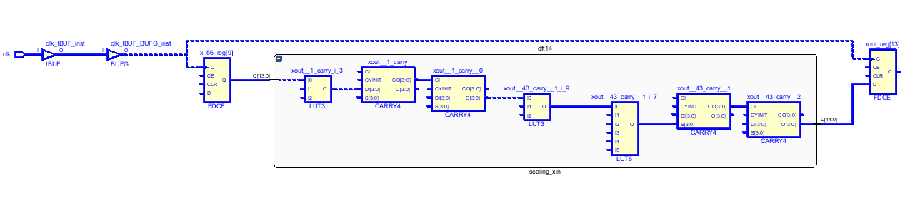

Hold timing report:

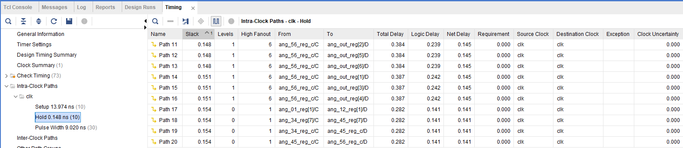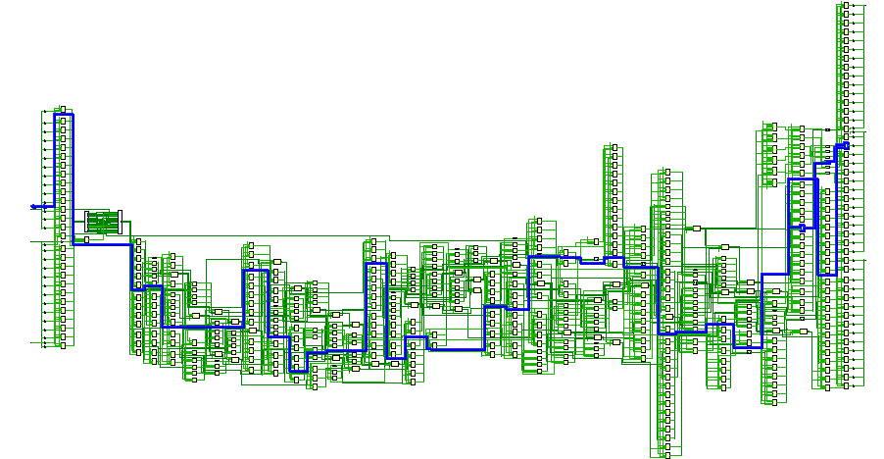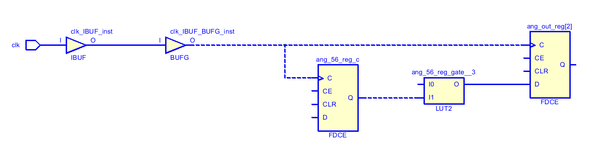

12. Show your measurement results of Q8 and Q10 (40%). Please paste your measurement results and show the error between measurement results and post-route simulation results by Matlab figure.

Input:

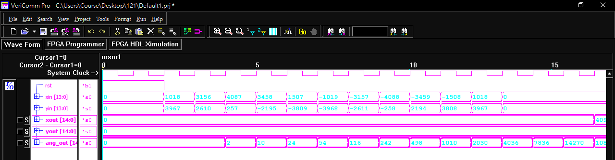

Output:

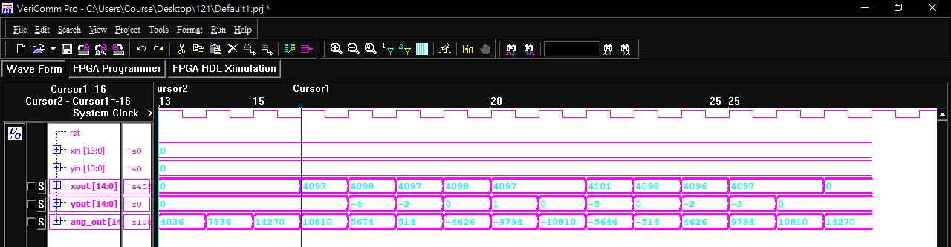

Xout:

[4097 4098 4097 4098 4097 4097 4101 4098 4096 4097 4097]

Yout:

[0 -4 -2 0 1 0 -5 0 -2 -3 0]

Ang_out:

[10810 5674 514 -4626 -9794 -10810 -5646 -514 4626 9794 10810]

The error between the measurement results and the post-route simulation results:

