**DCCDL LAB2**

**matlab**

電機碩一 111521035 林豪澤

1. Please use Matlab to draw the impulse response and frequency response of the 33-tap square-root raised-cosine FIR filter. Note that you need to use scale in dB for the magnitude of the frequency response and use radian for the phase of frequency response versus normalized frequency. The x-axis must be marked with correct the label. Please explain whether the filter is high-pass, band-pass or low-pass and why.

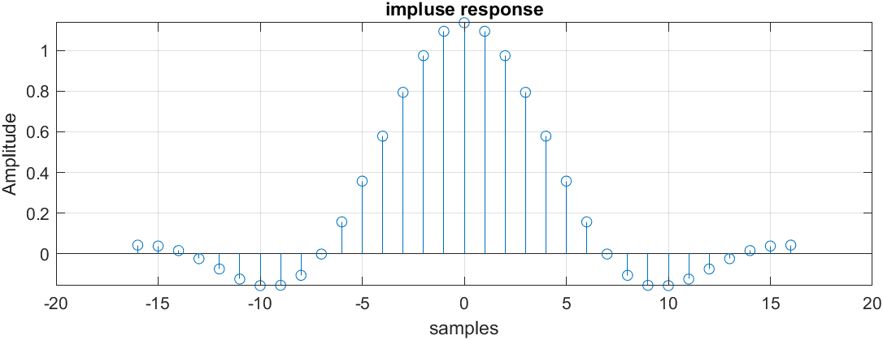

圖一 impluse response

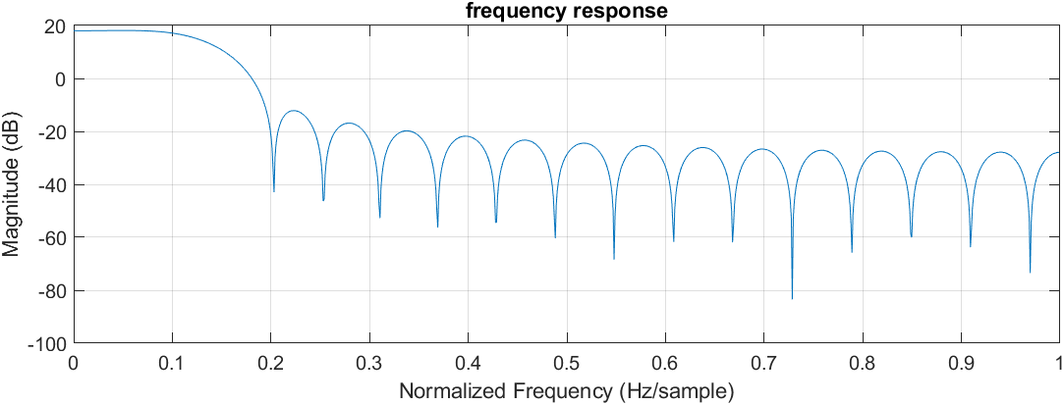

圖二 frequency response波德圖

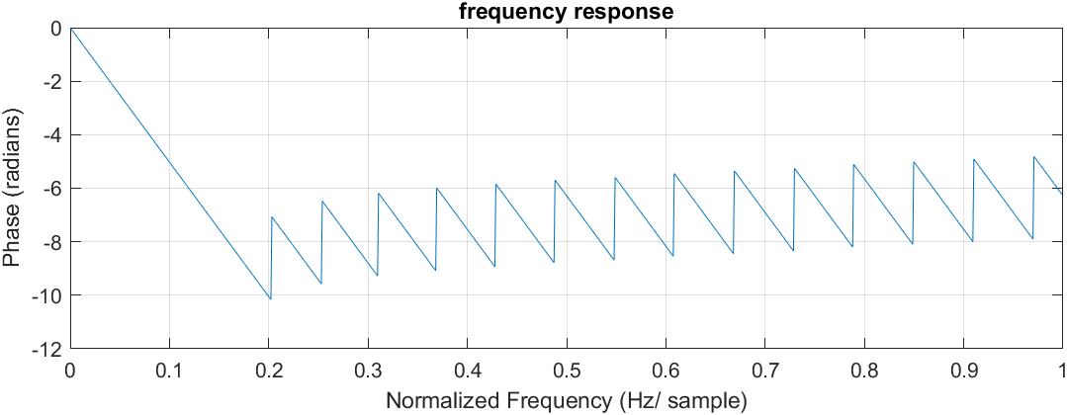

圖三 frequency response相位圖

Low pass

1. Draw the time-domain waveform and frequency-domain response of the input and output in procedure 2.

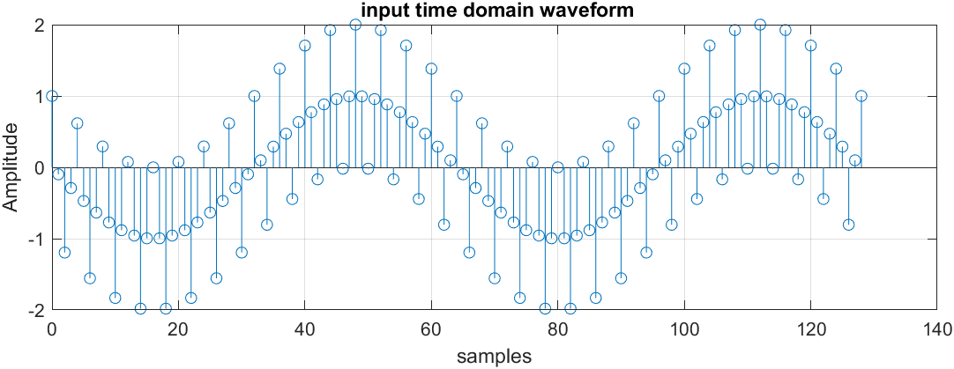

圖四 input time-domain waveform

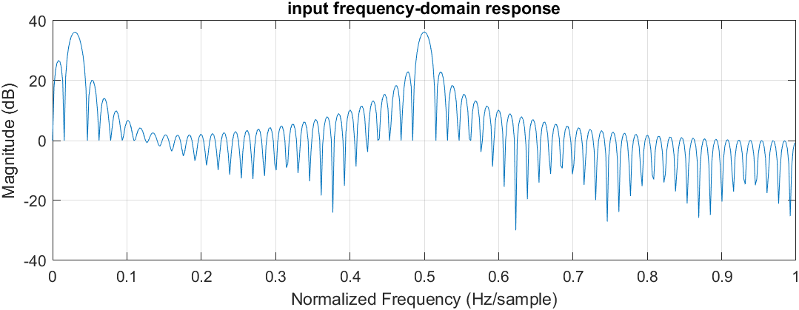

圖五 input frequency-domain 波德圖

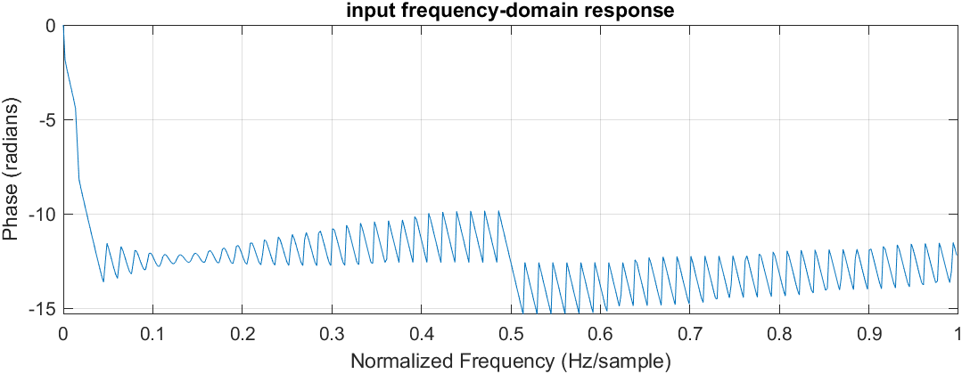

圖六 input frequency-domain相位圖

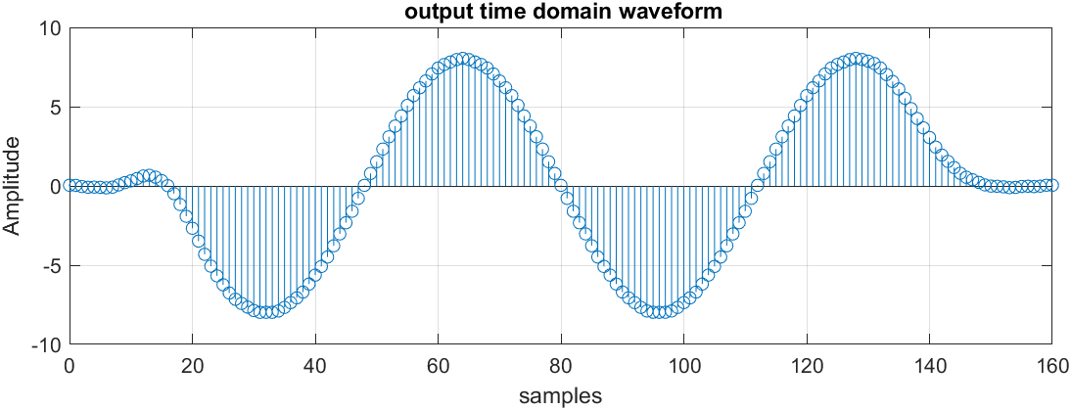

圖七 output time-domain waveform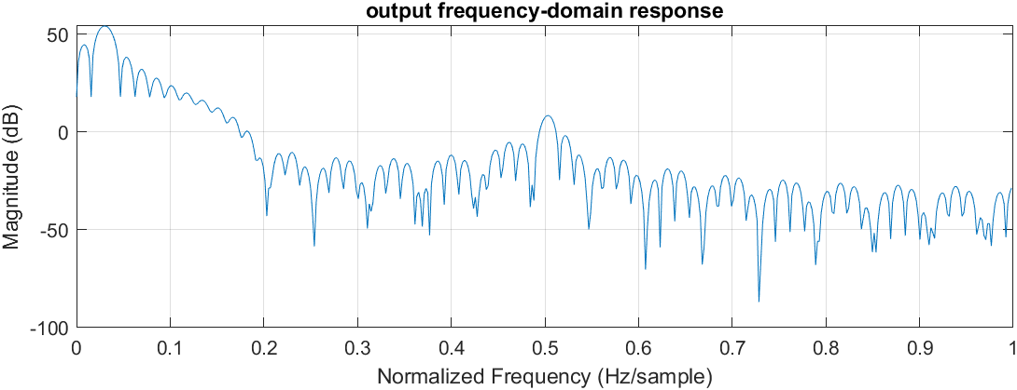

圖八 output frequency-domain 波德圖

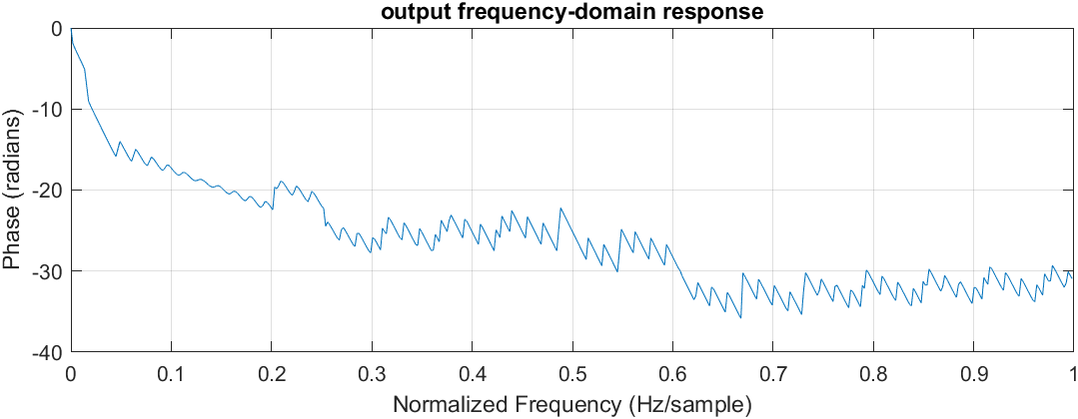

圖九 output frequency-domain 相位圖

1. To show how you determine the word-length, please use the word-length of data paths as the X-axis and error as the Y-axis. Scan the quantization error versus the word-length. Mark the word-length settings in the block diagram of the direct form FIR filter.
2. Output error versus input word-lengths

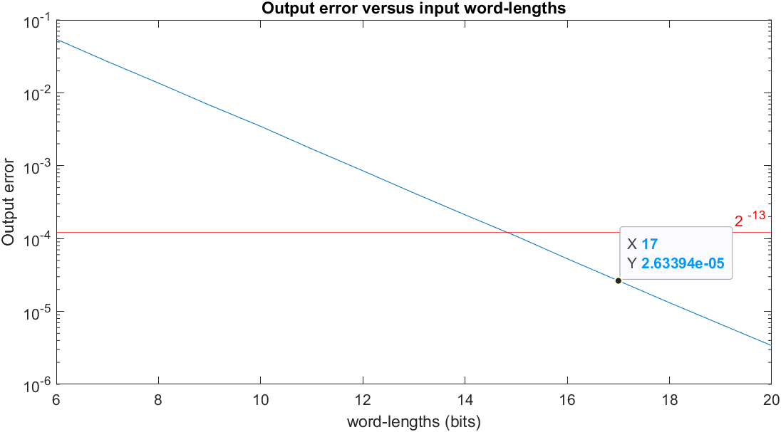

1. Output error versus coefficient word-lengths

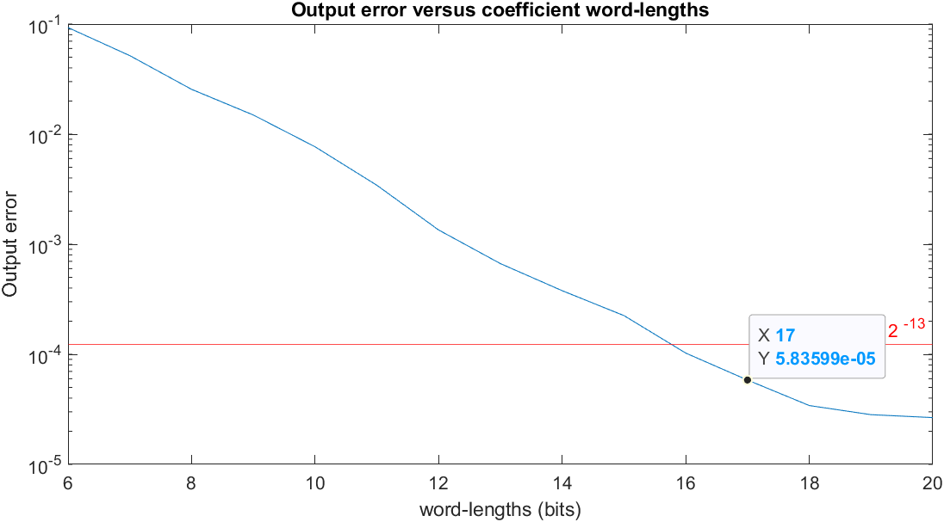

1. Output error versus word-lengths after multiplication

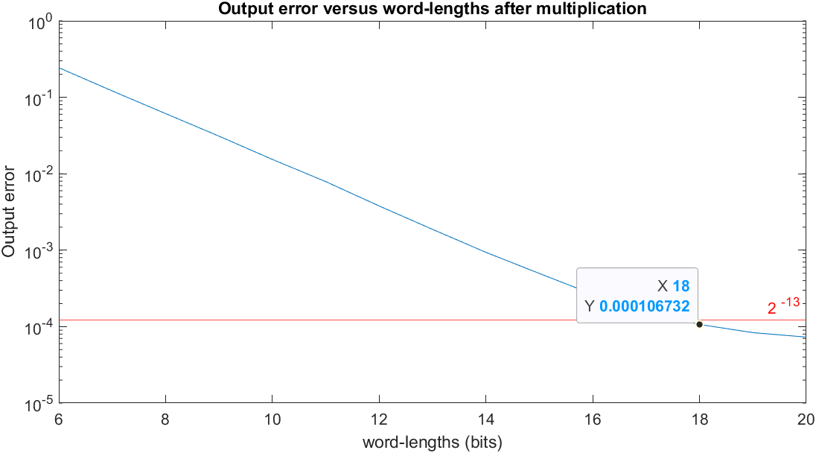

1. Output error versus word-lengths after addition

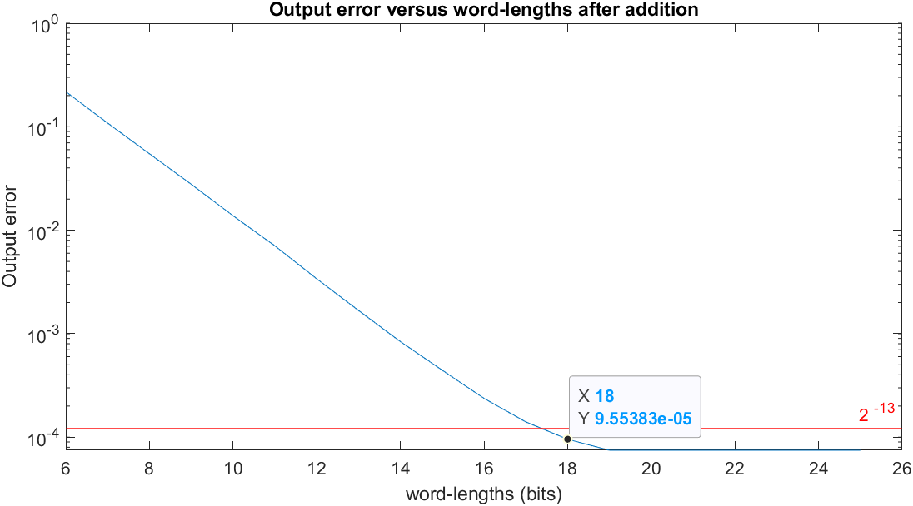

1. To show how you determine the word-length, please use the word-length of coefficients as the X-axis and error as the Y-axis. Scan the quantization error versus the word-length. Mark the word-length settings in the block diagram of the transposed form FIR

filter.

1. Output error versus input word-lengths

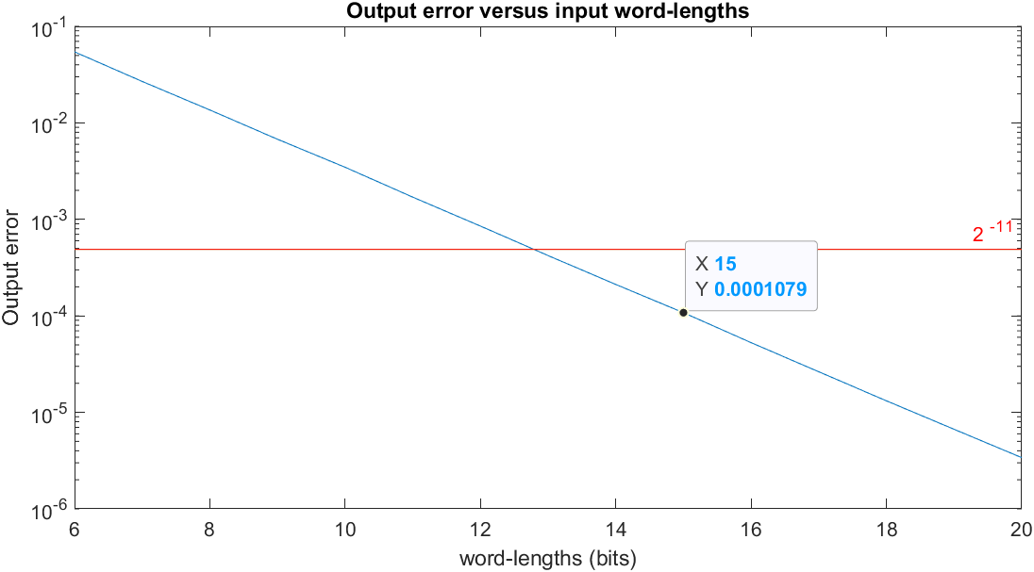

1. Output error versus coefficient word-lengths

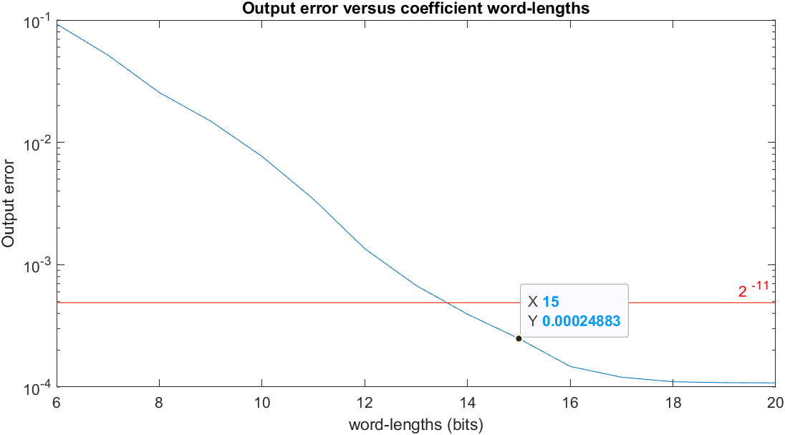

1. Output error versus word-lengths after multiplication

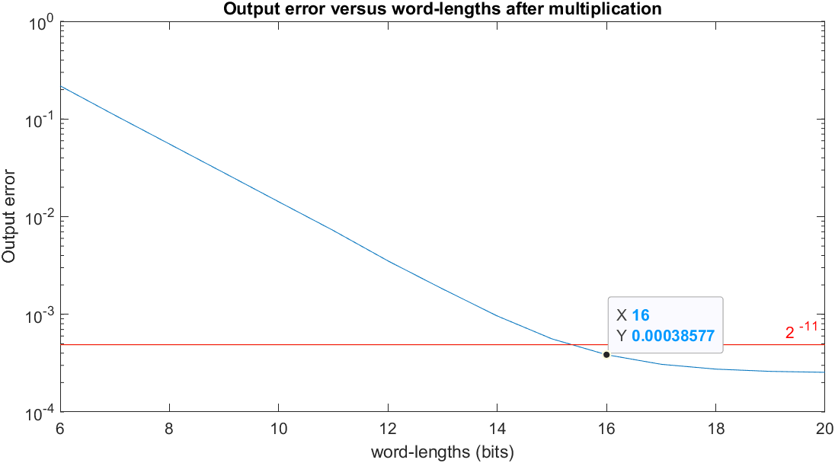

d. Output error versus word-lengths after addition

