Memory Circuit Design

Homework #1

Student name: 林豪澤 111521035

1. Plot the transfer curve in function of the Vinput as x axle against Voutput as y axle with Vdd= 1V and different ratios of Wp/Wn, such as 0.5, 1, and 2.

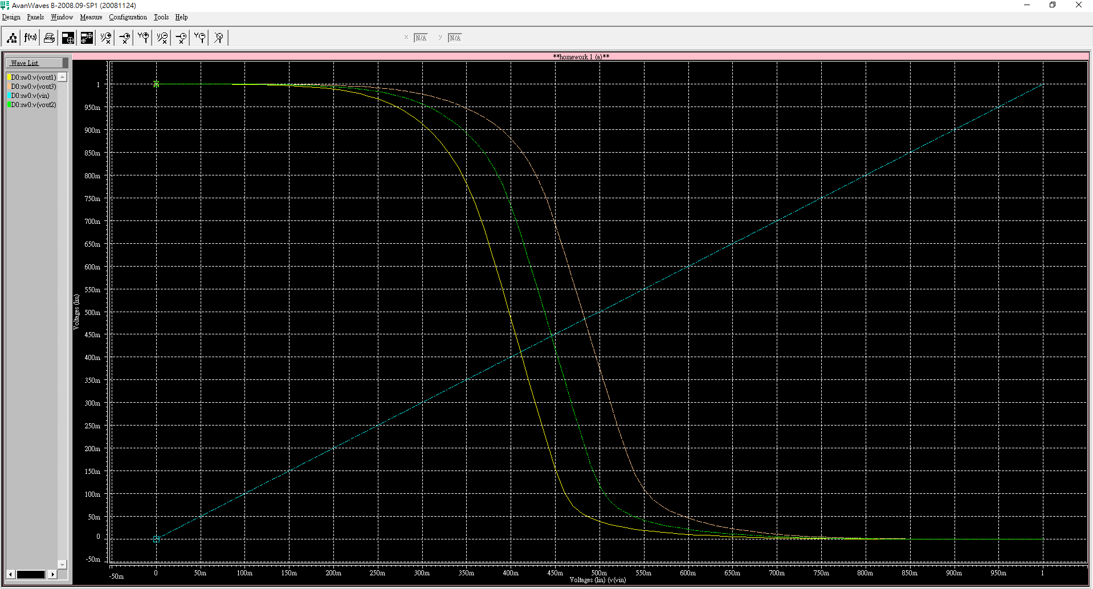

Figure 1. different Wp/Wn inverter curve result

Figure 1.為inverter在不同的Wp/Wn比例下的Vout 輸出結果，根據Wp/Wn的大小不同，輸出的曲線分別由右到左遞增。可以觀察到縱使在Wp/Wn=2的情況下此inverter還不算真正的對等，Wp/Wn大約要設置在2~3之間的比例才能夠使inverter 達到真正對等。

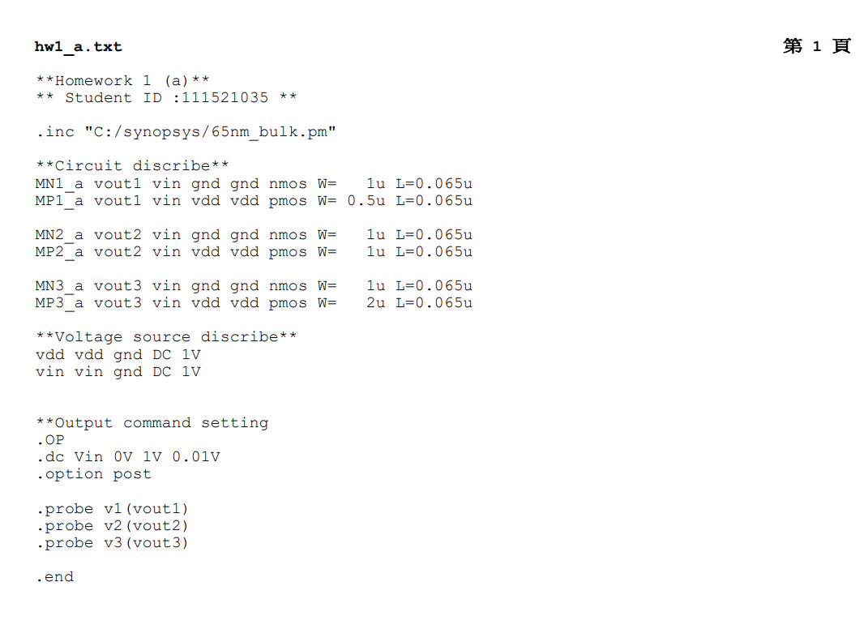

1. Plot the transfer curve in function of the Vinput as x axle against Voutput as y axle with different values of Vdd= 1V, 0.8V, 0.6V, and 0.4V

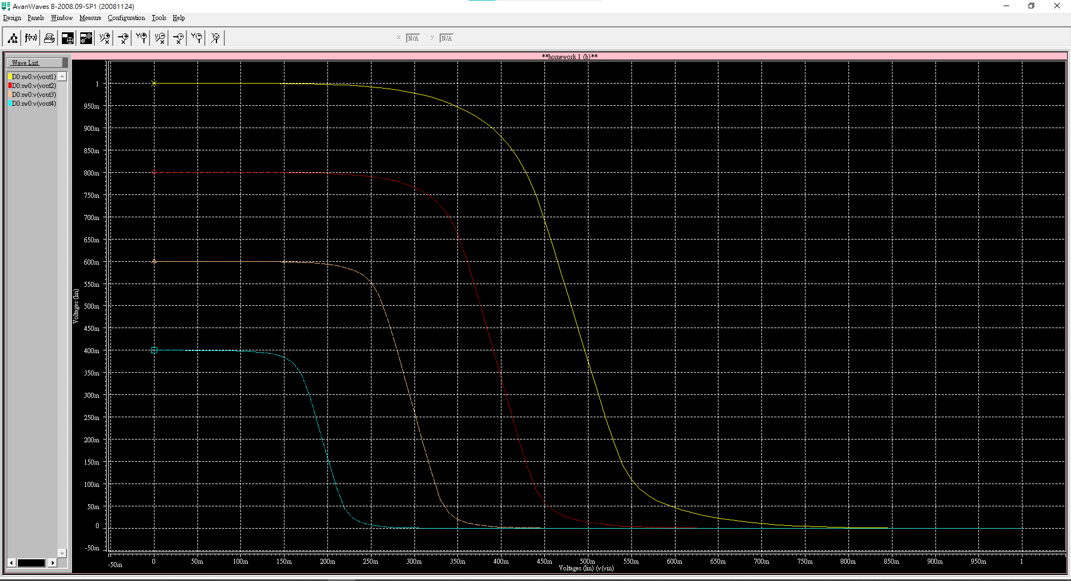

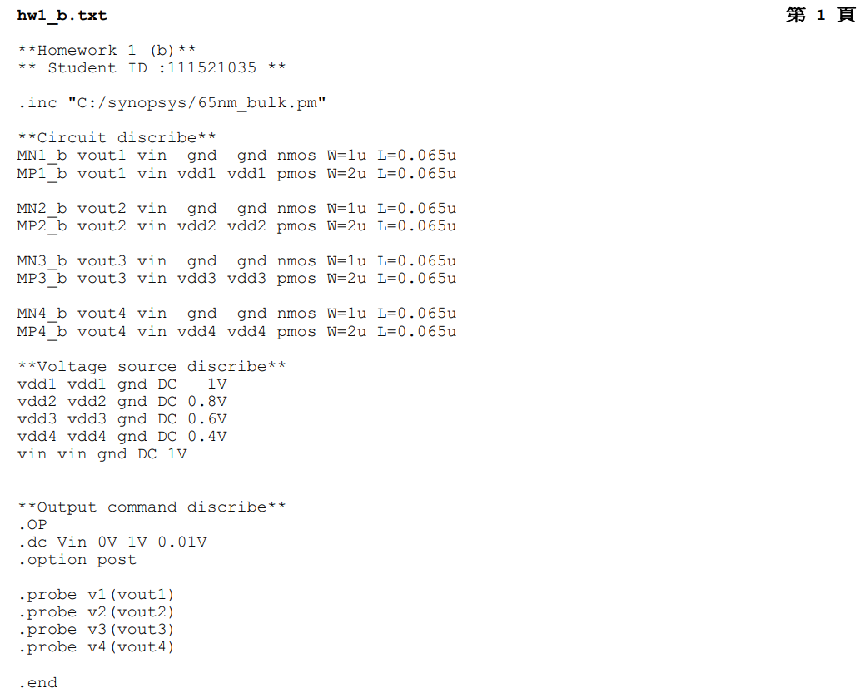

1. Plot the Idd, which flows from the ground to the Vdd, in function of the Vinput. You may sweep the Vinput from 0V to Vdd to collect the data of Idd and plot it.

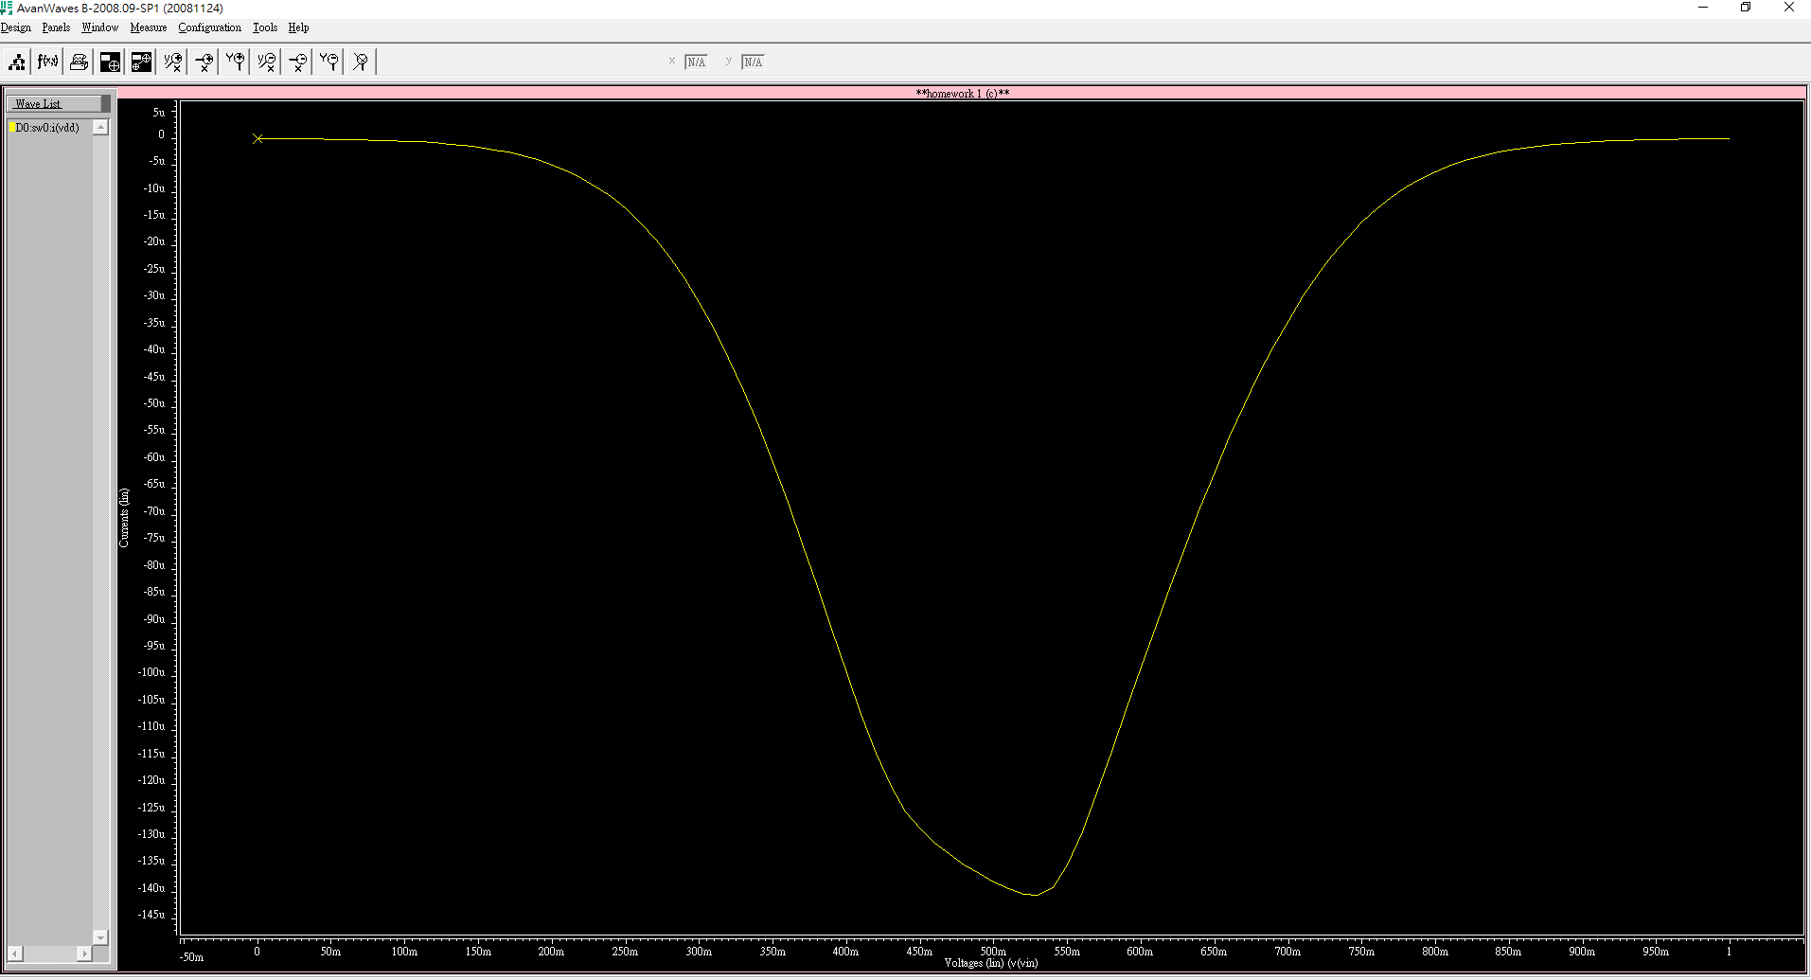

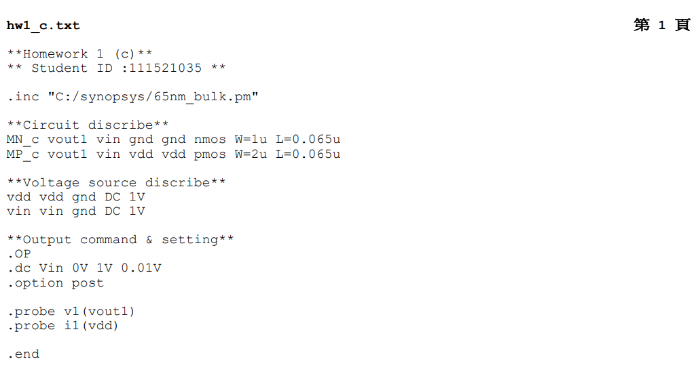

1. Plot the output power, which is defined as Poutput=Voutput x Idd. You may sweep the Vinput from 0V to Vdd to collect the data of Idd and Voutput.

