Memory Circuit Design

Homework #1

Student name: 林豪澤 111521035

1. Plot the transfer curve in function of the Vinput as x axle against Voutput as y axle with Vdd= 1V and different ratios of Wp/Wn, such as 0.5, 1, and 2.

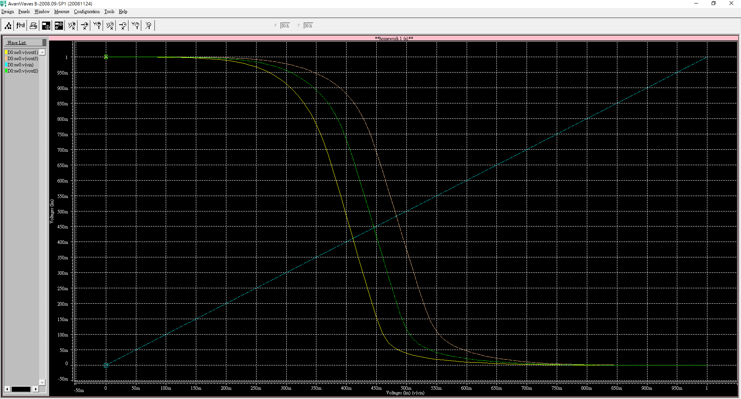

Figure 1. different Wp/Wn inverter curve result

Figure 1.為inverter在不同的Wp/Wn比例下的Vout 輸出結果，根據Wp/Wn的大小不同，輸出的曲線分別由右到左遞增。可以觀察到縱使在Wp/Wn=2的情況下此inverter還不算真正的對等，Wp/Wn大約要設置在2~3之間的比例才能夠使inverter 達到真正對等。

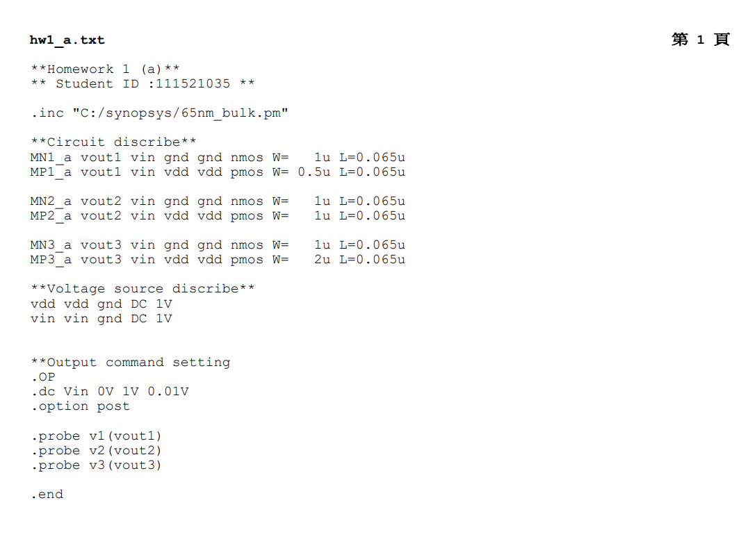

1. Plot the transfer curve in function of the Vinput as x axle against Voutput as y axle with different values of Vdd= 1V, 0.8V, 0.6V, and 0.4V

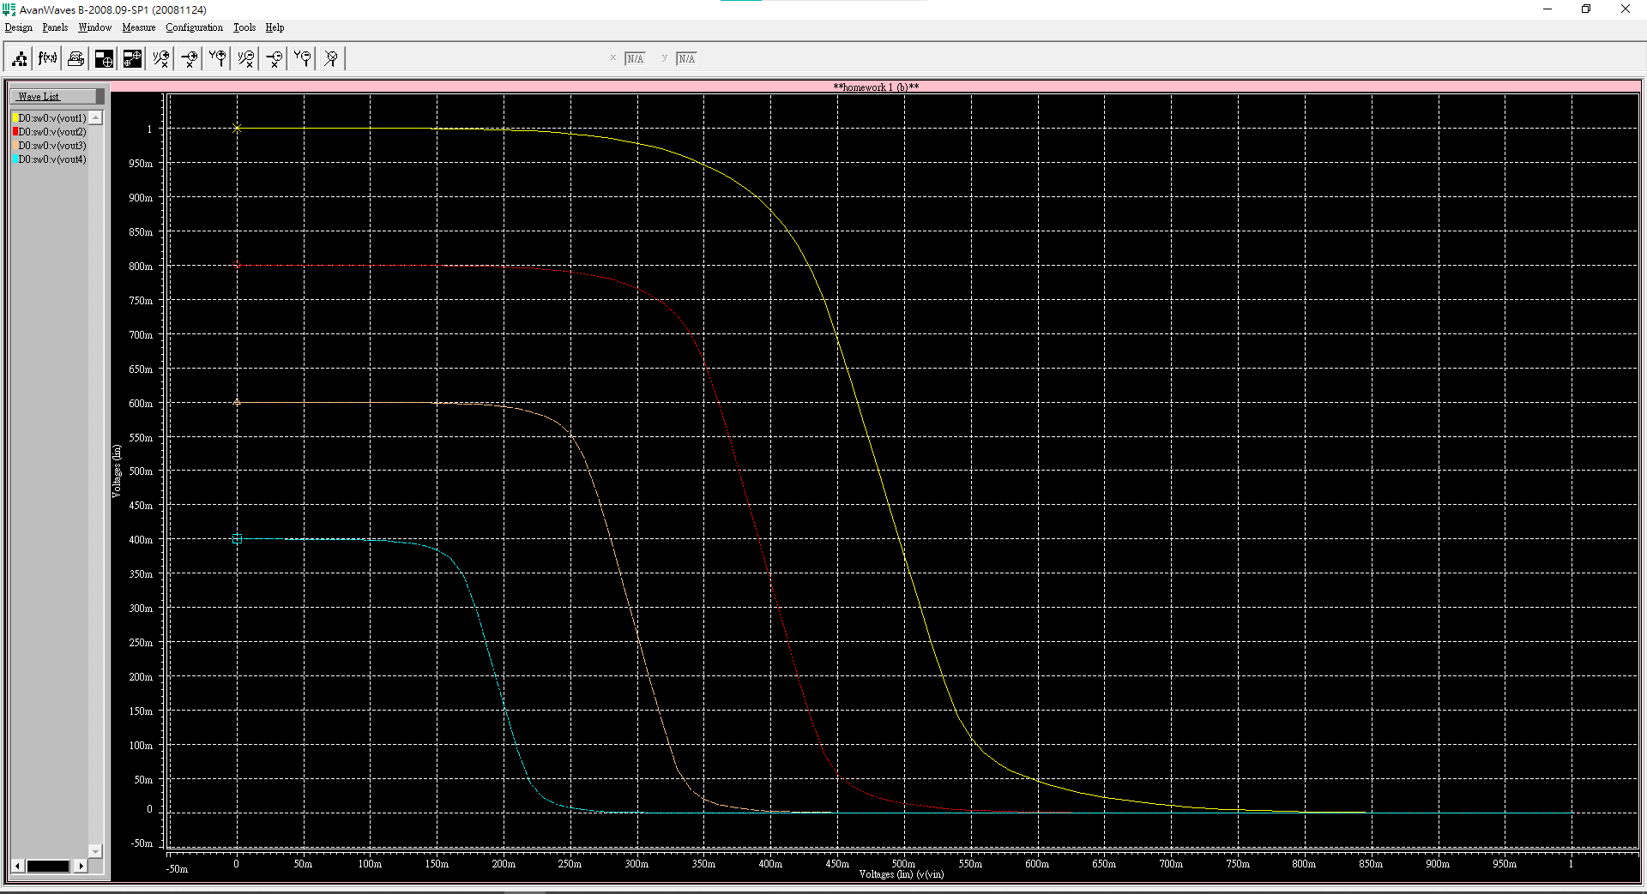

Figure 2. different values of Vdd versus Voutput

Figure 2.為inverter在不同的Vdd下的Vout 輸出結果，根據Vdd的大小不同，輸出的曲線分別由右到左遞增。隨著Vdd的不同inverter的操作電壓也隨著Vdd的上升而增加。

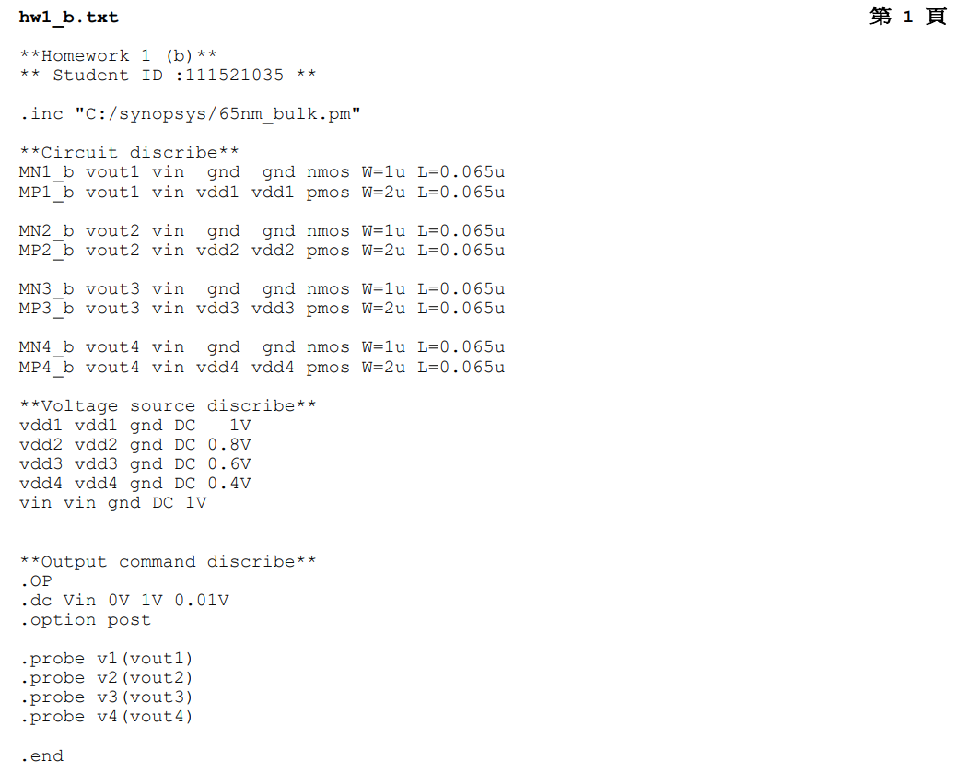

1. Plot the Idd, which flows from the ground to the Vdd, in function of the Vinput. You may sweep the Vinput from 0V to Vdd to collect the data of Idd and plot it.

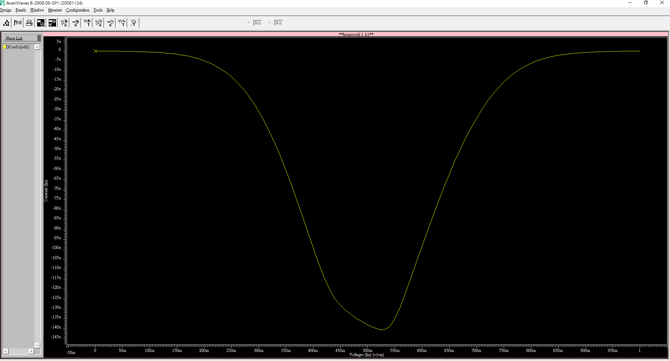

Figure 3. different Vinput versus Idd

如Figure 3所示，inverter 在 switching時idd的數值最大，而這也是動態功耗的主要電流，在idd最大時nmos與pmos皆有電流流過，並為同時打開的狀態。

功耗最大的地方並不是在idd最大的地方，而是Voutput\*Idd最大的點。

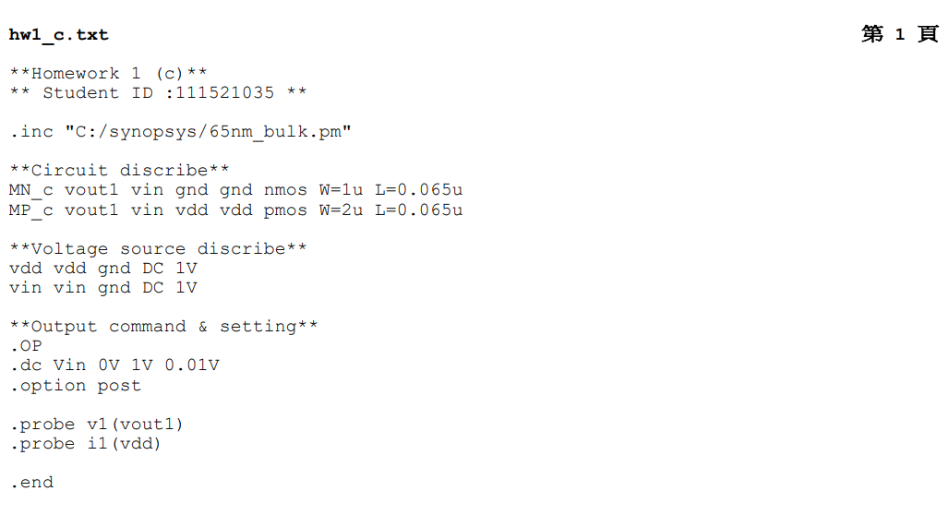

1. Plot the output power, which is defined as Poutput=Voutput x Idd. You may sweep the Vinput from 0V to Vdd to collect the data of Idd and Voutput.

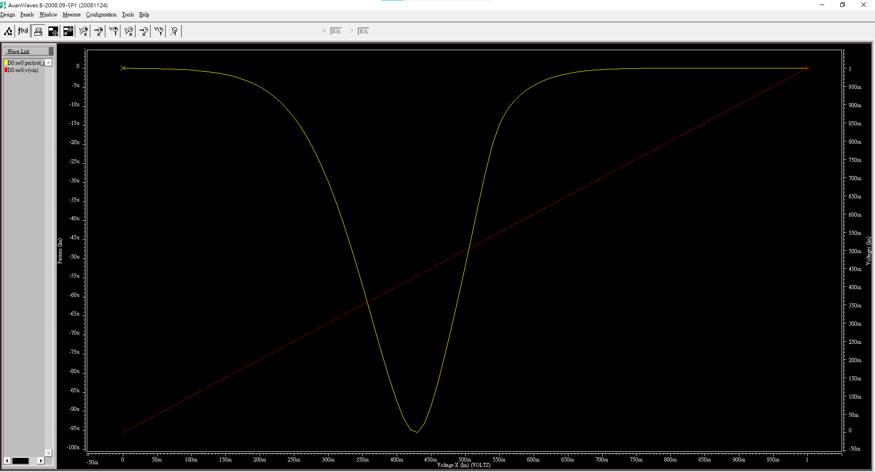

Figure 4. different Vinput versus output power Poutput

如Figure 4所示，inverter 在 switching時idd\* V­output的數值最大，而這也是動態功耗的主要原因。

