Memory Circuit Design Homeword #3

111521035 林豪澤

1. DC Analysis: Please compare the curves of RSNM and WNM for 6T, 8T SRAM cell with different VDD= 1V, 0.8V, 0.6V,and 0.4V. Also, with different VDD= 1V, 0.8V, 0.6V, and 0.4V, please extract the values of the RSNM and WNM, which aredefined as the diagonal line of the maximal square between two curves of RSNM or WNM plots.

6T SRAM

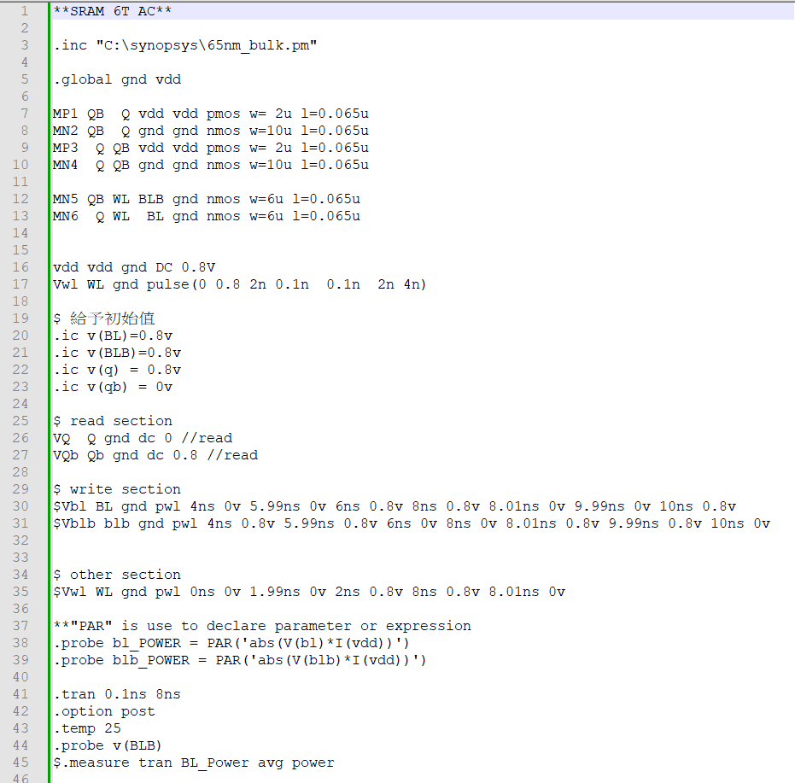

RSNM:

1v:

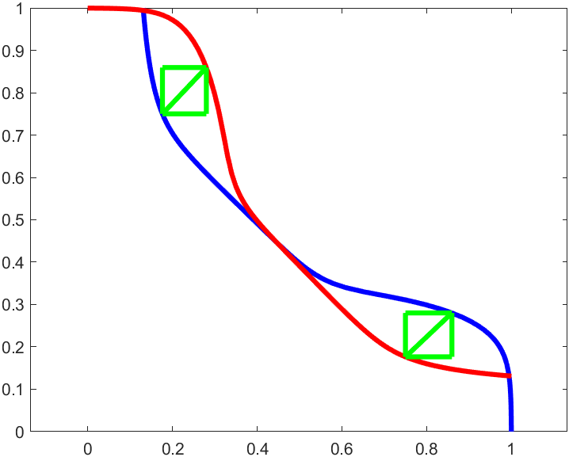

square diagonal length : 1.507041e-01v

lagrest square area: 1.135586e-02(v*v)

SNM = 4.262555e-01v

0.8v:

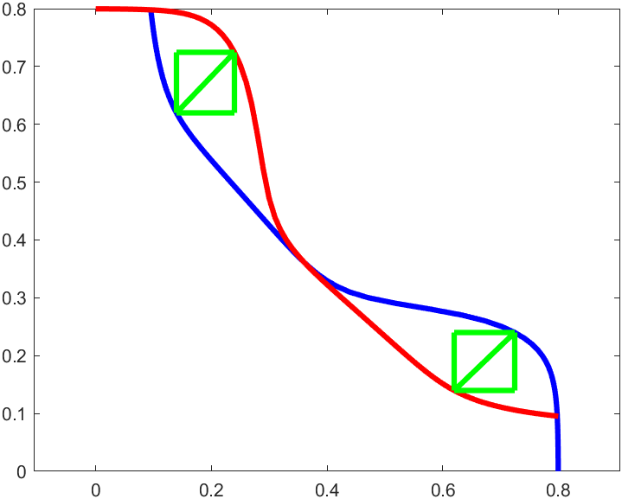

square diagonal length : 1.449913e-01v

lagrest square area: 1.051123e-02(v*v)

SNM = 4.100972e-01v

0.6v:

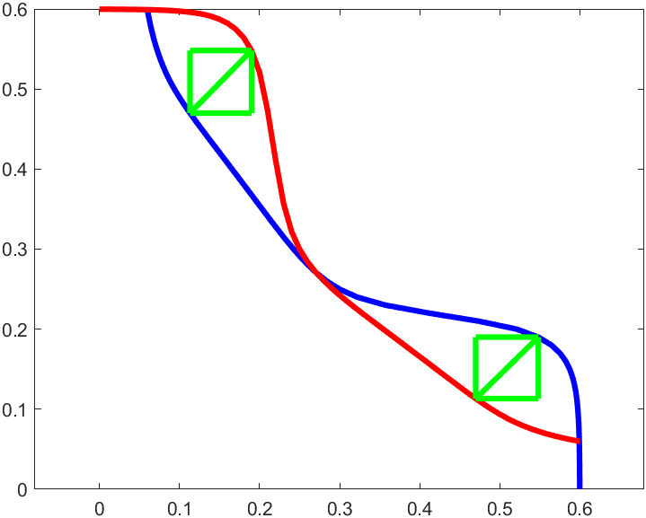

square diagonal length : 1.096480e-01v

lagrest square area: 6.011339e-03(v*v)

SNM = 3.101313e-01v

0.4v:

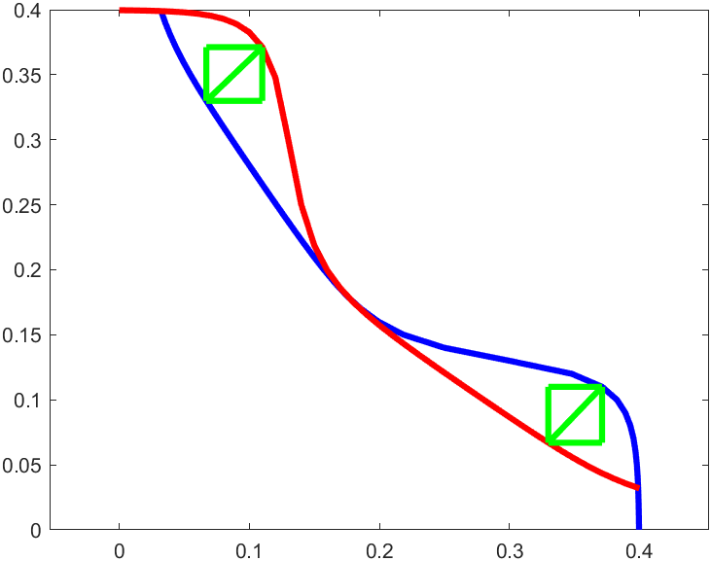

square diagonal length : 5.963761e-02v

lagrest square area: 1.778322e-03(v*v)

SNM = 1.686806e-01v

WNM

1v:

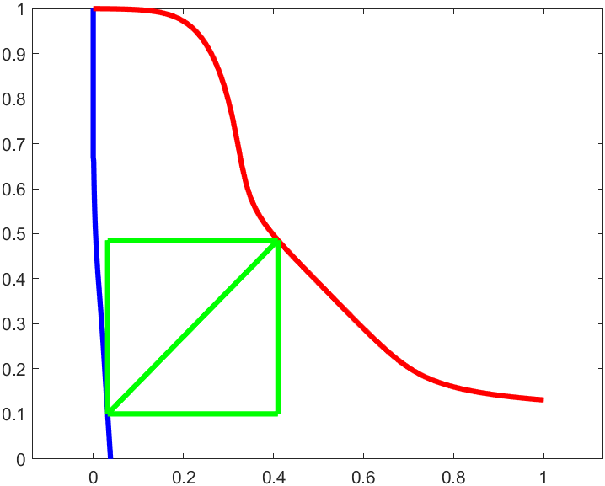

square diagonal length : 5.400224e-01v

lagrest square area: 1.458121e-01(v*v)

WNM = 1.527414e+00v

0.8v

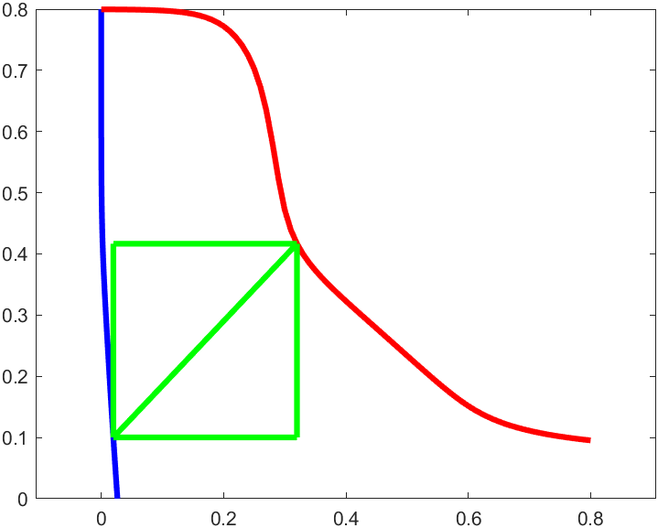

square diagonal length : 4.363950e-01v

lagrest square area: 9.522031e-02(v*v)

WNM = 1.234312e+00v

0.6v

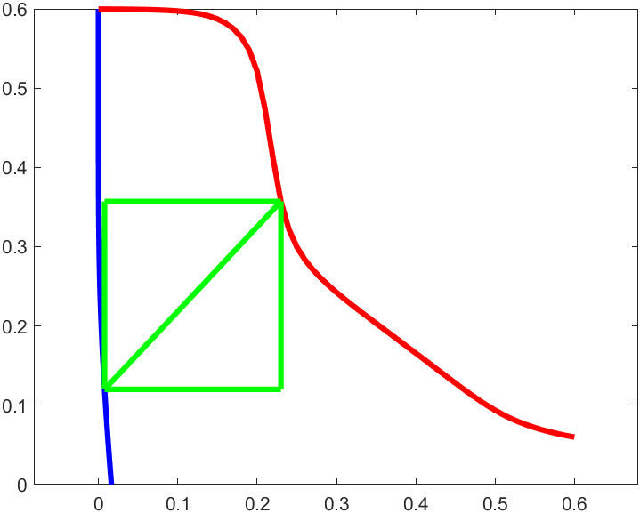

square diagonal length : 3.249793e-01v

lagrest square area: 5.280577e-02(v*v)

WNM = 9.191802e-01v

0.4v

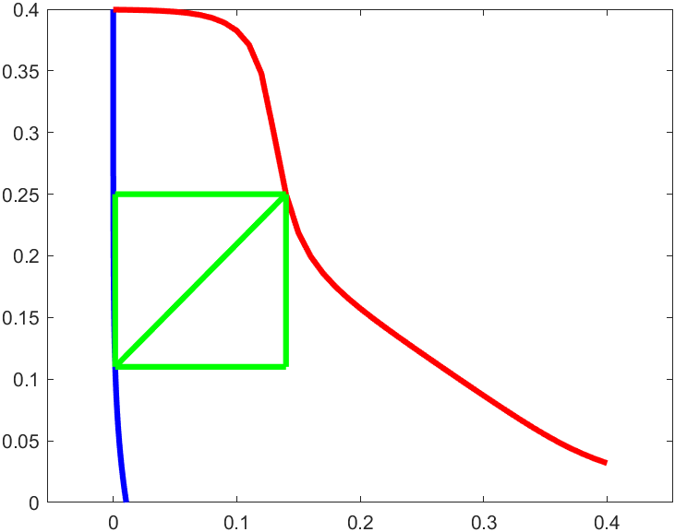

square diagonal length : 1.968859e-01v

lagrest square area: 1.938202e-02(v*v)

WNM = 5.568773e-01v

8T SRAM

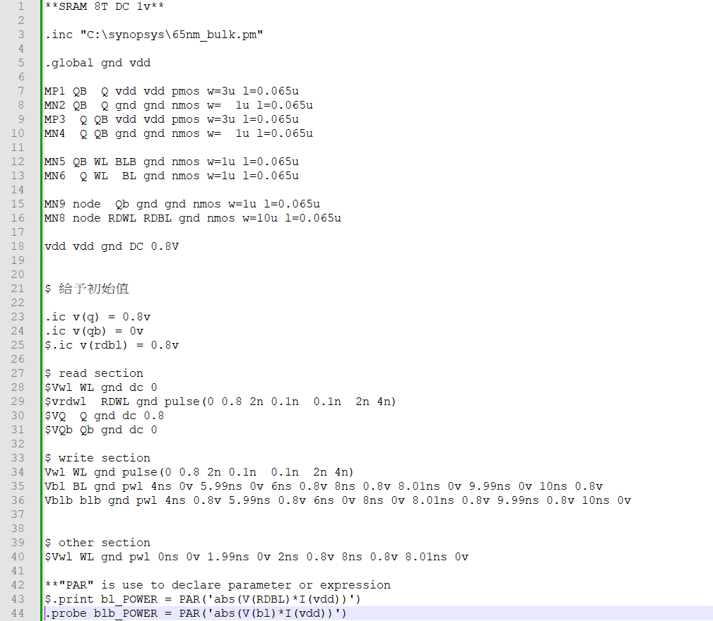 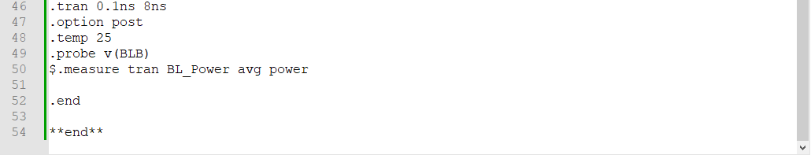

RSNM:

1v:

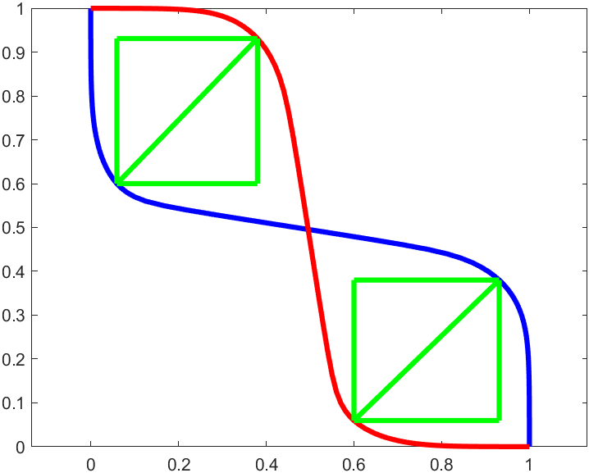

square diagonal length : 4.607226e-01v

lagrest square area: 1.061327e-01(v*v)

SNM = 1.303120e+00v

0.8v:

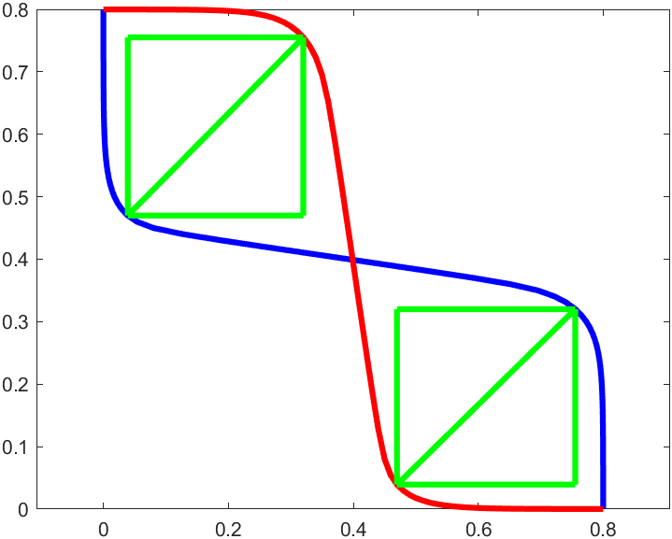

square diagonal length : 4.004623e-01v

lagrest square area: 8.018503e-02(v*v)

SNM = 1.132678e+00v

0.6v:

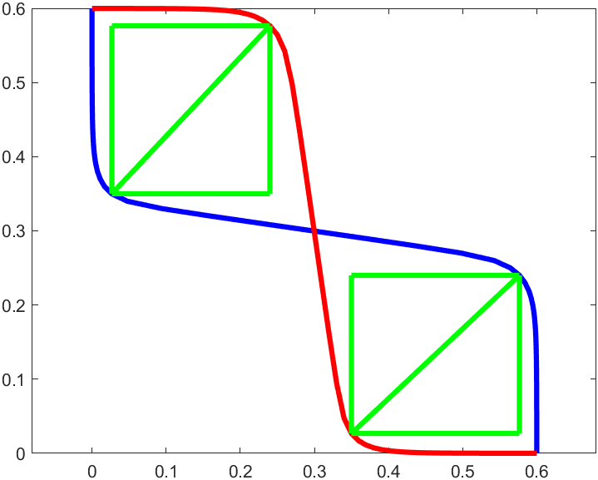

square diagonal length : 3.111642e-01v

lagrest square area: 4.841159e-02(v*v)

SNM = 8.801053e-01v

0.4v:

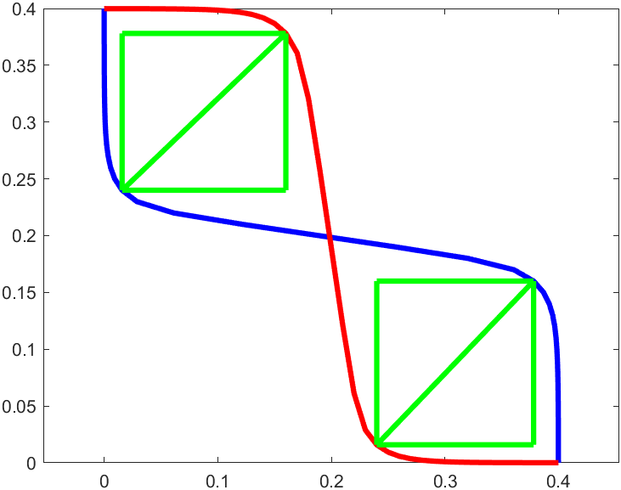

square diagonal length : 1.996891e-01v

lagrest square area: 1.993787e-02(v*v)

SNM = 5.648061e-01v

WNM:

1v

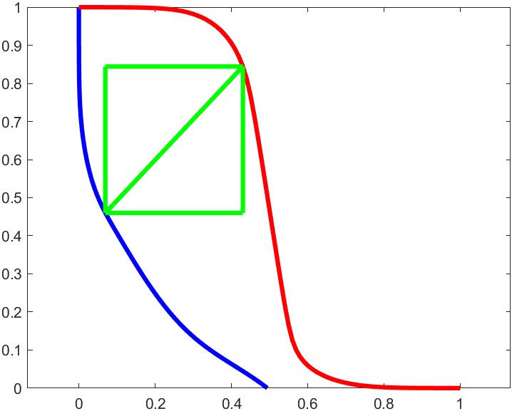

square diagonal length : 5.269827e-01v

lagrest square area: 1.388554e-01(v*v)

WNM = 1.490532e+00v

0.8v

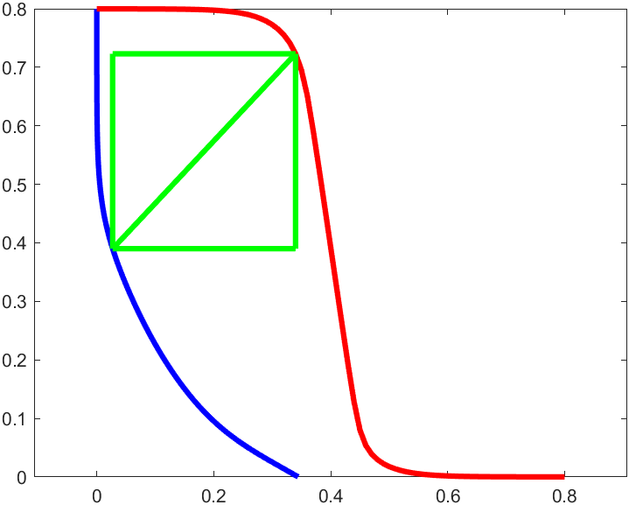

square diagonal length : 4.570721e-01v

lagrest square area: 1.044574e-01(v*v)

WNM = 1.292795e+00v

0.6v

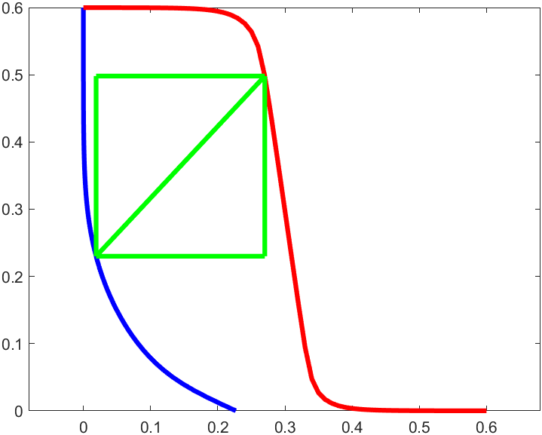

square diagonal length : 3.673589e-01v

lagrest square area: 6.747627e-02(v*v)

WNM = 1.039048e+00v

0.4v

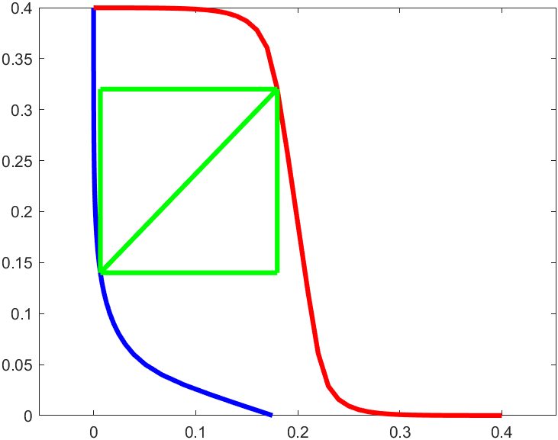

square diagonal length : 2.500330e-01v

lagrest square area: 3.125824e-02(v*v)

WNM = 7.072001e-01v

1. AC Analysis: Please show the BL (BLB) voltage transient curves of 6T, 8T SRAM during READ and WRITE. You may need toapply appropriate pulses on the WL or BL to READ or to WRITE the cells with VDD=0.8V and the pulse width equivalent to 2ns.

6T(read)

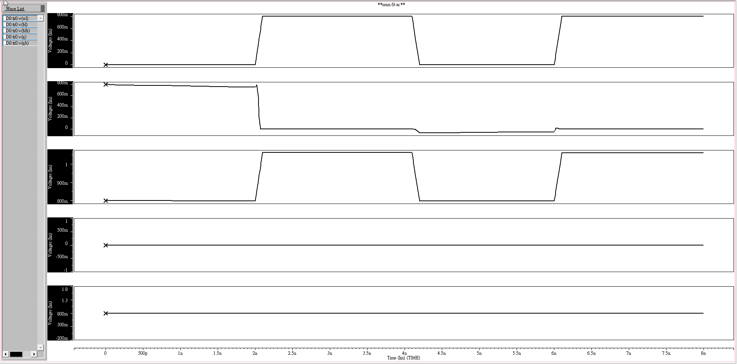

WL = 0 0.8v 0 0.8v

BL = 0.8v 0 0 0

BLB = 0.8v 0 0.8v 0

QB = 0v

Q = 0.8v

6T(read)

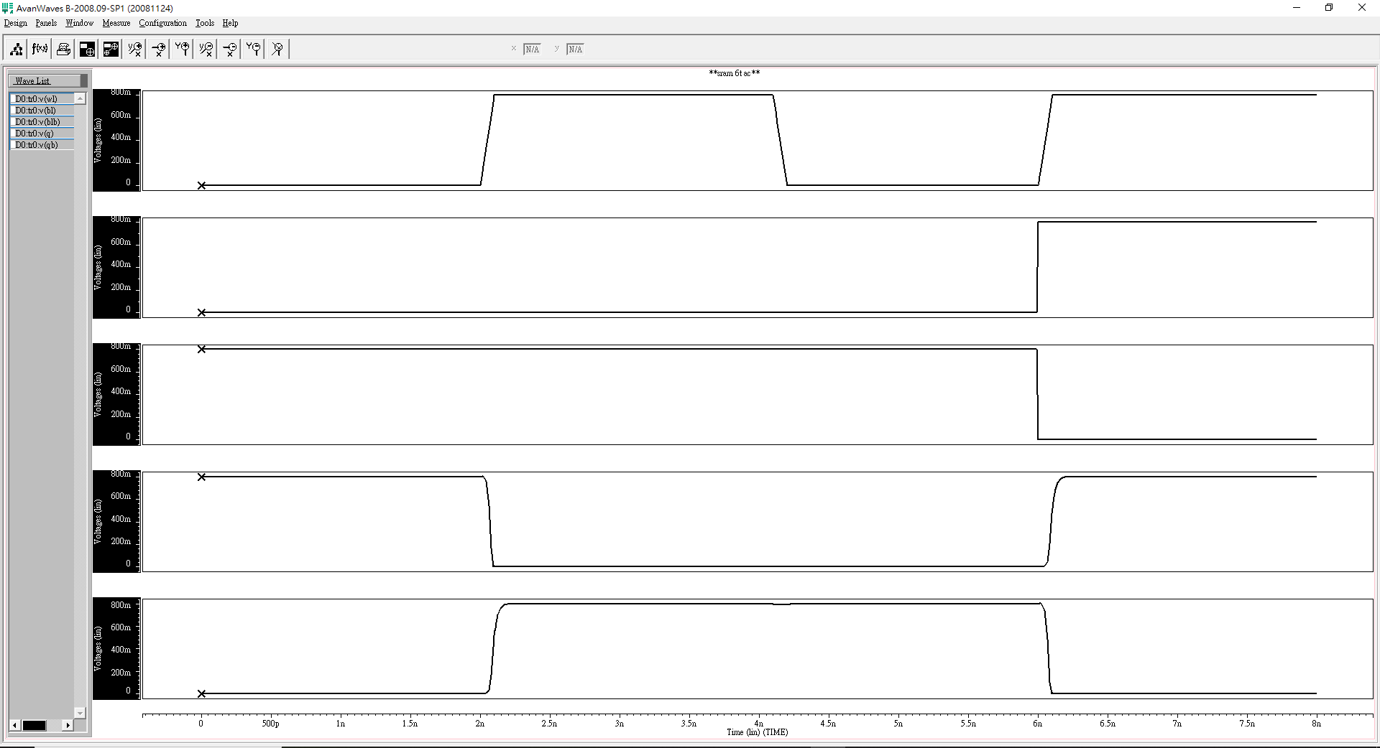

WL = 0 0.8v 0 0.8v

BL = 0 0 0 0.8v

BLB = 0.8v 0.8v 0.8v 0

Q = 0.8v 0 0 0.8v

QB = 0 0.8v 0.8v 0

8T_SRAM

READ 0:

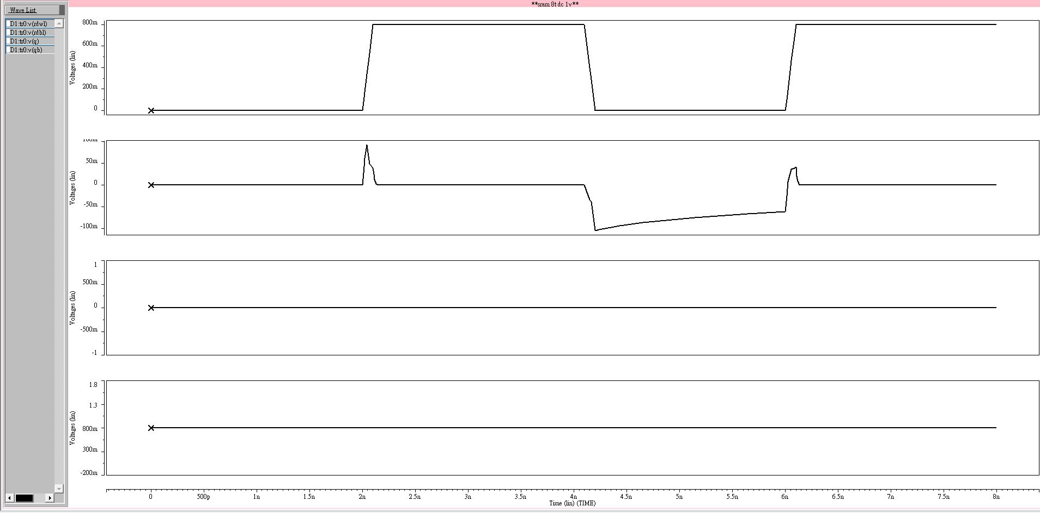

RDWL = [ 0 0.8 0 0.8]

RDBL = [ 0 0 0 0]

Q = 0

QB = 0.8

READ 1:

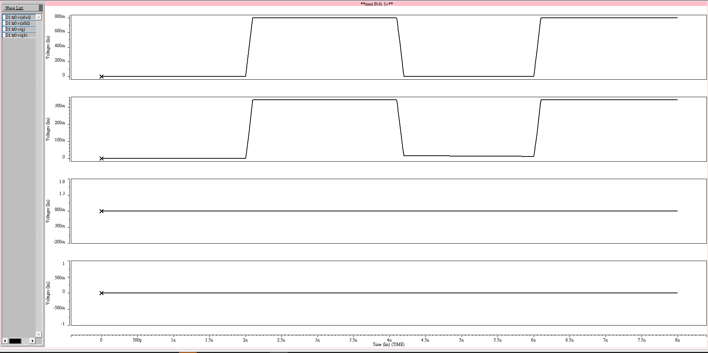

RDWL = [ 0 0.8 0 0.8]

RDBL = [ 0 0.4 0 0.4]

Q = 0.8

QB = 0

由於M8與M9所得的電壓為RDBL的浮接值因此漏電與分壓問題非常嚴重，可以看到圖中雖然RDWL打開但是由於上述問題RDBL的電壓嚴重降壓。

Write:

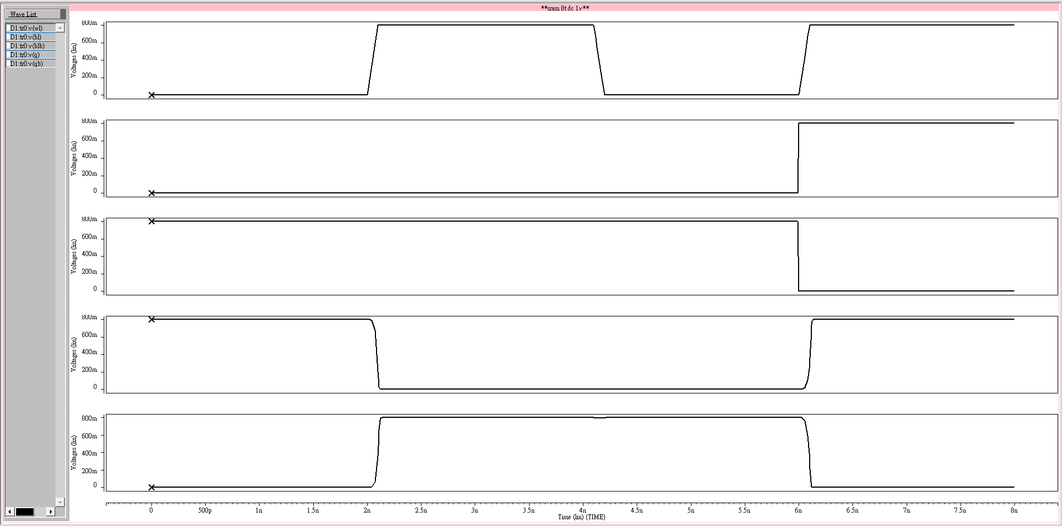

WL = [ 0 0.8 0 0.8]

BL = [ 0 0 0 0.8]

BLB = [0.8 0.8 0.8 0]

Q = [0.8 0 0 0.8]

QB=[ 0 0.8 0.8 0]

1. Power Analysis: Please show the BL (BLB) power transient curves of 6T, 8T SRAM during READ and WRITE. The power transient curves can be calculated by multiplication of voltage and current transient curves. (P=IxV) You may need to apply appropriate pulses on the WL or BL to READ or to WRITE the cells with VDD=0.8V and the pulse width equivalent to 2ns.

6T_SRAM

write power transient curves

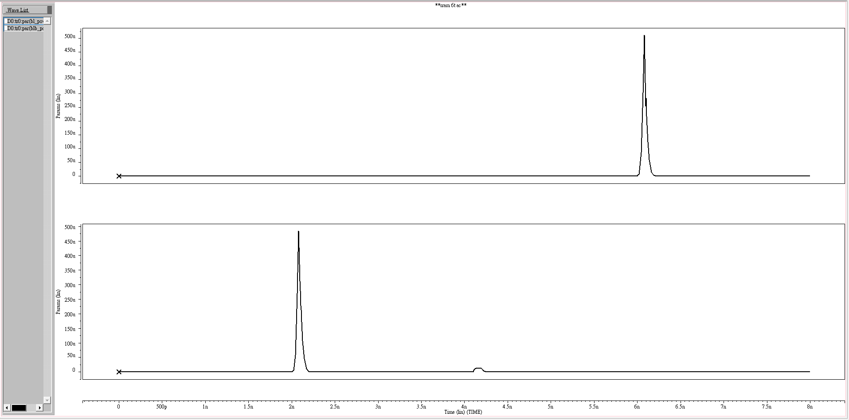

Up: BL power

Down : BLB power

Read power transient curves

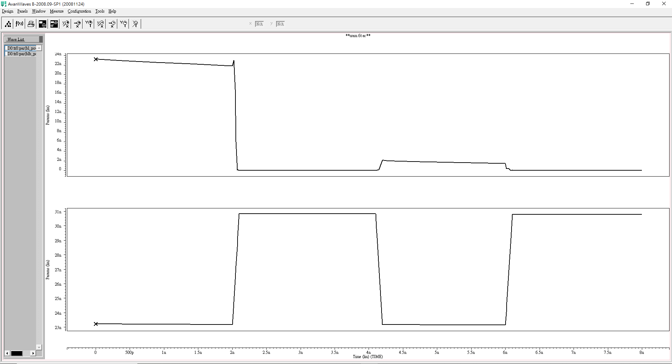 Up: BL power

Down : BLB power

8T_SRAM

read power transient curves

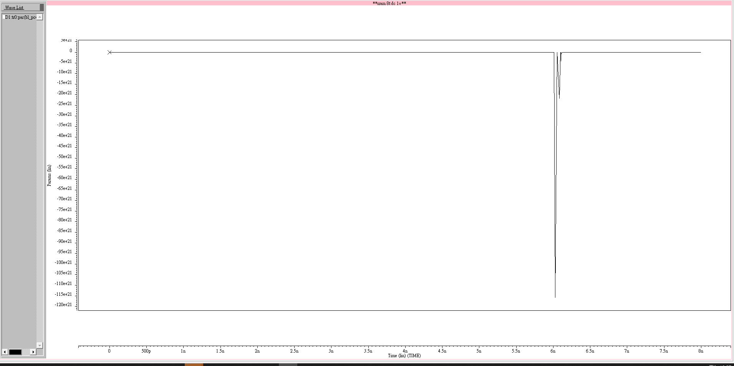

RDBL power

write power transient curves



BL power