**Chapter 6: User manual**

**6.1 Deployment guidelines**

**6.1.1 Environment for development**

* Operating system: Window 10 Pro
* Code IDE: Visual Studio 2017
* Code Editor: Visual Studio Code
* Node.js: 10.15.3
* Docker: 18.09.2
* Plugins:
  + TSLint
  + Dotcover

**6.1.1.1 Setup development environment**

*6.1.1.1.1 Install Visual Studio 2017*

* Go to <https://visualstudio.microsoft.com/downloads/>

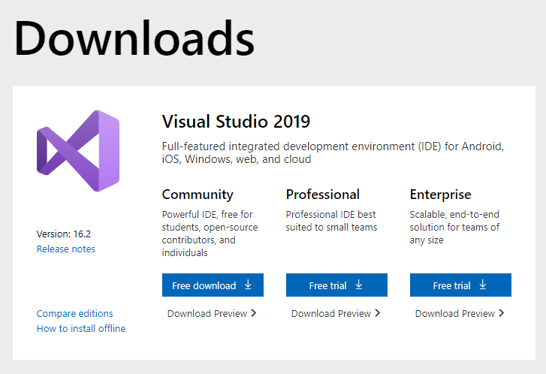

Figure 6-1: Visual Studio download page

* Currently, If the last version is not the Visual Studio 2017, scroll to the bottom of the page then click “Older versions” button. Otherwise, Click “Free download” button
* In older version page, Choose the right version (2017) and click “Download” button.

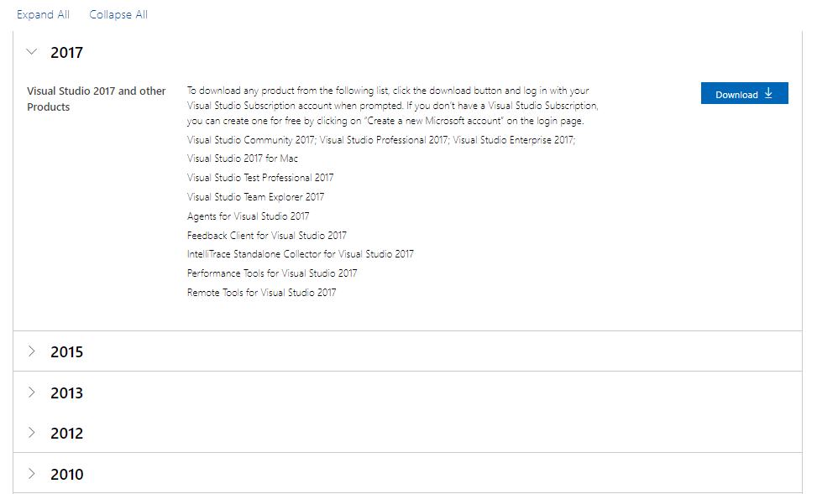

Figure 6-2: Visual Studio download old version page

* Run the downloaded executable file, follow the instructions.
* Start the application by opening the shortcut on desktop or from start menu.

*6.1.1.1.2 Install Visual Studio Code*

* Go to <https://code.visualstudio.com/> and click on “Download” button.

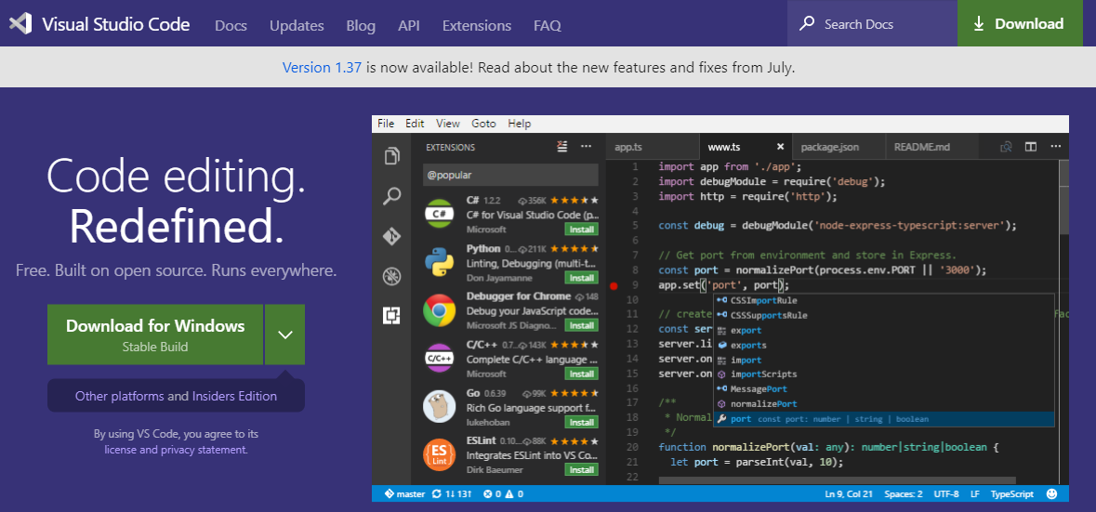

Figure 6-3: Visual Studio Code download page

* Run the downloaded executable file, follow the instructions.
* Start the application by opening the shortcut on desktop or from start menu.

*6.1.1.1.3 Install Node.js*

* Go to <https://nodejs.org/en/download/> and click “Windows Installer” to download the installation file.

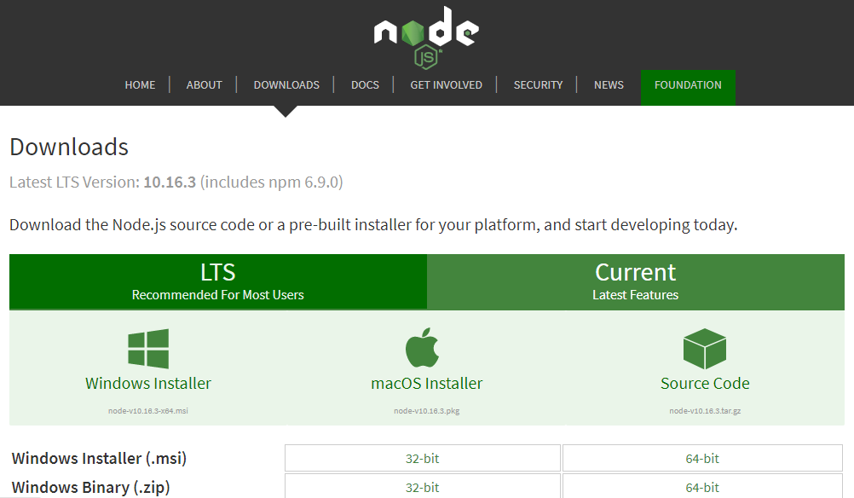

Figure 6-4: Node.js download page

* Run the downloaded executable file, follow the instructions.
* To test if Node.js is install successful, open Command Prompt then enter “node -v”.

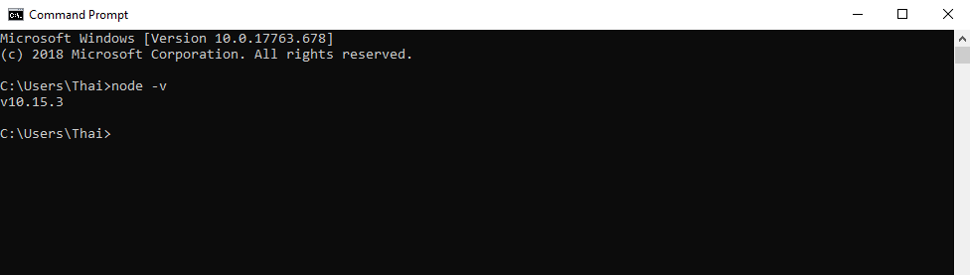

Figure 6-5: Show node's version

*6.1.1.1.4 Install Docker*

* Go to <https://hub.docker.com/editions/community/docker-ce-desktop-windows> and click “Get Docker” button.

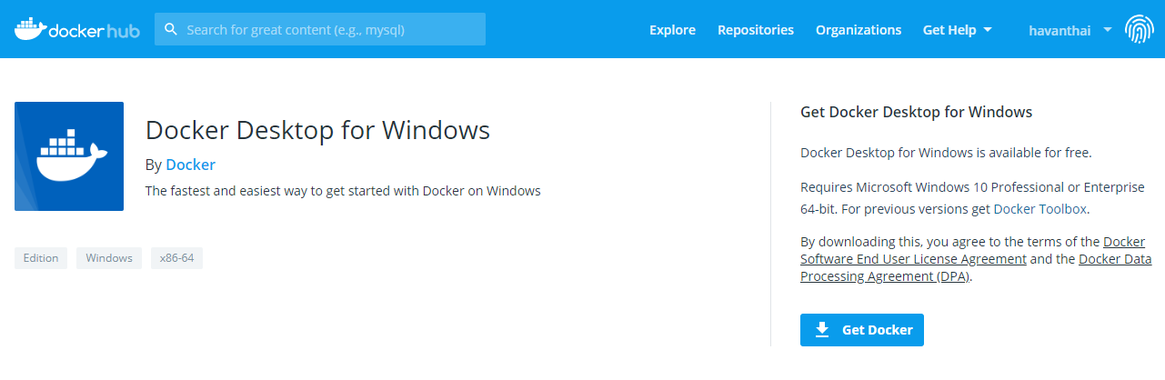

Figure 6-6: Docker download page

* Run the downloaded executable file, follow the instructions. Be sure to keep using Linux container when prompted to switch to Windows container.
* Start the application by open the short cut “Docker Desktop” on the desktop.

**6.1.1.2 Run unit test and coverage**

* Run unit test:
* Open the solution which is needed to run test with visual studio.
* On the menu bar, click **Test > Run > All Tests**

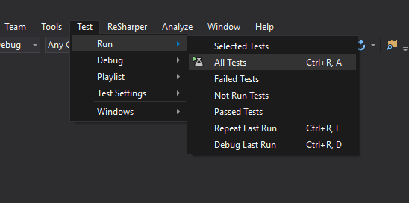

Figure 6-7: Run unit test

* Unit test result will be displayed in Test Explorer.

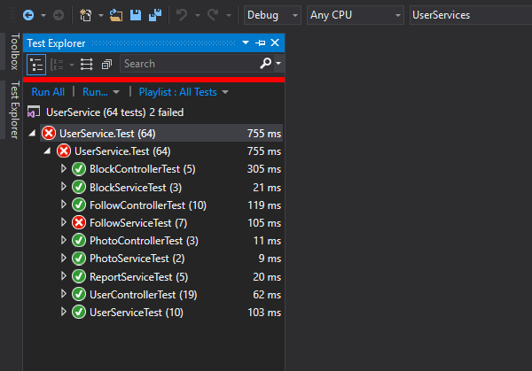

Figure 6-8: Unit test result

* Run coverage:
* In Solution Explorer, right-click on solution name, then select **Cover Unit Tests**

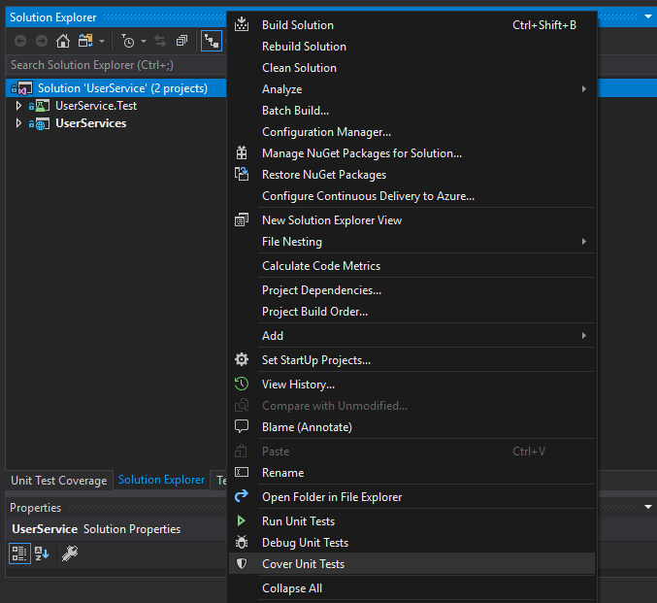

Figure 6-9: Run test coverage

* Wait for the process finish, test coverage result will be displayed in **Unit Test Coverage tab**.

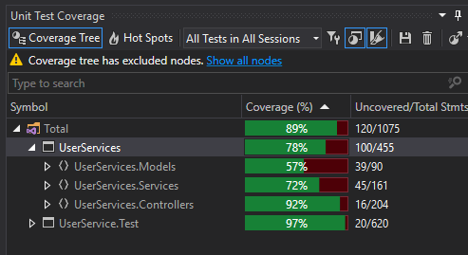

Figure 6-10: Test coverage result

**6.1.1.3 Local network setup**

* Run “Notepad” as Administrator.
* From File menu, click “Open”.
* Navigate to <Windows Drive>\Windows\system32\drivers\etc\.
* Choose “All Files (*.*)” from the dropdown to the right of the “File name” box.
* Choose “hosts” file and click “Open”.
* Add the following new lines at the end of the file:

127.0.0.1 dev-trip-sharing.net

**6.1.2 Environment for deployment**

Platform: Kubernetes Engine on Google Cloud Platform

**6.1.2.1 Install Google Cloud SDK**

* Download the Google Cloud SDK installer:

<https://dl.google.com/dl/cloudsdk/channels/rapid/GoogleCloudSDKInstaller.exe>

* Launch the installer and follow the prompts.
* After installation has completed, the installer presents several options:

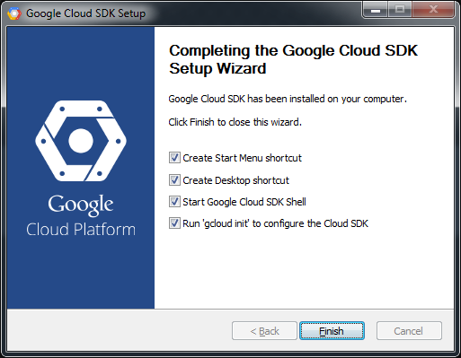

Figure 6-11: Google cloud SDK’s installation completed window

* Make sure that the following are selected:
  + Start Google Cloud SDK Shell
  + Run 'gcloud init'
* The installer then starts a terminal window and runs the gcloud init command.

*Reference:* [*https://cloud.google.com/sdk/docs/quickstart-windows*](https://cloud.google.com/sdk/docs/quickstart-windows)

**6.1.2.2 Configure for Google Cloud SDK**

* Run the following at a command prompt:

> gcloud init

* Accept the option to log in using your Google user account:

To continue, you must log in. Would you like to log in (Y/n)? Y

* In your browser, log in to your Google user account when prompted and click *Allow* to grant permission to access Google Cloud Platform resources.
* At the command prompt, select a Cloud Platform project from the list of those where you have *Owner*, *Editor* or *Viewer* permissions:

Pick cloud project to use:

[1] [my-project-1]

[2] [my-project-2]

...

Please enter your numeric choice:

If you only have one project, “gcloud init” selects it for you.

* If you have the Google Compute Engine API enabled, “gcloud init” allows you to choose a default Compute Engine zone:

Which compute zone would you like to use as project default?

[1] [asia-east1-a]

[2] [asia-east1-b]

...

[14] Do not use default zone

Please enter your numeric choice:

“gcloud init” confirms that you have complete the setup steps successfully:

gcloud has now been configured!

You can use [gcloud config] to change more gcloud settings.

Your active configuration is: [default]

*Reference:* [*https://cloud.google.com/sdk/docs/quickstart-windows*](https://cloud.google.com/sdk/docs/quickstart-windows)

**6.1.2.3 Setup Kubernetes Engine on Google Cloud**

* Setting a default project

> gcloud config set project [PROJECT_ID]

Replace [PROJECT_ID] with your project ID.

* Setting a default compute zone

> gcloud config set compute/zone [COMPUTE_ZONE]

where [COMPUTE_ZONE] is the desired geographical compute zone

* Get authentication credentials for the cluster

> gcloud container clusters get-credentials [CLUSTER_NAME]

* Creating the Deployment

> kubectl create deployment <DEPLOYMENT-NAME> --image=asia.gcr.io/trip-sharing-cp/<SERVICE-NAME>

* Exposing the Deployment

kubectl expose deployment <DEPLOYMENT-NAME> --type LoadBalancer \ --port 80 --target-port 8080

*Reference:* [*https://cloud.google.com/kubernetes-engine/docs/quickstart*](https://cloud.google.com/kubernetes-engine/docs/quickstart)

**6.1.2.4 Build and push docker images**

* Build the docker image

> docker build -t asia.gcr.io/trip-sharing-cp/<SERVICE-NAME> .

* Push the docker image

> docker push asia.gcr.io/trip-sharing-cp/<SERVICE-NAME>

**6.1.2.5 Setup Google pub/sub**

* Create a topic

> gcloud pubsub topics create mail-sending-topic

* Create a subscription

> gcloud pubsub subscriptions create --topic mail-sending-topic mail-service-sub

**6.1.2.6 Setup SendGrid**

* Go to <https://signup.sendgrid.com/> and register a SendGrid account.

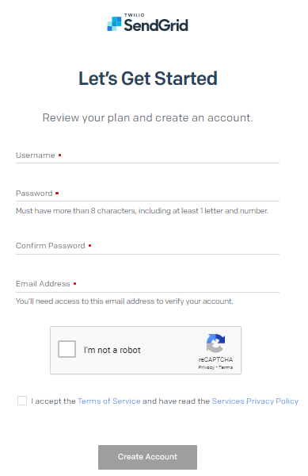

Figure 6-12: Sign up SendGrid

* Go to <https://app.sendgrid.com> and sign in
* From the menu bar on the left, click **Settings** > **API Keys** to navigate to API Keys management page
* Click **Create API Key** at the top right corner and follow instructions to create a new API Key

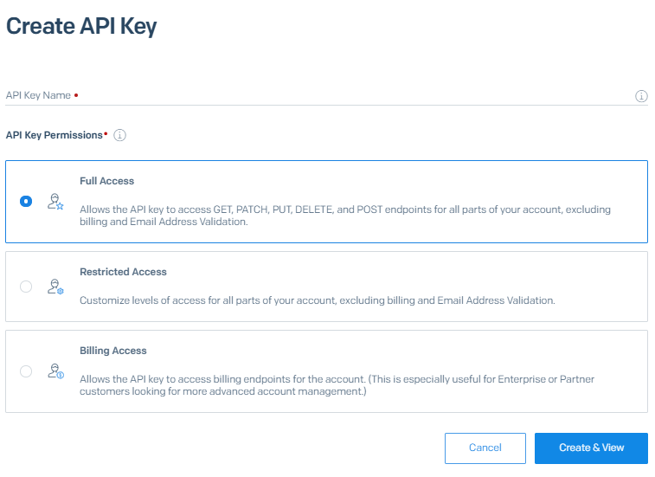

Figure 6-13: Create SendGrid API key

**6.2 User guidelines**

* Our system work well on Google Chrome browser for desktop, so we suggest using it to access our system.
* User visits <https://trip-sharing.net> and follows our guidelines bellow.

**6.2.1 User sign up**

* On any page, user click on “Đăng nhập” button.
* Sign in popup will be displayed, user click on “Đăng kí” link at the bottom of the popup.

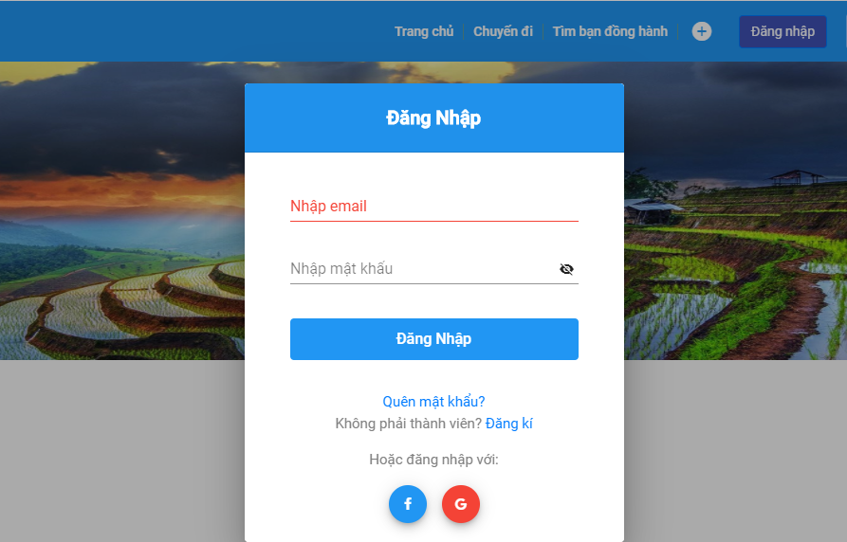

Figure 6-14: Sign in form

* Browser will redirect to sign up page. User fill in all needed field and click “Đăng kí” button.

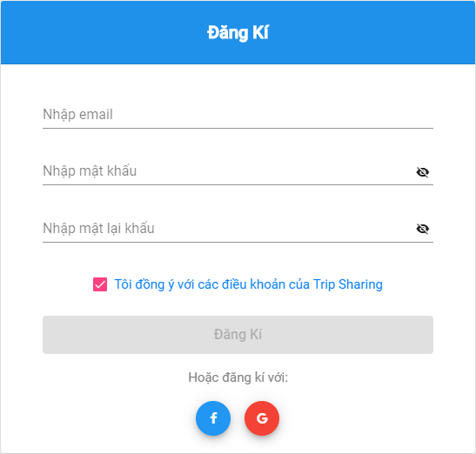

Figure 6-15: Sign up form

* System will send to user an email to confirm. User click on link on the email to complete.

**6.2.2 User sign in**

* On any page, user click on “Đăng nhập” button.
* Sign in popup will be displayed. User fill in email and password to sign in.

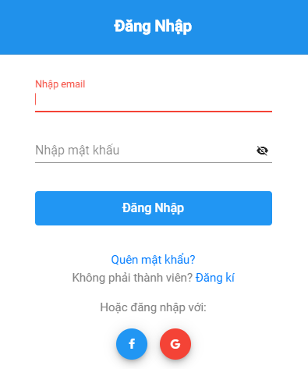

Figure 6-16: Sign in form

* User now signed in the system and redirect to homepage.

**6.2.3 User sign out**

* On any page, user click on image profile on the header.
* System will display a list of options, then user click on “Đăng xuất” option.

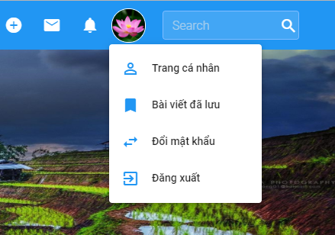

Figure 6-17: User's menu

* User now signed out of the system.

**6.2.4 User update profile**

* On any page, user click on image profile on the header.
* System will display a list of options, then user click on “Trang cá nhân”.
* Browser will redirect to user’s personal page.
* User click on “Chỉnh sửa trang cá nhân” at the left side of the page.

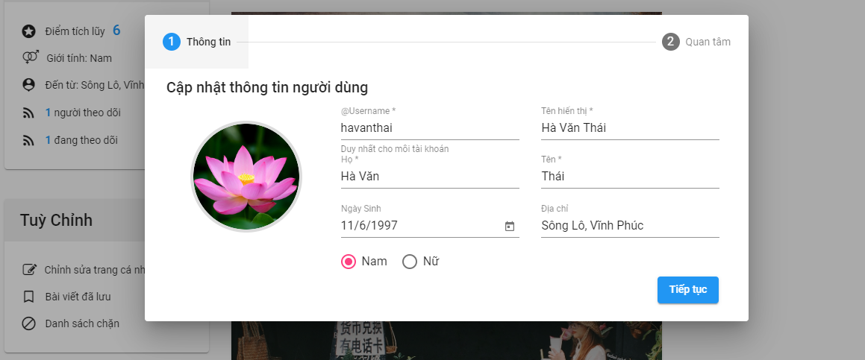

Figure 6-18: Update profile screen

* A popup of user information will be display, then user edit the field user want to change and click on “Tiếp tục” button.
* System will display update interest topics popup. User change the interest topics then click on “Cập nhật” button.

**6.2.5 User searches posts**

* *Search posts by location:*
  + From home page, user enter the location to the search input.
  + System will suggest list of location base on Google Maps. User select one location.

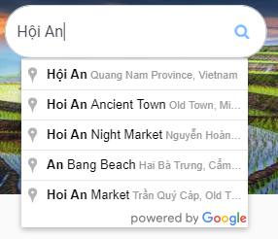

Figure 6-19: Search by Google Map location

* + Browser will redirect to search-result page.
* *Search posts by keyword:*
  + From any page, user enter search keyword into search field at the top-right of the page then press “Enter”.



Figure 6-20: Search by keyword

* + Browser will redirect to search-result page

**6.2.6 User searches other users**

* + From any page, user enter search keyword into search field at the top-right of the page then press “Enter”.
  + Browser will redirect to search-result page
  + User switch to “Mọi người” tab to see searched users.

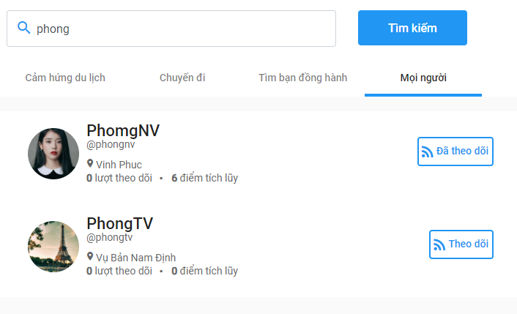

Figure 6-21: Search a user

**6.2.7 User creates posts**

* From any page, click on “+” button on the header. A list of post type will be displayed.
* User choose post type user want to create.

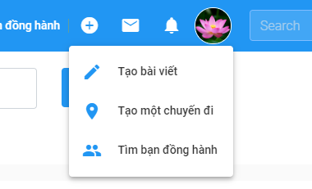

Figure 6-22: Create-post options

* Browser will redirect to create-post page.
* *Create an article*

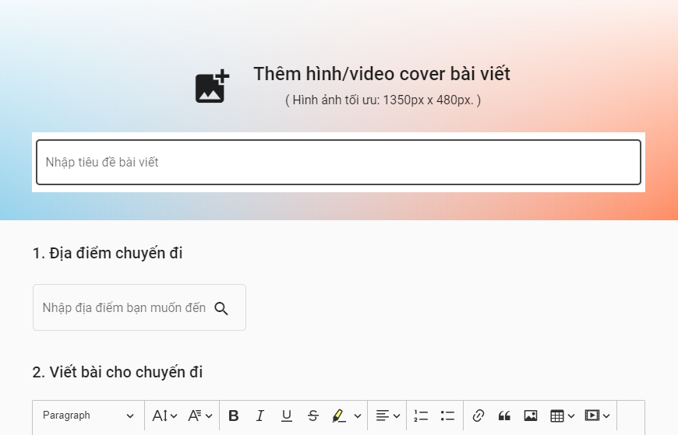

Figure 6-23: Create an article page

* *Create a virtual trip*

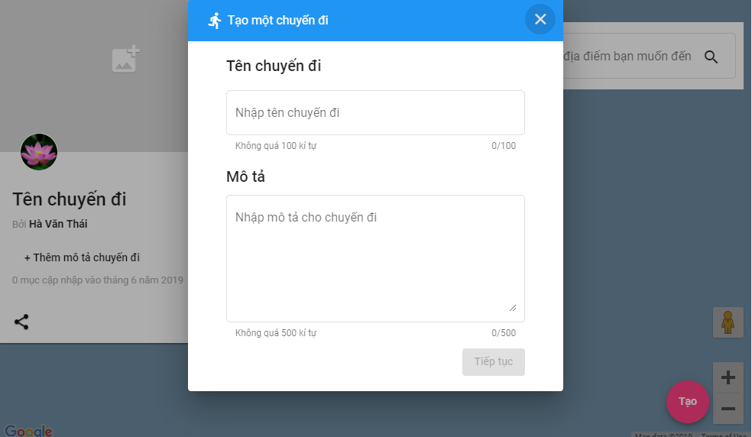

Figure 6-24: Create a virtual trip page

* *Create a finding-companion post*

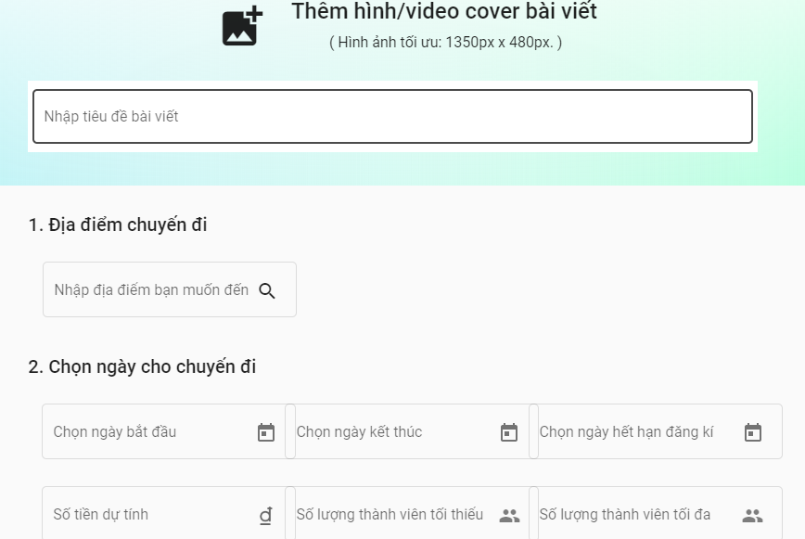

Figure 6-25: Create a finding-companion post page

**6.2.8 User chats with other users**

* User go to the personal page of the user that he/she want to chat with.
* User click on “Gửi tin nhắn” button.

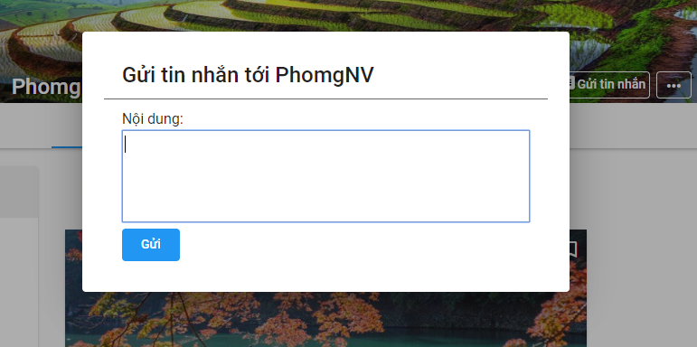

Figure 6-26: Send a message to another

* A popup will be displayed. User enter message then click on “Gửi” button.
* From now on, a conversation between two users is initiated. They can quickly see received message and send new message by click on message icon on the header and select conversation.

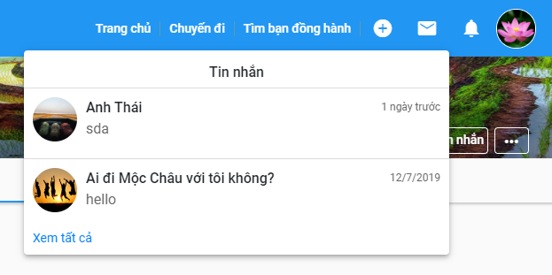

Figure 6-27: List of conversations

**6.2.9 User joins a group**

* User go to the finding-companion post page which he/she wants to join.
* At the right side of the page, click on “Tham gia” button.

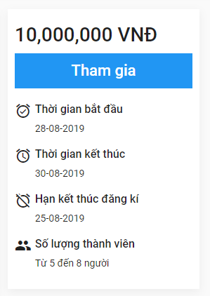

Figure 6-28: Finding-companion post information box

* System will send a request to the post’s author
* If the author accepts your join request, system will notify to you. Now you can see the group chat in the list of your conversations.

**6.2.10 User follows other users and views followings/followers**

* On any page, user click on image profile on the header.
* System will display a list of options, then user click on “Trang cá nhân”.
* Browser will redirect to user’s personal page.
* User click on “n – Người đang theo dõi bạn” to see followers or “n – Người bạn đang theo dõi” to see followings.

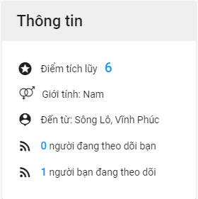

Figure 6-29: User profile

* System will display a popup with list of followings/followers

**6.2.11 User bookmarks posts and view bookmarked posts**

* On any page that display list of posts, click on bookmark icon at the top-right of post item.

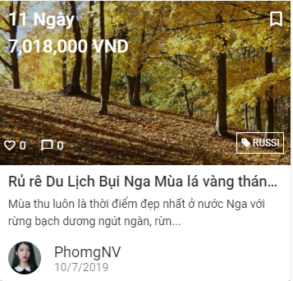

Figure 6-30: A post item

* Or on post detail page, click on bookmark icon at the left side of the page.

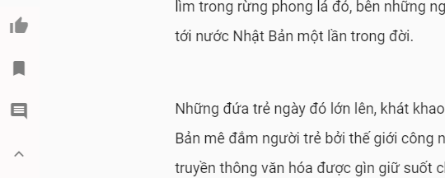

Figure 6-31: Post interaction in detail post page

**6.2.12 User blocks other users and views blocked users**

* On the personal page of the user he/she want to block, click on “…” at the right of user’s name.
* A list of options will be displayed. User click on “Chặn người dùng”

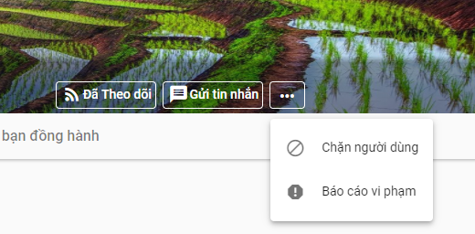

Figure 6-32: User options

* A popup will be appeared to notify block successfully.
* To view all blocked users. Go to personal page and click on “Danh sách chặn” at the left side of the page. A popup with list of blocked user will be displayed.

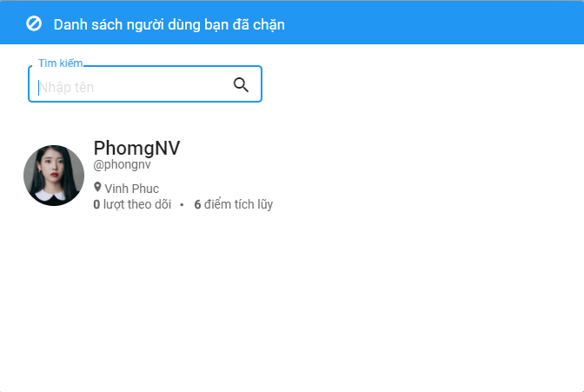

Figure 6-33: List blocked users