**Chapter 5: Software Testing Documentation**

**5.1 Introduction**

**5.1.1 Purpose**

This chapter’s primary goal is to create testing plans and execute the defects detection and prevention procedures, which may cause software malfunctioning. Another objective of this chapter is to provide details about the software quality and to ensure that the end result meets the business and user requirements.

**5.1.2 Scope of testing**

* **Stages of testing:**

There are 4 phases in the Testing Process: Unit testing, Integration testing, System testing and Acceptance testing.

|  |  |  |
| --- | --- | --- |
| **ID** | **Test Stages** | **Description** |
| 1 | Unit testing | Unit Tests are performed by developers to ensure that individual units of source code function as intended. Unit tests are primarily used to test complicated algorithms and automatically test important functions. |
| 2 | Integration testing | Integration Tests are performed by testers, this is a software testing method in which individual software modules are combined and tested as a group. We also know defects between the modules. After that, developer will fix the system suitably. |
| 3 | System testing | System Tests are performed by testers. In this test, tester will test of a complete, fully integrated software product and determine whether or not the system meets the requirements. |
| 4 | Acceptance testing | Testers create check list include some rules between team members and customers. If customers don’t have any requirements, we will build acceptance test base on the purpose of project |

* **Type of testing**

The following types of testing are performed:

* Functional testing
* User interface testing
* **Range of testing**

Team performs all functions defined in the SRS based on the approved version.

**5.2 Test plan**

**5.2.1 Testing tools and environment**

**5.2.1.1 Testing tools**

* **­Chrome Developer Tools: To view logs, inspect elements.**



Figure 5-1 Chrome Dev Tools

* **Trello and Backlog: manage bugs, to log bugs, resolve bugs and close bug**
* **Microsoft Excel: To manage test cases**



Figure 5-2 Microsoft Excel

* **Postman: A tool to test API endpoints and returned results.**



Figure 5-3 Postman

**5.2.1.2 Testing environment**

|  |  |  |
| --- | --- | --- |
| **Type of testing** | **Software** | **Hardware** |
| Unit test | Visual Studio | Personal computer for developing with the minimum configuration:  - Windows 10 Pro 64-bit.  - Intel® Core™ i5 5200 CPU.  - Installed memory (RAM): 8.00GB  - Visual Studio 2017 or 2019 |
| Integration Test | Google chrome | Personal computer for developing with the minimum configuration:  - Windows 10 Pro 64-bit.  - Intel® Core™ i5 5200 CPU.  - Installed memory (RAM): 8.00GB |
| System Test | Google chrome | Personal computer for developing with the minimum configuration:  - Windows 10 Pro 64-bit.  - Intel® Core™ i5 5200 CPU.  - Installed memory (RAM): 8.00GB |
| Acceptance Test | Google chrome | Personal computer for developing with the minimum configuration:  - Windows 10 Pro 64-bit.  - Intel® Core™ i5 5200 CPU.  - Installed memory (RAM): 8.00GB |

**5.2.2 Resources and responsibilities**

This table shows the staffing assumptions for the project.

|  |  |  |
| --- | --- | --- |
| **ID** | **Resources** | **Responsibilities** |
| 1 | Project Manager | * Responsible for Project Schedules and overall success of the project. * Review Test Plan and Test report. |
| 2 | Test Leader | * Manage Test resource and assign test tasks * Create Test Plan * Review Test case * Create Test report |
| 3 | Tester | * Preforming the actual system testing. * Create Test Cases. * Execute Test. * Report test result. * Log bugs |
| 4 | Developer | * Create and execute unit tests * Fix bugs. |

**5.2.3 Test strategy**

**5.2.3.1 Test model**

* TripSharing deploys a contemporary of traditional software development models is "V-Model":
* At V-model, corresponding to a test phase is a software development phase, testing in the V-model is done in parallel with the software development cycle.
* Each level of the development lifecycle is verified before moving on to the next level.
* This helps in identifying errors very early in the lifecycle and minimizes potential future defects appearing in the code later in the lifecycle.

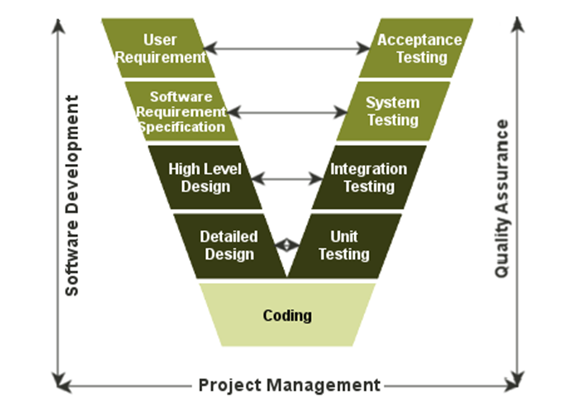

Figure 5-4 Architecture of V-Model

* + - 1. **Test types**

**5.2.3.2.1 Functional testing**

Functional testing is a formal type of testing performed by testers. Functional testing focuses on testing each function of the software application operates in conformance with the requirement specification.

* **Test Objective:**
  + Testing the main functions of an application
  + It involves basic usability testing of the system. It checks whether a user can freely navigate through the screens without any difficulties.
  + Checks the accessibility of the system for the user
  + Usage of testing techniques to check for error conditions. It checks whether suitable error messages are displayed.
* **Technique**
* Each and every functionality of the system is tested by providing appropriate input, verifying the output and comparing the actual results with the expected results.
* **Completion Criteria**
* All planned tests have been executed.
* All identified defects have been resolved and closed

**5.2.3.2.2 User interface testing**

User Interface testing is a testing technique used to identify the presence of defects is a product/software under test by using Graphical user interface [GUI].

* **Test Objective**
  + Ensure that the GUI provides the user with an appropriate access and navigation through the functions of the target-of-test.
  + GUI testing ensures that the objects within the GUI function as expected and conform to requirement.
* **Technique**
* GUI test will be performed fully on all screens
* Verification of the overall look and feel of the TripSharing system including initial position, text size, color, initial button, tab order, label, screen sizes and text font is readable.
* **Completion Criteria**
* Verifying that the application responds correctly to events such as clicking on the button.
* GUI testing would also confirm that appearance elements such as fonts and images conform to design specifications.

**5.2.3.3 Test schedule**

Table below is the Test Schedule for TripSharing Project

|  |  |  |
| --- | --- | --- |
| **Test Schedule** | **Start Date** | **End Date** |
| *Phase 1:* | 06/06/2019 | 20/07/2019 |
| Unit Testing | 10/06/2019 | 30/06/2019 |
| Integration Testing | 15/06/2019 | 10/07/2019 |
| System Testing | 17/06/2019 | 20/07/2019 |
| *Phase 2:* | 20/07/2019 | 25/08/2019 |
| Unit Testing | 23/07/2019 | 10/08/2019 |
| Integration Testing | 26/07/2019 | 15/08/2019 |
| System Testing | 28/07/2019 | 16/08/2019 |
| Acceptance Testing | 10/08/2019 | 20/08/2019 |

Table 5-1 Test schedule

**5.2.4 Features to be tested**

All features are listed in the use case list.

**5.2.5 Features not to be tested**

All features are listed in 1.5.1.3 above will not to be tested.

**5.3 Test Approach**

**5.3.1 Unit testing**

* Unit testing is a software testing method by which small units of source code are tested to determine whether they meet the requirements.
* Unit testing will be done by the developers and approved by the development team leader. The TripSharing development team embrace these features to gain the following advantages:
* Reduce the number of bugs in production code.
* Saving development time.
* Ensure the functions of the software are in accordance with customer requirements
* Identify errors very early in the development process and minimize potential future errors that may appear

**5.3.1.1 Unit testing framework**

* We use NUnit is a unit testing framework for .NET, it is the most used framework for writing unit test cases and JetBrains dotCover is a .NET unit test runner and code coverage tool.
* Mock function are simulated functions that mimic the behavior of real functions in controlled ways.
* Unit testing scripts are created manually and saved to ProjectName.Tests directory of TripSharing API services.

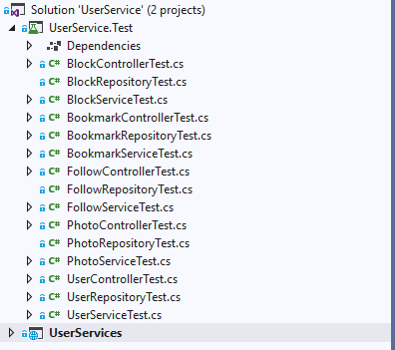

Figure 5-5 Test directory structure

* Unit tests focus on individual functions in a class and are created as in the picture.

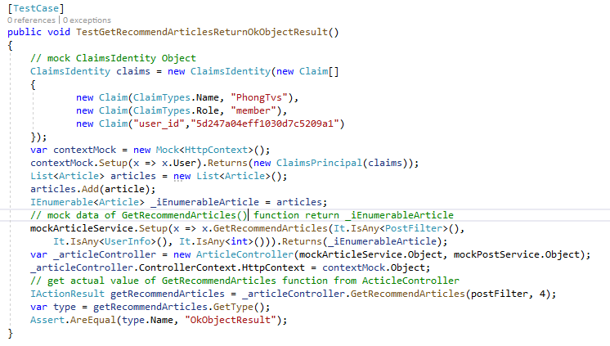

Figure 5-6: Unit test case sample

This factory function used to get recommend articles

* Coverage report:

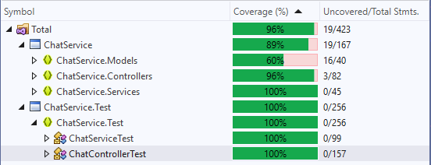

Figure 5-7: Unit test chat service coverage

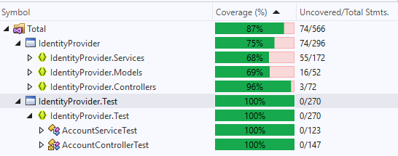

Figure 5-8 Unit test identity provider service coverage

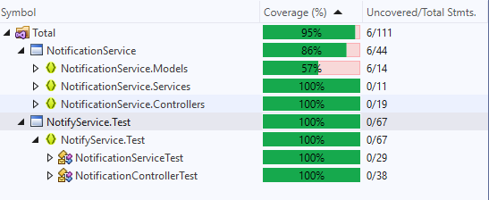

Figure 5-9 Unit test notification service coverage

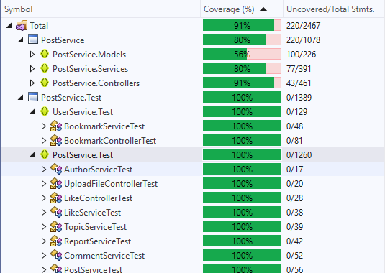

Figure 5-10 Unit test post service coverage

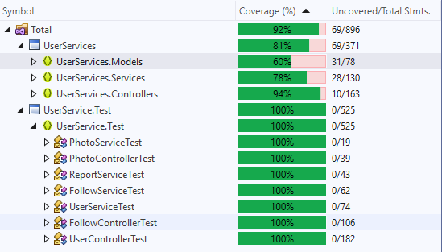

Figure 5-11 Unit test user service coverage

**5.3.2 Integration testing and System test**

* Integration testing is a software testing method in which individual software modules are combined and tested as a group.
* System testing is testing conducted on a complete integrated system to evaluate the system's compliance with its specified requirements.
* Detailed test cases will be described in TripSharing_TestCase_Final folder. As a standard definition, TripSharing defines that a test case is:
  + A set of test data and their expected results. A test case validates one or more system requirements and generates a result is pass or fail, from there can verify if the system works as expected or not.
  + A good test case should follow two basic aspects, the Contents and the Style. Test cases should be developed for each use case scenario
  + TripSharing Project System testing will not focus on common logic of system like length of text but focus on behavior of website and aims to validate that all software module dependencies are functionally correct, and the communications is maintained between separate modules.

**5.3.4 Acceptance Test**

Acceptance testing is a level of the software testing process where a system is tested for acceptability. The purpose of this test is to evaluate the system’s compliance with the business requirements and assess whether it is acceptable for delivery. But our project will use the checklist as a substitute for acceptance testing.

The content of the checklist is shown in the table below:

|  |  |  |  |
| --- | --- | --- | --- |
| **ID** | **Checklists** | **Yes** | **No** |
| **Functional** | | | |
| CL-001 | User can sign up a new account | ✓ |  |
| CL-002 | User can sign in to TripSharing.net by facebook account | ✓ |  |
| CL-003 | User can sign in to TripSharing.net by google account | ✓ |  |
| CL-004 | User can sign in to TripSharing.net by normal account | ✓ |  |
| CL-005 | User can change the new password for account | ✓ |  |
| CL-006 | User can reset the password | ✓ |  |
| CL-007 | User can update profile and update information | ✓ |  |
| CL-008 | User can choose more interested topics | ✓ |  |
| CL-009 | User can create a new article | ✓ |  |
| CL-010 | User can create a new virtual trip | ✓ |  |
| CL-011 | User can create a new finding companion post | ✓ |  |
| CL-012 | Users are allowed to delete their own posts | ✓ |  |
| CL-013 | Users are allowed to edit their own posts | ✓ |  |
| CL-014 | User can join to a companion group that other member created | ✓ |  |
| CL-015 | User can leave to a companion group that other member created | ✓ |  |
| CL-016 | User can share one or more posts from TripSharing.net to facebook application | ✓ |  |
| CL-017 | If a article violates the website's rules, user can report it to the administrator. | ✓ |  |
| CL-018 | If a comment violates the website's rules, users can report it to the administrator. | ✓ |  |
| CL-019 | If a member violates the website's rules, users can report them to the administrator. | ✓ |  |
| CL-020 | User can bookmark one or more posts and add them to the bookmarks list. | ✓ |  |
| CL-021 | User can view bookmarks list | ✓ |  |
| CL-022 | User can remove one or more posts from bookmarks list. | ✓ |  |
| CL-023 | User can add a new comment below the content of any post | ✓ |  |
| CL-024 | User can edit their own comments | ✓ |  |
| CL-025 | User can delete their own comments | ✓ |  |
| CL-026 | User can like any comment | ✓ |  |
| CL-027 | User can unlike any comment | ✓ |  |
| CL-028 | User can follow other member | ✓ |  |
| CL-029 | User can unfollow other member | ✓ |  |
| CL-030 | User can block one or more other members | ✓ |  |
| CL-031 | User can unblock one or more other members | ✓ |  |
| CL-032 | User can like one or more posts | ✓ |  |
| CL-033 | User can unlike one or more posts | ✓ |  |
| CL-034 | User can create a group chat | ✓ |  |
| CL-035 | User can remove a member from group chat | ✓ |  |
| CL-036 | User can send or receive messages and system will notify for user when they have new messages | ✓ |  |
| CL-037 | Administrator can add a new travel topic to topics list | ✓ |  |
| CL-038 | Administrator can remove one or more travel topic to topics list | ✓ |  |
| CL-039 | Administrator can edit a travel topic | ✓ |  |
| CL-040 | User can search 3 posts type: article, virtual trip and finding companion | ✓ |  |
| CL-041 | User can search a member from members list of system | ✓ |  |
| CL-042 | User can view recommended articles on home page | ✓ |  |
| CL-043 | User can view popular articles on home page | ✓ |  |
| CL-044 | User can view recently articles on home page | ✓ |  |
| CL-045 | User can view a post detail with category: article, virtual trip and finding companion | ✓ |  |
| CL-046 | User can view a other member’s profile | ✓ |  |
| CL-047 | User can view a other member's followings/followers number | ✓ |  |
| CL-048 | User can view a other member's created posts | ✓ |  |
| CL-049 | Administrator can view all user’s account | ✓ |  |
| CL-050 | Administrator can view all accounts that users reported | ✓ |  |
| CL-051 | Administrator can ban an account | ✓ |  |
| CL-052 | Administrator can unban an account |  |  |
| CL-053 | Administrator can view all posts reported by users | ✓ |  |
| CL-054 | Administrator can remove a post reported by users | ✓ |  |
| CL-055 | Administrator can restore a post that previously removed | ✓ |  |
| CL-056 | Administrator can view all comments that is reported by other members | ✓ |  |
| CL-057 | Administrator can remove a comment that is reported by other members | ✓ |  |
| CL-058 | Administrator can restore a comment that previously removed | ✓ |  |
| CL-059 | Administrator can view statistic of users | ✓ |  |
| CL-060 | Administrator can view statistic of posts | ✓ |  |
| CL-061 | Check application logout functionality. | ✓ |  |
| **GUI and Usability** | | | |
| CL-062 | All mandatory fields are validated. | ✓ |  |
| CL-063 | Validation error messages are displayed properly below the field. | ✓ |  |
| CL-064 | All error messages are displayed in red color. | ✓ |  |
| CL-065 | Delete functionality for any record on page are asked for confirmation. | ✓ |  |
| CL-066 | All like, comment number values are formatted properly. | ✓ |  |
| CL-067 | Application crash or unavailable pages are redirected to error page. | ✓ |  |
| CL-068 | The screen is well organized and easy to interact with. | ✓ |  |
| CL-069 | All fields on page (e.g. text box, radio options, dropdown lists) should be aligned properly. | ✓ |  |
| CL-070 | System display notification message when meet trouble, error. | ✓ |  |
| CL-071 | All images displayed on the website must be of good quality | ✓ |  |
| **Database** | | | |
| CL-072 | All data must saved in database when submit data successful. | ✓ |  |
| CL-073 | The id field in the data base is required, cannot be left blank. | ✓ |  |
| CL-074 | Field length shown to user on page and in database schema should be same. | ✓ |  |
| CL-075 | Database fields are designed with correct data type and data length. | ✓ |  |
| CL-076 | The relationship between the tables must be clear and true to the customer's requirements | ✓ |  |

**5.3.5 Defect Log**

* Trip Sharing project used http://www.trello.com in phase 1 and http://www.backlog.com in phase 2 to manager tasks and defects.
* Every member of TripSharing project creates an account backlog and trello to take part in activities: control bugs, fix bugs, re-test bugs and close bug. Bug will be log by tester or developer in develop progress.

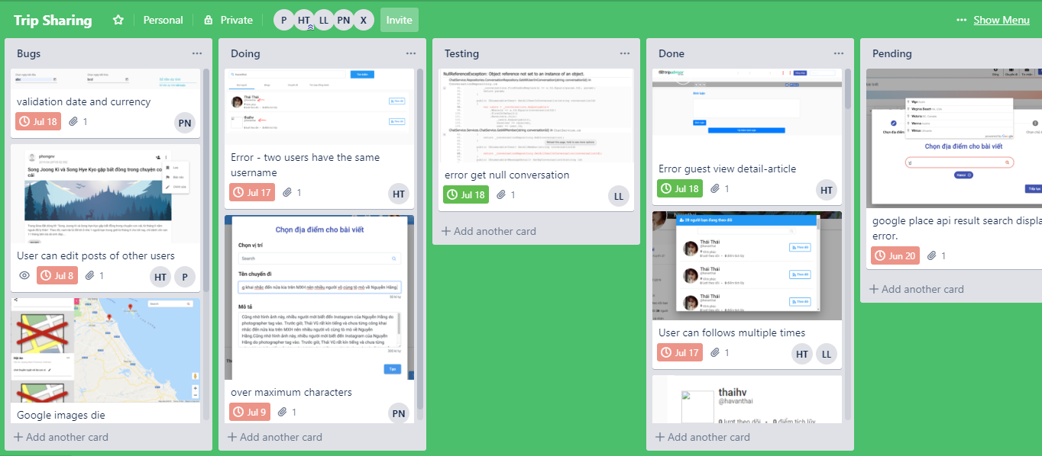

Figure 5-12 Control task and bug with Trello

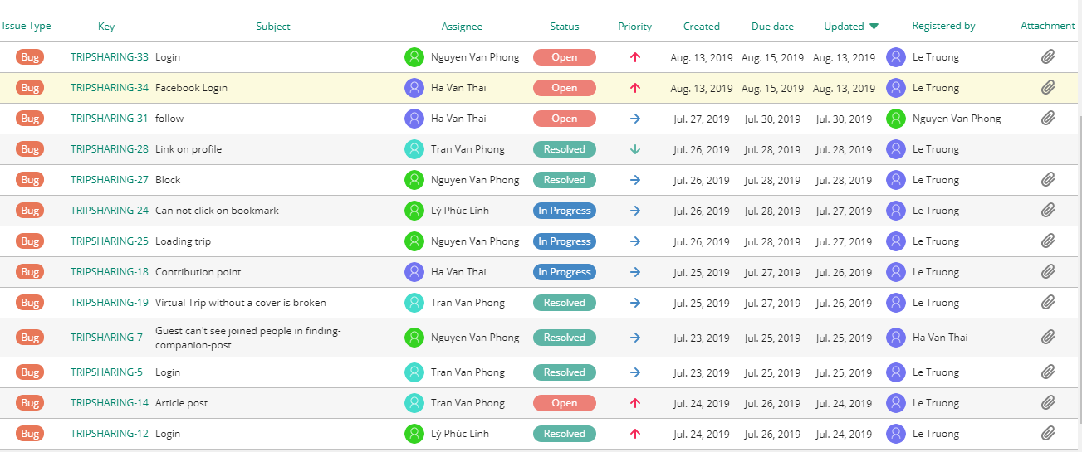

Figure 5-13 Control task and bug with Backlog

**5.4 Test Report**

**5.4.1 Unit test report**

The contents of the Unit Test Case Report are shown in the table below:

|  |  |  |  |  |  |
| --- | --- | --- | --- | --- | --- |
| **Service Name** | **Controller/Service Name** | **Pass** | **Fail** | **Not available** | **Number of Test Case** |
| Chat Service | Chat Controller | 15 | 0 | 0 | 15 |
| Chat Service | 10 | 0 | 0 | 10 |
| **Total** | **25** | **0** | **0** | **25** |
| Identity Provider | Account Controller | 16 | 0 | 0 | 16 |
| Account Service | 15 | 0 | 0 | 15 |
| **Total** | **31** | **0** | **0** | **31** |
| Notification Service | Notification Controller | 2 | 0 | 0 | 2 |
| Notification Service | 2 | 0 | 0 | 2 |
| **Total** | **4** | **0** | **0** | **4** |
| Post Service | Article Controller | 11 | 0 | 0 | 11 |
| Article Service | 8 | 0 | 0 | 8 |
| Author Service | 2 | 0 | 0 | 2 |
| Bookmark Controller | 6 | 0 | 0 | 6 |
| Bookmark Service | 5 | 0 | 0 | 5 |
| Comment Controller | 5 | 0 | 0 | 5 |
| Commnet Service | 5 | 0 | 0 | 5 |
| Companion Controller | 13 | 0 | 0 | 13 |
| Companion Post Service | 15 | 0 | 0 | 15 |
| Like Controller | 2 | 0 | 0 | 2 |
| Like Service | 4 | 0 | 0 | 4 |
| Post Controller | 6 | 0 | 0 | 6 |
| Post Service | 6 | 0 | 0 | 6 |
| Report Controller | 6 | 0 | 0 | 6 |
| Report Service | 5 | 0 | 0 | 5 |
| Topic Controller | 8 | 0 | 0 | 8 |
| Topic Service | 5 | 0 | 0 | 5 |
| Upload File Controller | 2 | 0 | 0 | 2 |
| Upload File Service | 1 | 0 | 0 | 1 |
| Virtual Trip Controller | 7 | 0 | 0 | 7 |
| Virtual Trip Service | 7 | 0 | 0 | 7 |
| **Total** | **133** | 0 | 0 | **133** |
| Follow Controller | 10 | 0 | 0 | 10 |
| Follow Service | 7 | 0 | 0 | 7 |
| Photo Controller | 3 | 0 | 0 | 3 |
| Photo Service | 2 | 0 | 0 | 2 |
| Report Service | 5 | 0 | 0 | 5 |
| User Controller | 19 | 0 | 0 | 19 |
| User Service | 10 | 0 | 0 | 10 |
| **Total** | **56** | 0 | 0 | **56** |
| Email Service | Email Service | 0 | 0 | 0 | 0 |
| **Total** | **0** | **0** | **0** | **0** |
| **Total of Test Case** | | **249** | **0** | **0** | **249** |

Table 5-2: Unit test case report

|  |  |  |  |  |  |
| --- | --- | --- | --- | --- | --- |
| **Service Name** | **Testcase number** | | | | **Final** |
| **Phase 1** | | **Phase 2** | |
| **Pass** | **Fail** | **Pass** | **Fail** |
| Chat Service | 25 | 0 | 25 | 0 | 25 |
| Identity Provider | 31 | 0 | 31 | 0 | 31 |
| Notify Service | 4 | 0 | 4 | 0 | 4 |
| Post Service | 113 | 0 | 133 | 0 | 133 |
| User Service | 42 | 0 | 56 | 0 | 56 |
| Email Service | 0 | 0 | 0 | 0 | 0 |
| **Total of test cases** | **215** | **0** | **249** | **0** | **249** |

Table 5-3: Unit test report

|  |  |  |
| --- | --- | --- |
| **Service Name** | **Coverage** | |
| **Phase 1** | **Phase 2** |
| Chat Service | 89% | 89% |
| Identity Provider | 75% | 75% |
| Notify Service | 86% | 86% |
| Post Service | 77% | 80% |
| User Service | 78% | 81% |
| Email Service | 0% | 0% |
| **Overall** |  |  |

Table 5-4: Unit test coverage report

|  |  |
| --- | --- |
|  | **Overall Coverage** |
| **Phase 1** |  |
| **Phase 2** |  |

Table 5-5: Unit test overall coverage report

**5.4.2 Integration test report**

|  |  |  |  |  |
| --- | --- | --- | --- | --- |
| **Module code** | **Pass** | **Fail** | **Not available** | **Number of test case** |
| Sign Up | 17 | 0 | 0 | 17 |
| Sign In | 14 | 0 | 0 | 14 |
| Forgot password | 6 | 0 | 0 | 6 |
| Sign Out | 2 | 0 | 0 | 2 |
| Change Password | 16 | 0 | 0 | 16 |
| Update Profile | 14 | 0 | 0 | 14 |
| Choose Interested Topic | 14 | 0 | 0 | 14 |
| View user's profile | 2 | 0 | 0 | 2 |
| Create a post | 60 | 0 | 0 | 60 |
| Edit a post | 59 | 0 | 0 | 59 |
| Like Unlike a post | 7 | 0 | 0 | 7 |
| Delete a post | 11 | 0 | 0 | 11 |
| Comment to a post | 6 | 0 | 0 | 6 |
| Edit a comment | 5 | 0 | 0 | 5 |
| Delete a comment | 5 | 0 | 0 | 5 |
| Like Unlike a comment | 8 | 0 | 0 | 8 |
| View a post detail | 14 | 0 | 0 | 14 |
| Bookmark a post | 6 | 0 | 0 | 6 |
| View all bookmarks | 2 | 0 | 0 | 2 |
| Remove a bookmark | 7 | 0 | 0 | 7 |
| Follow Unfollow an user | 13 | 0 | 0 | 13 |
| ViewPost | 6 | 0 | 0 | 6 |
| View user's follower following | 3 | 0 | 0 | 3 |
| View user's created posts | 6 | 0 | 0 | 6 |
| TravelTopic | 14 | 0 | 0 | 14 |
| Search | 11 | 0 | 0 | 11 |
| Join Leave to a companion group | 5 | 0 | 0 | 5 |
| Share a post | 4 | 0 | 0 | 4 |
| Send receive messages | 9 | 0 | 0 | 9 |
| View all users' account | 3 | 0 | 0 | 3 |
| View Statistic | 5 | 0 | 0 | 5 |
| View Reported | 3 | 0 | 0 | 3 |
| Reported | 17 | 0 | 0 | 17 |
| Ban an user | 4 | 0 | 0 | 4 |
| Unban an user | 4 | 0 | 0 | 4 |
| Remove a reported post | 4 | 0 | 0 | 4 |
| Restore a removed post | 4 | 0 | 0 | 4 |
| Remove a reported comment | 4 | 0 | 0 | 4 |
| Restore a removed comment | 4 | 0 | 0 | 4 |
| **Total of Test Case** | **398** | **0** | **0** | **398** |

Table 5-6 Integration test case report

|  |  |  |  |  |  |
| --- | --- | --- | --- | --- | --- |
| **Integration test** | **Phase 1** | | **Phase 2** | | **Final** |
| **Pass** | **Fail** | **Pass** | **Fail** |
| **Total of test case** | 346 | 0 | 52 | 0 | 398 |

Table 5-7 Integration test report

**5.4.3 System test report**

The contents of the System Test Case Report are shown in the table below:

|  |  |  |  |  |
| --- | --- | --- | --- | --- |
| **Module code** | **Pass** | **Fail** | **Not available** | **Number of test case** |
| Guest | 10 | 0 | 0 | 10 |
| Member | 74 | 0 | 0 | 74 |
| User | 15 | 0 | 0 | 15 |
| Admin | 6 | 0 | 0 | 6 |
| **Total of Test Case** | **105** | **0** | **0** | **105** |

Table 5-8 System test case report

We execute test with 2 stages with 2 phases of process model, to finish project.

The contents of the Test Report are shown in the table below:

|  |  |  |  |  |  |
| --- | --- | --- | --- | --- | --- |
| **Service Name** | **Testcase number** | | | | **Final** |
| **Phase 1** | | **Phase 2** | |
| **Pass** | **Fail** | **Pass** | **Fail** |
| Guest | 10 | 0 | 0 | 0 | 10 |
| Member | 74 | 0 | 0 | 0 | 74 |
| User | 15 | 0 | 0 | 0 | 15 |
| Admin | 0 | 0 | 6 | 0 | 6 |
| **Total of test cases** | 99 | **0** | 6 | **0** | 105 |

Table 5-9 System test report