**4.1 Remove a reported post**

**Screen Design**

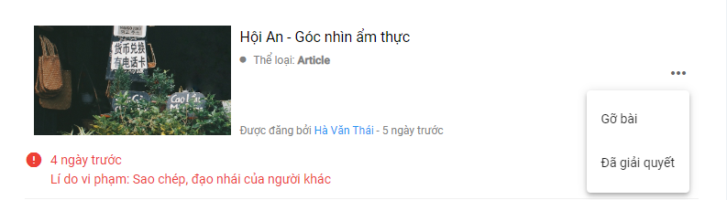

Figure 4: Remove a reported post screen design

**Class Diagram**

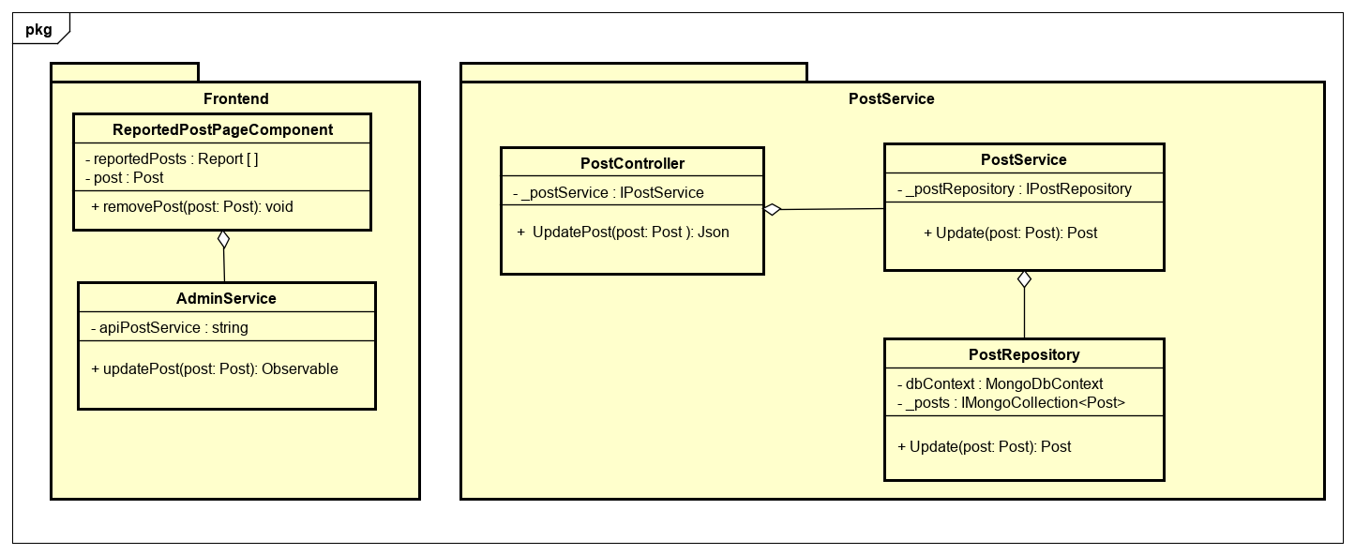

Figure 4: Administrator removes a reported post class diagram

**Class Specification**

**ReportedPostPageComponent**

|  |  |  |  |
| --- | --- | --- | --- |
| **ReportedPostPageComponent** | | | |
| Physical address | src/app/admin/pages/dashboard-page/components/reported-post-page/reported-post-page.component.ts | | |
| Base class | Class | | |
| **Attributes** | | | |
| No | Name | Type | Description |
| 1 | reportedPosts | Report [ ] | A object reports array |
| 2 | post | Post | A object post |
| **Operation** | | | |
| No | Name | Return Type | Description |
| 1 | removePost | void | Function remove a post |

**AdminService**

|  |  |  |  |
| --- | --- | --- | --- |
| **AdminService** | | | |
| Physical address | src/app/admin/services/admin-service/admin.service | | |
| Base class | Class | | |
| **Attributes** | | | |
| No | Name | Type | Description |
| 1 | apiPostService | string | Url api call post service |
| **Operation** | | | |
| No | Name | Retun Type | Description |
| 1 | updatePost | Observable | Function update a post |

**PostController**

|  |  |  |  |
| --- | --- | --- | --- |
| **PostController** | | | |
| Physical address | src/Services/PostService/PostService/Controllers/PostController.cs | | |
| Base class | ControllerBase | | |
| **Attributes** | | | |
| No | Name | Type | Description |
| 1 | _postService | IPostService |  |
| **Operation** | | | |
| No | Name | Retun Type | Description |
| 1 | UpdatePost | Json | Update a post return object json |

**PostService**

|  |  |  |  |
| --- | --- | --- | --- |
| **PostService** | | | |
| Physical address | src/Services/PostService/PostService/Service/PostService.cs | | |
| Base class | IPostService | | |
| **Attributes** | | | |
| No | Name | Type | Description |
| 1 | _postRepository | IPostRepository |  |
| **Operation** | | | |
| No | Name | Retun Type | Description |
| 1 | Update | Post | Update a post return post object |

**PostReposiory**

|  |  |  |  |
| --- | --- | --- | --- |
| **PostRepository** | | | |
| Physical address | src/Services/PostService/PostService/Repository/PostRepository.cs | | |
| Base class | IPostRepository | | |
| **Attributes** | | | |
| No | Name | Type | Description |
| 1 | dbContext | MongoDbContext |  |
| 2 | _posts | ImongoCollection  <Post> |  |
| **Operation** | | | |
| No | Name | Retun Type | Description |
| 1 | Update | Post | Update a post return post object |

**Sequence Diagram**

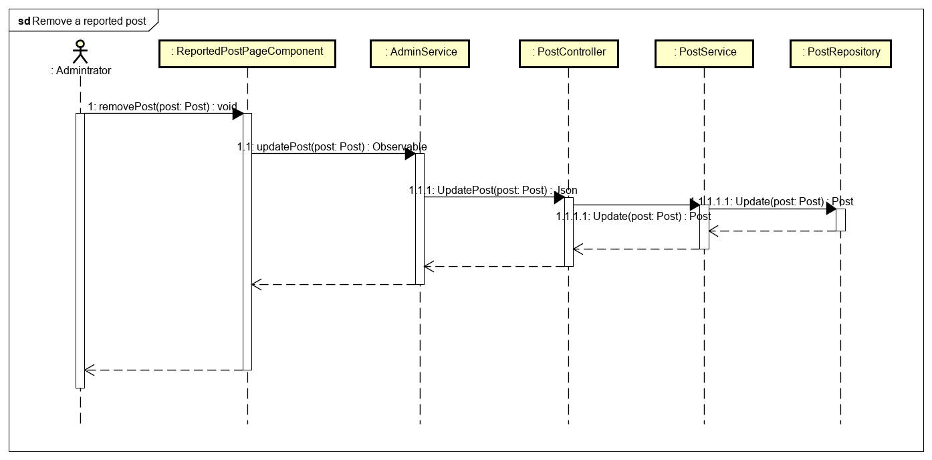

Figure 4: Administrator remove a reported post sequence diagram

**4.2 Restore a removed post**

**Screen Design**

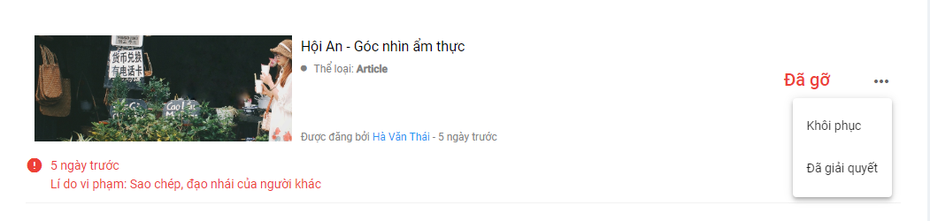

Figure 4: Restore a removed post screen design

**Class Diagram**

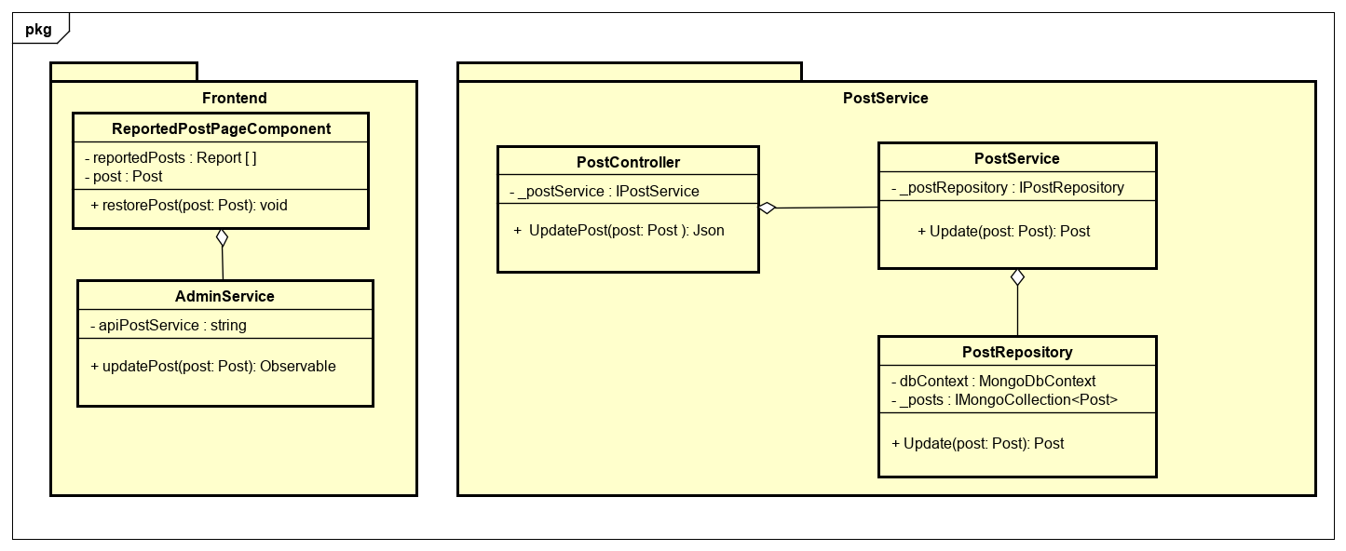

Figure 4: Administrator restore a removed post class diagram

**Class Specification**

**ReportedPostPageComponent**

|  |  |  |  |
| --- | --- | --- | --- |
| **ReportedPostPageComponent** | | | |
| Physical address | src/app/admin/pages/dashboard-page/components/reported-post-page/reported-post-page.component.ts | | |
| Base class | Class | | |
| **Attributes** | | | |
| No | Name | Type | Description |
| 1 | reportedPosts | Report [ ] | A object reports array |
| 2 | post | Post | A object post |
| **Operation** | | | |
| No | Name | Return Type | Description |
| 1 | restorePost | void | Function restore a removed post |

**AdminService**

|  |  |  |  |
| --- | --- | --- | --- |
| **AdminService** | | | |
| Physical address | src/app/admin/services/admin-service/admin.service | | |
| Base class | Class | | |
| **Attributes** | | | |
| No | Name | Type | Description |
| 1 | apiPostService | string | Url api call post service |
| **Operation** | | | |
| No | Name | Retun Type | Description |
| 1 | updatePost | Observable | Function update a post |

**PostController**

|  |  |  |  |
| --- | --- | --- | --- |
| **PostController** | | | |
| Physical address | src/Services/PostService/PostService/Controllers/PostController.cs | | |
| Base class | ControllerBase | | |
| **Attributes** | | | |
| No | Name | Type | Description |
| 1 | _postService | IPostService |  |
| **Operation** | | | |
| No | Name | Retun Type | Description |
| 1 | UpdatePost | Json | Update a post return object json |

**PostService**

|  |  |  |  |
| --- | --- | --- | --- |
| **PostService** | | | |
| Physical address | src/Services/PostService/PostService/Service/PostService.cs | | |
| Base class | IPostService | | |
| **Attributes** | | | |
| No | Name | Type | Description |
| 1 | _postRepository | IPostRepository |  |
| **Operation** | | | |
| No | Name | Retun Type | Description |
| 1 | Update | Post | Update a post return a post object |

**PostReposiory**

|  |  |  |  |
| --- | --- | --- | --- |
| **PostRepository** | | | |
| Physical address | src/Services/PostService/PostService/Repository/PostRepository.cs | | |
| Base class | IPostRepository | | |
| **Attributes** | | | |
| No | Name | Type | Description |
| 1 | dbContext | MongoDbContext |  |
| 2 | _posts | ImongoCollection  <Post> |  |
| **Operation** | | | |
| No | Name | Retun Type | Description |
| 1 | Update | Post | Update a post return a post object |

**Sequence Diagram**

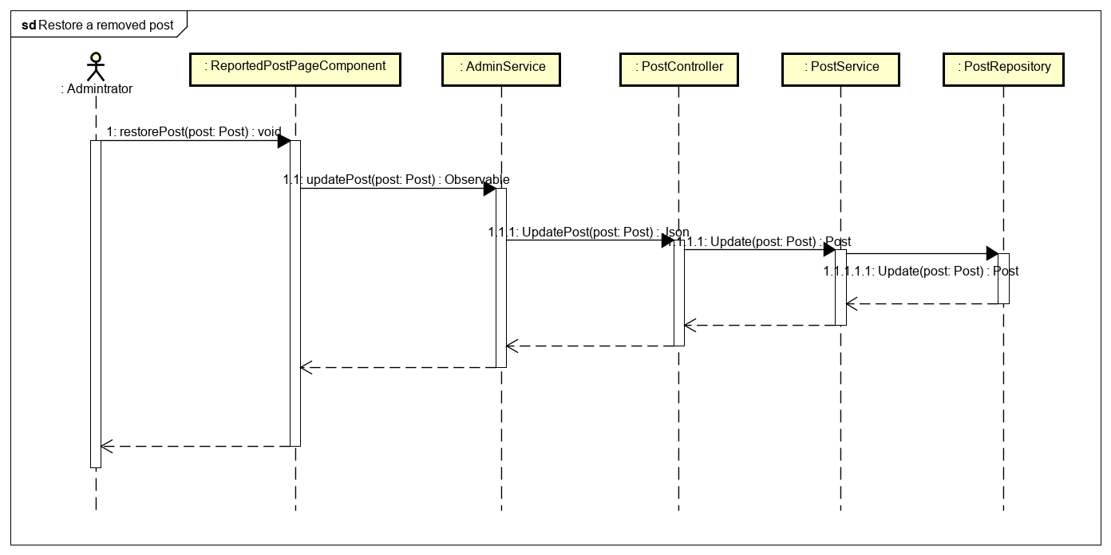

Figure 4: Administrator restore a removed post sequence diagram

**4.3 View reported comments**

**Screen Design**



Figure 4: View reported comments screen design

**Class Diagram**

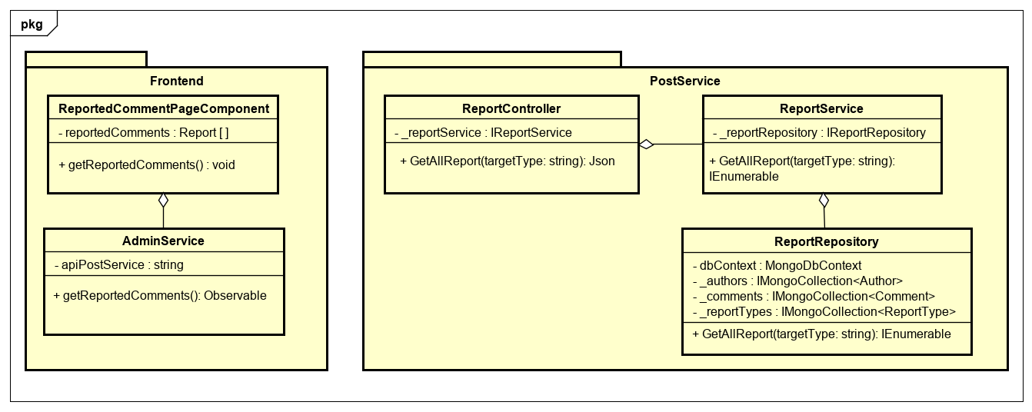Figure 4: Administrator view reported comment class diagram

**Class Specification**

**ReportedCommentPageComponent**

|  |  |  |  |
| --- | --- | --- | --- |
| **ReportedCommentPageComponent** | | | |
| Physical address | src/app/admin/pages/dashboard-page/components/reported-comment-page/reported-comment-page.component.ts | | |
| Base class | Class | | |
| **Attributes** | | | |
| No | Name | Type | Description |
| 1 | reportedComments | Report [ ] | A report object array |
| **Operation** | | | |
| No | Name | Return Type | Description |
| 1 | getReportedComments | void | Function get reported comments |

**AdminService**

|  |  |  |  |
| --- | --- | --- | --- |
| **AdminService** | | | |
| Physical address | src/app/admin/services/admin-service/admin.service | | |
| Base class | Class | | |
| **Attributes** | | | |
| No | Name | Type | Description |
| 1 | apiPostService | String | Url api call post service |
| **Operation** | | | |
| No | Name | Type | Description |
| 1 | getReportedComments | Observable | Get list reported comments |

**ReportController**

|  |  |  |  |
| --- | --- | --- | --- |
| **ReportController** | | | |
| Physical address | src/Services/PostService/PostService/Controllers/ReportController.cs | | |
| Base class | ControllerBase | | |
| **Attributes** | | | |
| No | Name | Type | Description |
| 1 | _reportService | IReportService |  |
| **Operation** | | | |
| No | Name | Return Type | Description |
| 1 | GetAllReport | Json |  |

**ReportService**

|  |  |  |  |
| --- | --- | --- | --- |
| **ReportService** | | | |
| Physical address | src/Services/PostService/PostService/Service/ReportService.cs | | |
| Base class | IReportedService | | |
| **Attributes** | | | |
| No | Name | Type | Description |
| 1 |  |  |  |
| **Operation** | | | |
| No | Name | Return Type | Description |
| 1 | GetAllReport | IEnumerable |  |

**ReportRepository**

|  |  |  |  |
| --- | --- | --- | --- |
| **ReportRepository** | | | |
| Physical address | src/Services/PostService/PostService/Repository/ReportRepository.cs | | |
| Base class | IReportRepository | | |
| **Attributes** | | | |
| No | Name | Type | Description |
| 1 | dbContext | MongoDbContext |  |
| 2 | _authors | ImongoCollection  <Author> |  |
| 3 | _comments | ImongoCollection  <Comment> |  |
| 4 | _reportTypes | ImongoCollection  <ReportType> |  |
| **Operation** | | | |
| No | Name | Return Type | Description |
| 1 | GetAllReport | IEnumerable |  |

**Sequence Diagram**

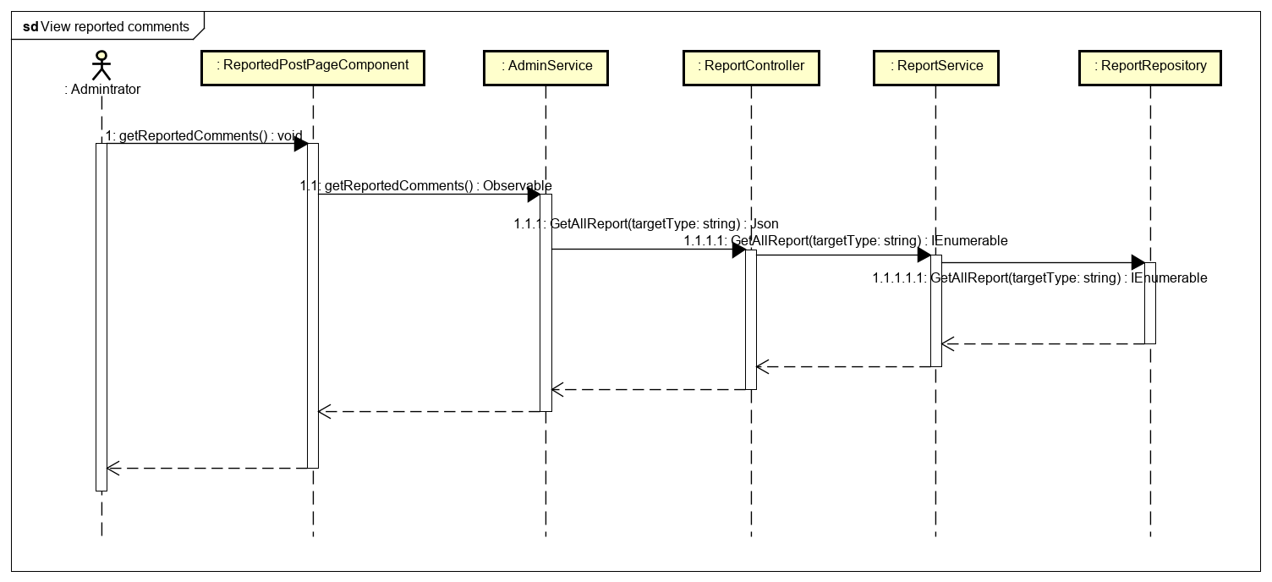

Figure 4: Administrator view reported comment sequence diagram

**4.4 Remove a reported comment**

**Screen Design**

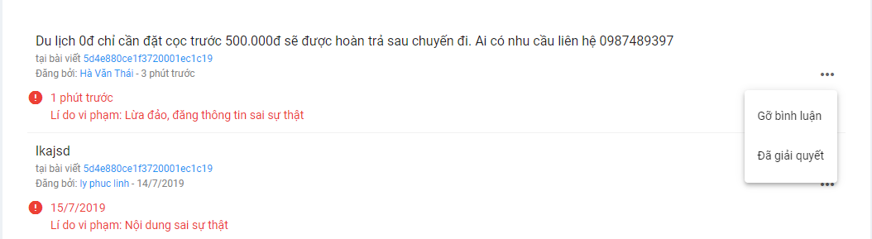

Figure 4: Remove a reported comment screen design

**Class Diagram**

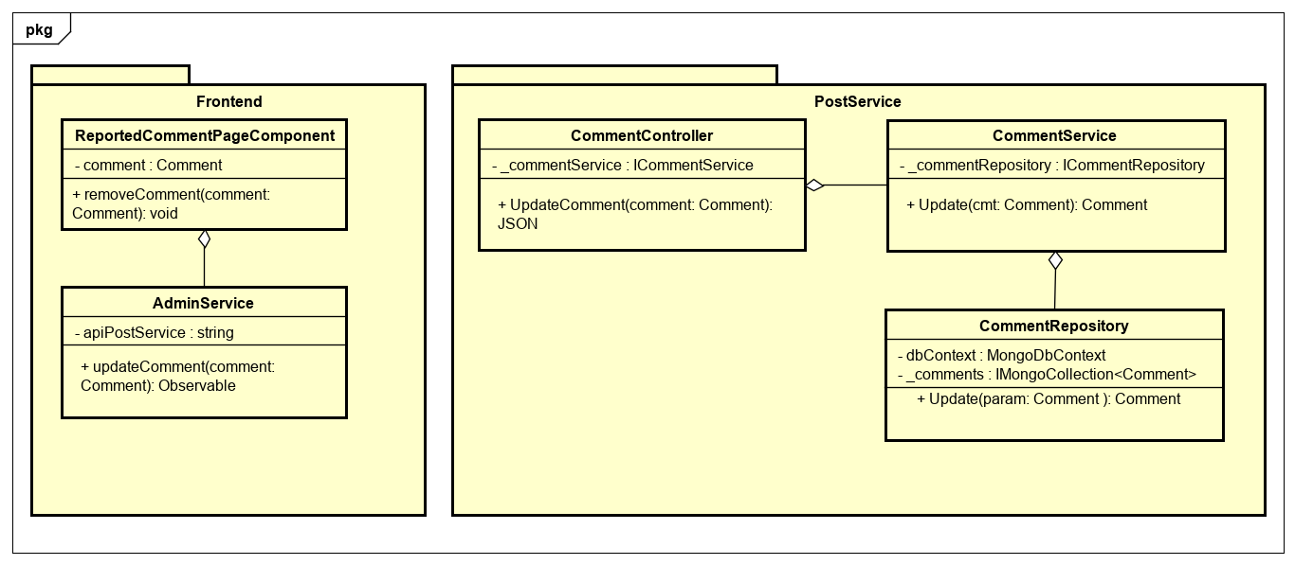

Figure 4: Administrator remove a reported comment class diagram

**Class Specification**

**ReportedCommentPageComponent**

|  |  |  |  |
| --- | --- | --- | --- |
| **ReportedCommentPageComponent** | | | |
| Physical address | src/app/admin/pages/dashboard-page/components/reported-comment-page/reported-comment-page.component.ts | | |
| Base class | Class | | |
| **Attributes** | | | |
| No | Name | Type | Description |
| 1 | Comment | Comment |  |
| **Operation** | | | |
| No | Name | Type | Description |
| 1 | removeComment | void |  |

**AdminService**

|  |  |  |  |
| --- | --- | --- | --- |
| **AdminService** | | | |
| Physical address | ./ src/app/admin/services/admin-service/admin.service | | |
| Base class | Class | | |
| **Attributes** | | | |
| No | Name | Type | Description |
| 1 | apiPostService | String |  |
| **Operation** | | | |
| No | Name | Return Type | Description |
| 1 | updateComment | Observable |  |

**CommentController**

|  |  |  |  |
| --- | --- | --- | --- |
| **CommentController** | | | |
| Physical address | src/Services/PostService/PostService/Controllers/CommentController.cs | | |
| Base class | ControllerBase | | |
| **Attributes** | | | |
| No | Name | Type | Description |
| 1 | _commentService | ICommentService |  |
| **Operation** | | | |
| No | Name | Type | Description |
| 1 | UpdateComment | Json |  |

**CommentService**

|  |  |  |  |
| --- | --- | --- | --- |
| **CommentService** | | | |
| Physical address | src/Services/PostService/PostService/Service/CommentService.cs | | |
| Base class | ICommentService | | |
| **Attributes** | | | |
| No | Name | Type | Description |
| 1 | _commentRepository | ICommentRepository |  |
| **Operation** | | | |
| No | Name | Type | Description |
| 1 | Update | Comment |  |

**CommentRepository**

|  |  |  |  |
| --- | --- | --- | --- |
| **CommentRepository** | | | |
| Physical address | src/Services/PostService/PostService/Repository/CommentRepository.cs | | |
| Base class | ICommentRepository | | |
| **Attributes** | | | |
| No | Name | Type | Description |
| 1 | dbContext | MongoDbContext |  |
| 2 | _comments | ImongoCollection  <Comment> |  |
| **Operation** | | | |
| No | Name | Type | Description |
| 1 | Update | Comment |  |

**Sequence Diagram**

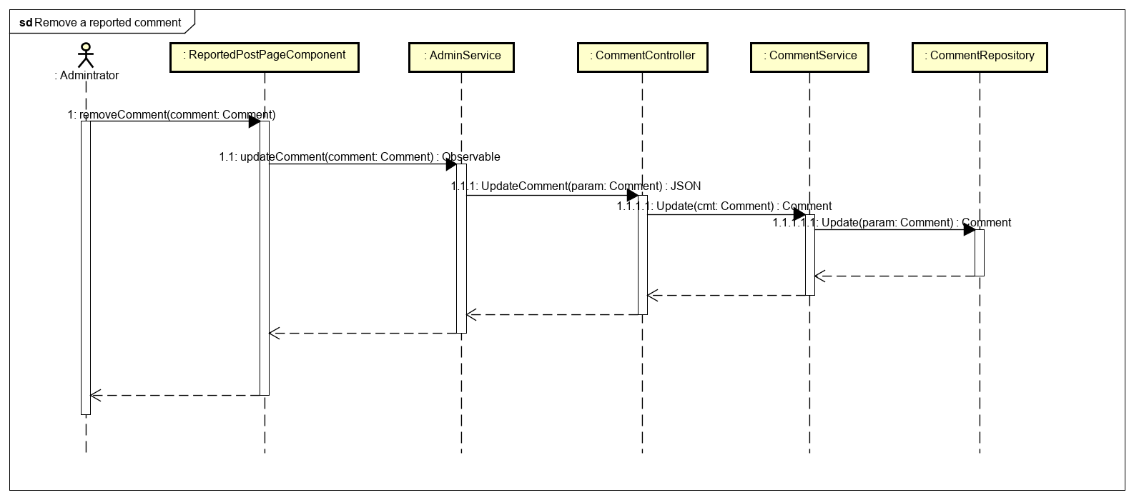

Figure 4: Administrator remove a reported comment sequence diagram

**4.5 Restore a removed comment**

**Screen Design**

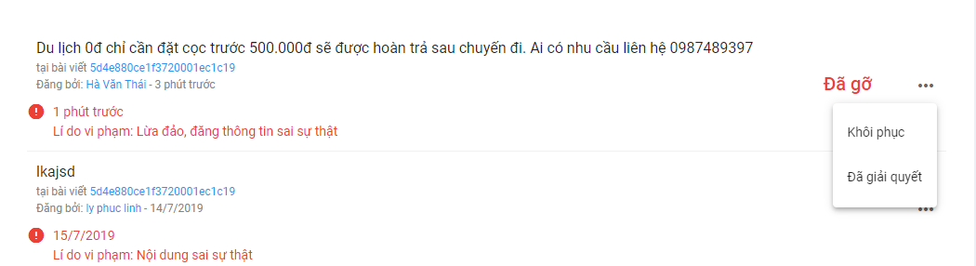

Figure 4: Restore a removed comment screen design

**Class Diagram**

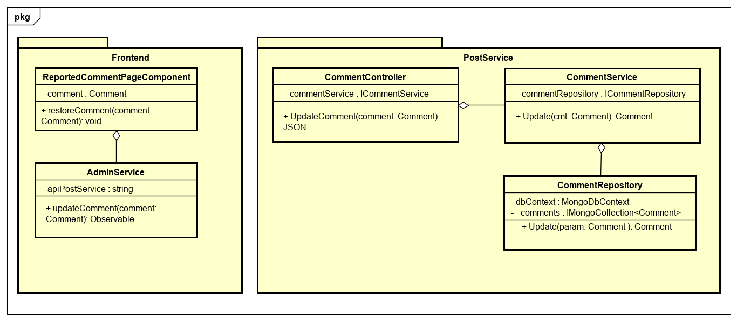

Figure 4: Administrator restore a removed comment class diagram

**Class Specification**

**ReportedCommentPageComponent**

|  |  |  |  |
| --- | --- | --- | --- |
| **ReportedCommentPageComponent** | | | |
| Physical address | src/app/admin/pages/dashboard-page/components/reported-comment-page/reported-comment-page.component.ts | | |
| Base class | Class | | |
| **Attributes** | | | |
| No | Name | Type | Description |
| 1 | comment | Comment |  |
| **Operation** | | | |
| No | Name | Type | Description |
| 1 | restoreComment | void |  |

**AdminService**

|  |  |  |  |
| --- | --- | --- | --- |
| **AdminService** | | | |
| Physical address | src/app/admin/services/admin-service/admin.service | | |
| Base class | Class | | |
| **Attributes** | | | |
| No | Name | Type | Description |
| 1 | apiPostService | String |  |
| **Operation** | | | |
| No | Name | Return Type | Description |
| 1 | updateComment | Observable |  |

**CommentController**

|  |  |  |  |
| --- | --- | --- | --- |
| **CommentController** | | | |
| Physical address | src/Services/PostService/PostService/Controllers/CommentController.cs | | |
| Base class | ControllerBase | | |
| **Attributes** | | | |
| No | Name | Type | Description |
| 1 | _commentService | ICommentService |  |
| **Operation** | | | |
| No | Name | Type | Description |
| 1 | UpdateComment | Json |  |

**CommentService**

|  |  |  |  |
| --- | --- | --- | --- |
| **CommentService** | | | |
| Physical address | src/Services/PostService/PostService/Service/CommentService.cs | | |
| Base class | ICommentService | | |
| **Attributes** | | | |
| No | Name | Type | Description |
| 1 | _commentRepository | ICommentRepository |  |
| **Operation** | | | |
| No | Name | Type | Description |
| 1 | Update | Comment |  |

**CommentRepository**

|  |  |  |  |
| --- | --- | --- | --- |
| **CommentRepository** | | | |
| Physical address | src/Services/PostService/PostService/Repository/CommentRepository.cs | | |
| Base class | ICommentRepository | | |
| **Attributes** | | | |
| No | Name | Type | Description |
| 1 | dbContext | MongoDbContext |  |
| 2 | _comments | ImongoCollection  <Comment> |  |
| **Operation** | | | |
| No | Name | Type | Description |
| 1 | Update | Comment |  |

**1Sequence Diagram**

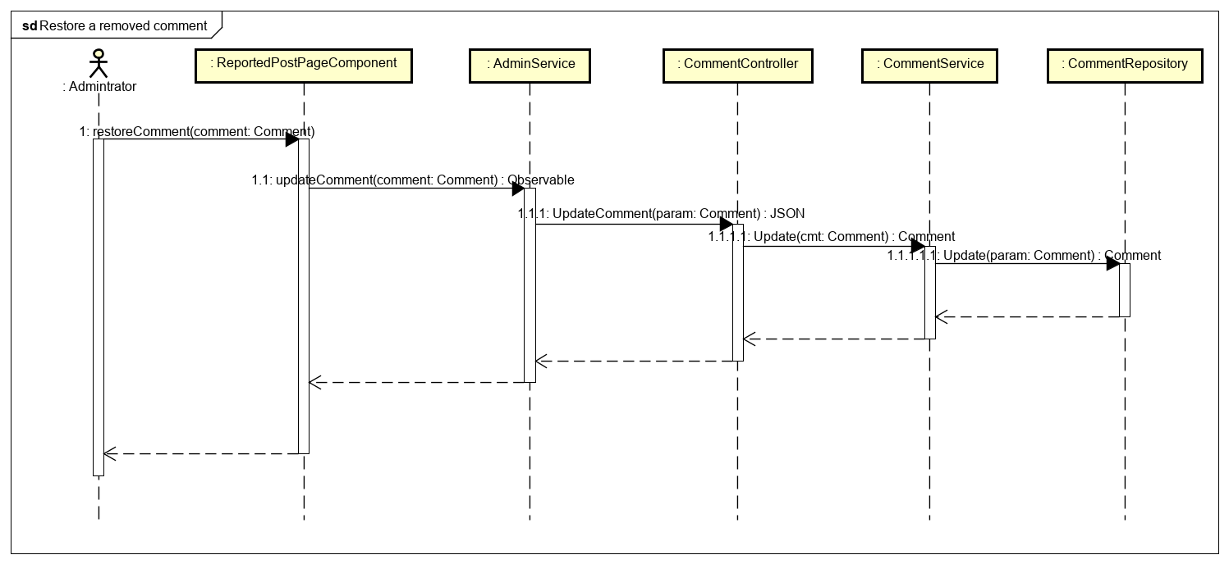

Figure 4: Administrator restore a removed comment sequence diagram

**4.6 Add a travel topic**

**Screen Design**

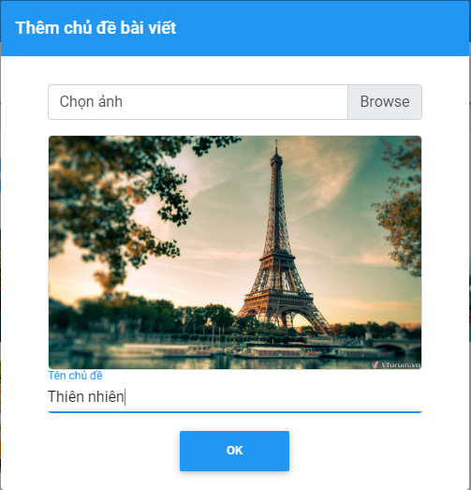

Figure 4: Add a travel topic screen design

**Class Diagram**

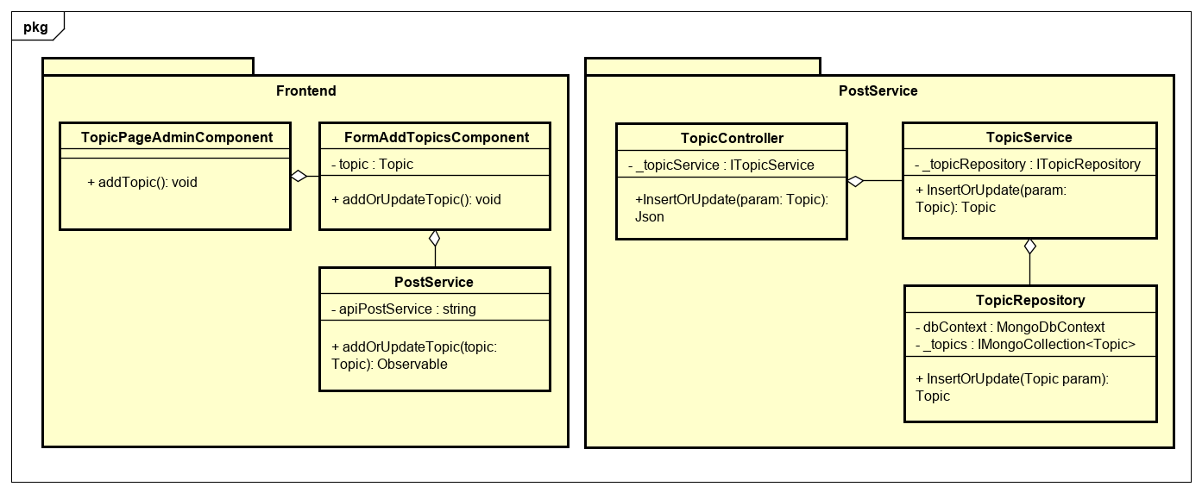

Figure 4: Administrator add a travel topic class diagram

**Class Specification**

**TopicPageAdminComponent**

|  |  |  |  |
| --- | --- | --- | --- |
| **TopicPageAdminComponent** | | | |
| Physical address | src/app/admin/pages/dashboard-page/components/topic-page-admin/topic-page-admin.component.ts | | |
| Base class | Class | | |
| **Attributes** | | | |
| No | Name | Type | Description |
|  |  |  |  |
| **Operation** | | | |
| No | Name | Type | Description |
| 1 | addTopic | void |  |

**FormAddTopicsComponent**

|  |  |  |  |
| --- | --- | --- | --- |
| **FormAddTopicsComponent** | | | |
| Physical address | src/app/admin/pages/dashboard-page/components/topic-page-admin/form-add-topics/form-add-topics.component.ts | | |
| Base class | Class | | |
| **Attributes** | | | |
| No | Name | Type | Description |
| 1 | topic | Topic |  |
| **Operation** | | | |
| No | Name | Type | Description |
| 1 | addOrUpdateTopic | void |  |

**PostService**

|  |  |  |  |
| --- | --- | --- | --- |
| **PostService** | | | |
| Physical address | src/app/core/services/post-service/post.service.ts | | |
| Base class | Class | | |
| **Attributes** | | | |
| No | Name | Type | Description |
| 1 | apiPostService | String |  |
| **Operation** | | | |
| No | Name | Return Type | Description |
| 1 | addOrUpdateTopic | Observable |  |

**TopicController**

|  |  |  |  |
| --- | --- | --- | --- |
| **TopicController** | | | |
| Physical address | src/Services/PostService/PostService/Controllers/TopicController.cs | | |
| Base class | ControllerBase | | |
| **Attributes** | | | |
| No | Name | Type | Description |
| 1 | _topicService | ITopicService |  |
| **Operation** | | | |
| No | Name | Type | Description |
| 1 | InsertOrUpdate | Json |  |

**TopicService**

|  |  |  |  |
| --- | --- | --- | --- |
| **TopicService** | | | |
| Physical address | src/Services/PostService/PostService/Service/TopicService.cs | | |
| Base class | ITopicService | | |
| **Attributes** | | | |
| No | Name | Type | Description |
| 1 | _topicRepository | ITopicRepository |  |
| **Operation** | | | |
| No | Name | Type | Description |
| 1 | InsertOrUpdate | Topic |  |

**TopicRepository**

|  |  |  |  |
| --- | --- | --- | --- |
| **TopicRepository** | | | |
| Physical address | src/Services/PostService/PostService/Repository/TopicRepository.cs | | |
| Base class | ITopicRepository | | |
| **Attributes** | | | |
| No | Name | Type | Description |
| 1 | dbContext | MongoDbContext |  |
| 2 | _topics | ImongoCollection  <Topic> |  |
| **Operation** | | | |
| No | Name | Type | Description |
| 1 | InsertOrUpdate | Topic |  |

**Sequence Diagram**

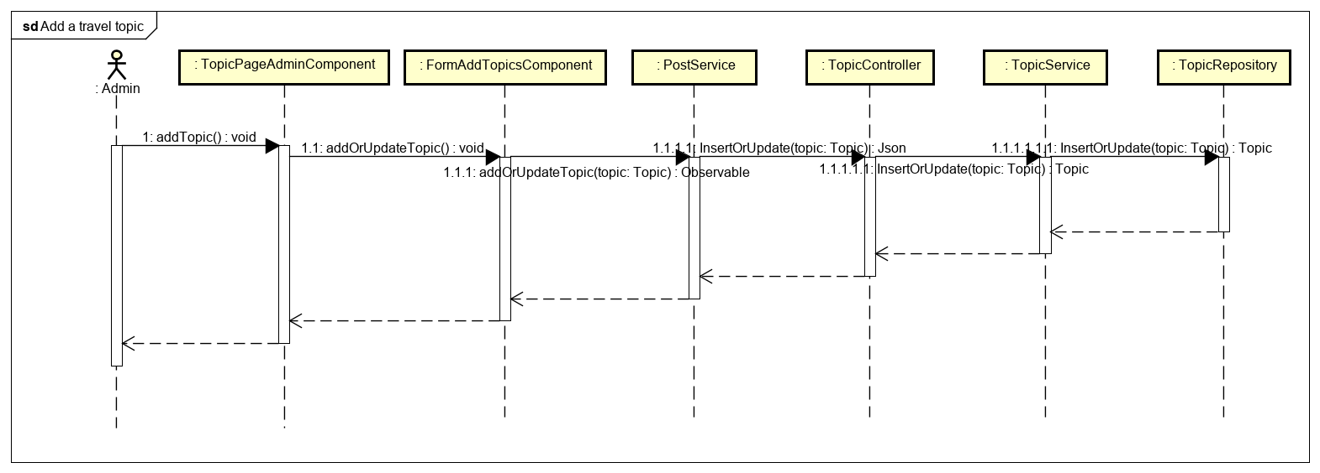

Figure 4: Administrator add a travel topic sequence diagram

**4.7 Edit a travel topic**

**Screen Design**

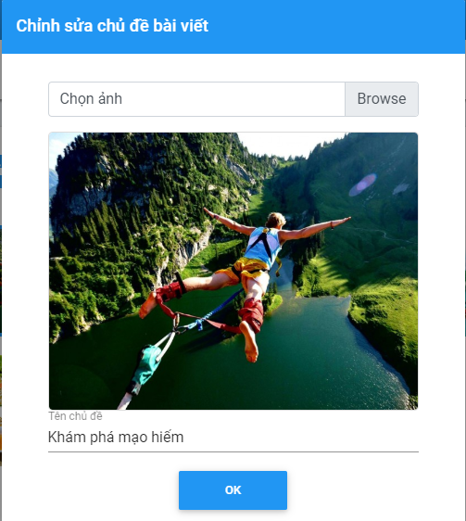

Figure 4: Edit a travel topic screen design

**Class Diagram**

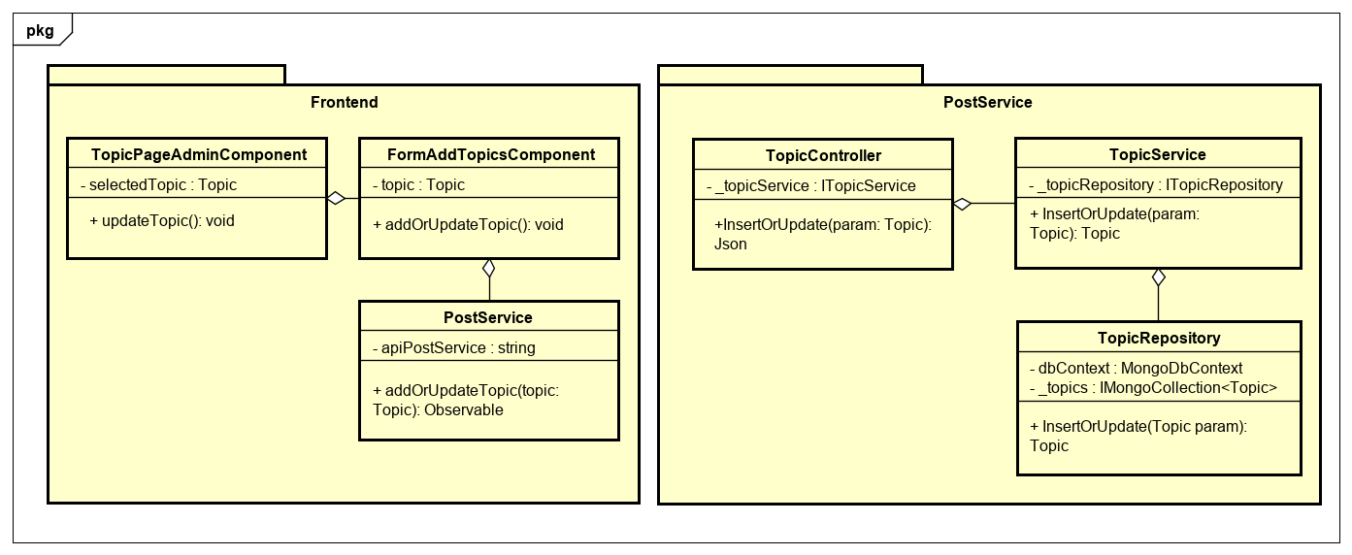

Figure 4: Administrator edit a travel topic class diagram

**Class Specification**

**TopicPageAdminComponent**

|  |  |  |  |
| --- | --- | --- | --- |
| **TopicPageAdminComponent** | | | |
| Physical address | src/app/admin/pages/dashboard-page/components/topic-page-admin/topic-page-admin.component.ts | | |
| Base class | Class | | |
| **Attributes** | | | |
| No | Name | Type | Description |
| 1 | selectedTopic | Topic |  |
| **Operation** | | | |
| No | Name | Type | Description |
| 1 | updateTopic | void |  |

**FormAddTopicsComponent**

|  |  |  |  |
| --- | --- | --- | --- |
| **FormAddTopicsComponent** | | | |
| Physical address | src/app/admin/pages/dashboard-page/components/topic-page-admin/form-add-topics/form-add-topics.component.ts | | |
| Base class | Class | | |
| **Attributes** | | | |
| No | Name | Type | Description |
| 1 | topic | Topic |  |
| **Operation** | | | |
| No | Name | Type | Description |
| 1 | addOrUpdateTopic | void |  |

**PostService**

|  |  |  |  |
| --- | --- | --- | --- |
| **PostService** | | | |
| Physical address | src/app/core/services/post-service/post.service.ts | | |
| Base class | Class | | |
| **Attributes** | | | |
| No | Name | Type | Description |
| 1 | apiPostService | String |  |
| **Operation** | | | |
| No | Name | Return Type | Description |
| 1 | addOrUpdateTopic | Observable |  |

**TopicController**

|  |  |  |  |
| --- | --- | --- | --- |
| **TopicController** | | | |
| Physical address | src/Services/PostService/PostService/Controllers/TopicController.cs | | |
| Base class | ControllerBase | | |
| **Attributes** | | | |
| No | Name | Type | Description |
| 1 | _topicService | ITopicService |  |
| **Operation** | | | |
| No | Name | Type | Description |
| 1 | InsertOrUpdate | Json |  |

**TopicService**

|  |  |  |  |
| --- | --- | --- | --- |
| **TopicService** | | | |
| Physical address | src/Services/PostService/PostService/Service/TopicService.cs | | |
| Base class | ITopicService | | |
| **Attributes** | | | |
| No | Name | Type | Description |
| 1 | _topicRepository | ITopicRepository |  |
| **Operation** | | | |
| No | Name | Type | Description |
| 1 | InsertOrUpdate | Topic |  |

**TopicRepository**

|  |  |  |  |
| --- | --- | --- | --- |
| **TopicRepository** | | | |
| Physical address | src/Services/PostService/PostService/Repository/TopicRepository.cs | | |
| Base class | ITopicRepository | | |
| **Attributes** | | | |
| No | Name | Type | Description |
| 1 | dbContext | MongoDbContext |  |
| 2 | _topics | ImongoCollection  <Topic> |  |
| **Operation** | | | |
| No | Name | Type | Description |
| 1 | InsertOrUpdate | Topic |  |

**Sequence Diagram**

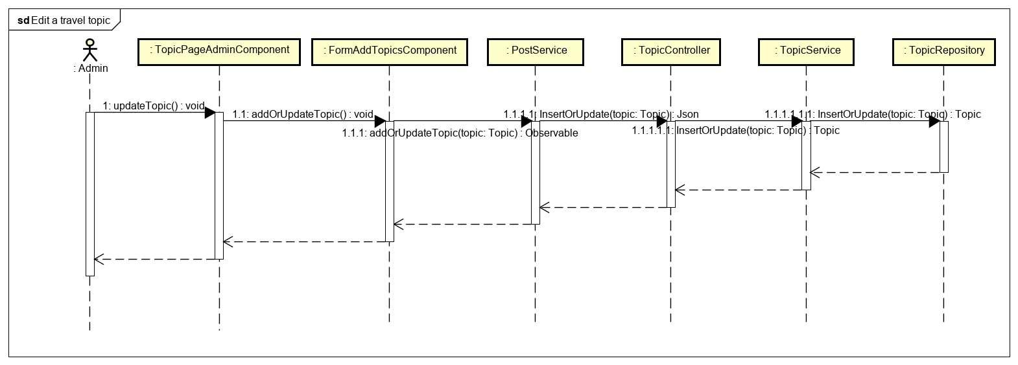

Figure 4: Administrator edit a travel topic sequence diagram

**4.8 Delete travel topics**

**Screen Design**

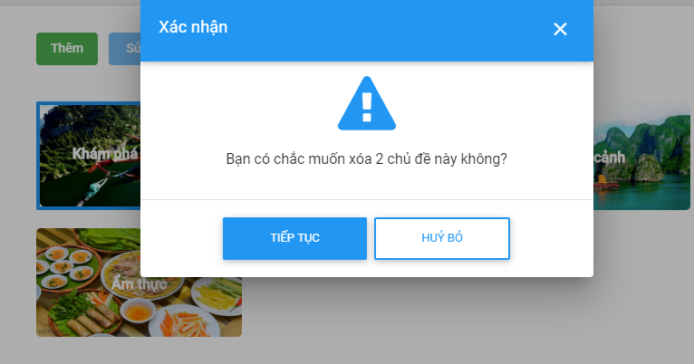

Figure 4: Delete travel topics screen design

**Class Diagram**

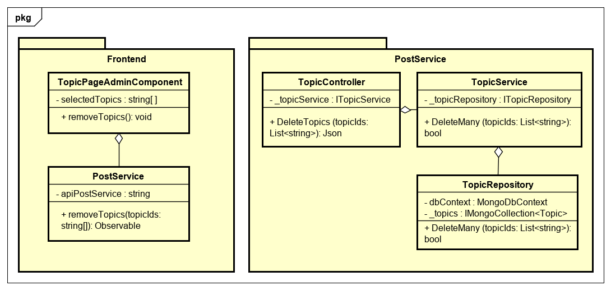

Figure 4: Administrator delete travel topics class diagram

**Class Specification**

**TopicPageAdminComponent**

|  |  |  |  |
| --- | --- | --- | --- |
| **TopicPageAdminComponent** | | | |
| Physical address | src/app/admin/pages/dashboard-page/components/topic-page-admin/topic-page-admin.component.ts | | |
| Base class | Class | | |
| **Attributes** | | | |
| No | Name | Type | Description |
| 1 | selectedTopics | String [ ] |  |
| **Operation** | | | |
| No | Name | Type | Description |
| 1 | removeTopics | void |  |

**PostService**

|  |  |  |  |
| --- | --- | --- | --- |
| **PostService** | | | |
| Physical address | src/app/core/services/post-service/post.service.ts | | |
| Base class | Class | | |
| **Attributes** | | | |
| No | Name | Type | Description |
| 1 | apiPostService | String |  |
| **Operation** | | | |
| No | Name | Return Type | Description |
| 1 | removeTopics | Observable |  |

**TopicController**

|  |  |  |  |
| --- | --- | --- | --- |
| **TopicController** | | | |
| Physical address | src/Services/PostService/PostService/Controllers/TopicController.cs | | |
| Base class | ControllerBase | | |
| **Attributes** | | | |
| No | Name | Type | Description |
| 1 | _topicService | ITopicService |  |
| **Operation** | | | |
| No | Name | Type | Description |
| 1 | DeleteTopics | Json |  |

**TopicService**

|  |  |  |  |
| --- | --- | --- | --- |
| **TopicService** | | | |
| Physical address | src/Services/PostService/PostService/Service/TopicService.cs | | |
| Base class | ITopicService | | |
| **Attributes** | | | |
| No | Name | Type | Description |
| 1 | _topicRepository | ITopicRepository |  |
| **Operation** | | | |
| No | Name | Type | Description |
| 1 | DeleteMany | Bool |  |

**TopicRepository**

|  |  |  |  |
| --- | --- | --- | --- |
| **TopicRepository** | | | |
| Physical address | src/Services/PostService/PostService/Repository/TopicRepository.cs | | |
| Base class | ITopicRepository | | |
| **Attributes** | | | |
| No | Name | Type | Description |
| 1 | dbContext | MongoDbContext |  |
| 2 | _topics | ImongoCollection  <Topic> |  |
| **Operation** | | | |
| No | Name | Type | Description |
| 1 | DeleteMany | Bool |  |

**Sequence Diagram**

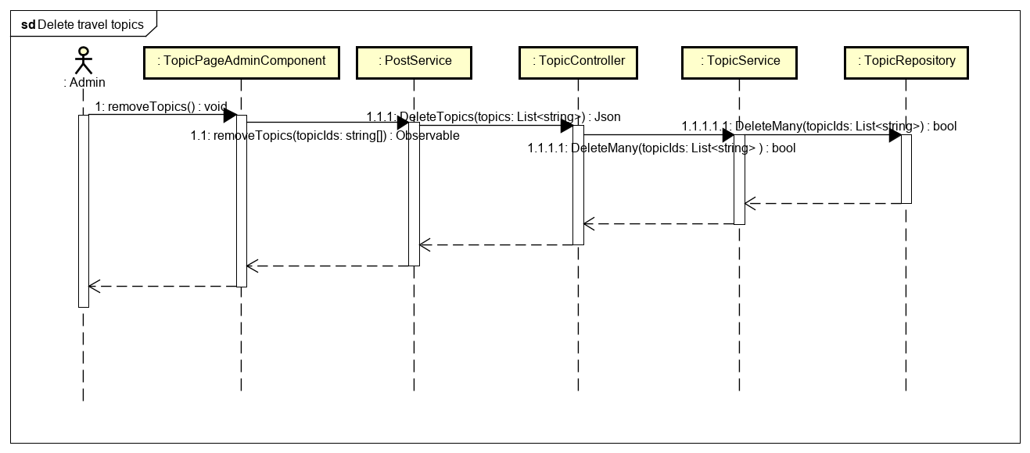

Figure 4: Administrator delete travel topics sequence diagram

**4.9 View statistic of users**

**Screen Design**

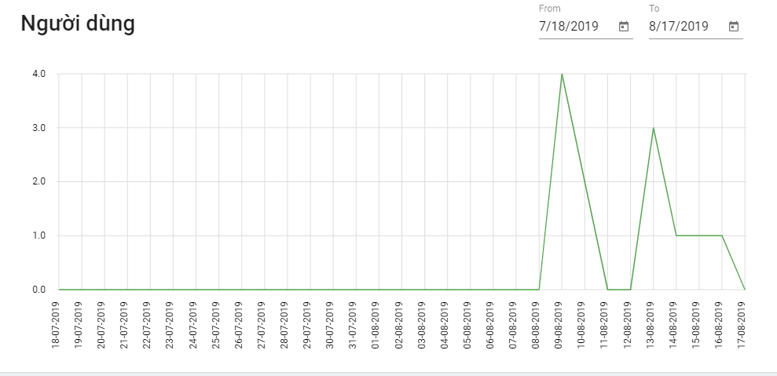

Figure 4: View statistic of user screen design

**Class Diagram**

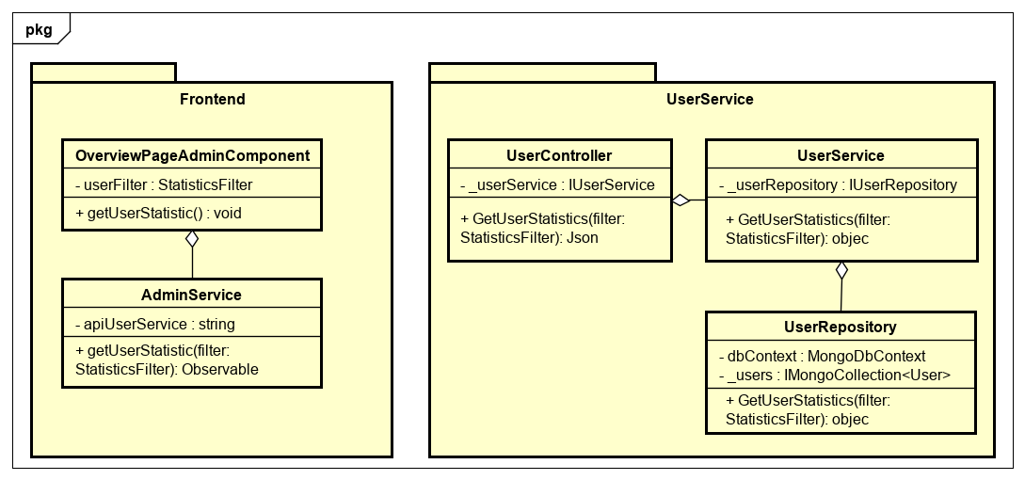

Figure 4: Administrator view statistic of user class diagram

**Class Specification**

OverviewPageAdminComponent

|  |  |  |  |
| --- | --- | --- | --- |
| **OverviewPageAdminComponent** | | | |
| Physical address | src/app/admin/pages/dashboard-page/components/overview-page-admin/overview-page-admin.component.ts | | |
| Base class | Class | | |
| **Attributes** | | | |
| No | Name | Type | Description |
| 1 | userFilter | StatisticsFilter |  |
| **Operation** | | | |
| No | Name | Type | Description |
| 1 | getUserStatistic | void |  |

**AdminService**

|  |  |  |  |
| --- | --- | --- | --- |
| **AdminService** | | | |
| Physical address | src/app/admin/services/admin-service/admin.service.ts | | |
| Base class | Class | | |
| **Attributes** | | | |
| No | Name | Type | Description |
| 1 | apiUserService | String |  |
| **Operation** | | | |
| No | Name | Return Type | Description |
| 1 | getUserStatistic | Observable |  |

**UserController**

|  |  |  |  |
| --- | --- | --- | --- |
| **UserController** | | | |
| Physical address | src/Services/UserService/UserService/Controllers/UserController.cs | | |
| Base class | ControllerBase | | |
| **Attributes** | | | |
| No | Name | Type | Description |
| 1 | _userService | IUserService |  |
| **Operation** | | | |
| No | Name | Type | Description |
| 1 | GetUserStatistics | Json |  |

**UserService**

|  |  |  |  |
| --- | --- | --- | --- |
| **UserService** | | | |
| Physical address | src/Services/UserService/UserService/Service/UserService.cs | | |
| Base class | IUserService | | |
| **Attributes** | | | |
| No | Name | Type | Description |
| 1 | _userRepository | IUserRepository |  |
| **Operation** | | | |
| No | Name | Type | Description |
| 1 | GetUserStatistics | Object |  |

**UserRepository**

|  |  |  |  |
| --- | --- | --- | --- |
| **UserRepository** | | | |
| Physical address | src/Services/UserService/UserService/Repository/UserRepository.cs | | |
| Base class | IUserRepository | | |
| **Attributes** | | | |
| No | Name | Type | Description |
| 1 | dbContext | MongoDbContext |  |
| 2 | _users | ImongoCollection  <User> |  |
| **Operation** | | | |
| No | Name | Type | Description |
| 1 | GetUserStatistics | Object |  |

**Sequence Diagram**

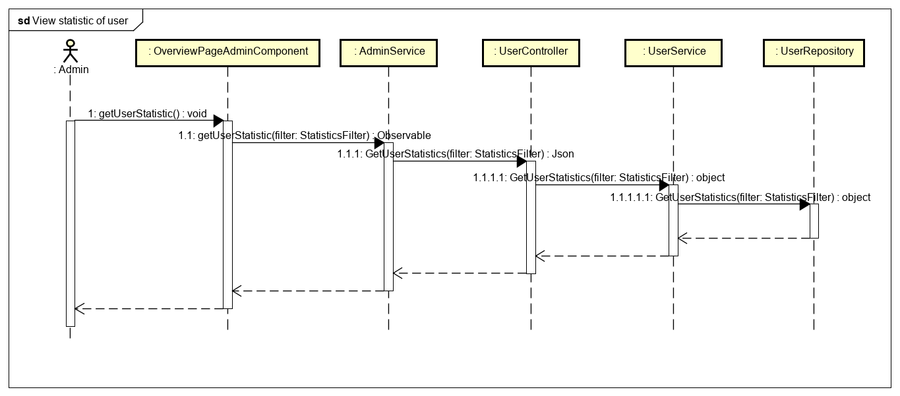

Figure 4: Administrator view statistic of user sequence diagram

**4.10 View statistic of posts**

**Screen Design**

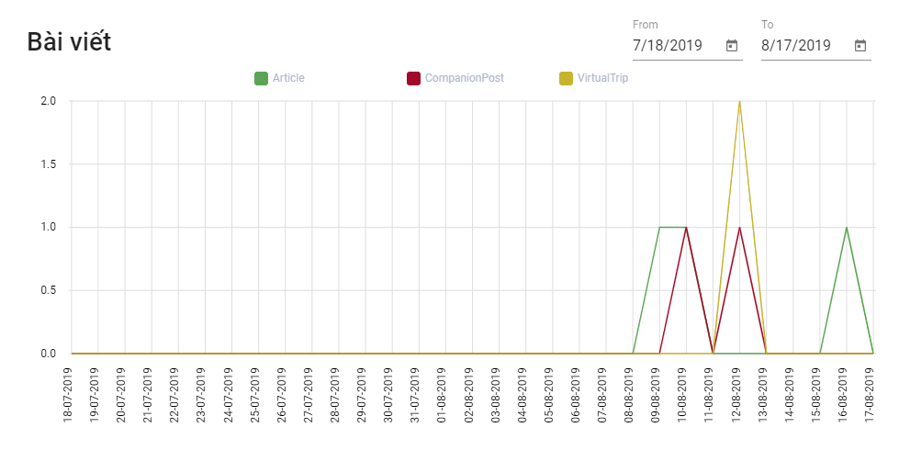

Figure 4: View statistic of posts screen design

**Class Diagram**

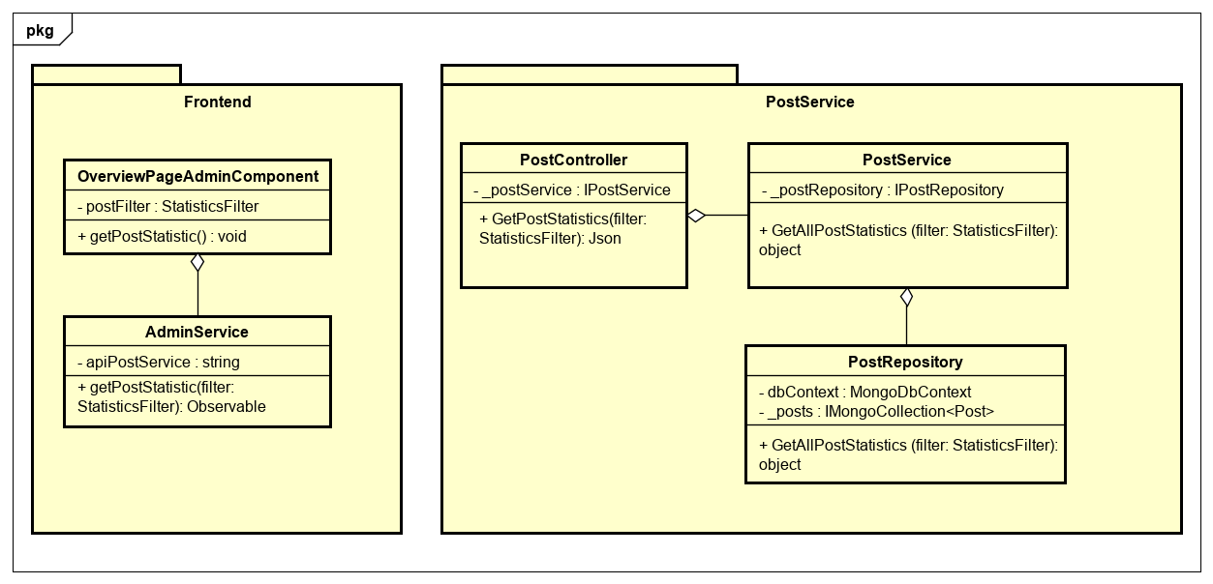

Figure 4: Admintrator view statistic of posts class diagram

**Class Specification**

**OverviewPageAdminComponent**

|  |  |  |  |
| --- | --- | --- | --- |
| **OverviewPageAdminComponent** | | | |
| Physical address | src/app/admin/pages/dashboard-page/components/overview-page-admin/overview-page-admin.component.ts | | |
| Base class | Class | | |
| **Attributes** | | | |
| No | Name | Type | Description |
| 1 | postFilter | StatisticsFilter |  |
| **Operation** | | | |
| No | Name | Type | Description |
| 1 | getPostStatistic | void |  |

**AdminService**

|  |  |  |  |
| --- | --- | --- | --- |
| **AdminService** | | | |
| Physical address | src/app/admin/services/admin-service/admin.service.ts | | |
| Base class | Class | | |
| **Attributes** | | | |
| No | Name | Type | Description |
| 1 | apiPostService | String |  |
| **Operation** | | | |
| No | Name | Return Type | Description |
| 1 | getPostStatistic | Observable |  |

**PostController**

|  |  |  |  |
| --- | --- | --- | --- |
| **PostController** | | | |
| Physical address | src/Services/PostService/PostService/Controllers/PostController.cs | | |
| Base class | ControllerBase | | |
| **Attributes** | | | |
| No | Name | Type | Description |
| 1 | _postService | IPostService |  |
| **Operation** | | | |
| No | Name | Type | Description |
| 1 | GetPostStatistics | Json |  |

**PostService**

|  |  |  |  |
| --- | --- | --- | --- |
| **PostService** | | | |
| Physical address | src/Services/PostService/PostService/Service/PostService.cs | | |
| Base class | IPostService | | |
| **Attributes** | | | |
| No | Name | Type | Description |
| 1 | _postRepository | IPostRepository |  |
| **Operation** | | | |
| No | Name | Type | Description |
| 1 | GetAllPostStatistics | Object |  |

**PostRepository**

|  |  |  |  |
| --- | --- | --- | --- |
| **PostRepository** | | | |
| Physical address | ./src/Services/ PostService/PostService /Repository/PostRepository.cs | | |
| Base class | IPostRepository | | |
| **Attributes** | | | |
| No | Name | Type | Description |
| 1 | dbContext | MongoDbContext |  |
| 2 | _posts | ImongoCollection  <Post> |  |
| **Operation** | | | |
| No | Name | Type | Description |
| 1 | GetAllPostStatistics | Object |  |

**Sequence Diagram**

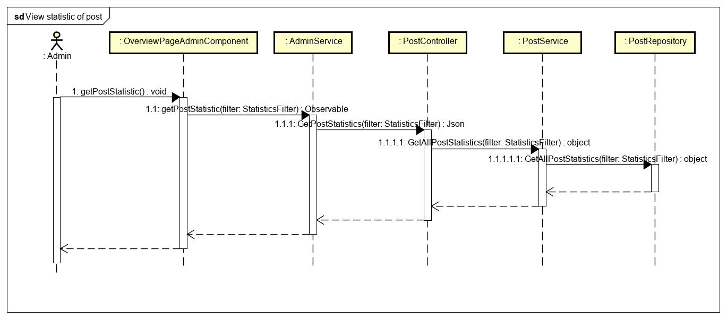

Figure 4: Admintrator view statistic of posts sequence diagram

**4.11 Search posts**

**Screen Design**

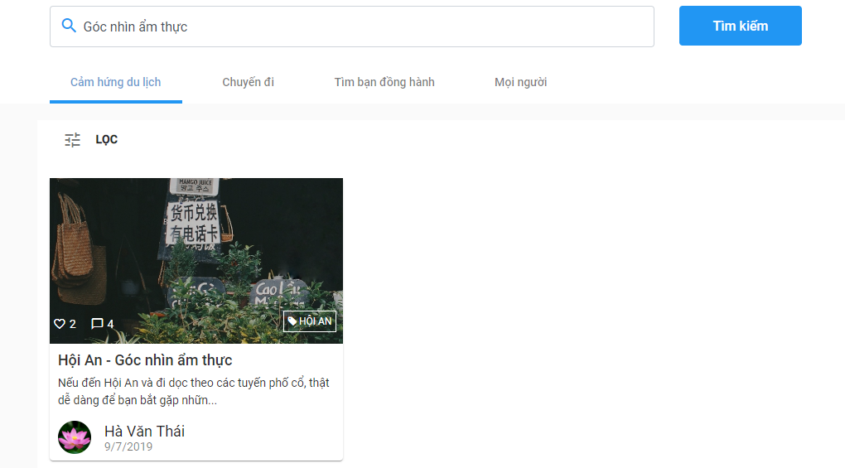

Figure 4: Search posts screen design

**Class Diagram**

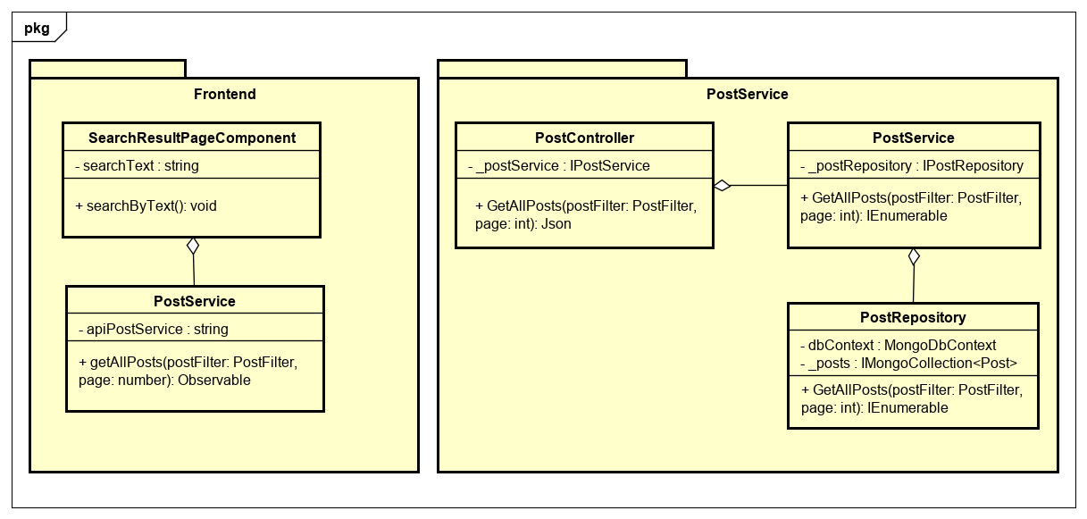

Figure 4: Search posts class diagram

**Class Specification**

**SearchResultPageComponent**

|  |  |  |  |
| --- | --- | --- | --- |
| **SearchResultPageComponent** | | | |
| Physical address | src/app/pages/search-result-page/search-result-page.component.ts | | |
| Base class | Class | | |
| **Attributes** | | | |
| No | Name | Type | Description |
| 1 | searchText | String |  |
| **Operation** | | | |
| No | Name | Type | Description |
| 1 | searchByText | void |  |

**PostService**

|  |  |  |  |
| --- | --- | --- | --- |
| **PostService** | | | |
| Physical address | src/app/core/services/post-service/post.service.ts | | |
| Base class | Class | | |
| **Attributes** | | | |
| No | Name | Type | Description |
| 1 | apiPostService | String |  |
| **Operation** | | | |
| No | Name | Return Type | Description |
| 1 | getAllPosts | Observable |  |

**PostController**

|  |  |  |  |
| --- | --- | --- | --- |
| **PostController** | | | |
| Physical address | src/Services/PostService/PostService/Controllers/PostController.cs | | |
| Base class | ControllerBase | | |
| **Attributes** | | | |
| No | Name | Type | Description |
| 1 | _postService | IPostService |  |
| **Operation** | | | |
| No | Name | Type | Description |
| 1 | GetAllPosts | Json |  |

**PostService**

|  |  |  |  |
| --- | --- | --- | --- |
| **PostService** | | | |
| Physical address | ./src/Services/ PostService/PostService/Service/PostService.cs | | |
| Base class | IPostService | | |
| **Attributes** | | | |
| No | Name | Type | Description |
| 1 | _postRepository | IPostRepository |  |
| **Operation** | | | |
| No | Name | Type | Description |
| 1 | GetAllPosts | IEnumerable |  |

**PostRepository**

|  |  |  |  |
| --- | --- | --- | --- |
| **PostRepository** | | | |
| Physical address | ./src/Services/ PostService/PostService /Repository/PostRepository.cs | | |
| Base class | IPostRepository | | |
| **Attributes** | | | |
| No | Name | Type | Description |
| 1 | dbContext | MongoDbContext |  |
| 2 | _posts | ImongoCollection  <Post> |  |
| **Operation** | | | |
| No | Name | Type | Description |
| 1 | GetAllPost | IEnumerable |  |

**Sequence Diagram**

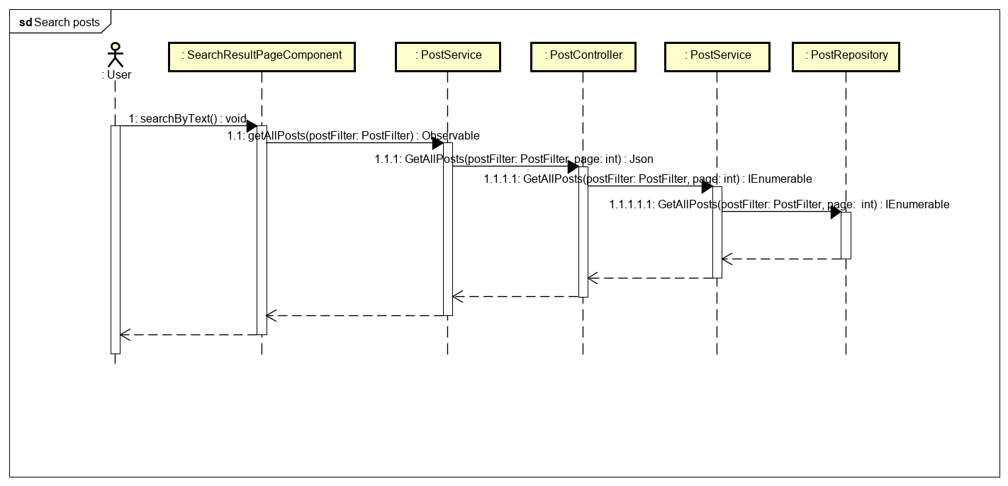

Figure 4: Search posts sequence diagram

**4.12 Search a user**

**Screen Design**

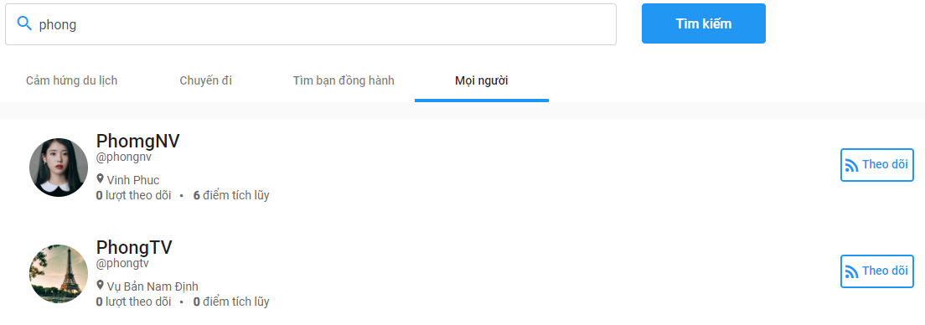

Figure 4: Search a user class diagram

**Class Diagram**

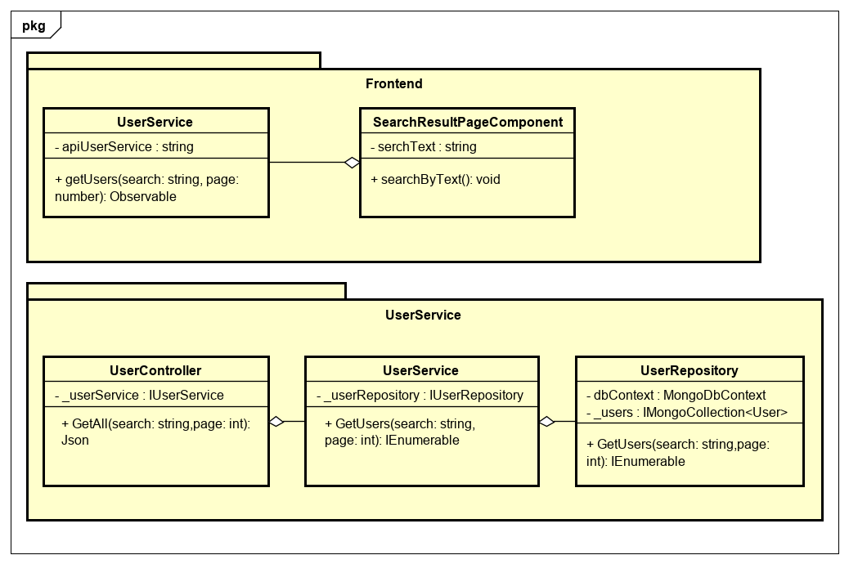

Figure 4: Search a user class diagram

**Class Specification**

**SearchResultPageComponent**

|  |  |  |  |
| --- | --- | --- | --- |
| **SearchResultPageComponent** | | | |
| Physical address | src/app/pages/search-result-page/search-result-page.component.ts | | |
| Base class | Class | | |
| **Attributes** | | | |
| No | Name | Type | Description |
| 1 | serchText | String |  |
| **Operation** | | | |
| No | Name | Type | Description |
| 1 | searchByText | void |  |

**UserService**

|  |  |  |  |
| --- | --- | --- | --- |
| **UserService** | | | |
| Physical address | src/app/core/services/user-service/user.service.ts | | |
| Base class | Class | | |
| **Attributes** | | | |
| No | Name | Type | Description |
| 1 | apiUserService | String |  |
| **Operation** | | | |
| No | Name | Return Type | Description |
| 1 | getUsers | Observable |  |

**UserController**

|  |  |  |  |
| --- | --- | --- | --- |
| **UserController** | | | |
| Physical address | src/Services/UserService/UserService/Controllers/UserController.cs | | |
| Base class | ControllerBase | | |
| **Attributes** | | | |
| No | Name | Type | Description |
| 1 | _userService | IUserService |  |
| **Operation** | | | |
| No | Name | Type | Description |
| 1 | GetAll | Json |  |

**UserService**

|  |  |  |  |
| --- | --- | --- | --- |
| **UserService** | | | |
| Physical address | src/Services/UserService/UserService/Service/UserService.cs | | |
| Base class | IUserService | | |
| **Attributes** | | | |
| No | Name | Type | Description |
| 1 | _userRepository | IUserRepository |  |
| **Operation** | | | |
| No | Name | Type | Description |
| 1 | GetUsers | IEnumerable |  |

**UserRepository**

|  |  |  |  |
| --- | --- | --- | --- |
| **UserRepository** | | | |
| Physical address | src/Services/UserService/UserService/Repository/UserRepository.cs | | |
| Base class | IuserRepository | | |
| **Attributes** | | | |
| No | Name | Type | Description |
| 1 | dbContext | MongoDbContext |  |
| 2 | _users | ImongoCollection  <User> |  |
| **Operation** | | | |
| No | Name | Type | Description |
| 1 | GetUsers | IEnumerable |  |

**Sequence Diagram**

