# Tutorial for the tool

This tutorial explains how to us the TWIC and ChessCom downloader tool.  
It targets the release 116 – //github.com/haveljo4/chess-games-download/releases/tag/116

## Download and run the tool

1. A screenshot of a computer

   Description automatically generatedDownload the zipped binaries from GitHub
2. Extract the whole folder from the .zip file.
3. A screenshot of a computer

   Description automatically generatedOpen the folder with binaries, keep the .dll files in the same folder as the .exe file.
4. A screenshot of a computer

   Description automatically generatedRun the Chess-tool-exe.exe file by double clicking.

## Chess.com games download

1. Click the “Chess.com” button.
2. Specify the following fields
   1. **Output Folder** – This field allows you to select the folder where the downloaded .pgn file will be saved. By default, the file will be saved in the same location as the application binaries.
   2. **User Name** – Enter the user name of the player on Chess.com whose games you want to download
   3. **Year From, Month From** – Specify the starting date from which you want to download games. Enter desired year and month.
   4. **Year To, Month To** – Specify the ending date from which you want to download games. Enter desired year and month.
3. Press the download button.
4. 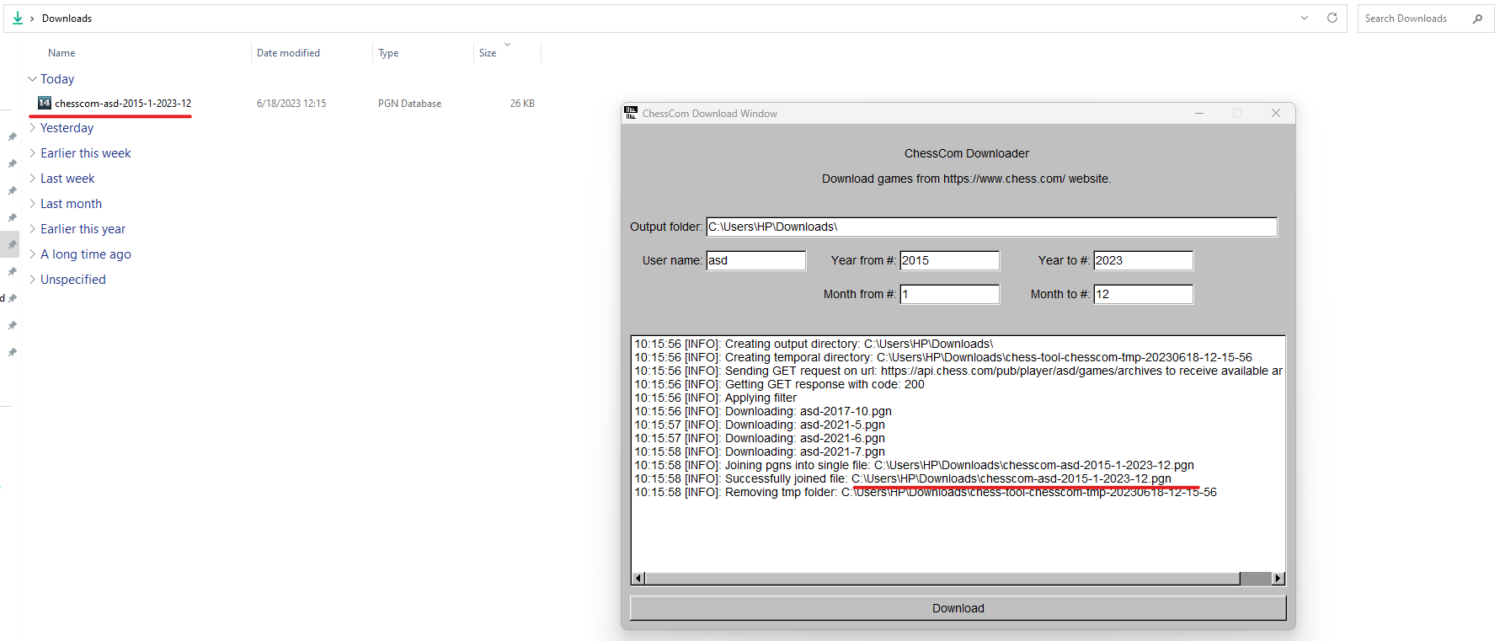In the text box you can see the logs.

## TWIC Games Download

1. Click the “TWIC” button.
2. Specify the following fields
   1. **Output Folder** – This field allows you to select the folder where the downloaded .pgn file will be saved. By default, the file will be saved in the same location as the application binaries.
   2. **Index From**, **Index To** – Specify the range of files you want to download from the TWIC website.
3. Press the download button.

