??2?PGP??????
?Thunderbird + OpenPGP?
?? | ????
?? | ????
??/?? | ????
?? | 2026-05-13

??????
?? Thunderbird ? OpenPGP ?????????????????????????? PGP ??????????????

??????
???? | 17392437906@163.com
????? | Mozilla Thunderbird
Thunderbird?? | 150.0.1.0
PGP?? | OpenPGP
?????? | 2640624354@qq.com

??????
- 1. ? Thunderbird ?? 17392437906@163.com ?? OpenPGP ????????????????????
- 2. ??????????????????????????????
- 3. ?????????????????????????
- 4. ??????????????????????????
- 5. ?? OpenPGP ???????????????????????

?????????

4.1 ?????
???????????? 17392437906@163.com?Thunderbird ????????????? OpenPGP ??????? ID ? 0x3E89EFCF8FAA89D7?
??????????????????????
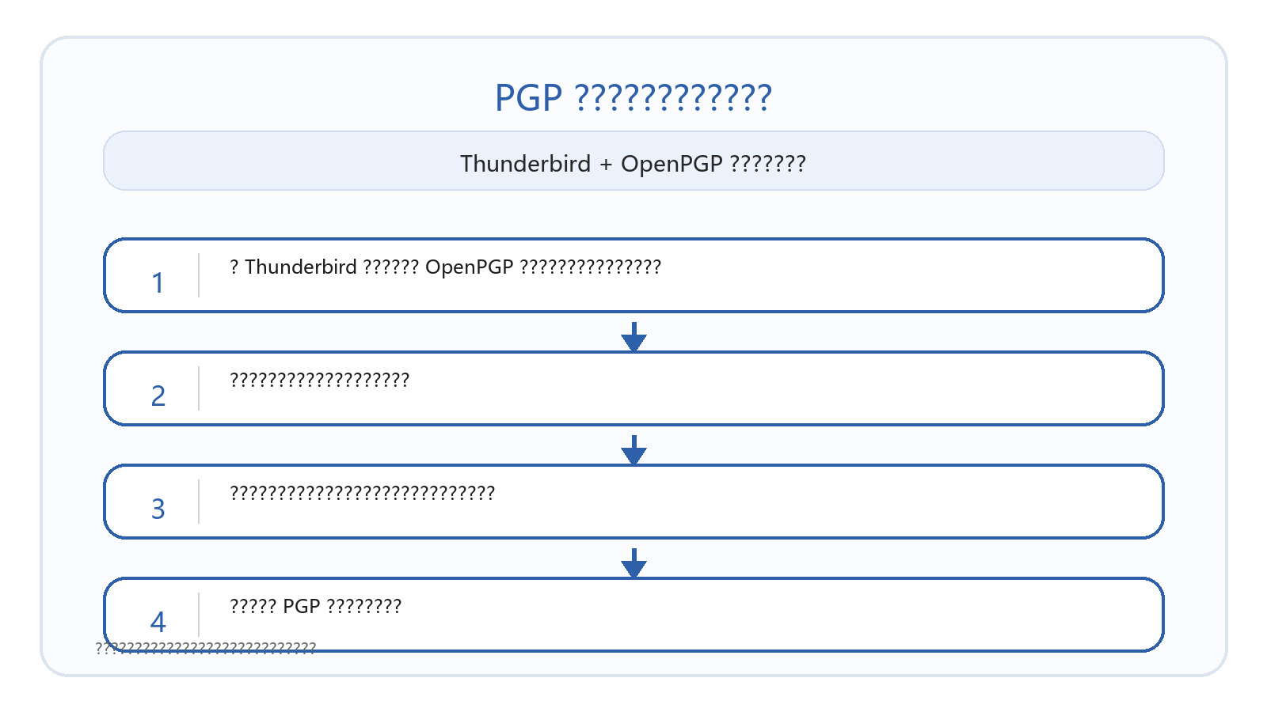
???????????OpenPGP ???????????????????????

4.2 ?????????
?1??????????????????????????????????????????? PGP ????????????

?2?????????????????????????????????????????????????????Thunderbird ????????
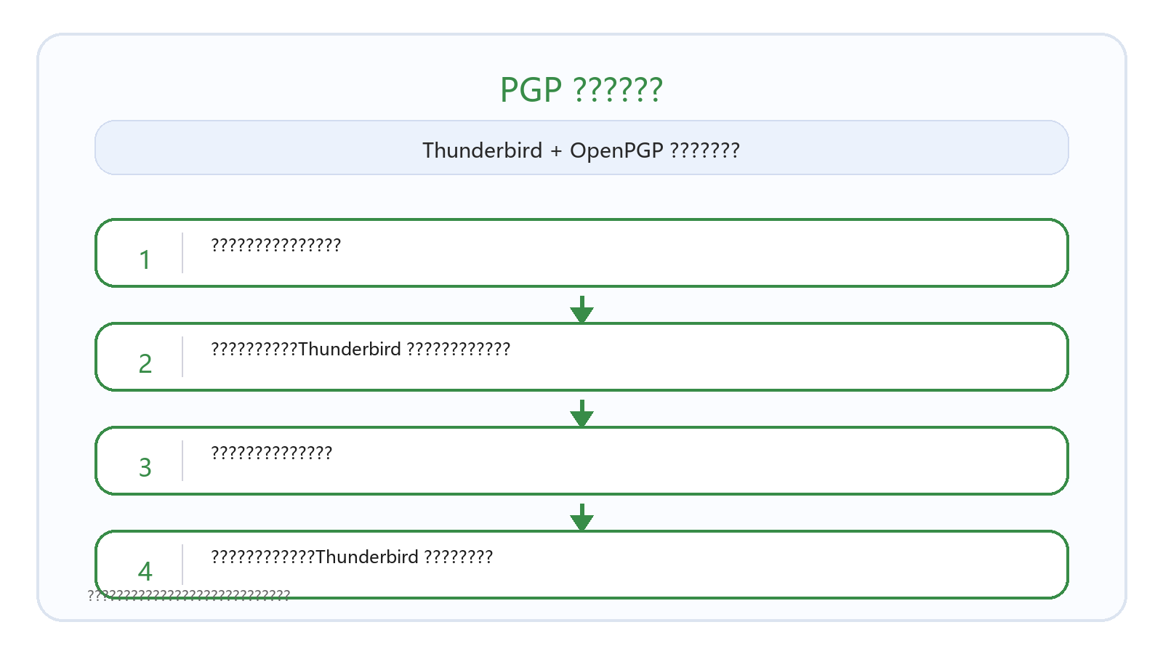
?3???????????????????????????????????????????? PGP ?????
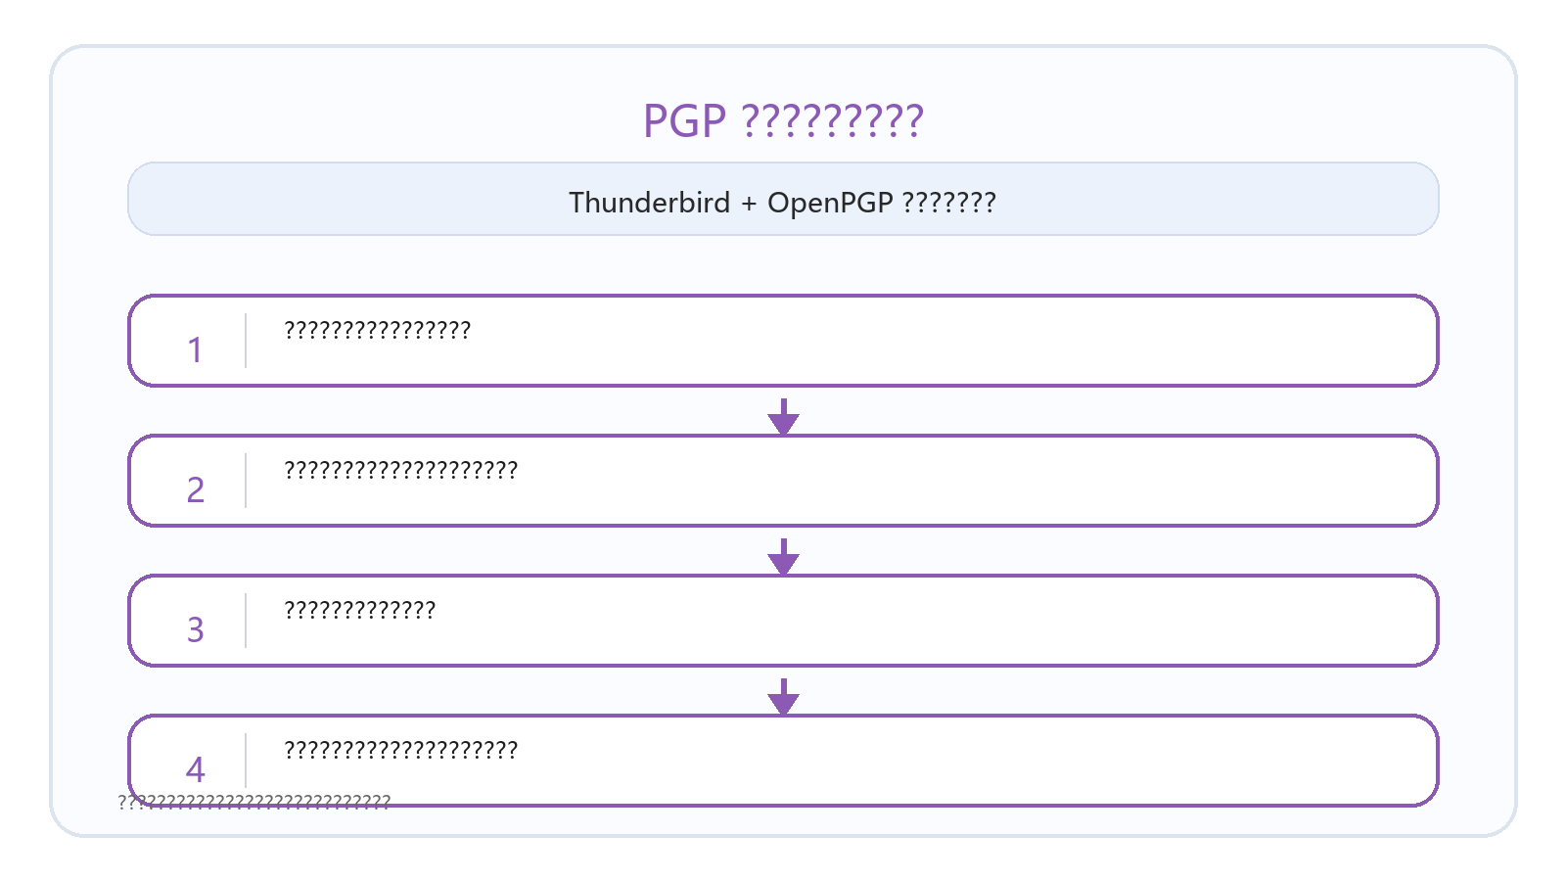

4.3 PGP????
Thunderbird ? OpenPGP ??????????????????????????????????????????????????????????????????
????????????????????????????????????????????????????????????
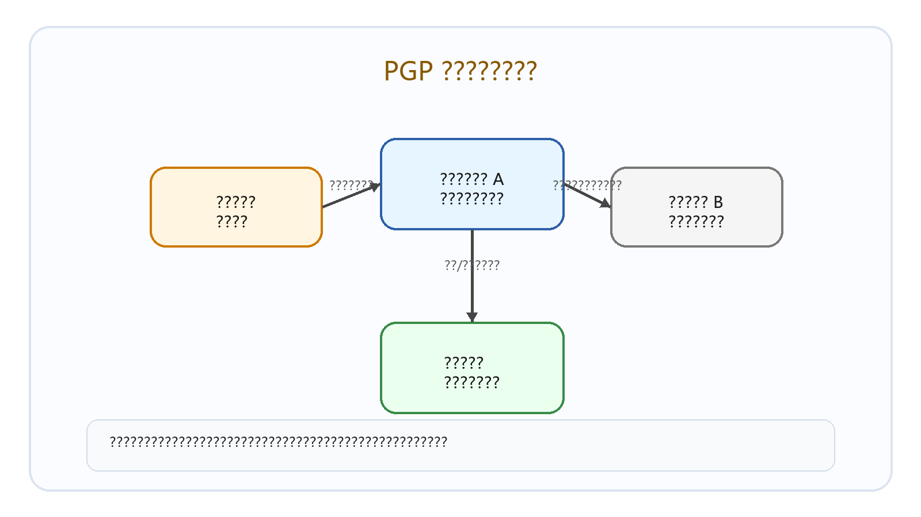

??????
?????? Thunderbird ? OpenPGP ????????????????????????????PGP ????????????????????????????????????????

??????
- https://support.mozilla.org/en-US/kb/openpgp-thunderbird-howto-and-faq
- https://support.mozilla.org/en-US/kb/thunderbird-help-openpgp-counterfeit-key
- https://support.mozilla.org/en-US/kb/thunderbird-help-cannot-encrypt

