BARANGAY COUNCIL OF SINDALAN  HON. BENJAMIN F. ANGELES  Punong Barangay  Sangguniang Barangay Members:  HON. JONEL L. ANTONIO  COMMITTEE ON ENVIRONMENTAL PROTECTION COMMITTEE ON LIVELIHOOD & ENTREPRENEURSHIP  HON. PACIFICO M. DATU  COMMITTEE ON HEALTH & SOCIAL WELFARE  HON. EMILIO P. SICAT  COMMITTEE ON PEACE & ORDER &  COMMITTEE ON ETHICS  HON. ALICIA I. DUMLAO  COMMITTEE ON PUBLIC WORKS & INFRASTRUCTURE DEVELOPMENT  COMMITTEE ON WOMEN & FAMILY  HON. DEXTER M. FRANCISCO  COMMITTEE ON FINANCE, BUDGET, & APPROPRIATION  COMMITTEE ON SENIOR CITIZEN & PWD  HON. ROMMEL M. SERRANO  COMMITTEE ON AGRICULTURE  COMMITTEE ON SOLO PARENTS & LGBT  HON. CHRISTIAN JON P. GAMPOY  SK CHAIRPERSON  ANGELYN M. TORNO  BARANGAY SECRETARY  JEROME Y. ALCONGA  BARANGAY TREASURER | 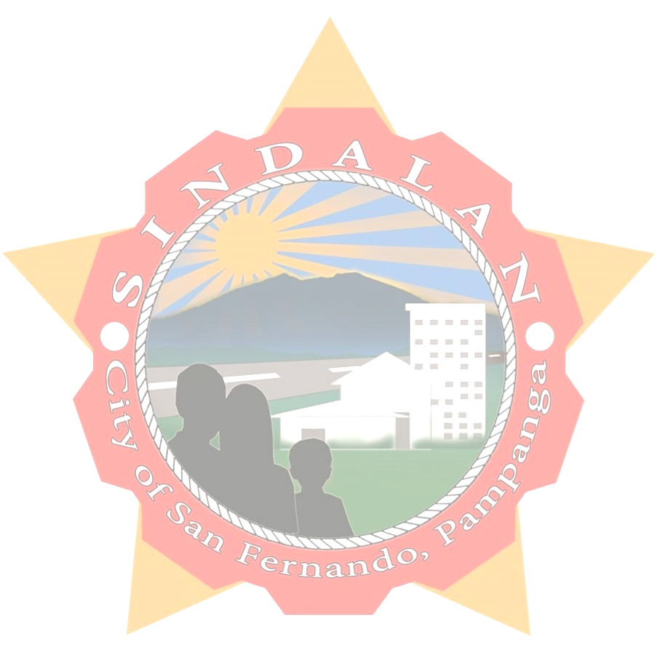  BARANGAY CLEARANCE  THIS IS TO CERTIFY that {name}, {age} years of age and was born {birthday}, Filipino citizen is a bonafide resident of this barangay and with postal/residence {address} SINDALAN, CITY OF SAN FERNANDO, PAMPANGA.  THIS IS FURTHER CERTIFIED that the above subject person has no derogatory or criminal record in this Barangay as of this date issued upon the request of the above-named person for whatever legal purposes.  ISSUED upon the request of the above-named person this {date} day of {month}, {year}.    HON. BENJAMIN F. ANGELES  Punong Barangay  Barangay Contact No.: 0969-473-5789/0965-721-6455  Barangay Email: sindalanbarangay@yahoo.com

