BARANGAY COUNCIL OF SINDALAN  HON. BENJAMIN F. ANGELES  Punong Barangay  Sangguniang Barangay Members:  HON. JONEL L. ANTONIO  COMMITTEE ON ENVIRONMENTAL PROTECTION COMMITTEE ON LIVELIHOOD & ENTREPRENEURSHIP  HON. PACIFICO M. DATU  COMMITTEE ON HEALTH & SOCIAL WELFARE  HON. EMILIO P. SICAT  COMMITTEE ON PEACE & ORDER & PUBLIC SAFETY & HUMAN RIGHTS COMMITTEE ON COOPERATIVES & LABOR & EMPLOYMENT  HON. ALFREDO S. DIZON JR.  COMMITTEE ON EDUCATION  COMMITTEE ON CULTURAL PRESERVATION  COMMITTEE ON ETHICS  HON. ALICIA I. DUMLAO  COMMITTEE ON PUBLIC WORKS & INFRASTRUCTURE DEVELOPMENT  COMMITTEE ON WOMEN & FAMILY  HON. DEXTER M. FRANCISCO  COMMITTEE ON FINANCE, BUDGET, & APPROPRIATION  COMMITTEE ON SENIOR CITIZEN & PWD  HON ROMMEL M. SERRANO  COMMITTEE ON AGRICULTURE  COMMITTEE ON SOLO PARENTS & LGBT  HON. CHRISTIAN JON P. GAMPOY  SK CHAIRPERSON  ANGELYN M. TORNO  BARANGAY SECRETARY  JEROME Y. ALCONGA  BARANGAY TREASURER | 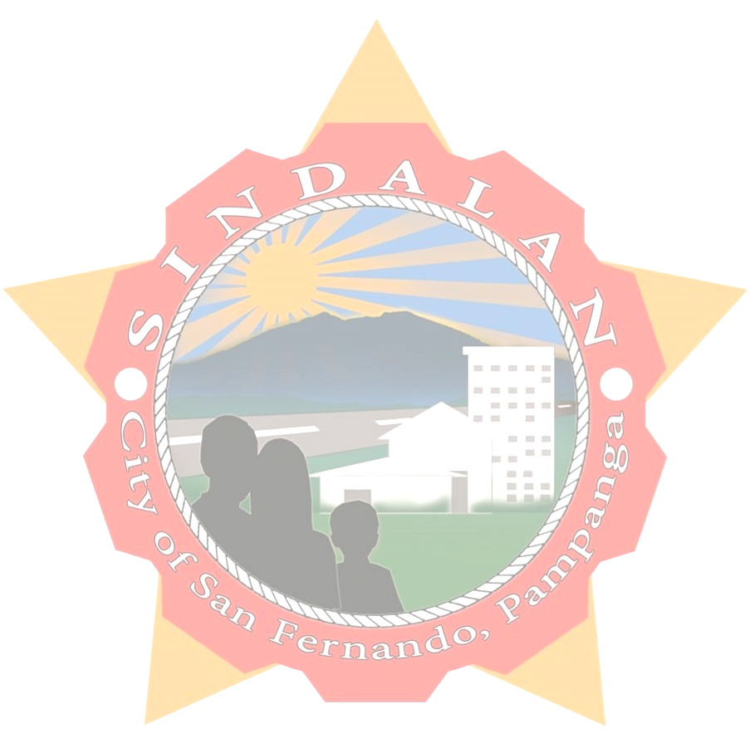  BARANGAY INDIGENCY  To whom it may concern:  THIS IS TO CERTIFY that {name} , {age} years of age, Filipino citizen is a bonafide resident of this barangay and with postal/residence {address} SINDALAN, CITY OF SAN FERNANDO, PAMPANGA.  THIS IS TO CERTIFY further that the above-named person belongs to an indigent family in this barangay.  THIS CERTIFICATION is being issued upon the request of the above person for {purpose} purposes.  GIVEN upon the request of the above-named person this {date} day of {month}, {year}.  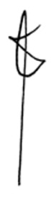  HON. BENJAMIN F. ANGELES  Punong Barangay  “This certification is valid within 1 year of issuance and not valid without barangay seal”

