BARANGAY COUNCIL OF SINDALAN  HON. BENJAMIN F. ANGELES  Punong Barangay  Sangguniang Barangay Members:  HON. JONEL L. ANTONIO  COMMITTEE ON ENVIRONMENTAL PROTECTION COMMITTEE ON LIVELIHOOD & ENTREPRENEURSHIP  HON. PACIFICO M. DATU  COMMITTEE ON HEALTH & SOCIAL WELFARE  HON. EMILIO P. SICAT  COMMITTEE ON PEACE & ORDER & PUBLIC SAFETY & HUMAN RIGHTS COMMITTEE ON COOPERATIVES & LABOR & EMPLOYMENT  HON. ALFREDO S. DIZON JR.  COMMITTEE ON EDUCATION  COMMITTEE ON CULTURAL PRESERVATION  COMMITTEE ON ETHICS  HON. ALICIA I. DUMLAO  COMMITTEE ON PUBLIC WORKS & INFRASTRUCTURE DEVELOPMENT  COMMITTEE ON WOMEN & FAMILY  HON. DEXTER M. FRANCISCO  COMMITTEE ON FINANCE, BUDGET, & APPROPRIATION  COMMITTEE ON SENIOR CITIZEN & PWD  HON ROMMEL M. SERRANO  COMMITTEE ON AGRICULTURE  COMMITTEE ON SOLO PARENTS & LGBT  HON. CHRISTIAN JON P. GAMPOY  SK CHAIRPERSON  ANGELYN M. TORNO  BARANGAY SECRETARY  JEROME Y. ALCONGA  BARANGAY TREASURER | 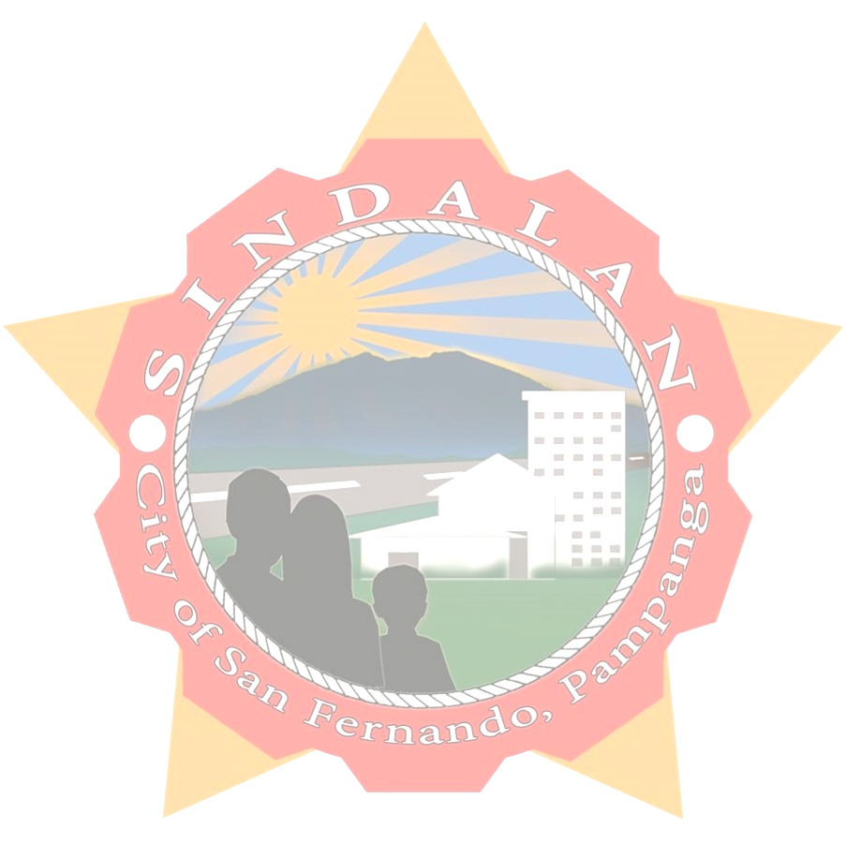  CERTIFICATE OF RESIDENCY  To whom it may concern:  THIS IS TO CERTIFY that {name}, {age} years of age, bonafide residents of this barangay and with postal/residence {address}, SINDALAN, CITY OF SAN FERNANDO, PAMPANGA.  THIS CERTIFICATION IS BEING ISSUED for {purpose} purposes.  GIVEN this {date} day of {month}, {year} at Barangay Hall of SINDALAN CITY OF SAN FERNANDO, PAMPANGA.    Dr. BENJAMIN F. ANGELES  Punong Barangay  “Not valid without Barangay dry seal.”

